Relocation of artefacts from HSM 68: Supply depot, Hell’s Gate Moraine

Relocation of artefacts from HSM 68: Supply depot, Hell’s Gate Moraine

**Working Paper submitted by New Zealand, Norway and the United Kingdom**

Summary

Artefacts from Historic Site and Monument No. 68 Supply Depot, Hell’s Gate Moraine (HSM 68) were removed from their original location in the 1994/95 season and have been stored in a container at New Zealand’s Scott Base ever since. New Zealand, Norway and the United Kingdom reviewed the future storage and display options for the artefacts and recommend they be removed from Antarctica for storage and safe keeping of the objects within the Reserve Collection supported by the New Zealand Antarctic Heritage Trust (AHT) at Canterbury Museum, Christchurch, New Zealand.

Background

Heroic-era artefacts from HSM 68: Supply Depot, Hell’s Gate Moraine located adjacent to Inexpressible Island, Terra Nova Bay, Ross Sea region (Figure 1), were removed from their original locations in 1994/95 (Figure 2) under the directive of the Director at the time of the New Zealand Antarctic Programme to prevent the permanent loss of the artefacts to the environment.

The cache or artefacts comprises a sled, tools and food left as an emergency depot for future sledging parties (Figure 3). In addition, some artefacts from an emergency depot were recovered and included within the cache including a handful of leather sledging straps, some wooden spars from a sledge and some rope.

The artefacts have been cared for by the New Zealand Antarctic Heritage Trust ever since. The artefacts have been conserved and stored in a shipping container outside at Scott Base (Figure 3, 4 and 5). With the Scott Base Redevelopment underway, a more permanent home is required for these artefacts. A list of artefacts is presented in Attachment 1.

Assessment of options

The cache constitutes a unique part of the story of heroic-era exploration, and their greatest value (having already been removed from their original site) lies in being understood as a grouping of objects.

With reference to the Guidelines for the designation and protection of Historic Sites and Monuments (Resolution 3 (2009)) and the Guidelines for the assessment and management of Heritage in Antarctica (Resolution 1 (2022)), New Zealand, Norway and the United Kingdom reviewed the provenance, condition, and future storage and display options for the artefacts as outlined in Table 1. It was identified that the most appropriate option for storage and safe keeping of the objects is as part of the Reserve Collection supported by the New Zealand Antarctic Heritage Trust at Canterbury Museum, Christchurch, New Zealand.

Recommendation:

New Zealand, Norway and the United Kingdom recommend the CEP:

1. Support the preferred long-term storage and safe keeping of the objects as part of the Reserve Collection supported by the New Zealand Antarctic Heritage Trust at Canterbury Museum, Christchurch, New Zealand for possible future display as part of the museums Antarctic collection or for possible return to Antarctica if desired; and
2. Update the Conservation Status on the HSM No. 68 listing on the Antarctic Protected Area database to read: *Sledge and supplies removed from site in 1994. The artefacts have been documented and conserved (2017) by the New Zealand-based Antarctic Heritage Trust. They are stored at Canterbury Museum, Christchurch, New Zealand as part of the Reserve Collection supported by the New Zealand Antarctic Heritage Trust. The artefacts are extremely fragile*.

Figure 1: Artefacts as found before removal.

Figure 2: Artefacts removed to Scott Base in 1994/95.

Figure 3: Conserved Hells Gate Moraine sledge, tent poles, tools and food boxes.

Figure 4: Hells Gate Moraine spade

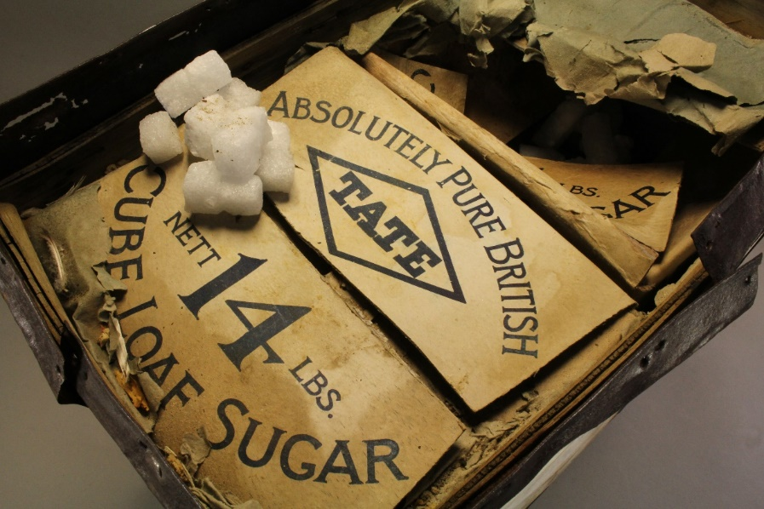

Figure 5: Hells Gate Moraine Venesta case, after conservation.

Table 1: Long term storage options of artefacts from HSM 68.

|  | **Storage option** | **Assessment of the options** |
| --- | --- | --- |
| **Retain artefacts in Antarctica** | 1. Return to the original cache sites | * Keeps the objects in Antarctica but this will result in the items’ deterioration and loss to the environment (as occurred to Granite Harbour depot) within 2-3 decades. * **Not recommended** |
| 1. Placement in Discovery Hut (Hut Point), ASPA 158 | * Keeps the objects in Antarctica, and in a heroic era context. * Keeps food products frozen for most of the year, slowing deterioration. * Places the cache collections at risk of being separated in the long term due to future generations not realising the provenance and significance of the cache items. It would also confuse the real Hut Point stories, and is not a site the stores originated from. * **Not recommended** |
| 1. Placement in Terra Nova Hut (Cape Evans), ASPA 155 | * Keeps the objects in Antarctica, and provides some context for the items as stores were loaded at Cape Evans directly before the Terra Nova headed north up McMurdo Sound and placed depots on the return voyage to New Zealand. * Keeps food products frozen for most of the year, slowing deterioration. * The sledge is 3 metres in length, and there isn’t an area big enough for the sled in the hut except the hut rafters, meaning it will have to be separated from the objects. * **Not recommended** |
| 1. Placement in Borchgrevink’s Stores Hut (Cape Adare) ASPA 159 | * Keeps the objects in Antarctica, and provides some context for the items. Scott’s Northern Party used both of the extant 1899 huts during 1911 for additional storage and workspace. The Hell’s Gate Moraine depot was left as a result of the Northern Party’s subsequent experience of being marooned across a winter, in case any future coastal party should find themselves in need of emergency supplies. * Keeps food products frozen for most of the year, slowing deterioration. * The sledge is 3 metres in length. There may be space for the sled and objects in the re-roofed store room at Cape Adare but it will be considerably cramped. There is no room in the Living Hut for these artefacts. * Logistics for transporting these items from Scott Base to Cape Adare and ongoing access for maintenance and conservation is extremely difficult. * **Not recommended** |
| **Return objects to New Zealand** | 1. Removal to the AHT Reserve Collection (New Zealand, based at Canterbury Museum) | * A controlled museum environment would ensure the artefacts are preserved for longer, and they could be viewed as a discrete collection from each cache site by researchers. Food products could be assessed and emptied for warm storage, or added to frozen collection. * Keeping the entire cache in the Reserve Collection is not part of that collection’s intended purpose (representative sample). However, it is not desirable to break up the cache collection. * The Reserve Collection offers the next best option to leaving in Antarctica, due to the existing approval for holding Antarctic items which cannot be cared for in Antarctica. * Logistics transport and movement of the artefacts from Scott Base to New Zealand would have less risk of damage during the transport process. * Canterbury Museum’s redevelopment means that the Reserve Collection will move temporarily to an offsite storage facility with stable (albeit uncontrolled) environmental conditions.Freezer space will be available for food products. * The flexibility of the Reserve Collection allows for the possible future display of the artefacts as part of the museums Antarctic collection or for possible return to Antarctica if required and as logistics allows. * **Recommended for consideration** |
| 1. Removal to the Canterbury Museum collection | * A controlled museum environment would ensure the artefacts are preserved for longer, and they could be viewed as a discrete collection from each cache site by researchers. Food products could be assessed and emptied for warm storage, or added to frozen collection. * Permanent addition of the items to a New Zealand museum collection implies an ownership claim by the museum, which is not desirable. * Canterbury Museum is initiating a complete rebuild in 2022, and their entire collection is moving to alternate offsite storage sites for the next few years. * Permanent museum-level storage will not be completed for another 4-5 years. * **Not recommended** |
| 1. Remove wet food products to frozen storage in New Zealand | * An additional possibility would be to retain dry artefacts in Antarctica, and return wet food products to frozen storage in New Zealand. This option is not preferred as it necessarily involves loss of the depot integrity. * **Not recommended** |