**SMART WATER SYSTEM**



* Ganthi parushuramudu

(au721421106017)

* Gorantla Manoj kumar

(au721421106018)

* Kaviyarasu.A

(au721421106031)

**Project definition:**

This project focuses on implementing IOT sensors to monitor water consumption in public places,such as parks, gardens. Smart water technology is implemented in this project to conserve water which is waster by carelessness and public unawareness.

**Project objects:**

Real-time monitoring.

Water quality assurance.

Leak detection.

Water conservation.

Predictive maintainance.

Data analytics.

**Design thinking process**

Define:

Smart Water Management is the activity of planning, developing, distributing and managing the use of water resources using an array of loT technologies which are designed to increase transparency, and make more reasonable and sustainable usage of these water resources.

Smart water system:

Based on the active combination of loT. sensors and artificial intelligence, smart water management solutions are currently understood in the existing literature as the future of water management and a powerful asset towards the continuous assurance of water security 126,27,28,291. Several works can be found in the scientific literature, such as the ones enumerated In Table 1. Still, there are no concrete proposals of solutions and tools for the intelligent management of low-pressure water.

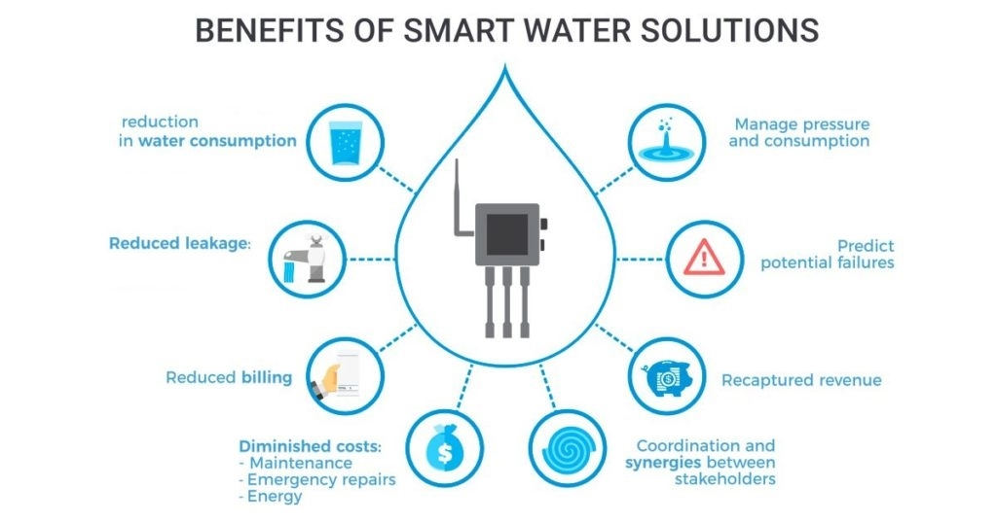

**Conclusion:**

The main motive of this project is to save and conserve water in our environment where the water is waster unsufully. We overcome the scaresity of water by implementing this project in our society.It is easy to handle and operate like user friendly.