SMART WATER SYSTEM

Project objectives:

Smart water system (SWS) is the use of technology to improve the efficiency and sustainability of water use. SWS systems use sensors and other devices to collect data on water flow, pressure, and quality. This data is then used to automate and optimize water systems, and to identify and repair leaks and other problems.

IOT Sensor setup:

* Water flow sensor: This sensor is attached to a water pipe to measure the flow of water.
* Water pressure sensor: This sensor is also attached to the water pipe to measure the pressure of the water.
* Gateway: The gateway is connected to the sensors via a wired or wireless connection. It collects data from the sensors and transmits it to a cloud server via the internet.
* Cloud server: The cloud server stores and analyses the data collected from the sensors. It can also be used to generate alerts if the water flow or pressure falls below or exceeds a certain threshold.

Mobile app development:

* Real-time water usage monitoring: Users can track their water consumption in real time and identify areas where they can save water.
* Leak detection and notification: The app can monitor water flow and pressure to detect leaks. It can then send users a notification if a leak is detected.
* Smart irrigation control: Users can use the app to control their irrigation system remotely. This can help to ensure that plants are watered efficiently and that water is not wasted.
* Water quality monitoring: The app can monitor water quality parameters such as pH, turbidity, and dissolved oxygen. It can then notify users if water quality falls below a certain threshold.
* Bill management: Users can use the app to view and pay their water bills.

Raspberry pi integration:

* Select the appropriate sensors and actuators: The type of sensors and actuators that are needed will depend on the specific application. For example, a water flow monitoring system will need a water flow sensor, while an irrigation control system will need a solenoid valve to control the flow of water to the irrigation system.
* Connect the sensors and actuators to the Raspberry Pi: The sensors and actuators can be connected to the Raspberry Pi using a variety of interfaces, such as GPIO, I2C, and SPI.
* Write software to collect data from the sensors, control the actuators, and communicate with other devices and systems: The software can be written in a variety of programming languages, such as Python, C, and C++.
* Deploy the Raspberry Pi system: The Raspberry Pi system can be deployed in a variety of ways, such as in a weatherproof enclosure or in a rack-mounted cabinet.

Code implementation:

import time

import board

import digitalio

# Define the water flow sensor pin

water_flow_sensor_pin = digitalio.DigitalInOut(board.D18)

water_flow_sensor_pin.direction = digitalio.Direction.INPUT

# Define the water pump pin

water_pump_pin = digitalio.DigitalInOut(board.D23)

water_pump_pin.direction = digitalio.Direction.OUTPUT

# Define a function to check if the water flow sensor is triggered

def is_water_flowing():

return water_flow_sensor_pin.value

# Define a function to turn on the water pump

def turn_on_water_pump():

water_pump_pin.value = True

# Define a function to turn off the water pump

def turn_off_water_pump():

water_pump_pin.value = False

# Set the initial state of the water pump

turn_off_water_pump()

# Start a loop to monitor the water flow sensor

while True:

# Check if the water flow sensor is triggered

if is_water_flowing():

# Turn on the water pump

turn_on_water_pump()

# Wait for 10 seconds

time.sleep(10)

# Turn off the water pump

turn_off_water_pump()

# Wait for 1 second

time.sleep(1)

Schematic diagram:

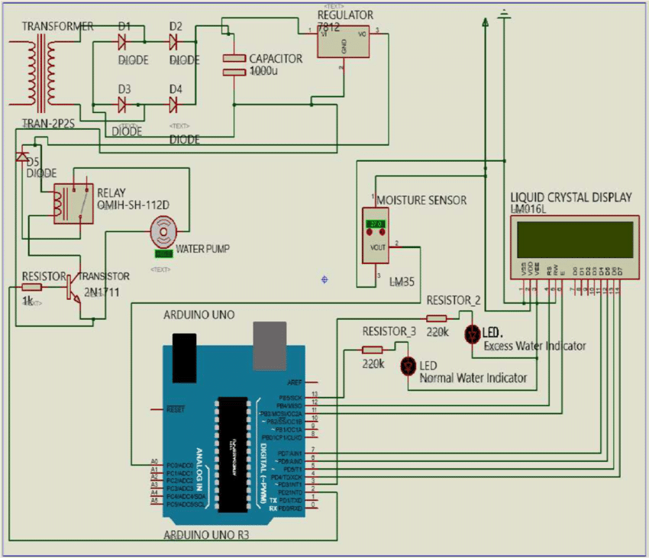

Screen shot of IOT:

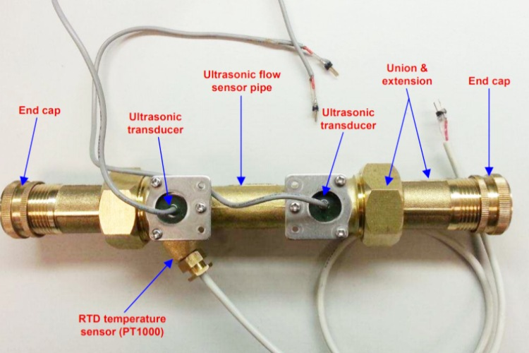

Real time water consumption monitoring system:

* Increased awareness of water usage: By providing real-time information on water consumption, the system can help users to become more aware of how much water they are using and where it is being used. This can lead to changes in behaviour, such as shorter showers, less frequent lawn watering, and fixing leaky faucets.
* Leak detection and notification: The system can also be used to detect leaks and send notifications to users when they occur. This allows users to quickly repair leaks and prevent water waste.
* Data-driven decision making: The data collected by the system can be used to make informed decisions about water management. For example, the data can be used to identify areas where water conservation efforts are needed, to optimize irrigation schedules, and to plan for future water needs.

In addition to these direct benefits, a real-time water consumption monitoring system can also promote water conservation and sustainable practices indirectly by:

* Empowering users: By giving users access to information about their water usage and the ability to control their water consumption, the system empowers them to take action to conserve water.
* Raising awareness of water scarcity: The system can be used to raise awareness of water scarcity and the importance of water conservation. This can lead to changes in public policy and behavior that support sustainable water management practices.

Overall, a real-time water consumption monitoring system is a valuable tool for promoting water conservation and sustainable practices in smart water system projects.

Here are some specific examples of how real-time water consumption monitoring systems can be used to promote water conservation and sustainable practices:

The project is submitted by:

NAME: Kaviyarasu.A

REGISTER NO: 721421106031

NAME: Ganthi parushuramudu

REGISTER NO: 721421106017

NAME: Gorantla manoj kumar

REGISTER NO: 721421106018