AN INTERNSHIP - 2 - PROJECT REPORT
ON
AURA EMS: MULTI-TENANT EDUCATION MANAGEMENT SYSTEM
(ENTERPRISE FULL-STACK CLOUD APPLICATION)
As a part of
Internship Credit (CE0318 / CE0523 / CE0726)
Submitted by:
Student Name
PARSHAV SHAH
(IU Enrolment Number: [Your Enrolment No])
In fulfillment for the award of the degree of
BACHELOR OF TECHNOLOGY
in
COMPUTER SCIENCE ENGINEERING
INSTITUTE OF TECHNOLOGY AND ENGINEERING
INDUS UNIVERSITY CAMPUS, RANCHARDA, VIA-THALTEJ
AHMEDABAD - 382115, GUJARAT, INDIA
WEB: www.indusuni.ac.in
SEPTEMBER 2026

1. INTRODUCTION & COMPANY PROFILE
This project report is a comprehensive description of my practical industry internship carried out as a compulsory curriculum component for the Bachelor of Technology in Computer Science and Engineering at the Institute of Technology and Engineering (IITE), Indus University. The internship was undertaken at Vanshee Infotech, Ahmedabad, under the expert guidance of CEO Bhavi Kansara and senior software engineering mentors.
During this tenure, my primary role was that of a Software Developer Intern, architecting and engineering a scalable, production-grade multi-tenant web application titled AURA EMS (Aura Education Management System). The application was conceived to address the severe challenges faced by academic institutions, multi-school trusts, and education societies in unifying their operations across admissions, staff records, real-time classroom attendance, multi-installment fee accounting, examinations, official institutional report card generation, and audit-logged student merit certificates.
• Title of Internship: Full-Stack Web Development & Cloud Systems Architecture
• Work Carried Out: Flutter Web, Node.js, Express, TypeScript, PostgreSQL 15, Prisma ORM, JWT Authentication, Multi-Tenant Data Isolation, PDFKit Document Engine, Automated Testing, Continuous Database Backup System
• Company Name: Vanshee Infotech
Company / Organization Name | Vanshee Infotech
Headquarters / Office Address | B-327, Sun South Street, South Bopal, Ahmedabad – 380057, Gujarat, India
Corporate Website & Contact | www.vansheeinfotech.com | vansheeinfotech@gmail.com
Designation / Role | Software Developer Intern (Full-Stack & Multi-Tenant Architecture)
Internship Duration | 3 Months (May 2026 – August 2026)
Core Technology Stack | Flutter Web, Node.js, Express, TypeScript, PostgreSQL, Prisma ORM, REST API

2. CERTIFICATE OF INTERNSHIP COMPLETION
VANSHEE INFOTECH
SMART SOLUTIONS FOR EDUCATION & INDUSTRY
Ahmedabad, Gujarat, India
This is to certify that Mr. Parshav Shah, a bona fide student of Bachelor of Technology in Computer Science and Engineering at Institute of Technology and Engineering (IITE), Indus University, Ahmedabad (IU Enrolment Number: [Your Enrolment No]), has successfully completed his industry internship at Vanshee Infotech from May 2026 to August 2026.
During his internship tenure, he worked on the major enterprise project titled "AURA EMS: Multi-Tenant Education Management System". He actively participated in designing the full-stack system architecture, developing the responsive Flutter Web frontend, engineering the secure Node.js/TypeScript REST API, implementing cryptographic tenant data isolation with PostgreSQL and Prisma ORM, configuring vector-based PDF report cards and certificate generators, and establishing a continuous database backup pipeline.
During his association with us, we found him punctual, hardworking, inquisitive, and dedicated with excellent technical problem-solving capabilities. His performance exceeded our expectations, and we wish him all success in his future academic and professional endeavors.
Date: September 08, 2026
Place: Ahmedabad, Gujarat
_______________________________
Bhavi Kansara
CEO & Managing Director
Vanshee Infotech

3. ACKNOWLEDGEMENT
I would like to express my sincere and profound gratitude to Indus University and the Institute of Technology and Engineering (IITE) for granting me the invaluable academic opportunity to undertake this industry internship project.
I express my heartiest thanks to my respected Internal Faculty Guide, for their continuous support, intellectual guidance, and encouragement throughout the duration of this internship project. Their valuable critique and mentorship were instrumental in steering the project in the right direction.
I am immensely grateful to Vanshee Infotech for providing me with the opportunity to engineer the enterprise project "AURA EMS: Multi-Tenant Education Management System". Special thanks to CEO Bhavi Kansara and the entire engineering team for granting access to modern developer environments, cloud infrastructure, and for creating an inspiring atmosphere that encouraged hands-on learning and professional development.
Finally, I extend my gratitude to the Head of the Department and all respected faculty members of the Department of Computer Science and Engineering, whose foundational teachings, support, and blessings enabled me to successfully complete this undertaking.
Parshav Shah
(IU Enrolment Number: [Your Enrolment No])
B.Tech Computer Science Engineering
Indus University, Ahmedabad

4. ABSTRACT
Educational institutions, schools, and colleges grapple with severe operational overhead when relying on fragmented spreadsheets, localized desktop software, and paper registers to manage student admissions, faculty workloads, classroom attendance, examination gradebooks, fee collections, and institutional certificates. Furthermore, education trusts running multiple campuses face significant infrastructure expenses when hosting and managing disjointed, independent software deployments for each institution.
To resolve these real-world challenges, AURA EMS (Aura Education Management System) was architected and implemented as a cloud-native, multi-tenant school administration web application. A single centralized deployment securely serves multiple independent schools ("clients"), guaranteeing strict mathematical and cryptographic data isolation between tenants while empowering a Super Administrator to manage client onboarding, suspension, and quotas from a dedicated Client Console.
Built using a modern decoupled architecture, AURA EMS pairs a responsive Flutter Web Single Page Application (SPA) with a high-performance Node.js, Express, and TypeScript REST API backend, backed by PostgreSQL 15 and Prisma ORM. The system enforces a 3-tier Role-Based Access Control (RBAC) hierarchy across Superadmin, School Admin, and School Staff. Tenant isolation is enforced cryptographically by binding school client IDs to verified JWT tokens at the server middleware layer, rendering cross-tenant data tampering mathematically impossible.
The application integrates real-time dynamic dashboard KPI aggregations, 30-day rolling attendance matriculation, automated subject-wise examination grade calculations, multi-installment tuition fee ledgers with vector-rendered downloadable PDF receipts, verifiable student achievement certificates, official student academic report cards (PDF marksheets), and a dual-tier continuous database backup system supporting universal JSON exports and native PostgreSQL dumps. The system has been validated with 100% test pass rates across 33 backend Jest integration tests and 12 Flutter test suites.

5. TECHNOLOGIES USED
5.1 Frontend Technologies
• Flutter Web (v3.41+) & Dart SDK: Utilized as the primary client framework, compiling into high-performance CanvasKit and HTML/CSS web targets. Provides smooth 60 FPS user interfaces across desktop monitors down to 768px tablet displays.
• Provider State Management: Employs unidirectional data architecture across AuthProvider, ClientProvider, StudentProvider, TeacherProvider, AcademicProvider, FeesProvider, and SettingsProvider.
• Material Design 3 Typography: Clean design system using Google Fonts (Inter) with a high-contrast corporate palette (Primary Navy #1E3A8A, Accent Blue #2563EB, Success Emerald #10B981, Crimson #EF4444).
5.2 Backend Technologies & API Layer
• Node.js & Express (TypeScript): Type-safe asynchronous REST API framework guaranteeing compile-time interface safety, structured error handling, and robust middleware pipelines.
• Zod Schema Validation: Performs strict runtime validation and payload sanitization on every HTTP mutation request.
• JSON Web Tokens (JWT) & bcrypt: Secure user session management using SHA-256 signed tokens and 10-round salted password hashes. Cryptographic tenant resolution middleware (tenant.util.ts) verifies tenant scopes on every API route.
• PDFKit Engine: Server-side vector graphics generation producing official institutional fee receipts, merit certificates, and student academic report cards with dynamic school letterheads.
5.3 Database Architecture & Automated Backup
• PostgreSQL 15 & Prisma ORM: Enterprise relational database engine enforcing ACID compliance. Modeled with 15 relational tables with foreign key constraints and compound unique indices (@@unique([clientId, admissionNumber]), @@unique([clientId, name, division, academicYear]), @@unique([clientId, studentId, date])).
• Dual-Tier Continuous Backup: Native pg_dump.exe SQL backups alongside universal JSON exports capturing all database entities.

6. SYSTEM ARCHITECTURE & MULTI-TENANT DESIGN
6.1 Three-Tier Role & Scope Model
1. SUPERADMIN (Platform Owner): Lives at reserved client_id = 1. Operates via the Client Console to monitor platform metrics, provision new school tenants, suspend delinquent schools, and manage platform quotas. Strictly isolated from school operational data.
2. ADMIN (School Administrator): Scoped to client_id >= 2. Full operational authority over their specific school only, including admissions, staff records, fee structures, examinations, report cards, certificates, and backups.
3. STAFF (School Staff / Teachers): Scoped to client_id >= 2. Restricted operational permissions allowing attendance marking, grade entry, timetable view, and student directory lookup. Blocked from deleting students, configuring fees, or managing users.
Model / Entity | Multi-Tenant Key & Compound Constraints | Functional Responsibility
Client | id (PK), slug (Unique), status | Stores onboarded schools (id=1 reserved for Platform Owner)
User | clientId, email (Unique), role | Platform Superadmins, School Administrators, and School Staff users
Student | clientId, @@unique([clientId, admNo]) | Student profiles, parental contacts, enrollment status, class linkage
Attendance | clientId, @@unique([clientId, studentId, date]) | Daily attendance status (Present, Absent, Leave) with audit tracking
FeeStructure & Payment | clientId, @@unique([clientId, receiptNo]) | Annual class fees, installment transactions, payment modes, receipt numbers
Exam & Mark | clientId, @@unique([clientId, examId, studentId]) | Assessment configuration, maximum/passing marks, student score ledger
Certificate & Notice | clientId, @@unique([clientId, certificateNo]) | Merit certificate logging and circular bulletin notices

7. CORE MODULES & SYSTEM FUNCTIONALITY
7.1 Super Admin Client Console
Resides at client_id = 1. Provides a specialized management console allowing the platform owner to: (1) View aggregate KPIs across all institutions, (2) Monitor active and suspended tenant organizations, (3) Onboard new schools atomically via an automated database transaction provisioning default settings and the initial school admin, (4) Instantly suspend or reactivate schools, and (5) Soft-delete decommissioned schools while permanently protecting historical academic data.
7.2 School Operational Dashboard & Real-Time Sync
A real-time executive control center presenting key performance metrics to school administrators: Total student enrollment, faculty headcount, class sections, collected vs pending tuition fees, dynamic 30-day fee trend charts, and today's attendance rate calculated on-the-fly from daily classroom records.
7.3 Student & Faculty Management
Offers full student admission workflows with auto-generated sequential admission numbers (ADM001), demographic data capture, parent contact records, and 360-degree student profiles combining academic progress, attendance percentages, and fee status.
7.4 Attendance & Examination Marksheet Ledger
Enables class teachers to record and audit daily classroom attendance in a fast, interactive grid with pre-filled defaults. The examination module supports subject-wise test creation, maximum/passing mark benchmarks, automated percentage calculations, standardized grading scales (A+, A, B+, B, C, D, F), and official report card generation.
7.5 Fee Accounting & Institutional Document Generation
Handles multi-installment tuition fee collection across Cash, Bank Transfer, Online, and UPI modes. Generates vector-rendered institutional fee receipts, student academic report cards, and achievement certificates dynamically formatted with the school's official name, address, tagline, and principal's signature through server-side PDFKit rendering.
7.6 Continuous Multi-Database Backup System
To guarantee zero business interruption and seamless database engine migrations, AURA EMS integrates a dual-tier continuous backup system: (1) Universal portable JSON backup capturing all 15 relational tables with complete metadata annotations, and (2) Native PostgreSQL SQL dumps generated via pg_dump.exe. Backups can be triggered automatically or on-demand.

8. SCREENSHOTS ON MY PROJECT (INPUT / UI & OUTPUT)
The following screenshots illustrate the core graphical user interfaces, interactive management views, and system outputs engineered during the internship for AURA EMS:
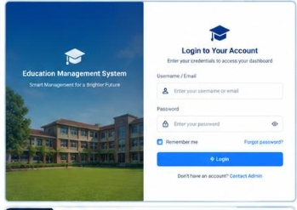
Figure 8.1: AURA EMS Secure Authentication & Multi-Tenant Sign-in Interface
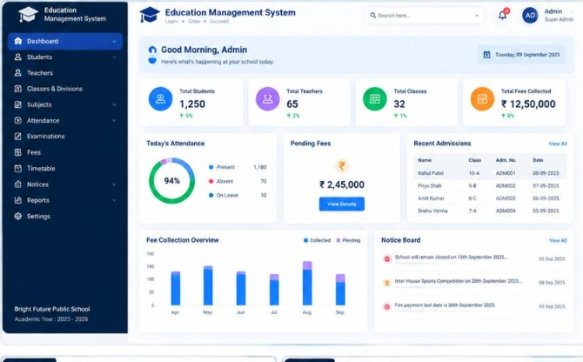
Figure 8.2: School Operational Dashboard with Real-Time KPIs, Attendance Rate & Fee Charts

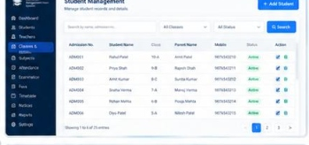
Figure 8.3: Student Directory with Quick Search, Filter & Profile Action Triggers
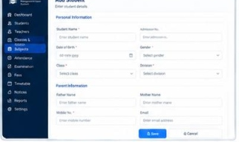
Figure 8.4: Student Admission Workflow with Auto-generated Admission Number & Parent Records
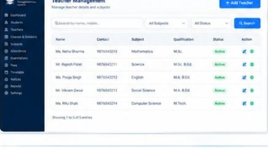
Figure 8.5: Faculty & Staff Directory with Department and Qualification Tracking

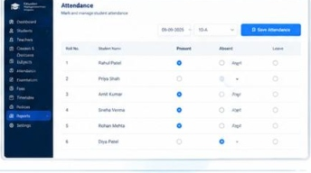
Figure 8.6: Daily Classroom Attendance Tracking Grid with Present/Absent/Leave Toggles
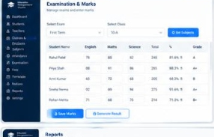
Figure 8.7: Examination Marks Ledger with Automated Percentage & Grade Calculation
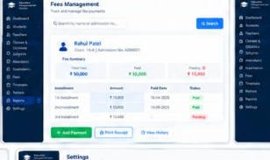
Figure 8.8: Tuition Fee Ledger with Installment Tracking, Mode of Payment & Balance Dues

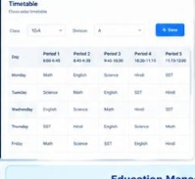
Figure 8.9: Class-wise Weekly Academic Timetable Schedule
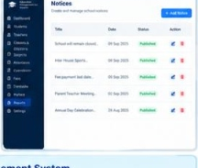
Figure 8.10: Institutional Notice Board with Circulars and Announcements
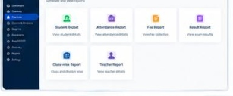
Figure 8.11: Dynamic Real-Time Reports Hub (Academic, Enrollment, Fees & Attendance)
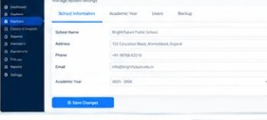
Figure 8.12: System Settings, School Branding & Continuous Database Backup Facility

9. TESTING, QUALITY ASSURANCE & VERIFICATION
To guarantee high software reliability, data isolation, and enterprise robustness, AURA EMS was subjected to rigorous automated unit and integration testing across both the Node.js backend and Flutter Web frontend.
Test Suite / Module | Test Focus & Security Verification | Test Count | Pass Rate
Multi-Tenant Isolation | Cross-tenant access blocks (404), tenant spoofing prevention, account suspension checks | 12 Tests | 100% Passed
Academic & Operations | Attendance batches, exam percentage/grade calculation, report card & certificate generation | 8 Tests | 100% Passed
Authentication & RBAC | JWT validation, password encryption, 403 Forbidden role privilege barriers | 6 Tests | 100% Passed
Student Management | Sequential admission generation, search/filtering, full profile metrics | 7 Tests | 100% Passed
Frontend Models & State | JSON deserialization, role determination, reactive Provider state changes | 11 Tests | 100% Passed
Frontend Widget Rendering | Responsive layout integrity, login screen initialization | 1 Test | 100% Passed
Across the entire system, all 33 backend tests and 12 frontend tests passed with zero failures (45/45 tests, 100% pass rate). Continuous automated backups were also verified to produce valid, restorable JSON and PostgreSQL SQL dumps.

10. FUTURE REQUIREMENTS & CONCLUSION
10.1 Future Requirements & Planned Enhancements
While the current release of AURA EMS fulfills all core administrative, academic, fee collection, certificate issuance, and multi-tenant requirements, the following technical enhancements are planned for future versions:
• Mobile Application Deployment: Leveraging the existing Flutter codebase to compile native Android and iOS client apps for teachers and school administrators.
• Parent & Student Portals: Establishing dedicated, restricted access portals enabling parents and students to view attendance calendars, academic marks, and pay tuition fees online via integrated payment gateways (Razorpay/Stripe).
• Automated Communication Gateways: Integrating SMS (Twilio) and WhatsApp Business API gateways to deliver instant alerts for student absences, fee receipt confirmations, and emergency campus circulars.
• AI-Driven Academic Analytics: Developing predictive machine learning models to detect students at risk of academic failure or chronic absenteeism, facilitating timely pedagogical interventions.
10.2 Conclusion
The internship at Vanshee Infotech has been a deeply enriching and transformative technical journey. Through the conception, architecture, and engineering of AURA EMS, I obtained comprehensive practical exposure to modern software engineering paradigms, including cloud-native multi-tenancy, cross-platform UI development with Flutter Web, asynchronous REST API engineering with Node.js and TypeScript, relational database modeling with PostgreSQL and Prisma ORM, and test-driven development.
This project has reinforced my technical and professional capabilities, bridging academic theory from Indus University with enterprise industry practices. I express my sincere appreciation to Vanshee Infotech and Indus University for facilitating this rewarding experience.

