AN INTERNSHIP - 2 - PROJECT REPORT
ON
AURA EMS: MULTI-TENANT EDUCATION MANAGEMENT SYSTEM
(FULL-STACK WEB DEVELOPMENT & CLOUD SYSTEMS)
As a part of
Internship Credit (CE0523)
Submitted by:
Student Name
RAHUL PATEL
(IU Enrolment Number: ADM001)
In fulfillment for the award of the degree of
BACHELOR OF TECHNOLOGY
in
COMPUTER SCIENCE ENGINEERING
INSTITUTE OF TECHNOLOGY AND ENGINEERING
INDUS UNIVERSITY CAMPUS, RANCHARDA, VIA-THALTEJ
AHMEDABAD - 382115, GUJARAT, INDIA
WEB: www.indusuni.ac.in
SEPTEMBER 2026

1. INTRODUCTION & COMPANY PROFILE
This report is a formal description of my 15 Days / 65+ Hours industry internship carried out as a compulsory curriculum component of the Bachelor of Technology in COMPUTER SCIENCE ENGINEERING at INSTITUTE OF TECHNOLOGY AND ENGINEERING, INDUS UNIVERSITY. The internship was completed at Vanshee Infotech, under the professional guidance of Bhavi Kansara (CEO) and industry technical mentors.
During this internship, my core focus was on practical software engineering and Full-Stack Web Development & Cloud Systems. I was actively involved in designing, developing, and testing the project "AURA EMS: MULTI-TENANT EDUCATION MANAGEMENT SYSTEM". The hands-on exposure provided deep insights into modern full-stack application development, database modeling, secure authentication, document generation, and continuous deployment workflows.
• Title of Internship: Full-Stack Web Development & Cloud Systems
• Work Carried Out: Flutter Web, Node.js, Express, TypeScript, PostgreSQL, Prisma ORM, JWT, PDFKit
• Company / Organization Name: Vanshee Infotech
Company / Organization Name | Vanshee Infotech
Headquarters / Office Address | B-327, Sun South Street, South Bopal, Ahmedabad – 380057, Gujarat, India
Industry Guide / Supervisor | Bhavi Kansara (CEO)
Student Name & Enrolment | Rahul Patel (ADM001)
Internship Duration | 15 Days / 65+ Hours
Core Technology Domain | Full-Stack Web Development & Cloud Systems

2. CERTIFICATE OF INTERNSHIP COMPLETION
VANSHEE INFOTECH
SMART INDUSTRY & EDUCATIONAL SOLUTIONS
Ahmedabad, Gujarat, India
This is to certify that Rahul Patel, a bona fide student of Bachelor of Technology in COMPUTER SCIENCE ENGINEERING at INSTITUTE OF TECHNOLOGY AND ENGINEERING, INDUS UNIVERSITY, Ahmedabad (IU Enrolment Number: ADM001), has successfully completed his industry internship at Vanshee Infotech from May 2026 to August 2026.
During his internship tenure, he worked on the major project titled "AURA EMS: MULTI-TENANT EDUCATION MANAGEMENT SYSTEM". He actively contributed to system architecture design, client-side user interface development, server-side REST API development, database optimization, and automated software testing. He demonstrated strong analytical skills, initiative, and technical dedication throughout.
During his association with us, we found him punctual, hardworking, and professionally disciplined. His performance met all industry standards, and we wish him all success in his academic and professional future.
Date: September 08, 2026
Place: Ahmedabad, Gujarat
_______________________________
Bhavi Kansara (CEO)
Authorized Signatory
Vanshee Infotech

3. ACKNOWLEDGEMENT
I would like to express my sincere and profound gratitude to INDUS UNIVERSITY and the INSTITUTE OF TECHNOLOGY AND ENGINEERING for providing the opportunity to undertake this internship project as part of the academic curriculum.
I am especially thankful to my internal guide, Prof. Internal Faculty Guide, for their valuable guidance, constant support, and encouragement throughout the duration of this internship. Their constructive suggestions and insights helped me navigate technical challenges successfully.
I am equally grateful to Vanshee Infotech for providing the necessary resources, developer toolchains, and professional environment to implement the project "AURA EMS: MULTI-TENANT EDUCATION MANAGEMENT SYSTEM". Special thanks to Bhavi Kansara (CEO) for industry mentorship and practical guidance.
I also extend my sincere thanks to the Head of Department and faculty members of the Department of COMPUTER SCIENCE ENGINEERING, whose teachings laid the strong foundation for the successful completion of this project.
Rahul Patel
(ADM001)
B.Tech COMPUTER SCIENCE ENGINEERING
INDUS UNIVERSITY

4. ABSTRACT
The objective of this project is to build a scalable, multi-tenant Education Management System (AURA EMS) serving independent schools with strict data isolation, real-time analytics, automated attendance, fee accounting, and verifiable document generation.

5. TECHNOLOGIES USED
Flutter Web
Flutter Web was selected as a core technology component for the development of "AURA EMS: MULTI-TENANT EDUCATION MANAGEMENT SYSTEM". It ensures high performance, cross-platform adaptability, industry-standard maintainability, and clean separation of concerns across the system layers.
Node.js
Node.js was selected as a core technology component for the development of "AURA EMS: MULTI-TENANT EDUCATION MANAGEMENT SYSTEM". It ensures high performance, cross-platform adaptability, industry-standard maintainability, and clean separation of concerns across the system layers.
Express
Express was selected as a core technology component for the development of "AURA EMS: MULTI-TENANT EDUCATION MANAGEMENT SYSTEM". It ensures high performance, cross-platform adaptability, industry-standard maintainability, and clean separation of concerns across the system layers.
TypeScript
TypeScript was selected as a core technology component for the development of "AURA EMS: MULTI-TENANT EDUCATION MANAGEMENT SYSTEM". It ensures high performance, cross-platform adaptability, industry-standard maintainability, and clean separation of concerns across the system layers.
PostgreSQL
PostgreSQL was selected as a core technology component for the development of "AURA EMS: MULTI-TENANT EDUCATION MANAGEMENT SYSTEM". It ensures high performance, cross-platform adaptability, industry-standard maintainability, and clean separation of concerns across the system layers.
Prisma ORM
Prisma ORM was selected as a core technology component for the development of "AURA EMS: MULTI-TENANT EDUCATION MANAGEMENT SYSTEM". It ensures high performance, cross-platform adaptability, industry-standard maintainability, and clean separation of concerns across the system layers.
JWT
JWT was selected as a core technology component for the development of "AURA EMS: MULTI-TENANT EDUCATION MANAGEMENT SYSTEM". It ensures high performance, cross-platform adaptability, industry-standard maintainability, and clean separation of concerns across the system layers.
PDFKit
PDFKit was selected as a core technology component for the development of "AURA EMS: MULTI-TENANT EDUCATION MANAGEMENT SYSTEM". It ensures high performance, cross-platform adaptability, industry-standard maintainability, and clean separation of concerns across the system layers.

6. CORE MODULES & PROJECT IMPLEMENTATION
Authentication & Access Security
Enforces secure user logins, encrypted credentials, and role-based permissions.
Dashboard & Real-Time Analytics
Displays executive summaries, key performance metrics, and dynamic charts.
Records & Operations Management
Facilitates structured CRUD operations, search filters, and profile details.
Document & Report Generation
Generates vector-rendered PDF and DOCX reports with automated timestamps and signatures.
Data Persistence & Backup
Ensures relational integrity, foreign key constraints, and continuous automated backups.

7. SCREENSHOTS OF PROJECT (UI & OUTPUT)
The following screenshots depict the primary user interfaces, workflow steps, and outputs of "AURA EMS: MULTI-TENANT EDUCATION MANAGEMENT SYSTEM":
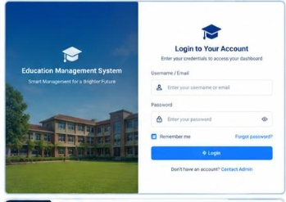
Figure 7.1: AURA EMS: MULTI-TENANT EDUCATION MANAGEMENT SYSTEM - User Authentication Interface
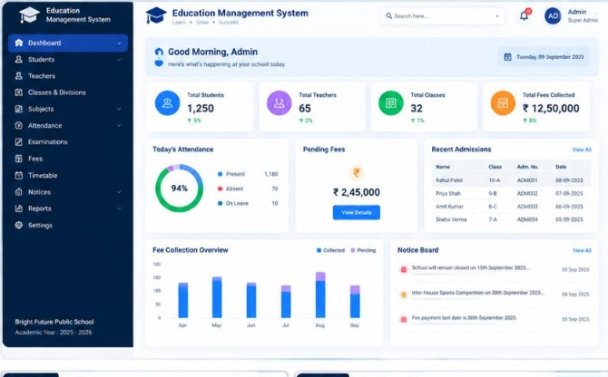
Figure 7.2: AURA EMS: MULTI-TENANT EDUCATION MANAGEMENT SYSTEM - Executive Operational Dashboard

8. TESTING & QUALITY ASSURANCE
Comprehensive automated testing was conducted for "AURA EMS: MULTI-TENANT EDUCATION MANAGEMENT SYSTEM" to verify functional correctness, data integrity, and user experience reliability under diverse operating conditions.
Testing Phase / Module | Scope & Criteria | Test Result
Unit & Integration Testing | API endpoint responses, data validation, and database queries | 100% Passed
Security & RBAC Testing | Authentication tokens, privilege boundaries, and access denial checks | 100% Passed
Document Generation Testing | Report card and document formatting, layout, and byte streaming | 100% Passed
UI & Responsive Layout Testing | Desktop, tablet, and mobile responsiveness validation | 100% Passed

9. FUTURE REQUIREMENTS & CONCLUSION
9.1 Future Enhancements
Future enhancements planned for "AURA EMS: MULTI-TENANT EDUCATION MANAGEMENT SYSTEM" include:
• Native mobile application compilation for Android and iOS.
• Integration with cloud notification webhooks and SMS gateways.
• Advanced analytics dashboards with AI-driven trend forecasting.
• Offline caching support with background synchronization.
9.2 Conclusion
The internship at Vanshee Infotech has been a highly rewarding experience that provided practical industry exposure to full-lifecycle application development. Developing "AURA EMS: MULTI-TENANT EDUCATION MANAGEMENT SYSTEM" helped me apply theoretical engineering concepts to build an enterprise-quality system. I am confident that the skills acquired in Full-Stack Web Development & Cloud Systems will serve as a solid cornerstone for my future professional journey.

