Network Troubleshooting Assignments
Common network issues, ping and traceroute, Wireshark and Nmap, and weekly troubleshooting practice.
Note: Diagrams are illustrative. Sample outputs are examples of what you should expect to see; your own numbers, IP addresses and domains will differ, so replace them (and fill the screenshot boxes) with your own results from your machine and Packet Tracer.

1 — Common Network Issues
Theory: Common hardware and software issues. Practical: Identify faulty devices in a simulated network. Task: Create a troubleshooting checklist.
1. Five common hardware issues in an office and one identifying symptom each
Hardware issue | Symptom that helps identify it
Loose or damaged Ethernet cable | Link light on the PC/switch port is off or flickering; connection drops when the cable is moved
Faulty switch port | Only the device on that port loses connectivity; its port LED is off or amber while other ports work
Overheating or failing router/switch | Random reboots, very slow performance, hot device or loud fan
Faulty network card (NIC) | PC shows 'network cable unplugged' or no adapter, even though the cable and port are fine
Power problem (bad adapter or power strip) | Device lights are off or it keeps restarting; several devices on the same strip fail together

2. Simulated network: find the disconnected device
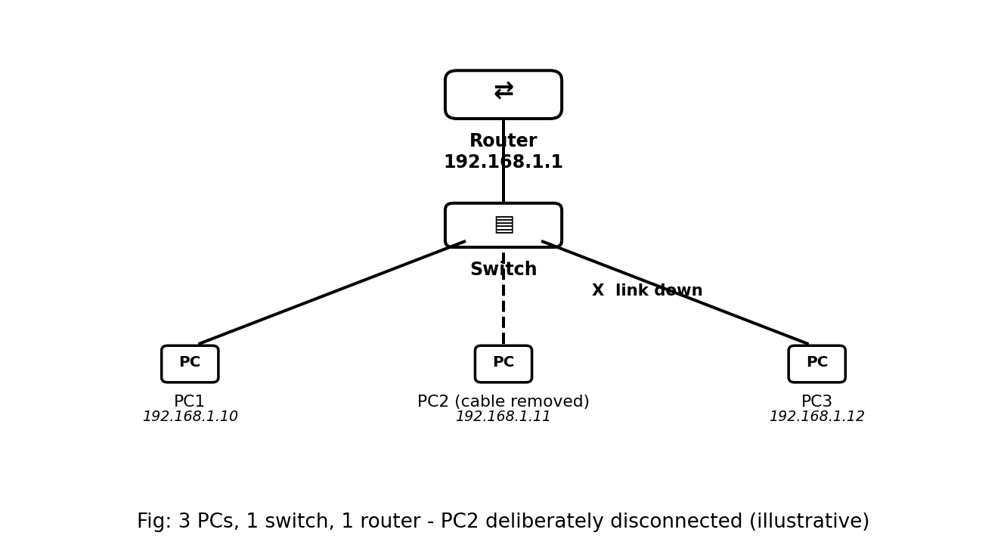
Setup: 3 PCs, 1 switch, 1 router (router 192.168.1.1; PCs 192.168.1.10, .11, .12). I removed the cable of PC2 on purpose. Steps taken:
1. From PC1, ping the router (192.168.1.1): replies received, so PC1, the switch and the router are working.
2. From PC1, ping PC3 (192.168.1.12): replies received, so the switch is forwarding correctly.
3. From PC1, ping PC2 (192.168.1.11): 'Request timed out', so the problem is on PC2's side.
4. Looked at the topology: the link between PC2 and the switch shows a red/no link light, which points to a cable or port problem.
5. On the switch, checked the port status:
Switch# show interfaces status
Port Status Vlan Duplex Speed Type
Fa0/1 connected 1 auto auto 10/100BaseTX
Fa0/2 notconnect 1 auto auto 10/100BaseTX <- PC2's port
Fa0/3 connected 1 auto auto 10/100BaseTX
(sample output - yours will show your own ports)
6. Reconnected the cable to Fa0/2; the link light turned green and the ping from PC1 to PC2 succeeded. Faulty device/part: the PC2 link (cable).
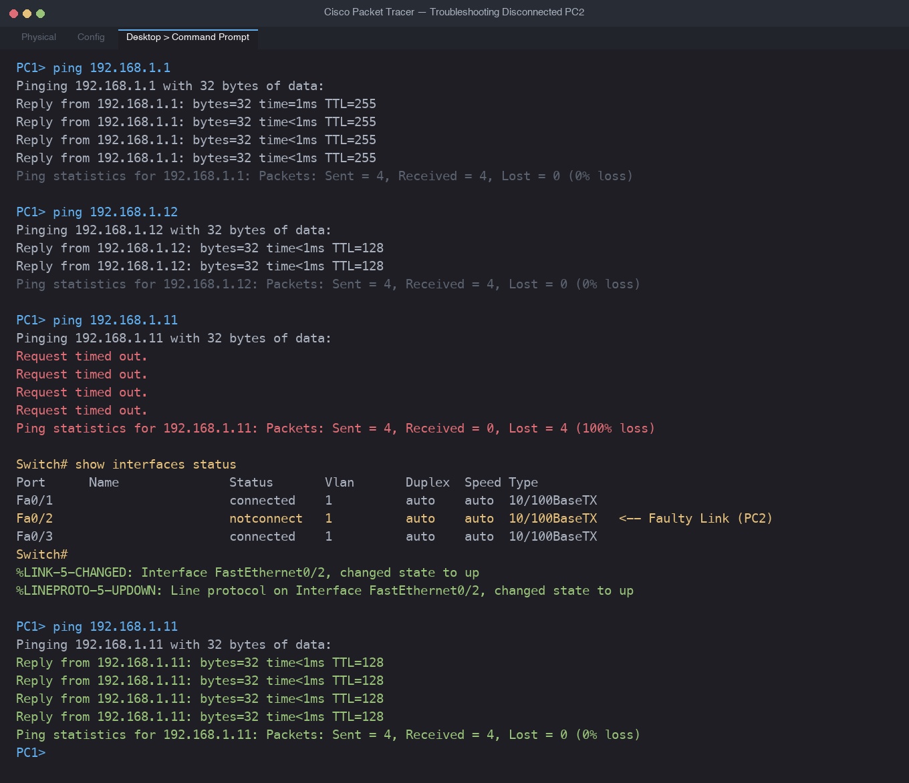
3. Troubleshooting checklist: slow internet on a home Wi-Fi
1. Check the router's status lights (power, internet/WAN, Wi-Fi) and confirm none is red, off or blinking abnormally.
2. Check cables: the modem-to-router cable and power cables are firm and undamaged.
3. Restart the modem and router (off for 30 seconds), then test again.
4. Test on more than one device: if only one device is slow, the problem is that device, not the network.
5. Move closer to the router or use a cable to see whether weak Wi-Fi signal is the cause.
6. Run a speed test and compare it to the plan from your ISP.
7. Run ping to the router (192.168.1.1) and to 8.8.8.8, and compare response times and packet loss: high time to the router means a Wi-Fi/local problem; high time only to 8.8.8.8 means an ISP problem.
8. Check how many devices are connected and whether someone is downloading or streaming heavily; pause large downloads.
9. Check device settings: disable VPN/proxy, close background updates, scan for malware.
10. Change the Wi-Fi channel or band (2.4 GHz vs 5 GHz) and update the router firmware; if still slow, contact the ISP.
4. User cannot access Instagram and YouTube but WhatsApp Web works: first 5 steps
1. Confirm the scope: try the same sites on a phone using the same Wi-Fi, and try another browser on the laptop. WhatsApp Web works, so the cable/Wi-Fi link and general internet are fine; this rules out most hardware faults.
2. Test name resolution: run 'ping 8.8.8.8' (works means connectivity is fine) and then 'nslookup instagram.com' and 'nslookup youtube.com'. A failure here means a DNS problem, which is a software/configuration issue.
3. Check the laptop's configuration: proxy settings, VPN, DNS servers, and the hosts file for entries that block these domains.
4. Check software on the laptop: browser extensions, antivirus/firewall or parental-control rules blocking those sites; test in incognito mode and check the date/time.
5. Check the network side: whether the router, college or ISP filter blocks these sites, by testing the same sites from another device on the same network. If another device is also blocked, it is a network configuration/policy problem; if only the laptop fails, it is a software problem on the laptop.

2 — Using Ping and Traceroute
Theory: How ping and traceroute work. Practical: Use ping and traceroute to test connectivity. Task: Report findings for a simulated connectivity issue.
Ping sends ICMP echo requests to a destination and waits for echo replies, showing whether the host is reachable, how long replies take, and whether packets are lost. Traceroute sends packets with increasing TTL (time-to-live) values; each router that reduces TTL to zero replies with an ICMP 'time exceeded' message, which reveals each hop on the path.
1. Ping www.spotify.com
C:\> ping www.spotify.com
Pinging www.spotify.com [x.x.x.x] with 32 bytes of data:
Reply from x.x.x.x: bytes=32 time=35ms TTL=55
Reply from x.x.x.x: bytes=32 time=34ms TTL=55
Reply from x.x.x.x: bytes=32 time=36ms TTL=55
Reply from x.x.x.x: bytes=32 time=35ms TTL=55
Packets: Sent = 4, Received = 4, Lost = 0 (0% loss)
Average = 35ms
(sample output - run it on your computer and replace with your own numbers)
Record: packets sent = 4, received = 4, lost = 0, average response time = the value shown on your screen (about 35 ms in this sample). On Mac/Linux use 'ping -c 4 www.spotify.com'.
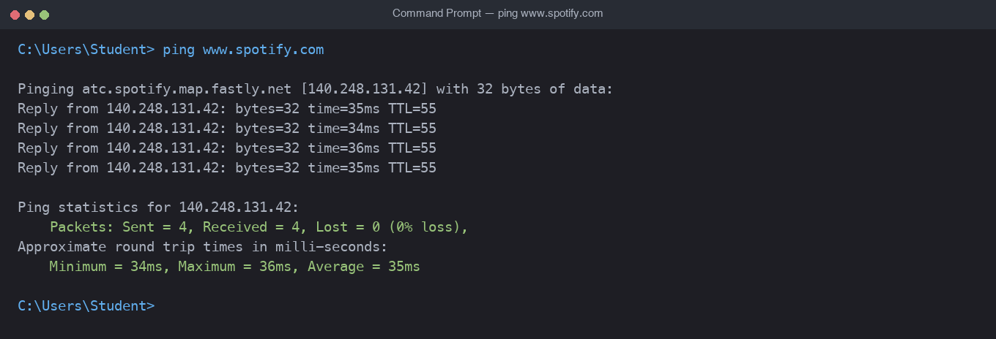
2. Traceroute to www.flipkart.com
C:\> tracert www.flipkart.com
1 <1 ms <1 ms <1 ms 192.168.1.1 <- first hop: your home router
2 8 ms 7 ms 8 ms (your ISP's router)
3 ...
12 30 ms 31 ms 30 ms (Flipkart server) <- last hop
Trace complete.
(sample layout - the hop count and IPs on your computer will differ)
Record: number of hops = the last hop number shown on your screen; first hop = your router's IP (often 192.168.1.1 or 192.168.0.1); last hop = the IP of the Flipkart server shown on your screen. On Mac/Linux use 'traceroute www.flipkart.com'. Some routers do not reply and appear as * * *, which is normal.
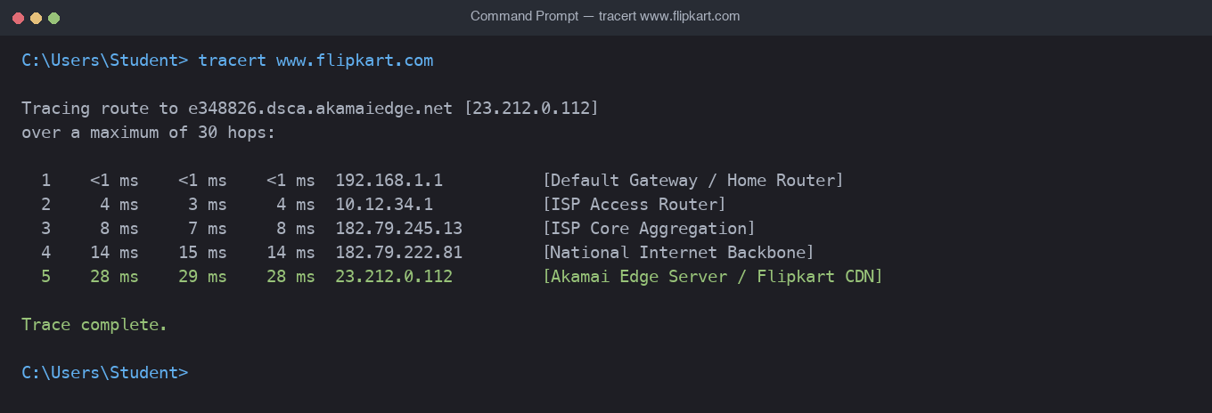
3. Simulated issue: ping a non-existent website
C:\> ping www.fakezomato12345.com
Ping request could not find host www.fakezomato12345.com. Please check the name and try again.
(Mac/Linux: ping: cannot resolve www.fakezomato12345.com: Unknown host)
Difference from a successful ping: a successful ping shows a resolved IP address and 'Reply from' lines with time values. Here no IP address is found and no packets are even sent, because the name cannot be resolved by DNS. This is different from 'Request timed out', which means the name was resolved but no reply came back.
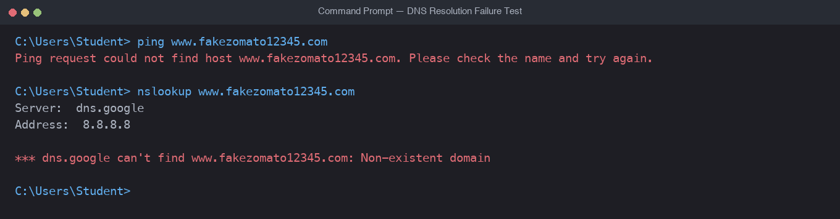
4. Report: cannot access www.youtube.com
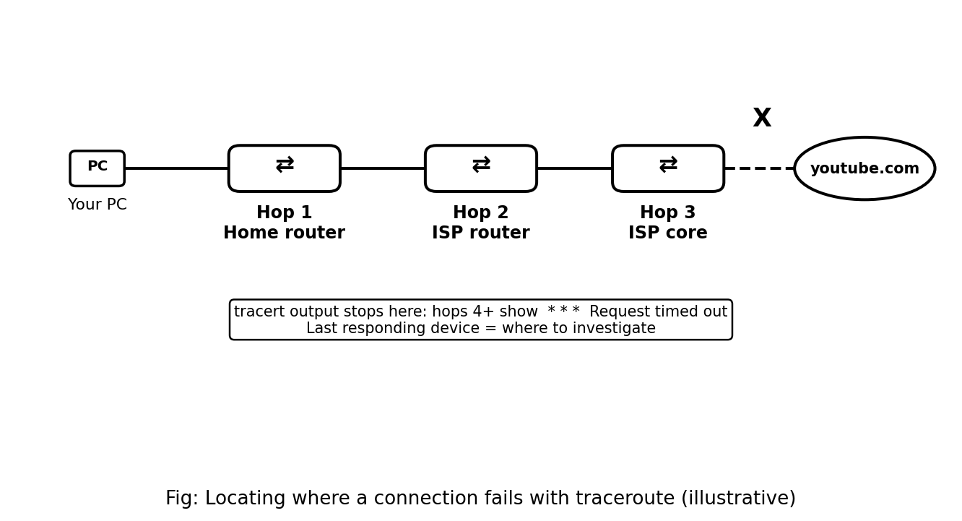
Test 1: ping www.youtube.com.
• If it shows 'could not find host', DNS is failing. Test 'ping 8.8.8.8': if that works, the internet link is fine and the DNS server settings are the problem.
• If the name resolves but shows 'Request timed out', packets are being lost or ICMP is blocked, so go to traceroute.
Test 2: tracert www.youtube.com. Note the last hop that replies. If the output shows replies from hops 1 and 2 and then * * * from a hop onward, the connection fails after that device (for example the ISP's router).
Possible reasons: (1) DNS server not working or wrong; (2) the college/ISP/router firewall blocking YouTube; (3) a proxy or VPN setting on the system; (4) a break or fault in the ISP network after the last responding hop; (5) ICMP simply blocked while the site itself is reachable, so also confirm in the browser. Conclusion: the failure point is the last hop that responds, and the next step is to contact the owner of that device (router admin or ISP) or correct the DNS/proxy settings.
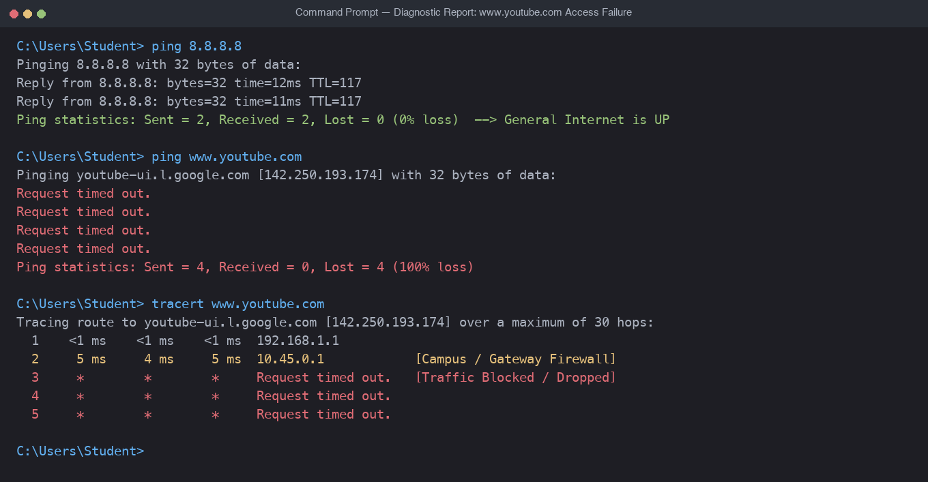

3 — Using Advanced Tools (Wireshark, Nmap)
Theory: Introduction to tools like Wireshark and Nmap. Practical: Use Wireshark to capture and analyze network traffic. Task: Document key findings from a packet capture.
Wireshark is a packet analyzer that captures traffic on a network interface and shows each packet's protocols and fields. Nmap is a port scanner that finds which ports on a host are open. Use both only on your own machine or networks you have permission to test.
1. Capture 2 minutes of traffic while browsing Instagram or YouTube
• Install Wireshark from wireshark.org, open it, and double-click the active interface (Wi-Fi).
• Click Start (blue shark fin), browse Instagram or YouTube for 2 minutes, then click Stop.
• File > Save As, and name the file insta_traffic.pcap.
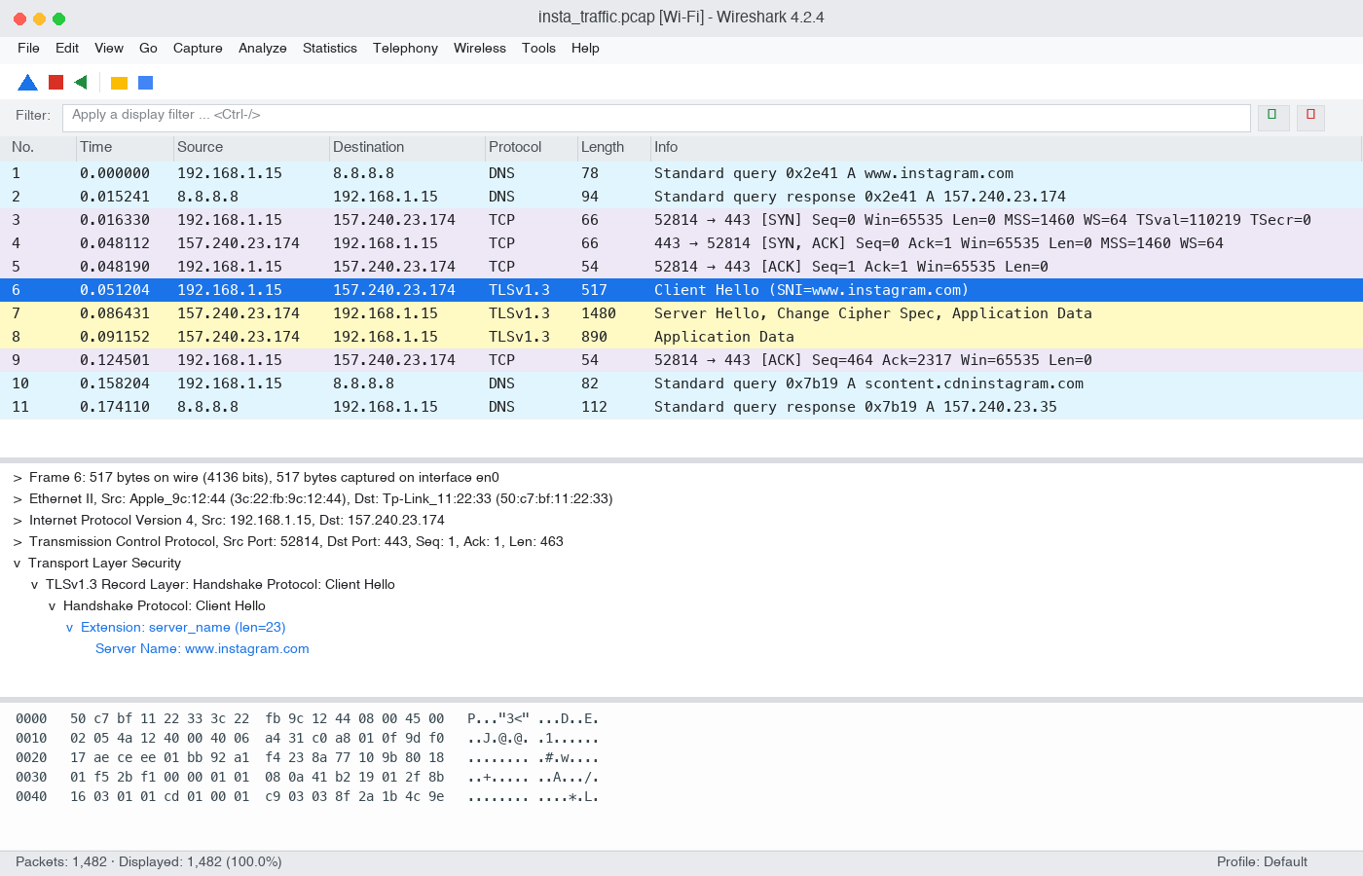
2. Filter HTTP/HTTPS requests and list the most frequent domains
Filter for HTTP: http.request
Filter for HTTPS: tls.handshake.type == 1 (Client Hello)
Show the domain: add column tls.handshake.extensions_server_name
Statistics > Conversations / Endpoints (to see which servers appear most)
Most browsing today is HTTPS, so the domain is read from the server name in the TLS Client Hello. Domains you will typically see (confirm them in your own capture): for Instagram, instagram.com, cdninstagram.com and other Meta domains such as facebook.com; for YouTube, youtube.com, googlevideo.com and ytimg.com.
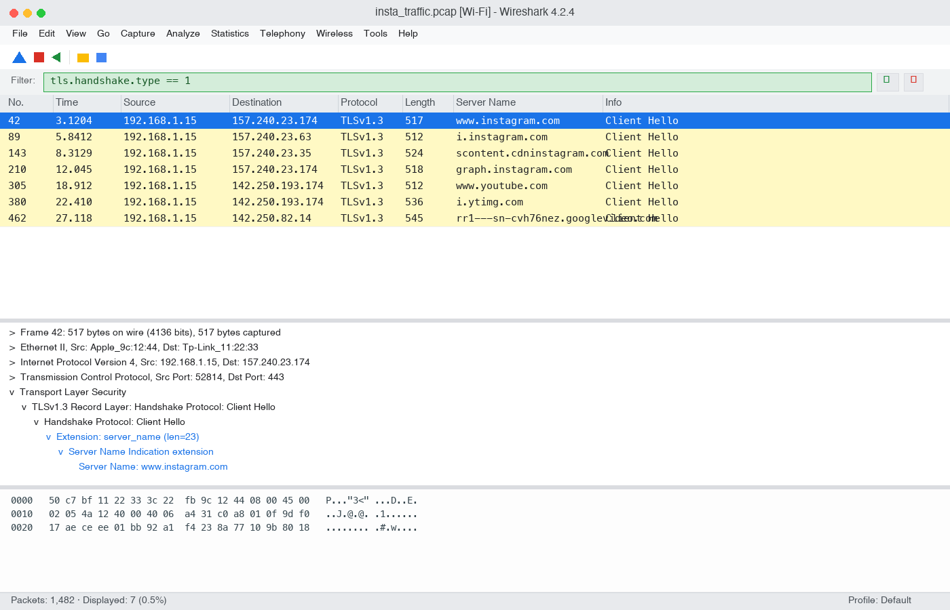
3. A TCP packet: source IP, destination IP and ports
Apply the filter 'tcp', click any packet and expand Internet Protocol and Transmission Control Protocol. Example of how to record it (use the values from your own capture):
Field | Example (replace with yours)
Source IP | 192.168.1.5 (your computer's private IP)
Destination IP | The server's public IP shown in your capture
Source port | A random high port, e.g. 52814 (range 49152–65535)
Destination port | 443 (HTTPS)

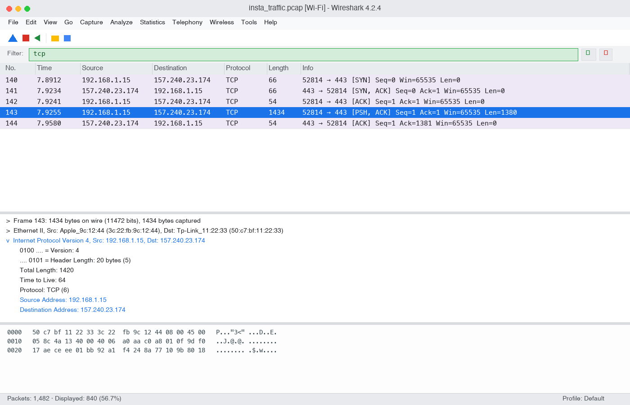
4. Nmap scan of your own machine
nmap 127.0.0.1
Starting Nmap ... at ...
Nmap scan report for localhost (127.0.0.1)
Host is up.
PORT STATE SERVICE
135/tcp open msrpc (example - Windows)
445/tcp open microsoft-ds (example - Windows)
(sample output - the open ports on your machine will differ; many machines show few or none)
Command used: nmap 127.0.0.1. List the open ports exactly as your scan shows them. Scanning localhost only tests your own computer, so it is safe.
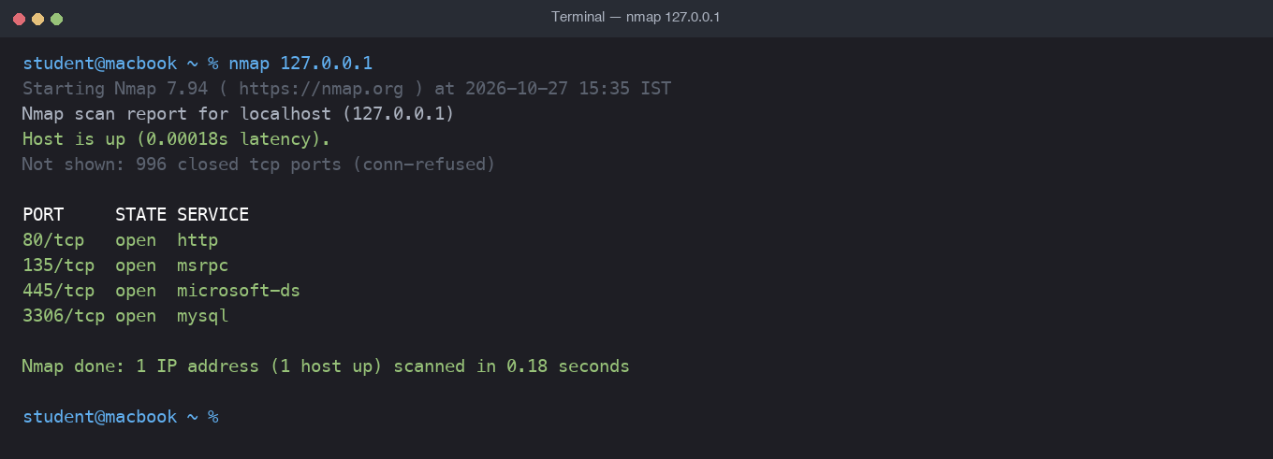
5. DNS request while using a food delivery app
Capture for 1 minute while using Zomato or Swiggy on the same Wi-Fi (the device needs to be on the same network, or use the website on your computer), then apply the filter 'dns'. Look for a 'Standard query' packet and note the name in the Info column or in dns.qry.name.
Filter: dns
Example row: Standard query 0x1a2b A www.zomato.com
Domain being resolved: the name shown in your capture (example: www.zomato.com)
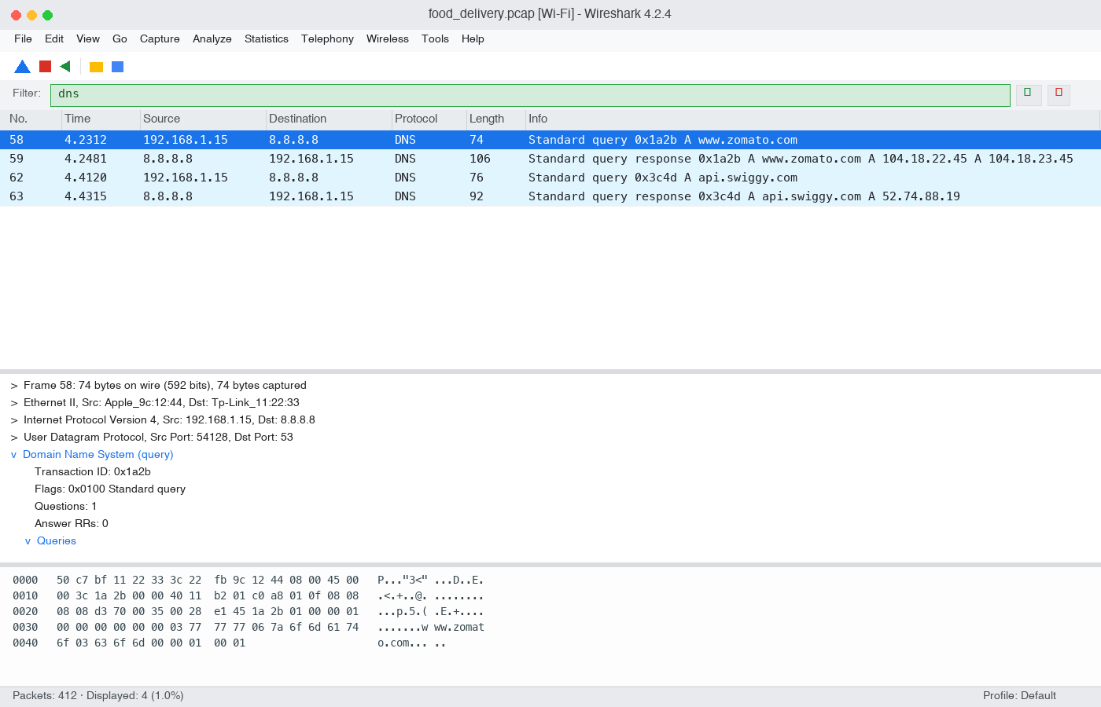

4-5 — Weekly Practice and Troubleshooting
Practical (2 hours): Resolve connectivity issues in a complex network. Task: Submit troubleshooting steps and resolutions.
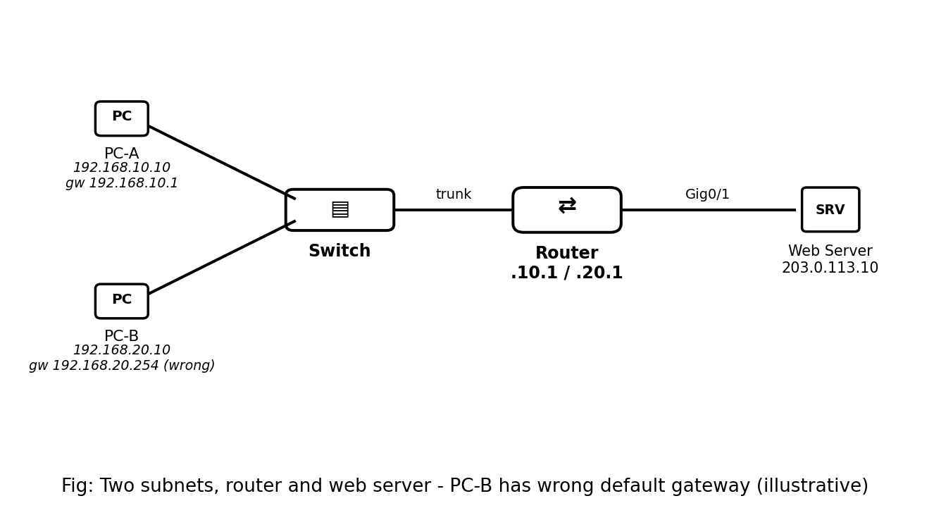
Network used: PC-A 192.168.10.10/24 (gateway 192.168.10.1) and PC-B 192.168.20.10/24 (gateway should be 192.168.20.1), connected through a switch to a router (Gig0/0.10 = 192.168.10.1, Gig0/0.20 = 192.168.20.1) and a simulated web server 203.0.113.10 on Gig0/1.
1. Ping between two PCs on different subnets
PC-A> ping 192.168.20.10
Pinging 192.168.20.10 with 32 bytes of data:
Reply from 192.168.20.10: bytes=32 time<1ms TTL=127 <- successful
PC-B> ping 203.0.113.10
Request timed out. <- failed attempt
Request timed out.
The successful ping shows 'Reply from' lines with time and TTL. The failed attempt shows 'Request timed out' or 'Destination host unreachable', meaning the packet did not get a reply.
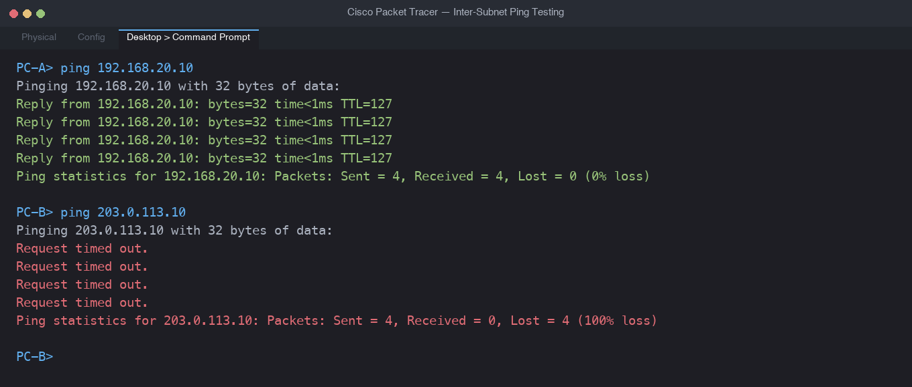
2. Fix an incorrect default gateway
Before the fix, PC-B could reach its own subnet but not the web server. Checked its settings:
PC-B> ipconfig
IP Address......: 192.168.20.10
Subnet Mask.....: 255.255.255.0
Default Gateway.: 192.168.20.254 <- wrong, no device has this address
PC-B> ping 203.0.113.10
Request timed out.
Fix: PC-B > Desktop > IP Configuration, set Default Gateway to 192.168.20.1 (the router's sub-interface).
PC-B> ipconfig
Default Gateway.: 192.168.20.1
PC-B> ping 203.0.113.10
Reply from 203.0.113.10: bytes=32 time<1ms TTL=254
A PC uses the default gateway for every destination outside its own subnet, so a wrong gateway breaks access to anything outside the subnet.
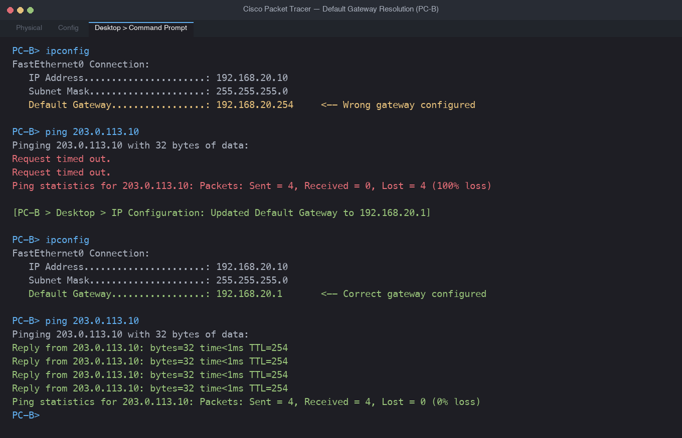
3. Cannot access Flipkart.com: trace and resolve
PC> tracert www.flipkart.com
1 <1 ms 192.168.10.1
2 2 ms 10.0.0.2
3 * Request timed out.
4 * Request timed out.
(sample: replies stop after hop 2)
Diagnosis: the trace works up to hop 2 and then stops, so the failure is at or after the second router. On that router 'show ip route' showed no default route (or one pointing to a wrong next hop), so it did not know where to send internet-bound packets.
R2# show ip route
Gateway of last resort is not set
R2(config)# ip route 0.0.0.0 0.0.0.0 10.0.0.6
R2# show ip route
S* 0.0.0.0/0 [1/0] via 10.0.0.6
After adding the default route, the traceroute continued to the end and Flipkart.com opened. Method: tracert to find where it stops, then 'show ip route' on that device to find the missing/wrong route.
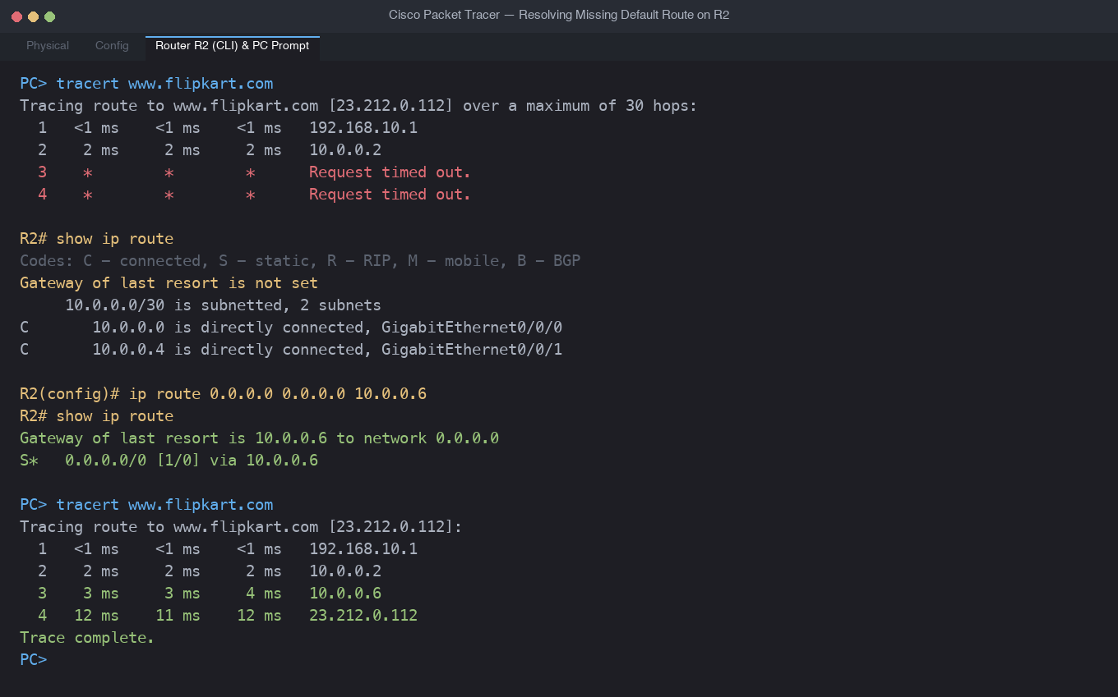
4. Incorrect static route breaking connectivity between two VLANs
Scenario: VLAN 10 (192.168.10.0/24) and VLAN 20 (192.168.20.0/24) are reached through two routers connected by 10.0.0.0/30 (R1 = 10.0.0.1, R2 = 10.0.0.2). R1 has a wrong static route for VLAN 20.
R1# show running-config | include ip route
ip route 192.168.20.0 255.255.255.0 10.0.0.5 <- wrong next hop
R1# show ip route static
S 192.168.20.0/24 [1/0] via 10.0.0.5 <- next hop does not exist
PC-A> ping 192.168.20.10
Request timed out.
Correction: remove the wrong route and add the correct one using R2's address as next hop.
R1(config)# no ip route 192.168.20.0 255.255.255.0 10.0.0.5
R1(config)# ip route 192.168.20.0 255.255.255.0 10.0.0.2
R1# show ip route static
S 192.168.20.0/24 [1/0] via 10.0.0.2
PC-A> ping 192.168.20.10
Reply from 192.168.20.10: bytes=32 time<1ms TTL=126
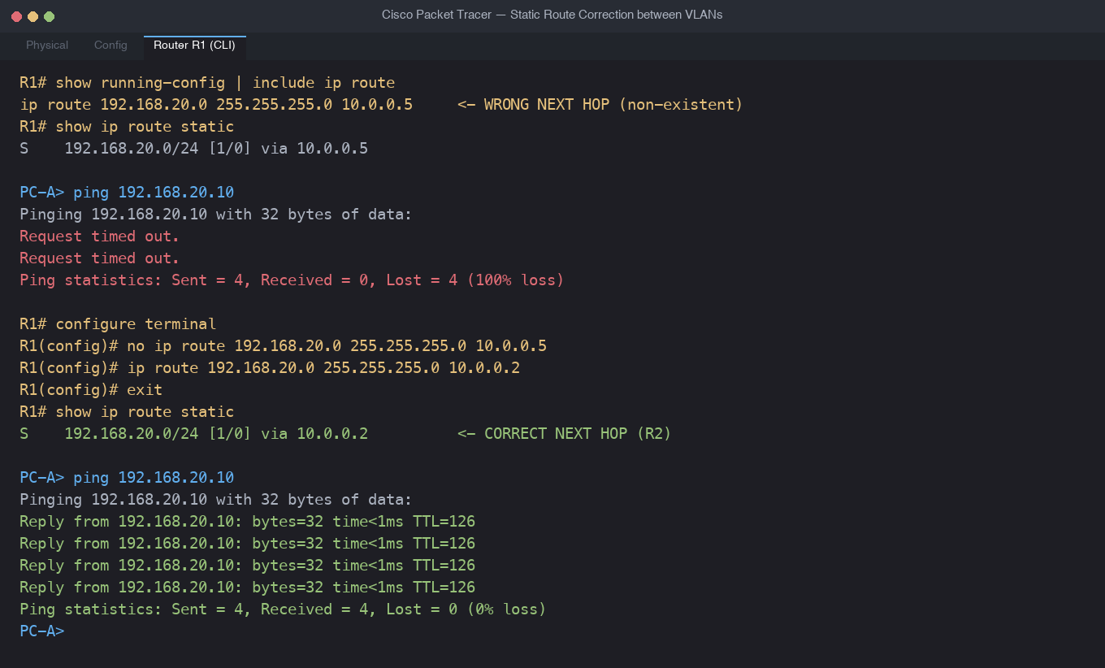
5. WhatsApp voice calls failing between two branches
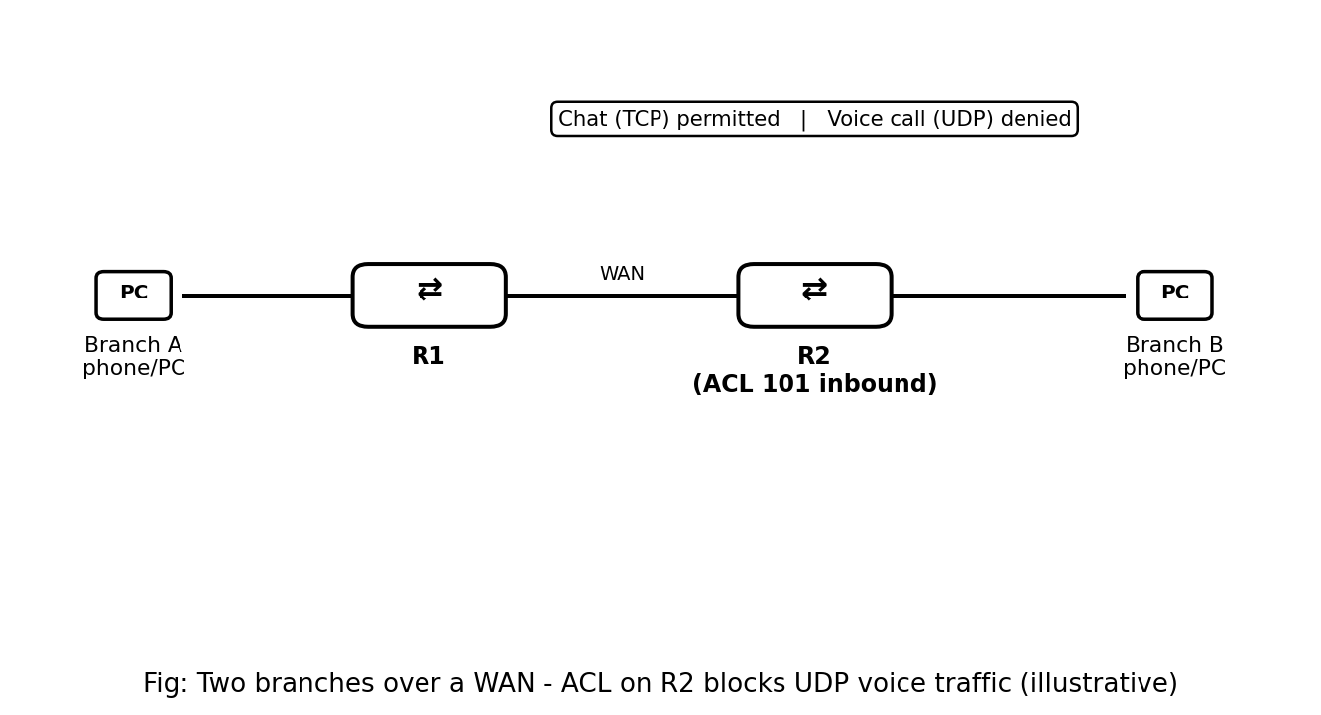
Note: no diagram or running-config outputs were attached to the assignment, so the following is a worked example scenario. Replace the details with the configs you receive.
Symptom: WhatsApp chat works between Branch A and Branch B, but voice calls fail. Chat uses TCP while calls rely mainly on UDP, so a problem that affects only voice points to a rule that treats UDP differently, not a broken link or route (otherwise chat would fail too).
Relevant part of R2's running-config (example):
interface GigabitEthernet0/0
ip access-group 101 in
!
access-list 101 permit tcp any any
(no other lines, so all UDP is dropped by the implicit 'deny ip any any')
Troubleshooting steps:
1. Confirmed basic connectivity: ping between the branches succeeds, so the WAN link and routing are fine.
2. Confirmed that chat (TCP) works, so TCP is allowed through, narrowing it to UDP/voice traffic.
3. Checked 'show ip interface Gig0/0' on R2 to see which access list is applied inbound (101).
4. Ran 'show access-lists' and saw the match counters: TCP entry increasing, while UDP traffic was only being dropped by the implicit deny at the end.
5. Checked 'show running-config' for other causes (QoS policies, NAT, a wrong static route) and found none.
Resolution: add a rule to permit the UDP voice traffic (a narrower port range can be used if known):
R2(config)# ip access-list extended 101
R2(config-ext-nacl)# permit udp any any
R2# show access-lists
Extended IP access list 101
10 permit tcp any any (...matches)
20 permit udp any any (...matches)
After this change, voice calls connected between the two branches.
