**TCSS 455 Machine Learning**

**Homework #2**

Tianyi Li

Student ID: 1827924

1. **Nearest Neighbour:**

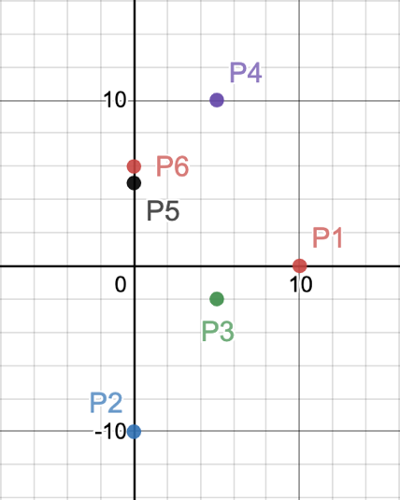Plot the given 6 training examples and show the decision boundary resulting from 1-NN.

*Point 1 (P1) →*

*Point 6 (P6) →*

*Point 5 (P5) →*

*Point 4 (P4) →*

*Point 3 (P3) →*

*Point 2 (P2) →*

|  |  |  |
| --- | --- | --- |
| *X1* | *X2* | *Y* |
| *10* | *0* | + |
| *0* | *-10* | + |
| *5* | *-2* | + |
| *5* | *10* | - |
| *0* | *5* | - |
| *5* | *5* | - |

*From the given points, there are 3 positive examples and 3 negatives. We need calculate the Euclidean distances between all the positive points versus all the negative points:*

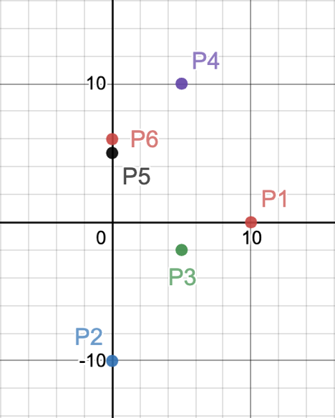

1. **Decision Trees:**

