***Experiment no.:-*** 1 ***UID:-***2019230071

***Name:-***Parshwa Shah

***Physical Layer***

***Aim:-*** To understand working of physical layer and various transmission media.

***Theory:-***

Physical layer is the lowest layer of the OSI reference model. It is responsible for sending bits from one computer to another. This layer is not concerned with the meaning of the bits and deals with the setup of physical connection to the network and with transmission and reception of signals.

**Functions of Physical Layer**

Following are the various functions performed by the Physical layer of the OSI model.

* Representation of Bits: Data in this layer consists of stream of bits. The bits must be encoded into signals for transmission. It defines the type of encoding i.e. how 0's and 1's are changed to signal.
* Data Rate: This layer defines the rate of transmission which is the number of bits per second.
* Synchronization: It deals with the synchronization of the transmitter and receiver. The sender and receiver are synchronized at bit level.
* Interface: The physical layer defines the transmission interface between devices and transmission medium.
* Line Configuration: This layer connects devices with the medium: Point to Point configuration and Multipoint configuration.
* Topologies: Devices must be connected using the following topologies: Mesh, Star, Ring and Bus.
* Transmission Modes: Physical Layer defines the direction of transmission between two devices: Simplex, Half Duplex, Full Duplex.

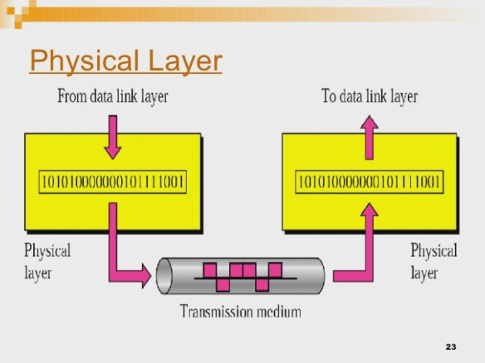

**Network Architectures:-**

LAN: A local-area network (LAN) is a computer network that spans a relatively small area. Most often, a LAN is confined to a single room, building or group of buildings, however, one LAN can be connected to other LANs over any distance via telephone lines and radio waves. Local Area Networks cover a small physical area, like a home, office, or a small group of buildings, such as a school or airport.

WAN: A computer network that spans a relatively large geographical area, generally having a radius of more than 1 km. . Typically, a WAN consists of two or more local-area networks (LANs). Computers connected to a wide-area network are often connected through public networks, such as the telephone system. They can also be connected through leased lines or satellites.

MAN: A metropolitan area network (MAN) is a network that interconnects users with computer resources in a geographic area or region larger than that covered by even a large local area network (LAN) but smaller than the area covered by a wide area network (WAN).

SAN: SAN (storage area network) is a high-speed network of storage devices that also connects those storage devices with servers. It provides block-level storage that can be accessed by the applications running on any networked servers. Storage Area Networks help attach remote computer storage devices, such as disk arrays, tape libraries, and optical jukeboxes, to servers in such a manner that that they appear to be locally attached to the operating system.

CAN: A Controller Area Network (CAN bus) is a vehicle bus standard designed to allow microcontrollers and devices to communicate with each other in applications without a host computer.

PAN: A personal area network (PAN) is a computer network used for data transmission amongst devices such as computers, telephones, tablets, personal digital assistants, fax machines and printers, that are located close to a single user.

GAN: A global area network (GAN) is a network used for supporting mobile across an arbitrary number of wireless LANs, satellite coverage areas, etc.

**Wired Media**

**Ethernet-**

Ethernet is a system for connecting a number of computer systems to form a local area network, with protocols to control the passing of information and to avoid simultaneous transmission by two or more systems.

**Specifications:**

802.3 is a standard specification for Ethernet, a method of packet-based physical communication in a local area network (LAN), which is maintained by the Institute of Electrical and Electronics Engineers (IEEE). In general, 802.3 specifies the physical media and the working characteristics of Ethernet. The first Ethernet standards to be defined support a data rate of 10 megabits per second (Mbps) and specify these possible physical media:

* 10BASE5 (Thickwire coaxial cable with a maximum segment length of 500 meters)
* 10BASE2 (Thinwire coaxial cable with a maximum segment length of 185 meters)
* 10BASE-F (optical fiber cable)
* 10BASE-T (ordinary telephone twisted pair wire)
* 10BROAD36 (broadband multi-channel coaxial cable with a maximum segment length of 3,600 meters)

This designation is an IEEE shorthand identifier. The "10" in the media type designation refers to the transmission speed of 10 Mbps. The "BASE" refers to baseband signalling, which means that only Ethernet signals are carried on the medium (or, with 10BROAD36, on a single channel in a shared cable). The "T" represents twisted-pair; the "F" represents fiber optic cable; and the "2", "5", and "36" refer to the coaxial cable segment length in 100 meter sections (the 185 meter length has been rounded up to "2" for 200).Modulation- Most forms of Ethernet use pulse amplitude modulation

**Modulation**- Most forms of Ethernet use pulse amplitude modulation (PAM) constellations. In PAM signal modulation, information is encoded in the amplitude of a series of signal pulses. For example, a two-bit modulator (PAM4) takes two bits and maps the signal amplitude to one of four possible voltage levels (perhaps –2V, -1V, 1V, 2V) over a specified period, Tp . Demodulation of the signal is accomplished by detecting the amplitude level of the carrier at each period Tp.The type of Ethernet determines which type of PAM is used. For example,100BASE-T2 (running at 100Mb/s) Ethernet utilizes a five-level PAM modulation over two wire pairs. The IEEE 802.3an standard defines the wire-level modulation for 10GBASE-T,etc.

**Signaling**- Early Ethernet standards used Manchester coding so thatthe signal was self-clocking and not adversely affected by high-pass filters.The StarLAN 10 signaling was used as the basis of 10BASE-T, with the addition of link beat to quickly indicate connection status.[c]Using twistedpair cabling, in a star topology, for Ethernet addressed several weaknesses of the previous standards were overcome.Ethernet and IEEE 802.3 networks represent their data differently than do Token-Ring networks but they both use the same clocking scheme. The clock signal is a constant pulse. On an Ethernet or 802.3 network the signal is present only when a frame is being transmitted. Otherwise the cable is electrically '0'.

**Twisted Pair Cables**:

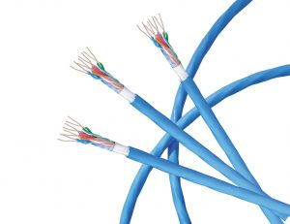

Twisted pair cables are literally a pair of insulated wires that are twisted together. While this does help to reduce outside noise, these cables are still very susceptible to it. Twisted pair cables are the most cost-effective option of the three – mostly due to their lower bandwidth capacity and [high attenuation](https://itel.com/what-is-attenuation/). There are two types of twisted pair cables:

**Unshielded twisted pair (UTP)**

* ‘Unshielded’ meaning it does not rely on physical shielding to block interference
* Most commonly used cable of the two, often utilized for both residential and business use
* There are several UTP categories, which increase in bandwidth as you move up the scale, for example:
  + **CAT1** = up to 1Mbps | **CAT2** = up to 4 Mbps | **CAT5e** = up to 1Gbps

**Shielded twisted pair (STP)**

* ‘Shielded’ with a foil jacket to cancel any external interference
* Used primarily for large-scale enterprises, high-end applications, and exterior cabling that will be exposed to environmental elements.

**Coaxial Cables**:

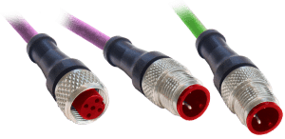

Coaxial cables are high-frequency transmission cables made up of a single solid-copper core that transfers data electrically over the inner conductor. Coax has **80X more transmission capacity** thantwistedpaircables.  
  
This type of cable is commonly used to deliver TV signals (its higher bandwidth makes it more suitable for video applications) and to connect computers in a network. Along with stable transmission of data, coax also has anti-jamming capabilities and can effectively protect signals from being interfered. The cost is slightly higher than twisted pair but still more economical than fibre. There are also two types of coaxial cables:

**75 Ohm**

* Most commonly used to transmit video signals
* Often used to connect video signals between different components like DVDs, VCRs, or receivers commonly known as A/V cables

**50 Ohm**

* Primarily utilized to transmit a data signal in a 2-way communication system
* Most commonly used for computer ethernet backbones, AM/FM radio receivers, GPS antenna, police scanners, and cell phone systems

**Range** – Up to 500m

**Modulation –**

10 Mbit/s Ethernet uses Manchester coding. A binary zero is indicated by a low-to-high transition in the middle of the bit period and a binary one is indicated by a high-to-low transition in the middle of the bit period. Manchester coding allows the clock to be recovered from the signal. However, the additional transitions associated with it double the signal bandwidth.

**Scalability –**

There are two types of coaxial cable

1.RG8 used in LAN also known as thick Ethernet.

2.RG-58 used for LAN and known as thin Ethernet.

**Fibre Optic Cables:**

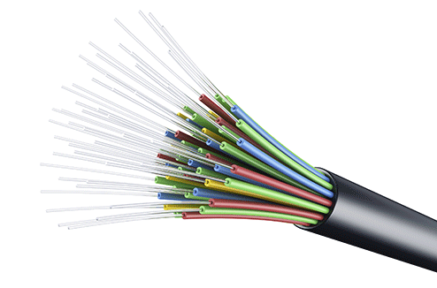

Fibre is the newest form of transmission cabling technology. Instead of transferring data over copper wires, these cables contain optical fibres that transmit data via light, rather than pulses of electricity. Each individual optical fibre is coated with plastic and contained in a protective tube. This makes fibre optic cables extremely resistant to external interference. The result is a super reliable, high speed connection with **26,000X more transmission capacity** than twisted-pair cables – but also a much higher cost. Again, there are two types of fibre cables:

**Singlemode**

* Has a small core and only allows one mode of light to propagate at a time
* Because of this, the number of light reflections decrease as they pass through the core
* The result is low attenuation and data that is able to travel further and faster
* Commonly used in telecom, CATV networks, and Universities.

**Multimode**

* Has a larger core diameter that lets multiple modes of light propagate
* The amount of light reflections increase as they travel through the core, which allows more data to pass through
* Because of its high dispersion, multimode cables have lower bandwidth, higher attenuation and reduced signal quality further it travels
* Most commonly used for communication over short distances such as LAN, security systems, and general fibre networks.

Wireless Media

## Electromagnetic Spectrum

Here is a quick look at the electromagnetic spectrum with common names for various regions.

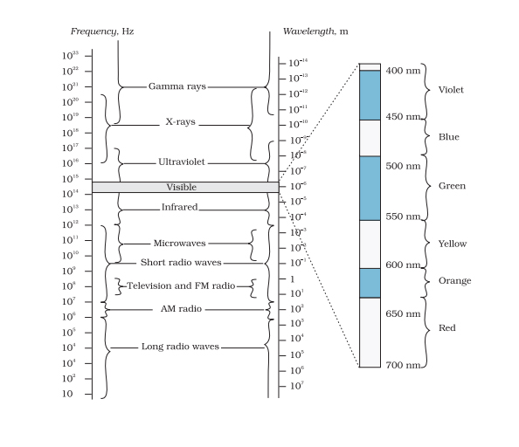

## Radio Waves

* Radio waves are usually in the frequency range from 500 kHz to 1000 MHz.
* Also, the range of the AM (amplitude modulated) band is between 530 kHz and 1710 kHz.
* Further, shortwave bands use higher frequencies of up to 54 MHz.
* TV waves range from 54 MHz to 890 MHz.
* The FM (frequency modulated) radio band is from 88 MHz to 108 MHz.
* Cellular phones also use radio waves to transmit voice communication in an ultra-high frequency (UHF) band.

### ****Generation of Radio Waves****

The accelerated motion of charges in conducting wires generates Radio waves. Radio and television communication systems widely use these waves.

## Microwaves

* Microwaves are short-wavelength radio waves with frequencies in the Gigahertz (GHz) range
* Best suited for the radar systems in aircraft navigation
* Another use of Radars is as speed-guns. These speed guns help time fastballs, tennis serves and automobiles.
* These waves form the basis of microwave ovens. In microwave ovens, the frequency of the microwaves is selected to match the resonant frequency of water molecules. This results in a direct transfer of energy from the waves to the kinetic energy of the water molecules raising the temperature of any food containing water.

### ****Generation of Microwaves****

Special vacuum tubes called klystrons, magnetrons and Gunn diodes generate microwaves.

## Infrared Rays

* ‘Heat Waves’ is another name for Infrared rays.
* Water molecules present in most materials readily absorb these rays.
* After absorption, their thermal motion increases which increases their heat and that of their surroundings.
* Many physical therapy treatments use Infrared lamps.
* These rays also play an important role in maintaining the earth’s average temperature through the greenhouse effect.
  + Greenhouse effect: The earth’s surface absorbs the incoming visible light. Then, it re-radiates it as infrared radiations. The greenhouse gases like carbon dioxide and water vapour trap these radiations.
* Earth Satellites deploy Infrared detectors for military purposes and to observe the growth of crops.
* Remote switches of household appliances like TV, video recorders, etc. use infrared rays.

### Generation of Infrared Rays

Hot bodies and molecules generate Infrared rays. Also, the band lies next to the low-frequency or long-wavelength end of the electromagnetic spectrum.

**Bluetooth**

It is a Wireless Personal Area Network (WPAN) technology and is used for exchanging data over smaller distances. This technology was invented by Ericson in 1994. It operates in the unlicensed, industrial, scientific and medical (ISM) band at 2.4 GHz to 2.485 GHz. Maximum devices that can be connected at the same time are 7. Bluetooth ranges upto 10 meters. It provides data rates upto 1 Mbps or 3 Mbps depending upon the version. The spreading technique which it uses is FHSS (Frequency hopping spread spectrum). A bluetooth network is called **piconet** and a collection of interconnected piconets is called **scatternet**.

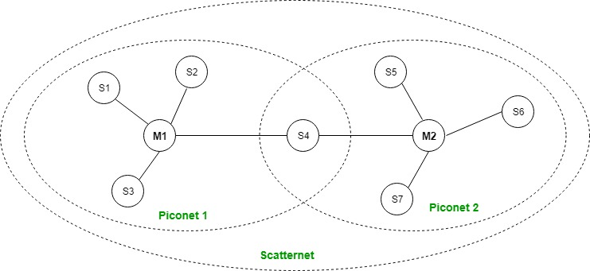

**Zigbee**

Zigbee is a wireless technology developed as an open global standard to address the unique needs of low-cost, low-power wireless IoT networks. The Zigbee standard operates on the IEEE 802.15.4 physical radio specification and operates in unlicensed bands including 2.4 GHz, 900 MHz and 868 MHz.

The 802.15.4 specification upon which the Zigbee stack operates gained ratification by the Institute of Electrical and Electronics Engineers (IEEE) in 2003. The specification is a packet-based radio protocol intended for low-cost, battery-operated devices. The protocol allows devices to communicate in a variety of network topologies and can have battery life lasting several years.

**Specifications-**

**Range**- Its low power consumption limits transmission distances to 10–100 meters line-of-sight, depending on power output and environmental characteristics. Zigbee devices can transmit data over long distances by passing data through a mesh network of intermediate devices to reach more distant ones. Data range is 250 kbps and the number of nodes that can be connected are around 64,000.

**Modulation**- Zigbee modulation is carried out through direct sequence spread spectrum (DSSS). The 2.4 GHz band, in which ZigBee transceivers are most commonly deployed, uses the OQPSK (offset quadrature phase-shift keying) modulation stream.

### Wi-Fi

Wi-Fi is a low-cost wireless communication technology. A WiFi setup consists of a wireless router which serves a communication hub, linking portable device with an internet connection.This network facilitates connection of many devices depending on the router configuration. These networks are limited in range due to the low power transmission, allowing the user to connect only in the close proximity.

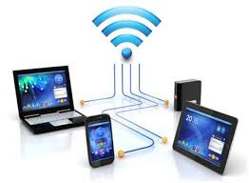

This network facilitates connection of many devices depending on the router configuration. These networks are limited in range due to the low power transmission, allowing the user to connect only in the close proximity.

802.11 and 802.11x refers to a family of specifications developed by the IEEE for wireless LAN (WLAN) technology. 802.11 specifies an over-the-air interface between a wireless client and a base station or between two wireless clients. The IEEE accepted the specification in 1997.

There are several specifications in the 802.11 family:

1. 802.11 — applies to wireless LANs and provides 1 or 2 Mbps transmission in the 2.4 GHz band using either frequency hopping spread spectrum (FHSS) or direct sequence spread spectrum (DSSS).
2. 802.11a — an extension to 802.11 that applies to wireless LANs and provides up to 54-Mbps in the 5GHz band. 802.11a uses an orthogonal frequency division multiplexing encoding scheme rather than FHSS or DSSS.
3. 802.11b (also referred to as 802.11 High Rate or Wi-Fi) — an extension to 802.11 that applies to wireless LANS and provides 11 Mbps transmission (with a fallback to 5.5, 2 and 1-Mbps) in the 2.4 GHz band. 802.11b uses only DSSS. 802.11b was a 1999 ratification to the original 802.11 standard, allowing wireless functionality comparable to Ethernet.
4. 802.11e — a wireless draft standard that defines the Quality of Service (QoS) support for LANs, and is an enhancement to the 802.11a and 802.11b wireless LAN (WLAN) specifications. 802.11e adds QoS features and multimedia support to the existing IEEE 802.11b and IEEE 802.11a wireless standards, while maintaining full backward compatibility with these standards.
5. 802.11g — applies to wireless LANs and is used for transmission over short distances at up to 54-Mbps in the 2.4 GHz bands.
6. 802.11n — 802.11n builds upon previous 802.11 standards by adding multiple-input multiple-output (MIMO). The additional transmitter and receiver antennas allow for increased data throughput through spatial multiplexing and increased range by exploiting the spatial diversity through coding schemes like Alamouti coding. The real speed would be 100 Mbit/s (even 250 Mbit/s in PHY level), and so up to 4-5 times faster than 802.11g.
7. 802.11ac — 802.11ac, or Wi-Fi 5, builds upon previous 802.11 standards, particularly the 802.11n standard, to deliver data rates of 433Mbps per spatial stream, or 1.3Gbps in a three-antenna (three stream) design. The 802.11ac specification operates only in the 5 GHz frequency range and features support for wider channels (80MHz and 160MHz) and beamforming capabilities by default to help achieve its higher wireless speeds.
8. 802.11ac Wave 2 — 802.11ac Wave 2 is an update for the original 802.11ac spec that uses MU-MIMO technology and other advancements to help increase theoretical maximum wireless speeds for the spec to 6.93 Gbps.
9. 802.11ad — 802.11ad is a wireless specification under development that will operate in the 60GHz frequency band and offer much higher transfer rates than previous 802.11 specs, with a theoretical maximum transfer rate of up to 7Gbps (Gigabits per second).
10. 802.11ah— Also known as Wi-Fi HaLow, 802.11ah is the first Wi-Fi specification to operate in frequency bands below one gigahertz (900 MHz), and it has a range of nearly twice that of other Wi-Fi technologies. It's also able to penetrate walls and other barriers considerably better than previous Wi-Fi standards.
11. 802.11r - 802.11r, also called Fast Basic Service Set (BSS) Transition, supports VoWi-Fi handoff between access points to enable VoIP roaming on a Wi-Fi network with 802.1X authentication.
12. 802.1X — Not to be confused with 802.11x (which is the term used to describe the family of 802.11 standards) 802.1X is an IEEE standard for port-based Network Access Control that allows network administrators to restricted use of IEEE 802 LAN service access points to secure communication between authenticated and authorized devices.
13. 802.11ax, or Wi-Fi 6, improves on Wi-Fi 5 with more speed, bandwidth and security.

**Advantages**

* Information can be transmitted quickly with a high speed and accuracy.
* The internet can be accessed from anywhere, at any time without any cables or wires.
* Emergency situations can be alerted through wireless communication.
* Wireless, no bunches of wire running out.
* Communication can reach where wiring is not feasible and costly.

**Disadvantages**

* An Unauthorized person can easily misuse the wireless signals which spread through the air.
* It is very important to secure the wireless network to protect information.
* High cost to set up the infrastructure.
* Wireless communication is influenced by physical constructions, climatic conditions and interference from other wireless devices.

**WiMax**

WiMAX is one of the hottest broadband wireless technologies around today. WiMAX systems are expected to deliver broadband access services to residential and enterprise customers in an economical way.

Loosely, WiMax is a standardized wireless version of Ethernet intended primarily as an alternative to wire technologies (such as Cable Modems, DSL and T1/E1 links) to provide broadband access to customer premises.

More strictly, WiMAX is an industry trade organization formed by leading communications, component, and equipment companies to promote and certify compatibility and interoperability of broadband wireless access equipment that conforms to the IEEE 802.16 and ETSI HIPERMAN standards.

WiMAX would operate similar to WiFi, but at higher speeds over greater distances and for a greater number of users. WiMAX has the ability to provide service even in areas that are difficult for wired infrastructure to reach and the ability to overcome the physical limitations of traditional wired infrastructure.

WiMAX was formed in April 2001, in anticipation of the publication of the original 10-66 GHz IEEE 802.16 specifications. WiMAX is to 802.16 as the WiFi Alliance is to 802.11.

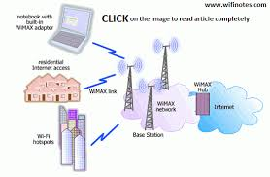

WiMAX is

Acronym for Worldwide Interoperability for Microwave Access.

* Based on Wireless MAN technology.
* A wireless technology optimized for the delivery of IP centric services over a wide area.
* A scalable wireless platform for constructing alternative and complementary broadband networks.
* A certification that denotes interoperability of equipment built to the IEEE 802.16 or compatible standard. The IEEE 802.16 Working Group develops standards that address two types of usage models −
  1. A fixed usage model (IEEE 802.16-2004).
  2. A portable usage model (IEEE 802.16e).

**Lifi[5]**

LiFi uses visible light as a medium for the transmission of data. As a type of VLC system, it requires two components: a photodiode and a light source. The photodiode acts as a transceiver that receives light signals and transmits them back. The light source transmits data using emitted light as the medium. In this case, light emitting diodes (LED) serve as the light source. They are outfitted with a chip that serves as the signal processing unit.

Li-Fi is a VLC (visible light communications) system and the speed of this system is very high. Li-Fi uses normal LEDs to allow the data to transfer and increase the speed up to 224 Gigabits/sec. The data transmission of this technology can be done via illumination. The essential devices of this system are the bright light emitting diodes.The ON/Off activity of LEDs permits a type of data transmission in the form of binary codes but the human eye cannot recognize this transform & the bulbs appear with a stable intensity.

LED light bulbs are semiconductors. This means current supplied to the bulb can be modulated, which in turn, modulates the light they emit. This process occurs at extremely high speeds that are unperceivable to the human eye. Data is fed into the light bulb and sends the data at extremely high speeds to the photodiode. It converts the data received into a binary data stream perceivable by humans such as video and audio applications.

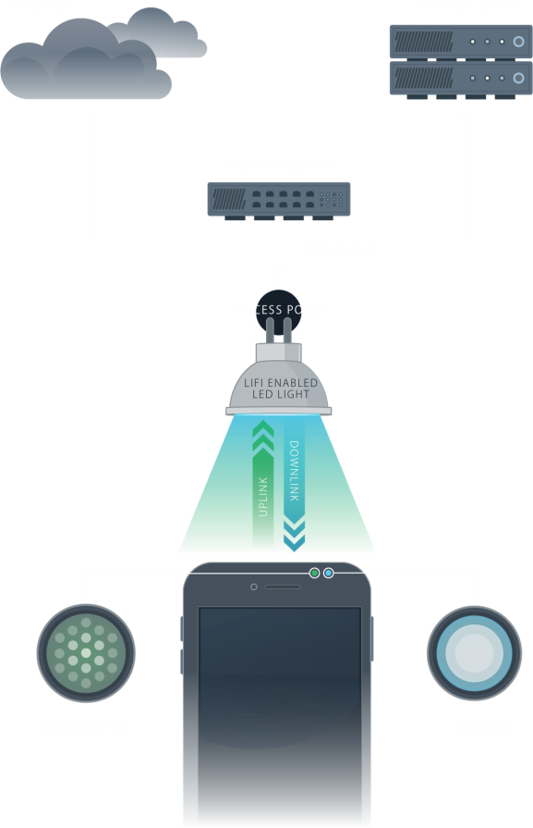

**TD-SCDMA[9]**

One of the key elements of TD-SCDMA is the fact that it uses a TDD, Time Division Duplex approach. As seen with UMTS TDD this has advantages in a number of areas, enabling the balance to be changed between uplink and downlink to accommodate the different levels of data transfer. It also has advantages in terms of using unpaired spectrum, spectrum efficiency for certain loads and it does not require expensive diplexers in the handsets to enable simultaneous transmission on the uplink and downlink, although transmit / receive switching times must be accommodated and can reduce the efficiency of the system.

As a further advantage, TD-SCDMA uses the same RAN as that used for UMTS. In this way it is possible to run TD-SCDMA alongside UMTS, and thereby simplifying multi-system designs.

Although UMTS (W-CDMA) and cdma2000 are widely recognized as 3G cellular standards, TD-SCDMA is equally valid. In fact it has been adopted as the low chip rate (LCR) version of the 3GPP TDD standard.

| **TD-SCDMA SPECIFICATION SUMMARY** | |
| --- | --- |
| **TD-SCDMA CHARACTERISTIC** | **FIGURE** |
| Bandwidth | 1.6 MHz |
| Chip rate per carrier | 1.28 Mcps |
| Frame Rate | 10ms |
| Spectrum spreading mode | DS SF=1/2/4/8/16 |
| Modulation | QPSK / 8PSK / 16QAM |
| Channel coding | Convolutional codes: R=1/2,1/3 Turbo implemented |
| Interleaving | 10/20/40/80 ms |
| Frame structure | Super frame 720ms,Radio frame 10ms Subframe 5 ms |
| Uplink synchronisation | 1/2 chip |
| Number of voice channels per carrier | 48 |
| Spectrum Efficiency | 25Erl./MHz |
| Total transmission rate provided by each carrier | 1.971Mbps |

**LTE technology[10]**

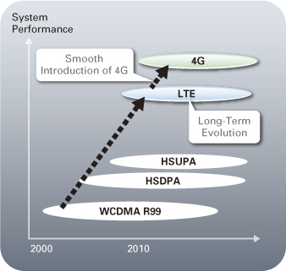

LTE (Long Term Evolution) is the project name given to development of a high performance air interface for cellular mobile communication systems. It is the last step toward the 4th generation (4G) of radio technologies designed to increase the capacity and speed of mobile telephone networks. While the former generation of mobile telecommunication networks are collectively known as 2G or 3G, LTE is marketed as 4G.

LTE has introduced a number of new technologies when compared to previous cellular systems. They enable LTE to operate more efficiently with respect to the use of spectrum, and also provide the much higher data rates that are now required.

OFDM (Orthogonal Frequency Division Multiplex)

OFDM technology has been incorporated into LTE because it enables high data bandwidths to be transmitted efficiently while still providing a high degree of resilience to reflections and interference.

MIMO (Multiple Input Multiple Output)

One of the main problems that previous telecommunications systems have encountered is that of multiple signals arising from the many reflections that are encountered in antenna deployments. By using MIMO, these additional signal paths can be used to advantage and are able to be used to increase the throughput.

SAE (System Architecture Evolution)

With the very high data rate and low latency requirements for 3G LTE, the system architecture must evolve to achieve the performance improvement benchmarks. One change is that a number of the functions previously handled by the core network have been transferred out to the periphery. Essentially this provides a much "flatter" form of network architecture. In this way latency times can be reduced and data can be routed more directly to its destination.

**5G Technology[8]**

5G technology is the next generation of wireless communications. It is expected to provide Internet connections that are least 40 times faster than 4G LTE. 5G technology may use a variety of spectrum bands, including millimeter wave (mmWave) radio spectrum, which can carry very large amounts of data a short distance. The drawback of the higher frequencies is that they are more easily obstructed by the walls of buildings, trees and other foliage, and even inclement weather.

The forthcoming 5G technology will come from various vendors and will be composed of solutions designed to provide very fast download speeds and low latency. Today—in advance of 5G’s expected debut around 2020—companies such as Verizon, AT&T, Samsung, and Ericsson are testing new advances in signal processing, chips, and antenna technologies that will enable the next generation of mobile connectivity.

As the 5G technology market comes into focus, we’re seeing a number of technologies emerge as vital to the 5G experience. These include the aforementioned mmWave technology; small cells; massive multiple input, multiple output (MIMO); full duplex; software-defined networking (SDN); and beamforming.

* Millimeter wave: Millimeter waves are broadcast at frequencies between 30 GHz and 300 GHz, compared with the bands below 6 GHz used for 4G LTE. The new 5G networks will be able to transmit very large amounts of data—but only a few blocks at a time. Although the 5G standard will offer the greatest benefits over these higher frequencies, it will also work in low frequencies as well as unlicensed frequencies that WiFi currently uses, without creating conflicts with existing WiFi networks. For this reason, 5G networks will use small cells to complement traditional cellular towers.
* Small cells: Small cells are low-powered portable base stations that can be placed throughout cities. Carriers can install many small cells to form a dense, multifaceted infrastructure. Small cells’ low-profile antennas make them unobtrusive, but their sheer numbers make them difficult to set up in rural areas. As 5G technology matures, consumers should expect to see ubiquitous 5G antennas, even in their own homes.
* Massive MIMO: 5G technology enables base stations to support many more antennas than 4G base stations. With MIMO, both the source (transmitter) and the destination (receiver) have multiple antennas, thus maximizing efficiency and speed. MIMO also introduces interference potential, leading to the necessity of beamforming.
* Beamforming: Beamforming is a 5G technology that finds the most efficient data-delivery route to individual users. Higher-frequency antennas enable the steering of narrower transmission beams. This user-specific beamforming allows transmissions both vertically and horizontally. Beam direction can change several times per millisecond. Beamforming can help massive MIMO arrays make more efficient use of the spectrum around them.
* Full duplex: Full duplex communication is a way to potentially double the speed of wireless communication. By employing a 5G full duplex scheme on a single channel, only one channel is needed to transmit data to and from the base station, rather than two. A potential drawback of full duplex is that it can create signal interference.
* SDN: SDN and network functions virtualization (NFV) are considered the foundation for how 5G will be deployed.

**Conclusion**:

Hence, I understood the working and use of physical layer in OSI model and also I got a chance to explore various wired and wireless transmission media.

**References:**

1. <https://www.cmscomputer.in/blog/what-is-lan-wan-man-san-can-pan-and-gan/#:~:text=MAN%3A%20A%20metropolitan%20area%20network,wide%20area%20network%20(WAN).>
2. <https://www.studytonight.com/computer-networks/osi-model-physical-layer>
3. <https://itel.com/understanding-network-cables/>
4. <https://www.toppr.com/guides/physics/electromagnetic-waves/electromagnetic-spectrum/>
5. <https://lifi.co/#:~:text=LiFi%20is%20a%20wireless%20optical,(LED)%20for%20data%20transmission.&text=Similar%20to%20WiFi%2C%20LiFi%20is,the%20bidirectional%20transmission%20of%20light.>
6. <https://www.digi.com/solutions/by-technology/zigbee-wireless-standard#:~:text=Zigbee%20is%20a%20wireless%20technology,900%20MHz%20and%20868%20MHz.>
7. <https://www.tutorialspoint.com/wimax/what_is_wimax.htm>
8. <https://www.sdxcentral.com/5g/definitions/5g-technology/#:~:text=5G%20technology%20is%20the%20next,of%20data%20a%20short%20distance.>
9. <https://www.electronics-notes.com/articles/connectivity/3g-umts/td-scdma.php>
10. <https://www.artizanetworks.com/resources/tutorials/what_lte.html>