**DCCN ISE Assignment**

**UID:-2019230071**

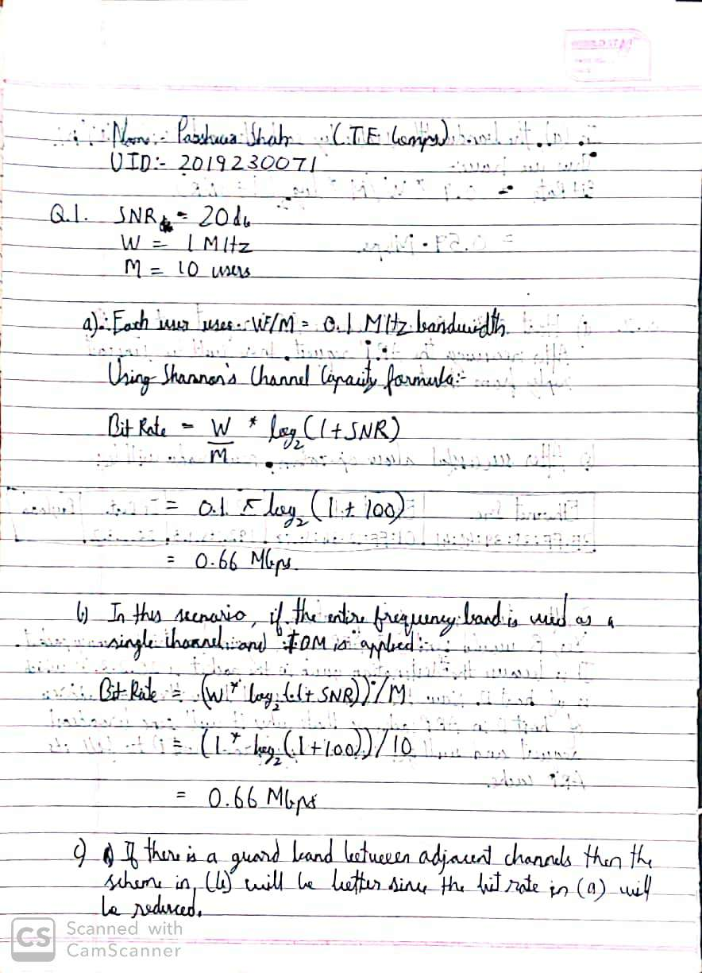

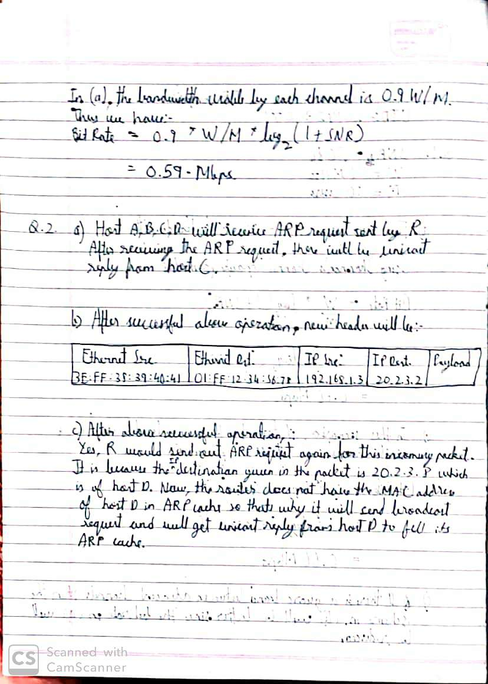

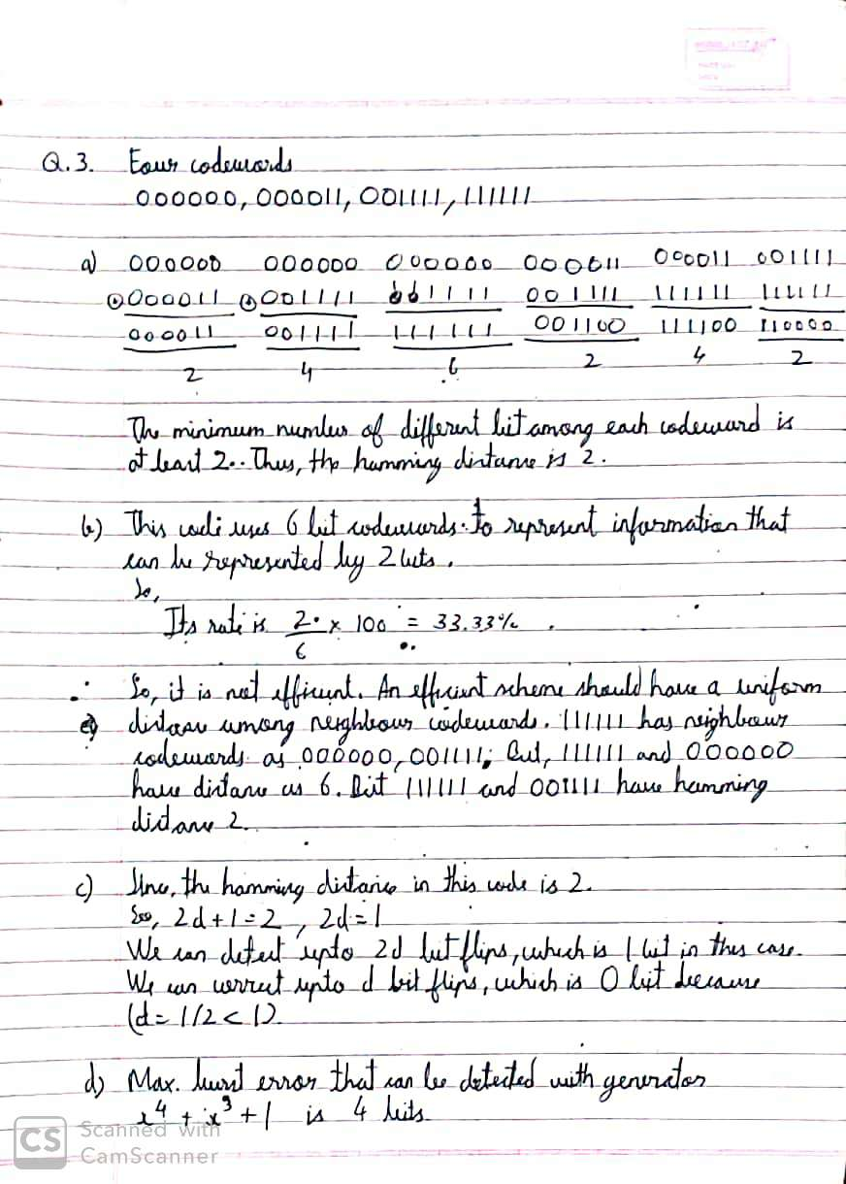

|  |  |  |
| --- | --- | --- |
| Name: Shah Parshwa | | |
| SID: 2019230071 | | |
| Q.No | Marks | Score |
| 1 | 3 |  |
| 2 | 3 |  |
| 3 | 4 |  |
| Total | 10 |  |