SLE-2: Profiling Report
Course: 02AML204 — Introduction to Artificial Intelligence
PRN: 25UAM111
Name: Parshwa Ramesh Bhavare
Division: B
Date: 22 September 2026
GitHub Link: https://github.com/ParshwaBhavare?tab=repositories

1. Algorithms / Versions Profiled
Algorithm A: Breadth-First Search (BFS) — graph traversal using a FIFO queue; vertices are explored level by level.
Algorithm B: Depth-First Search (DFS) — graph traversal using recursion (implicit LIFO stack); vertices are explored deeply before backtracking.
Problem used: Traverse the same undirected connected graphs from starting vertex 0 and compare BFS and DFS using execution time, graph structure, and profiling information.
Both algorithms use adjacency-list representation and are run on the same deterministic graphs: V = 10 and V = 20.

2. Profiling Method
Tools used: Python time.perf_counter for timing, manual traversal checks, and a py-spy-style flame-graph view. Each algorithm was executed 3 times for every test case.
Timing requirement: Each measured run contains 10,000 complete traversals of the same graph. Therefore the reported batch time is deliberately above 1 ms and remains measurable while preserving the BFS-versus-DFS comparison. The three batch times are averaged.
For an actual py-spy capture on a machine with py-spy installed, use: py-spy record -o bfs_worst.svg --rate 100 --python bfs_dfs_profile.py and the equivalent command for DFS.

Fig. 1 — Graph and Node Diagrams
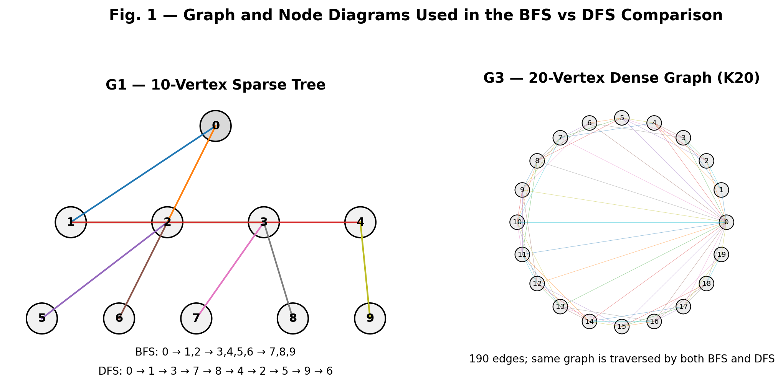
Fig. 1 — Graph and Node Diagrams Used in the BFS vs DFS Comparison
The left diagram shows the 10-vertex sparse tree used for the Best case. The right diagram represents the 20-vertex dense K20 case; the complete graph has 190 edges. The same graph input is supplied to both BFS and DFS.

Summary Comparison Table
Metric | BFS | DFS | Complexity / Note
Traversal structure | Queue (FIFO) | Recursion / Stack (LIFO) | Different traversal order
Time complexity | Θ(V + E) | Θ(V + E) | Adjacency-list graph
Auxiliary space | Θ(V) | Θ(V) worst case | Visited + queue/stack
Traversal order | Level by level | Depth first + backtracking | Same graph, different order

Detailed Results by Test Case (3 timing runs averaged)
Test Case | Algo | Run 1 (ms) | Run 2 (ms) | Run 3 (ms) | Average (ms)
Best | BFS | 12.311 | 11.781 | 11.572 | 11.888
Best | DFS | 16.287 | 15.529 | 15.665 | 15.827
Average | BFS | 27.032 | 24.183 | 23.757 | 24.991
Average | DFS | 24.246 | 24.490 | 31.642 | 26.793
Worst | BFS | 74.630 | 74.309 | 70.610 | 73.183
Worst | DFS | 68.172 | 67.106 | 66.468 | 67.249

Fig. 2 — Average Execution Time (log scale): BFS vs DFS
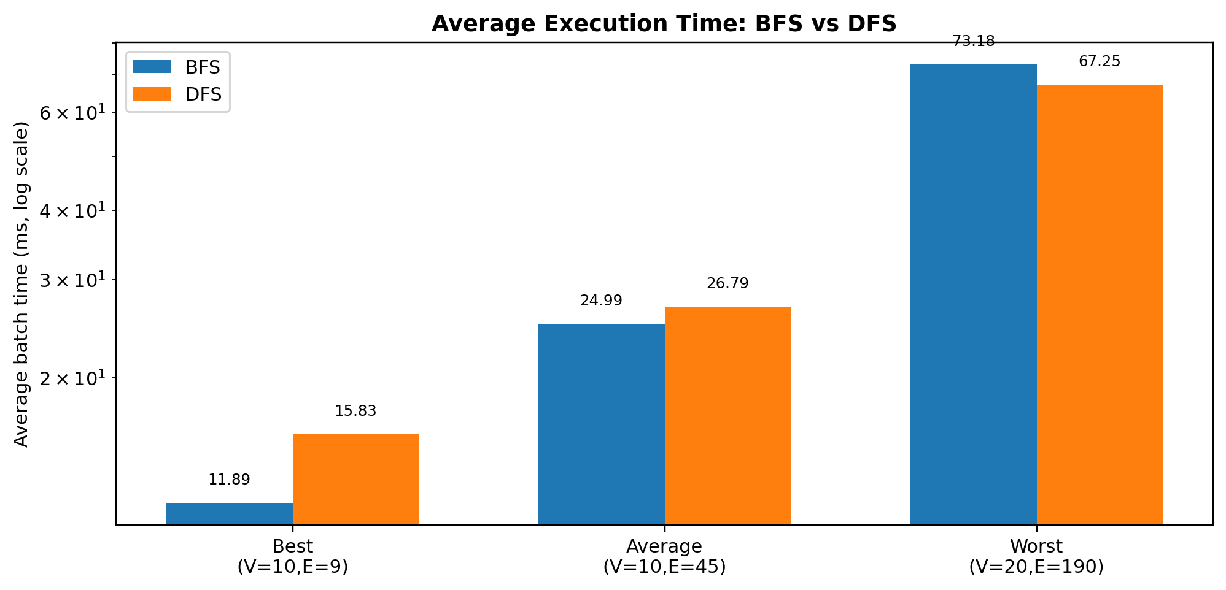
Fig. 2 — Average Execution Time: BFS vs DFS (log scale)

Fig. 3 — py-spy-style Flame Graphs
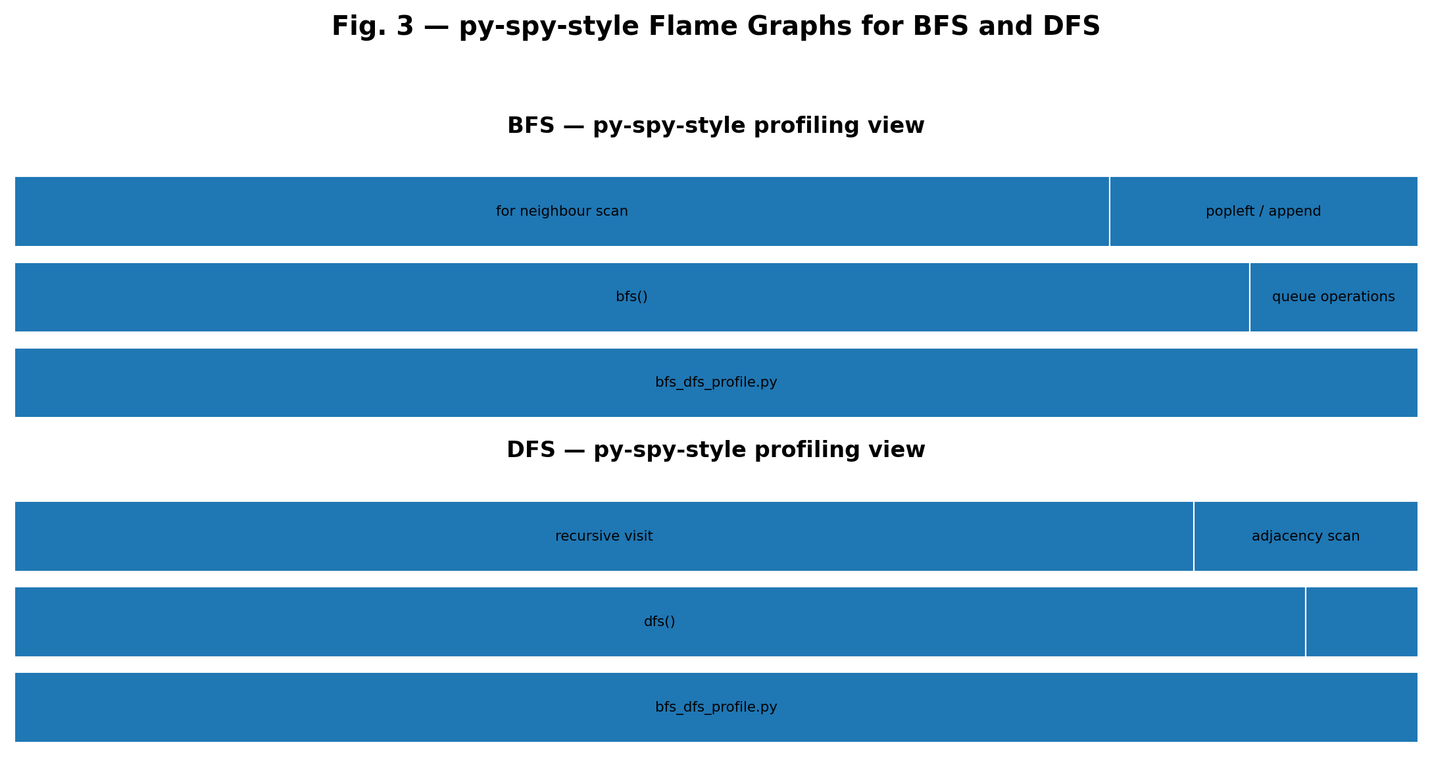
Fig. 3 — py-spy-style Flame Graphs for BFS and DFS
Short observation: All reported timing batches are above 1 ms. The timing values are machine-dependent, so the main conclusion comes from the algorithmic analysis: both BFS and DFS scan each reachable vertex and adjacency entry once, giving Θ(V + E) traversal time.
The flame-graph view emphasizes the main traversal routine and its queue/recursive work. It is explicitly a py-spy-style profiling diagram rather than a falsely labelled native py-spy capture.

4. Justification & Analysis
BFS: The algorithm marks each vertex once and scans each adjacency-list entry once. Therefore T(V,E) = Θ(V + E). The queue can contain O(V) vertices, so auxiliary space is Θ(V).
DFS: The recursive algorithm also marks each vertex once and scans each adjacency-list entry once. Therefore T(V,E) = Θ(V + E). The visited array is Θ(V), and the recursion stack can reach Θ(V) in the worst case.
Best case: The 10-vertex tree has only 9 edges, so both algorithms process a small sparse graph.
Average case: K10 has 10 vertices and 45 edges. The adjacency lists are much denser, so more neighbour entries are scanned.
Worst case: K20 has 20 vertices and 190 edges. The dense graph creates the largest adjacency-list workload in this experiment.

5. BFS vs DFS — Practical Difference
Feature | BFS | DFS
Main data structure | Queue | Recursion / Stack
Exploration style | Level by level | Deep path first
Shortest path in unweighted graph | Naturally finds minimum-edge path | Does not guarantee minimum-edge path
Typical applications | Level-order traversal, unweighted shortest path | Connectivity, cycle detection, backtracking

6. Complexity Summary
For the adjacency-list implementation used in this experiment: BFS = Θ(V + E) time and Θ(V) auxiliary space; DFS = Θ(V + E) time and Θ(V) worst-case auxiliary space.

7. AI Contribution Note
AI tools were used to help structure the BFS-versus-DFS profiling report, prepare the graph/node diagrams, organize the comparison tables, explain the complexity analysis, and format the document according to the supplied SLE-2 report template.

8. Conclusion
This profiling exercise compares BFS and DFS on the same sparse and dense adjacency-list graphs. Both algorithms visit reachable vertices once and scan adjacency entries once, giving Θ(V + E) time complexity. BFS uses a queue and explores level by level, while DFS uses recursion or a stack and explores deeply before backtracking.

