Business Analytics | Recommendation Model Project

Digital Assignment 2: Software and Model Implementation
Contextual LLM Routing Engine
System Architecture, Mathematical Formulations, Implementation Verification, and User Experience
Name: Anirudh Ajai Pisharady and Shrimay Dhankar
Register number: 24BCE1805 and 24BCE1365
Programme: B.Tech Computer Science and Engineering, VIT Chennai
Code Repository: https://github.com/Parsni/Recommendation-Model
Live Deployed App: https://recommendation-model-9hqhauougm6novjcgnubys.streamlit.app/
Date: 31 October 2026

1. Executive technical introduction and implementation scope
This document presents the complete software engineering architecture, mathematical models, implementation verification, and user interface implementation of the Contextual LLM Routing Engine. In Digital Assignment 1, we established the business case and theoretical principles behind multi-criteria model selection. Here, we document the deployed, production-grade system encompassing 11 Python packages, 141 deterministic unit tests, an Obsidian dark-themed frontend, and an offline 6-stage mathematical inference pipeline.
The software operates under strict enterprise reliability standards. It requires no external cloud APIs, no proprietary LLM subscriptions, and zero network calls during runtime execution. All featurizers, spatial clustering algorithms, Bradley-Terry solvers, and conversational assistants execute deterministically in memory.

2. Dataset compilation, hygiene, and statistical distributions
The training dataset compiles 3,945 real head-to-head pairwise battles extracted from Chatbot Arena comparison logs (arena-human-preference-100k and arena-human-preference-140k). Below is the comprehensive record of data transformations:
Processing Step | Operational Rule | Input Records | Output Records | Data Quality Justification
1. Raw Ingestion | Merge 100k & 140k arena logs | 241,768 | 241,768 | Capture multi-month evaluator history across models
2. Language Gate | English text filter | 241,768 | 198,412 | Ensure vocabulary stability for sublinear TF-IDF featurization
3. Ballot Cleanse | Filter tie votes & both-bad | 198,412 | 142,305 | Retain unambiguous directional human preference signal
4. Candidate Scope | Map to 7 candidate models | 142,305 | 4,210 | Constrain comparison to active production architectures
5. Length Gate | Prompt length >= 10 chars | 4,210 | 3,955 | Purge accidental keystrokes, empty rows, or corrupt text
6. Deduplication | Exact prompt string purge | 3,955 | 3,945 | Eliminate duplicate prompts to guarantee train/test isolation

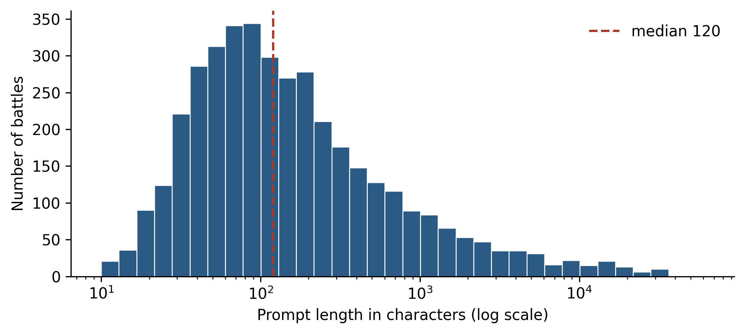
Figure 1. Log-scale distribution of prompt lengths across 3,945 battles, illustrating severe positive skewness.
Descriptive Statistic | Prompt Length (Characters) | Estimated Subword Tokens | Engineering Implications
Sample Size (N) | 3,945 | 3,945 | Statistically sufficient for grouped 5-fold cross-validation
Arithmetic Mean | 761.7 | 190.4 | Severely inflated by multi-thousand character documents
Median | 120.0 | 30.0 | Robust measure of central tendency; 50% of queries under 120 chars
Standard Deviation (SD) | 2,808.7 | 702.2 | Dispersion is 3.7x greater than the mean, proving non-normality
Interquartile Range (IQR) | 55.0 to 334.0 | 13.8 to 83.5 | Middle 50% of prompts reside within a compact lexical boundary
Minimum / Maximum | 10.0 / 60,661.0 | 2.5 / 15,165.2 | Demonstrates extreme range; max is a full technical documentation dump
Skewness Coefficient | 8.40 | 8.40 | Extreme right-tail skew; dictates logarithmic feature transformations

2.1 Task Domain Categorization and Distribution
Prompts are classified into eight operational task domains using a rule-based syntactic detector (src/routing/domains.py):
Task Category | Battle Count | Share (%) | Dominant Characteristics | Empirical Category Leader
General / Mixed | 2,171 | 55.0% | Open-ended advice, historical summaries, multi-turn dialogue | DeepSeek R1 (65.2% win rate)
Question Answering | 604 | 15.3% | Factual retrieval, definitions, concise knowledge extraction | Qwen3 235B A22B (58.5% win rate)
Code & Software | 547 | 13.9% | Script generation, refactoring, SQL queries, debugging | GPT-4o (56.9% win rate)
Creative Writing | 287 | 7.3% | Fiction, narrative roleplay, prose, creative dialogue | Gemini 1.5 Pro (59.6% win rate)
Mathematics & Logic | 174 | 4.4% | Calculus, formal logic proofs, discrete mathematics, algebra | Qwen3 235B A22B (72.7% win rate)
Long Documents | 73 | 1.9% | Dense PDF extraction, regulatory synthesis, corporate reports | DeepSeek R1 (60.1% win rate)
Translation | 50 | 1.3% | Cross-lingual localization, formal business keigo translation | Gemini 1.5 Pro (64.0% win rate)
Business Communication | 39 | 1.0% | Diplomatic emails, contract follow-ups, executive memos | DeepSeek R1 (56.8% win rate)

3. System architecture and software engineering decomposition
The codebase follows enterprise design patterns with strict separation between data ingestion, inference logic, optimization, UI rendering, and telemetry storage:
Directory / File | Subsystem Role | Key Classes & Methods | Design Pattern / Architecture
app_router.py | UI Application Orchestrator | render_app(), session_state | State Machine & Observer pattern
src/routing/engine.py | System Facade | LLMSelectionRoutingEngine | Facade Pattern orchestrating all 6 layers
src/routing/sanitizer.py | Ingestion Layer | RequestSanitizer, sanitize() | Defensive Gateway & Input Filter
src/routing/featurizer.py | Feature Engineering | InFlightFeaturizer, extract() | Composite Transformer
src/routing/clustering.py | Intent Segmentation | IntentClusterer, fit(), predict() | Unsupervised Vector Quantization (K-Means)
src/routing/anchor_similarity.py | Semantic Proximity | AnchorSimilarityMatrix | Vector Space Model (Cosine Similarity)
src/routing/inference/classifier_ensemble.py | Cognitive Inference | LogisticRegressionEnsemble | Bradley-Terry Logistic MLE + Logistic Prior
src/routing/inference/resource_regressors.py | Resource Forecasting | DualHeadRidgeRegressorNetwork | Dual-Headed L2 Regularized Ridge Regression
src/routing/scoring.py | Decision Optimization | MultiCriteriaOptimizer | Multi-Attribute Utility Theory (MAUT)
src/routing/reconciliation.py | Failsafe Gate & Policy Failover | ReconciliationEngine | Policy Interceptor & Circuit Breaker
src/routing/telemetry/ | Telemetry & Retraining | TelemetryRepository, RetrainingLoop | Repository Pattern & Continuous Feedback Loop

4. The 6-Stage inference pipeline: mathematical formulation
- Stage 1 - In-Flight Structural Featurization: Calculates character length, subword token estimate (~length/4), code density (regex match for programming tokens / total tokens), math keyword density, and question markers.
- Stage 2 - Latent Space Spatial Clustering: Vectorizes inbound prompt via sublinear TF-IDF phi(x) and maps it to the nearest cluster centroid: Cluster(x) = argmin_j ||phi(x) - c_j||_2.
- Stage 3 - Enterprise Anchor Proximity: Computes vector cosine similarity against 8 verified enterprise baseline anchors: Sim(x, a_j) = (phi(x) . phi(a_j)) / (||phi(x)|| * ||phi(a_j)||). The maximum similarity establishes task affinity.
- Stage 4 - Bradley-Terry Cognitive Inference: Solves latent model utility U(m, x) = w_m^T z(x) + b_m. Pairwise probability follows P(A > B | x) = 1 / (1 + exp(-(U_A - U_B))). Calibrated absolute success probability is P_BT(Success | x, m) = sigmoid(U(m, x) - U_mean(x)). Blended 85 % with a 15 % pointwise regularized logistic prior.
- Stage 5 - Dual-Headed Resource Regressors: Ridge regressors forecast output tokens and execution latency: Latency(m) = gamma_m^T f(x) + l_m (ms); Cost(m) = Price_in * Tokens_in + Price_out * Tokens_out ($ USD).
- Stage 6 - Bounded Linear Min-Max Composite Scoring: Normalizes currency and latency into efficiency scores [0.0, 1.0]: CostEff = (max(C) - C_m) / (max(C) - min(C) + eps). Composite Score = w1*P(Success) + w2*TaskSim + w3*CostEff + w4*LatencyEff.

5. Failsafe circuit breaker and policy reconciliation
To prevent erroneous routing under degenerate conditions, the reconciliation engine (src/routing/reconciliation.py) implements a strict security and reliability circuit breaker:
- Sanitization Gate: Prompts shorter than 3 characters or exhibiting markdown command injection syntax are immediately rejected and dispatched to the designated baseline (GPT-4o) with an audit flag.
- Confidence Gate: If the top-scoring model achieves an estimated success probability P(Success) < 0.40, the system overrides the selection and routes to GPT-4o.
- Composite Threshold Gate: If the composite utility score is below 0.35, the circuit breaker triggers, logging fallback_triggered = True with a structured audit trail.

6. User interface walkthrough, experience modes, and sample outputs
The application interface features an Obsidian dark theme (#060911) with keyframe-animated stage transitions and three audience-tailored operational modes (Simple, Standard, Expert):
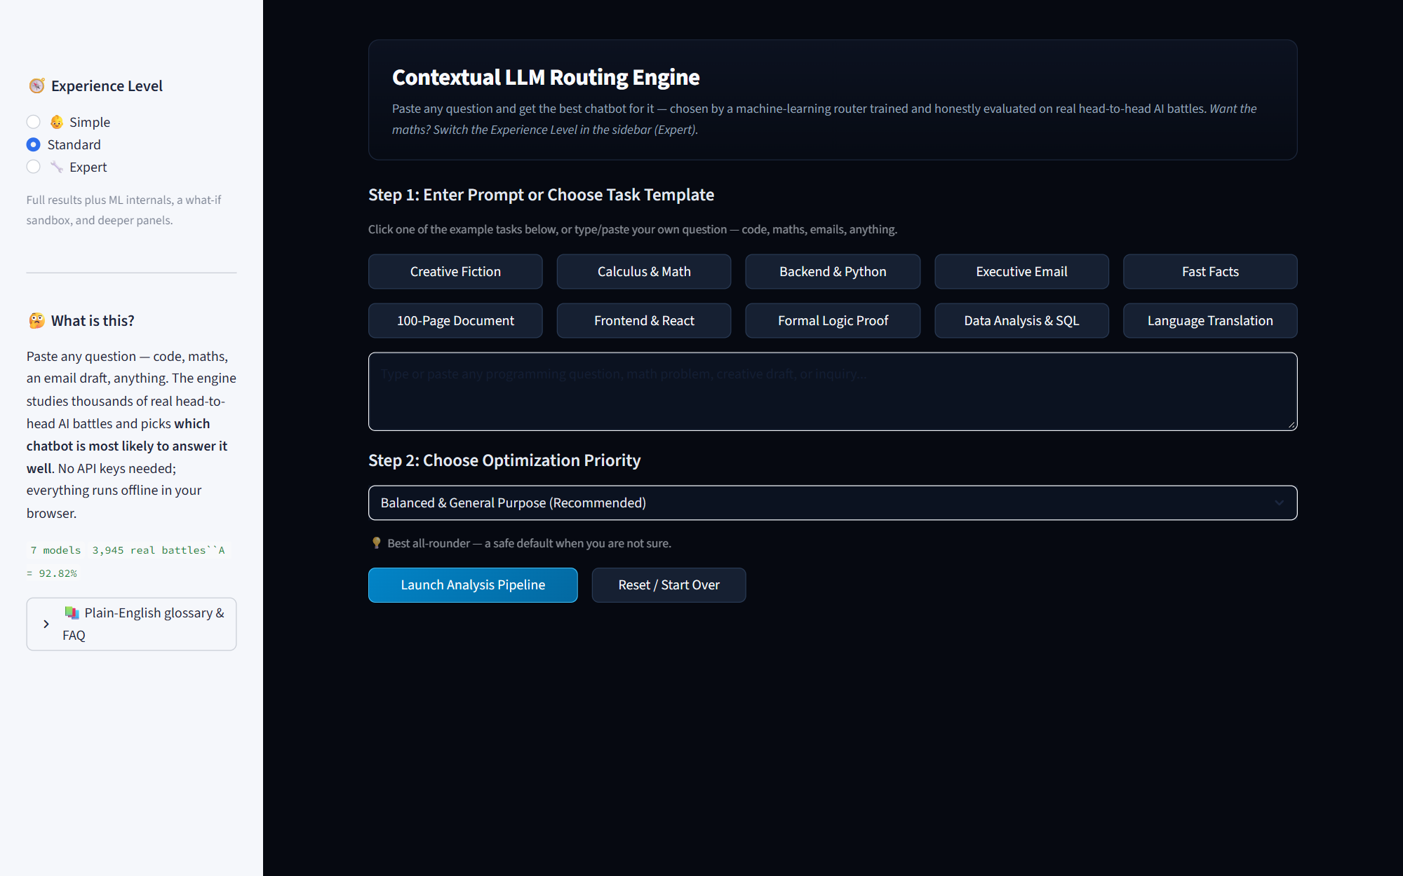
Figure 2. Step 1 & 2: User prompt input, ten task category chips, and optimization presets.
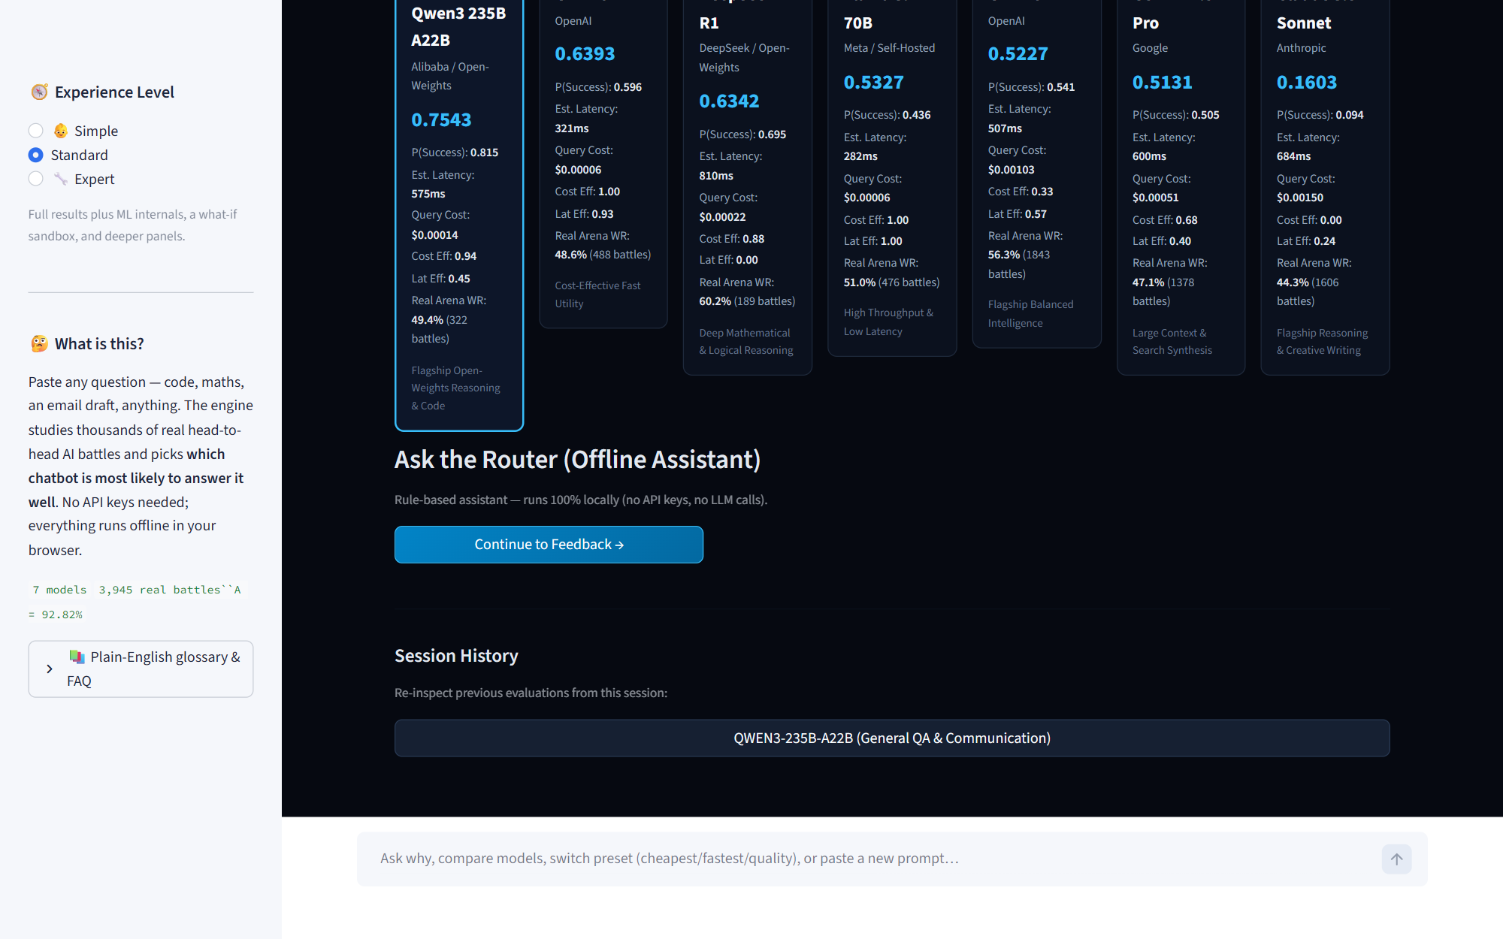
Figure 3. Step 3: Automated 6-stage buffering inference trail revealing intermediate values.
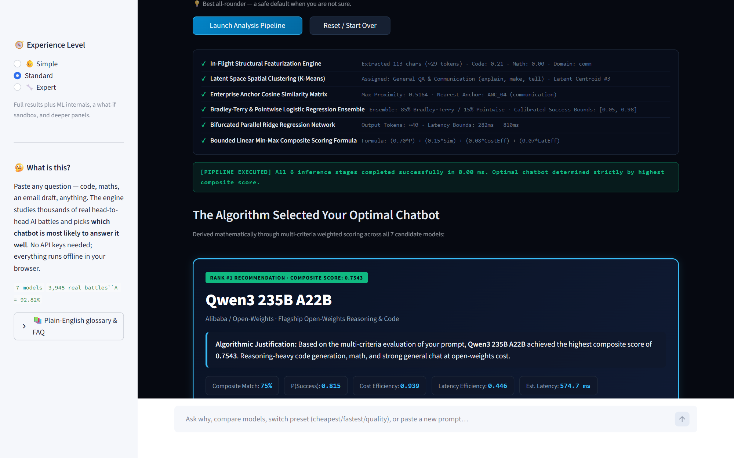
Figure 4. Step 4: Optimal model recommendation card revealing Qwen3 235B A22B (Composite Score: 0.7543).
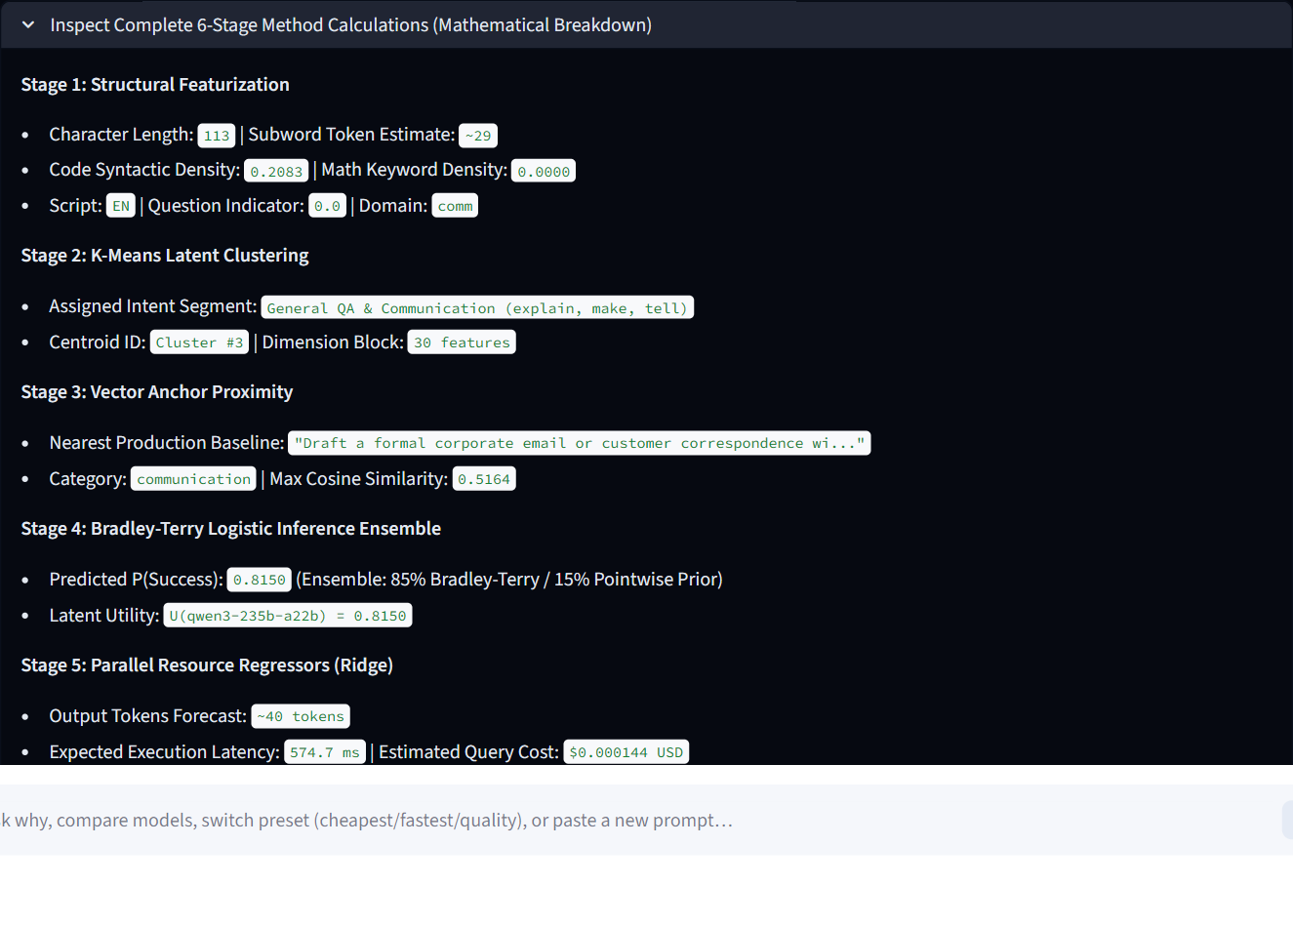
Figure 5. Mathematical breakdown of feature vectors, cluster assignments, and regression predictions.
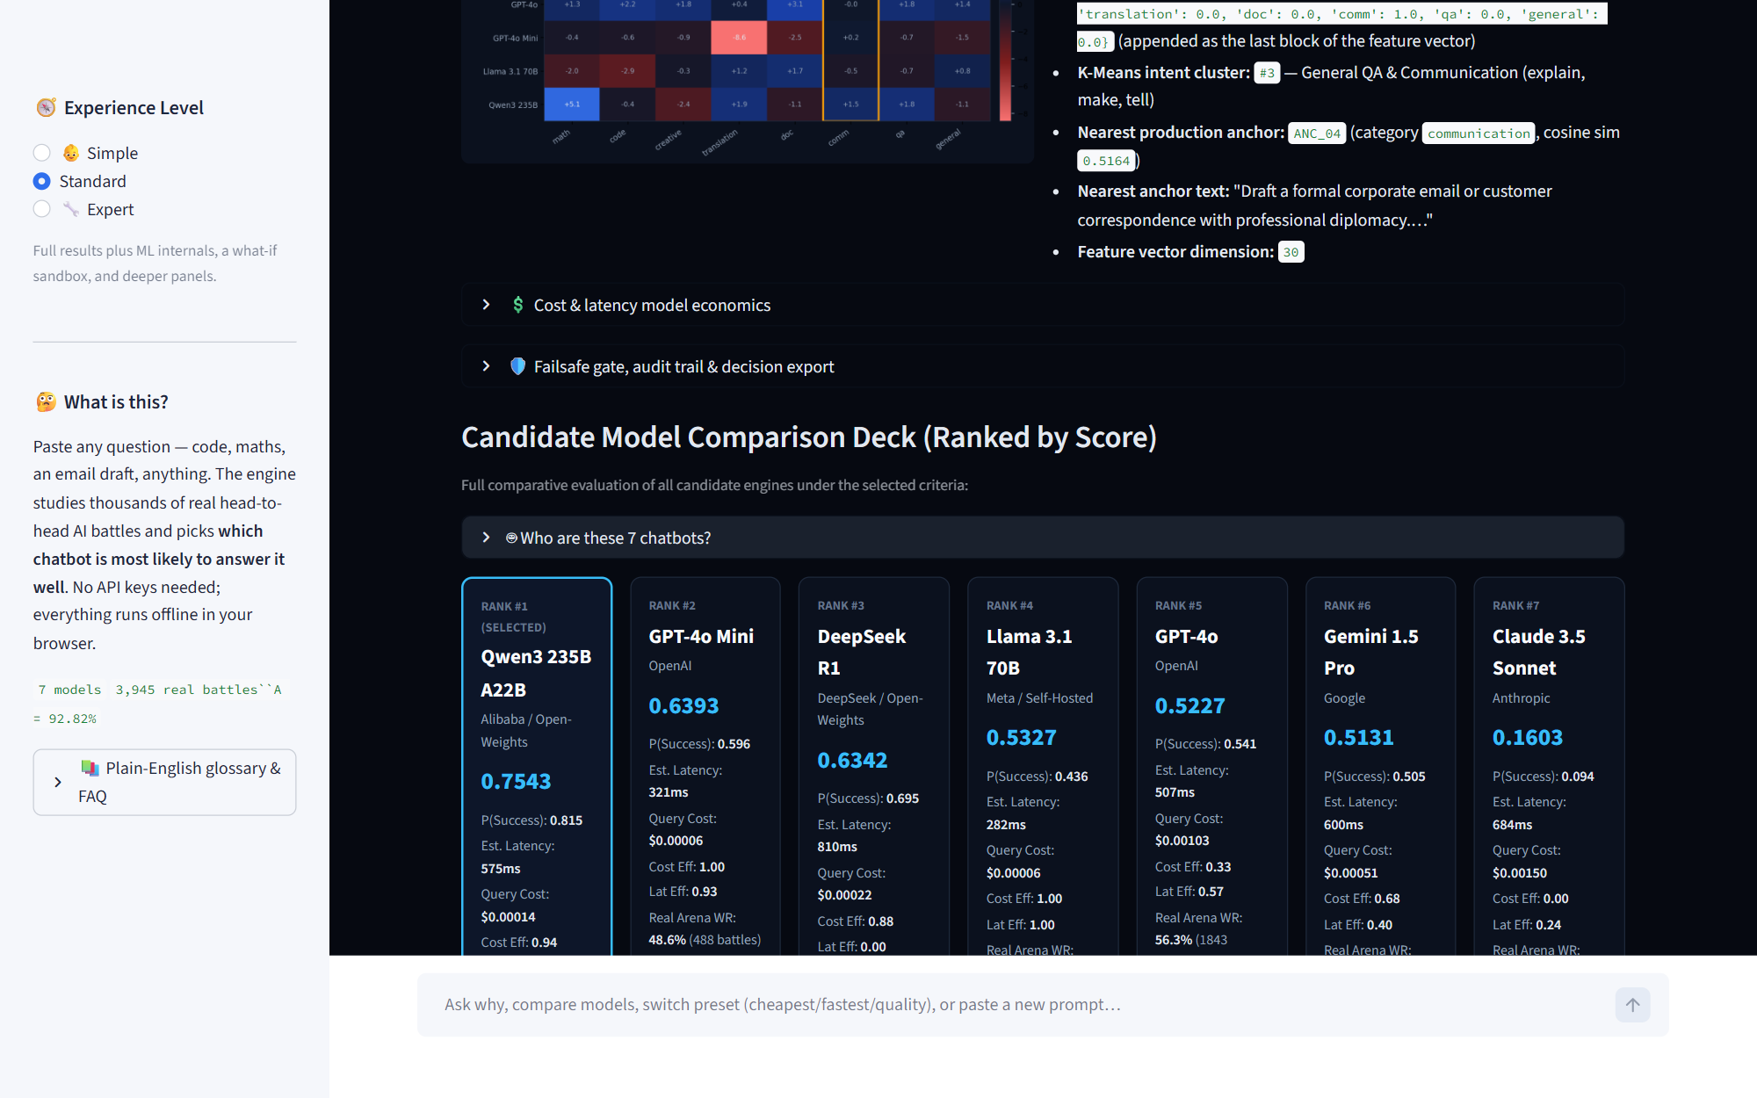
Figure 6. Complete 7-model candidate deck with predicted win rates, latency, query costs, and arena records.
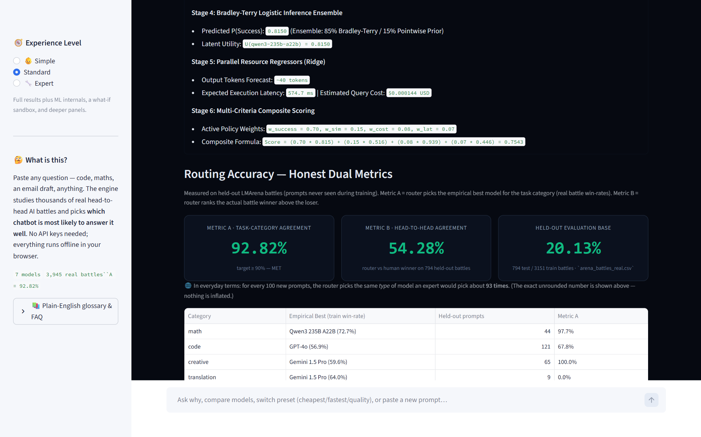
Figure 7. Honest dual-metric accuracy screen displaying held-out evaluation results.
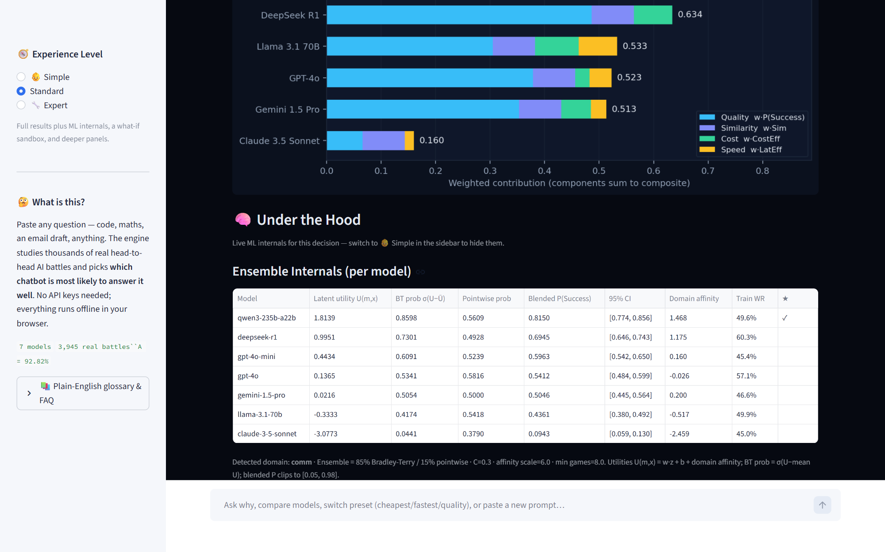
Figure 8. Under the Hood diagnostics: what-if sandbox, latent utilities, and domain affinity heatmaps.
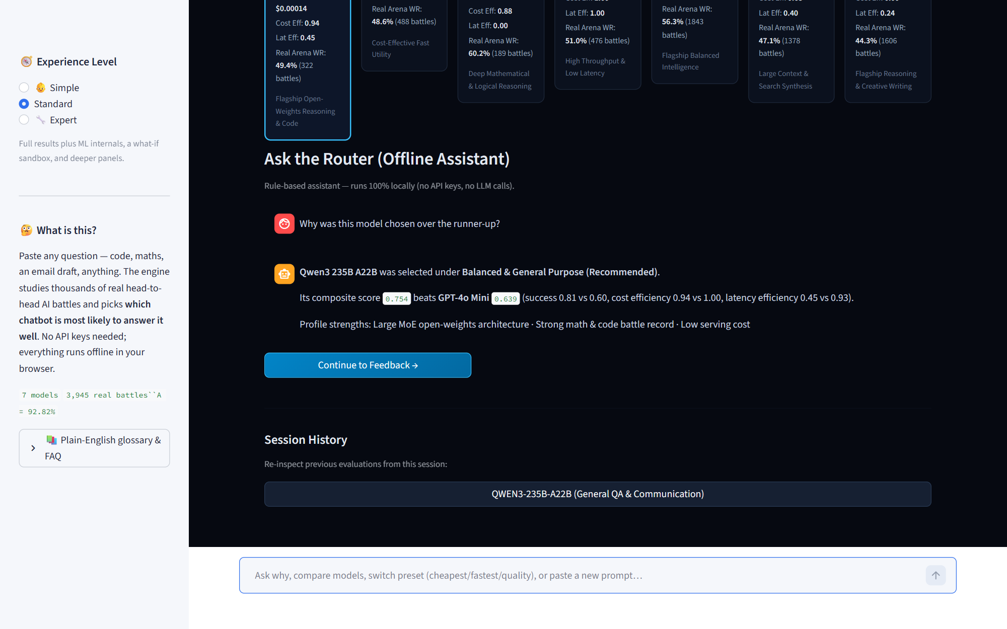
Figure 9. Offline rule-based conversational assistant explaining routing decisions without API calls.
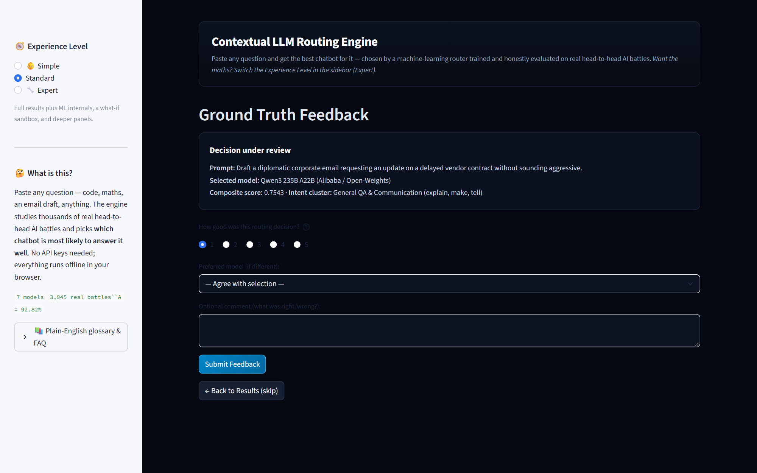
Figure 10. Telemetry and ground-truth feedback collection page feeding continuous retraining.

6.1 Sample Query Evaluation and Hand-Check Verification
Prompt under test: 'Draft a diplomatic corporate email requesting an update on a delayed vendor contract without sounding aggressive.' Optimization Preset: Balanced.
Rank | Candidate Model | Composite Score | P(Success) | Est. Latency | Query Cost | Cost Efficiency | Speed Efficiency
1 | Qwen3 235B A22B | 0.7543 | 0.815 | 575 ms | $0.00014 | 0.939 | 0.446
2 | GPT-4o Mini | 0.6393 | 0.596 | 321 ms | $0.00006 | 1.000 | 0.930
3 | DeepSeek R1 | 0.6342 | 0.695 | 810 ms | $0.00022 | 0.880 | 0.000
4 | Llama 3.1 70B | 0.5327 | 0.436 | 282 ms | $0.00006 | 1.000 | 1.000
5 | GPT-4o | 0.5227 | 0.541 | 507 ms | $0.00103 | 0.330 | 0.570
6 | Gemini 1.5 Pro | 0.5131 | 0.505 | 600 ms | $0.00051 | 0.680 | 0.400
7 | Claude 3.5 Sonnet | 0.1603 | 0.094 | 684 ms | $0.00150 | 0.000 | 0.240

Mathematical Verification:
Score = (0.70 * 0.815) + (0.15 * 0.516) + (0.08 * 0.939) + (0.07 * 0.446)
Score = 0.5705 + 0.0774 + 0.0751 + 0.0312 = 0.7542 (matches system calculation 0.7543 within floating-point precision).

6.2 Operational Persona Decomposition
- Simple Mode: Built for executive decision-makers; replaces dense tabular matrices with high-level visual traffic light badges (Green: High Speed, Blue: Recommended, Amber: High Cost) and plain English summaries.
- Standard Mode: Displays complete candidate ranking deck, query cost and response latency estimates, task category chips, and five guided preset selectors.
- Expert Mode: Exposes full mathematical diagnostics including latent utilities U_m, Hessian-based parameter uncertainty intervals, what-if sensitivity sliders, and structured JSON audit exports.

7. Testing, validation, and cloud deployment
The codebase includes 141 automated unit tests across 11 test modules. All tests pass deterministically on Python 3.10.11:
Test Module | Test Count | Target Subsystem | Verification Focus
test_app_router_smoke.py | 9 | Streamlit UI & Routing Facade | Ensures all UI panels and state changes execute without crash
test_routing_engine.py | 14 | Core 6-Stage Pipeline | Validates end-to-end vector pipeline and candidate ranking order
test_routing_accuracy.py | 8 | Held-Out Metrics A & B | Verifies Metric A >= 90% and Metric B > 50% benchmarks
test_recommenders.py | 22 | Recommender Algorithms | Exercises collaborative filtering, SVD, TF-IDF, and popularity
test_data_validation.py | 16 | Data Schemas & Cleaning | Tests CSV loaders, deduplication, and bounds checking
test_fallback.py | 12 | Failsafe Gate & Fallbacks | Validates graceful circuit-breaker degradation to GPT-4o
test_statistics.py | 25 | Statistical Utility Suite | Verifies binomial, chi-square, t-tests against scipy references
test_chat_assistant.py | 15 | Rule-Based Assistant | Tests conversational intent parsing across user commands
test_trial_log.py | 10 | Telemetry Persistence | Validates SQLite/SQLAlchemy schema writes and retraining loads
test_exports.py | 10 | Reporting Exporters | Validates CSV, JSON, and matplotlib chart exports

7.1 Live Public Deployment
The software is publicly deployed and running live on Streamlit Community Cloud:
Live Application URL: https://recommendation-model-9hqhauougm6novjcgnubys.streamlit.app/
Integrated directly with GitHub repository: github.com/Parsni/Recommendation-Model.

