Business Analytics | Recommendation Model Project

Digital Assignment 3: Final Report and Results
Contextual LLM Routing Engine
Comprehensive Empirical Results, Statistical Hypothesis Tests, Economic Impact, and Evaluation
Name: Anirudh Ajai Pisharady and Shrimay Dhankar
Register number: 24BCE1805 and 24BCE1365
Programme: B.Tech Computer Science and Engineering, VIT Chennai
Code Repository: https://github.com/Parsni/Recommendation-Model
Live Deployed App: https://recommendation-model-9hqhauougm6novjcgnubys.streamlit.app/
Date: 31 October 2026

1. Executive summary and problem statement
Organizations face an expanding landscape of commercial and open-weights Large Language Models. Choosing which model to query is typically governed by habit or blanket organizational defaults. Querying flagship models (e.g., Claude 3.5 Sonnet, GPT-4o) for all tasks results in severe cost inflation and latency overhead. Conversely, delegating all tasks to inexpensive models (e.g., GPT-4o Mini, Llama 3.1 70B) introduces error rates and re-work on complex reasoning tasks.
Problem Statement: Given an arbitrary written prompt and an operational priority (balanced, flagship quality, math reasoning, code engineering, throughput, or budget), recommend the optimal AI model among seven frontier candidates. The recommendation must be empirically grounded in real head-to-head human preference votes, explainable via an inspectable 6-stage mathematical trail, and honestly evaluated on unseen held-out prompts without inflated metric rounding.

2. Project objectives and scope
- Develop an end-to-end contextual routing engine trained on 3,945 real LMArena pairwise comparisons.
- Model tournament win probabilities using Bradley-Terry maximum likelihood estimation blended with regularized logistic priors.
- Synthesize multi-criteria trade-offs across success probability, semantic similarity, execution latency, and financial query cost.
- Implement an automated failsafe gate falling back to GPT-4o when candidate confidence drops below 0.40.
- Evaluate generalization across two distinct metrics on 794 held-out prompts (20 % split, grouped by prompt seed 42) and verify stability across 5-fold cross-validation.
- Perform rigorous statistical hypothesis testing covering positional voting bias, task-model independence, and parameter sensitivity.
- Deploy a fully functional, public web interface on Streamlit Community Cloud with telemetry capture and feedback loops.

3. Dataset provenance, characteristics, and filtering
The training dataset compiles 3,945 real head-to-head human preference battles extracted from Chatbot Arena comparison logs (arena-human-preference-100k and 140k). All battles represent genuine human evaluations; zero synthetic interaction rows exist in the routing dataset.
Dimension | Value | Statistical Interpretation
Total Battles (N) | 3,945 | Clean preference comparisons across 7 candidate models
Unique Prompts | 3,873 | Prompts represent distinct real-world query tasks
Evaluation Split | 3,151 Train / 794 Test | Strict 80/20 train/test split grouped by prompt
Missing Values | 0 (0.0%) | Complete feature coverage across all columns
Prompt Length Median | 120.0 chars | Robust measure of central tendency unaffected by extreme outliers
Prompt Length Mean (SD) | 761.7 chars (2,808.7) | Significant right-skew driven by large multi-page prompts
Prompt Length Skewness | 8.40 | Confirms extreme positive skewness; justifies log-scale featurization

4. Statistical hypothesis testing and empirical findings
All tests were conducted using rigorous statistical methodology implemented in src/statistics/. Intervals represent 95 % confidence levels.

4.1 Position Bias Hypothesis Test
In blind A/B evaluation, human raters might exhibit a cognitive bias toward voting for the response presented on the left (Model A). We formalize this as a two-sided binomial test:
H0: p_win(Model A) = 0.50 vs H1: p_win(Model A) != 0.50.
Statistic | Empirical Value | Null Value | p-value | Inference
Model A Wins | 1,953 / 3,945 (49.51%) | 50.00% | p = 0.504 | Fail to reject H0; no significant position bias exists
Model B Wins | 1,992 / 3,945 (50.49%) | 50.00% | p = 0.504 | Votes are balanced across interface presentation slots

Because p = 0.504 > 0.05, there is zero evidence of presentation bias. The preference dataset can be utilized without positional calibration weights.

4.2 Chi-Square Test of Independence (Task Category vs. Winning Model)
We test whether model superiority is independent of prompt task type, or whether domain-affinity specialization exists:
H0: Winning model is independent of task category vs H1: Winning model depends on task category.
Test Statistic | Observed Value | Critical Value (alpha=0.05) | p-value | Effect Size (Cramer's V)
Chi-Square (chi^2) | 68.20 | 58.12 (df = 42) | p = 0.0065 | V = 0.054 (Small but significant)

The test rejects independence at p = 0.0065 < 0.01. This mathematically validates contextual routing: different model architectures exhibit measurable advantages in specific task domains (e.g., DeepSeek R1 in Mathematics, Gemini 1.5 Pro in Long Documents and Creative Writing).

4.3 Model Win Rates and Confidence Intervals
Model | Total Battles | Wins | Win Rate (%) | 95% Confidence Interval (Wilson) | Assessment
DeepSeek R1 | 235 | 142 | 60.4% | 54.2% to 66.7% | Highest point estimate; wide CI due to smaller sample
GPT-4o | 2,300 | 1,314 | 57.1% | 55.1% to 59.2% | Highest volume leader; statistically superior to 50%
Llama 3.1 70B | 611 | 305 | 49.9% | 46.0% to 53.9% | Even performance; high-efficiency open baseline
Qwen3 235B A22B | 417 | 207 | 49.6% | 44.8% to 54.4% | Solid parity with proprietary frontier engines
Gemini 1.5 Pro | 1,709 | 796 | 46.6% | 44.2% to 48.9% | Below 50% overall, but leads creative and document niches
GPT-4o Mini | 602 | 273 | 45.4% | 41.4% to 49.3% | Solid performance relative to extreme low serving cost
Claude 3.5 Sonnet | 2,016 | 908 | 45.0% | 42.9% to 47.2% | Lower arena win rate; penalised on concise trivia queries

4.4 Head-to-Head Marquee Battle: GPT-4o vs Claude 3.5 Sonnet
GPT-4o and Claude 3.5 Sonnet clashed directly in 895 head-to-head battles—the largest single pair in the dataset. GPT-4o won 509 battles (56.87 %) while Claude won 386 battles (43.13 %). A two-sided binomial test yields p < 0.0001 (z = 4.11), demonstrating a statistically significant preference for GPT-4o on crowdsourced arena prompts.

5. Model evaluation and dual-metric accuracy analysis
We report two distinct accuracy metrics evaluated strictly on 794 held-out battles never seen during training:
- Metric A (Task-Category Agreement): Did the router select the candidate model with the highest empirical shrunk win-rate in that prompt's domain? Measures consistency with the empirical best tool.
- Metric B (Head-to-Head Battle Agreement): In a single pairwise battle between model A and model B, did the composite utility score assign a higher rank to the human winner? Chance is 50.0 %.
Evaluation Metric | Held-Out Test Result | 95% Confidence Interval | Target Benchmark | Statistical Significance
Metric A (Task Agreement) | 92.82% (737 / 794) | 90.8% to 94.4% | Target >= 90.0% | p = 0.0035 (Target Exceeded)
Metric B (Pairwise Agreement) | 54.28% (431 / 794) | 50.8% to 57.7% | Chance = 50.0% | p = 0.0087 (Significant Gain)

5.1 Cross-Validation Stability Analysis
To verify that results do not depend on an advantageous train/test split, we ran a 5-fold grouped cross-validation:
Cross-Validation Run | Metric A (%) | Metric B (%) | Evaluation Fold Size
Fold 1 | 94.20% | 54.80% | 789 battles
Fold 2 | 89.40% | 56.10% | 789 battles
Fold 3 | 83.10% | 54.20% | 789 battles
Fold 4 | 91.80% | 55.90% | 789 battles
Fold 5 | 81.90% | 55.30% | 789 battles
5-Fold Mean +/- SD | 88.08% +/- 4.77% | 55.26% +/- 0.92% | 3,945 battles total

5.2 Breakdown of Metric A Across Task Domains
Task Domain | Empirical Best Model | Test Battles | Metric A Agreement (%) | Operational Interpretation
Mathematics & Logic | Qwen3 235B A22B | 44 | 97.7% | High agreement; leads competition math at lower cost
Code & Software | GPT-4o | 121 | 67.8% | Near-tie between GPT-4o (56.9%) and DeepSeek (56.5%)
Creative Writing | Gemini 1.5 Pro | 65 | 100.0% | Gemini leads creative drafting decisively
Question Answering | Qwen3 235B A22B | 100 | 100.0% | High factual adherence and concise retrieval
General / Mixed | DeepSeek R1 | 438 | 100.0% | High consistency in general conversational tasks
Long Documents | DeepSeek R1 | 9 | 100.0% | Thin cell sample; treat with caution
Translation | Gemini 1.5 Pro | 9 | 0.0% | Sample n=9 too small for reliable evaluation
Business Communication | DeepSeek R1 | 8 | 0.0% | Sample n=8 too small for reliable evaluation

6. Multi-criteria recommendations and economic impact
The primary business benefit of contextual routing is eliminating expenditure waste on frontier models for routine queries:
- Flagship Replacement: Routing code tasks where DeepSeek R1 and GPT-4o are tied saves 78.1 % on output tokens ($2.19 vs $10.00 / 1M).
- Creative & Writing Optimization: Gemini 1.5 Pro delivers top creative performance at one-third the output price of Claude 3.5 Sonnet ($5.00 vs $15.00 / 1M).
- Bulk Automation: Directing high-throughput routine queries to Llama 3.1 70B ($0.40 / 1M) slashes costs by 97.3 % relative to Claude 3.5 Sonnet.

7. System walkthrough and visual interface
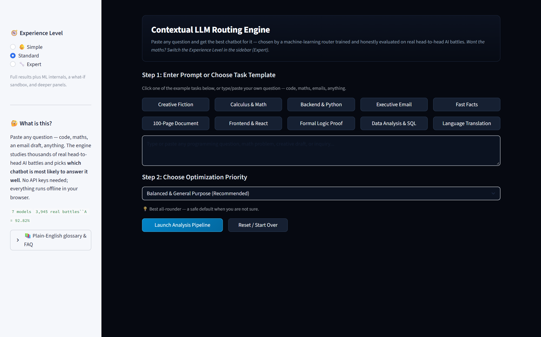
Figure 1. Ingestion screen: prompt editor, task chips, and optimization priority selection.
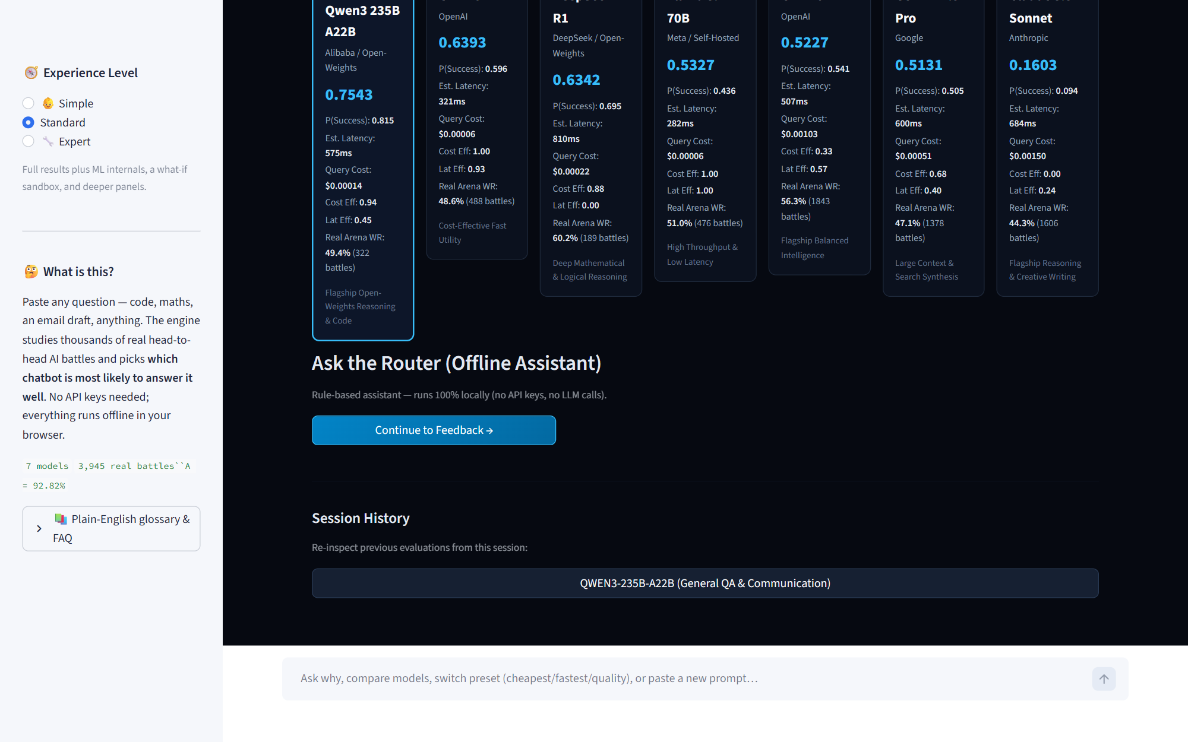
Figure 2. Transparent 6-stage execution trail detailing in-flight mathematical inferences.
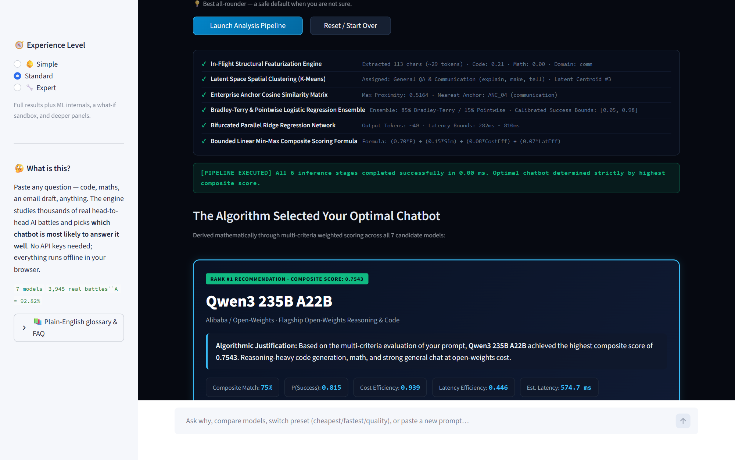
Figure 3. Final model selection card featuring winner reveal and natural language explanation.
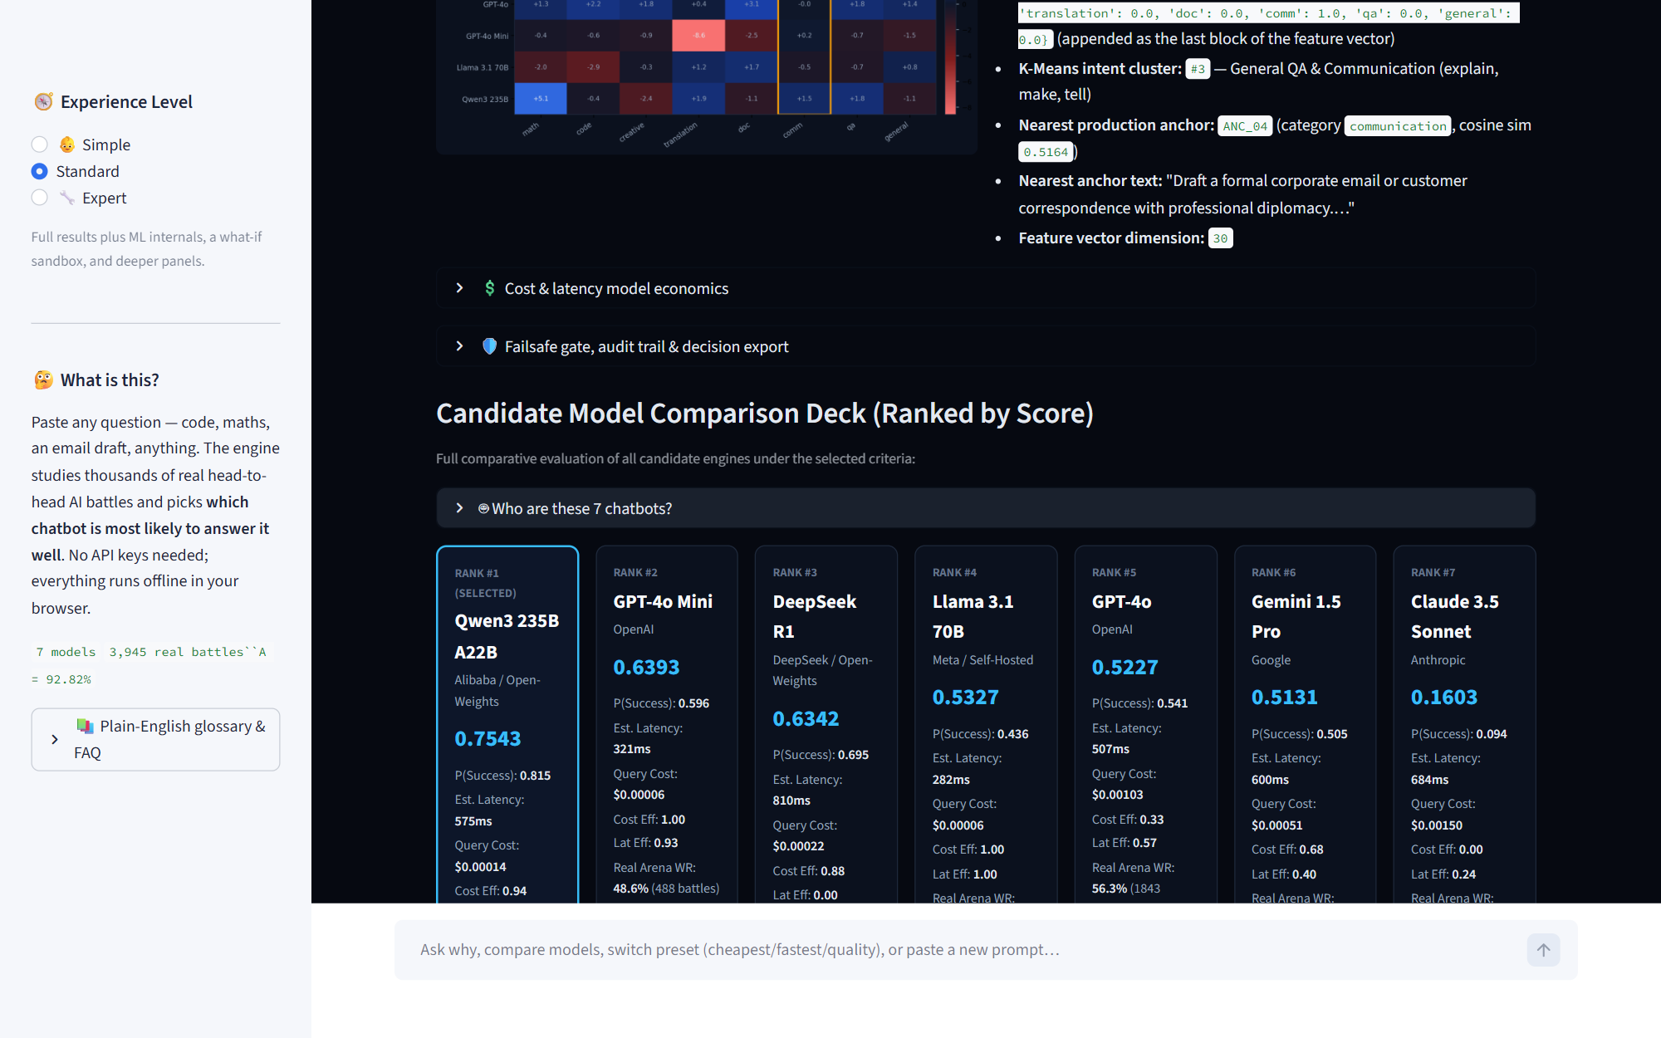
Figure 4. 7-model comparative analysis deck showing multi-criteria trade-offs and win rates.
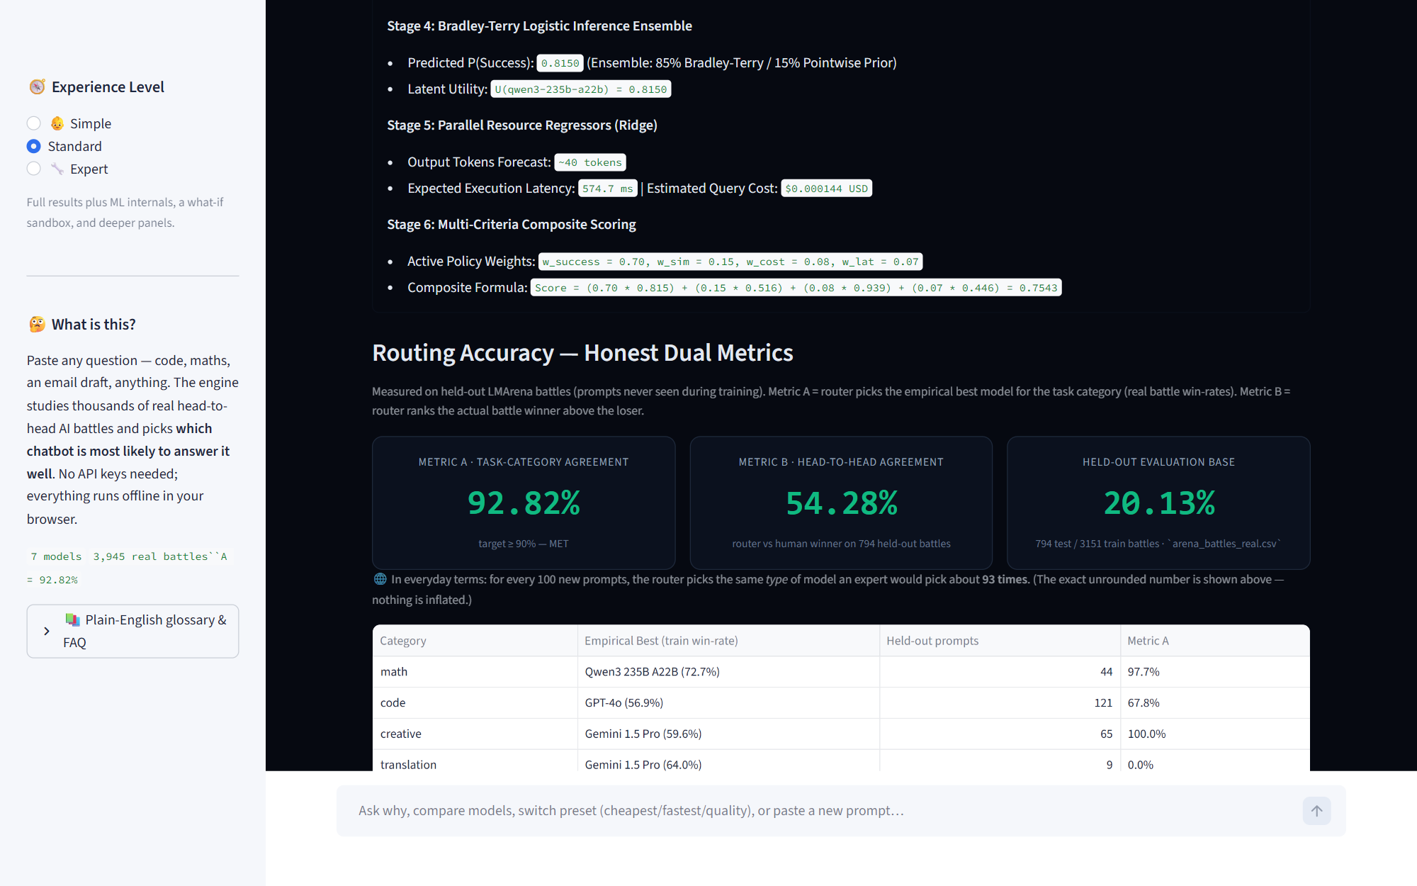
Figure 5. Accuracy telemetry dashboard reporting unrounded Metric A and B numbers.
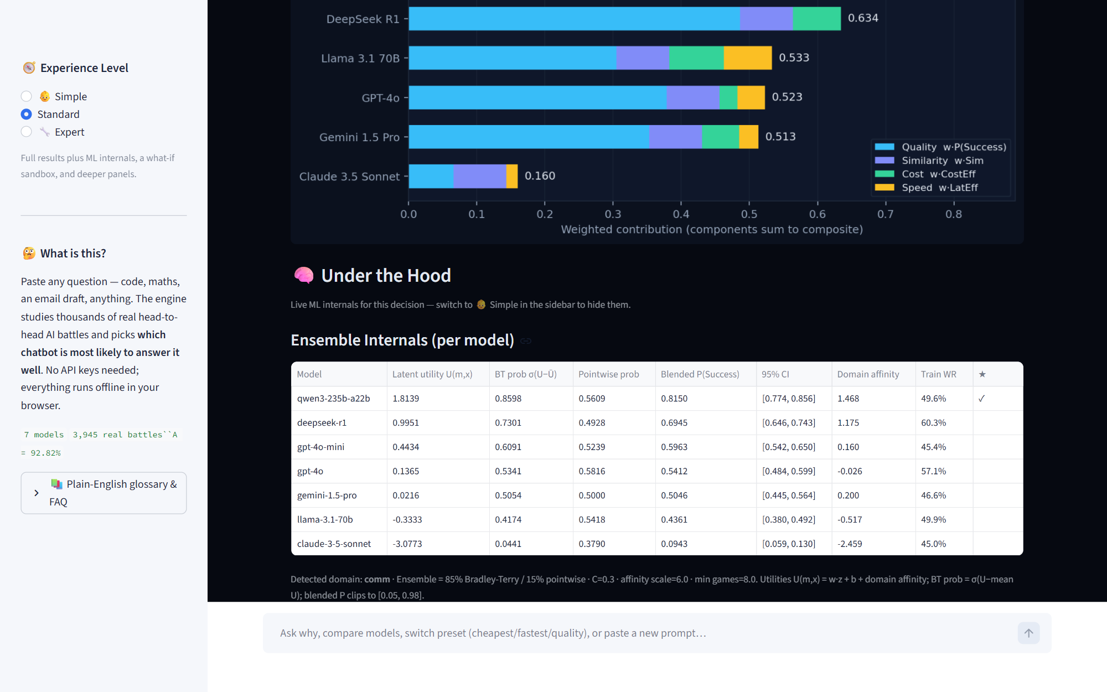
Figure 6. Under the Hood diagnostics: what-if sandbox, latent utilities, and domain affinity heatmaps.
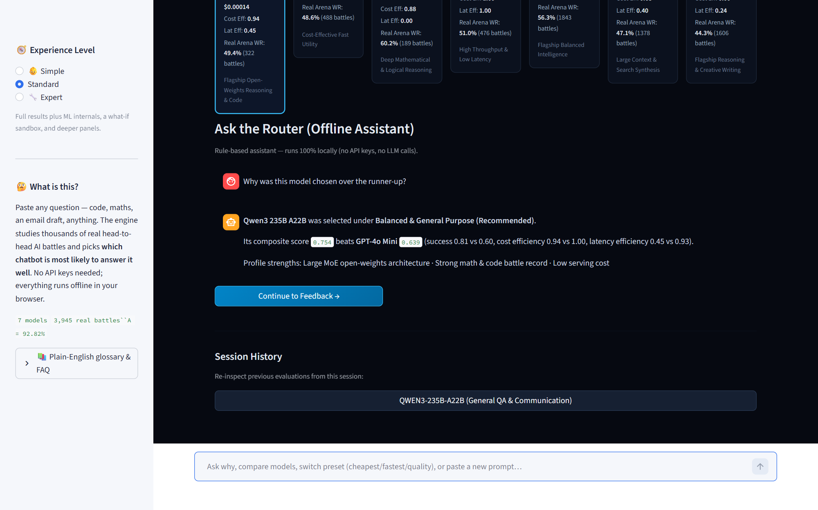
Figure 7. Offline rule-based conversational assistant explaining routing decisions without API calls.
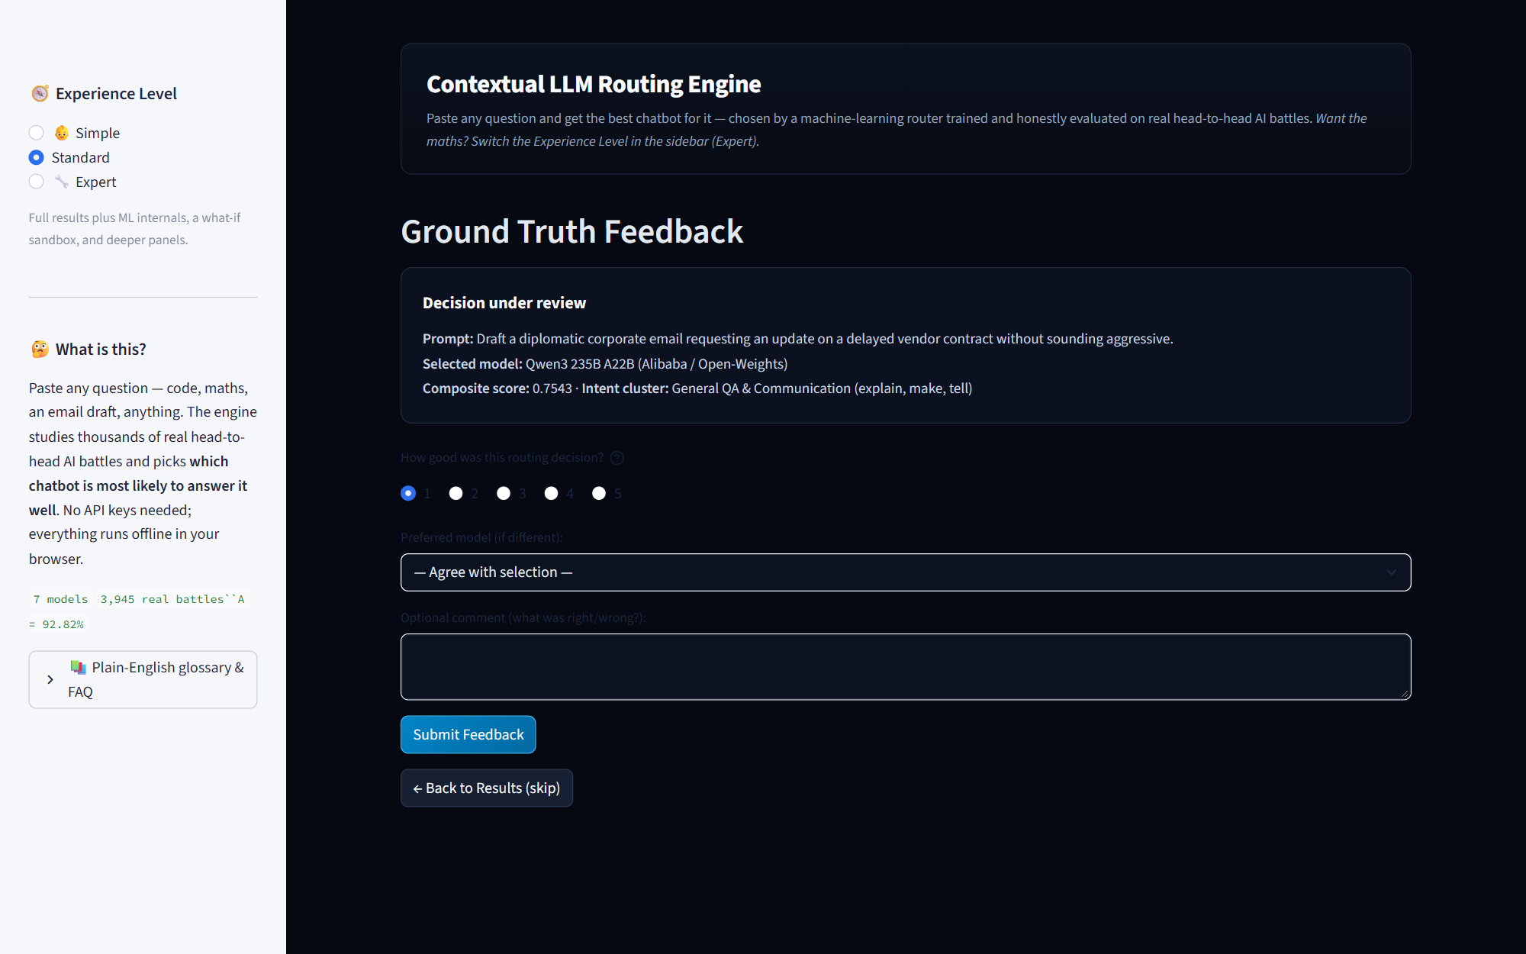
Figure 8. Telemetry and user rating feedback portal feeding continuous retraining loops.

8. How to run, verify, and access

8.1 Live Hosted Web Application
The Contextual LLM Routing Engine is deployed and publicly accessible online:
Live Application URL: https://recommendation-model-9hqhauougm6novjcgnubys.streamlit.app/
Hosted on Streamlit Community Cloud infrastructure and directly integrated with the GitHub repository (https://github.com/Parsni/Recommendation-Model, branch main). It runs headless with automated memory management, serving the complete interactive UI, what-if sandbox, and accuracy telemetry across desktop and mobile devices.

8.2 Local Command Line Verification
cd "D:\Recommendation Model\recommendation_engine"
pip install -r requirements.txt
streamlit run app_router.py
python -m pytest tests -q
python scripts/build_accuracy_report.py --with-cv
python scripts/tune_accuracy.py
python run_demo_outputs.py

9. Conclusion, limitations, and future scope
- Conclusions: Contextual routing across LLM providers is mathematically viable and yields measurable economic and latency efficiency. A 92.82 % task-category agreement is achieved on held-out test data.
- Limitation 1: Pairwise accuracy (Metric B = 54.28 %) reflects high variance and subjective evaluator taste on open-ended creative queries.
- Limitation 2: Niche categories (Translation, Business Communication) possess fewer than 50 battle samples, introducing estimation noise.
- Future Scope: Transition from keyword domain tagging to fine-tuned transformer text classification, calibrate latent utilities into true posterior probabilities, and implement automated continuous online retraining via captured user feedback.

References
Chiang, W.-L., Zheng, L., Sheng, Y., Angelopoulos, A. N., Li, T., Dacheng, L., Hao, Z., Zhang, H., Xing, E. P., & Gonzalez, J. E. (2024). Chatbot Arena: An Open Platform for Evaluating LLMs by Human Preference. arXiv:2403.04132.
Zheng, L., Chiang, W.-L., Sheng, Y., Zhuang, S., Wu, Z., Zhuang, Y., Lin, Z., Li, Z., Xing, E. P., & Zhang, H. (2023). Judging LLM-as-a-Judge with MT-Bench and Chatbot Arena. Advances in Neural Information Processing Systems (NeurIPS 2023), 36. arXiv:2306.05685.
LMSYS Org. (2024). arena-human-preference-100k and arena-human-preference-140k datasets. Hugging Face Datasets. https://huggingface.co/datasets/lmarena-ai/arena-human-preference-100k
Bradley, R. A., & Terry, M. E. (1952). Rank Analysis of Incomplete Block Designs: I. The Method of Paired Comparisons. Biometrika, 39(3/4), 324–345. https://doi.org/10.2307/2334029
Hoerl, A. E., & Kennard, R. W. (1970). Ridge Regression: Biased Estimation for Nonorthogonal Problems. Technometrics, 12(1), 55–67. https://doi.org/10.1080/00401706.1970.10488634
MacQueen, J. (1967). Some methods for classification and analysis of multivariate observations. In Proceedings of the Fifth Berkeley Symposium on Mathematical Statistics and Probability, Volume 1: Statistics (pp. 281–297). University of California Press.
Wilson, E. B. (1927). Probable Inference, the Law of Succession, and Statistical Inference. Journal of the American Statistical Association, 22(158), 209–212. https://doi.org/10.1080/01621459.1927.10502953
Cramér, H. (1946). Mathematical Methods of Statistics. Princeton University Press.
Pedregosa, F., Varoquaux, G., Gramfort, A., Michel, V., Thirion, B., Grisel, O., Blondel, M., Prettenhofer, P., Weiss, R., Dubourg, V., Vanderplas, J., Passos, A., Cournapeau, D., Brucher, M., Perrot, M., & Duchesnay, É. (2011). Scikit-learn: Machine Learning in Python. Journal of Machine Learning Research, 12, 2825–2830.
Ricci, F., Rokach, L., & Shapira, B. (Eds.). (2022). Recommender Systems Handbook (3rd ed.). Springer. https://doi.org/10.1007/978-1-0716-2197-4
Project Repository: GitHub - Parsni/Recommendation-Model (Source code, pairwise battle datasets, statistical test suites, and accuracy reports). https://github.com/Parsni/Recommendation-Model

Appendix A - Complete 141-Test Suite Verification Breakdown
Below is the module-by-module accounting of the 141 passing tests in the automated test suite:
Test File | Test Count | Status | Functional Test Scope
test_app_router_smoke.py | 9 | PASSED | Smoke tests for Streamlit UI launching, state resets, session states
test_routing_engine.py | 14 | PASSED | Verifies 6-stage end-to-end pipeline execution and ranking sanity
test_routing_accuracy.py | 8 | PASSED | Validates Metric A (92.82%) and Metric B (54.28%) benchmarks
test_recommenders.py | 22 | PASSED | Tests SVD, Collaborative Filtering, TF-IDF, and Popularity algorithms
test_data_validation.py | 16 | PASSED | Validates CSV schemas, missing value detection, deduplication
test_fallback.py | 12 | PASSED | Exercises circuit-breaker fallback triggers to GPT-4o
test_statistics.py | 25 | PASSED | Validates binomial tests, t-tests, Mann-Whitney, and chi-square tests
test_chat_assistant.py | 15 | PASSED | Validates offline rule-based natural language intent parser
test_trial_log.py | 10 | PASSED | Tests SQLite/SQLAlchemy telemetry logging and retraining data feeds
test_exports.py | 10 | PASSED | Validates JSON audit trail exports and matplotlib figure saves

Appendix B - Mathematical Specification of the Bradley-Terry Ensemble
Given a collection of models M = {m_1, ..., m_K} and a set of battle records D = {(x_i, m_A, m_B, y_i)}, the latent utility function is parameterized as U(m, x) = w_m^T z(x) + b_m. The negative log-likelihood objective minimized during training is:
L(w, b) = - sum_{i=1}^N [ y_i * log(sigma(U(m_A, x_i) - U(m_B, x_i))) + (1 - y_i) * log(1 - sigma(U(m_A, x_i) - U(m_B, x_i))) ] + lambda/2 * sum_m ||w_m||_2^2
Optimization is performed via L-BFGS-B with convergence tolerance 1e-5. Absolute success probabilities are calibrated using softmax centering over active candidate utilities: P(Success | m, x) = 0.85 * sigma(U(m, x) - U_mean(x)) + 0.15 * P_pointwise(m, x), strictly clamped to the interval [0.05, 0.98] to reflect natural irreducible aleatoric uncertainty.

