**Acute Effects of Psilocybin on Attention and Executive Functioning: A Systematic Review and Multilevel Meta-Analysis**

Yousefi, P.a , O”Higgins, F. J.b,d/ Lietz, M.P. b,c * / O”Higgins, F. J.c,  Rippe, R.C.A.e,Hasler, G.,  van Elk Ma,f,, Enriquez-Geppert, S.a,g,f  *

aCognitive Psychology Unit, Institute of Psychology, Leiden University, the Netherlands

bDepartment of Clinical and Developmental Neuropsychology, University of Groningen, Groningen, the Netherlands

c Royal College of Surgeons in Ireland, Dublin, Ireland

e Institute of Education and Child Studies, Leiden University, the Netherlands

f Amsterdam, the Netherlands

g Department of Biomedical Sciences of Cells & Systems, University Medical Center Groningen, Groningen, the Netherlands

f Psychedelic Treatment and Mechanisms Group, University Centre of Psychiatry, Groningen, the Netherlands

**Correspondence:**  
Stefanie Enriquez-Geppert  
Department of Clinical and Developmental Neuropsychology  
Faculty of Behavioural and Social Sciences  
University of Groningen  
Grote Kruisstraat 2/1  
9712 TS Groningen  
The Netherlands   
Email: [s.enriquez.geppert@rug.nl](mailto:s.enriquez.geppert@rug.nl)

**Abstract**

**Introduction:** Psilocybin, a psychedelic compound, has garnered attention for its potential therapeutic effects on neuropsychiatric disorders such as depression, anxiety, and substance use disorder. While the emotional and psychological impacts of psilocybin have been extensively studied, its effects on cognitive functions, particularly executive functions and attention, remain less understood. Executive functions, including working memory, inhibition, and cognitive flexibility, are critical for daily functioning and are often impaired in various psychopathologies. Understanding how psilocybin affects these cognitive domains is crucial for its clinical application.

**Methods:** This systematic review and multilevel meta-analysis aimed to evaluate the effects of psilocybin on cognitive functions. Comprehensive literature searches were conducted in PubMed, PsychInfo, Web of Science, and Cochrane databases for empirical studies assessing psilocybin’s impact on cognition. Studies included measured at least one cognitive domain: working memory, conflict monitoring, response inhibition, cognitive flexibility, and attention. Data from selected studies were extracted and effect sizes calculated for reaction time (RT) and accuracy (ACC). Multilevel meta-analytic techniques were employed to assess overall effects and explore potential moderators such as dosage, timing of measurement, and specific cognitive subcomponents.

**Results:** Thirteen studies met inclusion criteria, providing 42 effect sizes. Psilocybin generally increased reaction times (Hedges' g = 1.13) and decreased accuracy (Hedges' g = -0.45), indicating impairments in cognitive processing speed and precision. The effects on reaction times were dose-dependent, with higher doses associated with greater increases in RT. Timing relative to peak psilocybin effects did not significantly moderate outcomes. The analysis revealed significant between-study heterogeneity but negligible within-study variance. Moderation analyses indicated that cognitive function categories and task sensitivity did not significantly influence psilocybin's impact on accuracy or reaction time.

**The effects of psilocybin on attention and executive functioning: A systematic review and multilevel meta-analysis**

Psilocybin (and its metabolite psilocin), has gained increasing interest in recent years due to its potential therapeutic effects on various neuropsychiatric disorders, including depression (Carhart-Harris et al., 2021; Li et al., 2022; McCartney et al., 2022; Więckiewicz et al., 2021), anxiety (Griffiths et al., 2016; Ross et al., 2016) and substance use disorder (Bogenschutz et al., 2022, Johnson 2016…). While the effects of psilocybin on emotions and psychological functioning have been extensively studied (Barrett et al., 2020; Basedow et al., 2021; Irizarry et al., 2022; Nutt & Carhart-Harris, 2021), its impact on cognition remains a topic of ongoing research (Bonnieux et al., 2023; Sayalı & Barrett, 2023). Cognitive impairments, in particular in the domain of executive functioning, are commonly observed across various forms of psychopathology, making them transdiagnostic (Abramovitch et al., 2021; Snyder et al., 2015). Executive functions, which are sometimes referred to as cognitive control or executive control,  are voluntary, top-down mental processes that coordinate other, lower level cognitive abilities (e.g. attention) to enable goal-oriented actions and flexibly adjust behaviour in novel and challenging environments (Friedman and Miyake, 2017). This makes them crucial for successfully managing everyday life (Diamond, 2013). Conversely, executive dysfunctions are linked to decreased independence (Godefroy et al., 2010), hindered functional recovery (Liemburg et al., 2020), and reduce the effectiveness of both behavioural and pharmacological treatments across a range of disorders (Hybel et al., 2017; Crocker et al., 2018; Fertuck et al., 2011; Groves et al., 2018; D’Alcante et al., 2012), and are associated with higher relapse likelihood in Depression (ref).

Given the significant role of executive functions in managing other cognitive abilities and their impact on daily functioning, it is crucial to evaluate how novel therapeutic agents, such as psilocybin, influence these cognitive domains. It is particularly relevant to understand how moderating factors such as dose and time point of measurement play a role, to elucidate the potentially harmful or beneficial effects of psilocybin on cognition, thus furthering clinical applicability (Bălăeţ, 2022).

Despite initial efforts to quantify the effects of psilocybin on cognition, significant uncertainties remain regarding their overall impact, compounded by methodological challenges in this field (Hendy, 2018; Van Elk & Fried, 2023). Besides the problems with placebo groups and expectancy effects, the variability in dosages and administration protocols across studies makes it difficult to compare and generalise the findings. Additionally, the use of different cognitive assessment measures for different domains of cognition and the lack of standardised protocols further complicate the interpretation of results. Furthermore, the effects of psilocybin on cognitive functions may be influenced by individual factors such as, set and setting (Studerus et al., 2012; Viktorin et al., 2022). Given the mixed findings and methodological challenges in the existing literature, a comprehensive and critical appraisal of the effects of psilocybin on cognition is needed.

**Effects of psilocybin on Executive Functions and Attention**

Although most current studies have not focused on investigating the effect of psilocybin on cognitive processes as a primary outcome, the studies have nevertheless made assessments of the effect of psilocybin on cognitive processes, such as attention (Cavanna et al., 2022), working memory (Barrett et al., 2018), inhibition (Doss et al., 2021; Kometer et al., 2012; Marschall et al., 2021) using computerised or pen-and-paper-based cognitive tasks are commonly being employed. A prominent data-driven model using behavioural tasks (Miyake et al., 2000) dissociates the basic subcomponents: working memory updating, response inhibition, and shifting (cognitive flexibility). Notably, conflict monitoring can be further differentiated from response inhibition as a distinct and vital aspect of executive function, based on as suggested by neuroscientific findings (e.g. Enriquez-Geppert et al. (2010). These subcomponents underlie planning and problem solving abilities.

Further, lower level domains such as response speed, which is partially moderated by motor preparedness and optimal motor cortex functioning (Ebbesen& Brecht, 2017; Sanes & Donoghue, 2000), do also influence task performance, if manual responses are required. Thus, measuring only the cognitive domains of interest in isolation using these tests is difficult due to the interdependencies of higher and lower order cognitive domains (Bălăeţ, 2022).

Psilocybin drastically alters functional connectivity within networks associated with higher cognitive functions (e.g. executive control network,) and lower level cognitive function (e.g. salience network; for review see Yu et al., 2024). This makes it challenging to pinpoint the exact level at which psilocybin exerts its effect, driving the changes in task performance. For example, Mallaroni et al. (2023) used the Tower of London task to assess the effects of psilocybin on general executive functioning such as planning and problem-solving abilities. They found a slowing of reaction time and concluded that psilocybin reduces planning efficiency, however, other functions might have been driving this effect at least partially, such as attention, or motor functioning.

To further demonstrate this issue of task impurity, Luciana and colleagues (2009) found that inattention is negatively correlated with Tower of London taskL performance, which is plausible given that attention guides goal-directed behaviour. Additionally, motor functioning appears to be involved in Tower of Londontask performance, as Van Den Heuvel et al. (2003) demonstrated that ToL task load was positively associated with activation in the striatum, premotor cortex, supplementary motor area, and visuospatial system, in addition to the expected dorsolateral prefrontal cortex activation patterns.

Therefore, any interpretation of psilocybin’s effects on targeted cognitive functions must be made carefully. For example, if psilocybin affects attention, this would manifest in tests assessing cognitive functions dependent on attention. The same applies to motor function. Hence, it is crucial to carefully assess all collected tests to accurately interpret the effects of psilocybin on cognitive functions. The challenge lies in the fact that psilocybin’s impact on cognitive performance is likely influenced by multiple factors, making it difficult to isolate its effects on specific cognitive domains. Additionally, the complexity of cognitive functions, which involve interdependent higher and lower-order processes, complicates the interpretation of test results. As a result, there is a pressing need for comprehensive analyses that consider various moderators, such as specific cognitive domains affected and the specificity of measurement methods used, to gain a clearer understanding of psilocybin’s effects on cognition.

The present systematic review and meta-analysis is designed to address these questions by evaluating the effects of psilocybin on cognition, with a specific focus on executive functions as delineated by Miyake and Friedman's Additionally, we will include attention as a potential lower-order cognitive function to understand its role in psilocybin’s effects on higher order cognitive performance. We will employ state-of-the-art meta-analysis methods to systematically evaluate the effects of psilocybin on cognition.  Our study aims to determine the pooled effects of psilocybin on reaction time and accuracy across objective cognitive tasks, focusing on various subdomains of cognition. We will also investigate dose, timing of measurement, measurement sensitivity, and specific cognitive subcomponents as potential moderators of these effects. To our knowledge, this is the first meta-analysis to undertake such a comprehensive evaluation of psilocybin's impact on cognitive performance.

**Methods**

**Literature Search**

A comprehensive systematic review was conducted by searching multiple electronic databases, including PubMed, PsychInfo, Web of Science, and Cochrane) to identify empirical articles on psilocybin and executive functions using the key search terms *cognition* or *cognitive function\** or *executive function*\* or *cognitive control* or *inhibition* or *memory updating* or *conflict monitoring* or *task switching* or *set-shifting*, combined with one of the following terms: *psychedelic*\* or *hallucinogen*\* or *psiloc*\* or *psychotomimetic* or *entheog*\* or \**shrooms*\*. We searched for articles during the months of July and August 2022. The search was updated once in July 2023.

***Inclusion and exclusion criteria***

To meet the inclusion criteria, articles reporting on original studies had to satisfy the following requirements: They had to measure at least one of the following cognitive domains under the influence of psilocybin: (a) working memory (updating) (b) conflict monitoring c) response inhibition (d) cognitive flexibility (e) attention.

Exclusion criteria encompassed studies that (1) were not written in English, (2) did not involve psilocybin administration , (3) used an inappropriate study design that did not fulfil our objective(animal models, or lack of executive functions), (4) were of an incorrect publication type (background article, reviews, dissertation), (5) were inaccessible.

The software Rayyan (Ouzzani et al., 2016) was used for screening abstracts, and the detection of duplication. Three authors (PY, ML, FO) were responsible for independently screening abstracts of each study. For the exclusion of a study, the assessment of only one author was sufficient. However, for the inclusion of the study, at least two authors had to include the study.

**Data Extraction**

To systematically collect data, four authors (PY, ML, FOH, SEG) investigated the full-text articles of the selected studies from September to November 2023.. For data extraction, multiple outcome domains were targeted: cognitive function, specific cognitive measures, sample size, dependent variables for each cognitive measure, dosage, measurement time points, and either pre-calculated effect sizes or the raw data required to calculate them. T. For labelling purposes, we categorized the dosages of the included studies according to the following categories: 1-5 mg micro, 6-19 mg: low, 20-30 mg: medium, >30 mg: high (all per 70kg). In case of missing data for calculating effect sizes, the corresponding author of the respective study was contacted via email.

For the meta analytical procedures, the focus was on specific cognitive outcome measures of reaction time (RTs) and accuracy (ACC). Effect measures for these outcome measures were given as means and median differences, which were converted into standardized values and as the basis for the calculation of Cohen's d for each study. The scripts for the calculation of the effect sizes for each study and the extracted data used for these calculations can be found in the supplementary material. For the extraction of data from graphical representations in individual studies, the software WebPlotDigitizer (Rohatgi, 2022) was utilized (PY and FOH), and double checked by a second rater (ML).

**Risk of bias assessment**

Two independent authors (FOH and ML) employed the Cochrane Risk of Bias 2 (RoB) assessment tool (Higgins et al., 2023) to systematically evaluate the risk of bias in trials included in this study. They assessed each trial across five domains: randomization, deviations from intended intervention, missing data, measurement of outcome, and selection of the reported outcome, with each domain classified as having low, some concern, or high risk of bias. The assessments of both raters were combined and visualized using the Risk-of-Bias Visualization software (robvis) developed by McGuinness and Higgins (2020). Following the evaluations, an interrater reliability analysis was conducted to determine the consistency of the presence and level of bias identified. The evaluated bias domains included the categories ‘randomization process’, ‘deviations from intended interventions’, ‘missing outcome data’, the ‘measurement of the outcome’, the ‘selection of the reported result’, and the ‘overall risk of bias’. The risk of bias was assessed for each study and each domain across all trials. Studies with a high risk of bias in any single domain were noted as having some concerns regarding bias in the overall evaluation. Studies with some risk of bias in one or more domains were classified as having some concerns overall in terms of risk of bias. Risk of bias plots were created using the Excel-based Risk of Bias Tool (version 2) for randomized trials from Cochrane (ref).

To assess the potential risk of publication bias, we utilized funnel plot analysis complemented by Kendall’s rank correlation test. Additionally, we computed Rosenthal’s, Rosenberg’s, and Orwin’s fail-safe numbers to determine the number of unpublished studies required to negate the observed effect size.

**Meta Analysis**

A multilevel meta-analysis was chosen to accommodate the complex structure of our data, specifically the presence of multiple effect sizes extracted from single studies. The analysis was initiated with a multilevel random-effects model, allowing for the assessment of within-study and between-study variances. Hedges' g was selected as the effect size measure. For model comparisons, Bayesian information criterion (BIC) and Akaike information criterion (AIC) were used.

Heterogeneity among study results was quantified using the I² statistic and the Q statistic. The robustness of the findings was tested by comparing results from the multilevel model with those from a simpler non-nested random-effects model. Further analysis involved exploring potential moderators such as dosage, cognitive functional categories, and timing relative to peak psilocybin. Furthermore, we categorized each effect size based on its sensitivity to executive functioning or attention : 1 = pure (e.g., Reaction time of a incongruent condition subtracted from congruent condition to reflect a rather pure conflict monitoring time), 2=specific executive function condition (e.g., incongruent), and 3 = executive and other cognitive functions (e.g., main effect of drug averaged across incongruent and congruent conditions). This variation may impact the validity of the results, as it complicates the determination of which aspects of executive functioning are actually being measured.

Statistical procedures were conducted using R (v4.3.2; R Core Team, 2020), RStudio (Rstudio Team, 2020), the main multilevel analysis with the metafor package (Viechtbauer, 2010). For further details on other used packages referrer to the supplementary code.

Following the approach suggested by Viechtbauer and Cheung (2010), a study was considered an outlier if its confidence interval did not overlap with the confidence interval of the pooled effect (Viechtbauer and Cheung (2010). To identify influential cases, we employed three diagnostic measures: Cook's distance, hat values (leverage), and DFBETAS. Cook's distance assesses the influence of each study on the overall meta-analysis results, with values greater than 4/(n-2) considered potential outliers, where n is the number of studies. Hat values measure the influence of each study on the fitted values, and studies with hat values exceeding twice the mean hat value were deemed potential outliers. DFBETAS evaluates the influence of each study on the estimated coefficients, and studies with absolute DFBETAS values larger than 2/sqrt(n) were considered potential outliers.

**Results**

**Study Selection**

The search yielded a total of 2543 articles, which were screened by title (Figure 1 ). Articles that did not meet the inclusion criteria were excluded at this stage. The remaining articles were uploaded into Rayaan (Ouzzani et al., 2016), duplicates were removed, and the abstracts (and full-text where applicable) were screened. The screening process was conducted by four independent authors. Eventually, a total of 13 studies were suited for the present systematic review (Table 1). One study (ID = 4) initially included in the literature review was post-hoc excluded from the subsequent meta-analysis, as this study was the only study where the measurement time point was days after substance administration, unlike the other studies with measurement time points ranged from 60 to 360 minutes.

**Figure 1: PRISMA Flow Diagram illustrating the study selection process.**

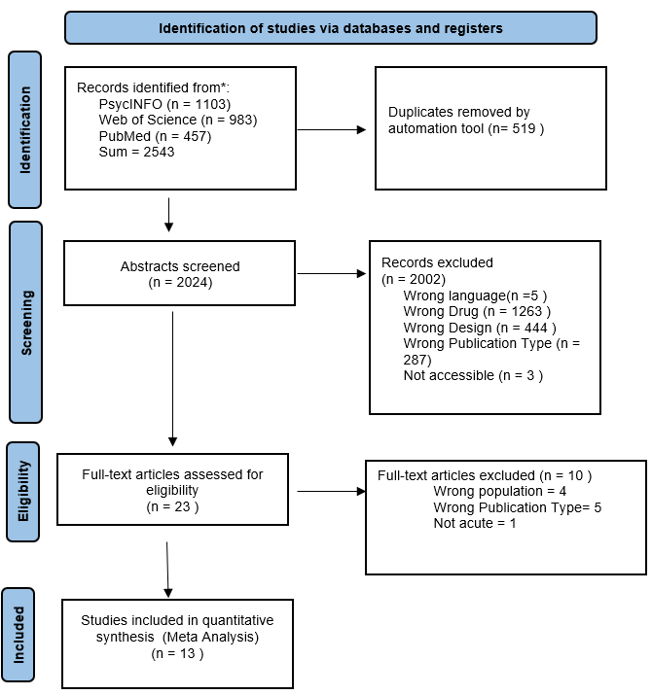

**Risk of Bias Assessment Results**

An overview of the risk of bias assessment is displayed in figures 2 and figure 3. The interrater reliability analysis yielded evidence of good agreement between raters as to the presence of bias in the studies (i.e. both raters marked some or high concern) Kappa = 0.629, z = 1.165, p = 0.247. However, poor interrater reliability was illustrated for the level of bias (i.e. both raters put some concerns as opposed to high concerns) Kappa = 0.170, z = 0.687, p= 0.492. Figure 2 contains the consensus combination chart illustrating level of bias between domains for each study.

|  |  |  |  |  |  |
| --- | --- | --- | --- | --- | --- |
| **Table 1** |  |  |  |  |  |
| *Included studies and study IDs* | |  |  |  |  |
| Study | Study ID | Nr of tasks | number of extracted effect sizes | | |
| Total | ACC | RT |
| Barrett et al (2018) | 1 | 3 | 15 | 9 | 6 |
| Carter et al (2015) | 2 | 2 | 2 | 2 | 0 |
| Cavanna et al (2022) | 3 | 4 | 6 | 3 | 3 |
| Doss et al (2021) | 4 | 0 | 0 | 0 | 0 |
| Gouzoulis-Mayfrank et al. (2002) | 5 | 1 | 1 | 0 | 1 |
| Hasler et al (2004) | 6 | 1 | 4 | 4 | 0 |
| Kometer et al (2012) | 7 | 1 | 1 | 1 | 0 |
| Quednow et al (2011) | 8 | 1 | 2 | 1 | 1 |
| Vollenweider et al (2007) | 9 | 1 | 1 | 1 | 0 |
| Wittmann et al (2006) | 10 | 1 | 4 | 4 | 0 |
| Marschall et al (2022) | 11 | 1 | 1 | 1 | 0 |
| Mallaroni et al (2023) | 12 | 4 | 4 | 1 | 3 |
| Vollenweider et al. (1998) | 13 | 1 | 1 | 0 | 1 |
| Total |  |  | 42 | 27 | 15 |

**Figure 2: Risk of Bias Assessment for individual studies**

*Note*. Heat map showing risk of bias assessments for 13 studies across five domains (D1-D5) and overall bias. Green (+) indicates low risk, yellow (-) indicates some concerns, and red (X) indicates high risk of bias. Domains assessed include randomization process (D1), intervention (D2), missing outcome data (D3), outcome measurement (D4), and selection of reported results (D5). The study ID is indicated after the study citation in the first column.

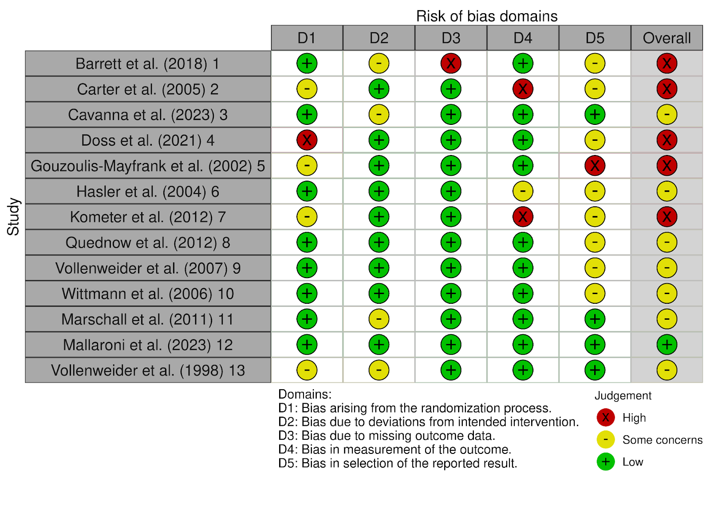

**Figure 3: Overall Risk of Bias across Studies**

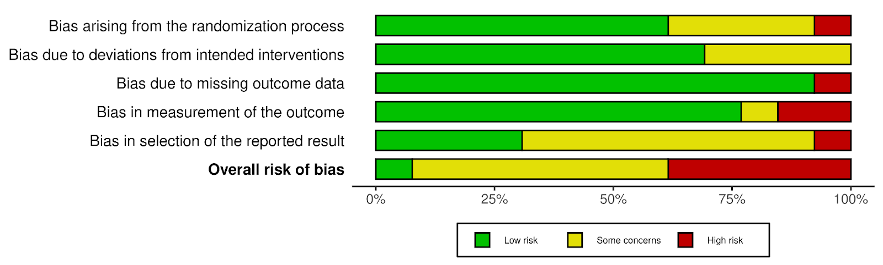

*Note:* Summary of overall risk of bias assessments for included studies. The chart displays the proportion of studies classified as having low risk, some concerns, or high risk of bias.

**Literature Review**

The following section describes the effects of psilocybin on executive functions and attention and is organized according to : the four components of executive functions: working memory (updating), conflict monitoring, inhibition, cognitive flexibility, and attention. The included studies used a variety of tasks to assess these different aspects of executive functions and attention. An overview of these tasks and their outcome measures is presented in Table 2.

|  |  |  |  |  |  |
| --- | --- | --- | --- | --- | --- |
| **Table 2** | | | | | |
| *Overview of cognitive measures used in the included studies* | | | | | |
| Domain | | Task | Study IDs | Description | Variables |
| **Specific Executive Function** | **Working memory (updating)** | N-back | (1) | The N-Back task is measure of working memory (updating). Participants view a sequence of letters and must indicate whether the current letter matches the one presented "n" steps back. | (1): Discriminately rate (hit rate [HR] - false alarm rate [FAR]),Response bias (FAR/[1-accuracy]), RT |
|  |
| Spatial Memory Task (SMT) | (12) | The Spatial Memory Test (SMT) is used mainly in psychopharmacological drug research to assess visuospatial memory and reasoning. It has two phases: immediate and delayed recall. In the immediate recall, participants view six sets of ten black-and-white images on a computer screen, each for 2 seconds with a 1-second gap in between. Subsequently, they must identify the original location of each image as it reappears on the screen. After a 30-minute interval, the delayed recall phase requires participants to recall the locations of the pictures. | (12): Mean ACC, Mean RT |  |
| Delayed Response Task (DRT) |  | The delayed-response task is a cognitive test that evaluates working memory, focusing particularly on spatial working memory. In this task, participants view a stimulus briefly displayed in a specific location on a touch screen. After the stimulus disappears, a numerical distraction task fills a ten-second delay period to prevent the rehearsal of the stimulus location. Subsequently, participants must accurately recall and indicate where the stimulus was located by touching the corresponding area on the screen. This task measures the ability to retain and manipulate visuospatial information over short periods without external cues and is commonly used to explore the functions of the dorsolateral prefrontal cortex, a key area for memory and executive functions. | (13): RT |  |
| Spatial Span Test | (10) (2) | The spatial range test is a measure of visual-spatial working memory performance. Nine white squares are randomly displayed on a black background on a touch screen. On each trial, some of the squares are highlighted at a specific interstimulus interval. Participants indicate the order of the highlighted squares. The trial starts with two squares and increases up to nine. The test ends after three wrong answers or reaching a maximum of 9 squares (Max. score). The number of squares correctly reproduced is the span-length. | (2): Span-length,# of errors (10): Span-length |  |
| **Conflict**  **monitoring** | Stroop task | (4) (3) (8) | The Stroop task is a measure of conflict monitoring. Typically a colour word is presented in aa specific colour.  Participants have to indicate the ink colour of the colour words, which can either be congruent (e.g., the word "red" in red ink) or incongruent (e.g., the word "red" in blue ink). The incongruent condition usually results in longer reaction times and more errors, illustrating the cognitive conflict between word reading and colour naming ("Stroop effect"). | (3): RT, ACC (4): Hit Rate, median RT, Signal detection (discrimination d') (8): RT, # errors, Interference, facilitation, Stroop effect |  |
| emotional Stroop task | (1) | The emotional Stroop task is a measure of emotional conflict monitoring. Participants are presented with words that are emotionally salient and neutral words. Participants indicate the colour in which the words are presented. | (1) RT, ACC |  |
| **Response Inhibition** | Go/NoGo | (3) | The Go/NoGo task is a measure of response inhibition. Participants are required to respond (Go) or withhold their response to a specific stimuli (NoGo) , allowing for the measurement of the ability to inhibit prepotent responses. | (3): ACC |  |
| emotional Go/NoGo | (7) (11) | The emotional Go/NoGo task is a measure of emotional inhibition. Participants see affective stimuli (e.g., positive, negative, or neutral words) and respond only to a specific emotional category (e.g., positive) while withholding a response to another (e.g., negative or neutral). | (7): RT, ACC, Sequential effects (11): RT, ACC |  |
| **Cognitive Flexibility** | Digit-Symbol Substitution Task (DSST) | (1) (12) | The Digit-Symbol Substitution Task (DSST) evaluates cognitive flexibility through rapid task-switching and adaptive strategy use. Participants must flexibly apply symbol-digit pairings, quickly shifting between different associations as they fill in a series of boxes. This constant adaptation of mental sets demonstrates cognitive flexibility in real-time problem-solving. | (1): Total # of attempted trials, Accuracy (% correct) (12): Total #Reponses,Total #Correct, Mean RT |  |
| Penn Conditional Exclusion Test (PCET) | (4) | The Penn Conditional Exclusion Test (PCET) directly assesses cognitive flexibility, mirroring the Wisconsin Card Sorting Test. By requiring participants to identify common characteristics among item sets, it measures their ability to flexibly shift mental strategies and adapt to changing rules - key components of cognitive flexibility. | (4): Preservation errors, Median RT, Correct, incorrect, total responses |  |
| Trail Making Test | (3) | The Trail Making Test, particularly Part B, is a prime measure of cognitive flexibility. While Part A involves simple sequencing, Part B demands flexible alternation between numbers and letters. This task switching directly taps into cognitive flexibility, requiring participants to mentally shift between two sequences, adapting their approach throughout the test. | (3): Time to finish the task, Number of errors |  |
| Tower of London (TOL) | (12) | The Tower of London (TOL) task evaluates cognitive flexibility within the context of planning and problem-solving. Participants must flexibly generate and modify strategies to rearrange beads with minimal moves. This constant adaptation of plans and approaches as the task progresses demonstrates cognitive flexibility in complex problem-solving scenarios, even in individuals with severe cognitive impairments. | (12): Total correct trials, RT |  |
| **Attention** | | Frankfurt Attention Inventory (FAIR) | (6) (9) | Frankfurt Attention Inventory (FAIR) is a paper-pencil measure of sustained and directed attention. Participants identify target stimuli within distractor items within a limited time by spiking at each target and drawing a continuous line below the distractors. The test yields three main scores: Performance score (P): Measures overall effectiveness in completing the task. Quality score (Q): Reflects accuracy, calculated as the ratio of correct decisions to total decisions made. Continuity score (C): Assesses the consistency of attention throughout the task duration. | (6)(9): Performance score (P) / Marker Value, Quality score (Q), Continuity score (C) |  |
| Attentional blink task | (3) | The attentional blink (AB) task is a measure for allocating attention over time. Participants view a rapid stream of letters with two digit targets (T1 and T2) inserted. The aim is to identify both digits, and performance is evaluated based on correct detection rates. When T2 appears with a short stimulus onset interval, T2 is often not detected. The task incorporates varying time lags between the targets to assess the duration of the attentional "blink". | (3): Visibility rate of targets (T1,T2) |  |
| Covert orienting of attention task (COVAT) | (5) | The Covert orienting of attention task (COVAT) assesses attentional control by requiring participants to quickly respond to visual stimuli appearing in different locations on a screen. Cues indicate where the stimulus may appear, but they may be misleading. | (5): RT, Validity effect (difference between invalid and valid reaction times) |  |
| Multiple Objects Tracking (MOT) | (2) | Multiple Objects Tracking (MOT) is a measure of divided visual attention to moving visual stimuli. During the task, participants keep their gaze on a fixation cross and look at a small set of identical stimuli of targets and distractors that start moving randomly on a display. Participants observe these moving objects among distractors and identifying them post-movement selecting the objects they believe were the original targets. | (2): The mean % of correct responses, Mean # of successfully tracked targets, Discriminability index |  |

***Acute psilocybin effects on Working Memory (Updating)***

Barrett et al. (2017) found that psilocybin selectively affects working memory in a dose-dependent manner. Using the Letter-N-Back task 180 minutes post-psilocybin administration, they observed significantly lowered discriminability, increased response bias, and prolonged response time during the 2-back condition compared to placebo. These effects on reaction time were more pronounced at higher doses (20-30 mg/70kg; d(20mg)=1.36, large effect; d(30mg)=1.89, large effect) compared to lower doses (10 mg/70kg; d(10mg) = 1.25, large effect).

In contrast, Carter et al. (2005) used the Spatial Span Test and reported that psilocybin did not significantly affect spatial working memory span or errors at a dose of 15mg, even though the psilocybin group did make more mistakes in their sample (d= -0.62, medium effect). This suggests a potential dissociation between the effects of psilocybin on different aspects of working memory functions (updating vs span) or tasks.

Wittmann et al. (2006) found that psilocybin reduced spatial span length at 100 minutes post-psilocybin administration of a low dose (17.5mg/kg; d = -0.31, small effect) but not at a lower dose (8.05mg/70kg; d(100 mins)=-0.04, negligible effect; d(360 mins)=-0.12, negligible effect) or at a later time point of 360 minutes post-psilocybin administration (d = 0.02, negligible effect).

Mallaroni et al. (2023) compared the acute effects of psilocybin and 2C-B on different cognitive functions. Both substances impaired global cognitive function, including working memory, as measured by the reduction in correct responses (d = -1.34, large effect) in the psilocybin group during the Spatial Memory Task at 225 minutes post-psilocybin administration.

Vollenweider et al. (1998) investigated the role of serotonin receptors in psilocybin-induced working memory effects. They found that psilocybin prolonged reaction times on a delayed response task at 80 minutes post-psilocybin administration (d = 1.75, large effect). These acute increases were prevented by pretreatment with serotonin-2 antagonists but not dopamine antagonists, suggesting that the effects are primarily mediated by serotonin-2A receptor activation.

***Acute psilocybin effects on conflict monitoring***

Several studies have investigated the effects of psilocybin on conflict monitoring using various cognitive tasks. Barrett et al. (2017) found that psilocybin induced dose-dependent effects in conflict monitoring as assessed by the emotional Stroop task. reaction times increased significantly with increasing doses of psilocybin across the incongruent and congruent conditions (10, 20, and 30 mg/70kg; d=1.44, 2.1, 2.5; all large effect sizes) compared to placebo at 240 minutes post-psilocybin administration. However, the study did not find a significant effect on accuracy.

Cavanna et al. (2022) investigated the effects of psilocybin microdosing (0.795 mg/70kg) using the Stroop . At 180 minutes post-psilocybin administration, participants exhibited longer reaction times (d = 0.51; medium effect) and lower accuracy ( incongruent - congruent condition; d = -0.11; small effect) in the Stroop task under psilocybin compared to an inactive placebo (edible mushroom). These findings suggest that even at microdoses, psilocybin may slightly slow down conflict monitoring.

Quednow et al. (2011) examined the effects of a low dose of psilocybin (18.5 mg/70kg) using the Stroop task. At 85 minutes post-psilocybin administration, psilocybin increased reaction times (d= 1.03; large effect) and decreased accuracy (d = -0.85; large effect ). The authors attributed these effects to the stimulation of serotonin-2A receptors by psilocybin, as pretreatment with the 5-HT2A/2C receptor antagonist ketanserin attenuated these effects.

Doss et al. (2021) explored the long-term effects of psilocybin treatment on conflict monitoring in patients diagnosed with Major Depressive Disorder (MDD). This open-label clinical trial involved 24 participants, administering either a medium dose of 20 mg/70 kg or a high dose of 30 mg/70 kg of psilocybin. Assessments were made at multiple time points: eight weeks before, at baseline, and one and four weeks after the treatment. Psilocybin showed no significant effect on reaction time or accuracy in the Stroop task.

To summarize, the four studies reviewed consistently demonstrate that psilocybin affects conflict monitoring in a dose-dependent manner. Higher doses of psilocybin lead to more pronounced increases in reaction times and decreases in accuracy on tasks involving conflict resolution. These effects are evident even at microdoses.

***Acute psilocybin effects on response inhibition***

Cavanna et al. (2022) investigated the effects of psilocybin microdosing (0.795 mg/70kg) on inhibition using the Go/No-Go task. At 150 minutes, the study found no significant differences in response accuracy between the psilocybin and placebo conditions. However, there was a slight decrease in accuracy in their sample (NoGo-Go condition; d =-0.01; very small effect).

Kometer et al. (2012) examined the effects of a low dose of psilocybin (15.05 mg/70kg) on inhibiting emotional stimuli using the emotional Go/No-Go task. At 120 minutes post-psilocybin administration, psilocybin decreased accuracy (d = -2.16; large effect) and increased reaction times (d = 1.56; large effect) compared to placebo. The increase in reaction time was modulated by the valence of the words used in the task. Specifically, the psilocybin group exhibited longer reaction times for negative words compared to positive suggesting an increased effect on negative cognitive control processing under the influence of psilocybin.

Marschall et al. (2022) also investigated the effects of psilocybin microdosing (1.5 mg/70kg) on inhibition using the emotional Go/No-Go task. At 90 minutes post-psilocybin administration, the study found no significant effect on reaction times or accuracy (d = -0.03; small effect) in the No-Go trials between the psilocybin and placebo (edible mushroom) conditions.

To summarize, the studies indicate that while low doses of psilocybin significantly impair accuracy and increase reaction times, particularly for emotional stimuli, microdoses generally show negligible effects on these measures.

***Acute psilocybin effects on attention***

Several studies have investigated the effects of psilocybin on various aspects of attention. Carter et al. (2005) found that psilocybin (15.05 mg/70kg) significantly reduced the accuracy of attentional tracking at 120 minutes post-psilocybin administration (effect size = -1.305). This might indicate a reduction in the ability to accurately track multiple objects.

Cavanna et al. (2022) investigated the effects of psilocybin microdosing (0.795 mg/70kg) on attention using the attentional blink task at 180 minutes post-psilocybin administration. Our analysis on the raw data revealed that reaction time was reduced (d= -0.04; very small effect) and accuracy (ACC) was increased (d = 0.3; small effect), suggesting that psilocybin microdosing enhances accuracy and slightly reduces reaction time in attentional tasks (see supplementary material for detailed methodology).

Gouzoulis-Mayfrank et al. (2002) found that psilocybin (14 mg/70kg) significantly prolonged reaction times in the Covert Orienting of Attention Task (COVAT) compared to placebo at 85 minutes post-psilocybin administration (d = 0.47; small effect). In particular, subjects had difficulty disengaging attention from the cued location and reorienting it to the target in the opposite visual field, especially for targets in the right visual field. The authors suggested a potential lateralized psilocybin effect in the visuospatial attentional network, particularly affecting the right hemisphere.

In the study by Hasler et al. (2004), psilocybin affected QV scores in a dose-dependent manner. The Quality Value (QV) scores in the Frankfurt Attention Inventory (FAIR) reflect the accuracy of attentively made decisions. A microdose (3.15 mg/70kg) and low dose (8.05 mg/70kg) of psilocybin slightly increased QV scores (d=0.4 and d= 0.62, respectively). However, the medium dose (15.05 mg/70kg) and high dose (22.05 mg/70kg) decreased QV scores (with d= -0.25; small effect; and -0.58; medium effect , respectively), indicating a reduction in accuracy at higher doses.

Vollenweider et al. (2007) also found that psilocybin dose-dependently effects on sustained attention as measured by the FAIR at 105 minutes post-psilocybin administration. The Performance Value scores were significantly reduced by low (8.05 mg/70kg d = -1.03 and 15.05 mg/70kg d = -1.27; large effect), and medium (22.05 mg/70kg; d = -1.17; large effect) doses of psilocybin. The Quality Value score, reflecting accuracy, was also significantly reduced by the medium dose (d = -0.95; large effect).

Mallaroni et al. (2023) reported that psilocybin (15 mg/70kg) selectively increased reaction times on the psychomotor vigilance task compared to placebo at 166 minutes post-psilocybin administration (effect size = 0.81; large effect), although it did not significantly impair overall performance or accuracy on this task of sustained attention.

In conclusion, while some studies suggest that psilocybin impairs attentional processes, such as attentional tracking (Carter et al., 2005), reorienting attention (Gouzoulis-Mayfrank et al., 2002), and sustained attention (Hasler et al., 2004; Vollenweider et al., 2007), one indicated a potential enhancement in specific aspects of attention, particularly at microdoses (Cavanna et al., 2022). The effects of psilocybin on attention appear to be more pronounced at higher doses, with medium and high doses leading to significant reductions in accuracy and performance on attentional tasks.

***Acute psilocybin effects on cognitive flexibility***

Three studies have investigated the effects of psilocybin on cognitive flexibility using the Digit Symbol Substitution Task (DSST), the Tower of London (TOL), and the Trail Making Test (TMT).

Barrett et al. (2017) found that psilocybin caused a dose-dependent decrease in the number of trials which were attempted by the participants in the DSST, indicating a reduction in processing speed. This effect was observed at 120, 240, and 360 minutes post-psilocybin administration for low (10 mg/70kg, d =-0.67; medium effect ), medium (20 mg/70kg, d=-1.47; large effect), and high (30 mg/70kg, d=-2.32; large effect) doses. Interestingly, while the number of attempted trials was reduced, the accuracy of responses (i.e., the proportion of correct trials out of all attempted trials) was slightly increased (low dose: d=0.17; small effect, medium dose: d=0.08; small effect, high dose: d=0.3; medium effect). This suggests that although psilocybin slows psychomotor speed, it may allow for compensatory strategies to maintain or even improve accuracy, indicating a complex interaction between dosage and cognitive processes.

Mallaroni et al. (2023) showed that psilocybin (15 mg/70kg) led to lower performance on the digit symbol substitution task compared to placebo (edible mushroom). At 172 minutes post-administration, psilocybin increased reaction times (d=1.75; large effect) without significantly affecting accuracy. These findings align with those of Barrett et al. (2017), indicating that psilocybin selectively impairs processing speed while preserving accuracy on the DSST. In addition to the DSST, Mallaroni et al. (2023) used the tower of London task to assess the effects of psilocybin on planning and problem-solving abilities. At 153 minutes post-psilocybin administration, psilocybin (15 mg/70kg) increased reaction times (d=1.8) compared to placebo, suggesting a reduction in planning efficiency. However, the accuracy of task performance was not significantly affected. These results indicate that psilocybin slows down cognitive processes involved in planning and problem-solving without compromising the ability to execute planned actions correctly.

Cavanna et al. (2022) investigated the effects of psilocybin microdosing (0.795 mg/70kg) using the Trail Making Test (TMT). For Part B of the TMT, which involves alternating between numbers and letters in sequence, participants took significantly longer to complete the task under the psilocybin condition compared to the placebo (d=0.76; medium effect ) at 60 minutes post-administration. This result suggests that even at microdoses, psilocybin can impair cognitive flexibility and task-switching abilities.

In conclusion, the three reviewed studies consistently demonstrate that psilocybin affects cognitive flexibility, particularly in processing speed and planning efficiency. These effects seem dose-dependent, with higher doses leading to more pronounced effects. Interestingly, while psilocybin slows down cognitive processing, it does not significantly compromise the accuracy of task performance in the DSST and TOL tasks.

**Meta Analytic Results: Reaction Time**

The effects of psilocybin on reaction time across different doses and studies are summarized in a forest plot (Figure 4). There were no outliers identified for the reaction time dataset based on the criterion of non-overlapping confidence intervals of a single study with the pooled effect. One influential case (effect size id= 35), was found to have substantial leverage. Another case (effect size id = 7) was found to be an outlier because of very high standardized residuals (>2). Removing these effect sizes and re-running the analysis yielded a slightly reduced but still significant overall hedge’s g of 1.20 (SE = 0.29, t = 4.16, df = 12, p = 0.0013, 95% CI [0.57, 1.83], and significant heterogeneity ( I2 Total = 39%, p=0.001), suggesting the robustness of the measured effect (see supplementary material for more details). These two cases were not excluded, as the heterogeneity without outliers was slightly higher than the heterogeneity in the model with outliers.

The dataset of reaction times included 15 effect sizes (see Table 1) from six unique studies. A multilevel random effects meta-analysis with three levels, accounting for the nesting of multiple effect sizes within the same study, revealed an overall increase in reaction time under the influence of psilocybin (Hedges’ g = 1.13, SE = 0.26, t = 4.33, p = 0.0007, 95% CI [0.57, 1.7]).

The estimated variance components (the random-effects variances calculated for each level of our model) showed a between-study heterogeneity variance of σ2Level3 =0.27 and a within-study variance of σ2Level2 = 0.015. Hereby σ2 represents the variance of the true effect sizes underlying the data. The total heterogeneity was moderate and significant ( I2 Total = 36.77%, p=0.0024). The precise amount of heterogeneity variance captured by each level was at follows: I2 Level3= 34.88% of the total heterogeneity can be attributed to between-study differences, and I2 Level2= 1.89% to within-studies differences. Overall, this indicates that there is between-study heterogeneity. Only a small fraction of the total variance can be explained by differences within studies.

**Figure 4: Forrest Plot Reaction Time**

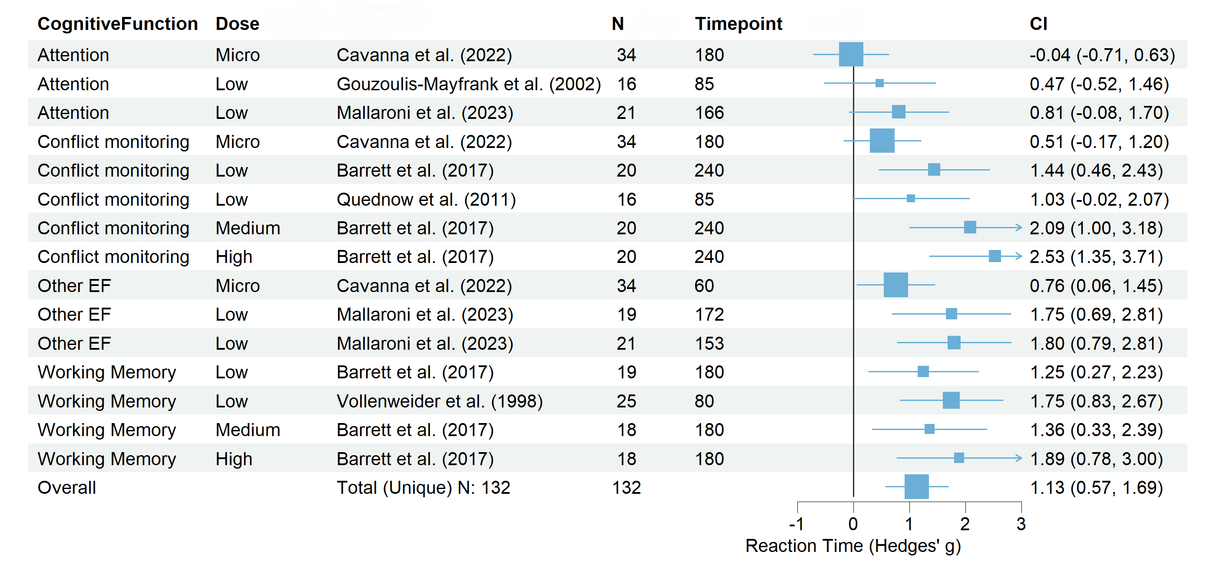

*Note.* Forest plot of effect sizes (Hedges' g) for psilocybin's impact on reaction time. Results are sorted by cognitive domain, showing individual study effects and the overall pooled effect. Positive values indicate increased reaction time with psilocybin compared to placebo. The size of the squares indicates the relative weight of each study, with larger squares representing larger sample sizes.

The comparison of the full model with the reduced model using the likelihood ratio test revealed that the additional parameters in the full model improved model performance significantly ( 𝝌12 = 4.93, p = 0.0263). The Akaike Information Criterion (AIC) and Bayesian Information Criterion (BIC) were slightly lower for the full model, indicating that the nested model with more parameters provides a significantly better fit to the data than the reduced model. The Q statistic for heterogeneity was the same for both models, suggesting that the difference in model fit is not due to a change in how the models account for heterogeneity.

***Timing as moderator of reaction times***

The peak window boundaries were defined to explore the main effect in the moderation analysis. This decision was based on the work of Holze et al. (2024), which documented that the time to maximal subjective effect of psilocybin, across different dosages (15, 25, and 30 mg), typically centered around two hours post-administration, with a reported range slightly extending from 1.7 to 2.4 hours. To accommodate this range and ensure coverage of the peak subjective effects, we decided to conduct the moderation analysis using a 90-180 minutes interval.

We categorized studies as either falling within the defined peak boundary of 90-180 minutes (reference category) or outside this interval. Among the studies analyzed, eight effect sizes fell within the peak window, while seven were outside. The moderation analysis indicated that the use of this peak window as a moderator did not yield a statistically significant effect (QM(df = 1) = 2.19, p = 0.1387). This suggests that the timing of peak psilocybin effects, as defined by our interval, does not significantly influence the outcomes measured across different studies.

***Dosage as moderator of reaction time***

Dosage was categorized into four levels: micro (the reference category), low, medium, and high. The analysis identified significant moderation by dosage (QM(df = 3) = 20.78, p = 0.0001), indicating that reaction times varied significantly across different dosage levels. The intercept, representing the micro dosage level, approached significance, suggesting a potential increase in reaction times at this minimal dosage level (estimate = 0.4, SE = 0.21, z = 1.88, p = 0.0589, 95% CI = -0.02 to 0.82). The effect sizes increased with each escalating dosage level: the low dosage already showed a significant increase in reaction times (estimate = 0.87, SE = 0.28, z = 3.12, p = 0.0018, 95% CI = 0.32 to 1.42); the medium dosage continued this trend (estimate = 1.3, SE = 0.44, z = 2.92, p = 0.0035, 95% CI = 0.43 to 2.17); and the high dosage exhibited the largest increase (estimate = 1.79, SE = 0.47, z = 3.8, p = 0.0001, 95% CI = 0.87 to 2.72). These findings suggest a dose-response relationship where higher doses are associated with greater increases in reaction times. The Test for Residual Heterogeneity indicated no significant residual heterogeneity (QE(df = 11) = 11.02, p = 0.4412), confirming that the variability among study outcomes is adequately captured by the dosage categories, affirming that the model appropriately accounts for differences across studies.

***Cognitive function and task sensitivity as moderators of reaction time***

The moderation analysis of cognitive function categories (Attention, Working Memory, Conflict Monitoring, Cognitive Flexibility; inhibition was missing in this subset) in the reaction times dataset , the overall test for cognitive function as a moderator was not significant (QM(df = 3) = 5.7613, p = 0.1238), suggesting that variations in cognitive functions did not strongly influence the observed slowing of RT.

As described in our methods, we categorized each effect size based on its sensitivity to executive functioning or attention: Type 1 = pure (e.g., reaction time difference between incongruent and congruent conditions, reflecting a specific executive function process like conflict monitoring), Type 2 = specific executive function condition (e.g., performance on incongruent trials only), and Type 3 = executive and other cognitive functions (e.g., main effect of drug averaged across all task conditions). This categorization aimed to differentiate between tasks that isolate specific executive processes and those that involve multiple cognitive functions.

The moderation analysis of these sensitivity levels revealed significant differences (QM(df = 2) = 9.16, p = 0.0103). With Type 3 (executive and other cognitive functions) as the reference category, the model results indicated a robust baseline effect size (estimate = 1.69, SE = 0.27, p < 0.0001, CI = 1.15 to 2.23). This suggests that tasks involving multiple cognitive functions are most sensitive to the effects of psilocybin. In contrast, Type 1 (pure executive function measures) showed a significantly lesser effect (estimate = -0.92, SE = 0.34, p = 0.0072, CI = -1.59 to -0.25). This indicates that when tasks isolate specific executive processes, the effect of psilocybin is less pronounced. Type 2 (specific executive function conditions) also exhibited a reduced, small, effect compared to Type 3 (estimate = -0.68, SE = 0.39, p = 0.049, CI = -1.43 to -0.0025).

***Publication bias reaction times***

The rank correlation test for funnel plot asymmetry showed significant evidence of asymmetry, suggesting potential publication bias (Kendall's τ = 0.619, p = 0.0008). Additionally, a modified Egger's test was performed, which also indicated significant evidence of publication bias (estimate = -1.2413, p < .0001), suggesting a tendency of smaller studies with less precision to report larger effect sizes. To further assess and correct for potential publication bias, a trim-and-fill analysis was conducted. This analysis estimated that four studies were potentially missing on the left side of the funnel plot (SE = 2.5999). After adjusting for these potentially missing studies, the random-effects model still showed a significant overall effect (estimate = 0.9578, 95% CI [0.5775, 1.3382], p < .0001), with substantial heterogeneity (I² = 66.56%, Q = 51.8259, p < .0001).

The fail-safe N calculations using the Rosenthal, Orwin, and Rosenberg approaches indicated that many studies with an average sample size and null result would be required to negate the observed effects. Specifically, the Rosenthal approach indicated a fail-safe N of 515, while the Rosenberg approach indicated a fail-safe N of 304. These numbers substantially exceed the threshold of 5*k + 10 = 85 studies, suggesting robust evidence against the likelihood of publication bias undermining the findings. However, according to Orwin’s fail-safe number, only 148 studies of average sample size and null results would be required to reduce the current pooled effect to a trivial Cohen’s d level of 0.1. This number suggests that the robustness of the observed effect size is probably not sensitive to the omission of smaller or unpublished studies that could yield trivial results. Figure 5 shows the funnel plot for reaction times.

**Figure 5: Funnel Plot Reaction Time**

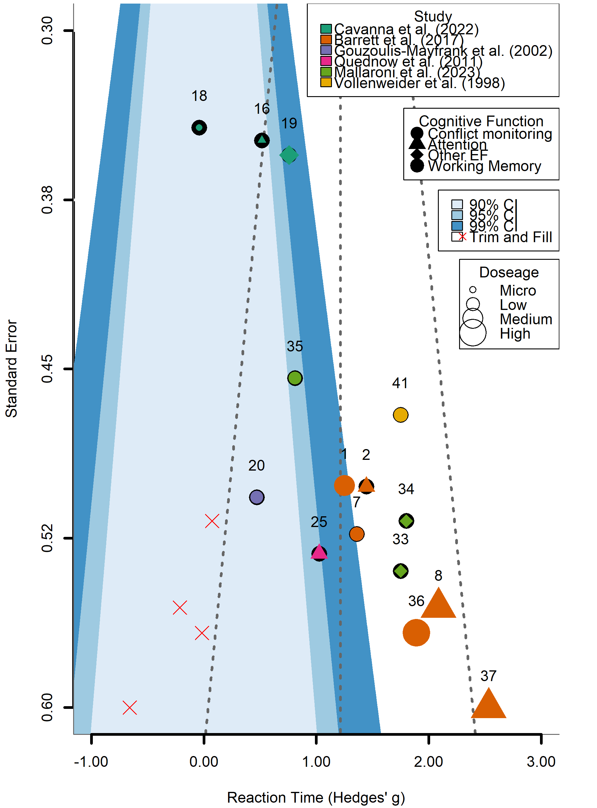

*Note.* Funnel plot of effect sizes for psilocybin's impact on reaction time across studies. Points represent individual study outcomes, differentiated by cognitive function (shape), study (color), and dosage (size). Shaded areas indicate confidence intervals. Red crosses show trim-and-fill adjustments for potential publication bias. The plot suggests some asymmetry, with smaller studies showing more variable effects.

**Meta Analysis: Accuracy**

One outlier was found (Effect Size ID= 24). Running the model without this outlier did not change the direction of the effect, nor changed heterogeneity. Thus, his effect size was not excluded from the above mentioned analyses.

A multilevel meta-analysis on the subset of 27 accuracy effect sizes from 10 unique studies revealed a negative overall pooled effect size of Hedges’ g = -0.45 (SE = 0.23, t = -1.90, df = 26, p = 0.0681, 95% CI [-0.93, 0.034]). Heterogeneity was moderate and significant (I2 = 42.53%, Q(26) = 39.74, p = 0.0414). Notably, the majority of detected heterogeneity I2Level3=42.54%, originated from between-study differences, while no variability, I2Level2= 0% was attributed to within-study differences.

A between-study heterogeneity variance of 2Level3= 0.39 and no within-study variance (2Level2 = 0) was observed. The absence of within-study variance might indicate that the variability within individual studies (e.g., due to measurement error or within-study sampling variability) is negligible. This could imply that the effect sizes from individual studies are very consistent.

The comparison of the nested model with the non-nested model revealed that the model was statistically superior ( 𝝌12 =10.33 , p = 0.0013), as indicated by its lower AIC and BIC values (Full model AIC = 50.3, BIC = 54.01; Reduced model AIC = 58.63, BIC = 61.14), suggesting that the nested model provides a better fit by effectively capturing additional variability.

**Figure 6: Forrest Plot Accuracy**

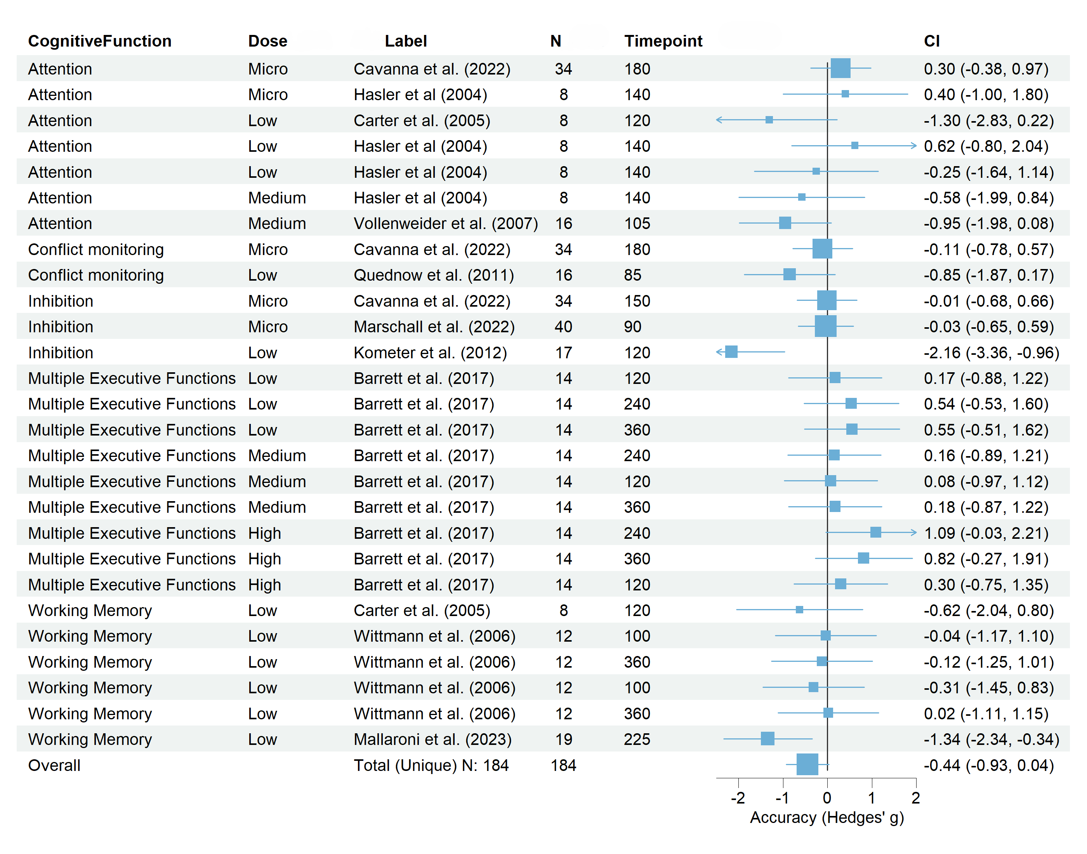

*Note.* Forest plot of effect sizes (Hedges' g) for psilocybin's impact on accuracy. Results are sorted by cognitive domain, showing individual study effects and the overall pooled effect. Negative values indicate decreased accuracy with psilocybin compared to placebo. The size of the squares indicates the relative weight of each study, with larger squares representing larger sample sizes.

**Figure 7: Funnel Plot Accuracy**

*Note.* Funnel plot illustrating the effects of psilocybin on accuracy across various studies. Each point represents an individual study outcome, with different shapes indicating cognitive functions, colors denoting studies, and sizes reflecting dosages. Shaded areas represent 90%, 95%, and 99% confidence intervals. The plot does not indicate presence of publication bias.

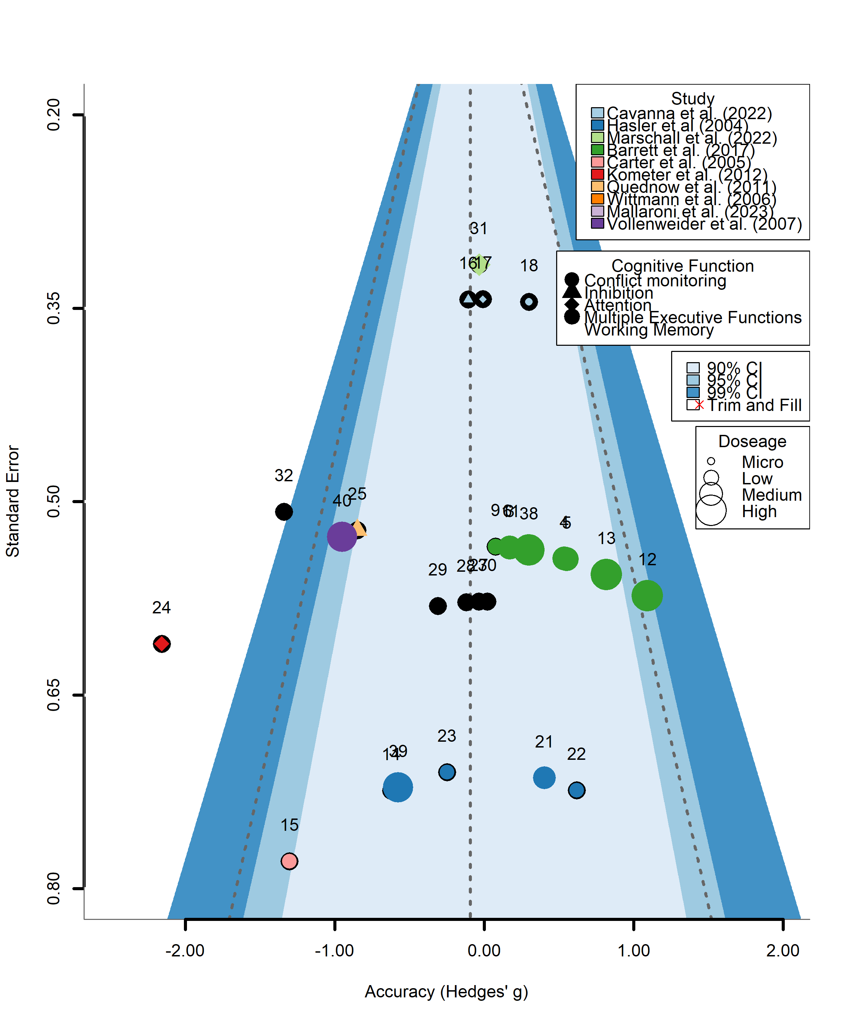

***Moderation Analysis Accuracy***

Subgroup analyses were conducted to explore potential moderators of psilocybin's effect on accuracy. The timing of psilocybin administration (peak vs. non-peak) did not significantly moderate the effect (QM(1) = 0.52, p = .47). Dosage categorization (micro, low, medium, high) also did not yield significant moderation (QM(3) = 4.38, p = .22), nor did a simplified micro/low vs. medium/high comparison (QM(1) = 0.02, p = .90). Cognitive function categories (attention, conflict monitoring, other executive functions, working memory) showed no significant moderation effect (QM(3) = 2.96, p = .40). Similarly, executive function task sensitivity levels did not significantly moderate the effect (QM(2) = 0.19, p = .91). In line with these results, a metaforest machine learning algorithm also did not reveal a sufficient fit of the moderation model with the mentioned variables (See supplementary material).

These results indicate that while overall heterogeneity was observed, our tested moderators did not significantly explain this variability in psilocybin's effects on accuracy.

**Discussion**

While previous research has extensively explored the effects of psilocybin on mood and perception, this meta-analysis uniquely focuses on its impact on cognition aspects particularly on cognitive functions. After initial abstract screening, 42 effect sizes from 12 individual studies were extracted and categorised into the domains of executive functions and attention.  Importantly, the overall risk of bias across the studies included in our analysis is moderate to high. Most noticeably, this is driven by concerns about blinding procedures as well as lack of pre-registrations. Additionally, our investigation points towards a publication bias, given the asymmetry of the funnel plot. In the original studies included in the meta-analysis, cognition was often of secondary interest, which poses the question, whether other research groups failed to report their non-significant results, as they were also not primarily interested in cognition, thus driving the publication bias. Consequently, the heterogeneity, risk of bias, and potential for publication bias could lead to an overestimation of the true effect size within our analysis, skewing the data towards significant findings. The overall conclusions drawn from the meta-analysis may therefore be misleading, and should be taken with caution.

With that in mind, we found that psilocybin reduces accuracy slightly to moderately, albeit non-significantly, and largely slows reaction times in cognitive tasks assessing executive functions and attention. We further found that this effect on reaction time was significantly moderated by (i) dosage (micro, small, mid, high), in that higher doses more strongly impacted reaction times; and (ii) measurement sensitivity (general, specific, pure), in which more general measure showed larger effects. No significant moderation has been observed in (iii) subcomponents of executive functions and attention (working memory updating, inhibition, multiple EFs, attention) and (iv) time point of measurement (during peak, after peak). Before discussing the main effect in more depth, we briefly summarise our findings of each moderator analysis.

**Moderation of Reaction Time**

***The influence of dose on reaction time***

First, the reaction time slowing on executive functions and attention follow a linear dose-dependent relationship, with higher doses showing a stronger slowing of reaction times, and lower doses having less impact. Given that psilocybin has a dose response effect on psilocybin plasma concentration (Holze et al., 2023), and subjective experience ratings (Hirschfeld and Schmidt, 2021), it is not surprising that this trend is present for performance in executive functions and attention as well. This dose-dependent effect is observed in all four studies that investigated different dosages. Interestingly, both studies investigating working memory (updating) (Wittmer et al., 2006; Barrett et al.2018), showed significantly slower reaction times at high dose, but not at medium dose compared to placebo. However, studies investigating attention (Hasler et al., 2004; Vollenweider et al., 2007) found reduced performance already at both low and medium dosages. This suggests that while generally there is a dose-dependent effect of psilocybin across cognitive functioning, specifically executive functions, such as working memory updating might be slightly more resilient towards the effects.

***The influence of timing on reaction time***

In the included studies, executive functions and/or attention were measured between 60 and 240 minutes post-psilocybin administration, out of which seven effect sizes were obtained during the peak window (90-180 min post ingestion; Barrett et al., 2017; Cavanna et al., 2022; Kometer et al., 2012; Mallaroni et al., 2023), and eight outside the peak window (>90 and ,<180 min post ingestion) of psilocybin drug effect (Barrett et al., 2017; Cavanna et al., 2022; Gouzoulis-Mayfrank et al., 2002; Quednow et al., 2011; Vollenweider et al., 1998). In contrast to dose as a moderator, the measurement timepoints did not significantly influence the effects of psilocybin on reaction time. This suggests that the initial dose has a greater impact than the timing of measurements, especially given the time points examined in this analysis. Although our study differentiated between measurements taken within the peak window (90-180 minutes post-ingestion) and those taken outside it, all measurement timepoints still fall within the acute phase of psilocybin's effects. The data indicate that the effects are consistently distributed throughout this period, irrespective of whether they occur within or outside the peak window. To establish a robust dose-response curve for psilocybin's effects on cognition, further studies incorporating a wider range of acute and post-acute timepoints are necessary.

***The influence of measurement sensitivity on reaction time***

Observations from the primary studies varied widely due to differences in measurement techniques and statistical methods, prompting us to examine if the granularity of these measures affected reported effects on reaction times. This moderator analysis revealed that the degree of measurement sensitivity moderates the effect on reaction time, with more general measures of sensitivity showing a stronger effect than more specific measures. This suggests that psilocybin's impact on reaction time is more general rather than specific to executive functions, as more specific methods aim to account for general function by, for example, calculating a difference score. The tests and methods we scored as being more specific partially factor out low-level function by contrasting conditions that both require the same amount of low-level processing in terms of stimuli perception and motor involvement but differ only in the degree to which the targeted cognitive domain is being assessed. For instance, in the Stroop task, the congruent and incongruent conditions both necessitate similar levels of basic sensory processing and motor responses (Adlema et al., 2002); however, they vary in the extent to which they engage cognitive control and conflict monitoring, thereby partially isolating the cognitive domain of interest if the scores are subtracted from each other. The fact that measurement sensitivity is a significant moderator, favouring more general measures of executive function over specific ones, suggests that a significant amount of the effect could be attributed to the underlying general functions mentioned above, rather than the specific cognitive domain. This suggests that the lower level cognitive and motor functions involved in these tasks could play an important part in the observed reaction time slowing, on top of the specific cognitive domains targeted by the more precise measures.

***The influence of subcomponents of executive functions and attention on reaction time***

We further investigated whether the reaction time slowing effects of psilocybin vary across subcomponents of executive functions and attention. Our analysis revealed that specific cognitive domains do not play a moderating role, suggesting that psilocybin acutely affects executive functions and attentional abilities in a similar manner. This points to a potential lower-level mechanism that equally impacts all assessed cognitive domains. To fully understand the breadth of psilocybin's cognitive effects, future research should continue to explore these mechanisms across a broader spectrum of executive function and attention subcomponents.

**Reaction time and Accuracy**

Our data suggest that psilocybin slows reaction time in attention and executive functioning tasks in a dose dependent manner, while having less effects on accuracy. Although the cognitive tasks included in this analysis aim to isolate specific cognitive domains, overall performance is inevitably influenced by a variety of additional functions. These include lower-level processes such as motor preparedness and psychomotor speed (involved in executing a button press), middle-level functions such as attentional capabilities (e.g., how much was listened to instructions), and higher-level executive functions such as cognitive control and task switching abilities. Therefore, we discuss our results within the framework of a multilevel explanation and propose potential mechanisms through which psilocybin may lead to these outcomes by impacting various cognitive levels separately or simultaneously. It is important to note that this interpretation is speculative and should be used to form new, testable hypotheses for future research.

***Possible factors influencing cognitive task performance: Psychomotor speed***

As pointed out above, the moderator analyses indicated that psilocybin's impact on reaction time is more general rather than specific, with general measures showing a stronger effect than specific ones. Additionally, subcomponents of executive functions and attention did not moderate the effect, suggesting psilocybin affects these functions uniformly. These findings imply that lower-level functions shared across these domains might be influenced by psilocybin.

One such low-level mechanism might be the motor apparatus, and its associated functions like psychomotor speed and voluntary motor response. It seems plausible that reduction in psychomotor speed negatively impacts reaction time on a wide range of tasks, as it is reflected in general processing speed. In particular, the study by Barrett et al. (2007) found that psilocybin acutely leads to a reduction in psychomotor speed for medium and high doses, but not for low doses. Similarly, Wittmann et al. (2006) found that psilocybin acutely and significantly slowed responses in a motor-praxis task (Wittmann et al., 2006). The observed reduction in psychomotor speed is not surprising, considering that the serotonin system partially modulates the motor system including the motor cortex and basal ganglia circuits (for review see Kawashima, 2018).

As the motor cortex is responsible for the execution of voluntary movements, modulation of 5HT-2a receptor activity through psilocybin could affect motor cortex excitability and thus impact reaction times in cognitive tasks by slowing motor response. In line with this, a recent fMRI pilot study by Pagni et al. (2024) found that psilocybin decreases activity in several brain regions, including the motor cortex and cerebellum, post-acutely in patients with Alcohol Use Disorder (AUD). Other lower level areas might be involved in the generalised slowing of reaction time. Alterations of the sensitivity of the visual system might play a role as well.  Several studies suggest that psilocybin and other 5HT-2ar agonist inhibit connectivity within the visual pathway, potentially reducing its responsiveness, thus slowing the overall processing speed (Stoliker et al.,2023; Azimi et al., 2020; Evarts et al., 1955; Michaiel et al., 2019).

Taken together, modulation through psilocybin within the motor apparatus as well as the visual pathways might explain parts of the reaction time slowing observed in our data. However, reduced accuracy is not usually observed in individuals with reduced visual or motor functions, which suggests that there might be additional working mechanisms involved.

***Possible factors influencing cognitive task performance through attention and motivation***

While parts of the effects of psilocybin on reaction time might be driven by alterations in low-level functions such as motor and visual domains, other parts, in particular the effects on accuracy, may lie in its impact on attention. Attention is crucial as it dictates which stimuli enter our conscious experience (De Brigard and Prinz, 2009) and determines the extent of our engagement with these stimuli (Ki, Kelly and Parra, 2016). This selective focus is essential for goal-oriented behaviour, suggesting that the alterations observed reaction time and accuracy could be a result of changes in attentional dynamics induced by psilocybin.

Attention serves as a fundamental building block for higher cognitive functions (Burgoyne and Engle, 2020; Rose et al., 2003). Adequate attentional resources are essential for optimal task performance, and a lack of attention can lead to reduced performance or slower reaction times. Psilocybin's impact on attentional processes can thus significantly influence cognitive task outcomes, which could explain the pattern we observe in our data. When attention is compromised, individuals may find it difficult to maintain focus, adhere to task instructions, or manage distractions effectively, leading to poorer performance across various tasks regardless of their specific demands (Prinzmetal et al., 2005). Indeed, Vollenweider et al. (2007) demonstrated significant reductions in performance on the FAIR task, which assess attentional capacity across low, medium, and high doses of psilocybin, during both the peak and post-peak drug effect. This suggests a global negative impact on attentional performance, a trend similarly observed in Hasler et al. (2004), who also used the FAIR task. Furthermore, Carter et al. (2005) reported that attentional tracking was adversely affected under low doses during an attentional object tracking task, proposing that even lower doses of psilocybin can impair attentional capacities. Interestingly, reduced attentional capabilities do not only lead to slower reaction times, but also to reduced accuracy (see Chen et al., 2022 for recent meta-analysis), which is in line with our findings. This suggests that attention may be a key factor influencing task performance on most (if not all) cognitive tests included in our analysis, as general performance is dependent on attentional capabilities.

In addition to that, motivation could play a further key role in task performance, as it directly translates to how much effort a participant is willing to invest in a cognitive task (for review see Maddox, 2010). As exerting cognitive control to suppress distractors and focus on the task is effortful, which might become even more effortful through psilocybin (e.g. due to added task-switching costs), participants might be less motivated to invest their energy, especially if the alternative is much higher in salience. Since the psychedelic experience is often profound and captivating, a significant mismatch between what the participants find meaningful during the experience and what experimenters expect of them is likely to occur. For example, McCulloch et al. (2021) reported, a participant in their study expressed a deep existential insight, saying, "I have the answer to the riddle of the universe,” yet felt constrained by the mundane requirement to "look into a TV-screen". This profound distraction underscores a potential disinterest in the structured tasks required by the experimenters. Similarly, another participant noted a disinterest in the test stimuli as reported by Robinson (1966), expressing a desire to immerse themselves in the overwhelming sensation of the experience rather than perform experimental tasks, stating: "Somehow, though, [the test stimuli] were not interesting to me and I couldn’t keep my mind on them. I had never felt this wonderful before and I would never feel this wonderful again. It was my intention to enjoy it and to hell with the tests" (Robinson, 1966).

These quotes illustrate that the intensely transformative and immersive nature of psychedelic experiences can lead participants to prioritise their internal experiences over external demands, significantly impacting their motivation to engage with the experimental tasks. This misalignment might explain some variability in task performance, suggesting that researchers need to consider the intrinsic motivation and engagement of participants when designing and interpreting the results of psychedelic research.

***Possible factors influencing cognitive task performance on higher-level functions. Dual-Task and Cognitive Control***

It is essential to consider that the effects of psilocybin may extend beyond low-level sensory and motor functions, and mid-level functions like attention and motivation, to also encompass higher-level cognitive processes. Our results share similarities with such observed in task assessing higher level mechanisms such as the dual-task interference paradigms. The dual-task interference theory posits that the processing of multiple interfering processes leads to a cognitive cost in the form of slowing of reaction time and drops in accuracy (ref). In the case of cognitive research during the acute phase of psilocybin, managing the intense subjective experiences of the psychedelic trip itself could act as a secondary task, demanding significant cognitive resources. This theory is supported by research showing that dual-task processing often leads to slower reaction times and decreased accuracy due to rapid task switching and cognitive recalibration. These processes involve ignoring interferences, implementing new task rules, and updating working memory (Shallice et al., 1996; Shallice & Burgess, 1991; Burgess et al., 2007; Strayer et al., 2006; Strayer & Johnston, 2001; Chen and Hsieh, 2023; Wylie and Allport, 2000; Monsell, 2003; Kieffaber and Hetrick, 2005; Snyder et al., 2021). Thus, the cognitive load induced by psilocybin's subjective effects could theoretically introduce additional cognitive costs similar to those observed in dual-task scenarios, impacting reaction time and accuracy (see Figure 8).

**Figure 8: Hypothetical Impact of Psilocybin on Task Switching and Cognitive Costs**

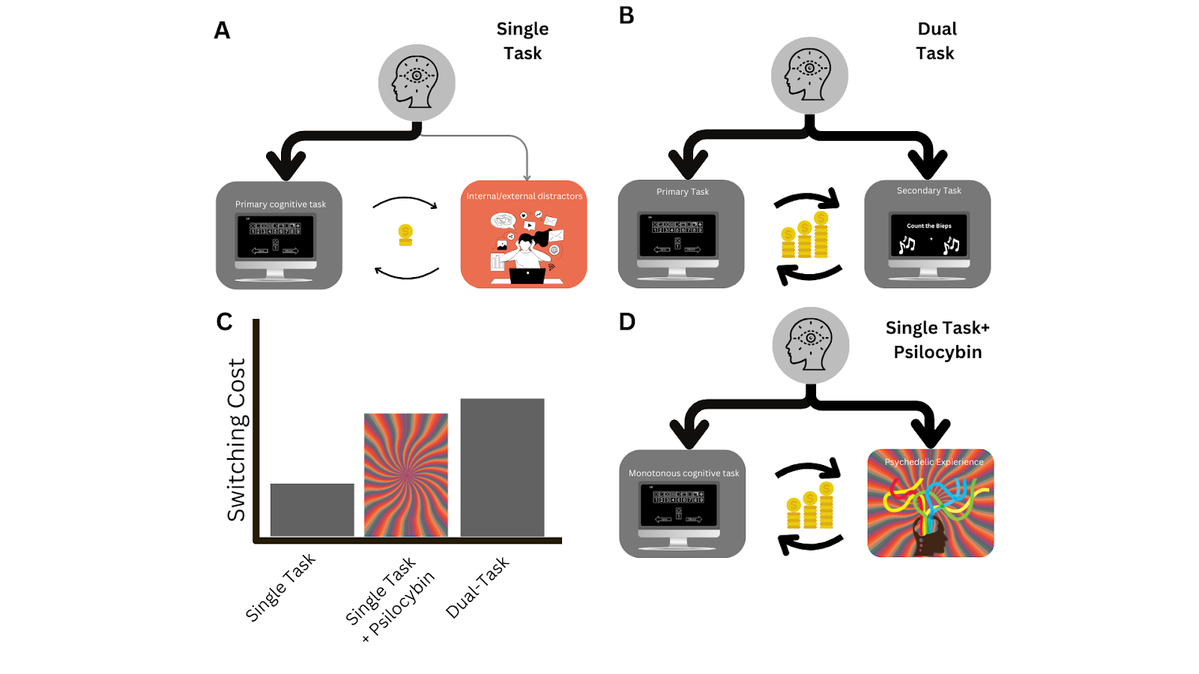

*Note.* Schematic illustration of how psilocybin might acutely impact executive function performance and attention due to a dual-task-like scenario. **A)** During a single task, participants have little to no switching costs, as no second task has to be performed. **B)** During a true dual-task, participants are rapidly switching between the tasks, at a cost of reduced reaction time. **C)** Hypothetical representation of cognitive costs associated with switching. The switching cost between doing tasks or doing one task and having a psychedelic experience are similarly high**,**  **D)** Performing a cognitive task, while experiencing psychedelic-induced subjective experiences could introduce dual-task-like costs.

Another high-level target of psilocybin, which aligns with the results of our meta-analysis, could be understood through the lens of the claustro-cortical-circuit network (CCC-Network) disruption hypothesis (Doss et al., 2022). While empirical evidence specifically substantiating the CCC-Network as a key hub affected by psilocybin is currently limited, one fMRI study provides tentative support for this model. This study suggests that psilocybin transiently disrupts higher-level cognitive control mechanisms through 5HT-2Ar mediated desynchronisation in the CCC-Network (Barrett et al., 2020). The CCC-model emphasises the role of the claustrum to explain psychedelics action, as it is a highly interconnected subcortical grey matter structure rich in serotonin receptors, (Mathur, 2014; Nichols, 2016; Nichols et al., 2017, Cortes et al., 1989). The claustrum's activity, influenced by the prefrontal cortex, supports cortical network states and is key in cognitive control (Atlan et al., 2018; Krimmel et al., 2019; White and Mathur, 2018; White et al., 2017), defined as the capacity to voluntarily allocate attentional resources to task-relevant processes, while ignoring distractions and interferences (Lavie, 2010; Miller, 2000; (O’Reilly et al., 2010). Additionally, cognitive control plays a key role in governing task switching abilities (for recent review see Egner, 2023, or Meiran, 2000). A disruption of the CCC-network by psilocybin could result in a similar drop in task performance as observed in our meta-analysis, as reduced cognitive control is less efficient in guiding attention towards task relevant stimuli while ignoring task irrelevant stimuli.

**Recommendations for future assessment of cognition under the influence of psychedelics**

The impact of psilocybin on task performance on executive function and attention, while speculative at this point, could be explained through a combination of mechanisms affecting various cognitive levels. Psilocybin's modulation of lower-level motor and visual pathways, its impairment of attentional and motivational processes, and its potential disruption of the CCC-Network as well as additional cognitive costs due to dual-task interference could collectively contribute to the observed changes in reaction time and accuracy on these cognitive test. Given this multi-level impact, it is essential to adapt our approach when testing cognitive function under its influence. Traditional cognitive tests may not fully capture the broad and overlapping effects of psilocybin, leading to potential misinterpretations of its impact. Researchers should consider developing and utilising more comprehensive and integrative testing paradigms that account for the simultaneous influences on lower-level, middle-level, and higher-level cognitive processes, or use testing paradigms that are robust against these influences. One promising direction is the incorporation of no-response or task-free paradigms, inspired by consciousness research, which can provide insights into cognitive function without relying on conventional task performance measures (for review see Duman et al., 2022; Baror and He, 2021). This approach could help mitigate the confounding effects of psilocybin on cognitive tasks, offering a more accurate assessment of its impact on cognitive processes.

**No statements possible on long-term effects of psilocybin on executive functions and attention**

A major limitation of this meta-analysis is that it focuses exclusively on the acute effects of psilocybin on cognition, as there were almost no studies with measurements at later time points that met our inclusion criteria. A clinical study by Doss et al. (2021) reported the enduring impact of psilocybin on executive functions using the Penn Conditional Exclusion Test to assess cognitive flexibility in MDD patients (2021). They found that psilocybin significantly decreased depressive symptoms in nearly all subjects within a week after treatment, with these benefits lasting up to a year for the majority of the participants (follow-up paper by Gukasyan, 2022). Concurrently, improvements in cognitive flexibility were observed up to 1 month post treatment (Doss et al., 2021). Further, a recent large scale self-report based longitudinal study involving 2,503 older adults (average age 64 ± 11), showed that psychedelic use was linked to favourable changes in executive function and fewer depressive symptoms, although no similar effect was observed for episodic memory (Fearn et al., 2024). This research points to potential long-term cognitive benefits of psychedelics, Thus, contrary to the acute slowing of reaction times and reduced accuracy under the influence of psychedelics, more research is pointing towards potential long-term cognitive benefits. Some papers suggest that these long term changes might be mediated and facilitated by an increase in neuronal plasticity after psychedelics use (for review see Calder and Hasler, 2023). Psilocybin administration in particular has been linked to increased global resting-state connectivity, particularly in the frontoparietal network, a region associated with cognitive control, for up to one month post-treatment, along with reduced signs of negative affect, indicating neuroplastic changes (Barrett et al., 2020). However, further research is needed to establish a clearer picture on the mechanisms that guide the acute functional disturbances and long term improvements of cognitive task performance. Such studies could clarify whether and how psilocybin and similar substances offer lasting cognitive benefits and identify the conditions under which they are most effective.

**Implications of the meta-analytic results on safety**

The results of our meta-analysis indicate a notable slowing of reaction times and reduced accuracy on cognitive task performance, underscoring the necessity for adequate supervision in therapeutic and recreational settings. Importantly, all studies included in the analysis were done in a healthy population. As medications in clinical populations mitigate the impact of symptoms on cognitive domains, they have the potential to enhance cognitive performance, as observed with antipsychotics and antiepileptic drugs (Rehse et al., 2016; Rajji et al., 2017). Hence, more clinical studies looking into the long-term effects of psilocybin on cognition are needed.

**Limitations**

Research exploring the acute effects of psychedelics on cognition has employed a variety of testing paradigms, leading to varied results. For instance, the study by Carter et al. (2005) using the Spatial Span task from the CANTAB battery found that psilocybin had no impact on working memory in eight human volunteers. In contrast, Barrett et al. (2018) reported that psilocybin did affect working memory in 20 healthy volunteers, as evidenced by increased response times in the Letter N-back task. One difficulty in conducting this meta-analysis was that due the multifaceted nature of executive functions, a variety of tasks were, which is reflected in the heterogeneity.  The lack of consistent use of testing paradigms across studies has impeded efforts to replicate findings and has led to a stage where conclusive interpretations of the data are challenging. This inconsistency is further reflected in the heterogeneity tests, indicating significant variation in study outcomes.

As pointed out above, the risk of bias analysis reveals significant concerns, indicating that many findings should be interpreted with caution. Factors such as compromised blinding, placebo effects, small sample sizes, and selective reporting can significantly influence study outcomes.

**Further Information**

***Registration and protocol***

For the present study, no prior hypotheses were set. Furthermore, the present study was not pre registered, and also no study protocol was produced prior to data collection and analysis, thus, the present study is considered exploratory.

***Author contributions***

The conceptualization of the research was collaboratively developed by SEG, MVE, and ML. The methodology was designed by PY, RR, and SEG, with PY and RR also responsible for the software development and validation. Formal analysis was conducted by PY and RR, with PY leading the investigation. Resources were provided by SEG and MVE, and data curation was handled by PY and FOH. The original draft of the manuscript was written by PY and ML, and the manuscript was reviewed and edited by PY, ML, GH, MVE, and SEG. Data visualisation was executed by PY, RR and ML. Risk of Bias assessment completed by FOH and ML. Supervision of the project was overseen by SEG and MVE. Project administration was conducted by PY, SEG, ML and MVE. Funding acquisition was solely managed by SEG.

***Availability of data and code***

All the data and code, as well as further analyses underlying the present study are available [here](https://1drv.ms/f/s!AquRzxZiGC1_h8kGEylVlzK9OX0gSA?e=zTW7Ge) as supplementary material. We adhere to OPEN guidelines and encourage the usage of our data for further exploration.

***Conflict of interest***

The authors declare no conflict of interest.

**References**

Abramovitch, A., Short, T., & Schweiger, A. (2021). The C Factor: Cognitive dysfunction as a transdiagnostic dimension in psychopathology. *Clinical Psychology Review*, *86*, 102007. https://doi.org/10.1016/j.cpr.2021.102007

Adleman, N. E., Menon, V., Blasey, C. M., White, C. D., Warsofsky, I. S., Glover, G. H., & Reiss, A. L. (2002). A Developmental fMRI Study of the Stroop Color-Word Task. *NeuroImage*, *16*(1), 61–75. https://doi.org/10.1006/nimg.2001.1046

Amir, I., & Bernstein, A. (2022). Dynamics of Internal Attention and Internally-Directed Cognition: The Attention-to-Thoughts (A2T) Model. *Psychological Inquiry*, *33*(4), 239–260. https://doi.org/10.1080/1047840x.2022.2141000

Azimi, Z., Barzan, R., Spoida, K., Surdin, T., Wollenweber, P., Mark, M. D., Herlitze, S., & Jancke, D. (2020). Separable gain control of ongoing and evoked activity in the visual cortex by serotonergic input. *eLife*, *9*. https://doi.org/10.7554/elife.53552

Badart, P., McDowall, J., & Prime, S. L. (2017). Multimodal Sustained Attention Superiority in Concentrative Meditators Compared to Nonmeditators. *Mindfulness*, *9*(3), 824–835. https://doi.org/10.1007/s12671-017-0822-y

Bălăeţ, M. (2022). Psychedelic Cognition—The Unreached Frontier of Psychedelic Science. *Frontiers in Neuroscience*, *16*. https://doi.org/10.3389/fnins.2022.832375

Baror, S., & He, B. J. (2021). Spontaneous perception: a framework for task-free, self-paced perception. *Neuroscience of Consciousness*, *2021*(2). https://doi.org/10.1093/nc/niab016

Barrett, F. S., Carbonaro, T. M., Hurwitz, E., Johnson, M. W., & Griffiths, R. R. (2018). Double-blind comparison of the two hallucinogens psilocybin and dextromethorphan: effects on cognition. *Psychopharmacology*, *235*(10), 2915–2927. https://doi.org/10.1007/s00213-018-4981-x

Barrett, F. S., Doss, M., Sepeda, N. D., Pekar, J. J., & Griffiths, R. R. (2020). Emotions and brain function are altered up to one month after a single high dose of psilocybin. *Scientific Reports*, *10*(1). https://doi.org/10.1038/s41598-020-59282-y

Basedow, L. A., Riemer, T., Reiche, S., Kreutz, R., & Majić, T. (2021). Neuropsychological Functioning in Users of Serotonergic Psychedelics – A Systematic Review and Meta-Analysis. *Frontiers in Pharmacology*, *12*. https://doi.org/10.3389/fphar.2021.739966

Bekinschtein, T. A., Dehaene, S., Rohaut, B., Tadel, F., Cohen, L., & Naccache, L. (2009). Neural signature of the conscious processing of auditory regularities. *Proceedings of the National Academy of Sciences of the United States of America*, *106*(5), 1672–1677. https://doi.org/10.1073/pnas.0809667106

Bogenschutz, M. P., Ross, S., Bhatt, S., Baron, T., Forcehimes, A. A., Laska, E., Mennenga, S. E., O’Donnell, K. C., Owens, L. T., Podrebarac, S. K., Rotrosen, J., Tonigan, J. S., & Worth, L. (2022). Percentage of Heavy Drinking Days Following Psilocybin-Assisted Psychotherapy vs Placebo in the Treatment of Adult Patients With Alcohol Use Disorder. *JAMA Psychiatry*, *79*(10), 953. https://doi.org/10.1001/jamapsychiatry.2022.2096

Bonnieux, J. N., VanderZwaag, B., Premji, Z., Garcia-Romeu, A., & Garcia-Barrera, M. A. (2023). Psilocybin’s effects on cognition and creativity: A scoping review. *Journal of Psychopharmacology*, *37*(7), 635–648. https://doi.org/10.1177/02698811231179801

Buetti, S., & Lleras, A. (2016). Distractibility is a function of engagement, not task difficulty: Evidence from a new oculomotor capture paradigm. *Journal of Experimental Psychology. General*, *145*(10), 1382–1405. https://doi.org/10.1037/xge0000213

Burgoyne, A. P., & Engle, R. W. (2020). Attention Control: A Cornerstone of Higher-Order Cognition. *Current Directions in Psychological Science*, *29*(6), 624–630. https://doi.org/10.1177/0963721420969371

Calder, A. E., & Hasler, G. (2022). Towards an understanding of psychedelic-induced neuroplasticity. *Neuropsychopharmacology*, *48*(1), 104–112. https://doi.org/10.1038/s41386-022-01389-z

Carhart-Harris, R., Giribaldi, B., Watts, R., Baker-Jones, M., Murphy-Beiner, A., Murphy, R., Martell, J., Blemings, A., Erritzoe, D., & Nutt, D. (2021). Trial of Psilocybin versus Escitalopram for Depression. *The New England Journal of Medicine*, *384*(15), 1402–1411. https://doi.org/10.1056/nejmoa2032994

Carter, O. L., Burr, D. C., Pettigrew, J. D., Wallis, G. M., Hasler, F., & Vollenweider, F. X. (2005). Using Psilocybin to Investigate the Relationship between Attention, Working Memory, and the Serotonin 1A and 2A Receptors. *Journal of Cognitive Neuroscience*, *17*(10), 1497–1508. https://doi.org/10.1162/089892905774597191

Cavanna, F., Muller, S., De La Fuente, L. A., Zamberlan, F., Palmucci, M., Janeckova, L., Kuchar, M., Pallavicini, C., & Tagliazucchi, E. (2022). Microdosing with psilocybin mushrooms: a double-blind placebo-controlled study. *Translational Psychiatry*, *12*(1). https://doi.org/10.1038/s41398-022-02039-0

Chen, E., & Hsieh, S. (2023). The effect of age on task switching: updated and extended meta-analyses. *Psychological Research*, *87*(7), 2011–2030. https://doi.org/10.1007/s00426-023-01794-z

Chen, J., Paul, J. M., & Reeve, R. (2022). Manipulation of attention affects subitizing performance: A systematic review and meta-analysis. *Neuroscience & Biobehavioral Reviews/Neuroscience and Biobehavioral Reviews*, *139*, 104753. https://doi.org/10.1016/j.neubiorev.2022.104753

Cortés, R., Gueye, B., Pazos, A., Probst, A., & Palacios, J. (1989). Dopamine receptors in human brain: Autoradiographic distribution of D1 sites. *Neuroscience*, *28*(2), 263–273. https://doi.org/10.1016/0306-4522(89)90178-4

Crocker, L. D., Jurick, S. M., Thomas, K. R., Keller, A. V., Sanderson-Cimino, M., Boyd, B., Rodgers, C., Twamley, E. W., & Jak, A. J. (2018). Worse baseline executive functioning is associated with dropout and poorer response to trauma-focused treatment for veterans with PTSD and comorbid traumatic brain injury. *Behaviour Research and Therapy*, *108*, 68–77. https://doi.org/10.1016/j.brat.2018.07.004

D’Alcante, C. C., Diniz, J. B., Fossaluza, V., Batistuzzo, M. C., Lopes, A. C., Shavitt, R. G., Deckersbach, T., Malloy-Diniz, L., Miguel, E. C., & Hoexter, M. Q. (2012). Neuropsychological predictors of response to randomized treatment in obsessive–compulsive disorder. *Progress in Neuro-psychopharmacology & Biological Psychiatry*, *39*(2), 310–317. https://doi.org/10.1016/j.pnpbp.2012.07.002

De Brigard, F., & Prinz, J. (2009). Attention and consciousness. *Wiley Interdisciplinary Reviews. Cognitive Science*, *1*(1), 51–59. https://doi.org/10.1002/wcs.27

Diamond, A. (2013). Executive Functions. *Annual Review of Psychology*, *64*(1), 135–168. https://doi.org/10.1146/annurev-psych-113011-143750

Doss, M. K., Považan, M., Rosenberg, M. D., Sepeda, N. D., Davis, A. K., Finan, P. H., Smith, G. S., Pekar, J. J., Barker, P. B., Griffiths, R. R., & Barrett, F. S. (2021). Psilocybin therapy increases cognitive and neural flexibility in patients with major depressive disorder. *Translational Psychiatry*, *11*(1). https://doi.org/10.1038/s41398-021-01706-y

Duman, I., Ehmann, I. S., Gonsalves, A. R., Gültekin, Z., Van Den Berckt, J., & Van Leeuwen, C. (2022). The No-Report Paradigm: A Revolution in Consciousness Research? *Frontiers in Human Neuroscience*, *16*. https://doi.org/10.3389/fnhum.2022.861517

Ebbesen, C. L., & Brecht, M. (2017). Motor cortex — to act or not to act? *Nature Reviews. Neuroscience*, *18*(11), 694–705. https://doi.org/10.1038/nrn.2017.119

Egner, T. (2023). Principles of cognitive control over task focus and task switching. *Nature Reviews Psychology*, *2*(11), 702–714. https://doi.org/10.1038/s44159-023-00234-4

Enriquez-Geppert, S., Konrad, C., Pantev, C., & Huster, R. J. (2010). Conflict and inhibition differentially affect the N200/P300 complex in a combined go/nogo and stop-signal task. *NeuroImage*, *51*(2), 877–887. https://doi.org/10.1016/j.neuroimage.2010.02.043

Evarts, E. V., Landau, W., Freygang, W., & Marshall, W. H. (1955). Some Effects of Lysergic Acid Diethylamide and Bufotenine on Electrical Activity in the Cat’s Visual System. *American Journal of Physiology/the American Journal of Physiology*, *182*(3), 594–598. https://doi.org/10.1152/ajplegacy.1955.182.3.594

Fearn, K., & Bhattacharyya, K. K. (2024). Is Use of Psychedelic Drugs a Risk or Protective Factor for Late-Life Cognitive Decline? *Gerontology & Geriatric Medicine*, *10*. https://doi.org/10.1177/23337214241250108

Fertuck, E. A., Keilp, J., Song, I., Morris, M. C., Wilson, S. T., Brodsky, B. S., & Stanley, B. (2011). Higher Executive Control and Visual Memory Performance Predict Treatment Completion in Borderline Personality Disorder. *Psychotherapy and Psychosomatics*, *81*(1), 38–43. https://doi.org/10.1159/000329700

Fisher, C. D. (1998). Effects of External and Internal Interruptions on Boredom at Work: Two Studies. *Journal of Organizational Behavior*, *19*(5), 503–522. https://www.jstor.org/stable/3100240

Friedman, N. P., & Miyake, A. (2017). Unity and diversity of executive functions: Individual differences as a window on cognitive structure. *Cortex*, *86*, 186–204. https://doi.org/10.1016/j.cortex.2016.04.023

Geiger, H. A., Wurst, M., & Daniels, R. N. (2018). DARK Classics in Chemical Neuroscience: Psilocybin. *ACS Chemical Neuroscience*, *9*(10), 2438–2447. https://doi.org/10.1021/acschemneuro.8b00186

Godefroy, O., Azouvi, P., Robert, P., Roussel, M., LeGall, D., & Meulemans, T. (2010). Dysexecutive syndrome: Diagnostic criteria and validation study. *Annals of Neurology*, *68*(6), 855–864. https://doi.org/10.1002/ana.22117

Gouzoulis-Mayfrank, E., Thelen, B., Maier, S., Heekeren, K., Kovar, K. A., Sass, H., & Spitzer, M. (2002). Effects of the Hallucinogen Psilocybin on Covert Orienting of Visual Attention in Humans. *Neuropsychobiology*, *45*(4), 205–212. https://doi.org/10.1159/000063672

Griffiths, R. R., Johnson, M. W., Carducci, M. A., Umbricht, A., Richards, W. A., Richards, B. D., Cosimano, M. P., & Klinedinst, M. A. (2016). Psilocybin produces substantial and sustained decreases in depression and anxiety in patients with life-threatening cancer: A randomized double-blind trial. *Journal of Psychopharmacology*, *30*(12), 1181–1197. https://doi.org/10.1177/0269881116675513

Groves, S. J., Douglas, K. M., & Porter, R. J. (2018). A Systematic Review of Cognitive Predictors of Treatment Outcome in Major Depression. *Frontiers in Psychiatry*, *9*. https://doi.org/10.3389/fpsyt.2018.00382

Gukasyan, N., Davis, A. K., Barrett, F. S., Cosimano, M. P., Sepeda, N. D., Johnson, M. W., & Griffiths, R. R. (2022). Efficacy and safety of psilocybin-assisted treatment for major depressive disorder: Prospective 12-month follow-up. *Journal of Psychopharmacology*, *36*(2), 151–158. https://doi.org/10.1177/02698811211073759

Halberstadt, A. L., & Geyer, M. A. (2011). Multiple receptors contribute to the behavioral effects of indoleamine hallucinogens. *Neuropharmacology*, *61*(3), 364–381. https://doi.org/10.1016/j.neuropharm.2011.01.017

Hasler, F., Grimberg, U., Benz, M. A., Huber, T., & Vollenweider, F. X. (2004). Acute psychological and physiological effects of psilocybin in healthy humans: a double-blind, placebo-controlled dose?effect study. *Psychopharmacology*, *172*(2), 145–156. https://doi.org/10.1007/s00213-003-1640-6

Hendy, K. (2018). Placebo Problems: Boundary Work in the Psychedelic Science Renaissance. In *Springer eBooks* (pp. 151–166). https://doi.org/10.1007/978-3-319-76720-8_9

Hesselgrave, N., Troppoli, T. A., Wulff, A. B., Cole, A. B., & Thompson, S. M. (2021). Harnessing psilocybin: antidepressant-like behavioral and synaptic actions of psilocybin are independent of 5-HT2R activation in mice. *Proceedings of the National Academy of Sciences of the United States of America*, *118*(17). https://doi.org/10.1073/pnas.2022489118

Higgins, J. P. T., Altman, D. G., Gotzsche, P. C., Juni, P., Moher, D., Oxman, A. D., Savovic, J., Schulz, K. F., Weeks, L., & Sterne, J. a. C. (2011). The Cochrane Collaboration’s tool for assessing risk of bias in randomised trials. *BMJ*, *343*(oct18 2), d5928–d5928. https://doi.org/10.1136/bmj.d5928

Higgins, J., Savović, J., Page, M., Elbers, R., & Sterne, J. (2023). Chapter 8: Assessing risk of bias in a randomized trial. In *Cochrane Handbook for Systematic Reviews of Interventions* (6.4). Cochrane. https://www.training.cochrane.org/handbook

Hirschfeld, T., & Schmidt, T. T. (2021). Dose–response relationships of psilocybin-induced subjective experiences in humans. *Journal of Psychopharmacology*, *35*(4), 384–397. https://doi.org/10.1177/0269881121992676

Holze, F., Avedisian, I., Varghese, N., Eckert, A., & Liechti, M. E. (2021). Role of the 5-HT2A Receptor in Acute Effects of LSD on Empathy and Circulating Oxytocin. *Frontiers in Pharmacology*, *12*. https://doi.org/10.3389/fphar.2021.711255

Holze, F., Becker, A. M., Kolaczynska, K. E., Duthaler, U., & Liechti, M. E. (2022). Pharmacokinetics and Pharmacodynamics of Oral Psilocybin Administration in Healthy Participants. *Clinical Pharmacology and Therapeutics/Clinical Pharmacology & Therapeutics*, *113*(4), 822–831. https://doi.org/10.1002/cpt.2821

Hybel, K. A., Mortensen, E. L., Lambek, R., Højgaard, D. R., & Thomsen, P. H. (2017). Executive function predicts cognitive-behavioral therapy response in childhood obsessive-compulsive disorder. *Behaviour Research and Therapy*, *99*, 11–18. https://doi.org/10.1016/j.brat.2017.08.009

Irizarry, R., Winczura, A., Dimassi, O., Dhillon, N. K., Minhas, A., & Larice, J. (2022). Psilocybin as a Treatment for Psychiatric Illness: A Meta-Analysis. *Cureus*. https://doi.org/10.7759/cureus.31796

Kawashima, T. (2018). The role of the serotonergic system in motor control. *Neuroscience Research*, *129*, 32–39. https://doi.org/10.1016/j.neures.2017.07.005

Ki, J. J., Kelly, S. P., & Parra, L. C. (2016). Attention Strongly Modulates Reliability of Neural Responses to Naturalistic Narrative Stimuli. *the Journal of Neuroscience/the Journal of Neuroscience*, *36*(10), 3092–3101. https://doi.org/10.1523/jneurosci.2942-15.2016

Kieffaber, P. D., & Hetrick, W. P. (2005). Event‐related potential correlates of task switching and switch costs. *Psychophysiology*, *42*(1), 56–71. https://doi.org/10.1111/j.1469-8986.2005.00262.x

Kiesel, A., Steinhauser, M., Wendt, M., Falkenstein, M., Jost, K., Philipp, A. M., & Koch, I. (2010). Control and interference in task switching—A review. *Psychological Bulletin*, *136*(5), 849–874. https://doi.org/10.1037/a0019842

Kometer, M., Schmidt, A., Bachmann, R., Studerus, E., Seifritz, E., & Vollenweider, F. X. (2012). Psilocybin Biases Facial Recognition, Goal-Directed Behavior, and Mood State Toward Positive Relative to Negative Emotions Through Different Serotonergic Subreceptors. *Biological Psychiatry*, *72*(11), 898–906. https://doi.org/10.1016/j.biopsych.2012.04.005

Lavie, N. (2010). Attention, Distraction, and Cognitive Control Under Load. *Current Directions in Psychological Science*, *19*(3), 143–148. https://doi.org/10.1177/0963721410370295

Lawn, T., Dipasquale, O., Vamvakas, A., Tsougos, I., Mehta, M. A., & Howard, M. A. (2022). Differential contributions of serotonergic and dopaminergic functional connectivity to the phenomenology of LSD. *Psychopharmacology/Psychopharmacologia*, *239*(6), 1797–1808. https://doi.org/10.1007/s00213-022-06117-5

Lewis, C. R., Preller, K. H., Braden, B. B., Riecken, C., & Vollenweider, F. X. (2020). Rostral Anterior Cingulate Thickness Predicts the Emotional Psilocybin Experience. *Biomedicines*, *8*(2), 34. https://doi.org/10.3390/biomedicines8020034

Li, N., Hu, Y., Chen, W., & Zhang, B. (2022). Dose effect of psilocybin on primary and secondary depression: a preliminary systematic review and meta-analysis. *Journal of Affective Disorders*, *296*, 26–34. https://doi.org/10.1016/j.jad.2021.09.041

Liemburg, E. J., Enriquez-Geppert, S., Wardenaar, K. J., Bruggeman, R., Aleman, A., Castelein, S., Knegtering, H., Veling, W., Alizadeh, B. Z., Van Amelsvoort, T., Bartels-Velthuis, A. A., Van Beveren, N. J., Bruggeman, R., Cahn, W., De Haan, L., Delespaul, P., Luykx, J. J., Myin-Germeys, I., Kahn, R. S., . . . Van Winkel, R. (2020). Expressive deficits and amotivation as mediators of the associations between cognitive problems and functional outcomes: Results from two independent cohorts. *Schizophrenia Research*, *218*, 283–291. https://doi.org/10.1016/j.schres.2019.12.018

Luciana, M., Collins, P. F., Olson, E. A., & Schissel, A. M. (2009). Tower of London Performance in Healthy Adolescents: The Development of Planning Skills and Associations With Self-Reported Inattention and Impulsivity. *Developmental Neuropsychology/Developmental Neuropsychology :*, *34*(4), 461–475. https://doi.org/10.1080/87565640902964540

Maddox, W. T., & Markman, A. B. (2010). The Motivation–Cognition Interface in Learning and Decision Making. *Current Directions in Psychological Science*, *19*(2), 106–110. https://doi.org/10.1177/0963721410364008

Madsen, M. K., Stenbæk, D. S., Arvidsson, A., Armand, S., Marstrand-Joergensen, M. R., Johansen, S. S., Linnet, K., Ozenne, B., Knudsen, G. M., & Fisher, P. M. (2021). Psilocybin-induced changes in brain network integrity and segregation correlate with plasma psilocin level and psychedelic experience. *European Neuropsychopharmacology*, *50*, 121–132. https://doi.org/10.1016/j.euroneuro.2021.06.001

Mallaroni, P., Mason, N. L., Reckweg, J. T., Paci, R., Ritscher, S., Toennes, S. W., Theunissen, E. L., Kuypers, K. P., & Ramaekers, J. G. (2023). Assessment of the acute effects of 2C-B vs psilocybin on subjective experience, mood and cognition. *-*. https://doi.org/10.1101/2023.02.16.528808

Marschall, J., Fejer, G., Lempe, P., Prochazkova, L., Kuchar, M., Hajkova, K., & Van Elk, M. (2021). Psilocybin microdosing does not affect emotion-related symptoms and processing: A preregistered field and lab-based study. *Journal of Psychopharmacology*, *36*(1), 97–113. https://doi.org/10.1177/02698811211050556

Mason, N. L., Mischler, E., Uthaug, M. V., & Kuypers, K. P. C. (2019). Sub-Acute effects of Psilocybin on empathy, creative thinking, and Subjective Well-Being. *Journal of Psychoactive Drugs*, *51*(2), 123–134. https://doi.org/10.1080/02791072.2019.1580804

McCartney, A. M., McGovern, H. T., & De Foe, A. (2022). Psychedelic assisted therapy for major depressive disorder: Recent work and clinical directions. *Journal of Psychedelic Studies*, *6*(1), 10–22. https://doi.org/10.1556/2054.2022.00211

McCulloch, D. E., Grzywacz, M. Z., Madsen, M. K., Jensen, P. S., Ozenne, B., Armand, S., Knudsen, G. M., Fisher, P. M., & Stenbæk, D. S. (2021). A quantitative and qualitative report of psilocybin induced Mystical-Type experiences and their relation to lasting positive effects. *Preprint*. https://doi.org/10.31234/osf.io/xqzu2

McGuinness, L. A., & Higgins, J. P. T. (2020). Risk‐of‐bias VISualization (robvis): An R package and Shiny web app for visualizing risk‐of‐bias assessments. *Research Synthesis Methods*, *12*(1), 55–61. https://doi.org/10.1002/jrsm.1411

Meiran, N. (2000). Modeling cognitive control in task-switching. *Psychological Research*, *63*(3–4), 234–249. https://doi.org/10.1007/s004269900004

Michaiel, A. M., Parker, P. R., & Niell, C. M. (2019). A Hallucinogenic Serotonin-2A Receptor Agonist Reduces Visual Response Gain and Alters Temporal Dynamics in Mouse V1. *Cell Reports*, *26*(13), 3475-3483.e4. https://doi.org/10.1016/j.celrep.2019.02.104

Miller, E. K. (2000). The prefontral cortex and cognitive control. *Nature Reviews. Neuroscience*, *1*(1), 59–65. https://doi.org/10.1038/35036228

Mitchell, J., G, M. O., Van Der Kolk, B., Shannon, S., Bogenschutz, M. P., Gelfand, Y., Paleos, C., Nicholas, C. R., Quevedo, S., Balliett, B., Hamilton, S., Mithoefer, M. C., Kleiman, S. E., Parker-Guilbert, K., Tzarfaty, K., Harrison, C., De Boer, A., Doblin, R., & Yazar-Klosinski, B. (2023). MDMA-assisted therapy for moderate to severe PTSD: a randomized, placebo-controlled phase 3 trial. *Nature Medicine*. https://doi.org/10.1038/s41591-023-02565-4

Miyake, A., Friedman, N. P., Emerson, M. J., Witzki, A. H., Howerter, A., & Wager, T. D. (2000). The Unity and Diversity of Executive Functions and Their Contributions to Complex “Frontal Lobe” Tasks: A Latent Variable Analysis. *Cognitive Psychology*, *41*(1), 49–100. https://doi.org/10.1006/cogp.1999.0734

Nutt, D., & Carhart-Harris, R. (2021). The Current Status of Psychedelics in Psychiatry. *JAMA Psychiatry*, *78*(2), 121. https://doi.org/10.1001/jamapsychiatry.2020.2171

O’Reilly, R. C., Herd, S. A., & Pauli, W. M. (2010). Computational models of cognitive control. *Current Opinion in Neurobiology*, *20*(2), 257–261. https://doi.org/10.1016/j.conb.2010.01.008

Ouzzani, M., Hammady, H., Fedorowicz, Z., & Elmagarmid, A. (2016). Rayyan—a web and mobile app for systematic reviews. *Systematic Reviews*, *5*(1). https://doi.org/10.1186/s13643-016-0384-4

Park, S., & Holzman, P. S. (1992). Schizophrenics Show Spatial Working Memory Deficits. *Archives of General Psychiatry*, *49*(12), 975. https://doi.org/10.1001/archpsyc.1992.01820120063009

Prinzmetal, W., McCool, C., & Park, S. (2005). Attention: Reaction Time and Accuracy Reveal Different Mechanisms. *Journal of Experimental Psychology. General*, *134*(1), 73–92. https://doi.org/10.1037/0096-3445.134.1.73

Quednow, B. B., Kometer, M., Geyer, M. A., & Vollenweider, F. X. (2011). Psilocybin-Induced Deficits in Automatic and Controlled Inhibition are Attenuated by Ketanserin in Healthy Human Volunteers. *Neuropsychopharmacology*, *37*(3), 630–640. https://doi.org/10.1038/npp.2011.228

R Foundation for Statistical Computing. (2022). *R: A Language and Environment for Statistical Computing* [Software]. https://www.R-project.org

Robinson, J. T. (1966). Drugs of Hallucination: The Uses and Misuses of Lysergic Acid Diethylamide. By Sidney Cohen. Foreword by John Rowan Wilson. London: Martin Secker & Warburg. 1965. Pp. 268. Price 30s. *British Journal of Psychiatry*, *112*(489), 869. https://doi.org/10.1192/bjp.112.489.869

Rohatgi, A. (2022, September). *WebPlotDigitizer - Copyright 2010-2022 Ankit Rohatgi*. https://automeris.io/WebPlotDigitizer. https://apps.automeris.io/wpd/

Rose, S. A., Feldman, J. F., & Jankowski, J. J. (2003). The building blocks of cognition. *the Journal of Pediatrics/the Journal of Pediatrics*, *143*(4), 54–61. https://doi.org/10.1067/s0022-3476(03)00402-5

Ross, S., Bossis, A. P., Guss, J., Agin-Liebes, G., Malone, T. C., Cohen, B. D., Mennenga, S. E., Belser, A., Kalliontzi, K., Babb, J. S., Su, Z., Corby, P., & Schmidt, B. L. (2016). Rapid and sustained symptom reduction following psilocybin treatment for anxiety and depression in patients with life-threatening cancer: a randomized controlled trial. *Journal of Psychopharmacology*, *30*(12), 1165–1180. https://doi.org/10.1177/0269881116675512

Sakashita, Y., Abe, K., Katagiri, N., Kambe, T., Saitoh, T., Utsunomiya, I., Horiguchi, Y., & Taguchi, K. (2015). Effect of Psilocin on Extracellular Dopamine and Serotonin Levels in the Mesoaccumbens and Mesocortical Pathway in Awake Rats. *Biological & Pharmaceutical Bulletin*, *38*(1), 134–138. https://doi.org/10.1248/bpb.b14-00315

Sanes, J. N., & Donoghue, J. P. (2000). Plasticity and Primary Motor Cortex. *Annual Review of Neuroscience*, *23*(1), 393–415. https://doi.org/10.1146/annurev.neuro.23.1.393

Sayalı, C., & Barrett, F. S. (2023). The costs and benefits of psychedelics on cognition and mood. *Neuron*, *111*(5), 614–630. https://doi.org/10.1016/j.neuron.2022.12.031

Shao, L., Liao, C., Gregg, I., Davoudian, P. A., Savalia, N. K., Delagarza, K., & Kwan, A. C. (2021). Psilocybin induces rapid and persistent growth of dendritic spines in frontal cortex in vivo. *Neuron*, *109*(16), 2535-2544.e4. https://doi.org/10.1016/j.neuron.2021.06.008

Smigielski, L., Kometer, M., Scheidegger, M., Krähenmann, R., Huber, T., & Vollenweider, F. X. (2019). Characterization and prediction of acute and sustained response to psychedelic psilocybin in a mindfulness group retreat. *Scientific Reports*, *9*(1). https://doi.org/10.1038/s41598-019-50612-3

Snyder, H. R., Friedman, N. P., & Hankin, B. L. (2020). Associations Between Task Performance and Self-Report Measures of Cognitive Control: Shared Versus Distinct Abilities. *Assessment*, *28*(4), 1080–1096. https://doi.org/10.1177/1073191120965694

Snyder, H. R., Miyake, A., & Hankin, B. L. (2015). Advancing understanding of executive function impairments and psychopathology: bridging the gap between clinical and cognitive approaches. *Frontiers in Psychology*, *6*. https://doi.org/10.3389/fpsyg.2015.00328

Stoliker, D., Preller, K. H., Novelli, L., Anticevic, A., Egan, G. F., Vollenweider, F. X., & Razi, A. (2024). Neural mechanisms of psychedelic visual imagery. *Molecular Psychiatry*. https://doi.org/10.1038/s41380-024-02632-3

Studerus, E., Gamma, A., Kometer, M., & Vollenweider, F. X. (2012). Prediction of Psilocybin Response in Healthy Volunteers. *PLOS ONE*, *7*(2), e30800. https://doi.org/10.1371/journal.pone.0030800

Van Den Heuvel, O. A., Groenewegen, H. J., Barkhof, F., Lazeron, R. H., Van Dyck, R., & Veltman, D. J. (2003). Frontostriatal system in planning complexity: a parametric functional magnetic resonance version of tower of london task. *NeuroImage*, *18*(2), 367–374. https://doi.org/10.1016/s1053-8119(02)00010-1

Van Elk, M., & Fried, E. I. (2023). History repeating: A roadmap to address common problems in psychedelic science. *Preprint*. https://doi.org/10.31234/osf.io/ak6gx

VanderZwaag, J., Halvorson, N. T., Dolhan, K., Šimončičová, E., Ben-Azu, B., & Tremblay, M. (2022). The Missing Piece? A Case for Microglia’s Prominent Role in the Therapeutic Action of Anesthetics, Ketamine, and Psychedelics. *Neurochemical Research*, *48*(4), 1129–1166. https://doi.org/10.1007/s11064-022-03772-0

Viechtbauer, W. (2010). Conducting Meta-Analyses in R with the metafor Package. *Journal of Statistical Software*, *36*(3). https://doi.org/10.18637/jss.v036.i03

Viechtbauer, W., & Cheung, M. W. (2010). Outlier and influence diagnostics for meta-analysis. *Research Synthesis Methods*, *1*(2), 112–125. https://doi.org/10.1002/jrsm.11

Vollenweider, F. X., Csomor, P. A., Knappe, B., Geyer, M. A., & Quednow, B. B. (2007). The Effects of the Preferential 5-HT2A Agonist Psilocybin on Prepulse Inhibition of Startle in Healthy Human Volunteers Depend on Interstimulus Interval. *Neuropsychopharmacology*, *32*(9), 1876–1887. https://doi.org/10.1038/sj.npp.1301324

Vollenweider, F. X., Vollenweider-Scherpenhuyzen, M. F. I., Bäbler, A., Vogel, H., & Hell, D. (1998). Psilocybin induces schizophrenia-like psychosis in humans via a serotonin-2 agonist action. *NeuroReport/Neuroreport*, *9*(17), 3897–3902. https://doi.org/10.1097/00001756-199812010-00024

Waters, K. (2021). Pharmacologic Similarities and Differences Among Hallucinogens. *The Journal of Clinical Pharmacology*, *61*(S2). https://doi.org/10.1002/jcph.1917

Więckiewicz, G., Stokłosa, I., Piegza, M., Gorczyca, P., & Pudlo, R. (2021). Lysergic Acid Diethylamide, Psilocybin and Dimethyltryptamine in Depression Treatment: A Systematic Review. *Pharmaceuticals*, *14*(8), 793. https://doi.org/10.3390/ph14080793

Wittmann, M., Carter, O., Hasler, F., Cahn, B. R., Grimberg, U., Spring, P., Hell, D., Flohr, H., & Vollenweider, F. X. (2006). Effects of psilocybin on time perception and temporal control of behaviour in humans. *Journal of Psychopharmacology*, *21*(1), 50–64. https://doi.org/10.1177/0269881106065859

Yu, Z., Burback, L., Winkler, O., Xu, L., Dennett, L., Vermetten, E., Greenshaw, A., Li, X., Milne, M., Wang, F., Cao, B., Winship, I. R., Zhang, Y., & Chan, A. W. (2024). Alterations in brain network connectivity and subjective experience induced by psychedelics: a scoping review. *Frontiers in Psychiatry*, *15*. https://doi.org/10.3389/fpsyt.2024.1386321