JANDRISHTI
जन-दृष्टि · The People's Vision
System Design Document
Data Flow Diagrams (DFD) · Entity Relationship Diagram (ERD) · Data Flow
Version 1.0
Date: 26 July 2026
Status: Draft for technical review

Prepared for: JanDrishti Project Team
Derived from: JanDrishti BRS v2.0 and SRS v1.0

Table of Contents

1. Introduction

1.1 Purpose
This System Design Document translates the JanDrishti Business Requirements Specification (BRS v2.0) and Software Requirements Specification (SRS v1.0) into a technical design view: how data moves through the system (Data Flow Diagrams), how the data is structured (Entity Relationship Diagram), and how a representative end-to-end flow behaves in practice. It is intended for architects, backend/frontend developers, and QA engineers implementing JanDrishti.

1.2 Scope
This document covers: a context-level DFD (Level 0), a decomposed Level 1 DFD covering all seven core processes, a worked data-flow example for the grievance lifecycle, the full Entity Relationship Diagram, a data dictionary, and a traceability mapping back to SRS requirement IDs.

1.3 Notation
- Rectangles represent external entities (people or systems outside JanDrishti).
- Circles represent processes (system functions that transform data).
- Open-style boxes labelled D1–D7 represent data stores (persisted records).
- Labelled arrows represent data flows, showing the direction data moves.
- In the ERD, boxes are entities with attributes; edge labels show cardinality (1, N, 0..N).

2. System Overview
JanDrishti is organised as five logical layers: a Presentation layer (web app, WhatsApp chatbot, SMS/IVR), an API layer (authentication, rate limiting, routing, and the public read-only API), a Service layer (seven core services matching the Level 1 DFD processes below), a Data layer (relational database plus object storage and an append-only hash-chained evidence log), and an Integration layer (government e-tendering and open-data portals, WhatsApp Business API, SMS/IVR gateway).
The diagrams in this document describe the Service and Data layers in detail; see the SRS Section 6 for the layer descriptions and non-functional requirements that constrain this design.

3. Data Flow Diagrams

3.1 Context Diagram (DFD Level 0)
The context diagram treats JanDrishti as a single process and shows every external entity it exchanges data with.
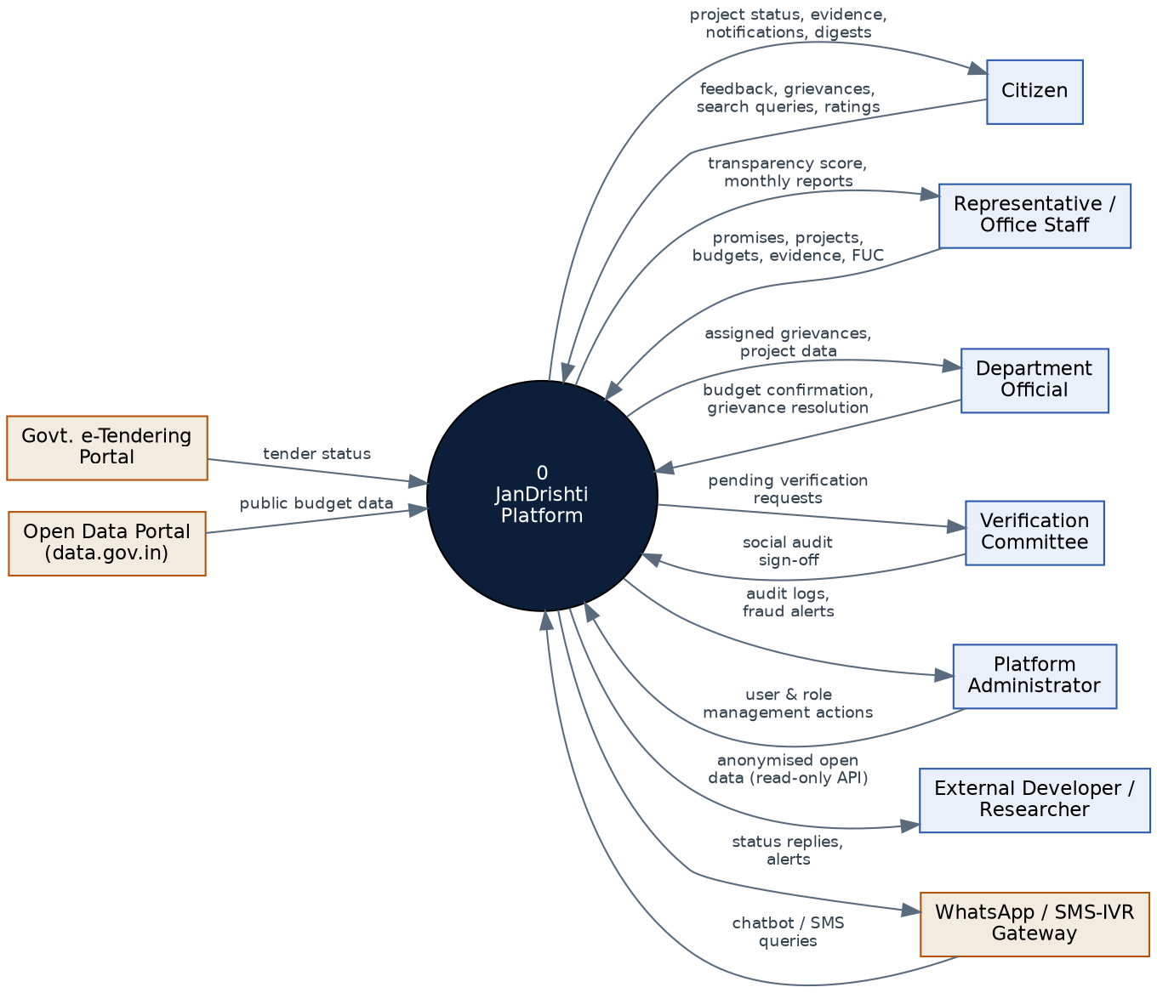
Figure 1 — DFD Level 0: Context Diagram

3.2 Level 1 DFD — Process Decomposition
Process 0 is decomposed into seven core processes, each reading from and writing to its own data store(s). Dashed arrows from 7.0 indicate that every process operates under the authenticated role context established by User & Access Management.
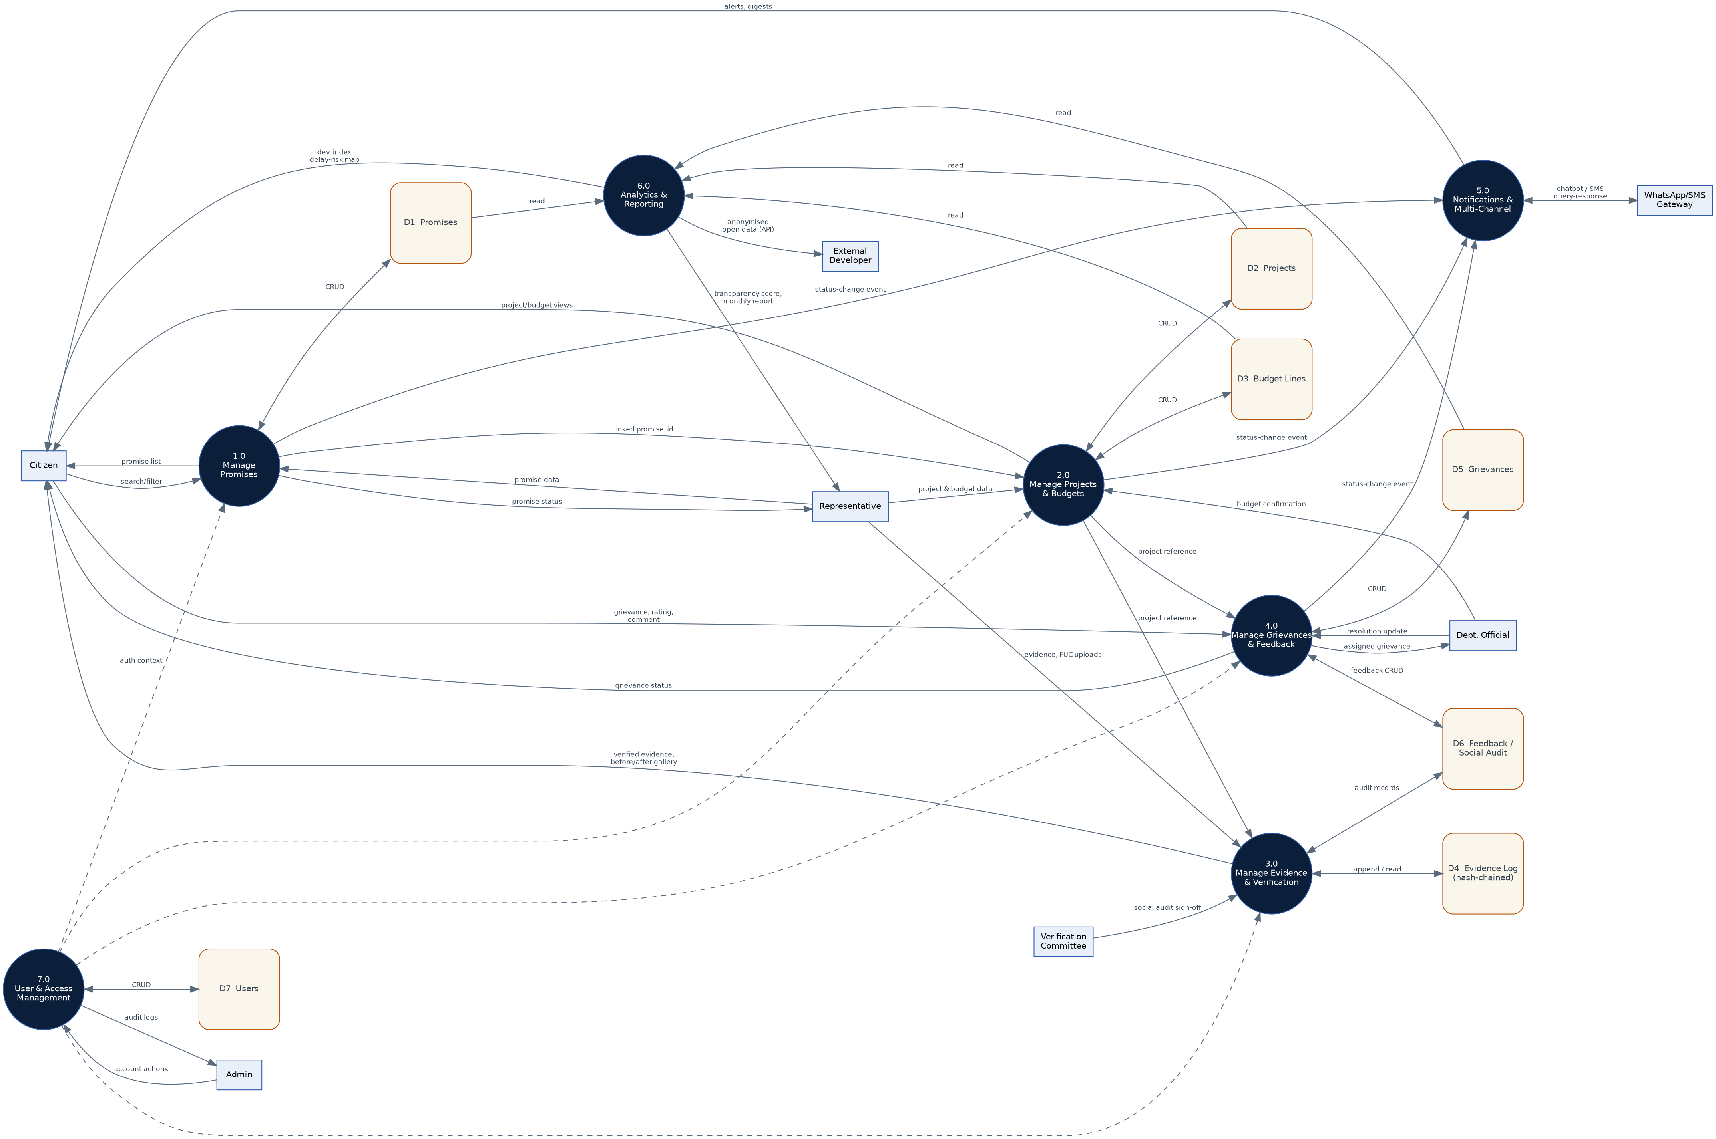
Figure 2 — DFD Level 1: Process Decomposition

3.3 Process Descriptions (Data Flow Narrative)
Process | Description | Data Stores Touched
1.0 Manage Promises | Create, update, and search promise records; log every status change | D1 Promises
2.0 Manage Projects & Budgets | Create/update projects and per-sector budget lines; link to promises and villages/wards | D2 Projects, D3 Budget Lines
3.0 Manage Evidence & Verification | Upload and hash-chain evidence; record FUC uploads and social audit sign-offs | D4 Evidence Log, D6 Feedback/Social Audit
4.0 Manage Grievances & Feedback | Accept citizen grievances/ratings, assign SLA, route to officials, track escalation | D5 Grievances, D6 Feedback/Social Audit
5.0 Notifications & Multi-Channel | Send status-change alerts and digests; serve WhatsApp/SMS/IVR queries | reads D1, D2, D5
6.0 Analytics & Reporting | Compute delay-risk, transparency score, development index; serve the public API | reads D1, D2, D3, D5
7.0 User & Access Management | Manage accounts, roles, and authentication context for all other processes | D7 Users

3.4 Worked Example: Grievance Lifecycle Data Flow
The diagram below traces a single grievance from submission through to resolution or escalation, and shows how it feeds the aggregate grievance heatmap (REQ-F-035).
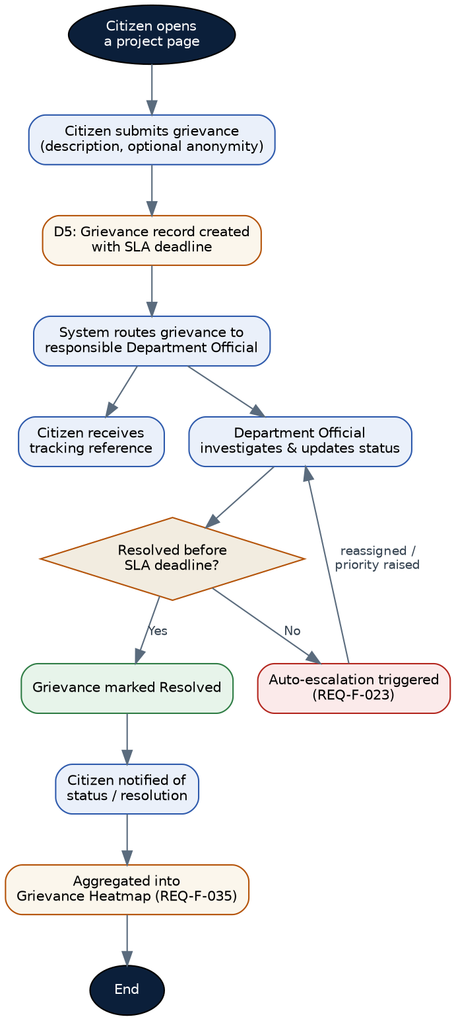
Figure 3 — Data Flow: Grievance Lifecycle (REQ-F-021 to REQ-F-023, REQ-F-035)

4. Entity Relationship Diagram
The ERD below shows all core entities, their key attributes, and the cardinality of each relationship, corresponding to the data model in SRS Section 7.
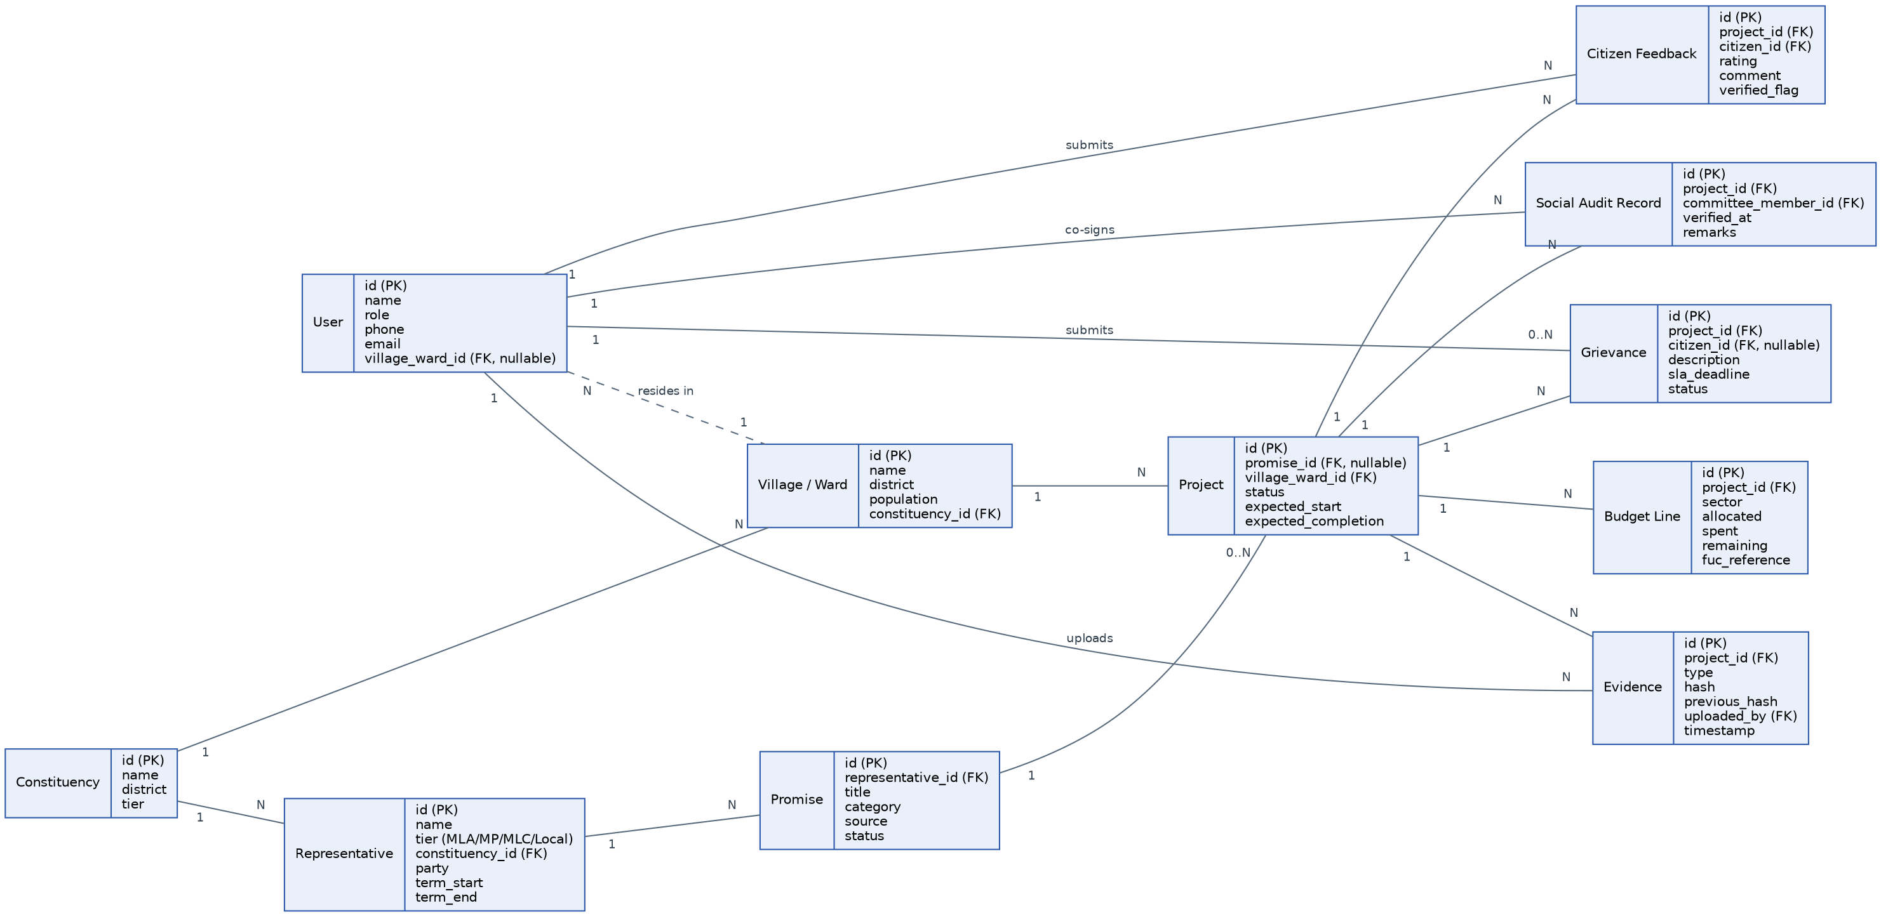
Figure 4 — Entity Relationship Diagram

5. Data Dictionary
Entity | Attribute | Type | Notes
Representative | id | PK, UUID
Representative | tier | Enum (MLA/MP/MLC/Local) | supports REQ-F multi-tier scope
Promise | status | Enum | Committed / In Progress / Completed
Project | promise_id | FK, nullable | a project may exist independent of a promise
Project | status | Enum | Completed / Ongoing / Pending
Budget Line | sector | Enum/String | Health, Education, Roads, Water, etc.
Evidence | hash / previous_hash | String (SHA-256) | forms the append-only tamper-evident chain
Grievance | citizen_id | FK, nullable | nullable to support anonymous submission
Grievance | sla_deadline | Timestamp | drives auto-escalation logic
Social Audit Record | committee_member_id | FK → User | restricted to Verification Committee role

6. Data Store Summary
Store | Contents | Primary Consumers
D1 Promises | Promise records and status history | Processes 1.0, 5.0, 6.0
D2 Projects | Project records, timelines, status | Processes 2.0, 3.0, 4.0, 5.0, 6.0
D3 Budget Lines | Allocated/spent/remaining per sector, FUC reference | Processes 2.0, 6.0
D4 Evidence Log | Hash-chained evidence metadata and file references | Process 3.0
D5 Grievances | Grievance records, SLA, status, escalation flags | Process 4.0, 6.0
D6 Feedback / Social Audit | Citizen ratings/comments and social audit sign-offs | Processes 3.0, 4.0
D7 Users | All accounts across roles, with role and linkage data | Process 7.0 (all others via auth context)

7. Traceability to SRS Requirements
Design Element | Related SRS Requirement IDs
Process 1.0 Manage Promises | REQ-F-005 to REQ-F-008
Process 2.0 Manage Projects & Budgets | REQ-F-009 to REQ-F-014
Process 3.0 Manage Evidence & Verification | REQ-F-015 to REQ-F-019
Process 4.0 Manage Grievances & Feedback | REQ-F-020 to REQ-F-025
Process 5.0 Notifications & Multi-Channel | REQ-F-024, REQ-F-025, REQ-F-026 to REQ-F-030
Process 6.0 Analytics & Reporting | REQ-F-031 to REQ-F-035, REQ-F-039
Process 7.0 User & Access Management | REQ-F-001 to REQ-F-004
Entity: Evidence (hash / previous_hash) | REQ-F-016, REQ-N-008
Entity: Grievance (sla_deadline) | REQ-F-022, REQ-F-023
Entity: Social Audit Record | REQ-F-019

8. Appendix

8.1 Assumptions Carried from SRS
- Every process operates within the role-based access control context established at authentication (REQ-F-002, REQ-F-003).
- All data stores are encrypted at rest (AES-256) and all flows between the client and API layer are encrypted in transit (TLS 1.3), per REQ-N-006 and REQ-N-007.

8.2 Open Items for Design Review
- Confirm whether Budget Line and FUC data require a separate approval workflow before publication.
- Confirm retention period for D4 Evidence Log and D5 Grievances to size storage and archival strategy.
- Confirm the anomaly-detection threshold used by Process 3.0 for FUC/spend discrepancy flags (REQ-F-018).

This System Design Document should be read alongside the JanDrishti BRS v2.0 and SRS v1.0.

