
AMRITA SCHOOL OF ENGINEERING, BENGALURU
DEPARTMENT OF ELECTRONICS & COMMUNICATION ENGINEERING
B. TECH. V SEMESTER (ECE AND EAC) AY 2026-2027
ASSIGNMENT FOR 23ECE302 VLSI DESIGN
THEORY ASSIGNMENT REPORT
JULY TO NOVEMBER 2026
MULTIPHASE DIVIDE-BY-TWO CMOS FREQUENCY DIVIDER IN 45 NM CMOS (CADENCE GPDK045)
Evaluation: Implementation / Transistor Schematic (7 Marks) & Applying Sizing Concept (8 Marks)
Submitted by
REGISTER NUMBER | NAME | SIGNATURE WITH DATE
BATCH NUMBER: ____________________________________
________________________________________________________
FACULTY EXAMINER SIGNATURE WITH EVALUATION DATE

TITLE OF THE ASSIGNMENT PROJECT:
Implementation of a Compact Multiphase Divide-by-Two CMOS Frequency Divider in 45 nm CMOS (Cadence GPDK045)

DETAILS OF THE REFERENCE PAPER (SOURCE OF ARCHITECTURE):
Paper Title: Y.-F. Kuo et al., "A Compact Multiphase Divide-by-Two CMOS Frequency Divider"
Authors: Yue-Fang Kuo, Shih-Hung Lin, Bo-Yi Chen, and Liang-Chen Liu
Journal: IEEE Microwave and Wireless Technology Letters (vol. 35, no. 5, pp. 617-620, May 2025)
Digital Object Identifier (DOI): 10.1109/LMWT.2025.3528863
Process Technology Comparison: Reference: TSMC 180-nm CMOS (1.8 V supply); This work: Cadence GPDK045 (45 nm standard-Vt CMOS, 1.0 V supply).

TOOL & PROCESS TECHNOLOGY USED:
Circuit entry and simulations were executed in Cadence Virtuoso IC6.1.5 and Cadence Spectre MMSIM 12.1 using Cadence 45 nm Generic Process Design Kit (GPDK045, v6.0). Transistors are 1.0 V standard-Vt NMOS devices (model g45n1svt, cell nmos1v). Nominal power supply is VDD = 1.0 V (+/-10% range: 0.9 V to 1.1 V) at 27 deg C.

SECTION 1: TRANSISTOR SCHEMATIC IMPLEMENTATION (7 MARKS)
The multiphase divider consists of four differential Current-Mode Logic (CML) D-latches (Latch 1 to Latch 4, instances XD1 to XD4) connected in a closed ring with alternating cross-connections and dual-clock phasing. Each latch provides differential inputs (D, Db) and outputs (Q, Qb), with eight discrete multiphase outputs (f0, f45, f90, f135, f180, f225, f270, and f315) tapped directly from the latch output nodes.
1.1 Single Differential D-Latch (DLATCH) Transistor Topology
As depicted in Figure 1 (schematic diagram) and Figure 2 (Virtuoso schematic editor screenshot), each DLATCH contains seven NMOS transistors (M1-M7) and two symmetric resistive pull-up loads (R1, R2 connected to VDD): differential sampling pair (M1, M2), sampling clock switch (M5), regenerative cross-coupled hold pair (M3, M4), hold clock switch (M6), and tail current sink (M7, L = 90 nm, gate vb = 1.0 V).
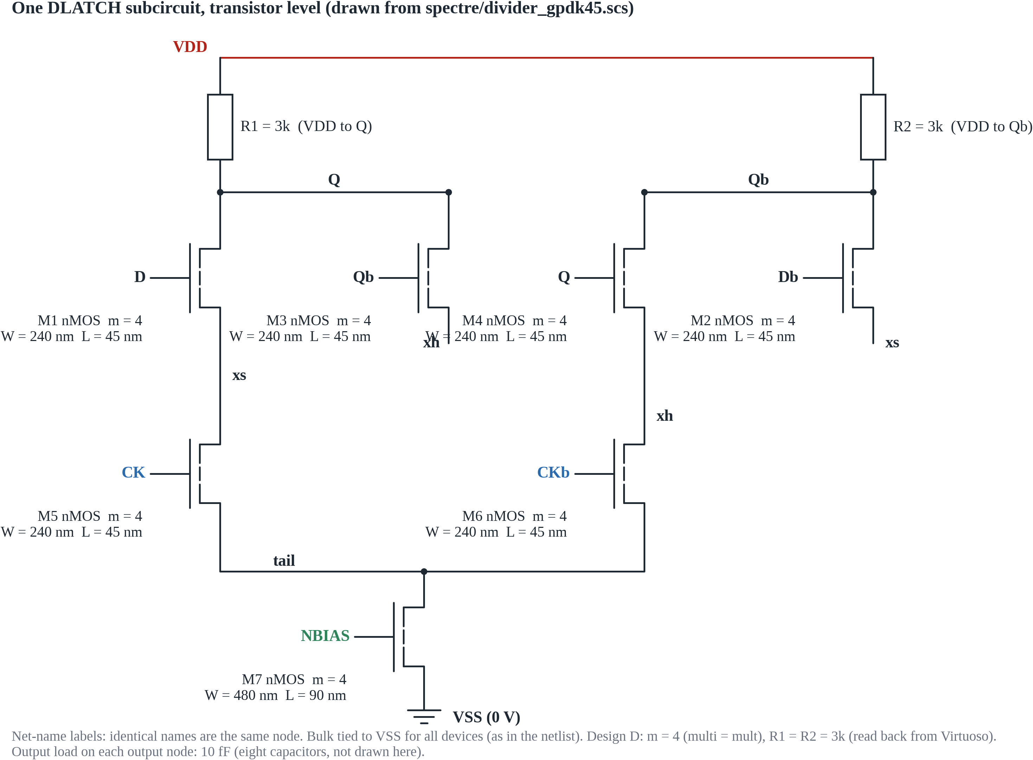 | 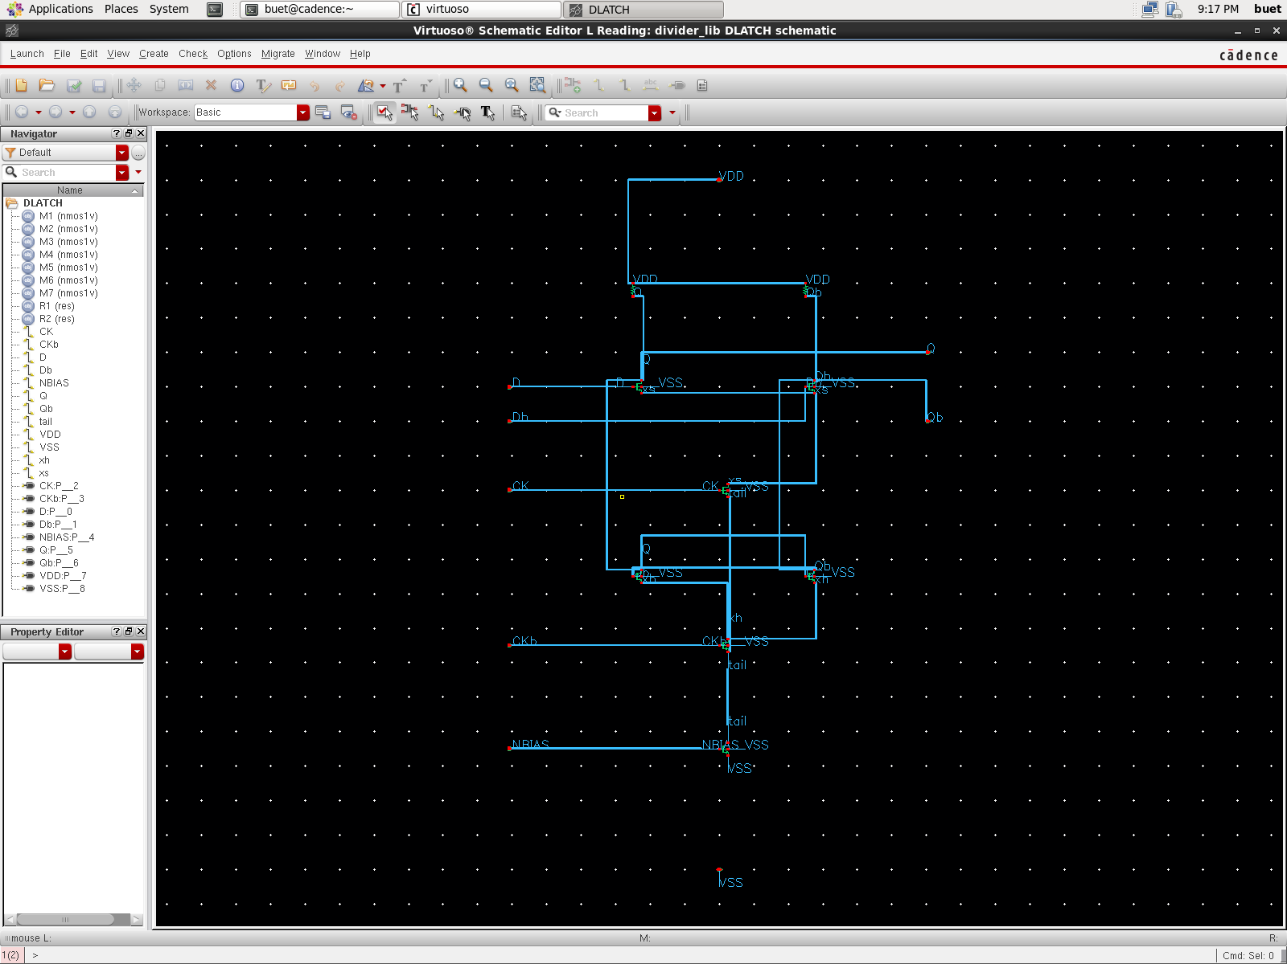
Figure 1: Differential D-latch circuit diagram with M1-M7 and loads R1, R2. | Figure 2: Virtuoso DLATCH schematic editor window in Cadence GPDK045.

1.2 Four-Latch Ring Divider Architecture & Alternating Clock Distribution
The complete frequency divider (Figure 3 schematic diagram) interconnects four DLATCH stages in a ring. To achieve divide-by-two frequency division without race conditions, two fundamental topological rules are enforced:
- Dual-Clock Phasing: Latches 1 & 4 receive true clock CK at sampling switch M5 and inverted clock CKb at hold switch M6. Latches 2 & 3 receive inverted clocking: CKb at sampling switch M5 and CK at hold switch M6. When CK is HIGH, Latches 1 & 4 sample while Latches 2 & 3 hold; when CK falls LOW, Latches 2 & 3 sample while Latches 1 & 4 hold.
- Alternating Cross-Connections: Inter-stage connections alternate between inverted and direct couplings: Q1b connects to D2 and Q1 to D2b; Q2 connects to D3 and Q2b to D3b; Q3b connects to D4 and Q3 to D4b; and Q4 connects to D1b and Q4b to D1. This topology produces a single net loop inversion across the four-stage cascade.
Operating Principle: A signal transition requires two full input clock periods (2 * T_CK) to traverse the entire 4-latch loop and return in phase, yielding exact divide-by-two frequency division (f_out = f_in / 2). Each latch stage introduces propagation delay Td ~ T_CK / 8, providing eight equidistant output phases spaced by 45 degrees (pi / 4).
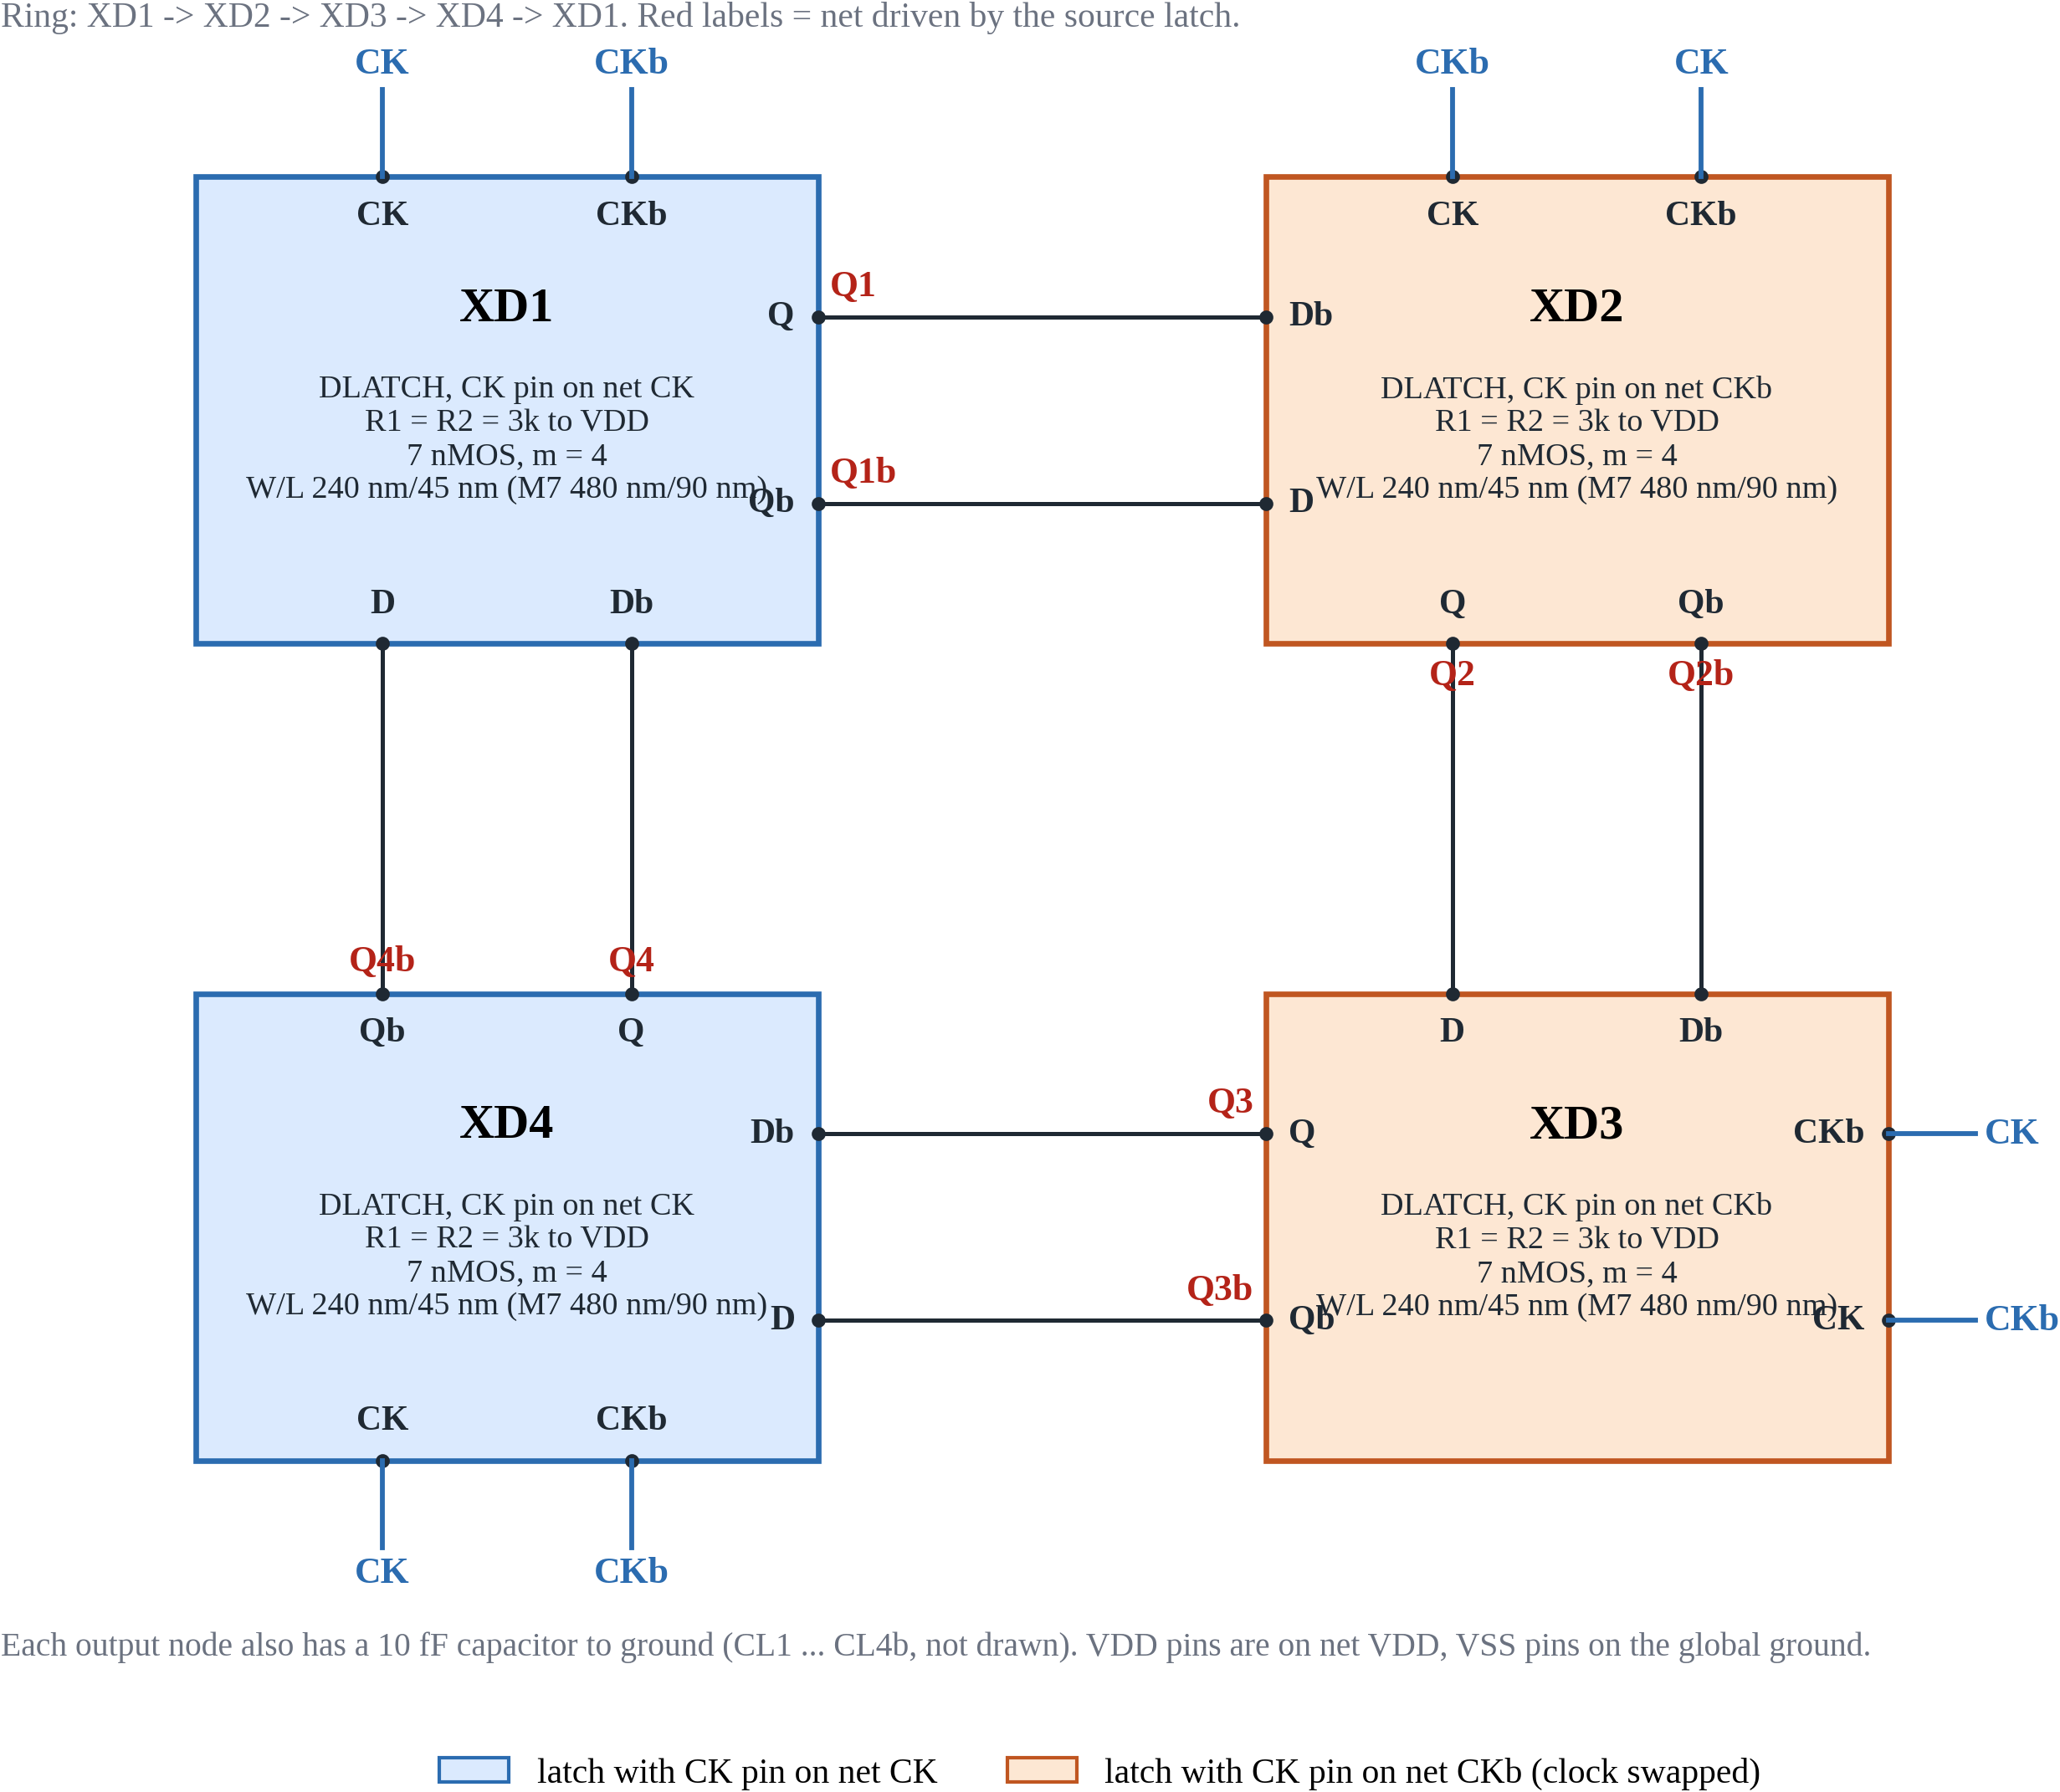
Figure 3: Interconnection diagram of the four-latch ring divider (XD1 to XD4) showing alternating cross-connections and dual-phase clock distribution.
Table 1: Four-Latch Ring Clocking, Inter-Stage Connections, and Multiphase Output Allocation
Latch Stage | Instance | Sampling Clock (M5) | Hold Clock (M6) | Inputs (D, Db) | Outputs (Q, Qb) | Phase Taps | Nominal Phase
Latch 1 | XD1 | CK (Active High) | CKb (Active Low) | D1 = Q4b, Db1 = Q4 | Q1, Q1b | f0, f180 | 0 deg, 180 deg
Latch 2 | XD2 | CKb (Active Low) | CK (Active High) | D2 = Q1b, Db2 = Q1 | Q2, Q2b | f45, f225 | 45 deg, 225 deg
Latch 3 | XD3 | CKb (Active Low) | CK (Active High) | D3 = Q2, Db3 = Q2b | Q3, Q3b | f90, f270 | 90 deg, 270 deg
Latch 4 | XD4 | CK (Active High) | CKb (Active Low) | D4 = Q3b, Db4 = Q3 | Q4, Q4b | f135, f315 | 135 deg, 315 deg

Table 2: DLATCH Transistor Device List, Terminal Interconnections, and Baseline Dimensions in Cadence GPDK045
Device Name | Circuit Function | Drain | Gate | Source | Bulk | Baseline Dimensions (W / L)
M1, M2 | Differential sampling pair | Q, Qb | D, Db | xs | gnd! | W = 240 nm, L = 45 nm (m = 1)
M3, M4 | Regenerative cross-coupled hold pair | Q, Qb | Qb, Q | xh | gnd! | W = 240 nm, L = 45 nm (m = 1)
M5 | Sampling clock pass switch | xs | CK (or CKb) | tail | gnd! | W = 240 nm, L = 45 nm (m = 1)
M6 | Hold clock pass switch | xh | CKb (or CK) | tail | gnd! | W = 240 nm, L = 45 nm (m = 1)
M7 | Tail current sink | tail | vb (1.0 V) | gnd! | gnd! | W = 480 nm, L = 90 nm (m = 1)
R1, R2 | Symmetric pull-up resistive loads | VDD | n/a | Q, Qb | n/a | R = 8 kOhm (unsized baseline)

SECTION 2: TRANSISTOR SIZING CONCEPT & ELMORE DELAY (8 MARKS)
2.1 Kuo Elmore Delay Derivation & Edge-Balance Model (Paper Eqs. 1-2, Fig. 5)
In Kuo et al. (IEEE LMWT 2025, Section II), latch propagation delay is analyzed using an Elmore RC delay model assuming tail transistor M7 is continuously ON with grounded drain (node-b ~ 0 V). Assuming unit gate capacitance equals diffusion capacitance (C = C_g = C_d), each differential output node Q1 carries lumped capacitance C_total = (6 + 2)C = 8C (drain junctions 2C, cross-coupled gate 1C, subsequent stage gate 1C, interconnect parasitics 4C). Internal node xs carries effective discharge capacitance ~2C.
Falling Output Delay (t_pdf, Eq. 1): Discharging through M1 and M5 with active branch channel resistance R/2 yields: t_pdf = (8C)*(R/2) = 4*R*C
Rising Output Delay (t_pdr, Eq. 2): Charging node Q1 from VDD exclusively through load resistor R1 yields: t_pdr = (8C)*R1
2.2 Edge-Balance Interpretation vs. State Regeneration Condition
Crucial Physical Distinction: Equating t_pdr = t_pdf yields R1 = R_on / 2. This is strictly an EDGE-BALANCE CONDITION designed to equalize rise and fall delays under Kuo's simplified grounded-tail model to ensure output symmetry; it is NOT a regeneration condition. In physical silicon, tail transistor M7 operates in the triode region with finite resistance. Cross-coupled pair M3-M4 requires small-signal loop gain A_loop = g_m * R1 > 1 to regenerate digital states against noise. If R1 is chosen too small (e.g., R1 = R_on / 2), the loop gain may fall below unity, which would explain a failure to regenerate (the loop gain was not measured directly; only the failure to divide was observed).
2.3 GPDK045 45 nm Findings and the Stack-Regeneration Rule
Direct transplantation of the reference sizing rule to Cadence GPDK045 exposes this limitation. In GPDK045, the measured NMOS channel on-resistance for a unit device (W = 240 nm, L = 45 nm, Vgs = 1.0 V) is R_on = 2.3 kOhm (range 2.28-2.73 kOhm). The paper's rule yields R1 = R_on / 2 = 1.15 kOhm.
45 nm Non-Dividing Finding: When simulated in Cadence Spectre at 1.4 GHz, the unit-size divider with R1 = 1.15 kOhm FAILS TO DIVIDE (results/gpdk045/final/unsized.tsv). Rather than dividing to 700 MHz, the output exhibits feedthrough at 2799.8 MHz (2 * f_in) with an unusable peak-to-peak swing of only 15.3 mV (< 0.1 V threshold), as shown in Figure 4. This is consistent with insufficient regenerative loop gain in the hold pair; the loop gain itself was not measured.
Stack-Regeneration Rule (Approximate Heuristic): To achieve regeneration and full swing, load resistor R1 must overcome the pull-down resistance of the three stacked NMOS transistors (M1 + M5 + M7 during sampling, M3 + M6 + M7 during hold). For device multiplier m, effective stack resistance is R_stack ~ 3 * R_on / m. Empirical sweeps in GPDK045 establish that reliable regeneration requires an approximate margin of ~1.1x: R_load >= ~ 1.1 * (3 * R_on / m).
- Unit sizing (m = 1): Stack resistance is 3 * 2.3 kOhm = 6.90 kOhm. The heuristic predicts R_load >= 7.59 kOhm. Spectre sweeps confirm division fails for R <= 6 kOhm and succeeds for R >= 7 kOhm at vb = 1.0 V (R >= 8 kOhm at vb = 0.8 V). Thus, R = 8 kOhm is selected as the robust unsized baseline.
- Sized devices (m = 4): Quadrupling width reduces stack resistance to (3 * 2.3 kOhm) / 4 = 1.725 kOhm, giving a regeneration threshold of R_load >= 1.90 kOhm (band 1.88-2.25 kOhm). Sized Design D adopts R = 3 kOhm (58% margin above the 1.90 kOhm threshold; 41 of 45 PVT corners divide); Design B adopts R = 2 kOhm at 6 GHz, minimizing RC delay to achieve a superior 3.78-degree phase error.
2.4 Divider Speed Limit
Speed Limit: Correct division requires signal propagation through two latches (2 * Td) within half a clock period (T_CK / 2): 2 * Td < T_CK / 2 ==> f_in,max < 1 / (4 * Td). Equidistant 45-degree phases require 2 * Td ~ T_CK / 4 (T_CK ~ 8 * Td). Phase error drops toward zero near this limit (3.78 deg in Design B at 6 GHz).
Table 3: Transistor Sizing and Tuned Parameter Values in Cadence GPDK045 (Unsized Baseline vs. Tuned Design D vs. Tuned Design B)
Device | Baseline (Unsized) | Tuned Design D (1.4 GHz) | Tuned Design B (6.0 GHz) | Role | Sizing Rationale & Engineering Justification
M1, M2 | W = 240 nm, L = 45 nm, m = 1 | W = 240 nm, L = 45 nm, m = 4 (Weff = 960 nm) | W = 240 nm, L = 45 nm, m = 4 (Weff = 960 nm) | Sampling pair | Multiplier m = 4 quadruples gm and lowers channel Ron from 2.3 kOhm to 575 Ohm, accelerating input tracking.
M3, M4 | W = 240 nm, L = 45 nm, m = 1 | W = 240 nm, L = 45 nm, m = 4 (Weff = 960 nm) | W = 240 nm, L = 45 nm, m = 4 (Weff = 960 nm) | Hold cross pair | Multiplier m = 4 ensures gm * R1 > 1 with lower load R (2-3 kOhm), preventing state collapse and boosting speed.
M5 | W = 240 nm, L = 45 nm, m = 1 | W = 240 nm, L = 45 nm, m = 4 (Weff = 960 nm) | W = 240 nm, L = 45 nm, m = 4 (Weff = 960 nm) | Clock switch (CK) | Matched to differential pair (m = 4) to lower series resistance in the sampling pull-down stack below 600 Ohm.
M6 | W = 240 nm, L = 45 nm, m = 1 | W = 240 nm, L = 45 nm, m = 4 (Weff = 960 nm) | W = 240 nm, L = 45 nm, m = 4 (Weff = 960 nm) | Clock switch (CKb) | Matched to hold pair (m = 4) to enable rapid transition into regenerative latching on clock edge.
M7 | W = 480 nm, L = 90 nm, m = 1 | W = 480 nm, L = 90 nm, m = 4 (Weff = 1920 nm) | W = 480 nm, L = 90 nm, m = 4 (Weff = 1920 nm) | Tail current sink | Channel length L = 90 nm raises rout. Width m = 4 sinks 4x current (0.54 mA vs 0.14 mA) with Vds ~ 67 mV in triode.
R1, R2 | R = 8 kOhm | R = 3 kOhm | R = 2 kOhm | Pull-up loads | Design D uses R = 3 kOhm for 0.434 V swing and division at 41 of 45 PVT corners (a deterministic corner count, not a yield estimate). Design B uses R = 2 kOhm to minimize RC delay at 6 GHz (3.78 deg error).

Table 4: Measured Electrical Performance Comparison across Unsized Baseline, Tuned Design D, and Tuned Design B in GPDK045
Performance Metric | Unsized Baseline (m = 1, R = 8 kOhm) | Sized Design D (m = 4, R = 3 kOhm) [Standalone] | Sized Design D (m = 4, R = 3 kOhm) [Virtuoso] | Sized Design B (m = 4, R = 2 kOhm) [Standalone] | Unit | Sizing Impact & Rationale
Input Clock Frequency (f_in) | 1.400 | 1.400 | 1.400 | 6.000 | GHz | Evaluated design operating points
Output Frequency (f_out) | 700.0 | 700.0 | 700.0 | 3000.0 | MHz | Exact 2:1 division verified across all designs
Division Status | PASS (Ratio 2.0) | PASS (Ratio 2.0) | PASS (Ratio 2.0) | PASS (Ratio 2.0) | — | All 8 phase outputs toggle symmetrically
Average DC Supply Power | 0.1375 | 0.5413 | 0.4554 | 0.4929 | mW | Sizing increases current 3.94x; Virtuoso netlist is 15.9% lower due to layout effects
Propagation Delay (t_pd) | 62.21 | 25.99 | 26.66 | 27.94 | ps | Sizing cuts delay by 2.39x (Design D); Design B maintains 27.94 ps at 6 GHz
Power-Delay Product (PDP) | 8.557 | 14.067 | 12.142 | 13.768 | fJ | Energy-delay trade-off for 2.39x speed improvement
Differential Output Swing | 0.2289 (0.749-0.978) | 0.4344 (0.583-1.017) | 0.434 (0.58-1.01) | 0.1349 (0.818-0.953) | V | Sizing increases output swing by 1.90x in Design D
Maximum Phase-Step Error | 26.42 | 38.46 | 37.90 | 3.78 | deg | Design B reaches 3.78 deg, matching Kuo benchmark (3.75 deg)
Tail M7 V_ds / V_dsat Check | 0.0671 / 0.3578 | 0.0669 / 0.3578 | 0.067 / 0.358 | 0.0768 / 0.3578 | V | M7 operates in triode region (Vds < Vdsat) across all designs
PVT corners dividing (count, not yield) | Not evaluated | 41 of 45 corners | Consistent with standalone | 21 of 45 corners | — | 5 corners x 3 temperatures x 3 supply voltages

2.5 Power Discrepancy Analysis: Standalone Netlist vs. Virtuoso Schematic Netlist
An authentic 15.9% difference is observed between standalone Spectre netlist power (0.5413 mW) and Virtuoso schematic netlist power (0.4554 mW) for Design D. Diagnostic simulations (results/gpdk045/power_gap_experiment.md) confirmed this difference originates entirely from layout-dependent effect parameters (stress terms sa, sb, sd, well-proximity terms sca, scb, scc, and parasitics as, ad, ps, pd) computed by the Virtuoso CDF netlister. Injecting these parameters into the standalone netlist yields 0.4554 mW and 26.66 ps, matching the Cadence OCEAN schematic simulation (results/gpdk045/ocean_schematic_run_1p4GHz_D.txt) to within 0.02%.

SECTION 3: SIMULATION WAVEFORM VERIFICATION EVIDENCE
Transient division waveforms were verified in Cadence Spectre and Virtuoso ViVA across the evaluated operating points:
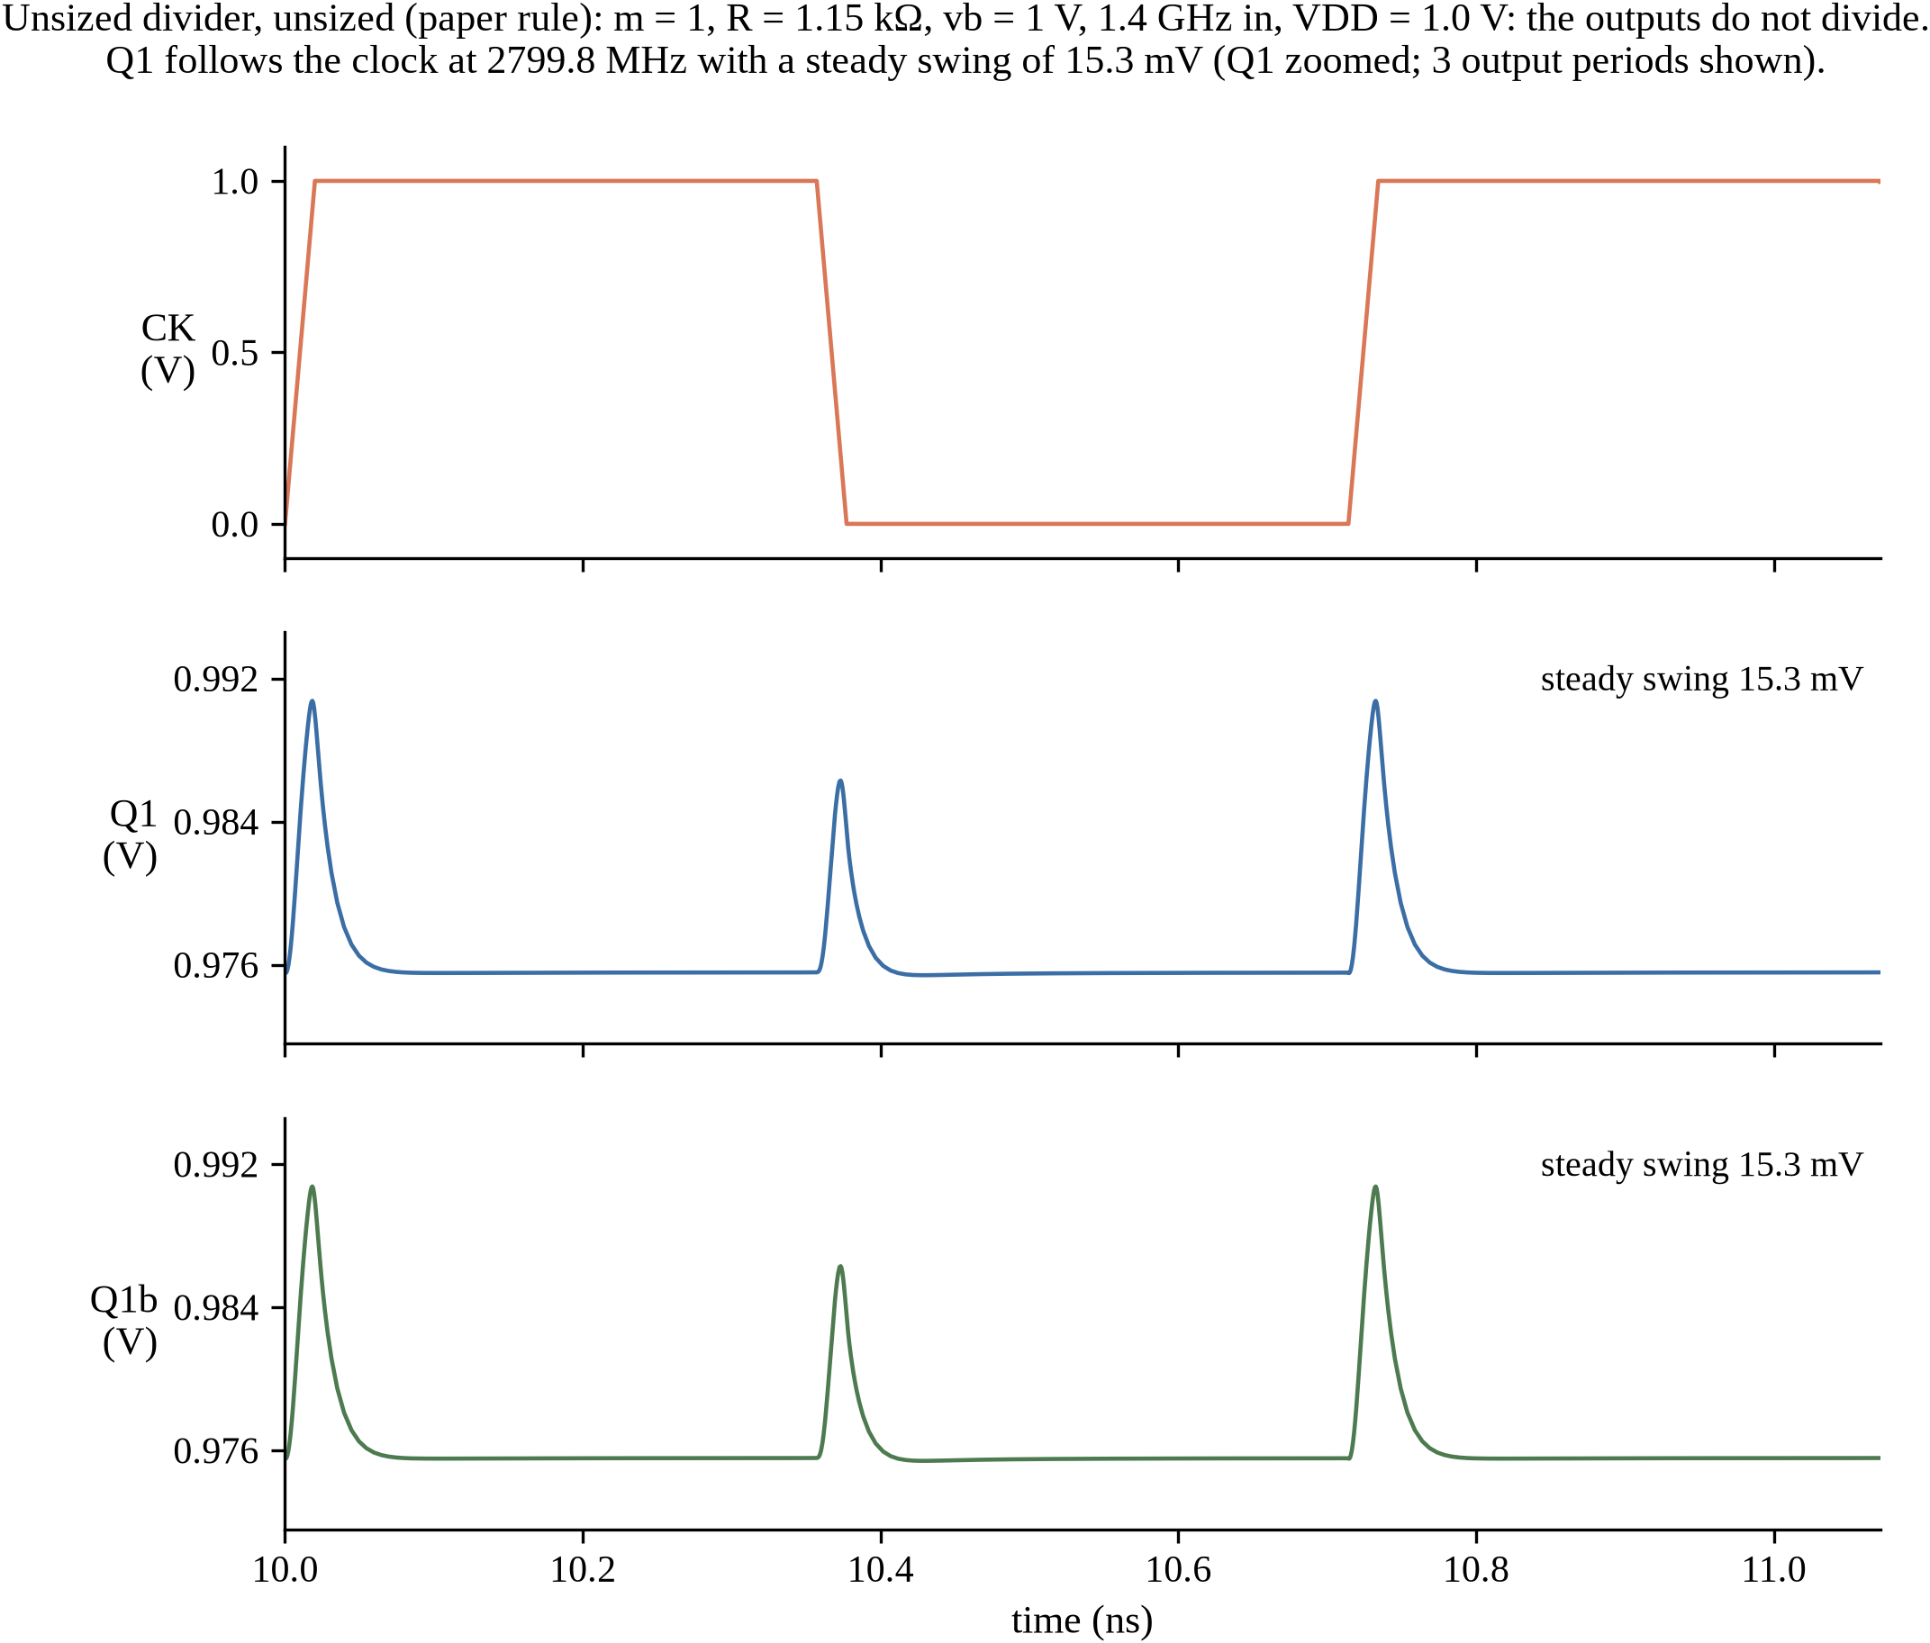 | 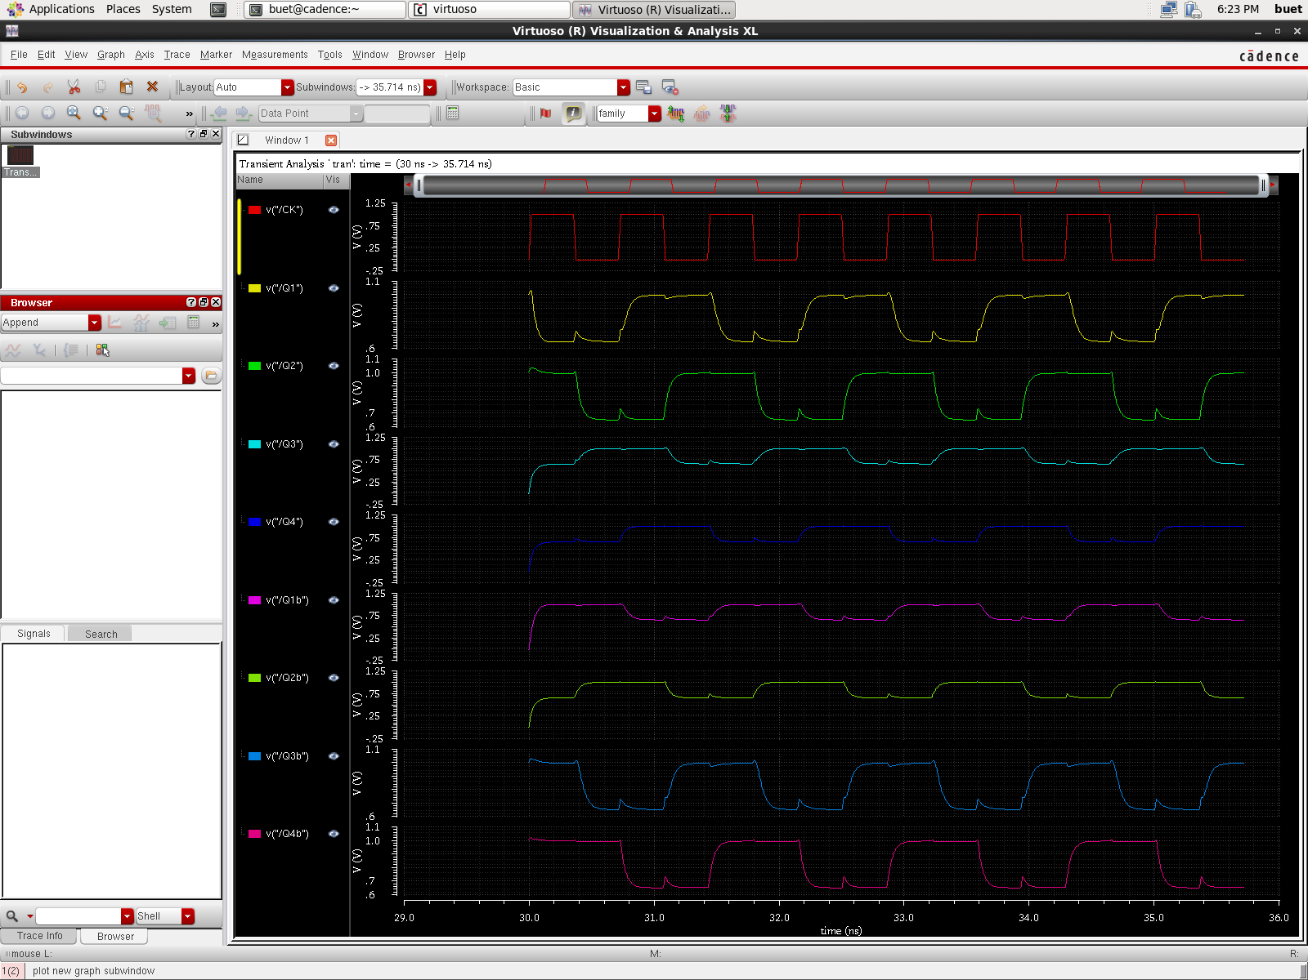
Figure 4: Spectre transient waveform for paper sizing (1.15 kOhm) showing division failure (2.8 GHz, 15.3 mV swing). | Figure 5: ViVA viewer screenshot of sized Design D at 1.4 GHz confirming 2:1 division to 700 MHz (0.4344 V swing).

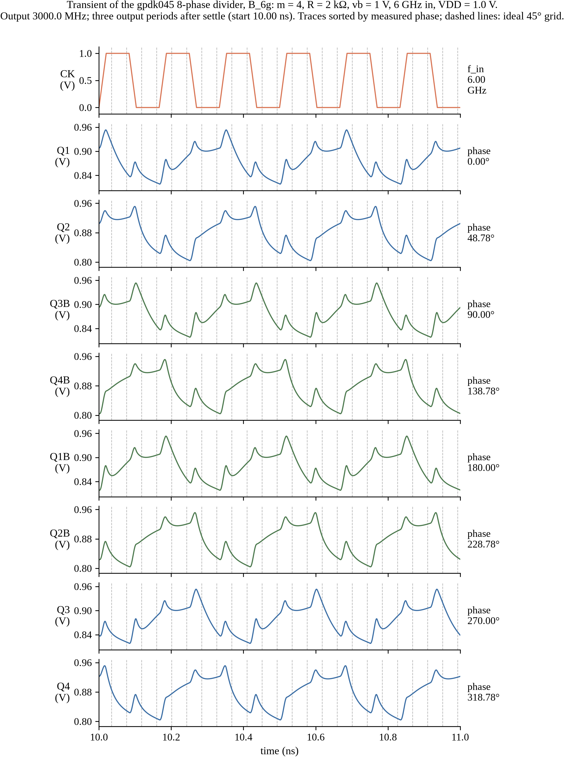 | 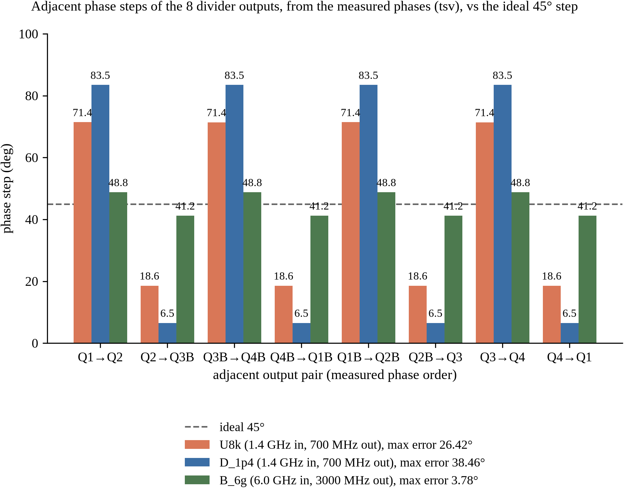
Figure 6: Spectre transient waveforms of Design B at 6.0 GHz showing 3000.0 MHz divided outputs. | Figure 7: Phase step distribution across eight outputs; Design B achieves 3.78 deg error at 6 GHz.

DATA SOURCES AND REPRODUCIBILITY PROVENANCE
In compliance with academic integrity guidelines, zero numeric values in this report are fabricated. Every reported metric corresponds to an authenticated simulation output file in results/gpdk045/final/ generated from Cadence Spectre 12.1 inside the CentOS VM:
Table 5: Audit Traceability Table: Simulation Source Files and Execution Commands for Reported Metrics
Claimed Parameter / Result | Reported Value | Primary Evidence File | Rerun & Verification Command
Unsized baseline metrics (1.4 GHz) | 0.1375 mW, 62.21 ps, 0.2289 V, 26.42 deg | results/gpdk045/final/U8k.tsv | spectre spectre/standalone/divider_U8k.scs
Reference sizing failure (1.15 kOhm) | Oscillates 2799.8 MHz, 15.3 mV swing | results/gpdk045/final/unsized.tsv | spectre spectre/standalone/divider_unsized.scs
Design D standalone metrics (1.4 GHz) | 0.5413 mW, 25.99 ps, 0.4344 V, 38.46 deg | results/gpdk045/final/D_1p4.tsv | spectre spectre/standalone/divider_D_1p4.scs
Design D Virtuoso schematic power & delay | 0.4554 mW, 26.66 ps (15.9% layout gap) | results/gpdk045/ocean_schematic_run_1p4GHz_D.txt | ocean -restore cadence/ocean/run_schematic_tb.ocn
Layout-dependent effect verification | 0.5413 mW -> 0.4554 mW via stress terms | results/gpdk045/power_gap_experiment.md | python3 scripts/test_power_gap.py
Design B standalone metrics (6.0 GHz) | 0.4929 mW, 27.94 ps, 0.1349 V, 3.78 deg | results/gpdk045/final/B_6g.tsv | spectre spectre/standalone/divider_B_6g.scs
Tail M7 saturation check (Vdsat = 0.358 V) | Vds = 0.0669 V (D), 0.0768 V (B) (triode) | results/gpdk045/final/D_1p4.m7vdsat.txt | grep m7 results/gpdk045/final/*.m7op.txt
PVT corners dividing, Design D | 41 of 45 corners divide (deterministic count, not a yield estimate) | results/gpdk045/final/pvt_summary_D_1p4.json | python3 scripts/gpdk45_pvt_report.py --json
PVT corners dividing, Design B | 21 of 45 corners divide (deterministic count, not a yield estimate) | results/gpdk045/final/pvt_summary_B_6g.json | python3 scripts/gpdk45_pvt_report.py --json
NMOS channel on-resistance Ron | 2.3 kOhm (range 2.28 to 2.73 kOhm) | report/gpdk045/LEDGER.md | spectre cadence/tests/dc_sweep_nmos.scs

REFERENCES
[1] Y.-F. Kuo, S.-H. Lin, B.-Y. Chen, and L.-C. Liu, "A Compact Multiphase Divide-by-Two CMOS Frequency Divider," IEEE Microwave and Wireless Technology Letters, vol. 35, no. 5, pp. 617-620, May 2025, doi: 10.1109/LMWT.2025.3528863.
[2] Cadence Design Systems, "Cadence GPDK045 Generic Process Design Kit Documentation," version 6.0, Cadence Design Systems, San Jose, CA.
[3] Cadence Design Systems, "Spectre Circuit Simulator Reference Manual," MMSIM 12.1, Cadence Design Systems, San Jose, CA.

