Local Simulation Report:
8-Phase Divide-by-Two CMOS Frequency Divider
ngspice validation of the Kuo et al. (IEEE MWTL, May 2025) topology
Date: 2026-10-30

Scope of every number in this report
- Simulations use a GENERIC LEVEL=1 180 nm model deck (spice/models/cmos180.mod). This is NOT a foundry model and NOT the Cadence gpdk045 PDK.
- The PVT corners are SYNTHETIC (VTO shifted by 50 mV, KP scaled by 15 percent). They are not foundry corners.
- The Cadence gpdk045 results will replace these numbers when that run is finished.

2 Purpose and scope
This report documents the ngspice simulations that were run locally for the 8-phase divide-by-two CMOS frequency divider in this repository. The topology is the one in Kuo et al., "A Compact Multiphase Divide-by-Two CMOS Frequency Divider", IEEE MWTL, May 2025, which is the reference of the project reports.
The work had four goals:
- check whether the original repository netlist divides by two (it does not, Section 5);
- find a calibrated netlist that divides, and record which change made the difference (Section 5, Table 4);
- measure the calibrated baseline: frequency, the eight output phases, CK-to-output delay, supply power and power-delay product (Section 6);
- run a 27-point PVT sweep of the calibrated netlist and check every measurement with an automated script (Sections 7 and 8).
Read this first
- The simulations use a GENERIC LEVEL=1 180 nm model deck (spice/models/cmos180.mod). It is not a foundry model and it is not gpdk045.
- The corners are SYNTHETIC. FF shifts VTO by -50 mV and scales KP by 1.15; SS shifts VTO by +50 mV and scales KP by 0.85 (both device types). The temperature points are -40, 27 and 125 C.
- The Cadence gpdk045 results will replace these numbers. spectre/divider_gpdk45.scs is written but has not been run, and no Cadence result file exists under results/.
- The calibration (5 kOhm loads, 1.2 V bias, 30 fF load on every output) was chosen by the division search in Section 5. These values differ from the original repository netlist.

3 Tools and environment
Simulator: ngspice-41 (the conda-forge ngspice-41 package; the binary reports "ngspice-41"). It is not on PATH in this environment, so the scripts take the binary from the NGSPICE environment variable. Measurement and plotting use Python with numpy and matplotlib. The report itself was generated with python-docx 1.2.0, matplotlib 3.11.2, numpy 2.5.4 under Python 3.14.6, in a separate virtual environment.
Project scripts used for the results in this report:
Table 1. Scripts and what each one does.
Script | Purpose
scripts/divider_sim.py | Shared runner. Writes a temporary deck from spice/divider_baseline_cal.cir with the given VDD, temperature and synthetic corner, runs ngspice in batch mode and measures the output.
scripts/measure_tran.py | Measurement. From the wrdata waveform: CK and output edges, frequency, division ratio, eight phases, supply power, CK-to-output delay and PDP.
scripts/analyze_baseline.py | Runs the calibrated baseline at TT / 27 C / 1.8 V and writes results/metrics_baseline.json.
scripts/run_pvt_matrix.py | 27-run PVT sweep (3 synthetic corners x -40/27/125 C x 1.62/1.80/1.98 V). Writes results/pvt_summary_table.csv; failing runs are kept as FAIL rows.
scripts/make_plots.py | Draws the three plots in results/plots/ from the measured waveform, JSON and CSV.
scripts/validate.py | 13 independent checks. Re-measures the raw waveform and compares it with the JSON and CSV (Section 8).
scripts/build_local_report.py | Builds this report: figures drawn from the netlist, the division-search chart, and the .docx.

4 Circuit description
The divider is a ring of four DLATCH subcircuits (XD1 to XD4). Each latch has a sampling pair (M1, M2, inputs D and Db) and a cross-coupled hold pair (M3, M4). Clock switch M5 (gate CK) steers the tail current from M7 (gate nbias) into the sampling pair through node xs. Clock switch M6 (gate CKb) steers the same tail current into the hold pair through node xh. Each latch has two 5 kOhm pull-up resistors to VDD, at Q and Qb. In the calibrated netlist every one of the eight outputs has a 30 fF load to ground.
Figure 1 shows one latch at transistor level. Figure 2 shows the ring. Both were drawn by scripts/build_local_report.py from the parsed netlist, and the script asserts the connectivity before drawing.
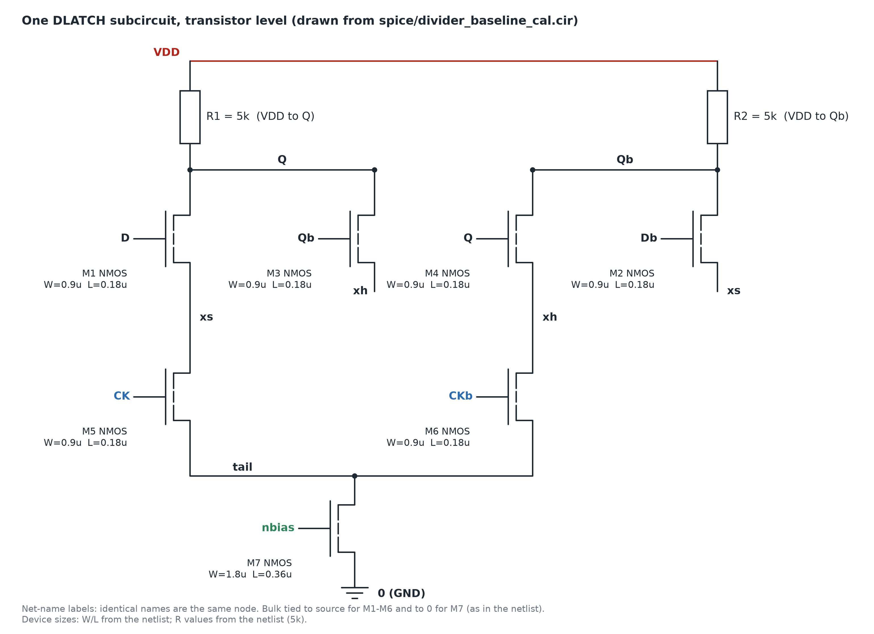
Figure 1. Transistor-level schematic of one DLATCH, drawn programmatically from the simulated netlist (spice/divider_baseline_cal.cir); not a Cadence screenshot. Device names, drain/gate/source/bulk nets, W/L and the R values are read from the netlist. Nets with the same name are the same node.
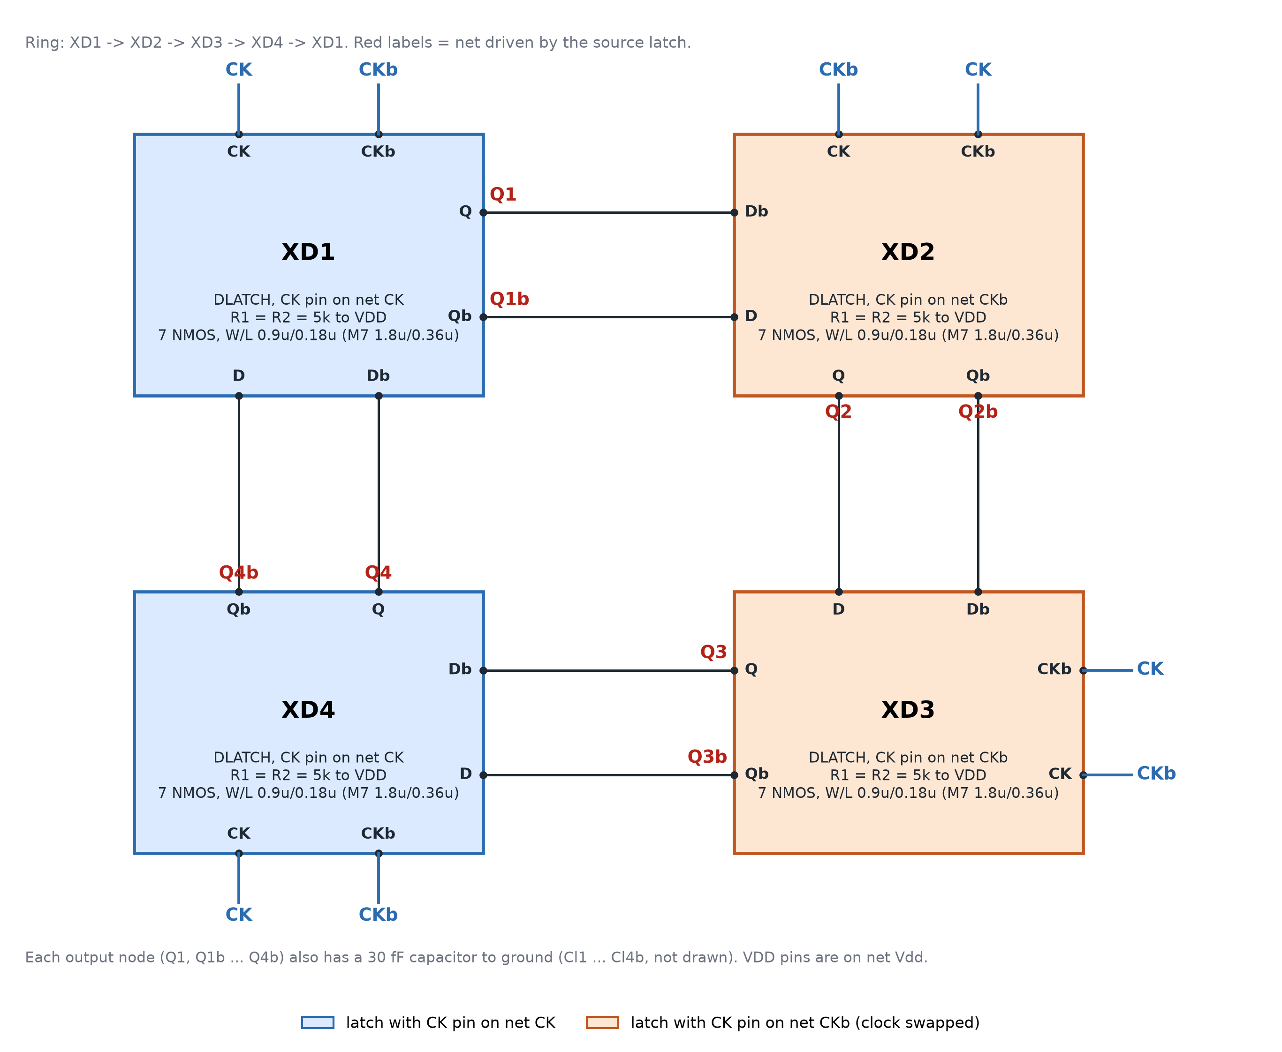
Figure 2. Top-level ring of four DLATCH instances, drawn programmatically from the simulated netlist; not a Cadence screenshot. Each latch takes both outputs of its predecessor (Q1b drives D2, Q1 drives Db2, and so on). Blue: latches whose CK pin is on net CK (XD1, XD4). Orange: latches whose CK pin is on net CKb (XD2, XD3), so the clock is swapped for these two.
Table 2. Device sizes of one DLATCH, from the netlist. All four instances use the same subcircuit.
Device | Type | Drain / n1 | Gate | Source / n2 | Bulk | W | L / value
M1 | NMOS | Q | D | xs | xs | 0.9u | 0.18u
M2 | NMOS | Qb | Db | xs | xs | 0.9u | 0.18u
M5 | NMOS | xs | CK | tail | tail | 0.9u | 0.18u
M3 | NMOS | Q | Qb | xh | xh | 0.9u | 0.18u
M4 | NMOS | Qb | Q | xh | xh | 0.9u | 0.18u
M6 | NMOS | xh | CKb | tail | tail | 0.9u | 0.18u
M7 | NMOS | tail | nbias | 0 | 0 | 1.8u | 0.36u
R1 | resistor | VDD | - | Q | - | - | 5k
R2 | resistor | VDD | - | Qb | - | - | 5k

Sources in the top level: Vdd = 1.8 V; CK and CKb are 1.4 GHz pulse clocks (CKb is delayed by half a period, as written in the netlist); nbias = 1.2 V in the calibrated netlist.
Table 3. Interconnect of the four latches, from the netlist (pin order D, Db, CK, CKb, Q, Qb).
Latch | D | Db | CK | CKb | Q | Qb | CK pin is on
XD1 | Q4b | Q4 | CK | CKb | Q1 | Q1b | CK
XD2 | Q1b | Q1 | CKb | CK | Q2 | Q2b | CKb
XD3 | Q2 | Q2b | CKb | CK | Q3 | Q3b | CKb
XD4 | Q3b | Q3 | CK | CKb | Q4 | Q4b | CK
Ring connections: Q1b -> D2 and Q1 -> Db2; Q2 -> D3 and Q2b -> Db3; Q3b -> D4 and Q3 -> Db4; Q4b -> D1 and Q4 -> Db1. Each latch receives both outputs of its predecessor, so the ring has eight data wires, not four.

5 Finding: the original netlist does not divide
The original repository netlist (spice/divider_baseline.cir) uses 1.5 kOhm loads, a 0.9 V bias, no output load and no .ic start-up. It was simulated as written and with an .ic start-up, and then swept in bias and load resistance. None of these settings divided. Table 4 lists the differences between the original and the calibrated netlist, derived by parsing both files. Table 5 gives the search results.
Table 4. Differences between the original repository netlist and the calibrated netlist (both parsed from the files). Transistor sizes are identical in both.
Item | Original (divider_baseline.cir) | Calibrated (divider_baseline_cal.cir)
Latch load resistors R1, R2 | 1.5k | 5k
Bias voltage nbias | 0.9 V | 1.2 V
Output load capacitors | 0 (none) | 8 x 30f to ground
Initial conditions (.ic) | no | yes (V(Q1)=1.8 V, V(Q1b)=0, ...)
.tran with uic (use initial conditions) | no | yes

Table 5. Division search (local ngspice runs). Generic 180 nm LEVEL=1 deck, fin 1.4 GHz, VDD 1.8 V, with .ic start-up where stated.
Case | Load R | Vbias | Output load | Result
Original netlist as written (no .ic) | 1.5k | 0.9 V | none | No division: Q and Qb of every latch sit at the same voltage (1.64 to 1.81 V)
Original + .ic | 1.5k | 0.9 V | none | No division (same)
Bias sweep | 1.5k | 1.0, 1.2, 1.4, 1.6 V | none | No division at any bias
R sweep | 3k, 5k, 8k | 0.9 / 1.2 V | none | 8k at 0.9 V and 5k at 1.2 V: outputs toggle at 1426-1451 MHz (ratio 0.96-0.98, following the clock, not dividing); 3k: no toggling
Calibrated, load 10 fF | 5k | 1.2 V | 10 fF | f_out 1451.9 MHz, ratio 0.964: not dividing
Calibrated, load 30 fF | 5k | 1.2 V | 30 fF | f_out 700.0 MHz, ratio 2.000: DIVIDES (chosen operating point)
Calibrated, load 40 fF | 5k | 1.2 V | 40 fF | 983.4 MHz, ratio 1.424: fails
Calibrated, load 50 fF | 5k | 1.2 V | 50 fF | 452.1 MHz, ratio 3.097: fails
Calibrated, load 60 fF | 5k | 1.2 V | 60 fF | 233.3 MHz, ratio 6.000: fails
Calibrated, load 80 fF | 5k | 1.2 V | 80 fF | 337.1 MHz, ratio 4.153: fails

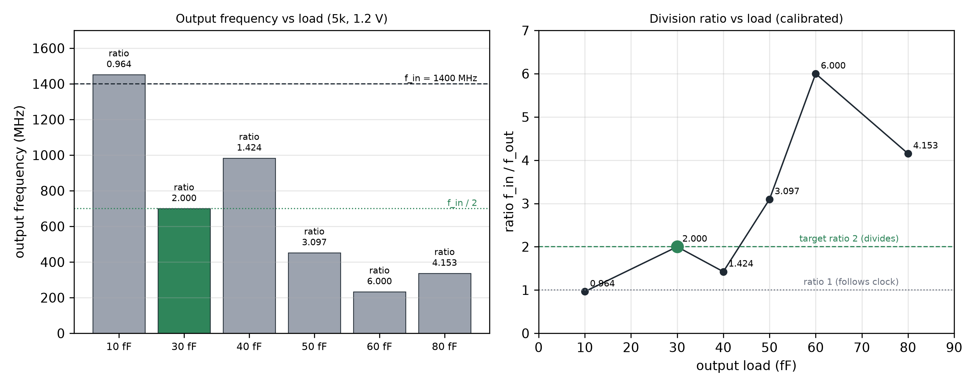
Figure 3. Division search, calibrated load sweep (5k loads, 1.2 V bias). Left: output frequency per load with the 1400 MHz input and 700 MHz half-rate references; the only divide-by-two point (30 fF) is green. Right: division ratio against load, with the target ratio of 2. Both panels use the values in Table 5 and the ratio is checked against f_in (f_out x ratio = 1400 MHz for every row).
Why the original netlist fails and why the calibrated one works:
- Hold pair gain. The cross-coupled pair M3/M4 must have a small-signal loop gain gm x R greater than 1 to regenerate and hold a state. With the original 1.5 kOhm loads, Q and Qb of every latch sit at the same voltage (1.64 to 1.81 V), so there is no stored state to divide. The R sweep is consistent with this: at 3k nothing toggled, while 5k at 1.2 V and 8k at 0.9 V did toggle.
- Load capacitance sets the delay. Without output load, the R sweep toggled at the clock rate (1426-1451 MHz, ratio 0.96-0.98): each latch regenerates within every clock phase, so the ring follows the clock instead of dividing. Adding 30 fF per output slows the latch enough for the ring to divide (700.0 MHz, ratio 2.000); 10 fF still follows the clock (ratio 0.964).
- Too slow fails again. With more load (40 to 80 fF) the latch cannot complete its update within a phase, and the ratio moves away from 2 (1.424, 3.097, 6.000, 4.153). In this sweep only 30 fF divides.

6 Calibrated baseline results
The calibrated netlist was simulated at TT / 27 C / 1.8 V. Table 6 gives the measured metrics from results/metrics_baseline.json. The power is averaged over 11 whole output periods after a 10 ns settling time. The delay is the mean time from each CK rising edge (50 percent point) to the next rising edge on any of the eight outputs, each measured at its own mid-swing level.
Table 6. Measured metrics of the calibrated baseline (TT / 27 C / 1.8 V), from results/metrics_baseline.json.
Metric | Value | Note
Supply VDD | 1.8 V | netlist .param VDD
Input clock f_in | 1.400 GHz | 1.4 GHz pulse clock (period 714.3 ps)
Output frequency f_out (Q1) | 700.0 MHz | mean of Q1 rising-edge periods
Division ratio f_in / f_out | 2.000 | divides by two: yes
CK-to-output delay (mean) | 110.0 ps | see definition above
Average supply current | 0.823 mA | trapezoidal average of i(Vdd)
Power P = VDD x I_avg | 1.482 mW | 11 whole output periods
Power-delay product | 163.1 fJ | P x delay (1 mW x 1 ps = 1 fJ)
Max phase-step error | 17.4 deg | against the ideal 45 deg step

Table 7. Measured phases of the eight outputs, relative to the Q1 rising edge, and the step to the next output.
Output | Phase (deg) | Step to next (deg) | Error vs 45 deg
v(q1) | 0.00 | 62.38 | +17.38
v(q2) | 62.38 | 27.60 | -17.40
v(q3b) | 89.98 | 62.40 | +17.40
v(q4b) | 152.38 | 27.62 | -17.38
v(q1b) | 180.00 | 62.38 | +17.38
v(q2b) | 242.38 | 27.60 | -17.40
v(q3) | 269.98 | 62.40 | +17.40
v(q4) | 332.38 | 27.62 | -17.38

The eight phases are distinct and every output swings between 0.769 V and 1.789 V. The phase steps alternate between about 62.4 and 27.6 degrees, so the outputs are not evenly spaced at 45 degrees. The largest step error is 17.4 degrees against the ideal 45 degrees. The reference paper reports phase error within 3.75 degrees on silicon. That accuracy is NOT reproduced by this simulation.
The search in Table 5 varied only the load resistance, the bias and the output load. Device sizes were not varied, and the output load was limited by the division window (40 fF and above no longer divide). Neither knob was tuned for phase balance in this report.
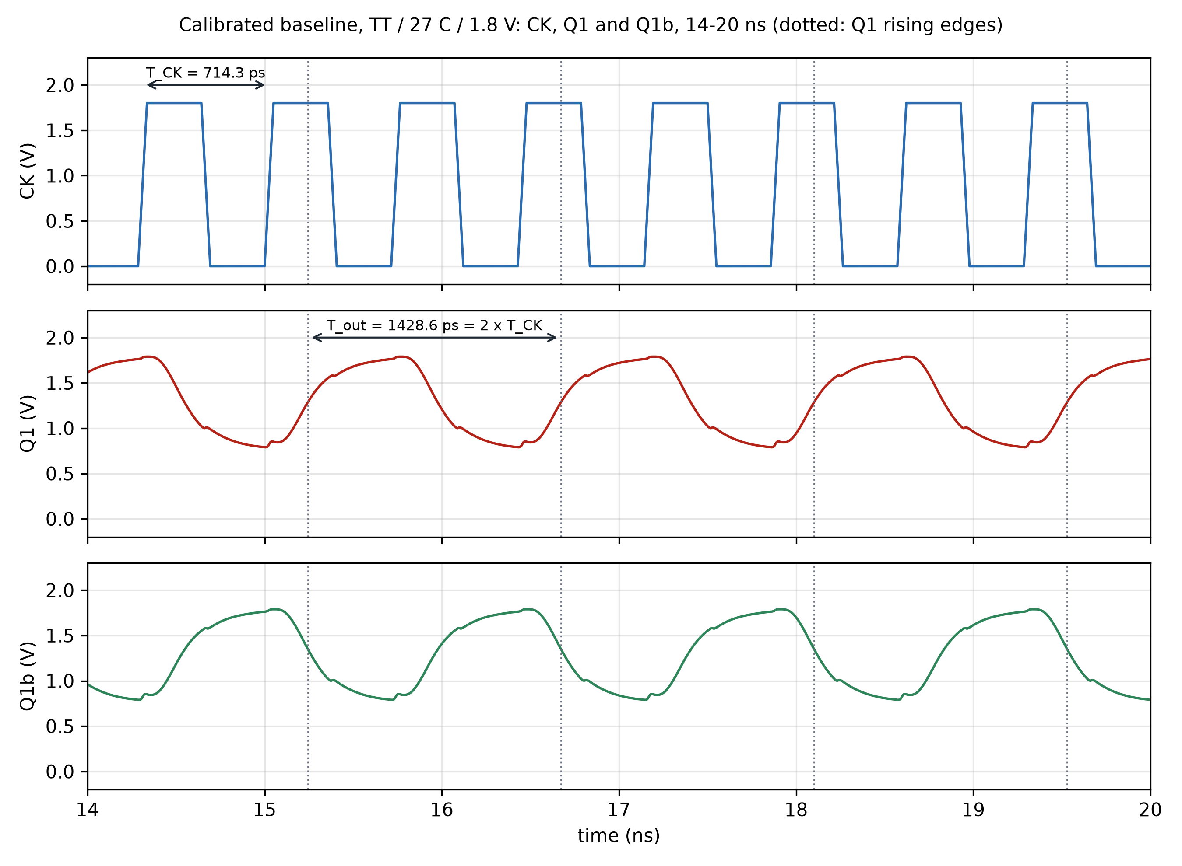
Figure 4. Waveform of the calibrated baseline (TT / 27 C / 1.8 V), from results/baseline_cal_tran.txt, 14 to 20 ns: CK, Q1 and Q1b. The measured CK period is 714.3 ps and the measured Q1 period is 1428.6 ps, so Q1 has half the frequency of CK. Dotted lines mark the Q1 rising edges.
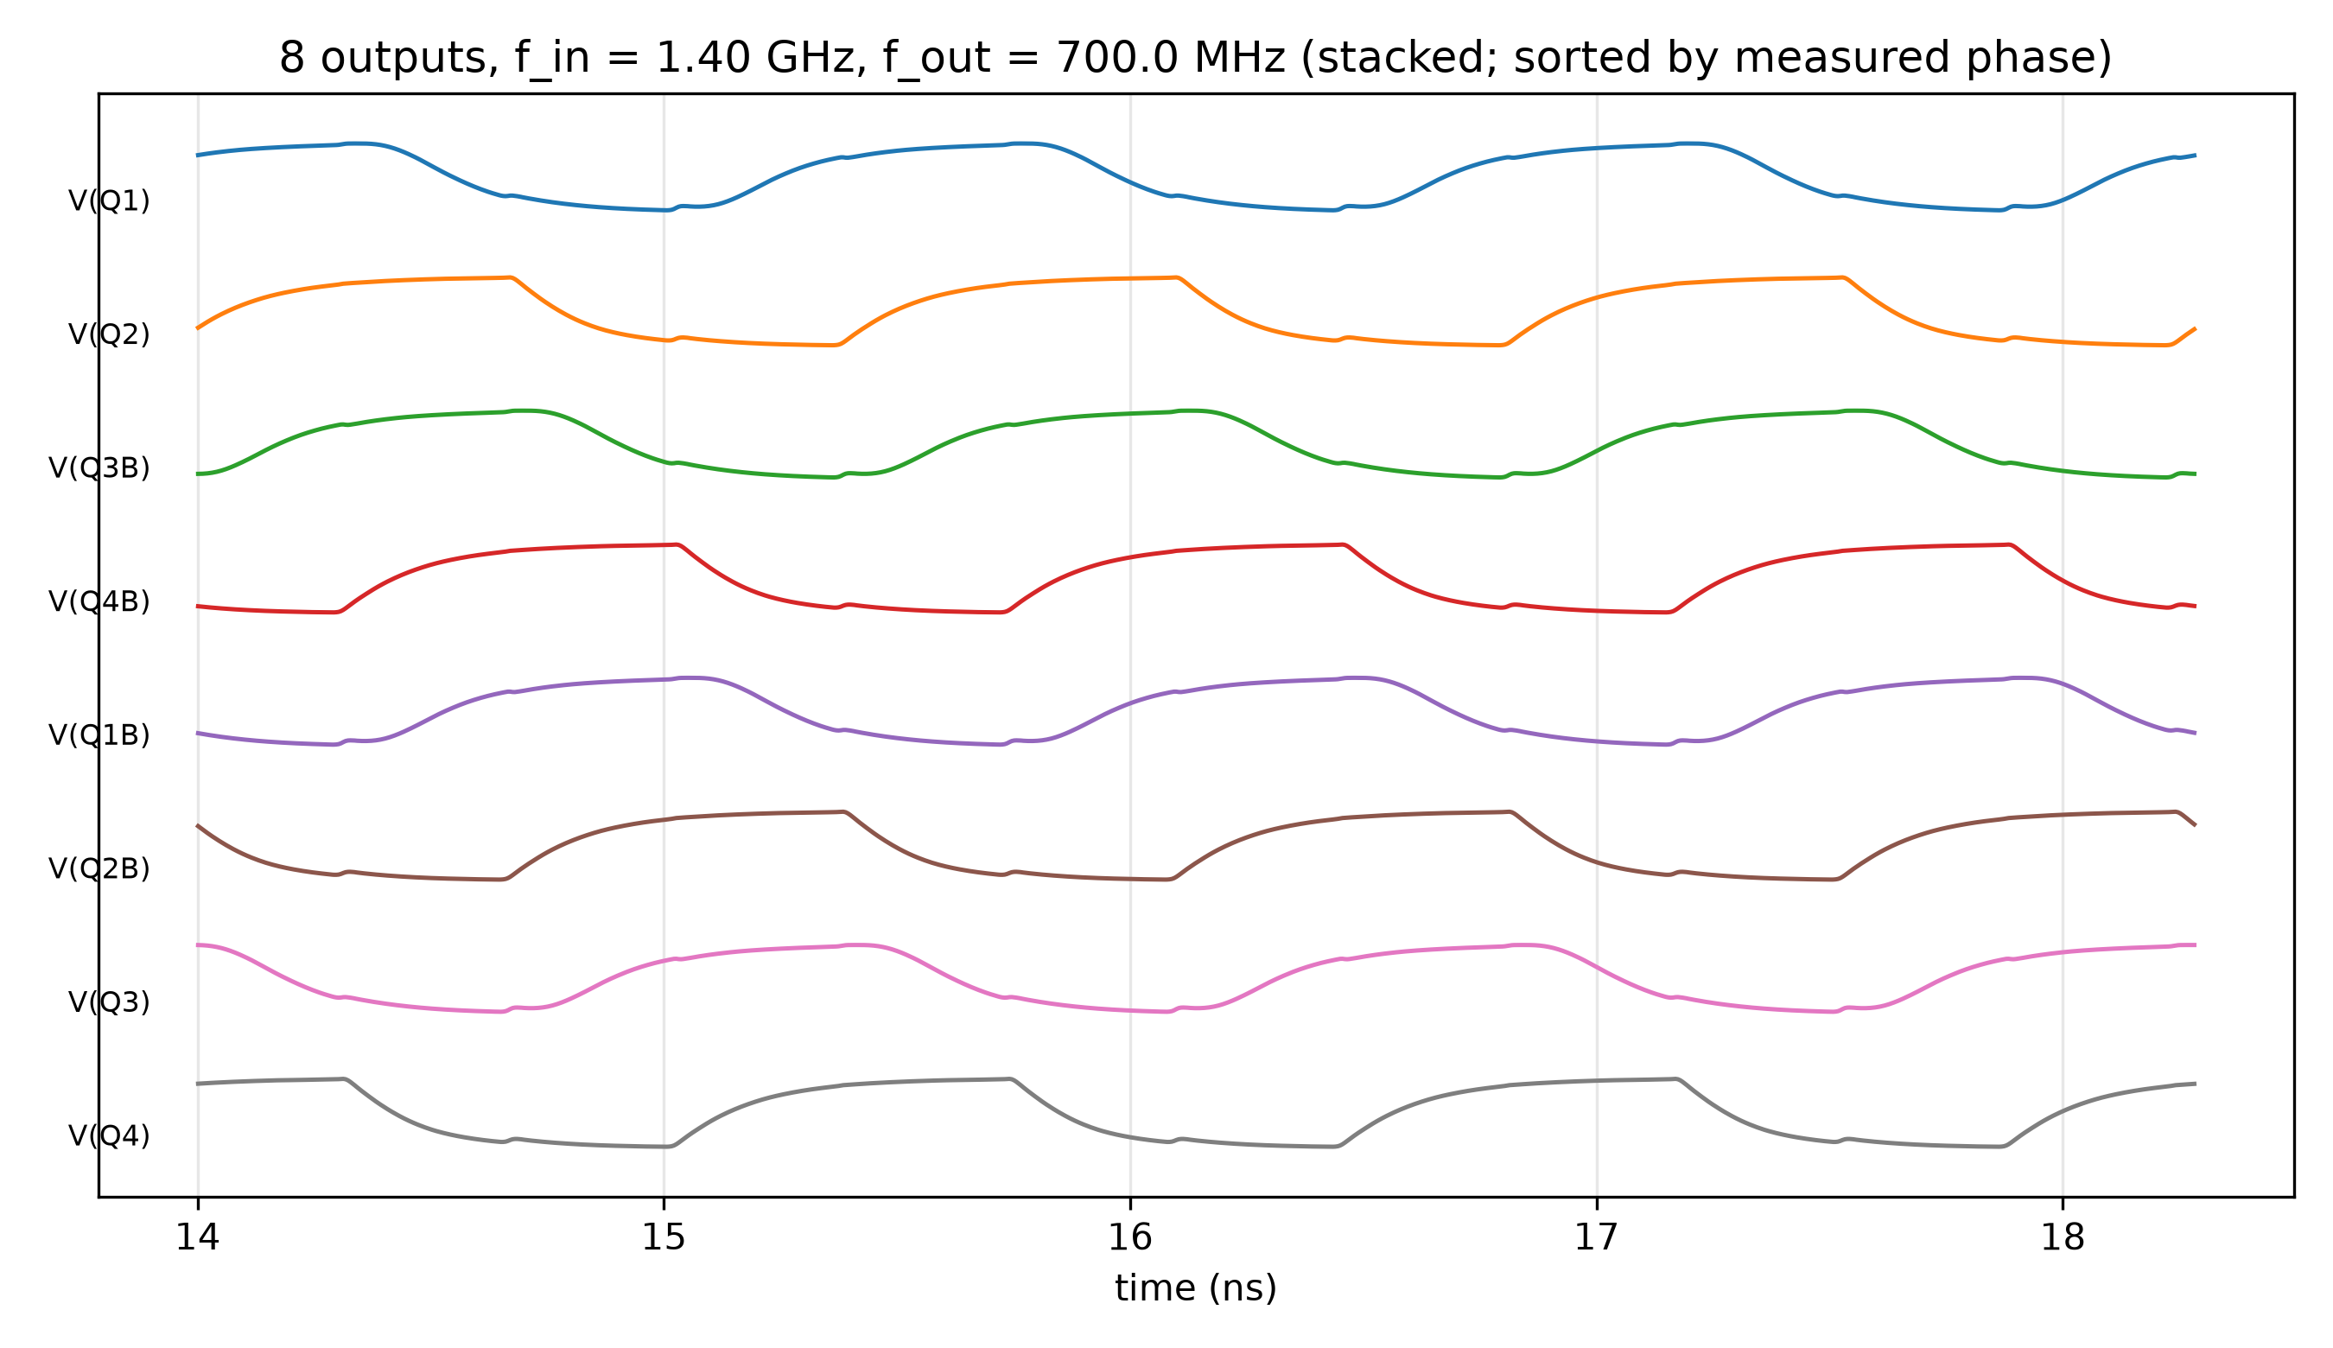
Figure 5. Eight outputs of the calibrated baseline over three output periods after start-up, stacked and sorted by measured phase (results/plots/baseline_8phases.png, drawn by scripts/make_plots.py).
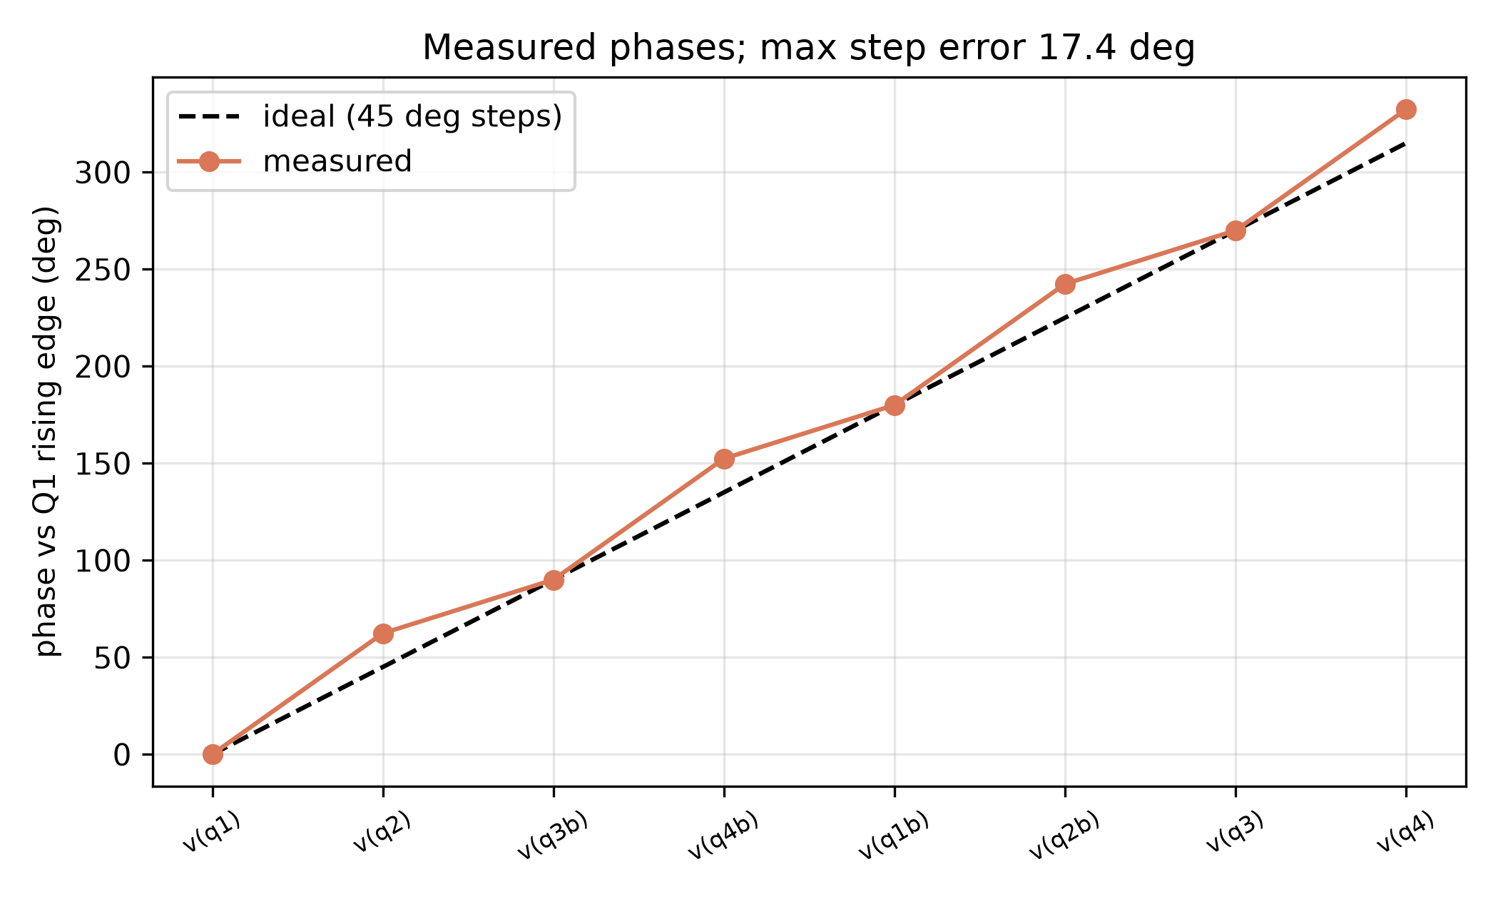
Figure 6. Measured phase of each output against the ideal 45-degree spacing (results/plots/baseline_phase_error.png).

7 PVT results
Table 8 lists all 27 runs of results/pvt_summary_table.csv: three synthetic corners (TT, FF, SS), three temperatures (-40, 27, 125 C) and three supply voltages (1.62, 1.80, 1.98 V). Runs that did not divide by two are kept in the table as FAIL rows (shaded), with the measured output frequency and ratio. The corners are synthetic (Section 2), so they are not foundry corners.
Table 8. PVT sweep of the calibrated netlist, all 27 runs, from results/pvt_summary_table.csv. Corners are synthetic. FAIL rows are shaded.
Corner | Temp (C) | VDD (V) | Divides | f_out (MHz) | Delay (ps) | Power (mW) | PDP (fJ) | Max phase-step err (deg), or reason
TT | -40 | 1.62 | PASS | 700.0 | 108.1 | 1.29 | 139.5 | 20.05
TT | -40 | 1.8 | PASS | 700.0 | 108.9 | 1.7 | 185.1 | 20.75
TT | -40 | 1.98 | PASS | 700.0 | 109.3 | 2.144 | 234.4 | 21.04
TT | 27 | 1.62 | PASS | 700.0 | 110.2 | 1.123 | 123.8 | 16.32
TT | 27 | 1.8 | PASS | 700.0 | 110.0 | 1.482 | 163.1 | 17.4
TT | 27 | 1.98 | PASS | 700.0 | 110.1 | 1.874 | 206.2 | 18.06
TT | 125 | 1.62 | PASS | 700.0 | 131.5 | 0.983 | 129.3 | 10.67
TT | 125 | 1.8 | PASS | 700.0 | 119.2 | 1.292 | 154.0 | 12.77
TT | 125 | 1.98 | PASS | 700.0 | 113.2 | 1.632 | 184.7 | 13.91
FF | -40 | 1.62 | PASS | 700.0 | 109.1 | 1.48 | 161.5 | 22.39
FF | -40 | 1.8 | PASS | 700.0 | 109.5 | 1.922 | 210.5 | 23.16
FF | -40 | 1.98 | PASS | 700.0 | 109.5 | 2.408 | 263.7 | 23.58
FF | 27 | 1.62 | PASS | 700.0 | 110.3 | 1.31 | 144.4 | 18.96
FF | 27 | 1.8 | PASS | 700.0 | 110.2 | 1.706 | 187.9 | 19.97
FF | 27 | 1.98 | PASS | 700.0 | 109.3 | 2.142 | 234.2 | 20.6
FF | 125 | 1.62 | PASS | 700.0 | 114.1 | 1.156 | 131.9 | 14.27
FF | 125 | 1.8 | PASS | 700.0 | 108.9 | 1.5 | 163.4 | 15.5
FF | 125 | 1.98 | PASS | 700.0 | 105.5 | 1.883 | 198.6 | 16.54
SS | -40 | 1.62 | PASS | 700.0 | 107.9 | 1.058 | 114.1 | 17.32
SS | -40 | 1.8 | PASS | 700.0 | 108.2 | 1.421 | 153.8 | 18.24
SS | -40 | 1.98 | PASS | 700.0 | 108.5 | 1.802 | 195.5 | 18.37
SS | 27 | 1.62 | PASS | 700.0 | 118.4 | 0.907 | 107.4 | 13.04
SS | 27 | 1.8 | PASS | 700.0 | 112.0 | 1.221 | 136.8 | 14.55
SS | 27 | 1.98 | PASS | 700.0 | 110.4 | 1.554 | 171.6 | 15.25
SS | 125 | 1.62 | FAIL | 466.8 |  |  |  | output at 466.8 MHz, ratio 2.999 (not 2)
SS | 125 | 1.8 | FAIL | 537.8 |  |  |  | output at 537.8 MHz, ratio 2.603 (not 2)
SS | 125 | 1.98 | PASS | 700.0 | 137.0 | 1.349 | 184.8 | 9.91

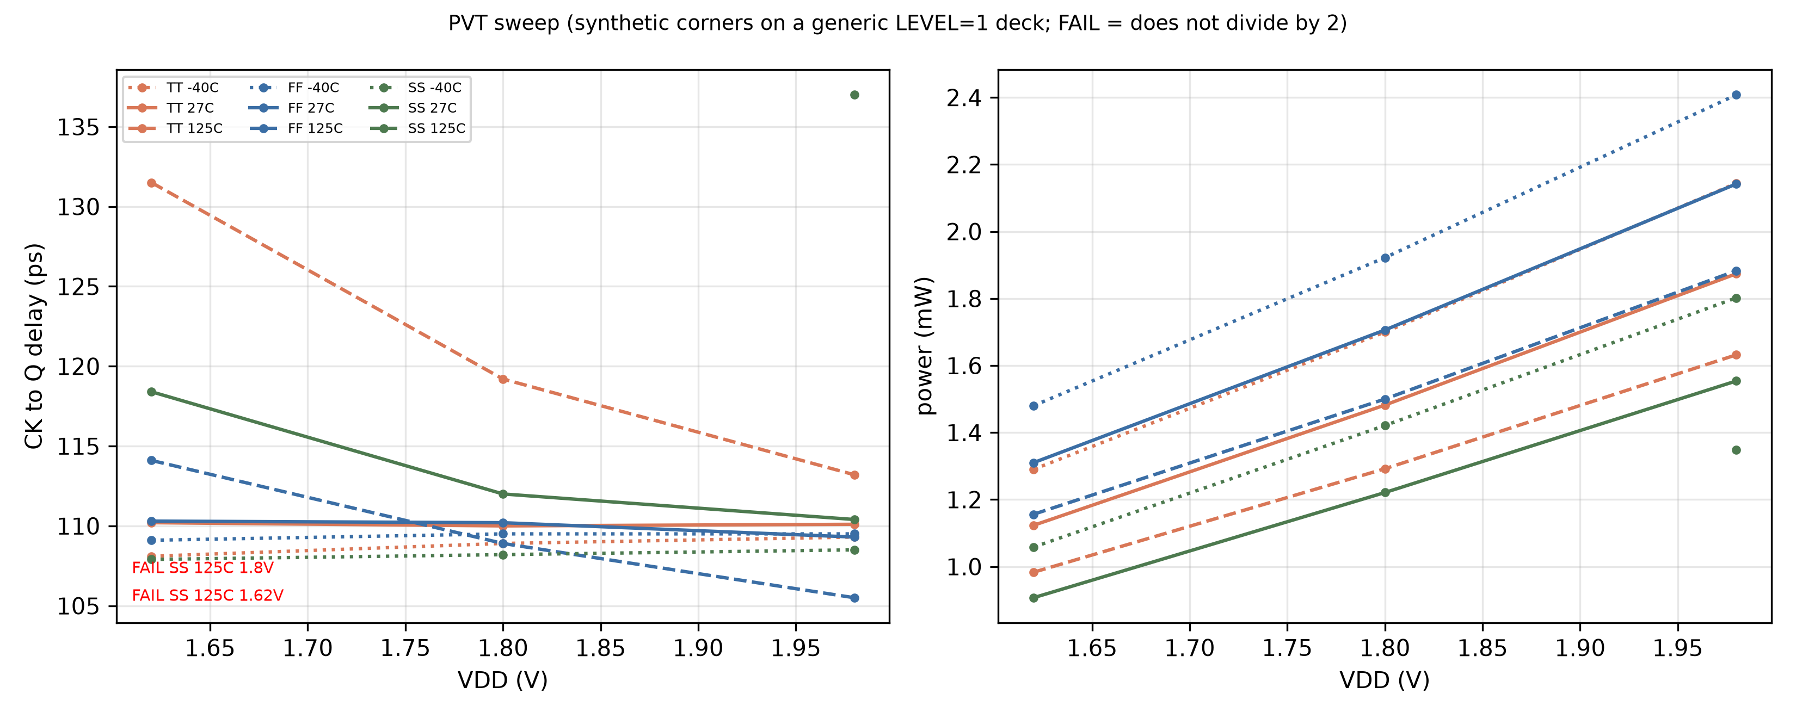
Figure 7. CK-to-output delay and supply power against VDD for each synthetic corner and temperature (results/plots/pvt_delay_power.png, drawn by scripts/make_plots.py). The FAIL points are annotated.
Reading the sweep:
- 25 of 27 runs divide by two. The 2 failures are at SS, 125 C, 1.62 V (output at 466.8 MHz, ratio 2.999 (not 2)); SS, 125 C, 1.8 V (output at 537.8 MHz, ratio 2.603 (not 2)). Both are at the SS corner and 125 C, and both are on the slow side of the sweep.
- Over the 25 passing runs the CK-to-output delay spans 105.5 to 137.0 ps (TT / 27 C / 1.8 V: 110.0 ps). The spread by temperature is -40 C 107.9 to 109.5 ps; 27 C 109.3 to 118.4 ps; 125 C 105.5 to 137.0 ps. The three slowest runs are SS 125 C 1.98 V (137.0 ps), TT 125 C 1.62 V (131.5 ps), TT 125 C 1.8 V (119.2 ps), all at 125 C.
- Power tracks the supply. In 8 of the 8 corner and temperature groups where all three supply points pass, power rises with VDD at every step. Across the passing runs it ranges from 0.907 to 2.408 mW.
- Phase accuracy is far from the paper's 3.75 degrees at every passing point. The max phase-step error over the passing runs is 9.91 to 23.58 degrees.

7 Validation
scripts/validate.py performs the 13 checks below. It re-measures the raw waveform (results/baseline_cal_tran.txt) with scripts/measure_tran.py and compares the result with the JSON and CSV files, so a hand-typed or stale result file cannot pass. The output below is the real output of that script, run for this report as /home/parshu/miniconda3/bin/python -I scripts/validate.py (exit code 0).
- baseline divides by 2 (re-measured ratio)
- f_out = 700 MHz within 0.1 percent
- JSON power matches the re-measurement
- JSON CK-to-output delay matches the re-measurement
- PDP units: mW x ps = fJ (PDP equals power x delay)
- Q and Qb in antiphase (phase of Q1b = 180 degrees)
- eight distinct output phases
- every output swings more than 0.3 V
- power is consistent with VDD x I_avg
- PVT table has 27 rows (3 corners x 3 temperatures x 3 VDD)
- PVT PDP equals power x delay on every PASS row
- PVT TT / 27 C / 1.8 V row equals the baseline JSON power
- failed corners are kept in the table (2 FAIL rows)
PASS baseline divides by 2 [ratio 2.0000]
PASS f_out = 700 MHz (+-0.1%) [700.00]
PASS JSON matches re-measurement (power)
PASS JSON matches re-measurement (delay)
PASS PDP units: mW*ps = fJ [163.1 fJ]
PASS Q and Qb in antiphase (phase of Q1b = 180)
PASS 8 distinct phases
PASS every output swings > 0.3 V
PASS power consistent with VDD*Iavg
PASS PVT has 27 rows (3 corners x 3 T x 3 VDD) [27]
PASS PVT PDP = power x delay on every PASS row
PASS PVT TT/27C/1.8V row equals baseline JSON
PASS failed corners are kept in the table [2 FAIL]
phase steps (deg): [62.38, 27.6, 62.4, 27.62, 62.38, 27.6, 62.4, 27.62] -> max step error 17.4 deg (NOT
within 0.5 or 3.75)

9 Limitations and next steps
- Generic model, not a PDK. All numbers use the generic LEVEL=1 180 nm deck (spice/models/cmos180.mod). They are not foundry or gpdk045 numbers and must not be quoted as such.
- Synthetic corners. FF and SS are a 50 mV VTO shift and a 15 percent KP scaling of the generic deck. They do not represent a process corner set.
- No layout. The netlist has no layout parasitics. The layout is being done in Cadence Virtuoso on gpdk045 and is not part of these simulations.
- Phase accuracy not reached. The max phase-step error is 17.4 degrees against the paper's 3.75 degrees on silicon. The steps alternate between about 62.4 and 27.6 degrees.
- Version 2 enhancements out of scope. The V2 enhancements (spice/divider_v2_enhanced.cir) were deliberately left out of this report.
- Cadence gpdk045 run pending. spectre/divider_gpdk45.scs is written but has not been run against a PDK (its header states it is untested), and no Cadence result file exists under results/. When it runs, the tables in this report should be replaced by the gpdk045 results.

10 Appendix

10.1 Calibrated netlist listing
Listing of spice/divider_baseline_cal.cir, reproduced exactly as it is in the repository.
* Baseline 8-phase divide-by-2 divider, LOCALLY CALIBRATED against spice/models/cmos180.mod
* (generic LEVEL=1 deck, NOT a foundry model). Differences from spice/divider_baseline.cir:
* - R1=R2 1.5k -> 5k, Vbias 0.9 -> 1.2 V, 30 fF load on every output, .ic + uic start-up.
* The original did not divide: the hold pair had too little gain and no output load/delay.
* Run: ngspice -b spice/divider_baseline_cal.cir (or scripts/analyze_baseline.py)
.include spice/models/cmos180.mod
.global nbias
.param VDD=1.8
.temp 27
Vdd Vdd 0 {VDD}
Vck CK 0 PULSE(0 {VDD} 0 50p 50p 307.14p 714.285p)
Vckb CKb 0 PULSE(0 {VDD} 357.14p 50p 50p 307.14p 714.285p)
Vbias nbias 0 1.2
.subckt DLATCH D Db CK CKb Q Qb VDD
R1 VDD Q 5k
R2 VDD Qb 5k
M1 Q D xs xs nmos W=0.9u L=0.18u
M2 Qb Db xs xs nmos W=0.9u L=0.18u
M5 xs CK tail tail nmos W=0.9u L=0.18u
M3 Q Qb xh xh nmos W=0.9u L=0.18u
M4 Qb Q xh xh nmos W=0.9u L=0.18u
M6 xh CKb tail tail nmos W=0.9u L=0.18u
M7 tail nbias 0 0 nmos W=1.8u L=0.36u
.ends
* Q1b->D2, Q2->D3, Q3b->D4, Q4->D1b
XD1 Q4b Q4 CK CKb Q1 Q1b Vdd DLATCH
XD2 Q1b Q1 CKb CK Q2 Q2b Vdd DLATCH
XD3 Q2 Q2b CKb CK Q3 Q3b Vdd DLATCH
XD4 Q3b Q3 CK CKb Q4 Q4b Vdd DLATCH
Cl1 Q1 0 30f
Cl1b Q1b 0 30f
Cl2 Q2 0 30f
Cl2b Q2b 0 30f
Cl3 Q3 0 30f
Cl3b Q3b 0 30f
Cl4 Q4 0 30f
Cl4b Q4b 0 30f
.ic V(Q1)=1.8 V(Q1b)=0 V(Q2)=1.8 V(Q2b)=0 V(Q3)=0 V(Q3b)=1.8 V(Q4)=0 V(Q4b)=1.8
.tran 5p 30n uic
.control
set wr_vecnames
set wr_singlescale
run
wrdata results/baseline_cal_tran.txt v(ck) v(q1) v(q2) v(q3) v(q4) v(q1b) v(q2b) v(q3b) v(q4b) i(vdd)
quit
.endc
.end

10.2 Reproduction commands
Run from the project root. NGSPICE must point to the ngspice-41 binary. The first command rewrites results/metrics_baseline.json and the PVT and plot commands rewrite files under results/, so run them only when you intend to regenerate those results. These commands were not re-run for this report.
NGSPICE=<path to ngspice> python3 scripts/analyze_baseline.py && python3 scripts/run_pvt_matrix.py
&& python3 scripts/make_plots.py && python3 scripts/validate.py && python3
scripts/build_reports.py

This report is rebuilt with the Python environment that has python-docx, matplotlib and numpy:
<venv>/bin/python scripts/build_local_report.py

The PDF copy is produced with:
libreoffice --headless --convert-to pdf --outdir report report/Local_Simulation_Report.docx

