报告文档

一、程序优化性说明
1．用户交互界面说明
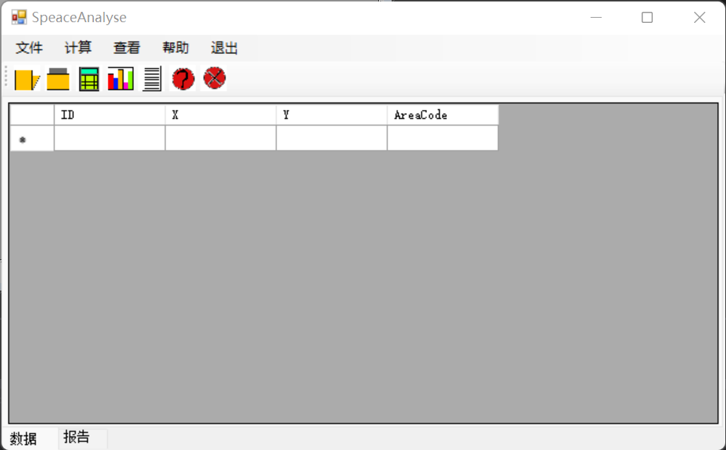
包括打开数据、保存报告、一键处理、查看数据、查看报告、问题解决、退出程序
2．程序运行过程说明
（1）打开数据，查看数据
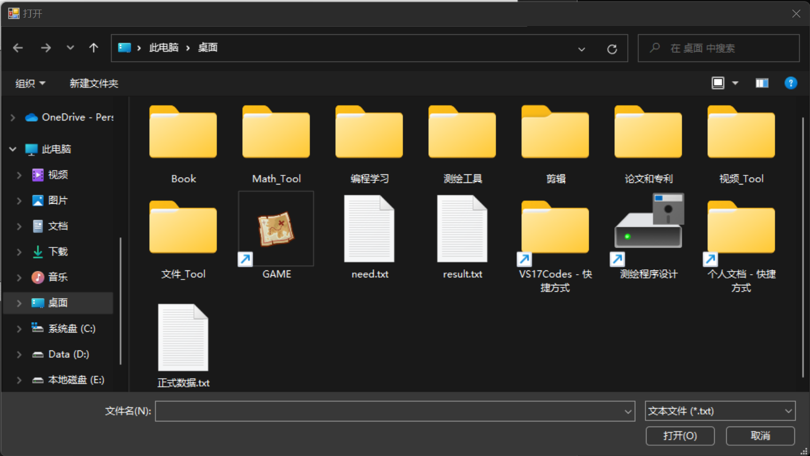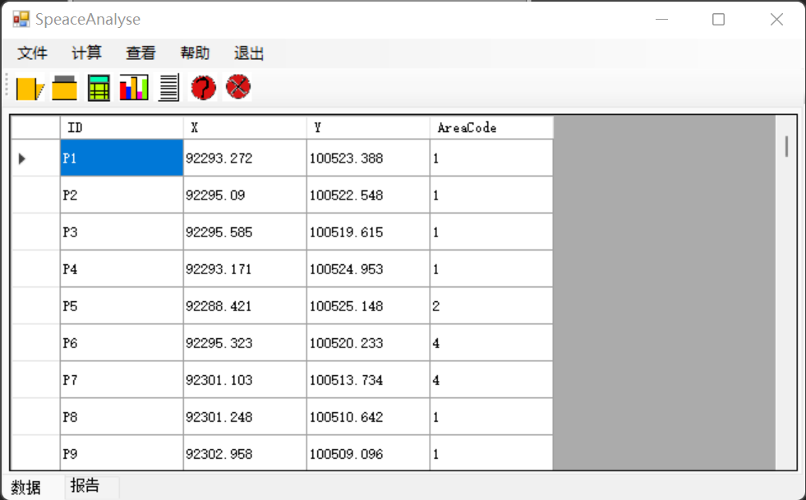
（2）一键计算，查看计算报告
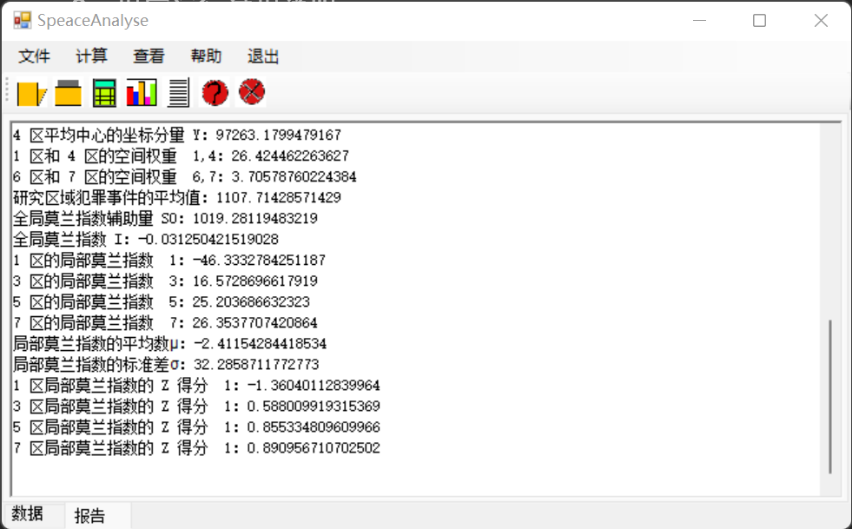
（3）如果有问题点击帮助
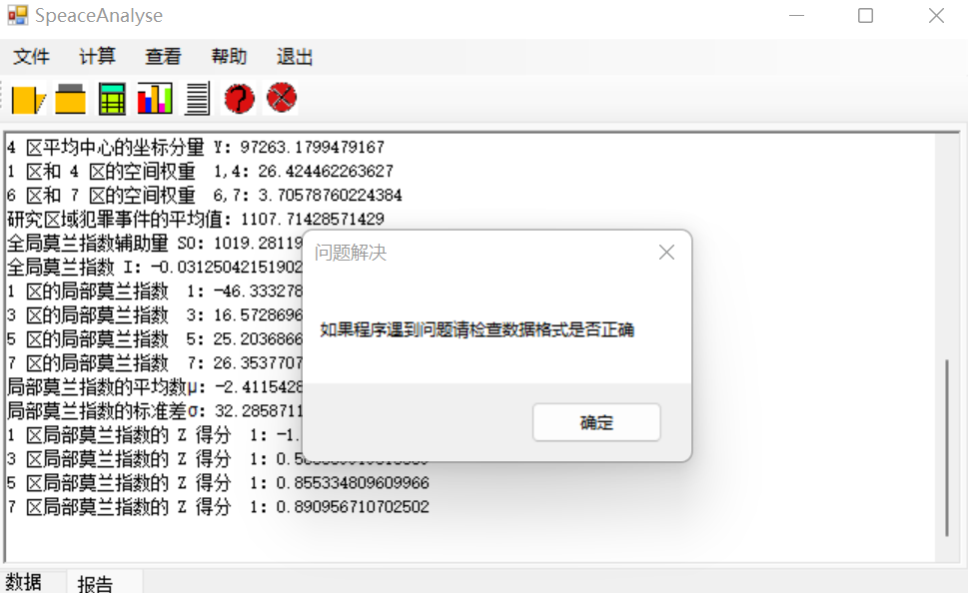
（4）导出计算报告
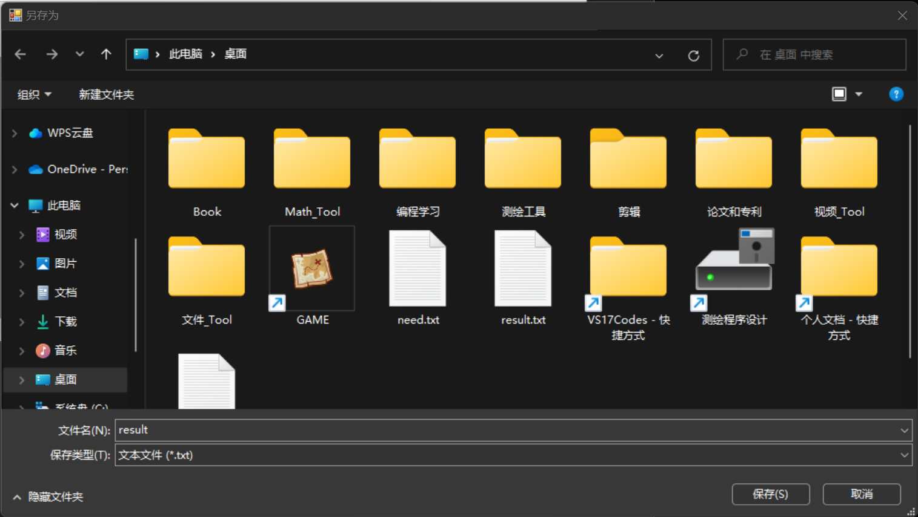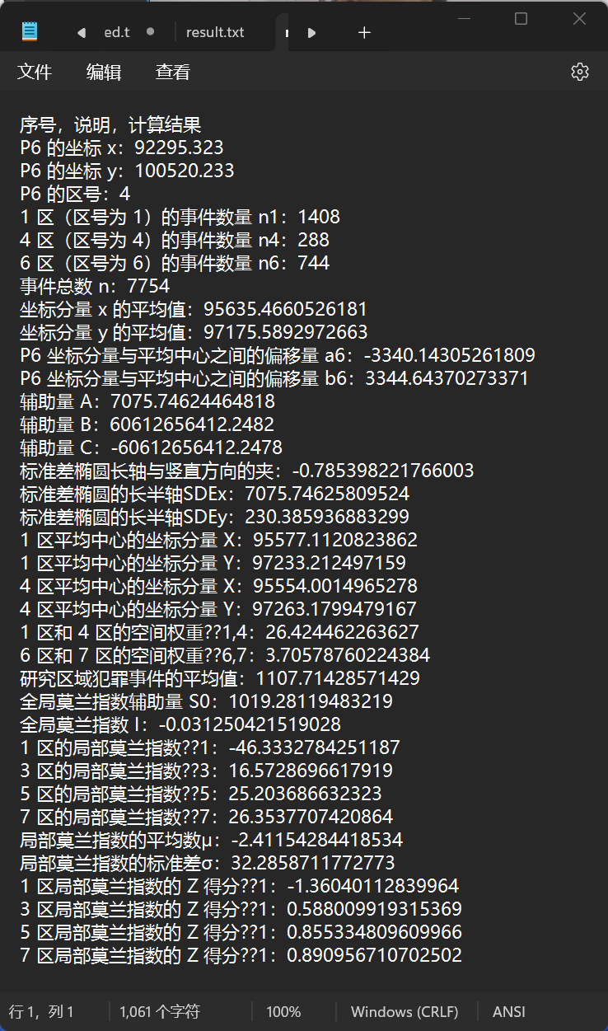
3．程序运行结果

二、程序规范性说明
1．程序功能与结构设计说明
核心类放在FIleHelp,DataCenter和Calculate中
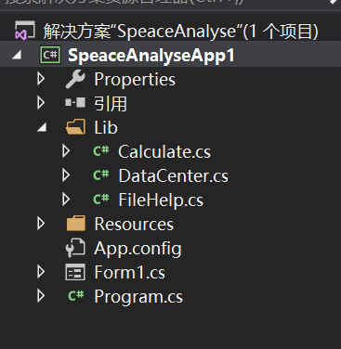
- FileHelp包括读取数据、保存数据、更新控件
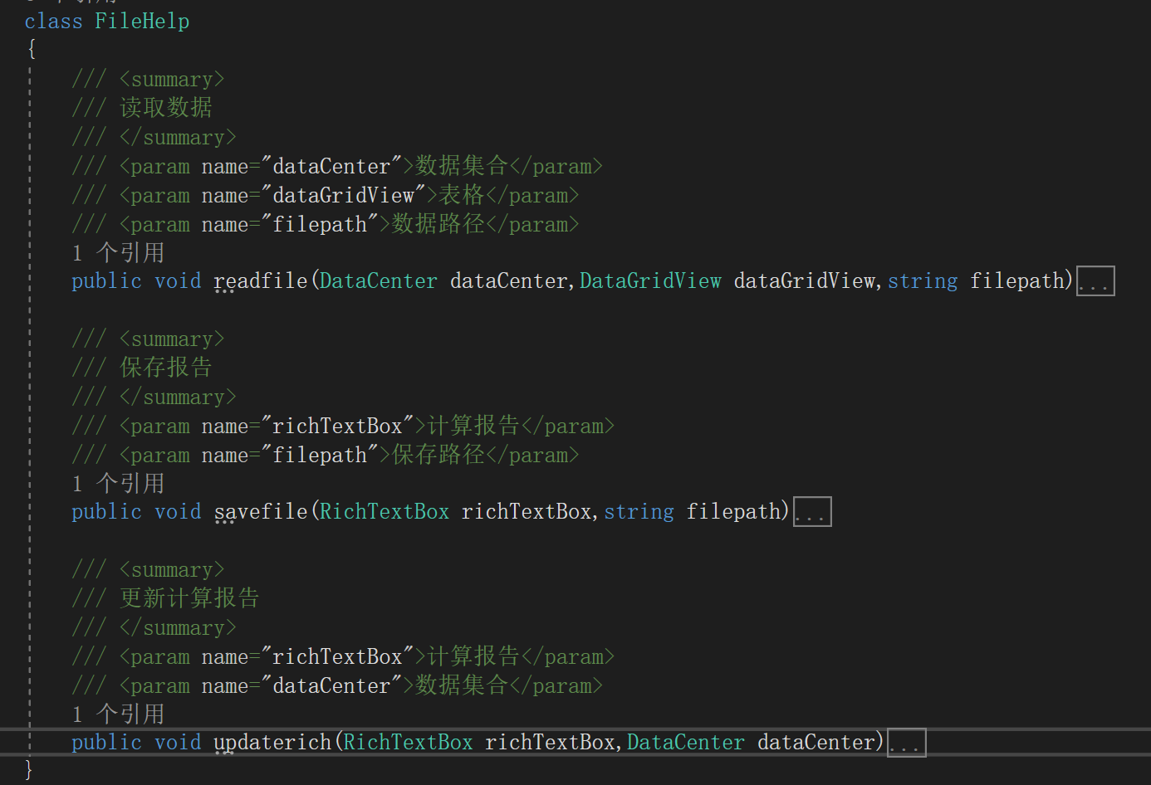
- DataCenter包含不同数据类型，点数据、椭圆参数等等
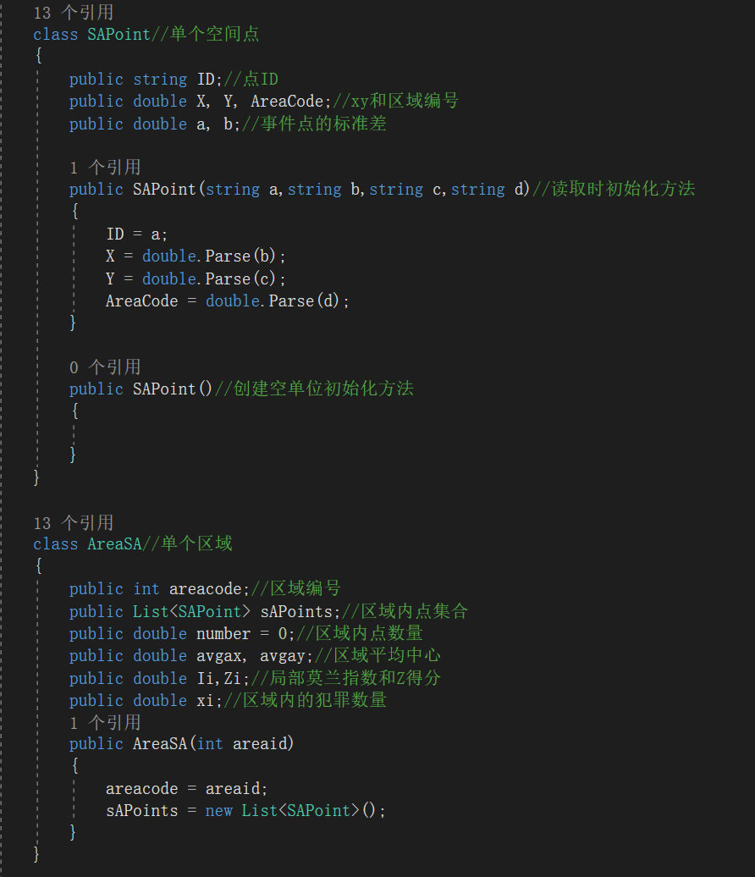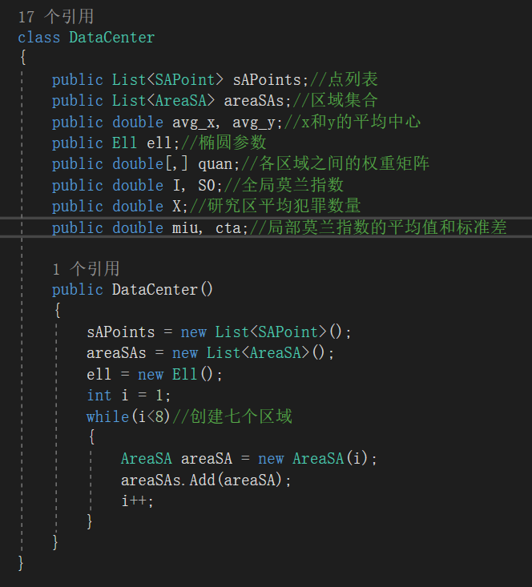
- Calculate包含了计算函数
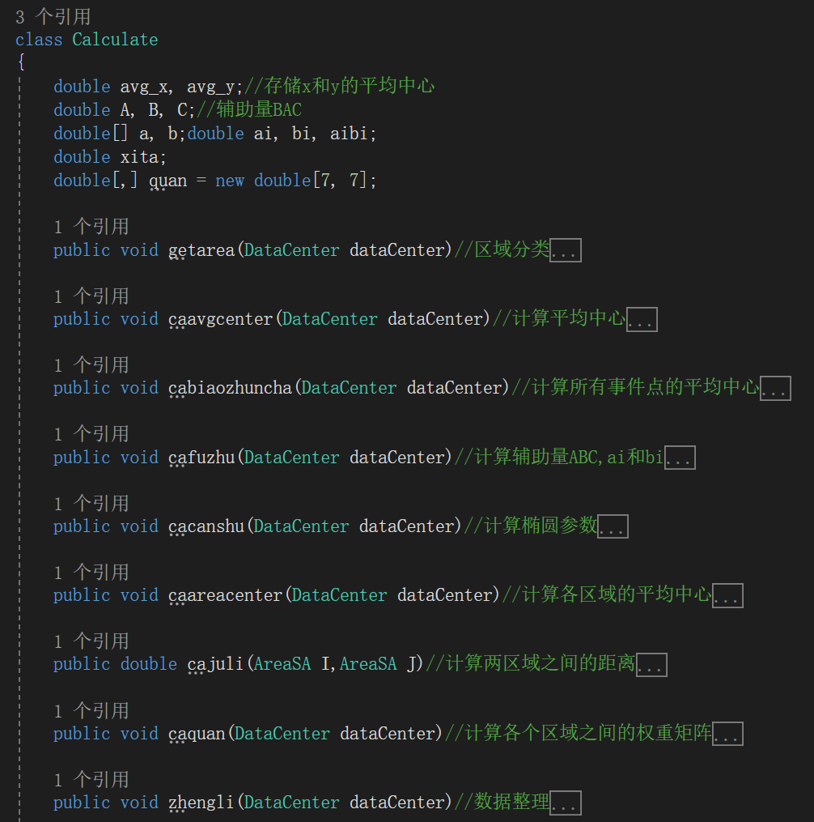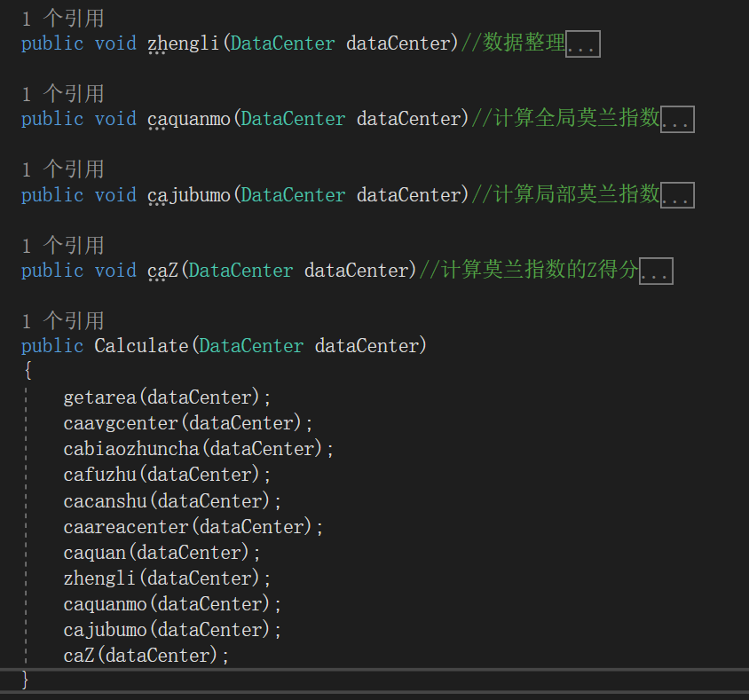
2．核心算法源码
下面是计算类Calculate中的主要代码:
using System;
using System.Collections.Generic;
using System.Linq;
using System.Text;
using System.Threading.Tasks;
using System.Windows.Forms;
using static System.Math;

namespace SpeaceAnalyseApp1.Lib
{
class Calculate
{
double avg_x, avg_y;//存储x和y的平均中心
double A, B, C;//辅助量BAC
double[] a, b;double ai, bi, aibi;
double xita;
double[,] quan = new double[7, 7];

public void getarea(DataCenter dataCenter)//区域分类
{
foreach(SAPoint sAPoint in dataCenter.sAPoints)
{
if (sAPoint.AreaCode == 1) dataCenter.areaSAs[0].sAPoints.Add(sAPoint);
else if (sAPoint.AreaCode == 2) dataCenter.areaSAs[1].sAPoints.Add(sAPoint);
else if (sAPoint.AreaCode == 3) dataCenter.areaSAs[2].sAPoints.Add(sAPoint);
else if (sAPoint.AreaCode == 4) dataCenter.areaSAs[3].sAPoints.Add(sAPoint);
else if (sAPoint.AreaCode == 5) dataCenter.areaSAs[4].sAPoints.Add(sAPoint);
else if (sAPoint.AreaCode == 6) dataCenter.areaSAs[5].sAPoints.Add(sAPoint);
else if (sAPoint.AreaCode == 7) dataCenter.areaSAs[6].sAPoints.Add(sAPoint);
else MessageBox.Show("不存在该区域");
}
foreach(AreaSA areaSA in dataCenter.areaSAs)
{
areaSA.number = areaSA.sAPoints.Count;
}
}

public void caavgcenter(DataCenter dataCenter)//计算平均中心
{
dataCenter.avg_x = dataCenter.sAPoints.Average(p => p.X);
dataCenter.avg_y = dataCenter.sAPoints.Average(p => p.Y);
avg_x = dataCenter.avg_x;
avg_y = dataCenter.avg_y;
}

public void cabiaozhuncha(DataCenter dataCenter)//计算所有事件点的平均中心
{
foreach (SAPoint sAPoint in dataCenter.sAPoints)
{
sAPoint.a = sAPoint.X - avg_x;
sAPoint.b = sAPoint.Y - avg_y;
}
}

public void cafuzhu(DataCenter dataCenter)//计算辅助量ABC,ai和bi
{
a = new double[dataCenter.sAPoints.Count];
b = new double[dataCenter.sAPoints.Count];
int i = 0;
foreach (SAPoint sAPoint in dataCenter.sAPoints)
{
a[i] = sAPoint.a;
b[i] = sAPoint.b;
aibi += a[i] * b[i];
}
ai = a.Sum();bi = b.Sum();

//A
A = ai - bi; dataCenter.ell.A = A;
//B
double need1, need2;
need1 = Pow((ai - bi), 2);
need2 = 4 * Pow(aibi, 2);
B = Sqrt(need1 + need2);dataCenter.ell.B = B;
//C
C = 2 * aibi;dataCenter.ell.C = C;
}

public void cacanshu(DataCenter dataCenter)//计算椭圆参数
{
dataCenter.ell.xita = Atan((A + B) / C);
xita = dataCenter.ell.xita;
double up1 = 0;double up2 = 0;
int i = 0;
while(i<a.Count())
{
up1 += Pow((ai * Cos(xita) + bi * Sin(xita)), 2);
up2 += Pow((ai * Sin(xita) - bi * Cos(xita)), 2);
i++;
}
dataCenter.ell.SDEx = Sqrt(2) * Sqrt(up1 / a.Count());
dataCenter.ell.SDEy = Sqrt(2) * Sqrt(up2 / a.Count());
}

public void caareacenter(DataCenter dataCenter)//计算各区域的平均中心
{
foreach(AreaSA areaSA in dataCenter.areaSAs)
{
double sumx = 0;double sumy = 0;
foreach(SAPoint sAPoint in areaSA.sAPoints)
{
sumx += sAPoint.X;
sumy += sAPoint.Y;
}
areaSA.avgax = sumx / areaSA.number;
areaSA.avgay = sumy / areaSA.number;
}
}

public double cajuli(AreaSA I,AreaSA J)//计算两区域之间的距离
{
double d = 0;
double need1 = Pow((I.avgax - J.avgax), 2);
double need2 = Pow((I.avgay - J.avgay), 2);
d = Sqrt(need1 + need2);
return d;
}

public void caquan(DataCenter dataCenter)//计算各个区域之间的权重矩阵
{
dataCenter.quan = new double[7, 7];
for(int i=0; i<7; i++)
{
for(int j=0;j<7;j++)
{
if (i == j) quan[i, j] = 0.0;
else quan[i, j] = 1000 / cajuli(dataCenter.areaSAs[i], dataCenter.areaSAs[j]);
}
}
dataCenter.quan = quan;
}

public void zhengli(DataCenter dataCenter)//数据整理
{
double n = 0;
foreach(AreaSA areaSA in dataCenter.areaSAs)
{
areaSA.xi = areaSA.sAPoints.Count;
n += areaSA.xi;
}
dataCenter.X = n / 7;
}

public void caquanmo(DataCenter dataCenter)//计算全局莫兰指数
{
double N = 7;
for(int i=0;i<7; i++)
{
for(int j=0;j<7;j++)
{
dataCenter.S0 += quan[i, j];
}
}
double need1 = 0;double need2 = 0;
for(int i=0;i<7;i++)
{
need2 += Pow((dataCenter.areaSAs[i].xi - dataCenter.X),2);
}
for (int i = 0; i < 7; i++)
{
for (int j = 0; j < 7; j++)
{
need1 += (quan[i, j] *
(dataCenter.areaSAs[i].xi - dataCenter.X) *
(dataCenter.areaSAs[j].xi - dataCenter.X));
}
}
dataCenter.I = (N / dataCenter.S0) * (need1 / need2);
}

public void cajubumo(DataCenter dataCenter)//计算局部莫兰指数
{
for (int i = 0; i < 7; i++)//7个区域
{
double sum1 = 0; double sum2 = 0;
for (int j = 0; j < 7; j++)//求两种分子
{
if(i!=j)
{
sum1 += quan[i, j] * (dataCenter.areaSAs[j].xi - dataCenter.X);
sum2 += Pow((dataCenter.areaSAs[j].xi - dataCenter.X),2);
}
}
double Si2 = sum2 / 6;
dataCenter.areaSAs[i].Ii = (dataCenter.areaSAs[i].xi - dataCenter.X) / Si2 * sum1;
}
}

public void caZ(DataCenter dataCenter)//计算莫兰指数的Z得分
{
double i = 0;
foreach(AreaSA areaSA in dataCenter.areaSAs)
{
i += areaSA.Ii;
}
dataCenter.miu = i / 7;

double need1 = 0;
foreach (AreaSA areaSA in dataCenter.areaSAs)
{
need1 += Pow((areaSA.Ii-dataCenter.miu),2);
}
dataCenter.cta = Sqrt(need1 / 6);

foreach (AreaSA areaSA in dataCenter.areaSAs)
{
areaSA.Zi = (areaSA.Ii - dataCenter.miu) / dataCenter.cta;
}
}

public Calculate(DataCenter dataCenter)
{
getarea(dataCenter);
caavgcenter(dataCenter);
cabiaozhuncha(dataCenter);
cafuzhu(dataCenter);
cacanshu(dataCenter);
caareacenter(dataCenter);
caquan(dataCenter);
zhengli(dataCenter);
caquanmo(dataCenter);
cajubumo(dataCenter);
caZ(dataCenter);
}
}
}

