报告文档
目录
一、程序优化性说明 1
1．用户交互界面说明 1
菜单、工具、数据、报告 1
2．程序运行过程说明 2
打开数据 2
一键计算 2
保存结果 3
3．程序运行结果（给出程序运行结果） 4
二、程序规范性说明 4
1．程序功能与结构设计说明 4
Form.cs 4
Lib 5

一、程序优化性说明

1．用户交互界面说明
菜单、工具、数据、报告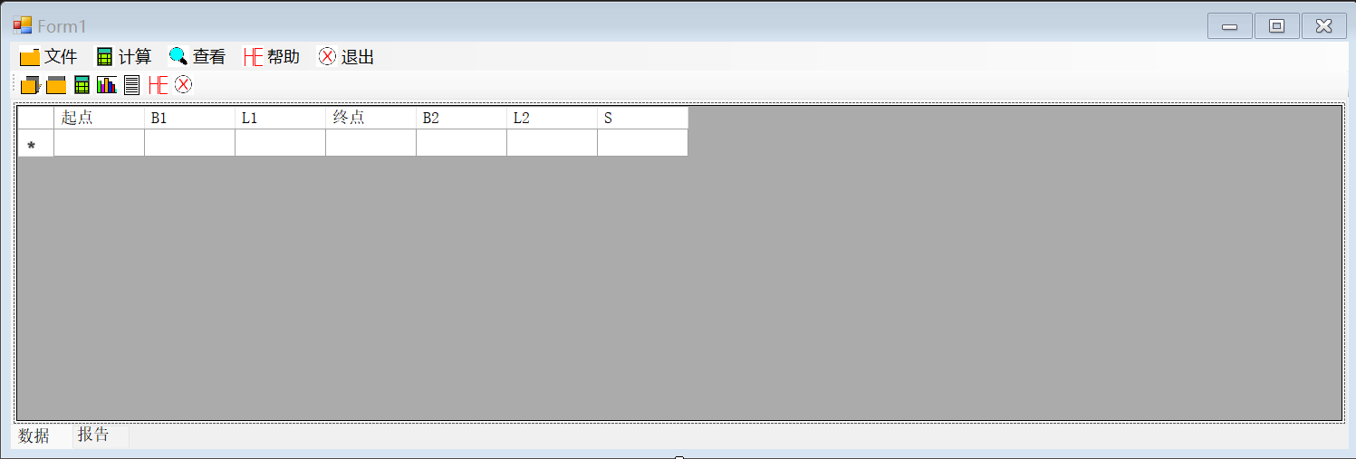
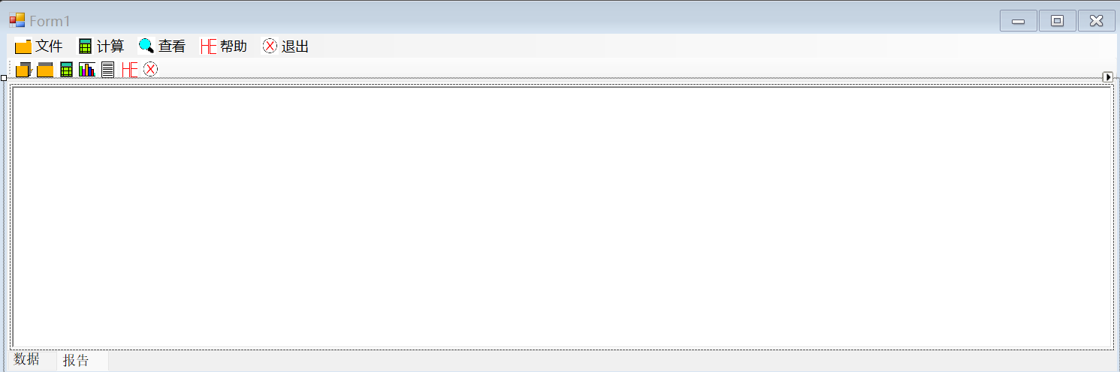

2．程序运行过程说明

打开数据
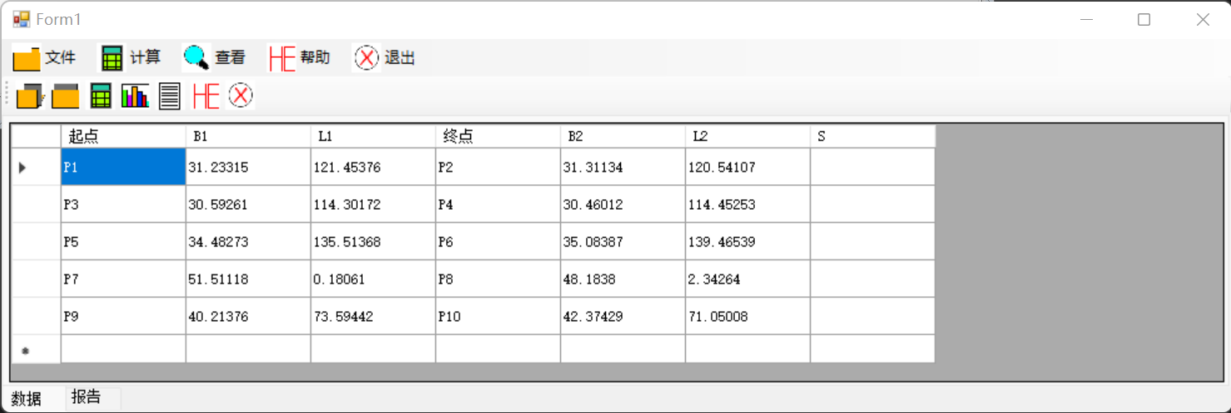

一键计算
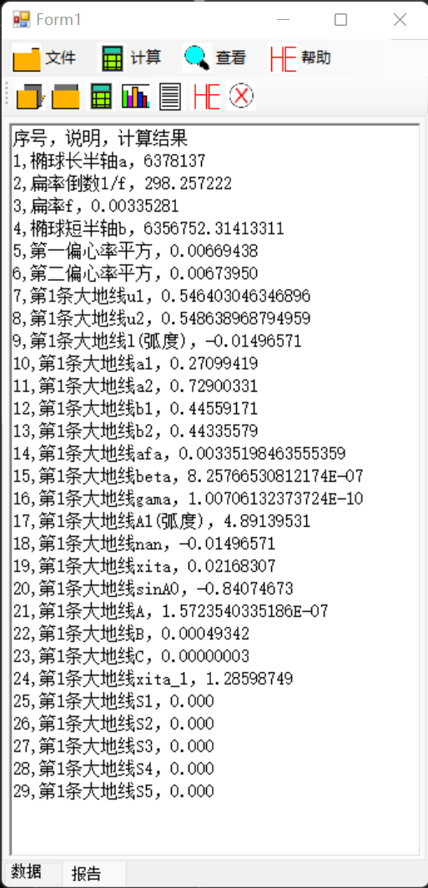

保存结果
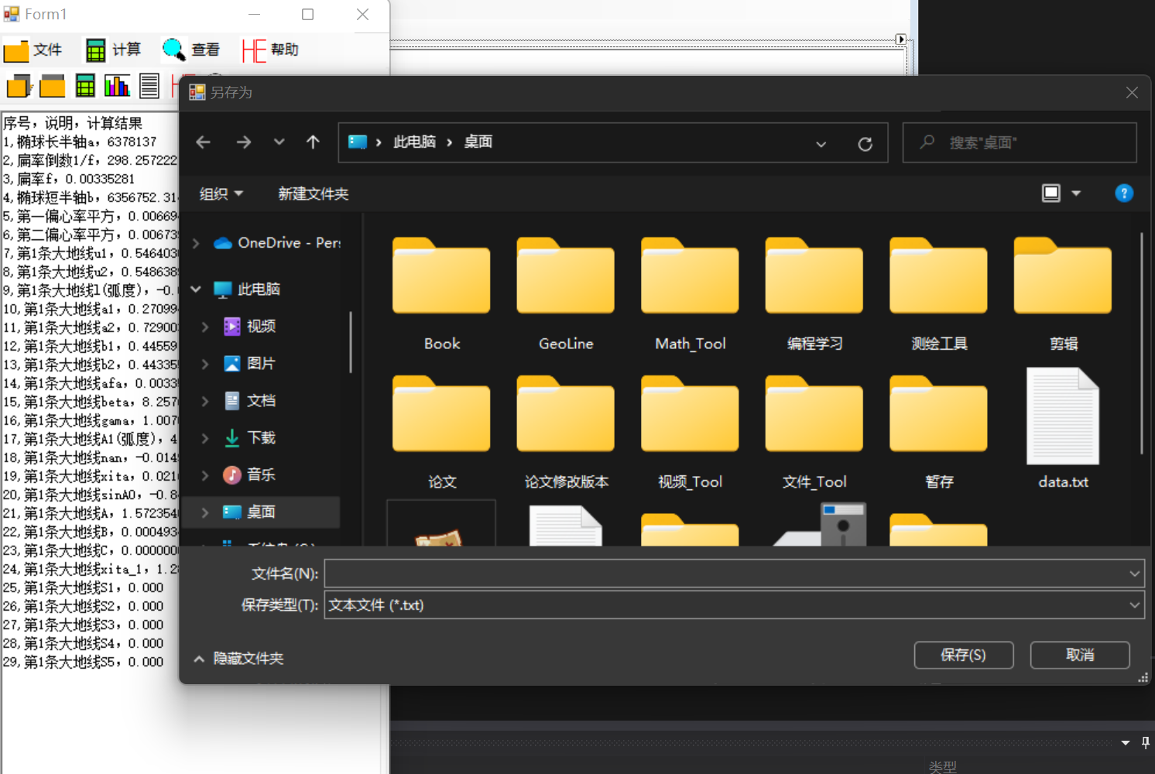

3．程序运行结果（给出程序运行结果）

二、程序规范性说明

1．程序功能与结构设计说明

Form.cs
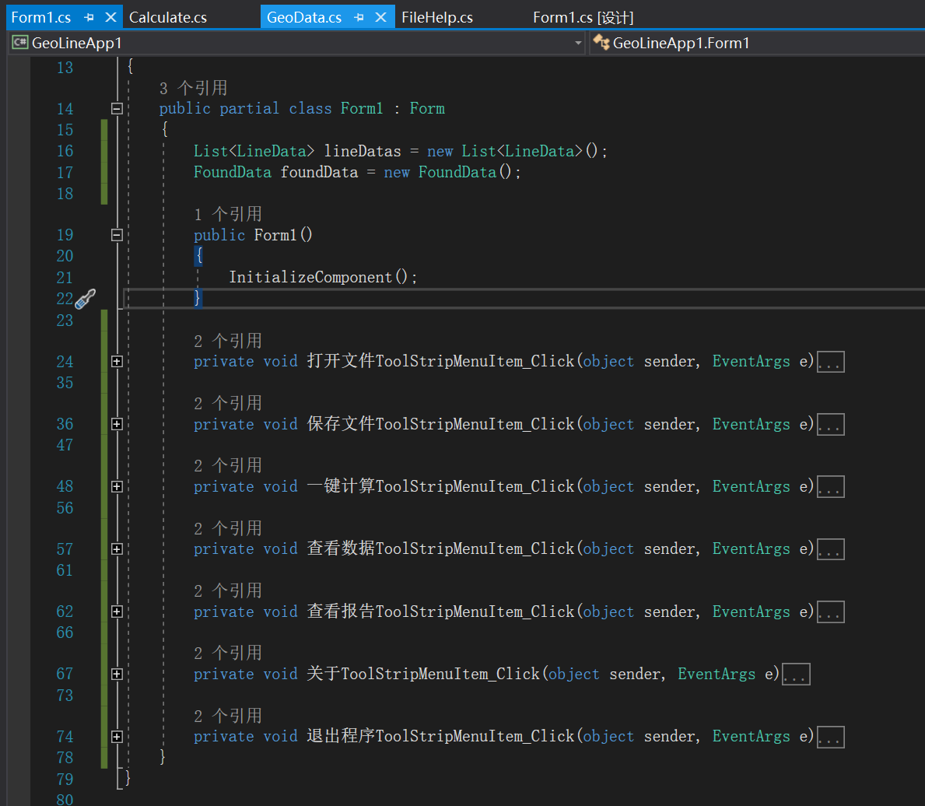

Lib

GeoData.cs
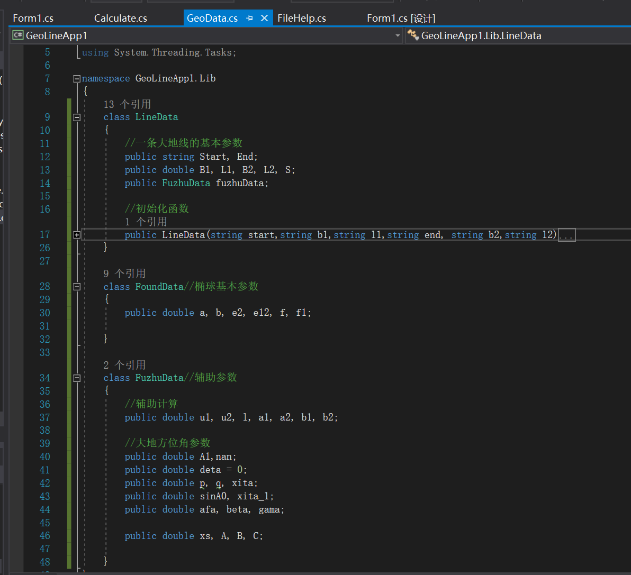

Calculate.cs
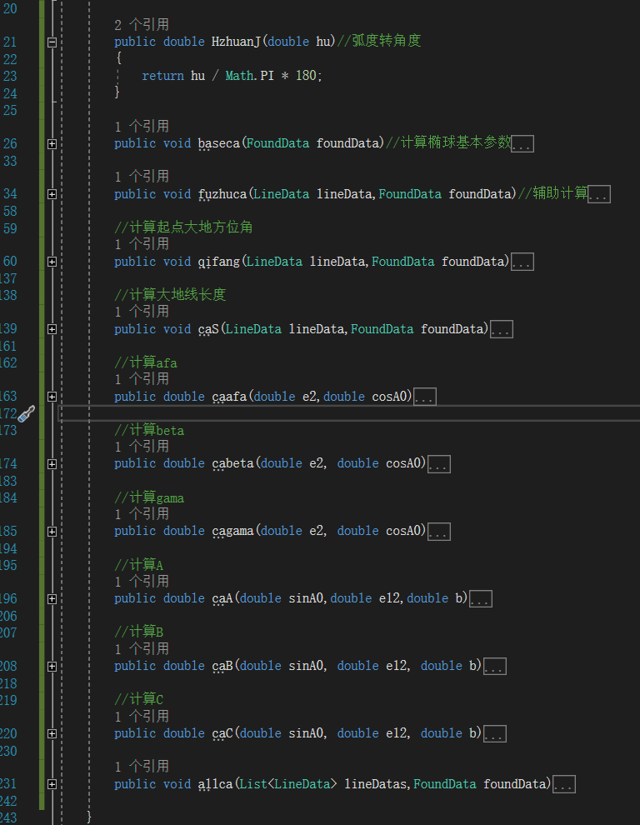

FileHelp.cs
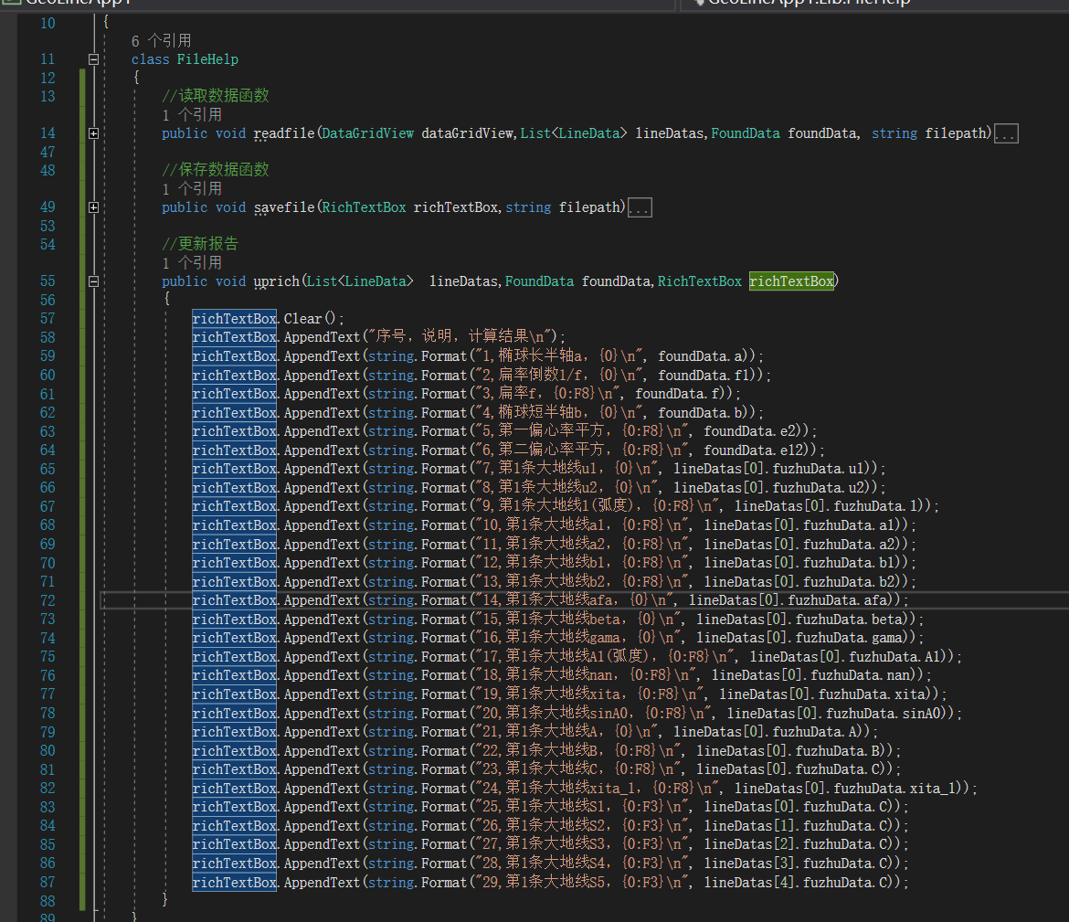
核心计算源码：
class Calculate
{
public double JzhuanH(double jiao)//角度转弧度
{
//12.34566
double du = (int)jiao;//12
double fen = (int)((jiao - du) * 100);//34
double miao = (((jiao - du) * 100) - fen) * 100;//56.6
double zong = du + fen / 60 + miao / 3600;
return zong / 180 * Math.PI;
}

public double HzhuanJ(double hu)//弧度转角度
{
return hu / Math.PI * 180;
}

public void baseca(FoundData foundData)//计算椭球基本参数
{
foundData.f = 1 / foundData.f1;
foundData.b = foundData.a * (1 - foundData.f);
foundData.e2 = (Math.Pow(foundData.a, 2) - Math.Pow(foundData.b, 2)) / (Math.Pow(foundData.a, 2));
foundData.e12 = foundData.e2 / (1 - foundData.e2);
}

public void fuzhuca(LineData lineData,FoundData foundData)//辅助计算
{
double B1 = JzhuanH(lineData.B1);double L1 = JzhuanH(lineData.L1);
double B2 = JzhuanH(lineData.B2);double L2 = JzhuanH(lineData.L2);
double e2 = foundData.e2;

double u1 = Math.Atan((Math.Sqrt(1 - e2)) * (Math.Tan(B1)));
double u2 = Math.Atan((Math.Sqrt(1 - e2)) * (Math.Tan(B2)));

double l = L2 - L1;

double a1 = Math.Sin(u1) * Math.Sin(u2);
double a2 = Math.Cos(u1) * Math.Cos(u2);
double b1 = Math.Cos(u1) * Math.Sin(u2);
double b2 = Math.Sin(u1) * Math.Cos(u2);

lineData.fuzhuData.u1 = u1;
lineData.fuzhuData.u2 = u2;
lineData.fuzhuData.l = l;
lineData.fuzhuData.a1 = a1;
lineData.fuzhuData.a2 = a2;
lineData.fuzhuData.b1 = b1;
lineData.fuzhuData.b2 = b2;
}

//计算起点大地方位角
public void qifang(LineData lineData,FoundData foundData)
{

double l = lineData.fuzhuData.l;
double u1 = lineData.fuzhuData.u1;
double u2 = lineData.fuzhuData.u2;
double a1 = lineData.fuzhuData.a1;
double a2 = lineData.fuzhuData.a2;
double b1 = lineData.fuzhuData.b1;
double b2 = lineData.fuzhuData.b2;

double afa, beta, gama, A1, nan, xita, sinA0;

double deta = 0;
double detaqian = 0;
while(deta==detaqian)
{
detaqian = deta;
nan = l + deta;
nan = l + deta;
double p = Math.Cos(u2) * Math.Sin(nan);
double q = b1 - b2 * Math.Cos(nan);
A1 = Math.Atan(p / q);
A1 = HzhuanJ(A1);

//判断pq符号
if (p > 0)
{
if (q > 0) A1 = Math.Abs(A1);
else A1 = 180 - Math.Abs(A1);
}
else
{
if (q < 0) A1 = 180 + Math.Abs(A1);
else A1 = 360 - Math.Abs(A1);
}

if (A1 < 0) A1 = A1 + 360;
else if (A1 > 360) A1 = A1 - 360;
A1 = JzhuanH(A1);

double sinxita = p * Math.Sin(A1) + q * Math.Cos(A1);
double cosxita = a1 + a2 * Math.Cos(nan);
xita = Math.Atan2(sinxita, cosxita);
xita = HzhuanJ(xita);

if (cosxita > 0) xita = Math.Abs(xita);
else xita = 180 - Math.Abs(xita);
xita = JzhuanH(xita);

sinA0 = Math.Cos(u1) * Math.Sin(A1);
double xita_1 = Math.Atan((Math.Tan(u1)) / (Math.Cos(A1)));
double A0 = Math.Asin(sinA0);
double cosA0 = Math.Cos(A0);

afa = caafa(foundData.e2, cosA0);
beta = cabeta(foundData.e2, cosA0);
gama = cagama(foundData.e2, cosA0);

deta =
(afa * xita +
beta * Math.Cos(2 * xita_1 + xita) * Math.Sin(xita) +
gama * Math.Sin(2 * xita) * Math.Cos(4 * xita_1 + 2 * xita)) * sinA0;

//赋值afa, beta, gama, A1, nan, xita, sinA0
lineData.fuzhuData.afa = afa;
lineData.fuzhuData.beta = beta;
lineData.fuzhuData.gama = gama;
lineData.fuzhuData.A1 = A1;
lineData.fuzhuData.nan = nan;
lineData.fuzhuData.xita = xita;
lineData.fuzhuData.sinA0 = sinA0;

}

}

//计算大地线长度
public void caS(LineData lineData,FoundData foundData)
{
double sinA0 = lineData.fuzhuData.sinA0;

double u1 = lineData.fuzhuData.u1;
double A1 = lineData.fuzhuData.A1;
double xita = lineData.fuzhuData.xita;
double xita_1 = Math.Atan((Math.Tan(u1)) / (Math.Cos(A1)));
double C = caC(sinA0, foundData.e12, foundData.b);
double xs = C * Math.Sin(2 * xita) * Math.Cos(4 * xita_1 + 2 * xita);
double B = caB(sinA0, foundData.e12, foundData.b);
double A = caA(sinA0, foundData.e12, foundData.b);
double S = (xita - B * Math.Sin(xita) * Math.Cos(2 * xita_1 + xita) - xs) / A1;

lineData.fuzhuData.A = A;
lineData.fuzhuData.B = B;
lineData.fuzhuData.C = C;
lineData.fuzhuData.xita_1 = xita_1;
lineData.fuzhuData.xs = xs;
lineData.S = S;
}

//计算afa
public double caafa(double e2,double cosA0)
{
double e4 = Math.Pow(e2, 2);
double e6 = Math.Pow(e2, 3);
double cos2A0 = Math.Pow(cosA0, 2);
double cos4A0 = Math.Pow(cosA0, 4);

return (e2 / 2 + e4 / 8 + e6 / 16) - ((e4 / 16 + e6 / 16) * cos2A0) + ((3 * e6 / 128) * cos4A0);
}

//计算beta
public double cabeta(double e2, double cosA0)
{
double e4 = Math.Pow(e2, 2);
double e6 = Math.Pow(e2, 3);
double cos2A0 = Math.Pow(cosA0, 2);
double cos4A0 = Math.Pow(cosA0, 4);

return ((e4 / 16 + e6 / 16) * cos2A0) - ((e6 / 32) * cos4A0);
}

//计算gama
public double cagama(double e2, double cosA0)
{
double e4 = Math.Pow(e2, 2);
double e6 = Math.Pow(e2, 3);
double cos2A0 = Math.Pow(cosA0, 2);
double cos4A0 = Math.Pow(cosA0, 4);

return (e6 / 256) * cos4A0;
}

//计算A
public double caA(double sinA0,double e12,double b)
{
double sin2A0 = Math.Pow(sinA0, 2);
double cos2A0 = 1 - sin2A0;
double k2 = e12 * cos2A0;
double k4 = Math.Pow(k2, 2);
double k6 = Math.Pow(k2, 3);

return (1 - k2 / 4 + 7 * k4 / 64 - 15 * k6 / 256) / b;
}

//计算B
public double caB(double sinA0, double e12, double b)
{
double sin2A0 = Math.Pow(sinA0, 2);
double cos2A0 = 1 - sin2A0;
double k2 = e12 * cos2A0;
double k4 = Math.Pow(k2, 2);
double k6 = Math.Pow(k2, 3);

return k2 / 4 - k4 / 8 + 37 * k6 / 512;
}

//计算C
public double caC(double sinA0, double e12, double b)
{
double sin2A0 = Math.Pow(sinA0, 2);
double cos2A0 = 1 - sin2A0;
double k2 = e12 * cos2A0;
double k4 = Math.Pow(k2, 2);
double k6 = Math.Pow(k2, 3);

return k4 / 128 - k6 / 128;
}

public void allca(List<LineData> lineDatas,FoundData foundData)
{
double test= JzhuanH(30);
foreach(LineData lineData in lineDatas)
{
baseca(foundData);
fuzhuca(lineData, foundData);
qifang(lineData, foundData);
caS(lineData, foundData);
}
}

}

