Spotter — Machine Learning Engineer Assessment
Freight Rate Prediction

1. Objective
Predict posted freight rates for 12,000 validation loads and produce the required fixed December 2025 prediction chart.

2. Data quality
Development: 48,000 labeled rows. Missing training values: weight=300, market_index=374. CatBoost handles missing numeric values natively.

3. Validation and split
A chronological split was used: January-August 2025 for training and September-October 2025 for validation. This mirrors the forward-in-time nature of the supplied November-December validation set and avoids random-split leakage.
Metric | Sep-Oct holdout
MAE | $109.34
RMSE | $633.18
MAPE | 5.18%
R² | 0.8279

4. Features
- Pickup, delivery and equipment categorical features; a combined route feature.
- Distance, weight and supplied numeric signals for the main validation model.
- Calendar features: year, month, day, day-of-week, day-of-year, ISO week, seasonal sine/cosine.
- Log-transformed distance and weight.
- load_id excluded. No target-derived features are used.

5. Model
CatBoostRegressor was selected for mixed categorical/numerical data, nonlinear relationships and missing values. The final 12,000 predictions use the mean of three seeds (42, 7, 2026). Main configuration: 500 iterations, depth 6, learning rate 0.03, L2 regularization 50.

6. December chart
The supplied December file does not contain market_index, quote_signal or coordinates. Those fields were not fabricated. A separate model uses only the supplied December information plus deterministic city coordinates recovered from the development data.
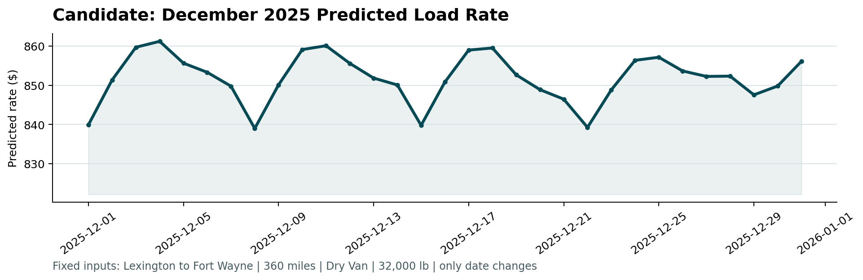
Figure 1. Scorer-generated December 2025 predicted-rate chart.

7. Reproducibility
The repository contains training code, requirements, README and the scorer. The final prediction file has exactly load_id,predicted_rate.

