- Title: NutriGuide (A Guide for healthy Nutrition)
Submitted by Parteek Saini (300323311)

- Introduction:
- Content: This website contains information about the essential components of human diet such as Protein, Carbohydrates, Fats, Vitamins and minerals and their ideal compositions in a meal. Furthermore, this website consists of tables having proportions of some of the best sources of these fundamental components of human meal so that people can educate themselves in regard to these healthy roots which make very own essence of healthy human life. At the end, this website is trying to help those individuals who are confused about how much should they eat?, and what should they eat?, by providing calories intake requirement and some meal choices which they can explore in their lifestyle.

- Inspiration: I got inspired to make this website from my own life. I have struggled a lot trying to find right options of nutrition for nearly 3 years when I was trying to put on weight and wasting a lot of time doing hours of sessions of weight training. After doing significant amount of research, I went under a transformation from 60Kgs to 75Kgs in 4 months and put on 15Kgs of lean muscle. That is why, I want to create a website on this topic for this project. I will keep on working on this website even after this course and have an ambition to make this website online in near future.

- Website Organisation:
  - Home (First Page): This is the very own first or home page of the website where I tried to give some theoretical information about the importance of nutrition. Honestly speaking, there is unimaginable amount of information present, which is important, but that much information can easily make this website a journal or an article which would be absolutely boring for users. Therefore, I tried to focus on the most important components of nutrition such as Macronutrients – Protein, Carbohydrates, and fat and Micronutrients – Minerals and Vitamin, with minimum possible scientific theory to which users can relate easily.

  - Nutrition Sources (Second Page): After familiarising the user to above most fundamental components of nutrition, then in second page I tried to educate them towards healthy sources of Macronutrients – Protein, Carbohydrates, and fat with which we are familiar in our day to day life but not really know the compositions inside these food sources. For example: Banana, Avocado and Seitan is a healthy source of Carbs, Fat and Protein, respectively. Having a basic knowledge of the macronutrient’s proportions would make people self-aware about what should they eat or what should they avoid. This page contains tables of food sources divided into 3 categories – 1) Sources of Carbohydrates, 2) Sources of Protein, and 3) Sources of Fats.

  - Calorie Guide (Third Page): Moving ahead after gathering some information about the compositions of some common but healthy food sources, this page would guide users regarding the daily calories intake requirement of a particular individual based on aspects such as Weight, Height, Age, Gender, Daily Physical Activity, and Weight Maintenance (for those who want to lose weight or maintain current weight or want to gain weight). This page basically contains a tool called Calorie Guide Tool consist a form asking above mentioned information with Full Name of user and displaying the daily calories intake need based upon entered information. The formula used to calculate this calories intake need is named as Harries Benedict Equation which is basically a standard formula used in nutrition world which is fully described in Content Declaration Part.
Having described above formula in Content Declaration part, this tool is susceptible to display slightly distorted data near extremities of Age range (10 and 90 years). Therefore, a disclaimer is provided below this tool explaining why it is vulnerable near edges of Age Range.
  - Meal Guide (Fourth Page): After realizing the calories intake need, the thing that will come into a user’s mind would be what are my meal options? Therefore, This page contains some meal choices for users depending upon the range of calories requirement which is divided into mainly three ranges- 1) Weight loss (1500-2000 cal), 2) Maintain Weight (2000-3000 cal), and 3) Weight Gain (3000-3500 cal). Every range will provide 6 meal options for one day – Breakfast, Lunch, Dinner, and 3 snacks options consisting of Macros’ breakdown for every meal and for whole day.
One thing should be kept in mind that these three categories are generalised and need not be true for every individual, meaning the meal options displayed by Weight loss calorie range (1500-200cal) may become Weight gain food option for a particular individual because of variation in Weight, Height, Age, Gender and Physical Activity. Thus, a disclaimer is provided below this tool describing above mentioned limitation of this tool. In conclusion, aim of this page is to provide a starting point to user who wants to monitor his/her calorie intake need.

- Website Layout Documentation:
  - Implementation of Website Layout for First Page (Home): The home page is straight forward in terms of implementation which was accomplished with the help of ‘article’ , ‘section’ and some ‘p’ tags but main focus of this page was to display some information which has figurative value for the users. That is why this page may not have utilised some advanced technologies in terms of web development, instead the significance of this page is showcase some knowledge and aim was to keep it simple and nice. At last video embedding from a media sharing website (Youtube) is used to enhance the experience of users to easy understand the information which was displayed oh the page.
  - Implementation of Website Layout for second Page(Nutrition Sources): This page is basically a link between the first Page and third page but nonetheless contain some important information without which the third Page’s tool would not have the accumulative impact on most of the users. This page was implemented with the help of mainly ‘tables’ but importance of ‘article’, and ‘sections’ can not be ignored at all. In the end, appropriate CSS was used to make the page fruitful to the eye of the user.
  - Implementation of Website Layout for third Page (Calorie Guide): This is the most complex page in term of HTML, CSS and JAVASCRIPT used. This page is basically designed to provide the daily calories intake need of a user based on Weight, Height, Age, and Physical Activity. This page is implemented with the help of form containing different labels and inputs such as radio, list, text, and number, in combination with ‘article’, ‘section’ and ‘div’. Other than that, the most part of javaScript is used to validate the inputs, calculating the calories with Weight goal if any and displaying the output on the html page.
  - Implementation of Website Layout for fourth Page (Meal Guide): This page the last page of the website where user can start customising their diet after knowing daily calories need from the third page. This page is implemented with the help of ‘tables’, ‘a small form’ and javaScript. The selected meal option is displayed on screen after submitting is achieved by javaScript coding where display of selected meal option is enabled. The displayed content is arranged using flexbox so that it looks nice to the viewer’s eye.

In conclusion, this website is a highly linked network where importance of every page is enhanced by previous page meaning home page is doorway to the Nutrition Page and Nutrition Page is doorway to next Page and so on.

Website Layout
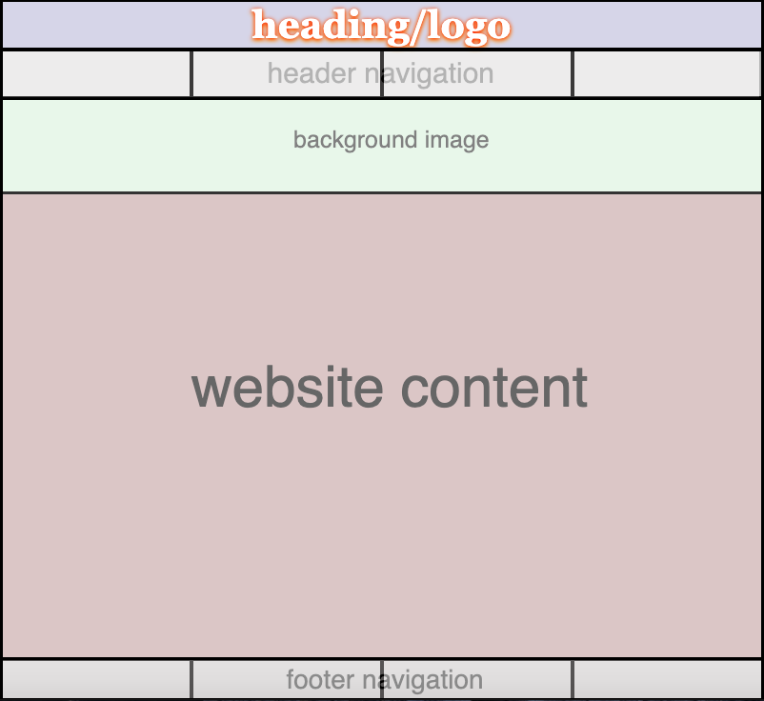

- Highlight Part:
  - Background Image: I have displayed image in a div, using background property in CSS. I used the background size as cover for the image so that if the page is resized, there is no image skewing or stretching as the page dimensions change. I have also defined the background attachment as fixed, that gives it no scroll property as the page is scrolled. It ends up giving an illusion of a responsive image that changes its view with scrolling.
  - Moving Text Strip (NutriGuide): This is the dynamic content added on the website with the help of JavaScript logical coding. This dynamic content looks simple to the eye, but it is much more difficult to implement on the ground level. The first challenge in the process of creating this dynamic content faced by me is to capture the width of HTML element and on top of that captured width should be changed automatically when size of the page is changed without refreshing the HTML page, but I managed to do that with the help of ClientWidth property of CSS and Event Listener on resize is used capture the changing width of page respectively. After that, the logic behind capturing the last value returned by event Listener was another difficult step to overcome but it was dealt with carefully placing the CurrentWidth function(the function which capture the current width of page) inside the moveFrame Function(the function which was executed after every 10ms) so that changing value of width do not initialize the multiple moveFrame function within 10ms of execution call which would mess up the whole walking strip illusion. I spent almost one day to implement this dynamic function without adding any extra library of JavaScript.

- Content Declaration:
  - Background image on every Page was taken from unsplash.com site with exact link of “https://unsplash.com/photos/4_jhDO54BYg”
  - The video embedded in very first page(Home) regarding importance of nutrition has been taken from
“https://www.youtube.com/watch?v=KD-FmeueFUo&feature=emb_title”
  - Text content on first page(Home) has been created with very little help of “https://www.medicinenet.com/script/main/art.asp?articlekey=15381”
“https://www.medicinenet.com/script/main/art.asp?articlekey=6554”
“https://www.helpguide.org/articles/healthy-eating/choosing-healthy-fats.htm”
  - Dietary Guidelines have been inspired from(Page- 2()Nutrition Sources)
“https://www.verywellfit.com/daily-diet-composition-calculator-charts-carbs-protein-fat-3861072#:~:text=USDA%20Dietary%20Guidelines%20provide%20percent,total%20calories%20from%20saturated%20fat.”
  - Composition of Carbohydrates, Protein and Fats of various food sources on Page 2(Nutrition Sources) have been taken from a mobile app named as “myFitnessPal” but choices of food option came from past experience.
  - Meal choices in Fourth page(Meal Guide) have been taken from Gurumann fitness programs which are named as “Shredded Next level” , “Size8” , and “MassUp” for Weight loss, Weight Maintain, and Weight Gain respectively and their links are as follows:
    - Youtube channel link: “https://www.youtube.com/channel/UClzDIMsdz5O5hHNz4iRgGTw”
    - Shredded Next Level: “https://www.youtube.com/watch?v=2F-uhPWOuB8&list=PLmvimH5cMub55KW1MUyCk-JsbqYR9-fQA”
    - Size8: “https://www.youtube.com/watch?v=ch3XoWwa0H4&list=PLPEuMohpXw6cVYcJhXPQFIkgOAHDT8Zdp”
    - MassUp: “https://www.youtube.com/watch?v=wP75L1KaX2A&list=PLPEuMohpXw6eHjRpS_GjnIN1KmnmBHaRA”
  - Harries Benedict Equation (Used in 3rd Page(Calorie Guide))

Calories for men = 66.5 + (13.8*bodyweight) + (5.8*Height) – (6.8*age)
Calories for women = 665.1 + (9.6*bodyweight) +(1.9*Height) – (4.7*age)

Daily Calories intake = Physically Activity Factor*calories for men or women

Physically Activity Factor = 1.2 for low physical Activity throughout day
= 1.3 for medium physical Activity throughout day
= 1.4 for heavy physical Activity throughout day
Calories intake for Weight Loss/Gain = Daily Calories intake + Weight Loss/Weight Gain Factor
Weight Loss Factor = -280 for slow weight loss
= -550 for rapid weight loss
Weight Gain Factor = +280 for slow weight Gain
= +550 for rapid Weight Gain

- References:
  - For Moving text strip: The basic idea was taken from W3schools having following link:
“https://www.w3schools.com/howto/tryit.asp?filename=tryhow_js_animate_3”

Submitted By:
Parteek Saini
300323311

