Box Cricket League 30th -31st January 2021

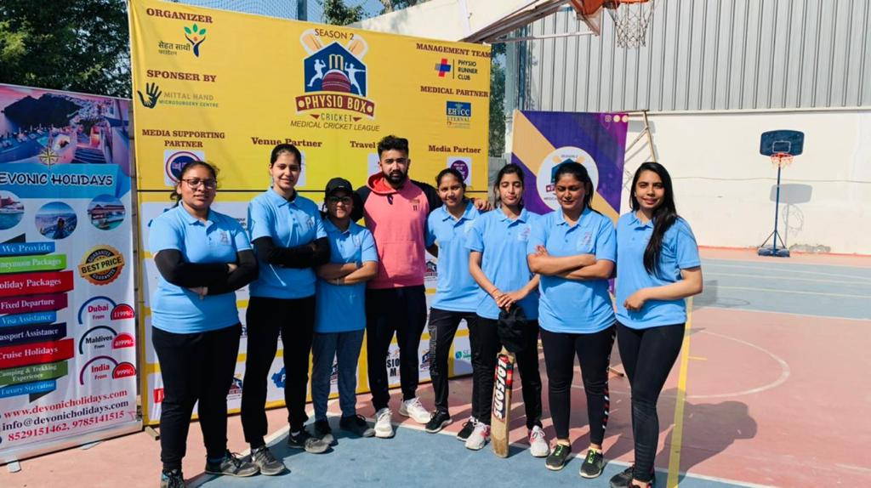

BPT Students of MGPC with Alumni Dr. Utkarsh Kulshreshtha (BPT Batch 2015) **Team Rehabit**

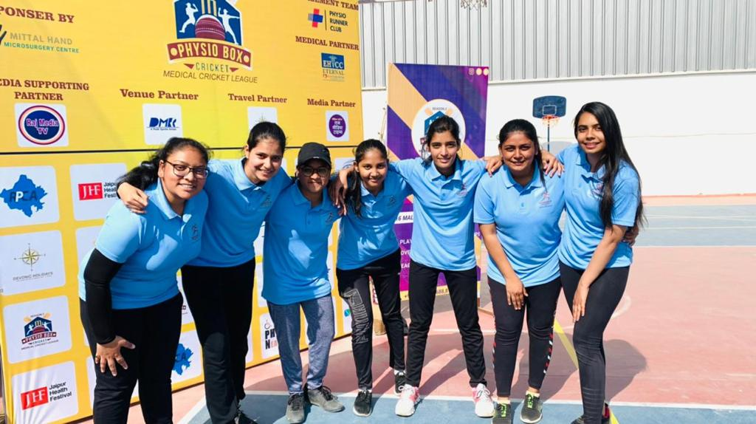

Box Cricket League 30th -31st January 2021

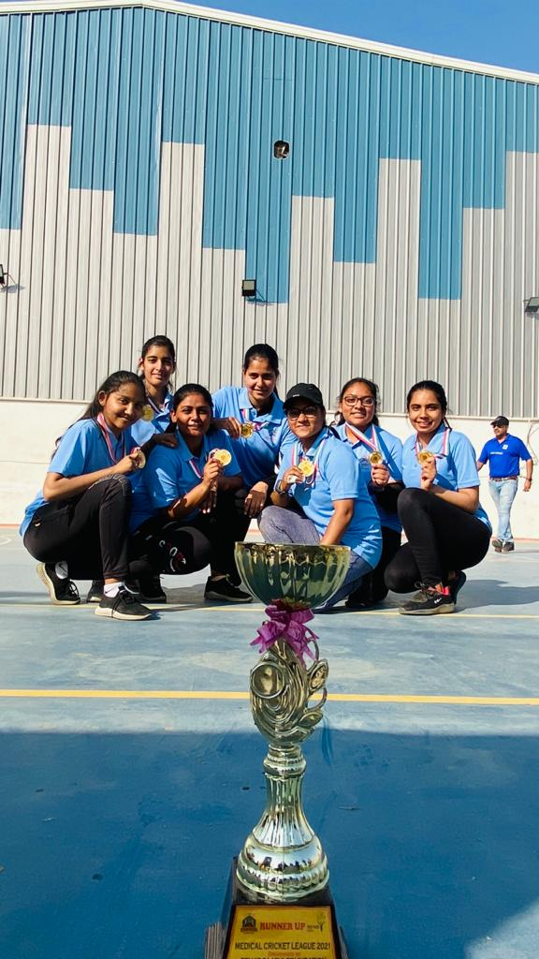

Box Cricket League 30th -31st January 2021

