**COMP 3123 – Full Stack Development – Lab 1**

* JavaScript Refresher Exercises

**Developer Note:**

* Answer any 4 of the JavaScript exercises below
* Try to solve the problems without using search engines or stack overflow for the solutions.

**Exercise 1:**

***Write a JavaScript program to capitalize the first letter of each word of a given string.***

**function capitalizeFirstLetter(str){**

**return str.replace(/\b\w/g, char => char.toUpperCase())**

**}**

**console.log(capitalizeFirstLetter("the quick brown fox"))**

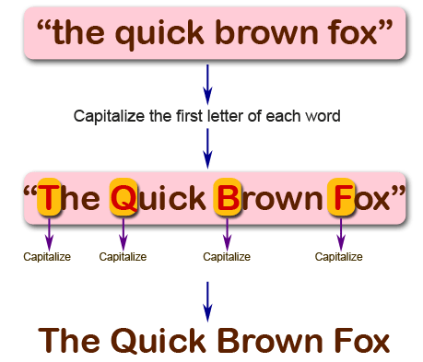

**Exercise 2:**

***Write a JavaScript program to find the largest of three given integers.***

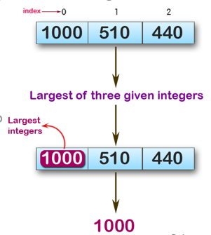

function findLargestNumber(a,b,c){

    return Math.max(a,b,c)

}

console.log(max (1,0,1));

console.log(max (0,-10,-20));

console.log(max (1000,510,440));

**Sample Output:**

1  
0  
1000

**Exercise 3:**

*Write a JavaScript program to move last three character to the start of a given string. The string length must be greater or equal to three****.***

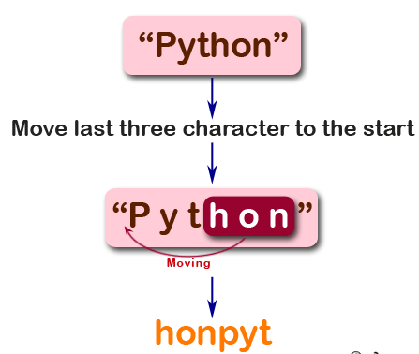

function right(str) {

    if (str.length >= 3) {

        let char = str.split('');

        let lastThreeChar = char.splice(-3);

        return lastThreeChar.join('') + char.join('');

    } else { return str; }

}

console.log(right("Python"));

console.log(right("JavaScript"));

console.log(right("Hi"));

**Sample Output:**

honPyt  
iptJavaScr  
Hi

**Exercise 4:**

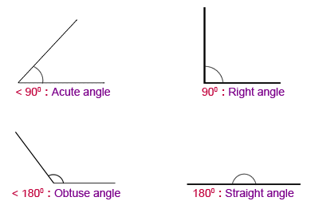*Write a JavaScript program to find the types of a given angle.*

Types of angles:  
• Acute angle: An angle between 0 and 90 degrees.  
• Right angle: An 90 degree angle.  
• Obtuse angle: An angle between 90 and 180 degrees.  
• Straight angle: A 180 degree angle.

function angle_Type(angle) {

    if (angle < 0 || angle > 180) {

        return "Invalid Angle";

    }

    else if (angle < 90) {

        return "Acute";

    }

    else if (angle === 90) {

        return "Right";

    }

    else if (angle > 90 && angle < 180) {

        return "Obtuse";

    }

    else if (angle === 180) {

        return "Straight";

    }

}

console.log(angle_Type(47))

console.log(angle_Type(90))

console.log(angle_Type(145))

console.log(angle_Type(180))

**Sample Output:**

Acute angle  
Right angle  
Obtuse angle  
Straight angle

