A
Summer Internship Report
On
"Data Analytics"

(CS343 – Summer Internship - II)

Prepared by
Parth Adesara

Under the Supervision of
Dr. Hemang Thakar

Submitted to
Charotar University of Science & Technology (CHARUSAT)
for the Partial Fulfillment of the Requirements for the
Degree of Bachelor of Technology (B.Tech.)
for Semester 7

Submitted at


Accredited with Grade A by NAAC
Accredited with Grade A by KCG



DEPARTMENT OF COMPUTER SCIENEC & ENGINEERING
Chandubhai S. Patel Institute of Technology (CSPIT)
Faculty of Technology & Engineering (FTE), CHARUSAT
At: Changa, Dist: Anand, Pin: 388421.
July 2023


Accredited with Grade A by NAAC
Accredited with Grade A by KCG

CERTIFICATE

This is to certify that the report entitled “Data Analytics” is a bonafied work carried out by Parth Adesara (20CS001) under the guidance and supervision of Dr. Hemang Thakar / Mr. Ankit Hasija for the subject Summer Internship – II (CS343) of 7th Semester of Bachelor of Technology in Computer Science & Engineering at Chandubhai S. Patel Institute of Technology (CSPIT), Faculty of Technology & Engineering (FTE) – CHARUSAT, Gujarat.

To the best of my knowledge and belief, this work embodies the work of candidate himself, has duly been completed, and fulfills the requirement of the ordinance relating to the B.Tech. Degree of the University and is up to the standard in respect of content, presentation and language for being referred by the examiner(s).

Under the supervision of,  Dr. Hemang Thakar  Counsellor – Department of Computer Science  & Engineering  Dept. of Computer Science & Engineering  CSPIT, FTE, CHARUSAT, Changa, Gujarat | Mr. Ankit Hasija  HR - MedTourEasy  MedTourEasy
Dr. Amit Thakkar
Head - Department of Computer Science & Engineering,
CSPIT, FTE, CHARUSAT, Changa, Gujarat.

Chandubhai S. Patel Institute of Technology (CSPIT)
Faculty of Technology & Engineering (FTE), CHARUSAT
At: Changa, Ta. Petlad, Dist. Anand, Pin: 388421. Gujarat.

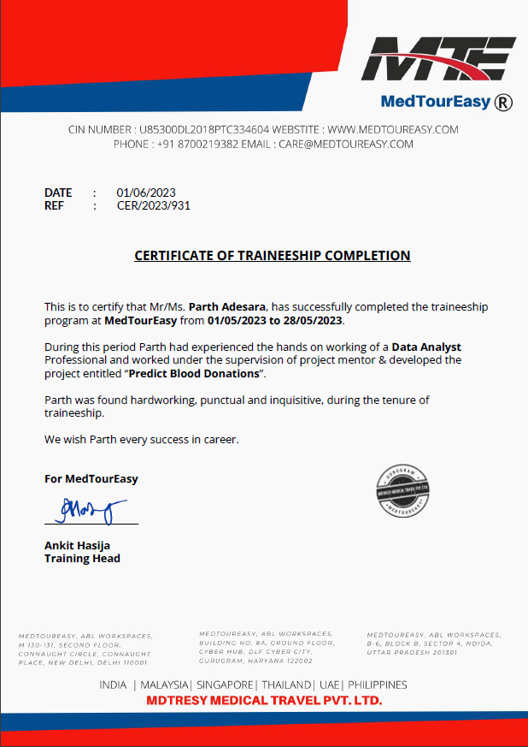

ABSTRACT
Industrial training is an important phase of a student life. A well planned, properly executed and evaluated industrial training helps a lot in developing a professional attitude. It develops an awareness of industrial approach to problem solving, based on a broad understanding of process and mode of operation of organization. In this internship, I have created a ‘Blood Prediction Model’. In essence, this model predicts whether or not a person would donate blood in the future based on historical data. The aim of this project is to develop an automated blood donation management system using the Python programming language. Blood donation plays a crucial role in healthcare systems, and an efficient management system is essential for maintaining an adequate blood supply. The proposed system leverages the power of Python to streamline the blood donation process, enhance donor engagement, and improve overall blood inventory management. Overall, this project aims to leverage the power of Python to create a comprehensive and efficient blood donation management system. By automating key processes, enhancing communication, and facilitating data-driven decision-making, the system can contribute to the optimization of blood supply and ultimately save lives.

ACKNOWLEDGEMENT
I would like to express my deepest gratitude to MedTourEasy for providing me with the opportunity to undertake my internship and gain valuable experience in the field of data analysis. This internship has been an exceptional learning journey, allowing me to apply my theoretical knowledge to real-world scenarios and develop essential skills in data analysis. I perceive this opportunity as a big milestone in my career development. I will strive to use gained skills and knowledge in the best possible way, and I will continue to work on their improvement, in order to attain desired career objectives.
I am immensely thankful to the management team at MedTourEasy for their continuous support and guidance throughout my internship. Their expertise and industry insights have been invaluable in shaping my understanding of data analysis and its applications in the healthcare industry. I would like to extend my special thanks to my mentor Mr. Ankit Hasija for their unwavering support, patience, and encouragement. Their guidance and mentorship have played a pivotal role in my professional growth and have significantly enhanced my analytical skills.

As a student of CSPIT (C.S.E.), we are highly thankful to Dr. Amit Patel (HOD, CSE) who allowed us for this internship at MedTourEasy. I also thank Dr. YP Costa (Principal) for providing me the valuable opportunity to this project.

DESCRIPTION OF COMPANY
MedTourEasy is a renowned healthcare technology company specializing in medical tourism and healthcare management solutions. The company aims to bridge the gap between patients seeking medical treatments and internationally-acclaimed healthcare providers. Through their innovative platform, MedTourEasy facilitates seamless access to quality medical services, enabling patients to make informed decisions about their healthcare journeys. MedTourEasy operates at the intersection of healthcare, technology, and tourism. Established with a vision to revolutionize medical tourism, the company has successfully established itself as a trusted name in the industry. By leveraging cutting-edge technology and an extensive network of healthcare providers, MedTourEasy strives to deliver exceptional healthcare experiences to patients worldwide. This organization also offers a wide range of services and solutions. Medical Tourism Platform, Healthcare Management, Data Analytics, and Quality Assurance are all part of this.

Website https://www.medtoureasy.com
Industries Healthcare Technology
Company size 201-500 employees

Headquarters New Delhi, Delhi

Founded 2009

Specialties Data Analytics, Healthcare Management, Quality Assurance, Financial Analytics, Business Analytics, Cloud Architecture

Location M Block, ABL Workspaces, 2nd floor, 130-131, Connaught Cir, Connaught Place, New Delhi, Delhi 110001

Table of Contents
Abstract………………………………………………………………………………… i
Acknowledgement…………………………………………………………………….... ii
Description of company organization………………………………………………… iii
Chapter 1 Introduction……………………………………………………………….. 1
1.1 Internship Objectives……………….………………………………………… 1
1.2 Overview of Internship activities….………………………………………….. 1
Chapter 2 Tools and Technologies…………………………………………………….. 2
2.1 Introduction to Excel……………………………………………………….. 2
2.2 Introduction to Python……………………………………………………… 2
2.3 Introduction to NumPy……………………………………………………… 3
2.4 Introduction to Pandas……………………………………………………… 3
2.5 Introduction to TPOT Classifier…………………………………………… 3
2.6 Introduction to Matplotlib..………………………………………………… 4
Chapter 3 Requirements of the system…………………………………………………. 5
3.1 Hardware Requirements….……………………………………...…………… 5
3.2 Software Requirements…………………………………………...…………… 5
Chapter 4 Task Description…………………………………………………………….... 6
About the Dataset……….…………………………………………...…………... 6
4.1 Task 1 Loading the blood donations data …………………………………… 7
4.2 Task 2 Inspecting transfusion Data Frame….. ……………………………… 8
4.3 Task 3 Creating Target Column and Target Incidence ...…………………… 10
4.4 Task 4 Count of values in Target column …………………………………… 11
4.5 Task 5 Exploring Data through Data Visualization and Statistics…………... 12
4.6 Task 6 Splitting data frame into train and test datasets……………………… 16
4.7 Task 7 Selecting model using TPOT………………………………………… 17
4.8 Task 8 Checking the variance…………...…………………………………… 19
4.9 Task 9 Log Normalization…………………………………………………… 20
4.10 Task10 Training the Regression Model… …………………………………. 21
4.11 Task 11 Saving the prediction…………… ………………………………… 22
4.12 Task 12 Modeling ………………………………………………...………… 23

Chapter 5 Learning Experience………...……………………………………………… 24
5.1 Knowledge Acquired / Skills learnt …………………….…………...... 24
5.2 Industry Practices Adapted........................…………….…………...... 25
5.3 Real time Applicability of Technologies Learnt….….…………...... 26
Internship Plan (Week wise) .....………...……………………………………………… 27
Chapter 6 Conclusion…….………...…………………………………………………… 28
References………………………………………………………………………………… 29

List of Figures

Fig 1 Donation Pie Chart 7
Fig 2 Donation Correlation 8
Fig 3 Correlation between frequency and monetary 8
Fig 4 Boxplot for Recency 9
Fig 5 Boxplot after excluding values outside 99 percentile for Recency 9
Fig 6 Boxplot for Frequency 10
Fig 7 Boxplot after excluding values outside 99 percentile for Frequency 11
Fig 8 Automation for TPOT 12

List of Tables

Table 1 Internship plan (Week wise) ……………………………………. 3

CHAPTER 1 INTRODUCTION
  - INTERNSHIP OBJECTIVES
Internships are a great way to apply the knowledge from the classroom to real-world experience. Learning is one thing, but taking those skills into the workforce and applying them is a great way to explore different career paths and specializations that suit individual interests.
The primary objective of my summer internship at MedTourEasy in the field of data analytics was to gain practical experience and apply my theoretical knowledge in a real-world setting. Utilizing analytical methods and technologies like Excel, and Python programming was part of this. Through this internship, I aimed to develop a comprehensive understanding of data analysis techniques and machine learning techniques, leveraging the power of Python, and their applications in the healthcare industry, specifically in the context of medical tourism. The purpose of the internship was to reflect the experience and knowledge gained during this internship in a target-oriented way.

  - OVERVIEW OF INTERNSHIP ACTIVITIES
The objective of this internship is to present a project on predicting blood donation behavior using historical data. Specifically, the project aims to predict whether a donor will give blood the next time the vehicle comes to campus based on their previous donation records. The focus is on utilizing data analysis and predictive modeling techniques to develop an effective prediction model. The methodology section outlines the steps taken to build the prediction model. It covers the data collection process, including the acquisition of historical donor records such as donation dates and relevant demographic information. The preprocessing and data cleaning steps, such as handling missing values and outliers, are also discussed.
Furthermore, feature engineering techniques employed to extract meaningful predictors from the data are described. The project delves into the exploratory data analysis phase, where descriptive statistics, visualizations, and correlation analyses are conducted to gain insights into the donor data. This analysis provides a deeper understanding of the donor characteristics, their donation patterns, and potential predictors that influence their decision to donate. The core of the project lies in the predictive modeling section. Various machine learning algorithms, such as logistic regression, decision trees, random forests, or gradient boosting, are applied to train and evaluate prediction models.

CHAPTER 2 TOOLS AND TECHNOLOGIES
2.1 Introduction to Excel
Excel, a widely used spreadsheet software, has become a fundamental tool in data analytics projects. Its versatility, user-friendly interface, and powerful features make it an excellent choice for managing, analyzing, and visualizing data.
Data preprocessing is a vital step in any data analytics project, and Excel excels in this area. It offers a wide range of functions and formulas to perform data cleaning, handle missing values, remove duplicates, and format data.
Visualization is a crucial aspect of data analytics, and Excel offers various charting and graphing tools to create meaningful visual representations of data. Analysts can easily create bar charts, line charts, pie charts, and more to visualize trends, patterns, and relationships in the data.
2.2 Introduction to Python
Python has emerged as a leading programming language in the field of data analytics, offering a robust ecosystem of libraries and tools that enable efficient data manipulation, analysis, and visualization. Its user-friendly syntax allows analysts to write clean and concise code, making it easier to understand and maintain.
Python's extensive library ecosystem is one of its greatest strengths for data analytics. Libraries such as NumPy, pandas, and scikit-learn provide essential data structures and algorithms for efficient data manipulation, processing, and statistical analysis. These libraries offer high-level abstractions that simplify complex tasks, enabling analysts to focus on extracting insights from the data.
Moreover, libraries like scikit-learn provide a comprehensive suite of algorithms for tasks such as regression, classification, clustering, and dimensionality reduction

2.3 Introduction to NumPy
NumPy, short for Numerical Python, is a powerful library in the Python ecosystem that provides efficient data structures and functions for numerical computing, making it an essential tool for handling and manipulating large datasets. NumPy's core component is its ndarray (n-dimensional array) data structure, which allows for efficient storage and manipulation of homogeneous data. The ndarray provides a powerful foundation for performing mathematical and logical operations on arrays, enabling fast and vectorized computations. This makes NumPy an ideal choice for handling large datasets and performing complex calculations.
2.4 Introduction to Pandas
Pandas is a powerful and versatile library in the Python ecosystem that is built on top of NumPy. Pandas provides high-performance, easy-to-use data structures and data analysis tools, making it a go-to choice for handling and manipulating structured data. At the core of Pandas are two primary data structures: Series and Data Frame. The Series is a one-dimensional array-like object that can hold any data type, while the DataFrame is a two-dimensional table that organizes data into rows and columns. These data structures provide powerful abstractions for working with structured data and offer efficient operations for indexing, filtering, aggregating, and transforming data. Pandas allows for easy import and export of data from various file formats such as CSV, Excel, SQL databases, and more. It also provides intuitive and flexible methods for data cleaning, data transformation, and data merging, enabling analysts to prepare and preprocess data efficiently for further analysis.
2.5 Introduction to TPOT Classifier
The TPOT Classifier is a powerful automated machine learning tool designed for data analytics projects. TPOT (Tree-based Pipeline Optimization Tool) leverages genetic programming to automate the process of building and optimizing machine learning pipelines. One of the main advantages of using TPOT Classifier is its ability to handle the end-to-end machine learning pipeline. It automates the selection and configuration of data preprocessing

steps, feature engineering techniques, feature selection methods, and model selection. This allows analysts to focus more on the interpretation of results and domain-specific knowledge rather than spending time on the tedious process of manually tuning and optimizing the pipeline. Matplotlib offers a wide range of plot types, including line plots, scatter plots, bar plots, histograms, and more. These plot types enable analysts to represent and visualize various types of data distributions, relationships, and patterns.
2.6 Introduction to Matplotlib
Matplotlib is a widely used data visualization library in the Python ecosystem that provides a comprehensive set of functions and tools for creating high-quality visualizations, allowing analysts to explore and communicate insights effectively.

CHAPTER 3 REQUIREMENTS OF THE SYSTEM
3.1 Hardware Requirements
The hardware requirements for this project are recommended as follows:

1. Processor (CPU): A modern multi-core processor, such as Intel Core i5 or equivalent, is recommended.

2. Storage: Sufficient storage space is required to store the project files, datasets, and any additional libraries or packages.

3. Python Environment: Set up a Python environment on your system with the necessary libraries and packages installed. You can use tools like Anaconda or pip to manage your Python environment and install the required dependencies.

4. Operating System: The project can be executed on various operating systems, including Windows, macOS, or Linux. Ensure that your chosen operating system is compatible with the Python programming language and the required libraries.

3.2 Software Requirements

The software requirements for this project are as follows:

1. Python (Install the latest version of Python programming language on your system.)

2. Integrated Development Environment (IDE)

3. NumPy

4. Pandas

5. Scikit-learn

6. Matplotlib

7. TPOT

CHAPTER 4 TASK DESCRIPTION
About the Dataset

The data that is being used is the transfusion data, it has been taken from the donor database of Blood Transfusion Service Center. Our dataset is from a mobile blood donation vehicle in Taiwan. The Blood Transfusion Service Center drives to different universities and collects blood as part of a blood drive.

The data is stored in Transfusion.data file and it is structured according to RFMTC marketing model (a variation of RFM). RFM stands for Recency, Frequency and Monetary Value and it is commonly used in marketing for identifying your best customers. In our case, our customers are blood donors. The above mentioned file is comma delimited.

RFMTC is a variation of the RFM model. Below is a description of what each column means in our dataset:

- R (Recency - months since the last donation)
- F (Frequency - total number of donation)
- M (Monetary - total blood donated in c.c.)
- T (Time - months since the first donation)
- A binary variable representing whether he/she donated blood in March 2007

The dataset contains 5 columns, as mentioned above respectively, and 748 data entries, starting from 0 to 747. The last column of the data contains a binary distribution, in which 1 represents that a person has donated blood after March 2007, and 0 represents that a person has not donated blood after March 2007.

- 4.1 Task 1
Loading the blood donations data
The data has been imported in the Python notebook using the pd.read_csv function in the Pandas Library, in a variable called transfusion. Here pd is used as the alias name for Pandas. We have also filtered out the warnings. Data can be viewed using df.head() this will give the first five rows of the dataset, which is given below:
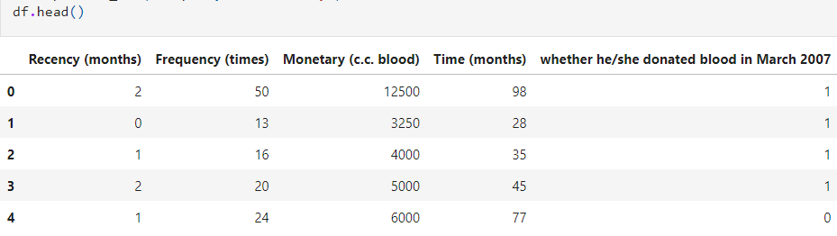

- 4.2 Task 2
Inspecting transfusion Data Frame
We verify our hypothesis so that we can get a basic overview of the data set, a sort of information about it, through the df.info() function. This gives the following result which describes about the columns, it tells about the null values and the data type of the columns. In our database we also check whether we have any null values or not. We also determine the datatype of every column, which is int64. The df.describe() method computes various summary statistics for each numerical column, such as count, mean, standard deviation, minimum, quartiles, and maximum values.The results can be seen below:
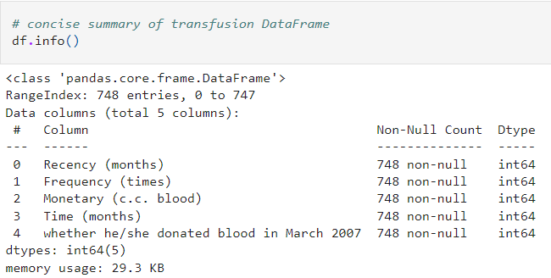
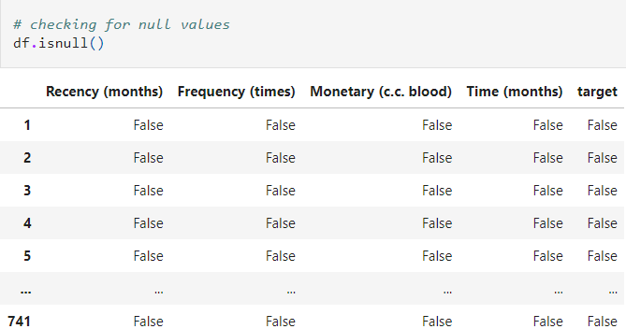

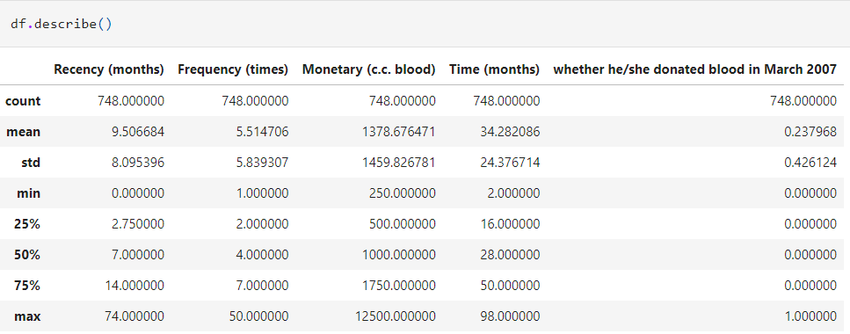

- 4.3 Task 3
Creating Target Column and Target Incidence

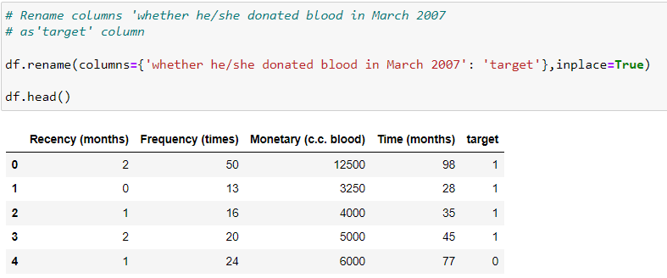

In this step we have renamed the target column ‘weather he/she donated blood in March 2007’ to ‘target’.

- 4.4 Task 4
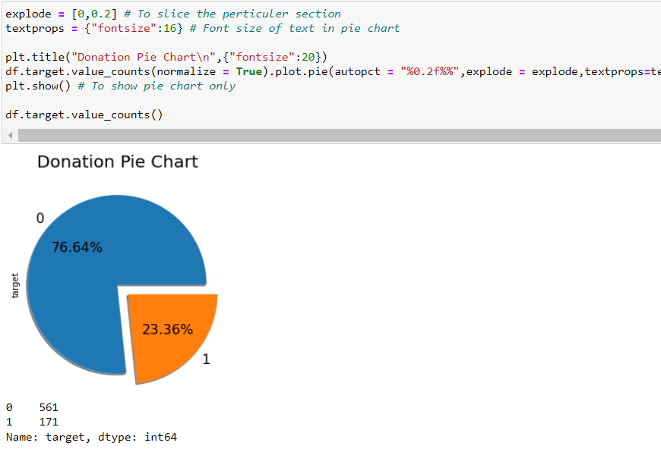

Figure 1

The plot shows us the distribution of the people who donated blood and who didn’t. We can clearly see maximum people did not donate blood. The above code snippet also represents the count of the values in the target column, it gives a count of 0’s & 1’s.

- 4.5 Task 5

Exploring Data through Data Visualization and Statistics

Data Correlation is a way to understand the relationship between multiple variables and attributes in our dataset. Using Correlation, we can get some insights such as, one or multiple attributes depend on another attribute.
Positive Correlation: means that if feature A increases then feature B also increases and vice versa.
Negative Correlation: means that if feature A increases then feature B decreases and vice versa.

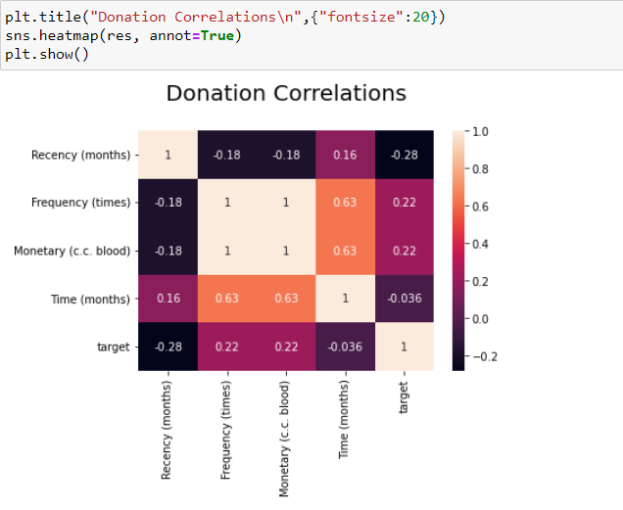
Figure 2

We can represent the correlation through a heatmap in the seaborn library. It represents the correlation in a color-coded format, and gives a legend of the colors at the side of the graph. We can see that we have a positive correlation between Frequency and Time. We can see the values of the correlation in each cell, by putting the value of annot = True.

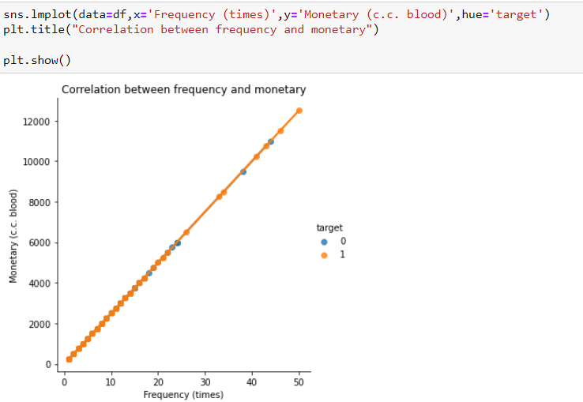

Figure 3

Frequency and monetary values are highly correlated. This means that the total amount of blood that a person has donated increases with no of times he/she has donated.

Handling Outliers:

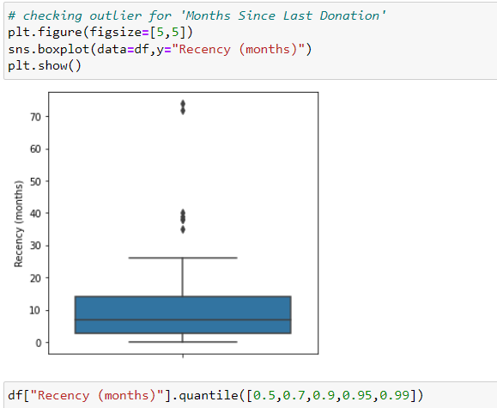
Figure 4

Checking outlier for 'Months Since Last Donation’. Boxplot is showing the outliers for Recency. There are few entries having very large Recency than others. Considering this entries will mislead the further analysis. So excluding values outside 99 percentile for Recency.

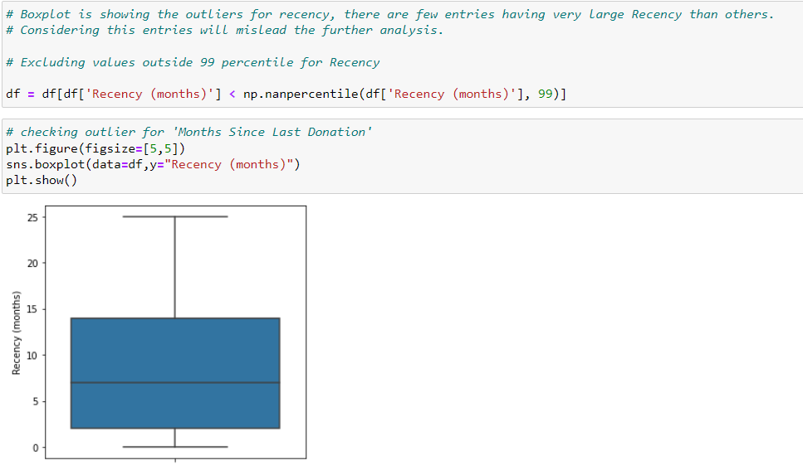
Figure 5

Months since last donation happened between 5th and 10th month.

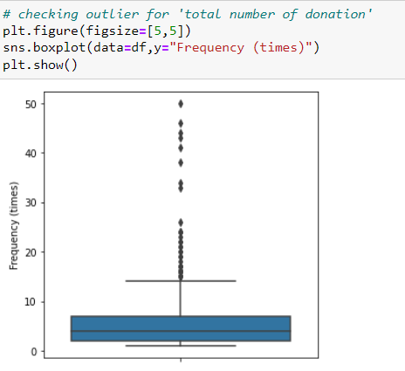
Figure 6

Checking outlier for 'Total number of donations’. Boxplot is showing the outliers for Frequency. There are few entries having very large Frequency than others. Considering this entries will mislead the further analysis. So excluding values outside 99 percentile for Frequency.

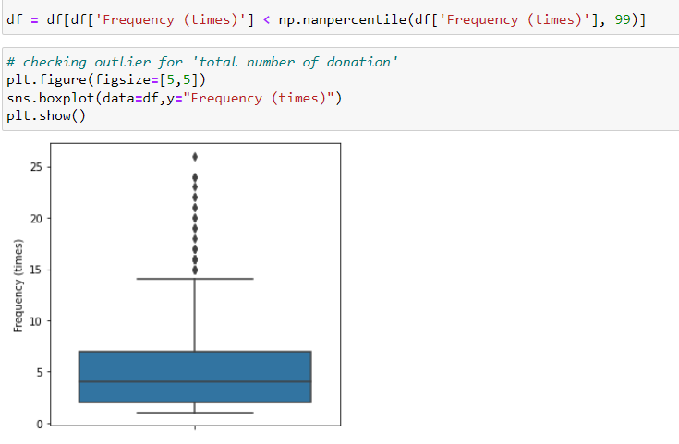
Figure 7

Total Number of Donations happened are approx. 5 times

- 4.6 Task 6

Splitting data frame into train and test datasets
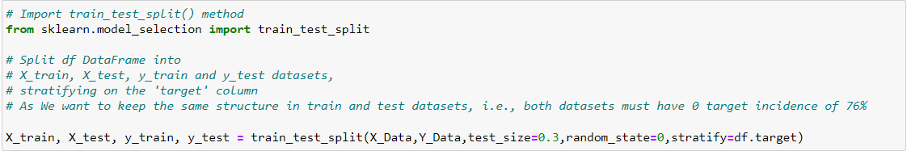
After these steps we can start the Machine Learning process, the first step is to start the Test and Train split which is splitting the data into 4 parts, X_train, X_test, Y_train, Y_test, In this we split our dataset, in the testing and training part, we have divided our dataset as 70% Train, and 30% Test. We have used the test_train_split function from sklearn_library. We
have initialized the random_state variable as 0 and test_size as 0.25, keeping the random state fixed makes the test and train data fixed.
Target incidence informed us that in our dataset 0s appear 76% of the time. We want to keep the same structure in train and test datasets, i.e., both datasets must have 0 target incidence of 76%. This is very easy to do using the train_test_split() method from the scikit learn library - all we need to do is specify the stratify parameter. In our case, we'll stratify on the target column.

- 4.7 Task 7

Selecting model using TPOT

The next task is to install and the import the TPOT library for further processing of the testing dataset. First, we installed TPOT library through ‘!pip install tpot’, then we import the TPOT library and the ‘roc_auc_score’ to measure the accuracy of the model.

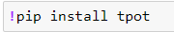

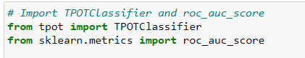

The next step we initialize the TPOTClassifier, by defining the basic attributes of the classifier function, we have kept the scoring method as roc_auc, defined a random state, generation & population size.

Next we fit our train data into the model by tpot.fit(X_train, y_train), after the fitting of the data onto the TPOT model, we now have to generate the AUC score by comparing the results of tpot.predict_proba, with y_test. We also print out the Best Pipeline Steps. The output is also shown below:
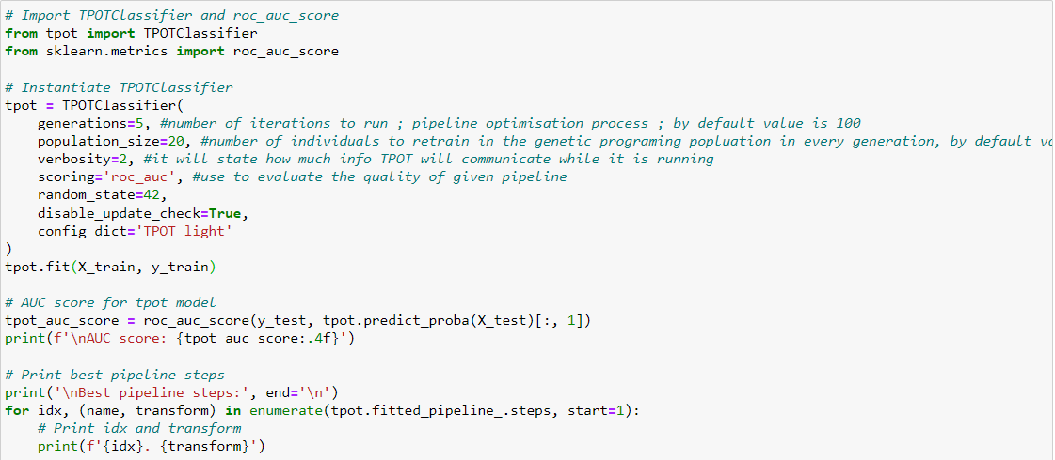

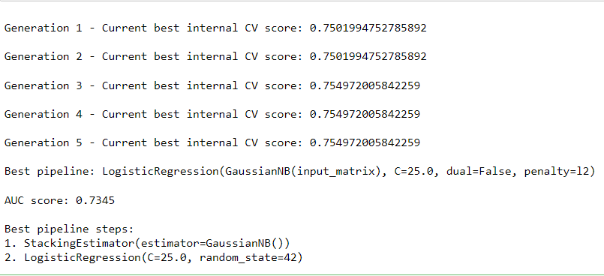

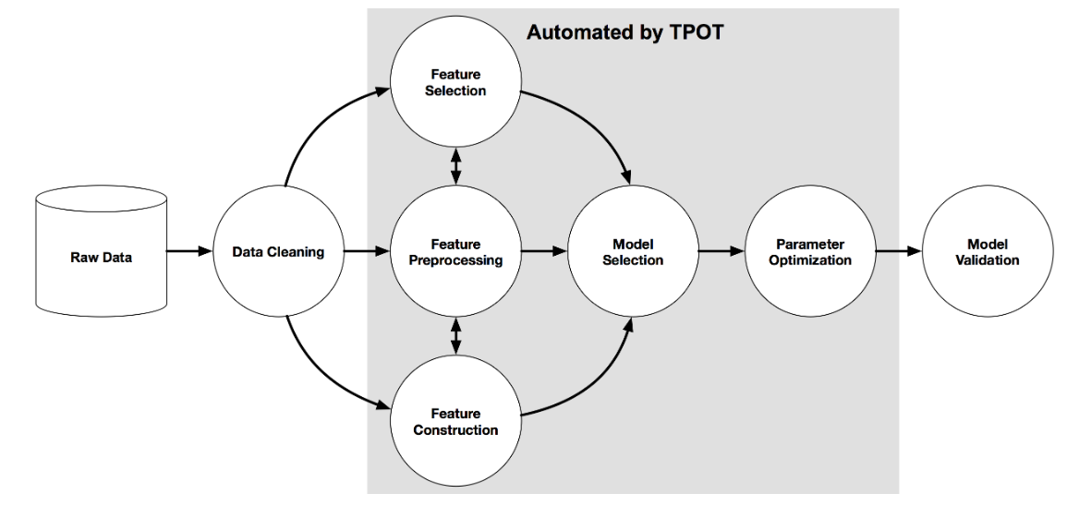
Figure 8

- 4.8 Task 8

Checking the variance
TPOT picked LogisticRegression as the best model for our dataset with no pre-processing steps, giving us the AUC score of 0.7345. This is a great starting point. Let's see if we can make it better.
If a feature in our dataset has a high variance that's an order of magnitude or more greater than the other features, this could impact the model's ability to learn from other features in the dataset.
Correcting for high variance is called normalization. It is one of the possible transformations you do before training a model. Let's check the variance to see if such transformation is needed.

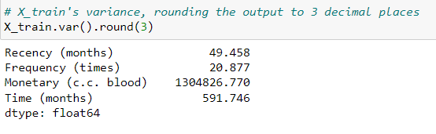

- 4.9 Task 9

Log Normalization
Monetary (c.c. blood)'s variance is very high in comparison to any other column in the dataset. This means that, unless accounted for, this feature may get more weight by the model (i.e. be seen as more important) than any other feature.
One way to correct for high variance is to use log normalization.

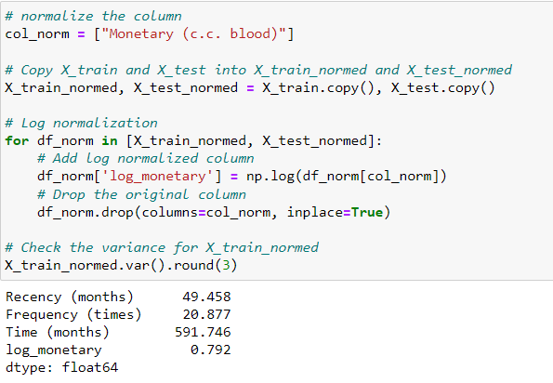

- 4.10 Task 10

Training the Regression Model
The variance looks much better now. Notice that now Time (months) has the largest variance, but it's not the orders of magnitude higher than the rest of the variables, so we'll leave it as is.
We are now ready to train the linear regression model.
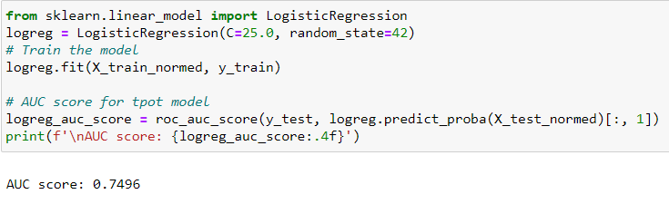

- 4.11 Task 11

Saving the prediction
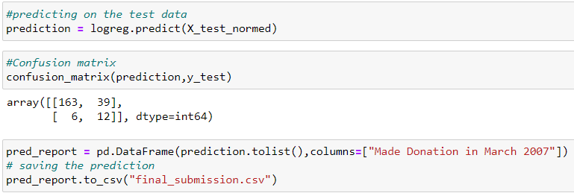

We saved the prediction through ‘logreg’ in a variable named ‘prediction’. Then we created a confusion matrix for ‘prediction’ and ‘y_test’. Further we transformed the “Made Donations in March 2007” columns to list and saved that data to a csv file named ‘final_submission’.

- 4.12 Task 12

Modeling

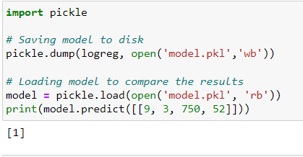

We then imported the pickle module and saved the model to the disk. Finally we loaded the model to compare the results.

CHAPTER 5 LEARNING EXPERIENCE
5.1 Knowledge Acquired / Skills learnt
- Python Programming Language: The project involves using Python as the primary programming language. I have acquired or improved your Python skills during the project, including understanding data structures, control flow, functions, and libraries.

- Data Manipulation: I have learned how to handle and manipulate data effectively, particularly with libraries like Pandas and NumPy. This includes data cleaning, transformation, and preparation for modeling

- Exploratory Data Analysis (EDA): EDA is a crucial step in any data science project. I have gained experience in using libraries like Pandas, Matplotlib and Seaborn to visualize data, identify patterns, and gain insights into the blood donation dataset.

- Data Preprocessing: Preparing data for machine learning models requires handling missing values, dealing with outliers, and encoding categorical variables. I have acquired skills in these areas.

- Feature Engineering: Feature engineering involves creating new features or transforming existing ones to improve model performance. Techniques like normalization, scaling, and creating derived features was a part of my skillset.

- Machine Learning: The core of the project lies in building a predictive model. I have learned about different machine learning algorithms like Logistic Regression, Random Forest, Support Vector Machines, etc.

5.2 Industry Practices Adapted
- Data Collaboration: Healthcare organizations often collaborate with blood banks, hospitals, and donation centers to gather comprehensive datasets. This ensures a more holistic view of donor behavior and donation patterns.

- Data Privacy and Security: Given the sensitive nature of healthcare data, strict adherence to data privacy and security protocols is crucial.

- Feature Engineering: Domain experts, along with data analysts, work together to identify relevant features that may influence blood donation behavior. These could include factors like past donation frequency, donation history, age, gender, location, and even local events.

- Real-Time Monitoring: In some cases, predictive models are deployed to monitor blood donation patterns in real-time. This allows organizations to identify potential blood shortages or surpluses and respond proactively.

- Collaboration with Blood Drive Events: Data analytics teams may collaborate with event organizers to optimize the timing and locations of blood drives based on predicted donor behavior.

5.3 Real time Applicability of Technologies Learnt
- Blood Supply Management: By predicting blood donation patterns in real-time, healthcare organizations and blood banks can proactively manage their blood supply. They can identify potential shortages or surpluses and take immediate action to ensure a sufficient and balanced blood inventory.

- Donor Targeting: Using predictive models, healthcare organizations can identify potential blood donors who are likely to donate in the near future. This information allows them to target these donors with personalized campaigns, encouraging them to donate when the need arises.

- Emergency Response: During emergencies, such as natural disasters or accidents, real-time prediction models can help in mobilizing donors and organizing blood drives in the affected areas to meet the increased demand for blood.

- Resource Allocation: Hospitals and healthcare facilities can use real-time predictions to allocate resources efficiently. For example, if a hospital is expecting a high number of blood transfusion cases, they can ensure they have enough staff and resources on hand to handle the situation.

- Personalized Donor Engagement: Real-time analytics can enable personalized interactions with donors. For example, if a donor is due for their next donation, they could receive an automated reminder through a mobile app or email, increasing the likelihood of participation.

 | Date | Day | Name of Topic/Module
Week 1 | 1/5/2023 | Monday | Introduction of Company and Internship plan
Week 1 | 2/5/2023 | Tuesday | Orientation and onboarding to company tools and projects
Week 1 | 3/5/2023 | Wednesday | Introduction to Excel for data organization and visualization
Week 1 | 4/5/2023 | Thursday
Week 1 | 5/5/2023 | Friday | Pivot tables in Excel and data sorting
Week 1 | 6/5/2023 | Saturday | Pivot tables in Excel and data sorting
Week 2 | 8/5/2023 | Monday | Assisted in data collection and cleaning
Week 2 | 9/5/2023 | Tuesday | Assisted in data collection and cleaning
Week 2 | 10/5/2023 | Wednesday | Basic data analysis with Python
Week 2 | 11/5/2023 | Thursday | Basic data analysis with Python
Week 2 | 12/5/2023 | Friday | Created interactive data visualizations in Python
Week 2 | 13/5/2023 | Saturday | Created interactive data visualizations in Python
Week 3 | 15/5/2023 | Monday | Collaborated on data analysis projects
Week 3 | 16/5/2023 | Tuesday | Collaborated on data analysis projects
Week 3 | 17/5/2023 | Wednesday | Worked on data modeling tasks using Python
Week 3 | 18/5/2023 | Thursday | Worked on data modeling tasks using Python
Week 3 | 19/5/2023 | Friday | Assisted in machine learning projects
Week 3 | 20/5/2023 | Saturday | Assisted in machine learning projects
Week 4 | 22/5/2023 | Monday | Worked on real-world Data Analytics project ‘Predict Blood Donations’
Week 4 | 23/5/2023 | Tuesday
Week 4 | 24/5/2023 | Wednesday
Week 4 | 25/5/2023 | Thursday
Week 4 | 26/5/2023 | Friday
Week 4 | 27/5/2023 | Saturday

Table 1 Internship plan (Week wise)

CHAPTER 6 CONCLUSION

In this notebook, we explored automatic model selection using TPOT. The AUC score we got was 0.7344. We then log normalized our training data and improved the AUC score by 1.5%. In the field of machine learning, even small improvements in accuracy can be important, depending on the purpose. Benefit of using logistic regression model is that it is interpretable. We can analyze how much of the variance in the target variable can be explained by other variables in our dataset.
The results of this project highlight the importance of preprocessing and feature engineering in data analysis tasks, particularly when dealing with machine learning algorithms that are sensitive to the scale of input features. Employing normalization as part of the data preparation pipeline can lead to more accurate predictions and enhance the overall performance of the model.
We check the output of the prediction of the TPOT library and the Logistic Regression model after the normalization below:\

-TPOT prediction
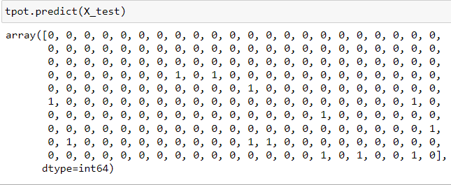

-Logreg predictions
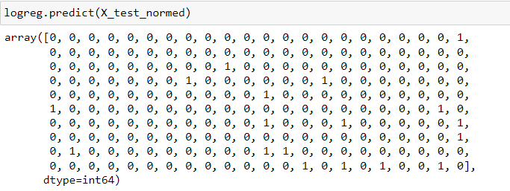

As we can see the accuracy has been increased after the normalization:
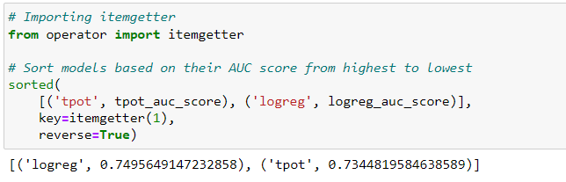

We can conclude that the demand for blood fluctuates throughout the year. As one prominent example, blood donations slow down during busy holiday seasons. An accurate forecast for the future supply of blood allows for an appropriate action to be taken ahead of time and therefore saving more lives.

REFERENCES

- https://www.figma.com
- https://dribbble.com
- Adobe Photoshop

