**Lab Practical 4:**

* ***Network Topologies.***

**Bus Topology:**

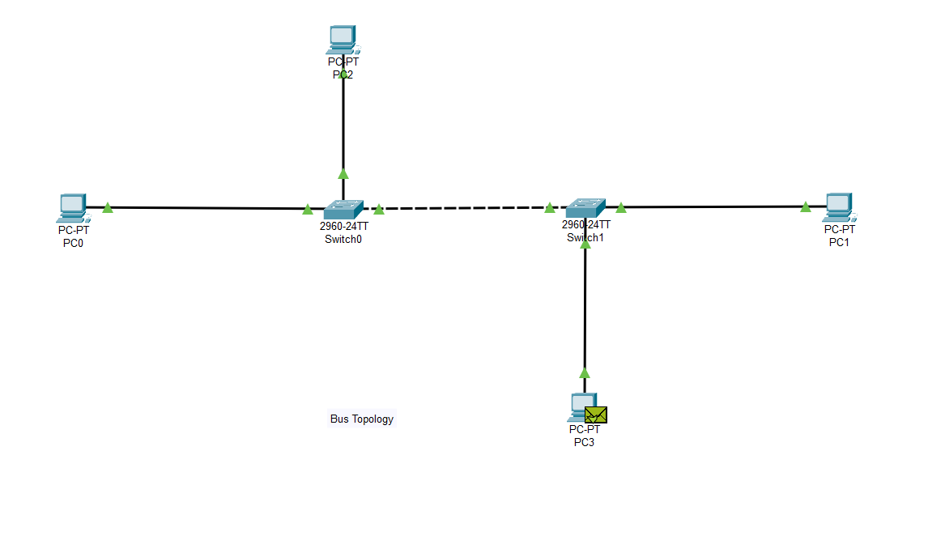 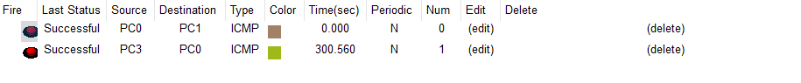

**Ring Topology:**

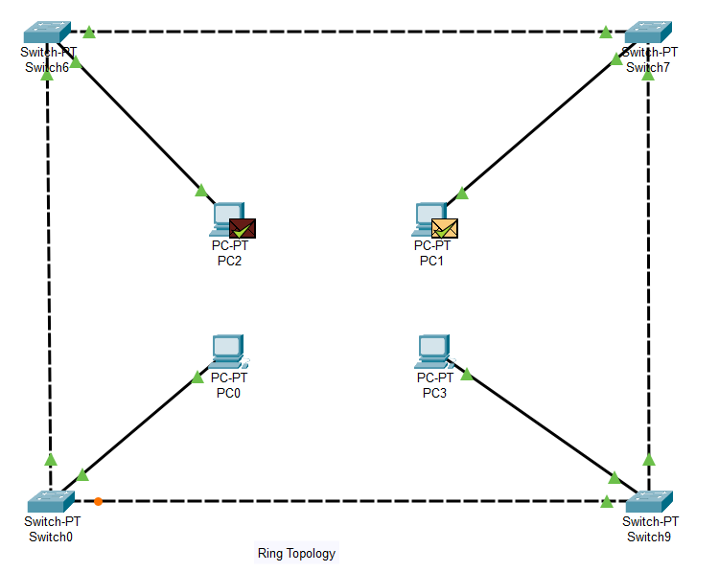

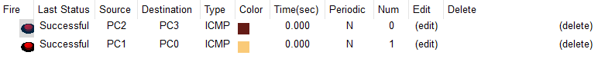

**Star Topology:**

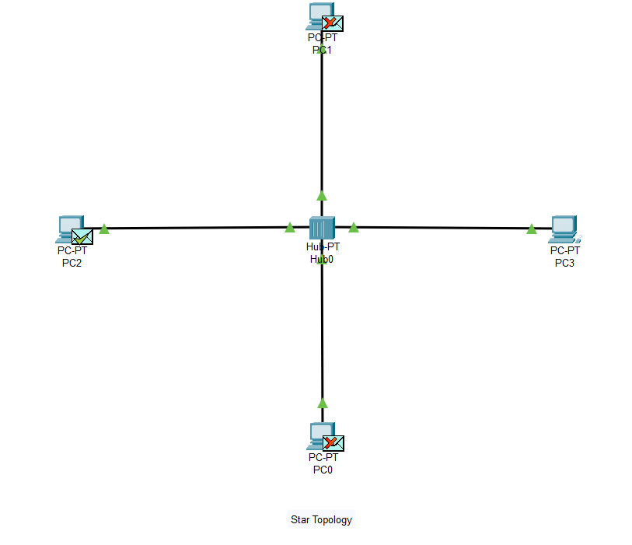

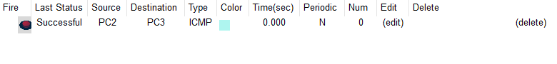

**Tree Topology:**

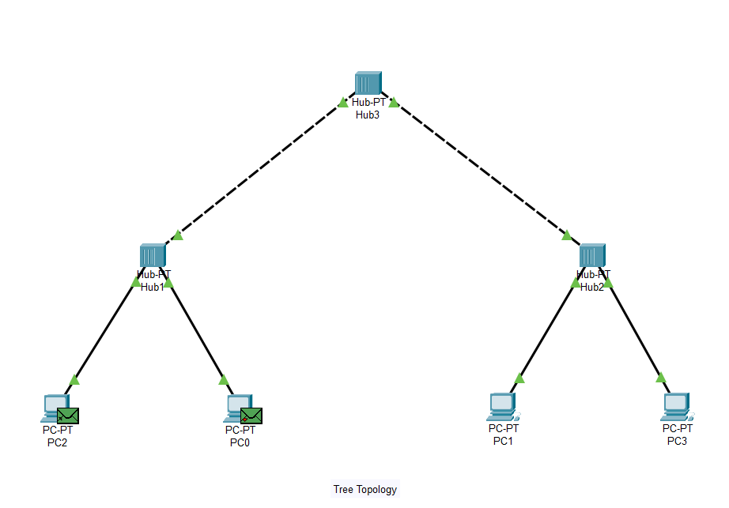

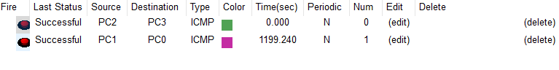

**Mesh Topology:**

