***Practical 6: Network Topologies***

**Bus Topology:**

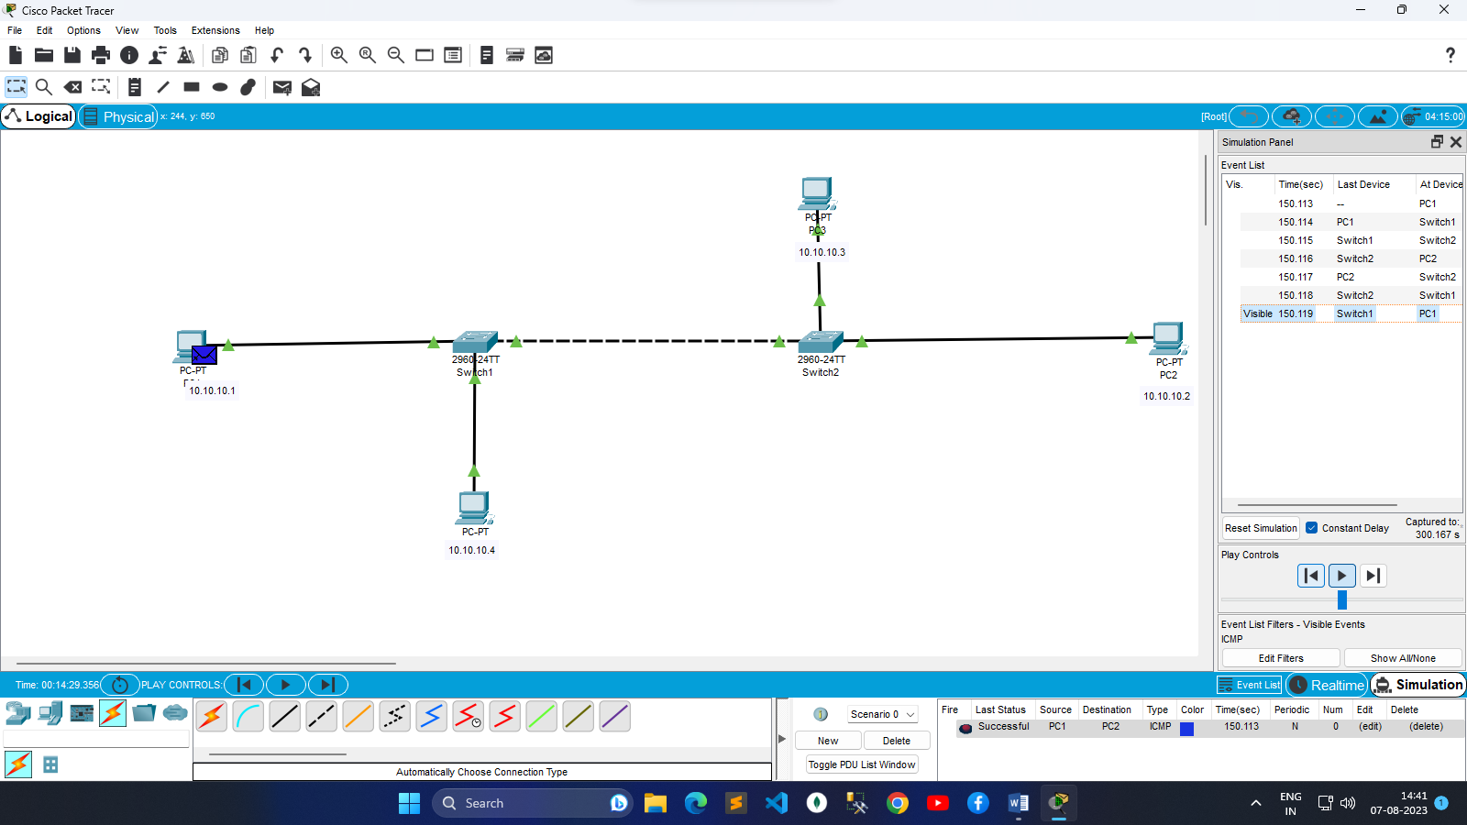

**Ring Topology:**

