- Open MySQL Workbench

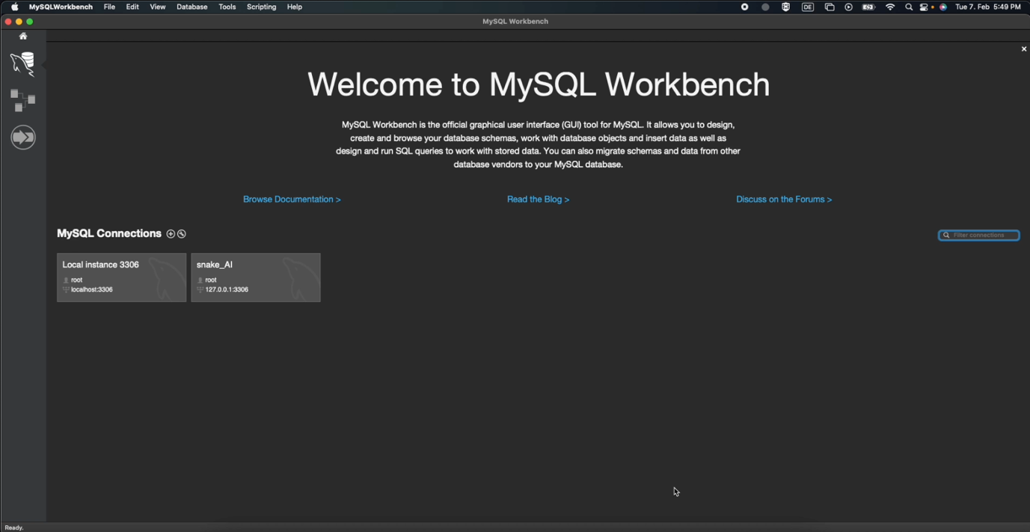

- Click on + to add MySQL Connection

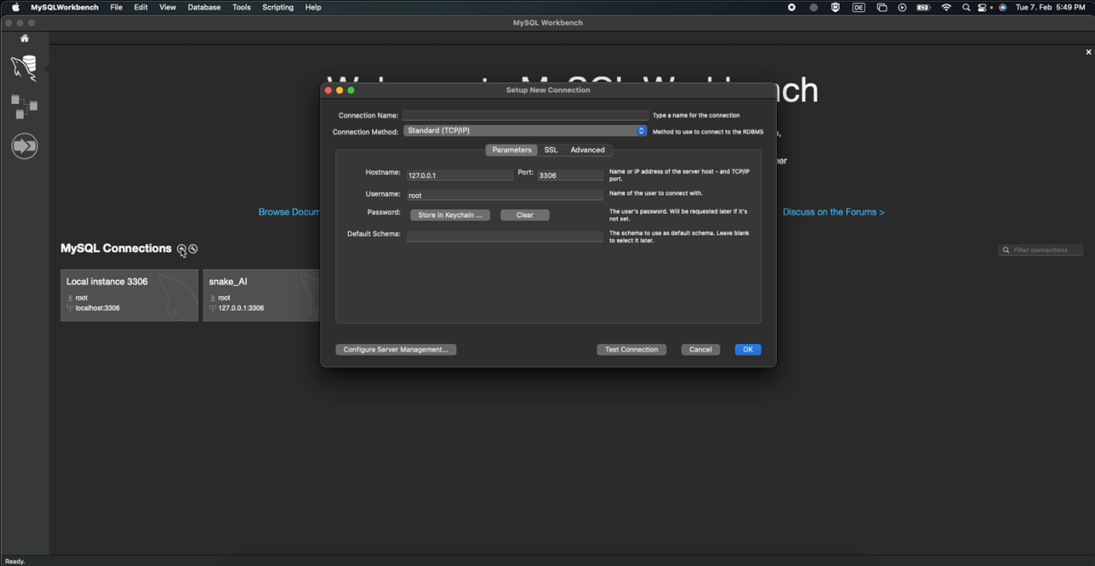

- Write snake_AI_2 as Connection Name and click on OK.

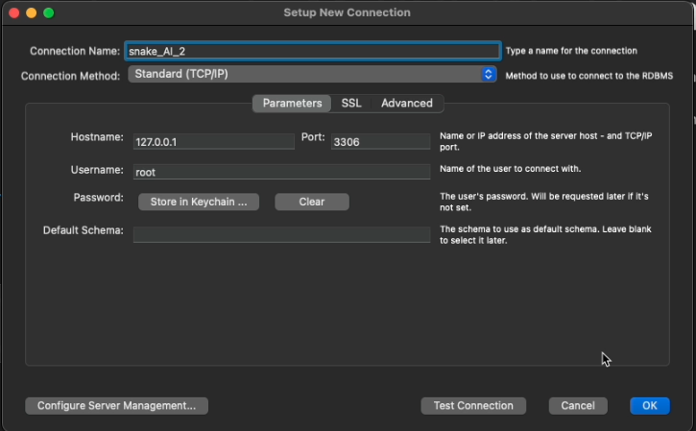

- Give your Password of MySQL Workbench and click on OK to open snake_AI Connection

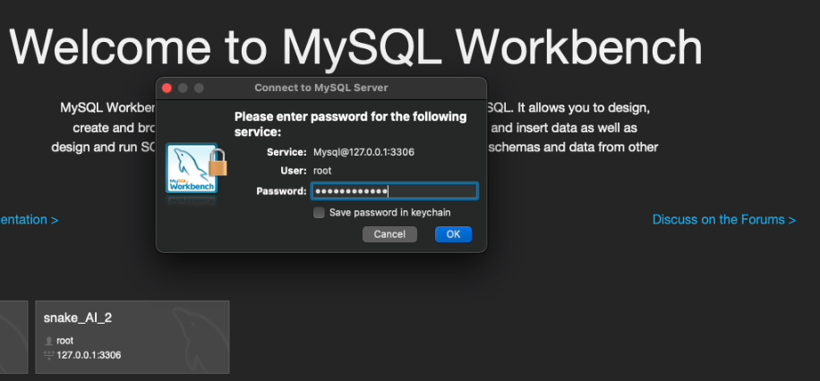

- Once Connection gets open, click on Server to import a Data

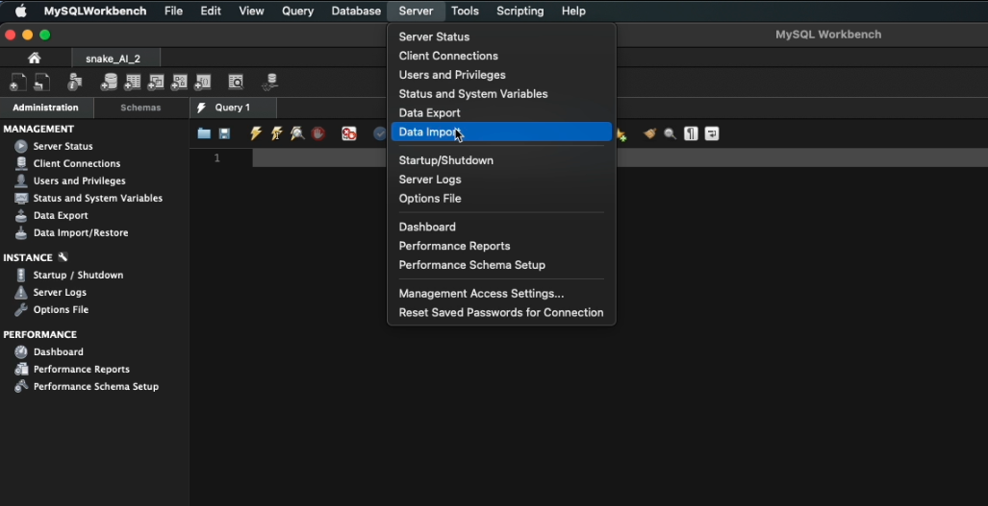

- Import a jdbc_snake_ai.sql file which you will find in zip

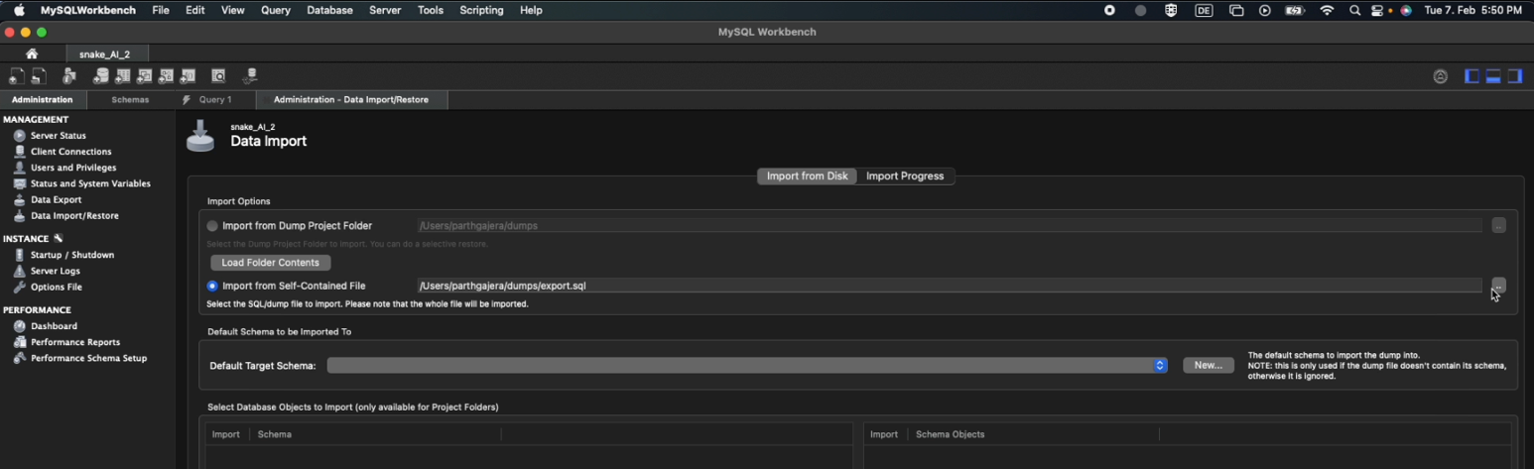

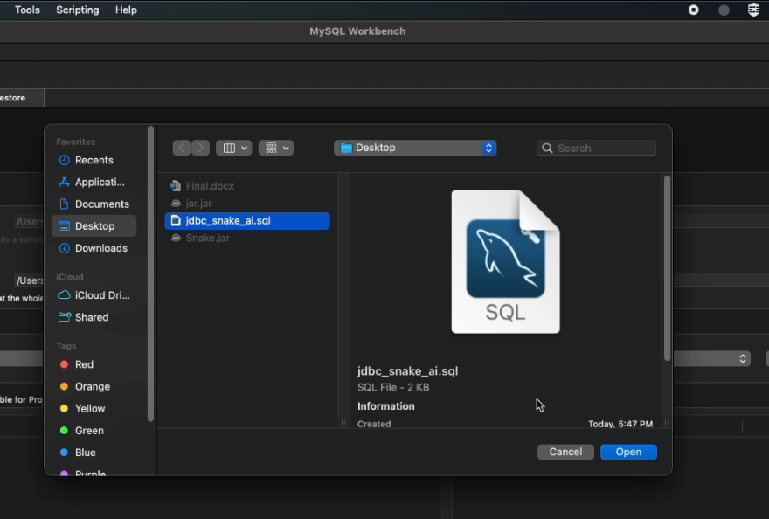

- Click on New to create a new Schema and write down same name as of sql file: jdbc_snake_ai

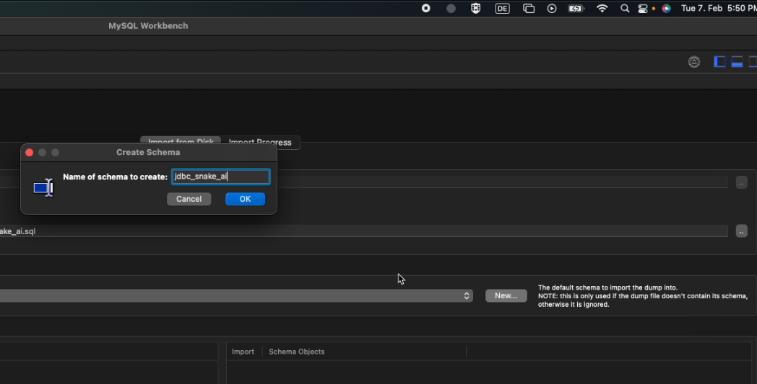

- Click on Ok and import a Data

- Once Data gets imported, close MySQL

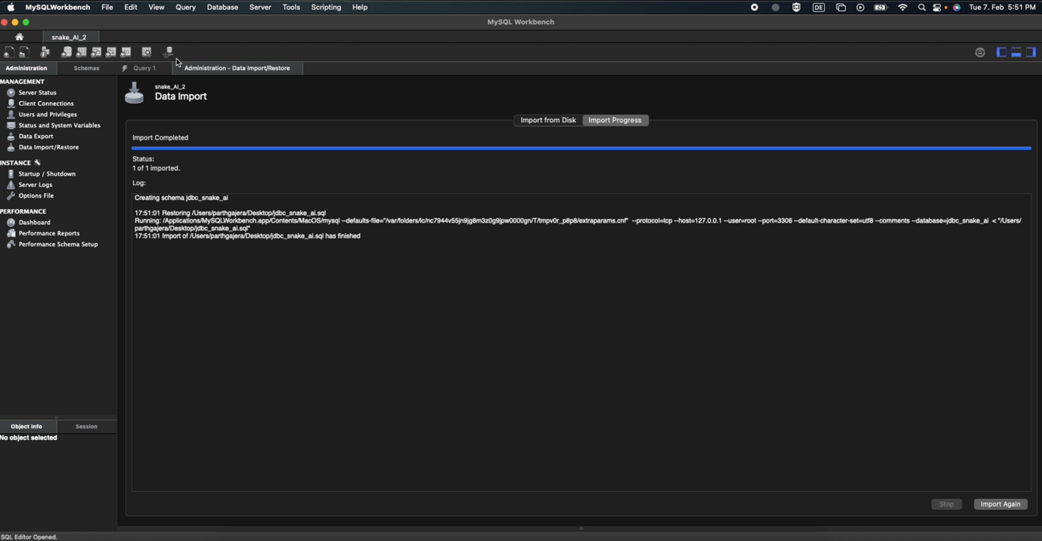

- Copy the path of jdbc_snake_ai.sql

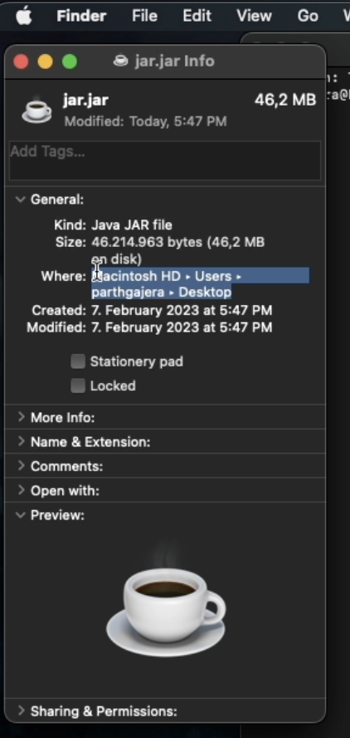

- Open Terminal and write the following: java -jar (path of jdbc file)/SnakeAI.jar (password of MySQL)

In our case it was java -jar /Users/parthgajera/Desktop/SnakeAI.jar <Password>

