1. Unzip the snake eclipse
2. Download Eclipse or if have already than open the Eclipse
3. Go to File and select Import

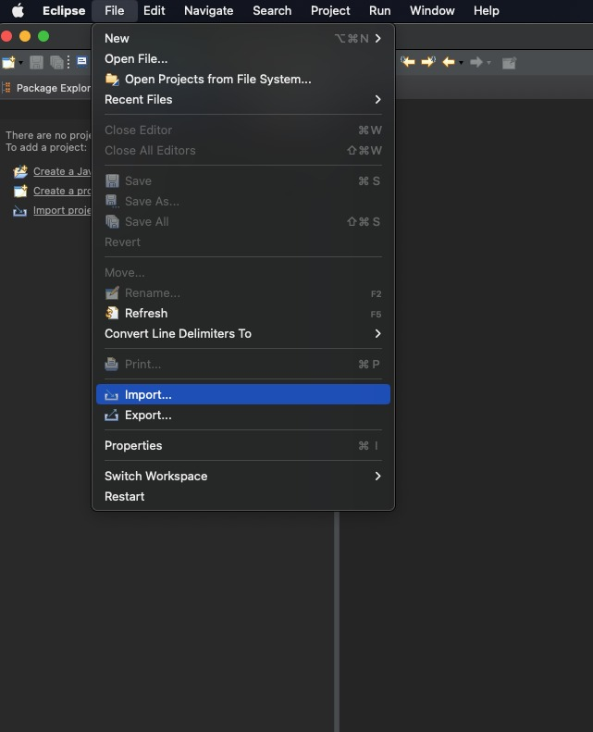

1. Click on General -> Existing Projects into Workspace

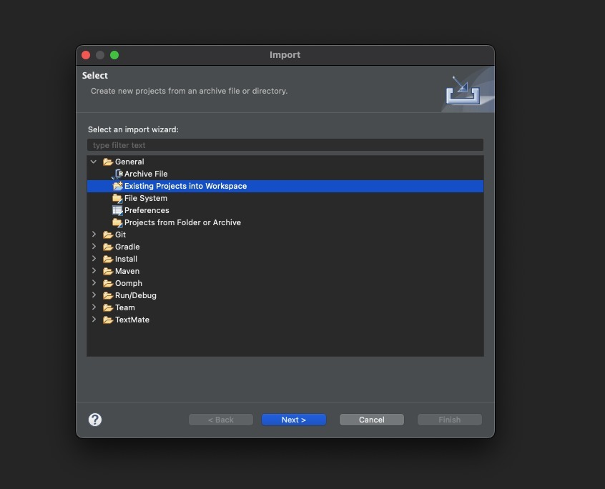

1. Click on Browse

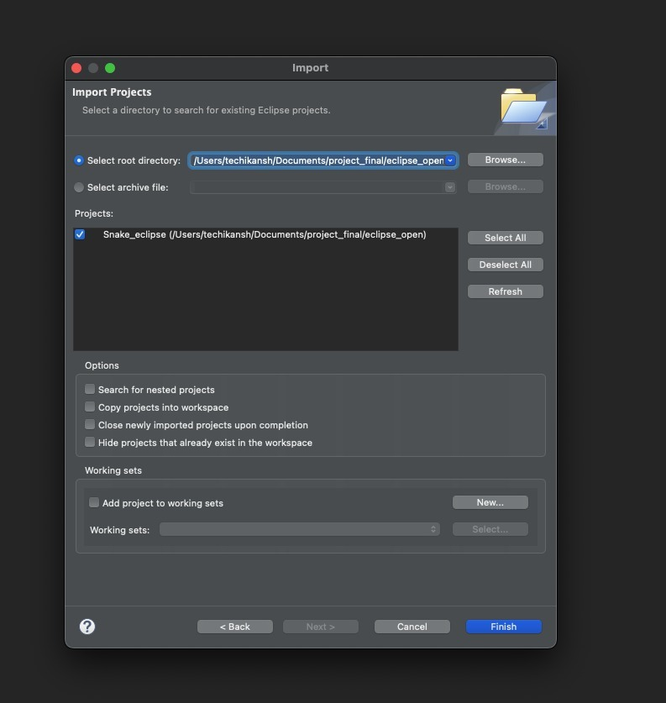

1. Go to “Snake_eclipse” file which you will find on zip file and click on Open

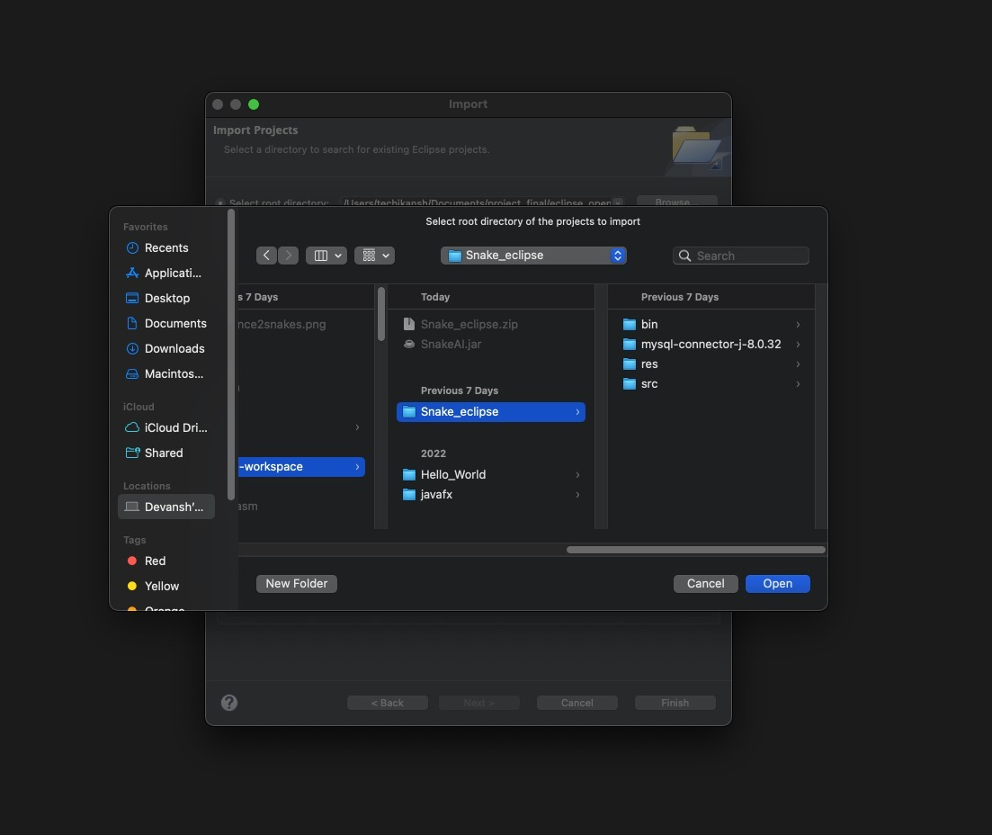

1. Once you Open a File click on Finish Button

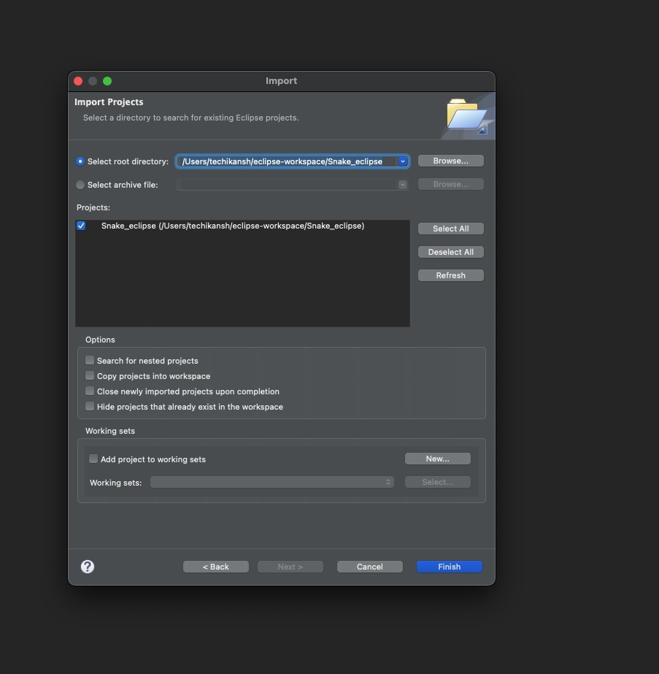

1. Open SnakeGame class and click on run button

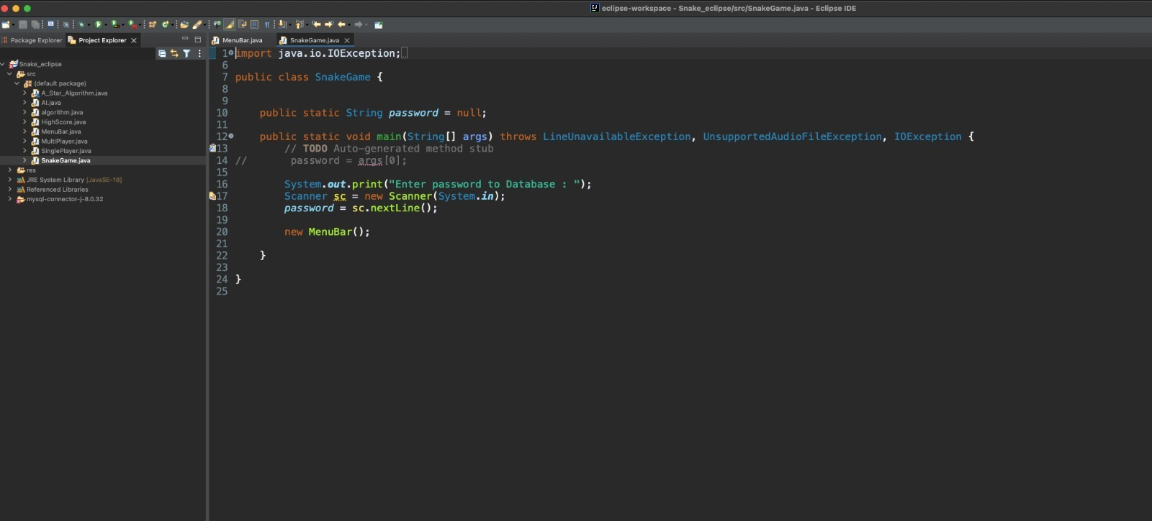

1. Enter Password to your Database

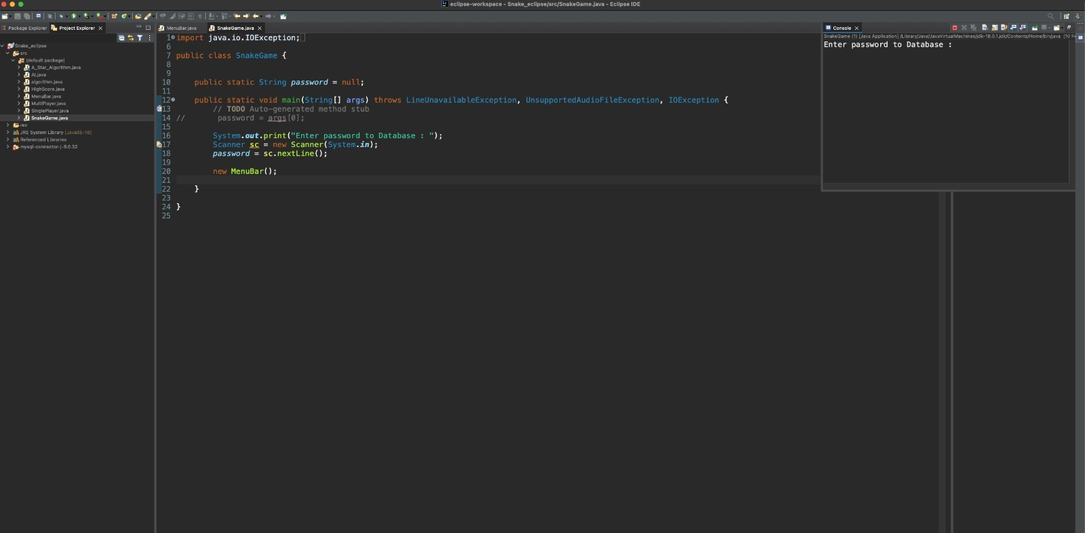

If (SQL not connected) otherwise IGNORE this step

1. If you haven’t connected to Database yet, give any word as Password and press enter and it will run without Database
2. Hurray!!! Have Fun

