**Author/Student Name** : Parthkumar Anilkumar Gandhi

**Subject** : IS 601

**Homework**: Web Application Part 4

**Introduction**: Created REST API end points in flask, using MySql database. Used Docker for building the application and as deployment tool.

**GitHub repository** : https://github.com/Parth-Gandhi96/oscarMaleFlask/tree/lesson4

**Screenshots**

Showing postman listing all records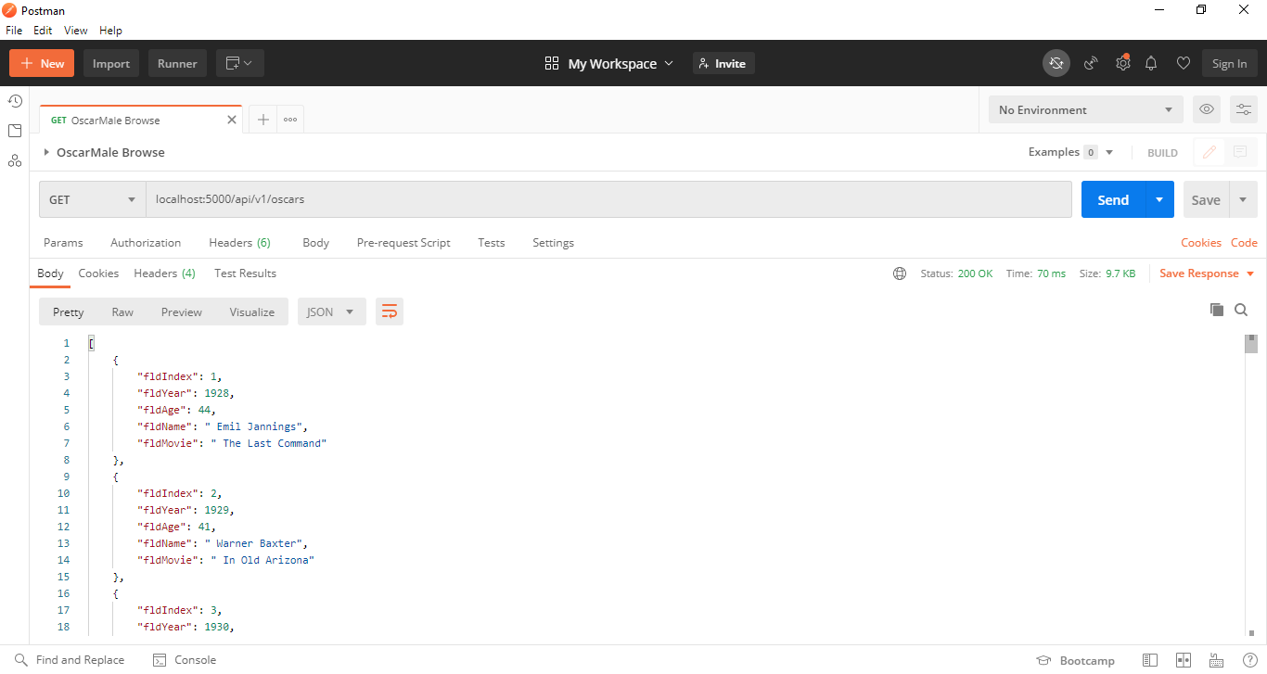

Showing postman showing one record with a get request

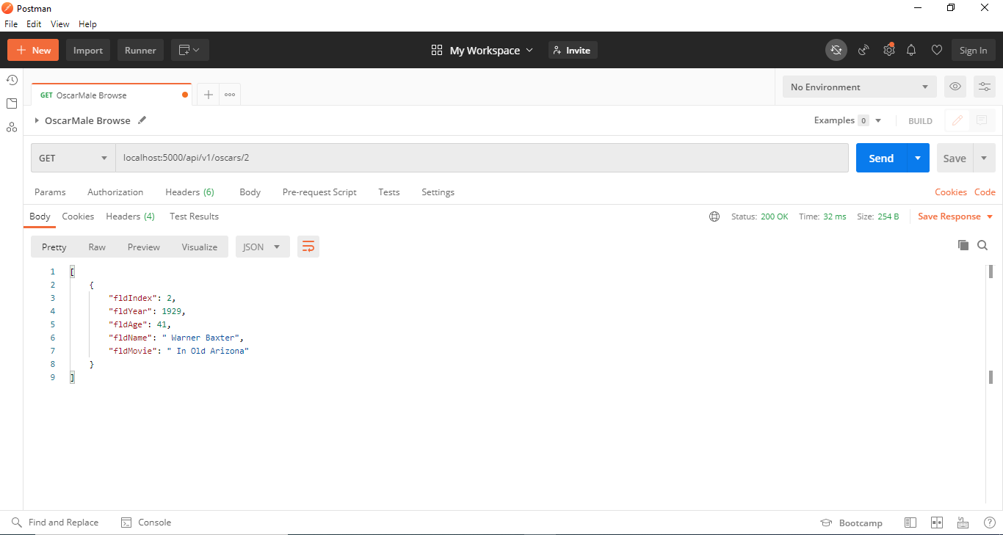

Showing postman creating a record by showing the post request and the results in

the record listing

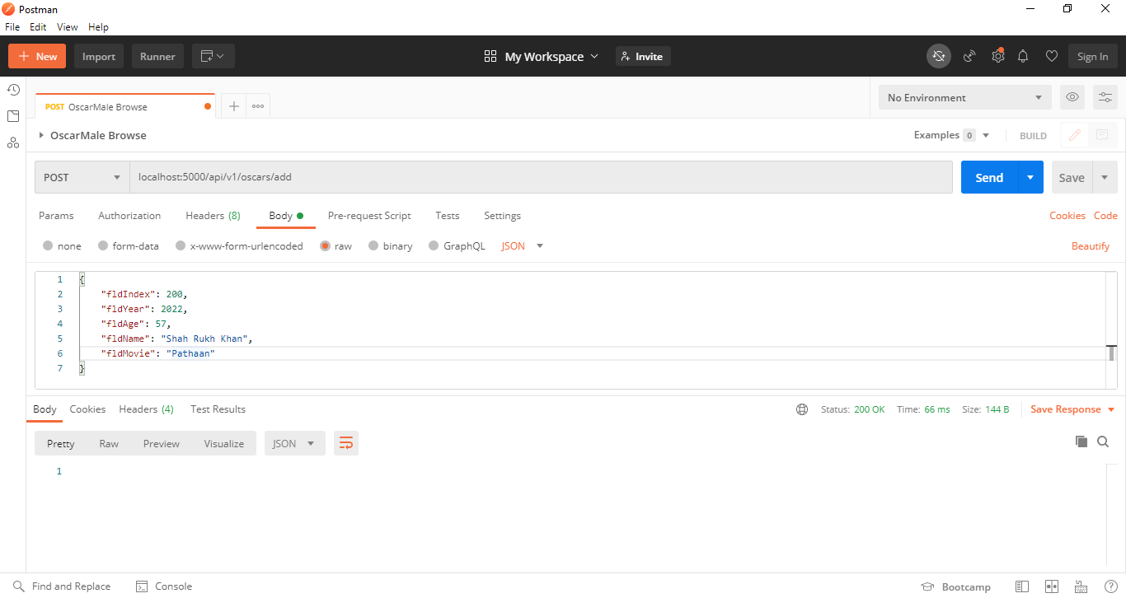

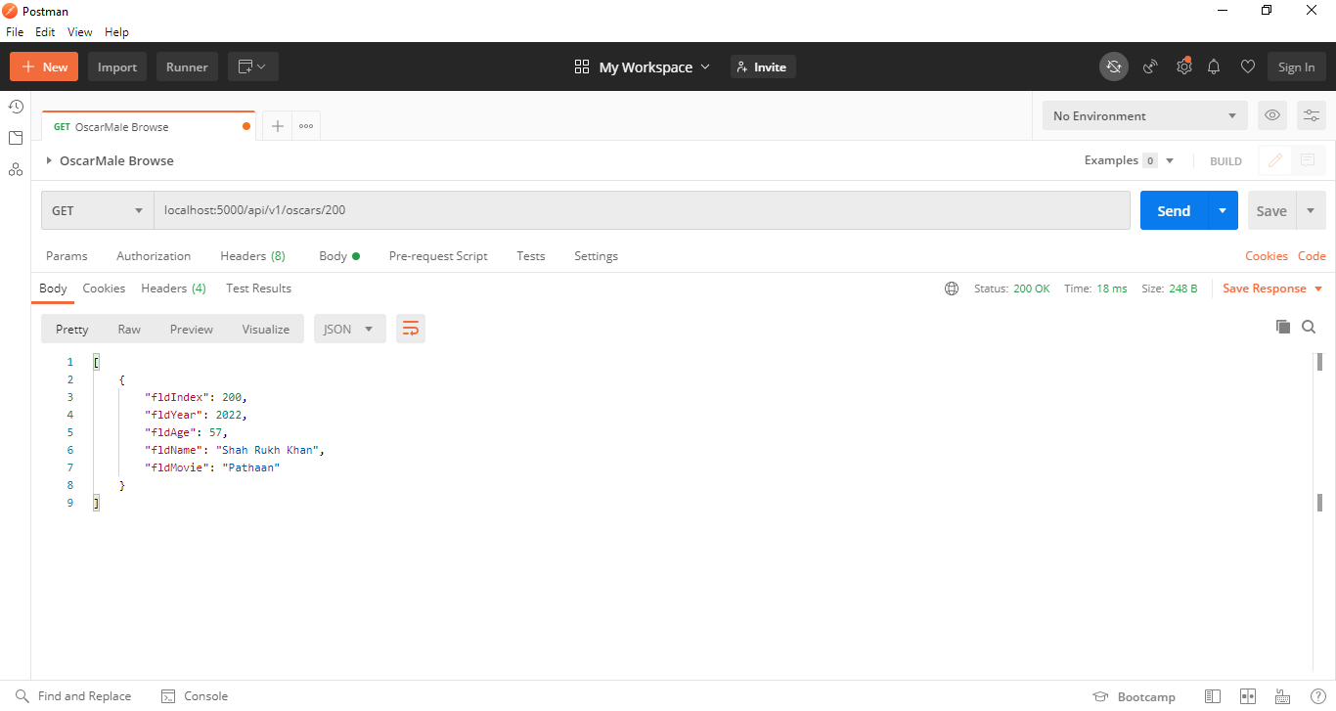

Showing postman edit a record by showing the put request and the results in the

record listing

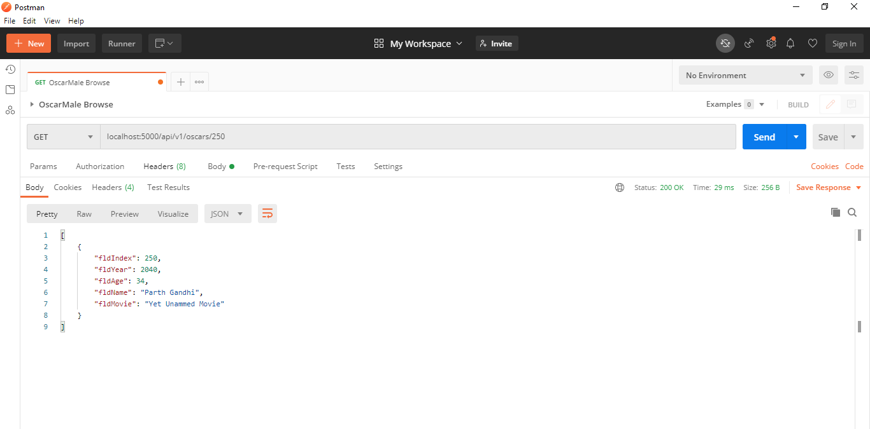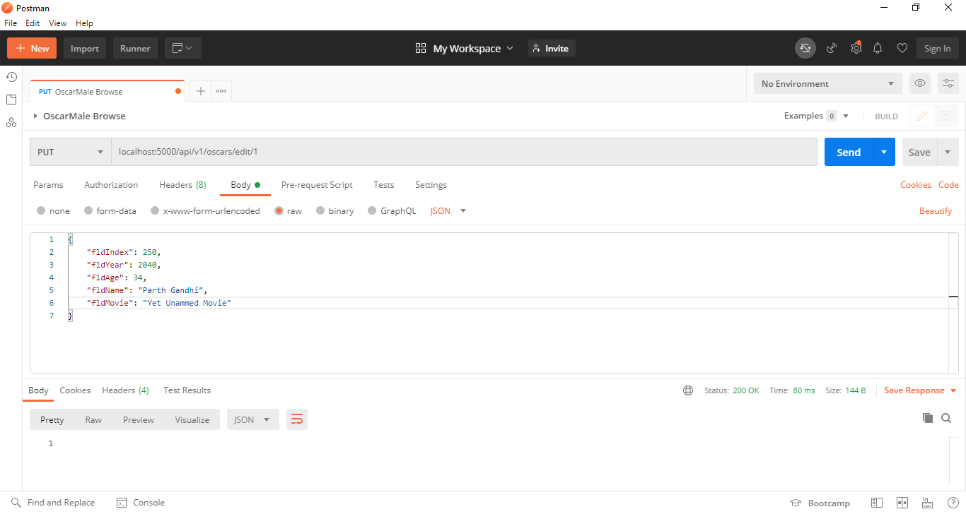

Showing postman delete a record by showing the delete request and the results in

the record listing

