Performance Analysis Using Type-2 Hypervisor
VMware Workstation • Ubuntu VM • Experimental Record

Student: Parth Karpe | Experiment: Type-2 Hypervisor Performance Analysis

This document records the user's own VMware screenshots and observations. The supplied Type-2 reference document was used as a structural reference only; its personal details and benchmark values are not reproduced.

1. Aim
To create and verify a virtual machine on VMware Workstation, inspect its CPU, memory and disk configuration, monitor resource utilization, and perform the prescribed CPU-performance measurements.

2. Experimental Configuration
Parameter | Observed / Configured
Hypervisor | VMware Workstation
Hypervisor Type | Type-2
Guest OS | Ubuntu 24.04.x LTS (visible in supplied VM screenshot)
CPU allocation | 2 vCPU / 2 CPU workers visible in supplied evidence
Memory allocation | Configured for the experiment; exact setting should be recorded from VM Settings
Virtual disk | Configured for the experiment; exact setting should be recorded from VM Settings
Network | VMware virtual network; connectivity evidence supplied

3. Procedure
1. Launch VMware Workstation and open the experiment VM.
2. Verify the VM hardware configuration.
3. Start the Ubuntu VM.
4. Verify CPU, memory and disk information from the guest.
5. Monitor CPU and memory usage.
6. Install the required benchmarking tool.
7. Run the prescribed Sysbench CPU benchmark and preserve the complete terminal output.
8. Record the benchmark metrics.
9. Shut down the VM after the experiment.

4. Commands Used
hostnamectl
lscpu
free -h
df -h
top
sudo apt update
sudo apt install sysbench -y
sysbench --version
sysbench cpu --cpu-max-prime=20000 run
sudo poweroff

5. Experimental Evidence
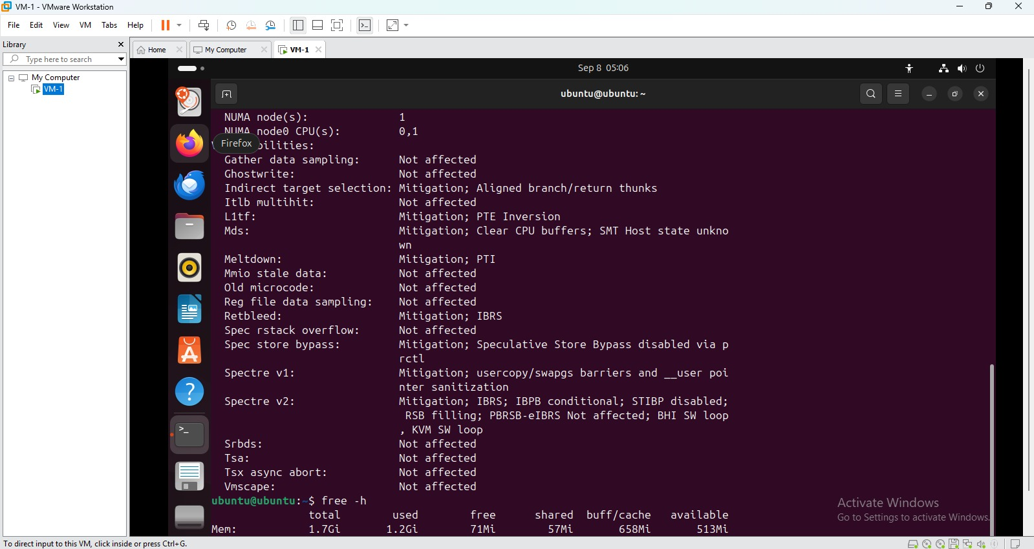
VMware Workstation VM configuration screen supplied by the user.

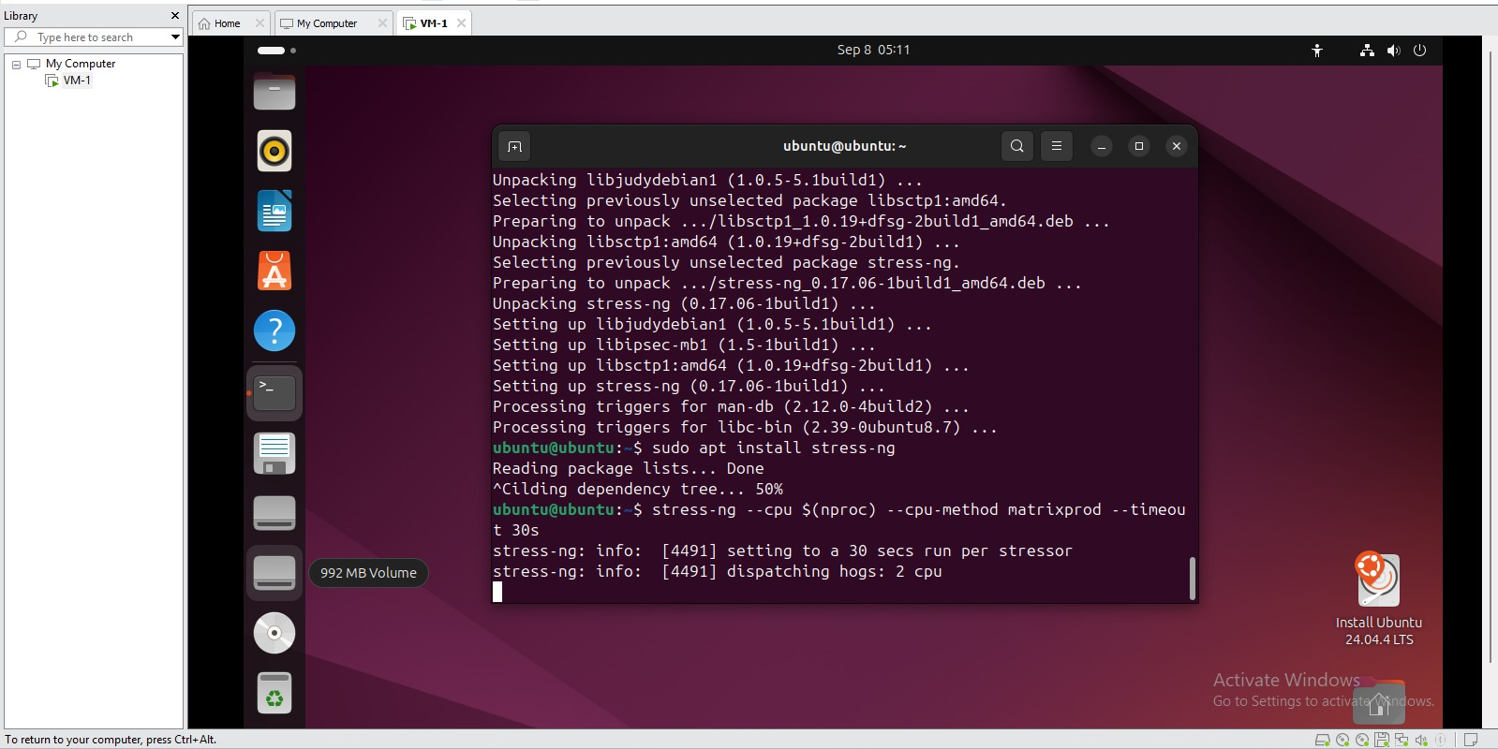
Running Ubuntu VM inside VMware Workstation; terminal shows a 2-CPU stress-ng run.

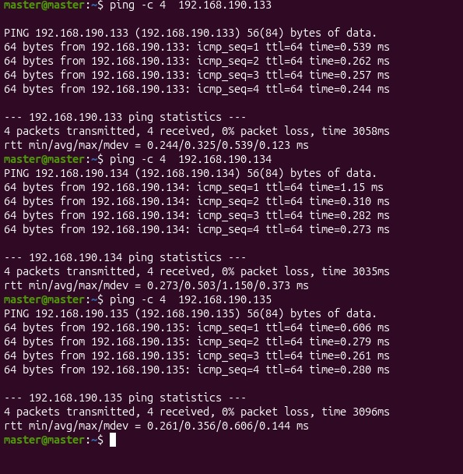
Ubuntu terminal showing SSH service enablement.

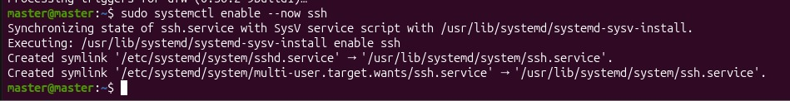
Network connectivity test with successful ICMP replies.

6. Observations From Supplied Screenshots
Observation | Recorded evidence
Virtual CPU usage | The stress-ng screenshot shows 2 CPU workers being dispatched.
CPU stress test | A 30-second stress-ng CPU test is visible and completed successfully in one supplied screenshot.
VM environment | The screenshot clearly shows Ubuntu running inside VMware Workstation.
Network | The supplied ping evidence shows successful replies with 0% packet loss to the tested addresses.
SSH | The supplied terminal evidence shows ssh.service being enabled.

7. Benchmark Results
No complete Sysbench CPU result is visible in the user's supplied VMware screenshots. The reference Type-2 document contains a Sysbench result, but those values belong to the reference experiment and are deliberately not copied here.
Metric | Your experimental result
Sysbench version | TODO — capture from your VM
CPU benchmark command | sysbench cpu --cpu-max-prime=20000 run
Total execution time | TODO
Total events | TODO
Events per second | TODO
Minimum latency | TODO
Average latency | TODO
Maximum latency | TODO

8. Resource Utilization Record
Metric | Observation
CPU | Stress-ng evidence demonstrates a 2-CPU workload; numeric utilization should be captured with top or another monitoring view.
Memory | TODO — capture using free -h.
Disk | TODO — capture using df -h.
Load / processes | TODO — capture using top.
Network | Successful ping evidence supplied; exact throughput not captured.

9. Missing Evidence Checklist
☐ VM Settings showing exact CPU/RAM/disk allocation
☐ hostnamectl output
☐ lscpu output
☐ free -h output
☐ df -h output
☐ top output
☐ Sysbench --version output
☐ Sysbench CPU benchmark output
☐ VMware resource utilization during benchmark
Reference documents supplied by a friend were used only for report structure and expected evidence categories. Their benchmark numbers are not used as this experiment's results.

10. Final Observation
The supplied screenshots establish the VMware environment, VM activity, CPU stress-test activity, SSH configuration and network connectivity. The final Sysbench performance record should be populated from the user's own benchmark run.

