Performance Analysis Using Type-1 Hypervisor
Proxmox VE • Ubuntu VM • Experimental Record

Student: Parth Karpe | Experiment: Type-1 Hypervisor Performance Analysis

This document records the user's own experimental screenshots and observations for the Proxmox VE Type-1 hypervisor. The structure follows the supplied laboratory manual and the supplied Type-1 reference document, while avoiding reuse of the reference student's personal information or benchmark values.

1. Aim
To create and verify a virtual machine on Proxmox VE, inspect CPU, memory and disk configuration, monitor resource utilization, and perform CPU-performance measurements using the prescribed benchmarking workflow.

2. Experimental Configuration
Parameter | Observed / Configured
Hypervisor | Proxmox VE 8.3.0 (visible in screenshots)
Hypervisor Type | Type-1
Guest OS | Ubuntu 24.04.x LTS (visible in supplied VM screenshots)
CPU allocation | 1 socket, 2 cores = 2 vCPU
Memory allocation | 2048 MiB / 2 GiB
Virtual disk | 20 GiB
Network | vmbr0 / VirtIO configuration visible in Proxmox

3. Procedure
1. Access the Proxmox VE web interface.
2. Create/select the Ubuntu virtual machine.
3. Configure 2 vCPU, 2 GiB RAM and a 20 GiB virtual disk.
4. Attach the VM to the configured Proxmox network bridge.
5. Start the VM and access the Ubuntu console.
6. Verify CPU, memory and system information using Linux commands.
7. Monitor the VM from the Proxmox Summary/Monitor interface.
8. Perform the required CPU benchmark and record the raw output.
9. Shut down the VM after measurements are complete.

4. Commands Used
hostnamectl
lscpu
free -h
df -h
top
sudo apt update
sudo apt install sysbench -y
sysbench --version
sysbench cpu --cpu-max-prime=20000 run
sudo poweroff

5. Experimental Evidence
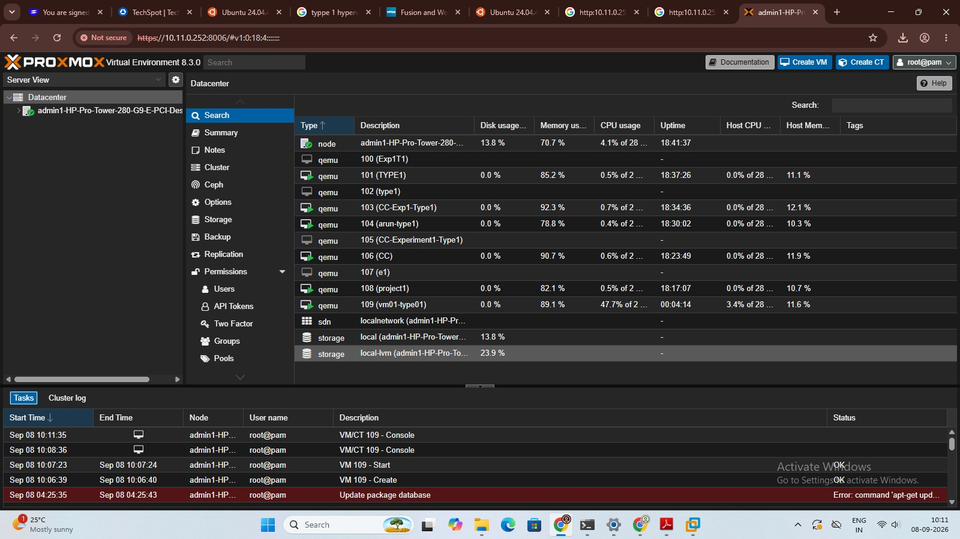
Proxmox VE dashboard and VM inventory.

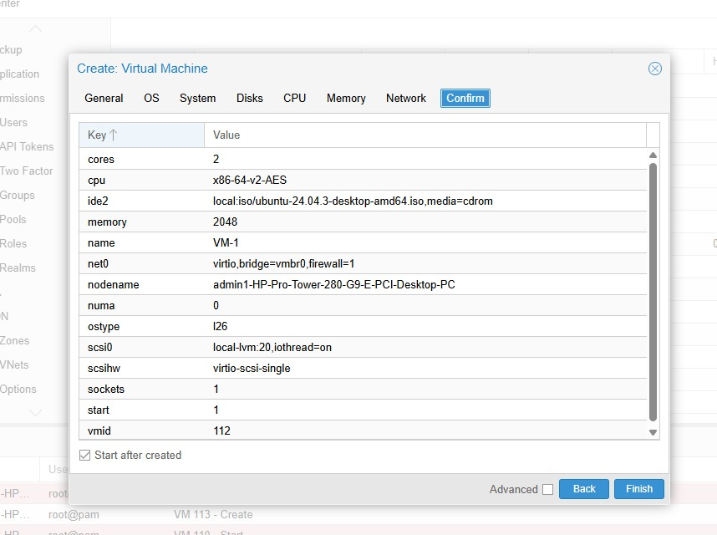
Proxmox Create Virtual Machine confirmation showing 2 cores, 2048 MiB memory and the configured virtual disk.

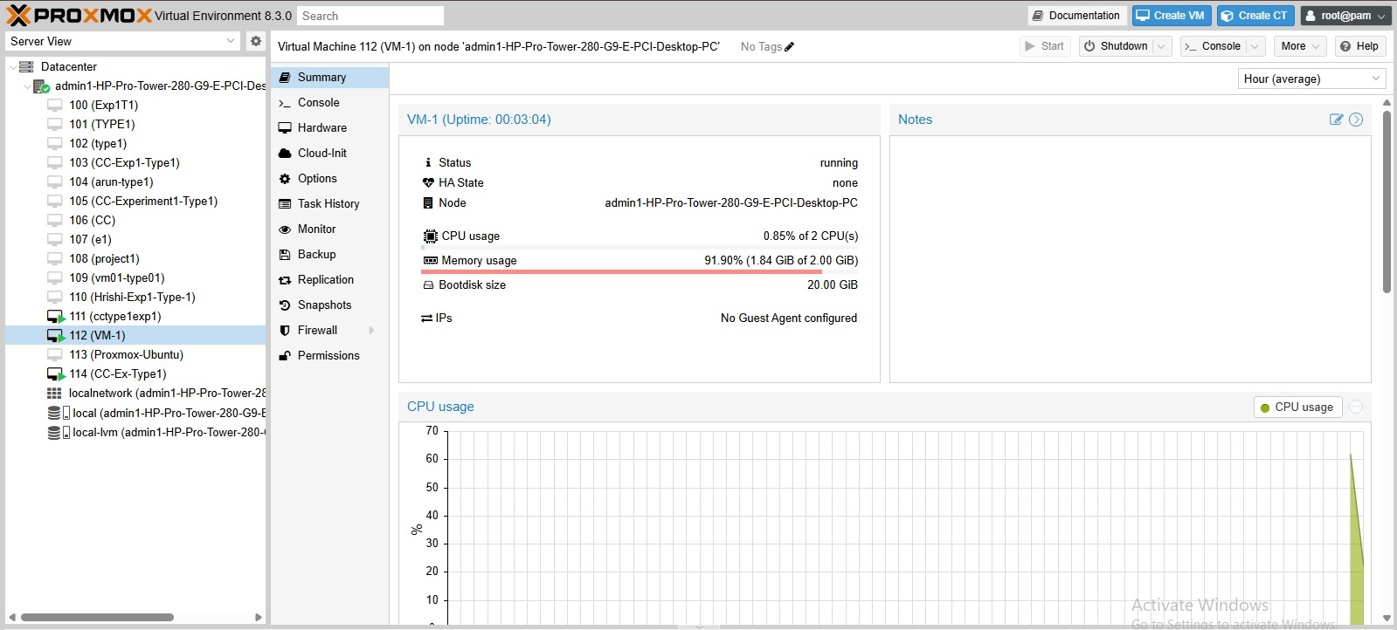
Running Ubuntu VM visible through the Proxmox environment.

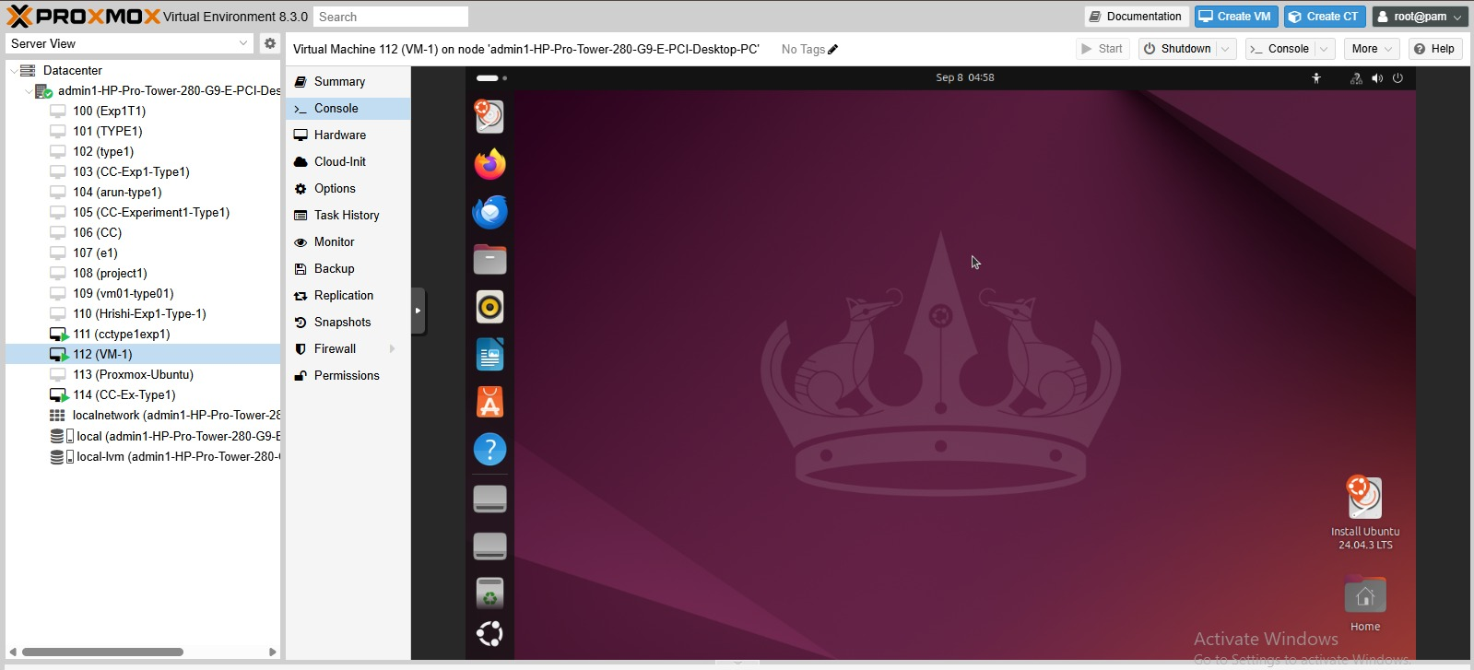
Ubuntu console inside the Proxmox VM; terminal activity is visible.

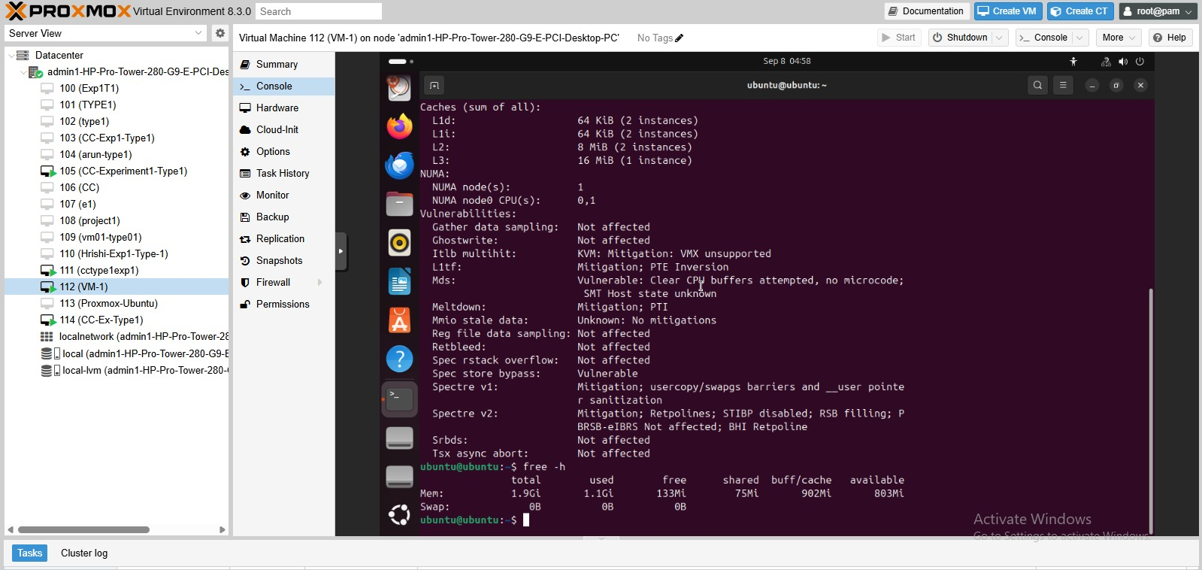
Ubuntu terminal showing CPU/cache/virtualization information and a free -h memory snapshot.

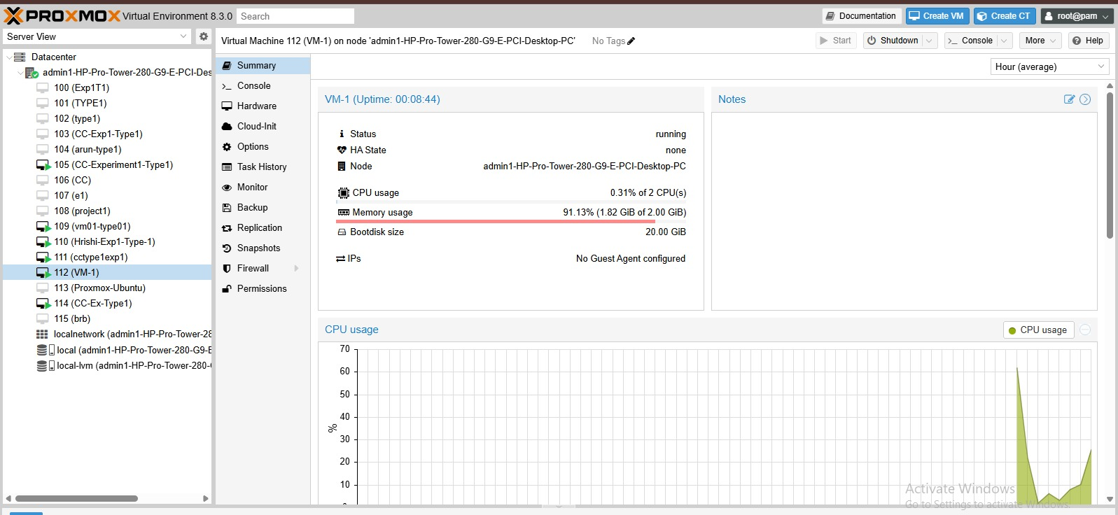
Proxmox VM Summary/resource view showing CPU, memory and 20 GiB boot disk.

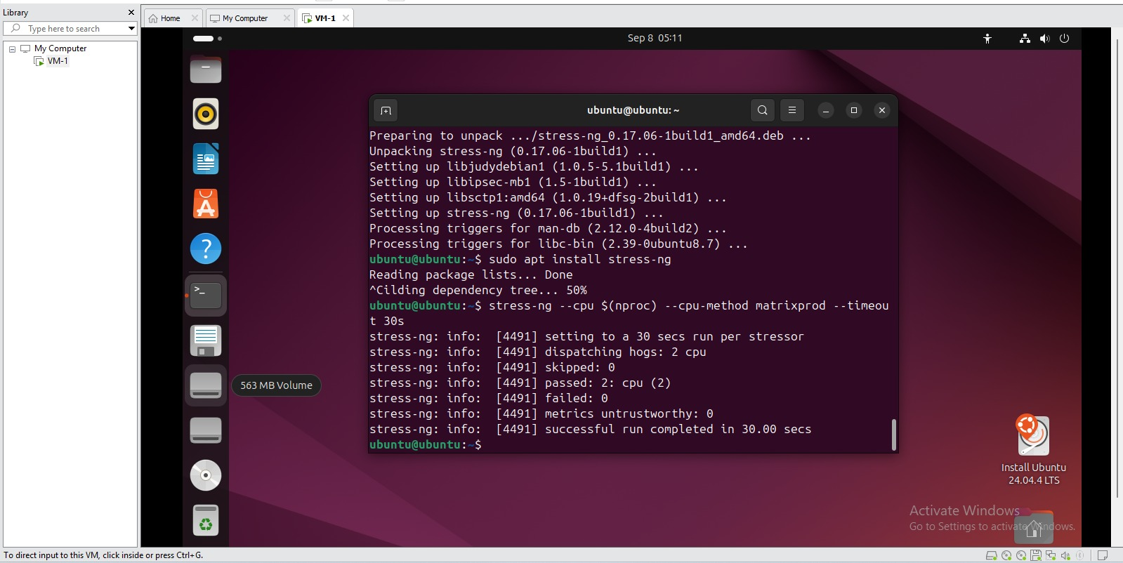
Proxmox task/history view captured during the experiment.

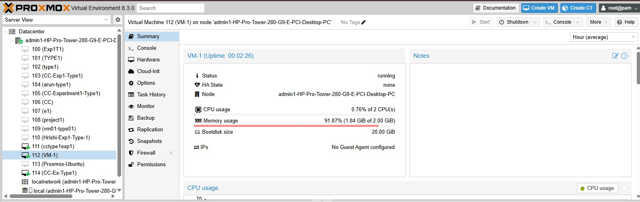
Network connectivity test from the experiment environment.

6. Observations From Supplied Screenshots
Observation | Recorded evidence
VM CPU allocation | 2 CPUs / 2 cores are visible in the Proxmox configuration and resource view.
VM memory allocation | 2048 MiB / 2.00 GiB is visible in the Proxmox configuration.
Virtual disk | 20.00 GiB boot disk is visible in the VM Summary.
Resource snapshot | One supplied Proxmox view shows about 0.85% CPU and 1.84 GiB / 2.00 GiB memory; another shows about 0.31% CPU and 1.82 GiB / 2.00 GiB memory.
Network evidence | Supplied ping screenshot shows successful replies with 0% packet loss to the tested addresses.
Additional CPU stress evidence | The supplied Ubuntu screenshot shows a stress-ng CPU test using 2 CPU workers for 30 seconds.

7. Benchmark Results
The supplied personal screenshots do not contain a complete Sysbench CPU result. Therefore, the Sysbench result fields below are intentionally left open rather than copying the reference document's values.
Metric | Your experimental result
Sysbench version | TODO — capture from your VM
CPU benchmark command | sysbench cpu --cpu-max-prime=20000 run
Total execution time | TODO
Total events | TODO
Events per second | TODO
Minimum latency | TODO
Average latency | TODO
Maximum latency | TODO

8. Resource Utilization Record
Metric | Observed / To be recorded
Proxmox CPU usage | Observed snapshots: ~0.85% and ~0.31% at different captured instants
Proxmox memory usage | Observed snapshots: ~1.84 GiB and ~1.82 GiB of 2.00 GiB
Network traffic | Graph visible; exact throughput not captured as a numeric value
Disk I/O | Graph/activity visible; exact numeric value not captured
Guest memory | free -h screenshot shows approximately 1.9 GiB total memory

9. Missing Evidence Checklist
☐ hostnamectl complete output
☐ complete lscpu beginning-to-end output
☐ df -h output
☐ top output during the benchmark
☐ Sysbench --version output
☐ Sysbench CPU benchmark output
☐ final Proxmox CPU/memory/network/disk observation after the benchmark
Reference documents supplied by a friend were used only to understand the expected report structure. Reference benchmark values were not copied into this record.

10. Final Observation
This record separates configuration evidence, live resource observations, and benchmark results. Final performance conclusions should be added only after the missing Sysbench output is captured from this VM.

