REVIEW 1 – PROBLEM FORMULATION
Constraint-Based Academic Timetable Scheduling
Team 06 | Theme: Concurrent and Transaction Systems | Guide: Mr. Mallikarjun Akki

Project Information
Field | Student Entry
Team No. | 06
Theme No. | Concurrent and Transaction System
Project Title | Constraint-Based Academic Timetable Scheduling Engine
Guide Name | Mr. Mallikarjun Akki
Review Stage | Review 1 – Problem Formulation

Team Members
Sl. No. | Student Name
1 | Srujana Patil
2 | Yash Raj
3 | Abhinav Raj
4 | Yashwanth Reddy

1. Motivation
Preparing an academic timetable involves coordinating courses, sections, faculty members, classrooms, laboratories and time slots while satisfying multiple interdependent constraints. Factors such as faculty and room availability, prescribed weekly teaching hours, fixed breaks and consecutive laboratory sessions make the scheduling process particularly complex.
Manual or iterative scheduling often requires repeated conflict checks, as resolving one conflict may introduce another. A faculty member may be assigned to overlapping classes, a section may receive two courses in the same time slot, or a room may be allocated to more than one class simultaneously. These conflicts can require repeated timetable revisions and make it difficult to maintain consistent schedules for all stakeholders.
The proposed Constraint-Based Academic Timetable Scheduling Engine aims to develop a structured system that models academic entities and scheduling rules, generates timetables that satisfy mandatory constraints, considers preferential requirements where feasible, and reports diagnostic information when no feasible schedule can be produced. The primary stakeholders are the Timetable Coordinator, Department Head (HoD), faculty members, and students/sections. Secondary stakeholders include room and laboratory coordinators and academic administration.

2. Project Objectives
- To develop a structured data model for courses, sections, faculty members, classrooms, laboratories and scheduling time slots.
- To identify, classify and represent mandatory (hard) and preferential (soft) scheduling constraints.
- To generate academic timetables that satisfy all mandatory constraints and eliminate resource-allocation conflicts.
- To incorporate faculty availability and workload considerations into the scheduling process.
- To provide consistent and synchronized timetable views for classes, faculty members and rooms.
- To generate meaningful conflict information and diagnostic feedback when no feasible timetable can be produced.

3. Foundation Course Integration
The following foundation courses are expected to contribute meaningful technical depth to the project.
Sl. No. | Foundation Course | Broad Concepts / Areas Expected to be Applied
1 | Data Structures and Algorithms | Backtracking, search strategies, conflict detection and optimization techniques.
2 | Database Management Systems (DBMS) | Relational data modelling, SQL, CRUD operations, transaction management and scheduling records.
3 | Discrete Mathematics | Sets, relations, propositional logic, combinatorial modelling and constraint satisfaction problems (CSPs).
4 | Object-Oriented Programming (OOP) | Classes, objects, encapsulation, abstraction and modular software design.
5 | Operating Systems | Scheduling principles, resource allocation and resource-conflict management.
6 | Software Engineering | Requirements analysis, UML modelling, feasibility assessment and software testing.

4. Conceptual Workflow / System View
The conceptual workflow begins with collecting academic information and defining the scheduling periods. The system then identifies sections, maps faculty to courses, collects faculty availability, and identifies classrooms and laboratories. After defining working days, time slots and breaks, it prepares an initial timetable, checks faculty, section and room conflicts, and revises assignments where necessary. The timetable is finalized only after the defined constraints have been validated.
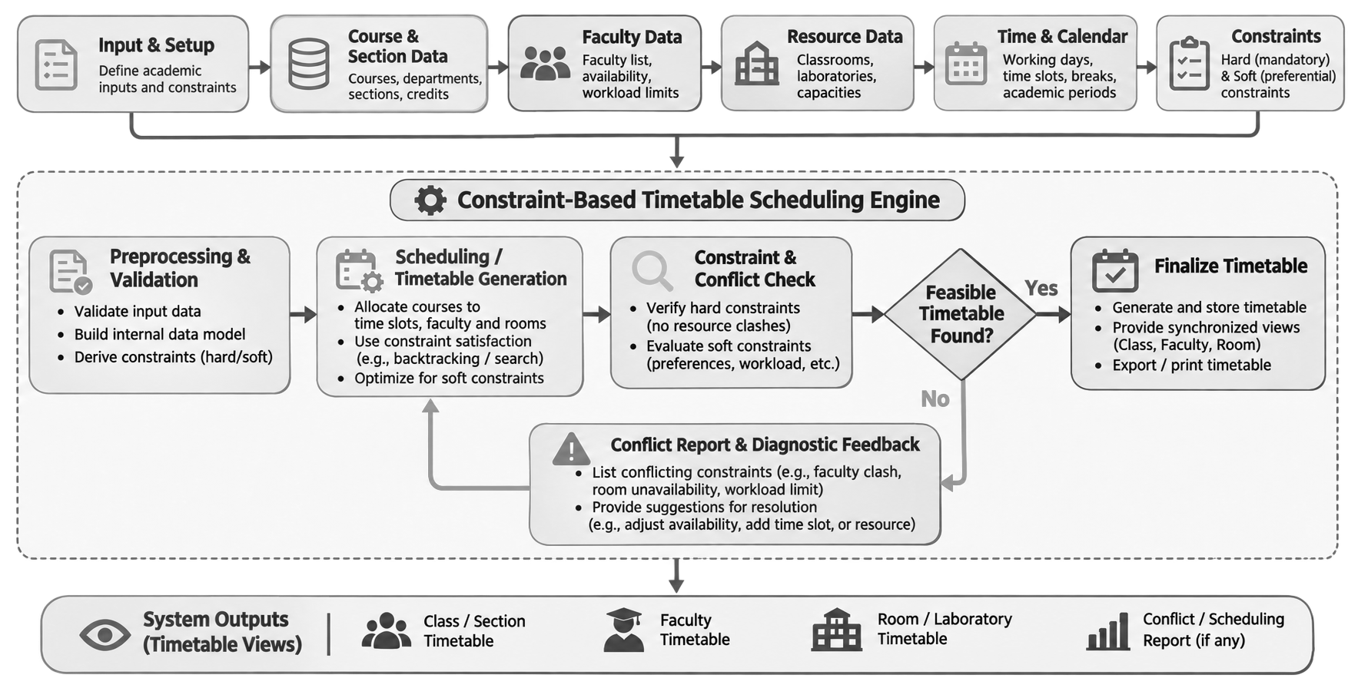
If the defined constraints make it impossible to generate a feasible timetable, the system shall report the relevant conflicts and diagnostic information instead of producing or presenting an invalid schedule.

5. Broad Project Scope

5.1 Broadly In Scope
# | What is in scope? | Foundational Subject / Meaning | Planned Technique and Purpose
1 | Course and section management | DBMS (organizing academic records) | Store course details, credits, sections and student strength; provide structured input data.
2 | Faculty allocation and availability management | DBMS + OOP (manage faculty data and mappings) | Maintain faculty–course assignments, availability and preferences to support valid allocation.
3 | Classroom and laboratory resource management | DBMS + Operating Systems (manage shared resources) | Record room capacity and laboratory requirements; avoid simultaneous allocation of the same room.
4 | Working days, time slots and academic periods | Discrete Mathematics (represent time and rule relationships) | Define working days, periods and fixed breaks used by the scheduling engine.
5 | Hard- and soft-constraint representation | Discrete Mathematics (constraint satisfaction) | Represent mandatory rules and preferential requirements separately.
6 | Timetable generation | DAA (search and optimization) | Use search/backtracking-based scheduling to construct a timetable satisfying mandatory constraints.
7 | Conflict detection and validation | DAA + Operating Systems (detect resource conflicts) | Check faculty, section/class and room overlaps; reject invalid assignments.
8 | Faculty workload assessment and balancing | DAA + DBMS (evaluate assigned teaching load) | Consider prescribed weekly teaching hours and workload while generating or revising assignments.
9 | Synchronized timetable views | DBMS + OOP (retrieve consistent records) | Provide consistent timetable views for classes/sections, faculty members and rooms.
10 | Conflict diagnostics | Software Engineering + DAA (explain infeasibility) | Report relevant conflicts and diagnostic information when no feasible timetable can be produced.

5.2 Out of Scope
# | Out-of-Scope Item | Reason
1 | Student attendance management | The project is focused on timetable preparation and constraint validation, not attendance recording.
2 | Examination timetable generation | The supplied Gate 0 scope addresses academic/course timetables; examination scheduling is excluded.
3 | Payroll and employee administration | Faculty records are used for allocation and availability only; payroll and broader HR functions are unrelated to the core objective.
4 | Comprehensive college ERP system | The project is limited to timetable generation and associated academic resource management.
5 | Timetable scheduling across multiple universities | The defined implementation is intended for department-level academic timetable preparation.

6. Feasibility & Constraints
Aspect | Project Assessment
Technical feasibility | The project can be implemented using established programming technologies such as Python or Java, a relational DBMS and appropriate scheduling algorithms. It applies DAA, DBMS, OOP, Discrete Mathematics, Operating Systems and Software Engineering concepts.
Operational and resource feasibility | The system is intended to support routine, department-level timetable preparation using standard student laptops, commonly available development tools and representative academic scheduling data. Specialized hardware is not required.
Time and scope constraints | The team has a 15-week semester and limited development resources. Priority should be given to feasible timetable generation, hard-constraint validation, conflict detection and consistent timetable views. Advanced optimization is secondary.
Prerequisite knowledge | Data Structures and Algorithms, Database Management Systems, Discrete Mathematics, Object-Oriented Programming, Operating Systems and Software Engineering.
Major project risks | Constraint combinations may produce no feasible solution; input data may be incomplete or inaccurate; resource mappings may be incorrect; scope expansion or development delays may occur.
Risk mitigation | Use early feasibility checks, systematic input validation, prioritization of mandatory constraints and phased implementation.
Overall feasibility | GO WITH MODIFICATIONS. The project is feasible provided its scope remains focused on essential timetable generation and constraint validation.

