GATE 1 – REQUIREMENTS ANALYSIS
Constraint-Based Academic Timetable Scheduling System
Team 06 | Project Guide: Mr. Mallikarjun Akki
Sl. No. | Student Registration Number (SRN) | Student Name
1 | 01FE24BCI020 | Srujana Patil
2 | 01FE24BCI064 | Yash Raj
3 | 01FE24BCI058 | Abhinav Raj
4 | 01FE24BCI010 | Yashwanth Reddy

Section 1: Functional Requirements
FR ID | Functional Requirement Description | Priority | Source Need (S0)
01 | The system shall enable authorized users to create, import, and update academic scheduling data, including courses, faculty members, rooms, sections, batches, and related information. | Mandatory | Maintain academic data and the weekly calendar in a centralized location.
02 | The system shall allow users to configure working days, working hours, breaks, lunch periods, and time-slot rules before timetable generation. | Mandatory | Maintain academic data and the weekly calendar in a centralized location.
03 | The system shall validate all required input data before timetable generation and identify missing, inconsistent, or incompatible scheduling information. | Mandatory | Identify incomplete or invalid data before scheduling.
04 | The system shall represent and enforce all mandatory constraints, including faculty, room, section, and batch availability; room suitability and capacity; and time-continuity requirements. | Mandatory | Generate a clash-free timetable across faculty, rooms, sections, and batches.
05 | The system shall generate a timetable by assigning every required academic session to an eligible day, time slot, and room while satisfying all mandatory constraints. | Mandatory | Generate a clash-free timetable across faculty, rooms, sections, and batches.
06 | The system shall support laboratory scheduling at the batch level, allowing different batches within the same section to use separate, suitable rooms concurrently when permitted by the scheduling constraints. | Mandatory | Generate a clash-free timetable across faculty, rooms, sections, and batches.
07 | The system shall evaluate and rank feasible timetable alternatives using configurable soft constraints, such as minimizing student gaps, avoiding repeated scheduling of the same subject on a day, balancing faculty workload, and improving room utilization. | Challenge / Stretch | Improve timetable quality by reducing gaps and balancing workload.
08 | The system shall provide actionable diagnostic information when the scheduling problem is infeasible or constraints cannot be satisfied. It shall also independently validate each generated timetable before assigning it a valid status. | Mandatory | Identify the reasons when timetable generation is unsuccessful.
09 | The system shall provide master, faculty-wise, section-wise, and batch-wise timetable views and support the export or sharing of timetable information in a suitable format. | Mandatory | View and print timetables by section, faculty, and room.

Section 2: Non-Functional Requirements
NFR ID | Non-Functional Requirement | Category | Measurable Acceptance Target
01 | Every timetable accepted by the system shall be free from violations of mandatory (hard) constraints. | Correctness | All hard-constraint validation checks (100%) must pass before a timetable is marked feasible.
02 | Timetable generation shall complete within a predefined execution limit for the agreed reference dataset. | Performance | The system shall either generate a result or terminate with a diagnostic status within 30 seconds on the agreed reference dataset.
03 | The system shall handle infeasible scheduling inputs without entering an indefinite execution state. | Reliability | Every generation attempt shall terminate with one of the following statuses: feasible, infeasible, or execution limit reached.
04 | The system shall support the agreed reference workload while preserving all academic and scheduling relationships. | Scalability | The reference test dataset shall include at least 30 courses, 20 faculty members, 10 rooms, 4 sections, and their associated laboratory batches.
05 | The system shall communicate input and scheduling errors clearly and consistently. | Usability | Every rejected or unsuccessful operation shall return a specific error message or diagnostic category.
06 | The system shall protect academic data and scheduling operations against unauthorized access or modification. | Security | In the production environment, only authenticated and authorized users shall be permitted to modify configuration or timetable data.
07 | The system architecture shall support independent testing and traceability of requirements and scheduling-engine responsibilities. | Maintainability | Every mandatory functional requirement shall be mapped to at least one acceptance test and one primary responsible engine component.

Section 3: Use Cases and User Interactions
ID | Actor | Use Case / User Story | Main Success Flow | Alternative / Exception Flow
01 | Scheduler / Administrator | Import or enter academic scheduling data. | Select the data source; enter or upload the required information; allow the system to parse and store the data; review the validation summary. | Missing, invalid, or duplicate records are identified and reported. Such records are not treated as valid input.
02 | Scheduler / Administrator | Configure the academic calendar and time-slot rules. | Specify working days, working hours, breaks, and lunch periods; allow the system to derive the permitted time slots; review and confirm the configuration. | Invalid, overlapping, or out-of-range time rules are rejected with an appropriate explanation.
03 | Scheduler / Administrator | Validate scheduling inputs before timetable generation. | Initiate validation; execute relationship, capacity, and configuration checks; display the validation status and any identified issues. | Any unresolved mandatory issue prevents timetable generation until the issue is corrected.
04 | Scheduler / Administrator | Generate a timetable using validated input data. | Initiate timetable generation; evaluate candidate assignments against the constraints; return the generated timetable when a feasible solution is found. | If no feasible solution is found within the execution limit, return an infeasible or limit-reached status with relevant diagnostics.
05 | Scheduler / Administrator | Review infeasibility and scheduling-conflict diagnostics. | Review the diagnostic report; identify the affected constraint or resource category; update the relevant academic data or configuration. | If the system cannot isolate the exact cause, it shall report the termination reason and the affected constraint or resource category.
06 | Faculty / Coordinator | View the master timetable. | Select a validated timetable generation; open the master timetable view; review the overall academic schedule and assignments. | If no validated timetable is available, display a clear unavailable-state message.
07 | Faculty / Coordinator | View an individual faculty timetable. | Select a faculty member; retrieve the corresponding validated assignments; display the faculty member's weekly schedule. | If the faculty member is unknown or has no assigned sessions, display an appropriate empty-state message.
08 | Faculty / Student / Coordinator | View section-wise and batch-wise timetables. | Select a section or batch; retrieve the corresponding validated assignments; display theory and laboratory sessions at the appropriate level. | Laboratory sessions assigned to individual batches shall not be incorrectly represented as sessions for the entire section.
09 | Coordinator | Export or share a validated timetable. | Select the required timetable view and export option; generate the corresponding shareable or downloadable representation. | If no validated timetable exists, the export operation shall be disabled or rejected with a clear message.
10 | Scheduler / Administrator | Regenerate the timetable after modifying constraints or academic data. | Modify the relevant data or constraints; revalidate the inputs; initiate generation; retain or version the previously validated timetable. | A new infeasible generation attempt shall not overwrite or remove the previously validated timetable.
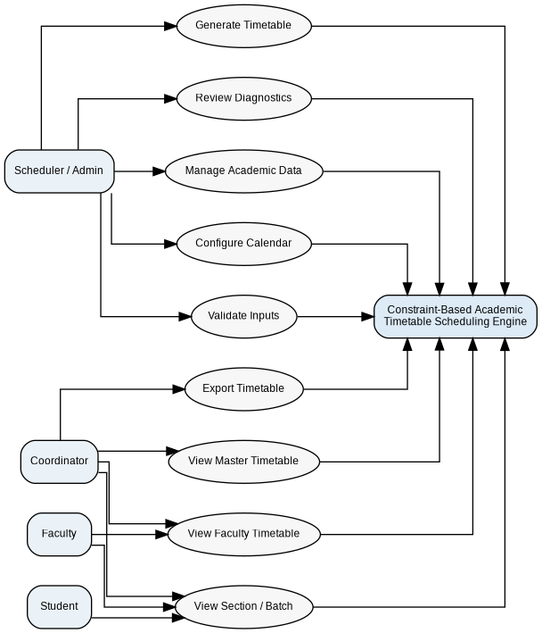
Figure 1. Use Case Diagram

Section 4: Acceptance Criteria and Verification
Requirement ID | Acceptance Criteria | Test / Verification Method
01 | Academic data can be created or imported successfully, and all required entities and their relationships are available for validation. | Perform create/import tests and verify entity counts, completeness, and relationships.
02 | Valid calendar configurations generate only permitted time slots, while invalid, overlapping, or out-of-range rules are rejected. | Conduct boundary-value tests using valid, overlapping, and out-of-range time configurations.
03 | The system identifies known missing or invalid inputs before generation and reports all mandatory validation issues. | Execute negative testing with deliberately incomplete, invalid, or inconsistent input data.
04 | Every timetable accepted by the system has zero violations across all mandatory constraints. | Run automated validation against every defined hard constraint.
05 | For a feasible reference dataset, each required academic session is assigned exactly once to a valid day, time slot, and room. | Perform end-to-end generation testing, followed by assignment-count and constraint-validation checks.
06 | Different laboratory batches may be assigned simultaneously to separate suitable rooms, while a single batch is never assigned overlapping sessions. | Execute batch-level laboratory scheduling tests, including concurrent assignments and overlap checks.
07 | When multiple feasible timetable alternatives are available, the system selects and ranks them using the configured soft-constraint scoring mechanism and makes the score available for review. | Compare controlled candidate timetables and verify the calculated scores and ranking.
08 | Infeasible or execution-limit outcomes provide diagnostic information. Every generated timetable is independently validated before being marked valid. | Test with an infeasible dataset and verify post-generation validation and status handling.
09 | The master, faculty, section, and batch views display consistent validated assignments, and exported data matches the selected timetable view. | Perform cross-view consistency checks and verify the exported timetable against the selected view.

