GATE 0 - PROJECT SYNOPSIS
Themes 1-5 | System / Tool / Engine based Mini Projects

Expected length: about 4 pages + cover page

Team No. | 1
Theme No. | System Software and Development Tools
Project Title | Mini -kernel with process, memory and file management
Guide Name | Ms. Arundati Aralimatti
Team Members | 1. Pradeep  2. Bhavana  3. Vikitha  4. Zakiya

Student Preparation Instruction
This synopsis is intended to demonstrate the team's own understanding of the proposed project. Students should study the project, discuss within the team, consult relevant textbooks/technical resources, and prepare the content in their own words. AI tools shall not be used to generate the contents of this document.
At Gate 0, do NOT finalize: detailed functional/non-functional requirements, architecture/modules, algorithms/data structures, APIs, technology stack, alternate designs, detailed KPIs or test cases.

Motivation
Our project focuses on understanding how a computer can start and run its own basic operating-system kernel. A kernel is the core part of an operating system that manages access to hardware resources and provides essential services to programs. Developing even a small kernel involves several connected responsibilities, such as starting execution after boot, managing memory, handling processes, and organizing data on storage.
Our proposed mini-kernel is a small x86-64 operating-system kernel developed from the ground up for learning and demonstration. It will be loaded by a bootloader and executed in an emulated computer environment during development. The project aims to implement selected kernel-level facilities and demonstrate how they work together. The work will use xv6 and other educational resources only for understanding operating-system concepts; the xv6 codebase will not be used as the project foundation.
We consider this a suitable Mini Project because it gives us an opportunity to study operating-system fundamentals through implementation rather than only theoretical discussion. It connects Operating Systems with process, memory and file management; Computer Organization with processor operation, booting and memory; Data Structures and Algorithms with managing kernel information; and Software Engineering with planning, implementation, integration and testing. A controlled scope will allow us to demonstrate the basic working of a kernel without attempting to build a complete commercial operating system.

Project Objectives
- To understand the role of a kernel in an operating system and study the basic stages involved in starting kernel execution.
- To design and develop a small x86-64 kernel from scratch, using an existing bootloader as the initial loading mechanism.
- To explore and implement selected fundamental kernel responsibilities related to process, memory and file management.
- To demonstrate the kernel in an emulated hardware environment and observe its behaviour during execution
- To apply foundational Computer Science and system-software concepts through a practical, demonstrable operating-system project.
FOUNDATION COURSE AND INTEGRATION AND CONCEPTUAL VIEW

Foundation Course Integration
Identify at least three foundational courses that are expected to contribute meaningful technical depth. Mention only broad concepts/areas at this stage.

Sl. No. | Foundation Course | Broad Concepts / Areas Expected to be Applied | Role
1 | Operating System Principles | Kernel responsibilities, process management, memory management, file systems, interrupts and resource management | Dominant
2 | Computer Organization and Architecture | processor basics, boot process, CPU operation, memory hierarchy and hardware interaction | Dominant
3 | Data Structures & Algorithms | Queues, lists, trees or other suitable structures, searching, scheduling concepts and efficient management of kernel data | Supporting

4. Conceptual Workflow / System View

Draw one high-level block/workflow diagram showing the broad functional flow or major interactions in the proposed artefact. Keep it conceptual; detailed architecture, finalized modules, algorithms, data structures, APIs and technologies belong to later stages

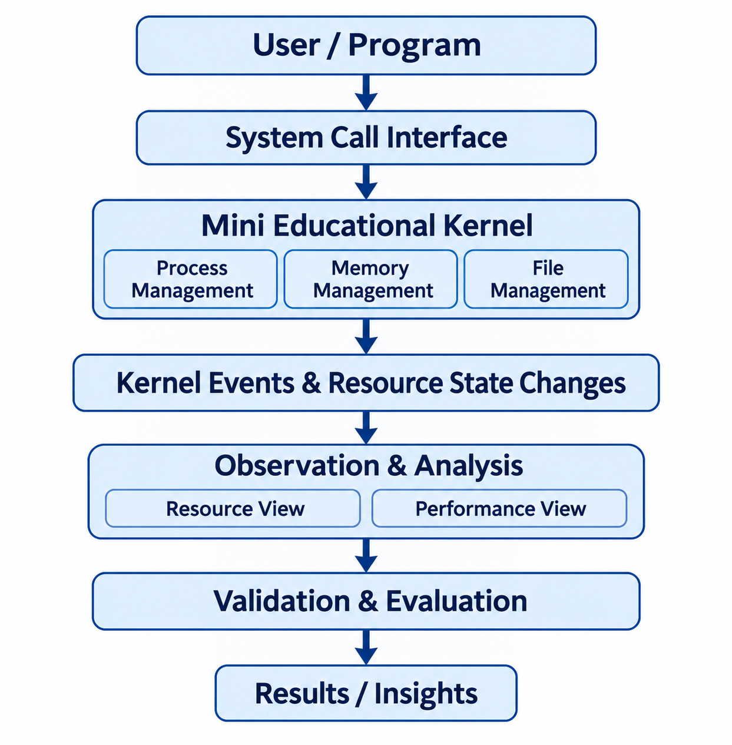

PROJECT SCOPE

Broad Project Scope
Define the tentative technical boundary of the project. Detailed requirements will be derived later in S1.

Broadly In Scope

Sl.no | Broad In-Scope Item
1 | Study and demonstrate the boot flow in which a bootloader loads the mini-kernel and transfers control to it.
2 | Develop a small kernel that can initialize and execute in a controlled emulated environment.
3 | Explore and implement basic process-management concepts, within the limits of the project scope.
4 | Explore and implement basic memory-management and file-management facilities, including a demonstration of persistent data using an emulated storage image if feasible.

Out of Scope

Sl.no | Out-of-Scope Item | Reason
1 | A complete general-purpose operating system with full POSIX or Linux compatibility | This would require a much larger development effort and is beyond the time and credit limits of the Mini Project.
2 | Support for multiple processor architectures | The project is restricted to keep implementation and testing manageable.
3 | Graphical desktop environment, networking stack and broad peripheral support | These features add substantial complexity and are not required to demonstrate the selected kernel fundamentals.

6.Feasibility
Briefly assess whether the proposed scope is achievable as a 3-credit Mini Project. Identify required resources, prerequisite knowledge and major constraints. Existing libraries/tools may support peripheral functionality but should not completely hide the core mechanisms students are expected to design, implement and study.

Feasibility | Explanation
Technical Feasibility | The x86-64 architecture, C programming, assembly language, and an existing bootloader provide a suitable foundation for developing the mini-kernel.
Software Resource Feasibility | Required open-source tools such as GCC, NASM, Make, Git, and QEMU are available for kernel development and testing.
Hardware Feasibility | A standard x86-64 laptop with WSL Ubuntu is sufficient to develop and test the kernel using QEMU emulation.
Knowledge Feasibility | Concepts from Operating Systems, Computer Organization and Architecture, C programming, and Data Structures support the development process.
Time and Team Feasibility | The project can be developed incrementally by dividing tasks among four team members and focusing on the selected Process, Memory, and File Management functionalities.

7. Constraints

Major Constraints | Explanation
Time Limitation | The project must be completed within the available academic project duration.
Hardware Limitation | Testing is initially restricted to the hardware and devices supported by QEMU emulation.
Technical Complexity | Kernel development requires low-level programming and careful handling of CPU operations, memory, and hardware interfaces.
Debugging Challenges | Errors in kernel code can cause crashes, unexpected behaviour, or boot failures, making debugging difficult.
Scope Limitation | The project focuses only on selected Process, Memory, and File Management functionalities rather than developing a complete operating system.

- The team was advised to study existing educational operating systems, particularly xv6, to understand kernel fundamentals and the working of process, memory and file management.
- The team discussed shifting the development target from RISC-V to x86-64 and building the mini-kernel from scratch rather than using an existing kernel codebase.
- The importance of understanding the boot process, kernel initialization and interaction with emulated hardware was discussed before proceeding with implementation.
- The team was guided to maintain a realistic project scope by focusing on the fundamental operating-system responsibilities, including process management, memory management and file management.

FACULTY REVIEW

