STAGE S0
Problem Definition & Need Identification
Consolidated Evidence — Steps 1 through 7, in working order

Team No. | 03
Theme No. | 22
Artefact Name: | Smart Campus Lab & Resource Optimizer
Team Members | 1. Parth Karpe  2. Vedant Khot  3. Nupur Bhagave  4. Sachi Aratti
Guide Name | Mr Amit K

Order of Work — What Gets Done First
This pack is sequenced in the order the work actually happens: understand the problem and its people first, map the current process, translate observations into needs and objectives, then bound the scope and check it's achievable.
1. The Problem — current situation, observed issue, why existing approach is inadequate
2. Who Is Involved — stakeholder role, need, difficulty faced, expected benefit
3. How It Works Today — current process before the proposed system: actors, steps, pain points
4. Problem & Goals — one concise computing problem, bounded and evidence-supported, plus the objectives it drives
5. What's Included — in-scope and out-of-scope items; avoid unrealistic feature expansion
6. Can We Do This — technical/operational feasibility, constraints, and initial risks
7. What Could Go Wrong — project-level risks and mitigation, revisited at later gates

THE PROBLEM
Step 1 of 7 — S0 Problem Definition & Need Identification
Stage S0 — Problem Definition & Need Identification │ General, Theme-Independent

Foundational Courses
SI.No. | Course | Core Concepts
1. | Design & Analysis of Algorithms | Algorithm-design paradigms (greedy, dynamic programming, backtracking, branch-and-bound); complexity and asymptotic analysis
2. | Data Structures & Algorithms | Graphs, trees, heaps, hashing, and interval/overlap structures for efficient conflict detection
3. | Operating Systems | Concurrency and resource coordination for simultaneous booking requests
4. | Discrete Mathematical Structures | Formal modelling of constraints (sets, relations, graphs); correctness and complexity reasoning
5. | Software Engineering & SDLC | Modular solver architecture; requirements traceability from constraints to acceptance evidence
6. | Database Management Systems | Persistent storage of booking instances, solutions, and constraint data

2. Existing Problem / Current Situation
Describe the real-world problem or gap as it exists today. What currently happens, and where does it fall short?
Campus labs, project rooms, and shared equipment (workstations, 3D printers, oscilloscopes, etc.) are booked manually through paper registers, spreadsheets, or ad-hoc WhatsApp/email requests. Booking requests are checked for conflicts by hand, one at a time, with no systematic way to verify that a resource's capacity or time-window constraints are respected across all simultaneous requests. As demand grows near exam weeks or project deadlines, this manual checking breaks down -- the same slot gets promised to more than one group, and no one can say, with evidence, how efficiently the available lab capacity is actually being used.

3. Who Is Affected
Briefly name the affected users/groups. (Full stakeholder detail belongs in the separate Stakeholder Analysis document.)
Students and project teams needing lab time; faculty/lab instructors who approve bookings; lab and facility administrators who resolve conflicts; and the timetable/scheduling committee responsible for term-wide resource allocation.

4. Why the Existing Approach Is Inadequate
Explain specifically what is missing, slow, error-prone, manual, or unreliable about the current approach.
The current process is manual and pairwise -- each new request is checked against existing bookings by a person reading a register, which is slow, error-prone at scale, and does not hold up past a handful of simultaneous requests. There is no optimization: slots are allocated first-come-first-served, not by any measure of overall utilization or fairness across competing student/course groups. When demand exceeds capacity, conflicts are discovered late -- sometimes only when two groups show up to the same lab -- and there is no principled way to decide priority or to report precisely which requests cannot be satisfied.

5. Evidence That This Problem Is Real
List observations, informal surveys, interviews, existing data, or references that support the problem's existence — not assumptions.
Informal review of lab-booking registers and spreadsheets from the past semester shows recorded double-bookings and last-minute manual reassignments. Conversations with lab instructors and facility staff confirm that conflict resolution is currently done from memory and manual cross-checking, with no utilization metric ever computed. This should be supplemented with the team's own survey/interview data (e.g., number of students and faculty surveyed, and the percentage reporting booking conflicts) once collected.

6. Sources / References
Cite where your evidence came from (people consulted, documents reviewed, existing systems observed, etc.).
Lab booking registers and spreadsheets from the current semester; informal interviews with lab instructors and facility/admin staff responsible for scheduling; direct observation of the current booking process.

💡 REMINDER: This document must be dated and completed BEFORE any requirements engineering (S1) work begins — Gate 0 checks this explicitly.
WHO IS INVOLVED
Step 2 of 7 — S0 Problem Definition & Need Identification
Stage S0 — Problem Definition & Need Identification │ General, Theme-Independent

1. Stakeholder Table
List every distinct group or role that interacts with, is affected by, or has an interest in this problem/system. Add rows as needed.
Stakeholder | Role / Description | Needs & Expectations | Current Pain Points | Influence (H/M/L)
Students / Project Teams | End users requesting lab time and equipment | Fair, timely access to a booked slot; clear visibility into availability | Booking conflicts, last-minute reassignment, unclear slot status | H
Faculty / Lab Instructors | Approve and manage bookings for their labs | Accurate, low-effort scheduling; fewer manual conflict resolutions | Time spent manually resolving clashes case-by-case | H
Lab & Facility Administrators | Maintain booking registers and oversee resource use | A reliable, auditable allocation record; visibility into utilization | No systematic way to measure utilization or detect conflicts early | H
Timetable / Scheduling Committee | Plan term-wide resource allocation | Evidence on how efficiently current capacity is used, to plan future terms | No utilization or fairness data available from the manual process | M
IT / Facilities Support | Maintain any supporting booking software or infrastructure | A low-maintenance, reliable system | No system currently exists to maintain | L

2. Primary vs. Secondary Stakeholders
Primary: directly use or are directly affected by the system. Secondary: indirectly involved (e.g., administrators, oversight bodies).
Primary Stakeholders | Secondary Stakeholders
Students / Project Teams | Lab & Facility Administrators
Faculty / Lab Instructors | Timetable / Scheduling Committee
 | IT / Facilities Support

3. Key Insight Summary
In 3–5 sentences, summarize what the stakeholder analysis reveals about whose needs the system must prioritize.
The stakeholder analysis shows the system must prioritize two groups whose needs are in direct tension: students need fair, predictable access to scarce lab slots, while faculty and administrators need a low-effort way to guarantee that no allocation violates a resource's capacity or eligibility rules. Secondary stakeholders -- the scheduling committee and facility staff -- care most about aggregate utilization and auditability rather than any individual booking. This means the allocation engine's core value is proving, with evidence, that no committed booking ever conflicts, and that achieved utilization/fairness is measurably better than the current first-come-first-served approach.

💡 REMINDER: Every stakeholder listed here should be traceable to at least one requirement in S1.

HOW IT WORKS TODAY
Step 3 of 7 — S0 Problem Definition & Need Identification
Stage S0 — Problem Definition & Need Identification │ General, Theme-Independent

1. Current Process — Narrative Summary
Describe, in plain language, how the process/task is currently carried out from start to finish.
A student or project team decides they need a lab slot and either fills in a paper register at the lab, emails/messages the lab instructor, or adds an entry to a shared spreadsheet. The lab instructor or admin checks the register/spreadsheet manually to see whether the requested resource and time window are already taken. If it looks free, the booking is confirmed verbally or by editing the sheet; if a clash is spotted, the two parties negotiate a new time informally. No one tracks whether the day's allocation is close to the lab's actual capacity, and no utilization report is ever produced -- the register is simply a running log, consulted one slot at a time.

2. Step-by-Step Workflow Table
Break the current process into individual steps. Add or remove rows as needed.
Step No. | Actor / Role | Action Performed | Tool / System Used | Pain Point Observed
1 | Student / Team | Requests a lab slot | Paper register / spreadsheet / email | Request not visible to other requesters in real time
2 | Student / Team | Provides desired resource, date & time window | WhatsApp / email / in person | No standard format; details often incomplete
3 | Lab Instructor / Admin | Manually checks register for the same resource/time-window | Paper register or spreadsheet | Slow, one-at-a-time check; error-prone at scale
4 | Lab Instructor / Admin | Confirms booking or flags a conflict | Verbal confirmation / spreadsheet edit | Conflicts often discovered only when two groups arrive
5 | Lab Instructor / Admin | Resolves conflict informally if found | Phone call / in-person negotiation | No fairness rule; resolved case-by-case, inconsistently

3. Workflow Diagram
Attach or paste a flowchart / swim lane diagram of the AS-IS process here (insert image after printing/exporting, or paste into this space in the digital copy).
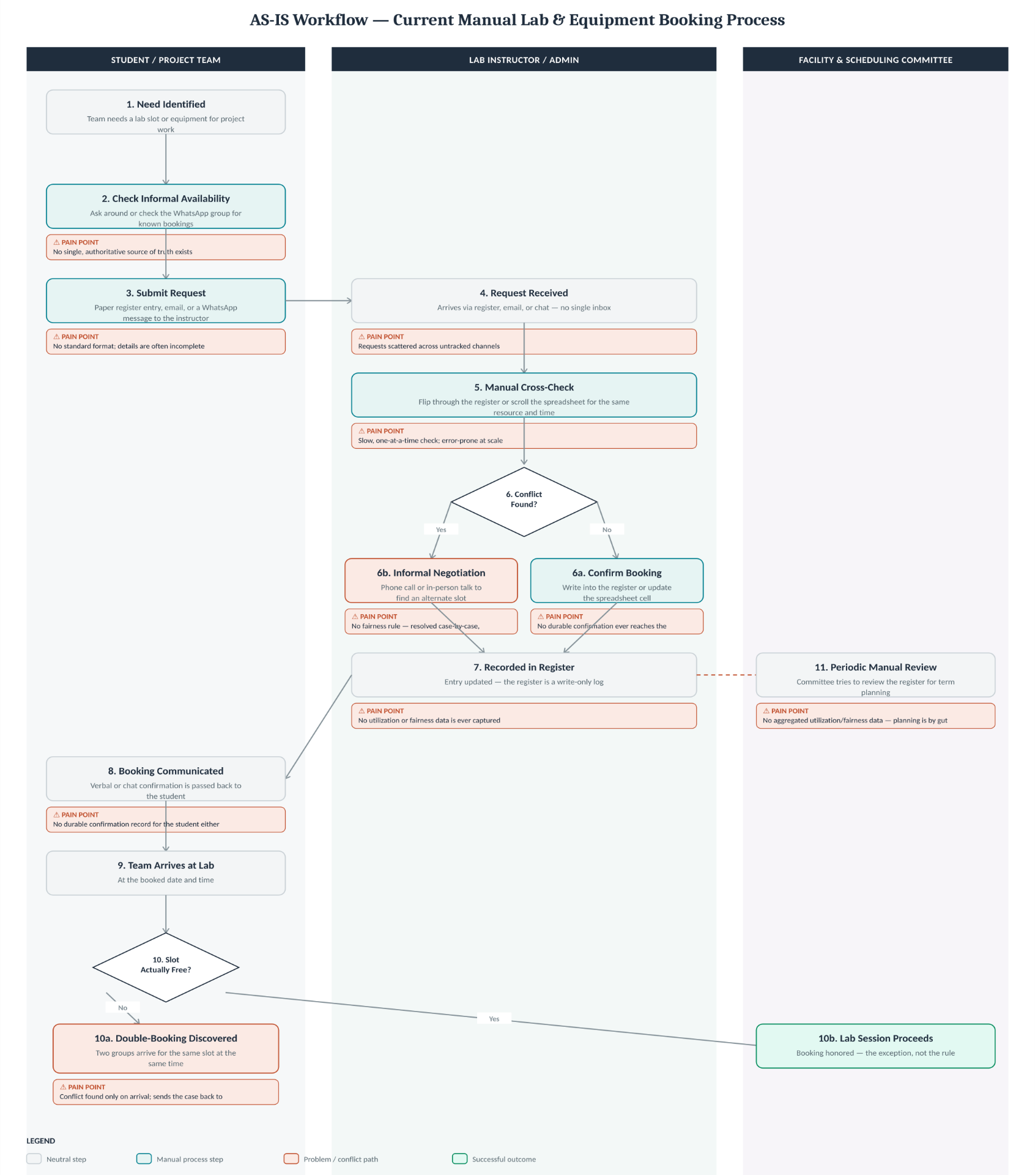

4. Bottlenecks & Inefficiencies Identified
Summarize the key weaknesses in the current workflow that the proposed system should address.
(1) Conflict checking is manual and pairwise, so it does not scale as request volume grows. (2) There is no single source of truth -- registers, spreadsheets, and messages can disagree. (3) Allocation is first-come-first-served with no optimization for overall utilization or fairness across competing groups. (4) Conflicts surface late, often only when both parties physically arrive. (5) No utilization or fairness metric is ever computed, so the scheduling committee has no evidence to plan future capacity.

💡 REMINDER: This document proves you understand the existing process before proposing a new one — required as Gate 0 evidence.

PROBLEM & GOALS
Step 4 of 7 — S0 Problem Definition & Need Identification
Stage S0 — Problem Definition & Need Identification │ General, Theme-Independent

1. Observed Problems → Underlying Needs
For every observed problem, state the evidence/source behind it, the underlying need it points to, and which stakeholder(s) it affects. Add rows as needed.
Observed Problem | Evidence / Source | Underlying Need | Linked Stakeholder(s)
Same lab/equipment slot promised to two groups | Manual register cross-checking; informal reports from instructors | An automated, systematic conflict-detection mechanism | Students, Faculty
Bookings allocated purely first-come-first-served | Observation of the current booking process | An allocation approach optimizing overall utilization/fairness, not just arrival order | Students, Scheduling Committee
No visibility into how much lab capacity is actually used | No utilization report exists in the current process | A utilization-measurement and reporting capability | Scheduling Committee, Facility Admins
Conflicts discovered late, on arrival | Instructor interviews | Conflict detection before a booking is confirmed, not after | Students, Lab Instructors
No consistent record of why a request could not be granted | Review of past booking disputes | Precise, evidence-based reporting of unavoidable conflicts | Students, Faculty

2. Prioritization
Rank the needs above by importance/urgency, and briefly justify the ranking.
Highest priority: correct, automated conflict detection -- an allocation that violates capacity or double-books a resource undermines trust in the system immediately. Second priority: an allocation strategy that improves utilization/fairness over first-come-first-served, since this is the core value proposition to the scheduling committee. Third priority: precise reporting of unavoidable conflicts, needed whenever demand genuinely exceeds capacity. Utilization reporting and audit visibility matter but rank after correctness and allocation quality, since they depend on the first two being solved correctly.

3. Problem Statement
State the single, concise computing problem this project solves — bounded, evidence-supported, and free of solution language.
Given a set of booking requests for shared campus lab resources -- each with a resource, a time window, and (optionally) an eligibility constraint -- under fixed resource capacities, determine a conflict-free allocation of resources to requests that maximizes overall utilization and fairness across competing requesters, and precisely identify any requests that cannot be satisfied when demand exceeds available capacity.

4. Project Objectives
State 4–6 clear, measurable objectives this project aims to achieve, based on the needs above. Each should be specific enough to later map to a requirement or deliverable.
1. Detect all resource/time-window conflicts among booking requests correctly and efficiently, at scale beyond simple pairwise checking.
2. Design and implement an allocation algorithm that respects every resource's capacity and eligibility constraints with zero violations.
3. Achieve a measurably higher utilization/fairness outcome than a naive first-come-first-served baseline, on the same booking-request set.
4. Precisely identify and report unavoidable conflicts whenever demand exceeds capacity, tracing each conflict to the competing requests responsible.
5. Demonstrate that conflict-detection and allocation performance scale acceptably as booking volume grows (10x/100x benchmark).

💡 REMINDER: Every need and objective here should map forward into a Functional or Non-Functional Requirement in S1 — keep this page for your Requirements Traceability Matrix later.

WHAT'S INCLUDED
Step 5 of 7 — S0 Problem Definition & Need Identification
Stage S0 — Problem Definition & Need Identification │ General, Theme-Independent

1. In-Scope
List what the system WILL do / include within this semester's project.
# | In-Scope Item
1 | Resource and booking constraint modelling (capacity, time windows, eligibility)
2 | Efficient interval/time-slot conflict detection at scale (interval-tree or sweep-line based)
3 | An allocation algorithm (constraint-based search or a utilization-optimizing heuristic)
4 | Precise reporting of unavoidable conflicts when demand exceeds capacity, plus a utilization/fairness report

2. Out-of-Scope
List what the system explicitly will NOT do / include — this prevents scope creep later.
# | Out-of-Scope Item | Reason for Exclusion
1 | Real-time IoT sensor integration with physical lab equipment (cameras, RFID, relays, occupancy sensors) | Explicitly out of scope per the assigned brief; adds hardware cost/risk without serving the core algorithmic problem
2 | Multi-building, campus-wide real deployment | A synthetic dataset / pilot-scale demonstration is sufficient to prove the algorithm this semester
3 | Payment/billing integration | Not relevant to the resource-allocation problem; would expand scope without adding algorithmic value

3. Assumptions
List anything assumed to be true for planning purposes (e.g., available data, user access, environment).
Booking-request data for demonstration is synthetic, generated to represent a realistic semester's worth of demand (including deliberately over-subscribed cases). Resource capacities and eligibility rules are known and fixed in advance for each test scenario. The team has access to standard open-source libraries/tools for implementing and benchmarking the algorithms, with no specialized hardware required since IoT integration is out of scope.

4. Constraints
List known limitations — time, team size, technology, data availability, etc.
15-week semester timeline; team of 4 with shared responsibility across algorithm design, implementation, and evidence/testing; no access to real institutional booking data, so evaluation relies on a synthetic but realistic dataset; scope is explicitly limited to the software allocation engine, not physical deployment.

💡 REMINDER: A clear Out-of-Scope list is just as important as In-Scope — reviewers will check both at Gate 0.

CAN WE DO THIS
Step 6 of 7 — S0 Problem Definition & Need Identification
Stage S0 — Problem Definition & Need Identification │ General, Theme-Independent

1. Technical Feasibility
Assess whether the team has (or can acquire) the technical skills, tools, and technology needed.
Aspect | Assessment | Justification
Algorithm design skill | Achievable | Interval-tree/sweep-line conflict detection and greedy/constraint-based allocation are well-documented, standard DAA/DSA techniques
Implementation tooling | Achievable | Standard open-source libraries (e.g., Python interval-tree packages, or a constraint solver such as OR-Tools) are freely available
Testing / benchmarking | Achievable | Synthetic data generation and brute-force pairwise comparison for correctness validation are straightforward to build
Team skill coverage | Achievable with effort | Team has coursework exposure to DAA/DSA/Discrete Math; OS-level concurrency concepts may need extra self-study

2. Operational Feasibility
Assess whether the proposed system will realistically work within the target environment/users.
The system is a software allocation engine consumed via a query/booking interface, evaluated against synthetic booking-request sets rather than a live institutional deployment this semester. This keeps operational risk low: there are no real users depending on the system in production, and its outputs (allocation, utilization report, conflict report) can be validated offline against a labelled test set before any real-world discussion.

3. Time Feasibility
Assess whether the scope is achievable within the semester timeline (15 weeks).
Achievable within the 15-week semester: constraint modelling and interval-based conflict detection can be built and unit-tested in the first third of the timeline; the allocation algorithm and its comparison against a naive baseline in the middle third; utilization/fairness reporting, scalability benchmarking, and documentation in the final third -- leaving buffer for the boundary/stress tests specified in the brief.

4. Resource Feasibility
Assess team size, skill distribution, and access to any needed data/hardware/software.
Team of 4 is sufficient to split the work by module (resource/booking modeler, allocation solver, conflict detector, utilization analyzer, query interface) as outlined in the assigned brief. No special hardware or paid software is required -- everything can be built and tested on standard laptops using open-source tools, which also removes the budget/procurement risk that a hardware-heavy (IoT) version of this project would have carried.

5. Overall Feasibility Conclusion
State a clear go / go-with-modifications / no-go conclusion, with reasoning.
Go. The algorithmic core defined in the assigned brief is feasible within the team's skillset, the semester timeline, and available tooling, with no hardware dependency. The main risk is underestimating the effort needed to get interval-based conflict detection and the allocation heuristic both correct and measurably better than a naive baseline -- this is addressed by prioritizing correctness first (Objectives 1-2) before optimizing for utilization (Objective 3).

💡 REMINDER: Feasibility must be realistic, not optimistic — reviewers will check this against your stated scope and timeline.

WHAT COULD GO WRONG
Step 7 of 7 — S0 Problem Definition & Need Identification
Stage S0 — Problem Definition & Need Identification │ General, Theme-Independent

1. Project-Level Risks
Identify risks that could affect the project at this early stage — technical, resource, scope, or timeline related. Add rows as needed.
Risk ID | Risk Description | Category | Likelihood (H/M/L) | Impact (H/M/L) | Mitigation Strategy
R1 | Interval-tree/sweep-line conflict detection implemented incorrectly | Technical | M | H | Validate against a brute-force pairwise reference on a labelled test set
R2 | Allocation heuristic fails to beat the naive FCFS baseline | Technical | M | M | Benchmark early against the baseline; fall back to a simpler greedy strategy if needed
R3 | Fairness metric is ambiguous or contested | Scope | M | M | Define and document the fairness measure explicitly before implementation begins
R4 | Scope creep toward the IoT/smart-campus vision discussed informally | Scope | M | H | Hold strictly to the Out-of-Scope list; treat IoT integration as a future extension only
R5 | Synthetic dataset not realistic enough to convince reviewers | Evidence | L | M | Base synthetic generation parameters on the informal register/interview evidence gathered in Step 1
R6 | Team member unavailability during a crunch period | Resource | L | M | Cross-train across modules per the module split so no module has a single owner

2. Risk Owner Summary
For each risk above, note which team member is responsible for monitoring it (optional but recommended).
Each risk above should be assigned to the team member owning the related module (e.g., the Conflict Detector owner monitors R1, the Allocation Solver owner monitors R2/R3, and the whole team jointly owns R4 as a scope-discipline risk). Assign specific names once the team's module split is finalized.

💡 REMINDER: This is an INITIAL register — it will be revisited and expanded at later gates as the project matures.

