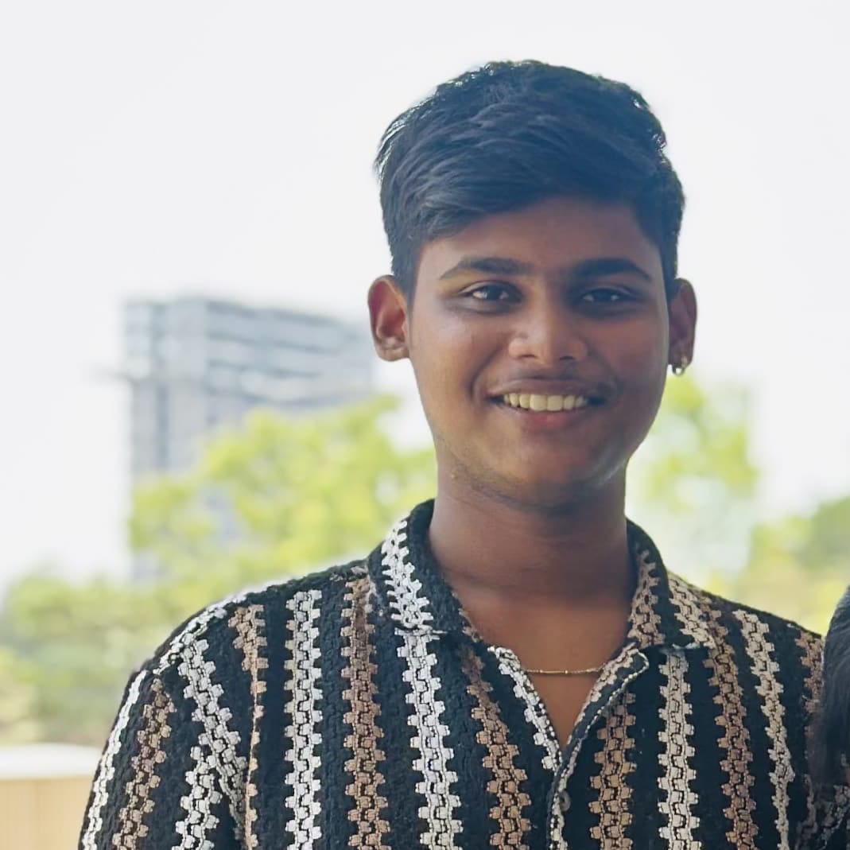

Parth Mhatre

Fullstack Web Developer
Crafting Digital Experiences with Clean Code & Modern Design
Passionate about creating responsive, user-friendly websites that make an impact

Fullstack Web Developer
Crafting Digital Experiences with Clean Code & Modern Design
Passionate about creating responsive, user-friendly websites that make an impact

About Me
I'm a web developer with a strong foundation in frontend development and programming fundamentals. I create responsive and user-friendly websites using HTML, CSS, and JavaScript, while also exploring other programming languages to expand my skills.

Skills
- • HTML
- • CSS
- • JavaScript
- • Responsive Design
- • Web Development Best Practices
- • React
- • Node.js
- • Figma
- • Python
- • Java (Basic)
- • JavaScript
- • Problem Solving
- • Algorithm & Data Structures
- • PHP
- • SQL
- • DBMS

My Projects
A basic calculator built with HTML, CSS, and JavaScript that performs basic arithmetic operations.
A comprehensive information portal about Sahiyadri, featuring details about its history, geography, and cultural significance.
A fun number guessing game where players try to guess a random number with hints and score tracking.

Contact Me
mhatreparth524@gmail.com
+91 9967440603
Kamothe

