1. What Is This Project?
This project builds an automated cervical cancer screening system using Deep Learning. It processes a raw microscope slide, detects individual cells, extracts morphological and texture features, and outputs a diagnosis for each cell into five medical categories (Dyskeratotic, Koilocytotic, Metaplastic, Parabasal, Superficial‑Intermediate).

2. Why Four AI Models?
- YOLOv8 – detects and crops each cell (Receptionist).
- U‑Net – segment nucleus vs cytoplasm and measures geometry (Biologist).
- EfficientNet‑B0 – classifies texture patterns (Pathologist).
- XGBoost – fuses the 13 extracted features into a final meta‑learner (Chief Medical Officer).

3. System Architecture
The flowchart below shows the complete data pipeline, from raw slide to final diagnosis.
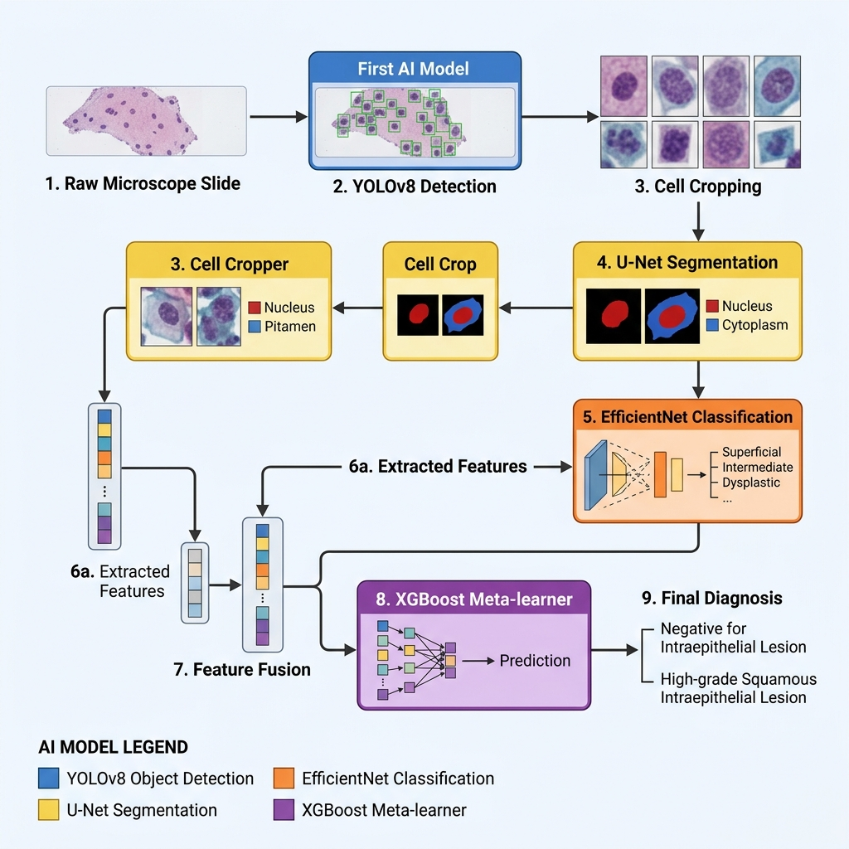

4. Data Flow (Step‑by‑Step)
1. Raw slide image is fed to YOLOv8.
2. YOLO outputs bounding boxes for each cell and crops the cells.
3. Each crop is sent to U‑Net for segmentation, producing nucleus and cytoplasm masks.
4. From the masks we compute:
- Nucleus area, Cytoplasm area, Total area, NC‑Ratio
- Nucleus perimeter, Circularity, Eccentricity, Chromatin variance (OpenCV).
5. The same crop is sent to EfficientNet‑B0, which outputs class probabilities Prob_0 … Prob_4.
6. All 13 numbers are merged into a CSV (extracted_features.csv).
7. XGBoost consumes the CSV and predicts the final class for each cell.
8. The slide is annotated with green boxes and the diagnosis label.

5. Notebook Overview
- Notebook 1: YOLO data preparation (converts SIPaKMeD annotations to YOLO format).
- Notebook 2: YOLO training (detects cells).
- Notebook 3: U‑Net training (pixel‑wise segmentation).
- Notebook 4: EfficientNet training (texture classification).
- Notebook 5: Feature extraction (produces CSV with 13 features).
- Notebook 6: XGBoost training and evaluation (grid‑search, confusion matrix, ROC).
- Notebook 7: Ablation study & Grad‑CAM explainability (clean vs corrupted data, side‑by‑side bar chart).
- Notebook 8: Final end‑to‑end pipeline (runs all models on a raw slide and visualises results).

6. Training Summaries
• U‑Net – ResNet‑34 encoder, 128×128 input, 93 % validation accuracy, early stop after 24 epochs.
• EfficientNet‑B0 – 224×224 input, 97 % validation accuracy, early stop after 21 epochs.
• XGBoost – GridSearchCV tested 72 hyper‑parameter combos across 3‑fold CV (216 fits). Best params: learning_rate 0.1, max_depth 5, n_estimators 100, subsample 1.0, colsample_bytree 1.0.

7. Advanced Morphological Features (OpenCV)
- Perimeter (cv2.arcLength)
- Circularity = 4π·Area / Perimeter²
- Eccentricity = major_axis / minor_axis (cv2.fitEllipse)
- Chromatin variance = variance of grayscale intensity inside the nucleus (cv2.meanStdDev).

8. Project Directory Structure
SIPaKMeD/\
├─ Dataset/ (raw images)\
├─ processed_data/ (YOLO, CNN, U‑Net datasets, extracted_features.csv)\
├─ trained_models/ (unet, cnn, xgboost)\
├─ runs/ (YOLO training output)\
├─ notebooks/ (1‑8)\
└─ README.md

9. Why This Architecture? (Big Picture)
- EfficientNet gives high accuracy on clean images but is texture‑only.
- U‑Net provides robust shape measurements that survive blurry or poorly stained images.
- XGBoost learns to balance both modalities, yielding a system that is both accurate and resilient (Multi‑Modal Feature Fusion).

10. How to Run
Prerequisites: Python 3.8+, CUDA‑enabled GPU, virtual environment sipakmed_env.
Execution order (run each notebook sequentially):
Notebook 1 → Notebook 2 → Notebook 3 → Notebook 4 → Notebook 5 → Notebook 6 → Notebook 7 → Notebook 8.

