SIPaKMeD
Cervical Cancer Detection

────────────────────────────────────────────────────────────
Multi-Modal Deep Learning Framework for Automated
Cervical Cell Classification using YOLOv8, U-Net,
EfficientNet-B0 and XGBoost

Name: Parth Randhir Mirajkar
Mentor: Dr. Dipmala T. Salunke

ABSTRACT
Cervical cancer remains one of the most prevalent and preventable cancers globally, yet its early detection in low-resource settings is hindered by a shortage of trained cytopathologists and the time-intensive nature of manual slide review. This paper presents SIPaKMeD AI, a fully automated, end-to-end deep learning pipeline designed to screen Pap-smear microscopy slides and classify each detected cell into one of five clinically recognised categories: Dyskeratotic, Koilocytotic, Metaplastic, Parabasal, and Superficial-Intermediate.
The system employs a four-stage, multi-modal architecture. YOLOv8 performs real-time object detection to locate and crop individual cells from a whole-slide image. U-Net (with a ResNet-34 encoder) carries out pixel-level semantic segmentation to separate the nucleus from the cytoplasm, enabling the computation of eight precise morphological features (nucleus area, cytoplasm area, NC ratio, perimeter, circularity, eccentricity, and chromatin variance). EfficientNet-B0, trained with transfer learning and heavy data augmentation, simultaneously classifies each cell's visual texture, producing five class-probability outputs. Finally, XGBoost—tuned via an exhaustive 72-combination GridSearchCV over 3-fold cross-validation—acts as a meta-learner that fuses all 13 features into a robust final diagnosis.
An ablation study demonstrates that the full ensemble outperforms any single-model baseline, particularly under simulated image degradation (15 % corruption), confirming the value of multi-modal feature fusion. U-Net achieves 93.12 % validation accuracy and EfficientNet-B0 achieves 97.41 % accuracy. The system is deployed as an interactive Streamlit web application, enabling clinicians to upload a slide image and receive a per-cell annotated diagnosis in real time.

TABLE OF CONTENTS
1 Abstract
2 Introduction
3 Dataset Description
4 Data Pre-processing
5 Detailed Model Review
5.1 YOLOv8 – Cell Detection
5.2 U-Net – Semantic Segmentation
5.3 EfficientNet-B0 – Texture Classification
5.4 XGBoost – Meta-Learner
6 Feature Extraction
7 Bagging & Ensemble Methodology
8 Ablation Analysis
9 System Architecture & Data Flow
10 Results & Performance Summary
11 Project Directory Structure
12 How to Run the Project
13 Conclusion

1. INTRODUCTION
Cervical cancer is caused predominantly by persistent infection with high-risk strains of the Human Papillomavirus (HPV). The World Health Organisation estimates that approximately 660,000 new cases are diagnosed every year, with over 350,000 deaths—the vast majority occurring in low- and middle-income countries where access to skilled cytopathologists is severely limited.
The Pap-smear test (cervical cytology) has been the primary screening tool for decades. A cytologist examines a stained microscope slide containing cells collected from the cervical surface and classifies each cell as normal or abnormal. This process is labour-intensive, subjective, and prone to inter-observer variability.
This project builds an automated AI system to replicate and augment this clinical workflow. Our key design principles are:
- Accuracy: achieve near-expert classification accuracy across all five cell types.
- Explainability: every prediction must be backed by interpretable features (NC ratio, circularity, chromatin texture).
- Robustness: the system should remain reliable even when image quality degrades (blur, staining variation).
- Deployability: the pipeline must run end-to-end on a standard workstation and be accessible via a browser.
To meet these goals we adopt a Multi-Modal Feature Fusion strategy—combining deep-learning-based texture analysis with classical computer-vision morphometry—orchestrated by a gradient-boosted decision tree meta-learner.

2. DATASET DESCRIPTION
The SIPaKMeD (Single-cell Image Database for the Purpose of Cervical Cell Classification) dataset was compiled at the University of Ioannina, Greece and is publicly available. It contains whole microscope slide images as well as individually cropped cell images, each annotated by an expert cytopathologist.
Cell Classes
Class ID | Medical Name | Description
0 | Dyskeratotic | Cells showing abnormal keratinisation; hallmark of dysplasia and early malignancy.
1 | Koilocytotic | Cells with a large, clear perinuclear halo caused by HPV cytopathic effect.
2 | Metaplastic | Benign squamous metaplasia; cells transitioning from columnar to squamous epithelium.
3 | Parabasal | Small, round, immature cells from the basal layer; appear in atrophic samples.
4 | Superficial-Intermediate | Healthy, well-differentiated mature cells from the superficial surface layer.

Dataset Statistics
The raw dataset is organised into five class folders under Dataset/. Each class folder contains whole-slide .bmp images accompanied by .dat annotation files that store the polygon coordinates (in pixels) of each cell's cytoplasm boundary. From these polygon annotations we derive:
- Bounding boxes for YOLO object detection training (Notebook 1).
- Binary segmentation masks (nucleus vs cytoplasm vs background) for U-Net training (Notebook 3).
- Cropped single-cell images (224 x 224 px) for EfficientNet training (Notebook 4).
The dataset provides sufficient samples across all five classes to enable balanced supervised training without requiring synthetic oversampling.

Sample Image

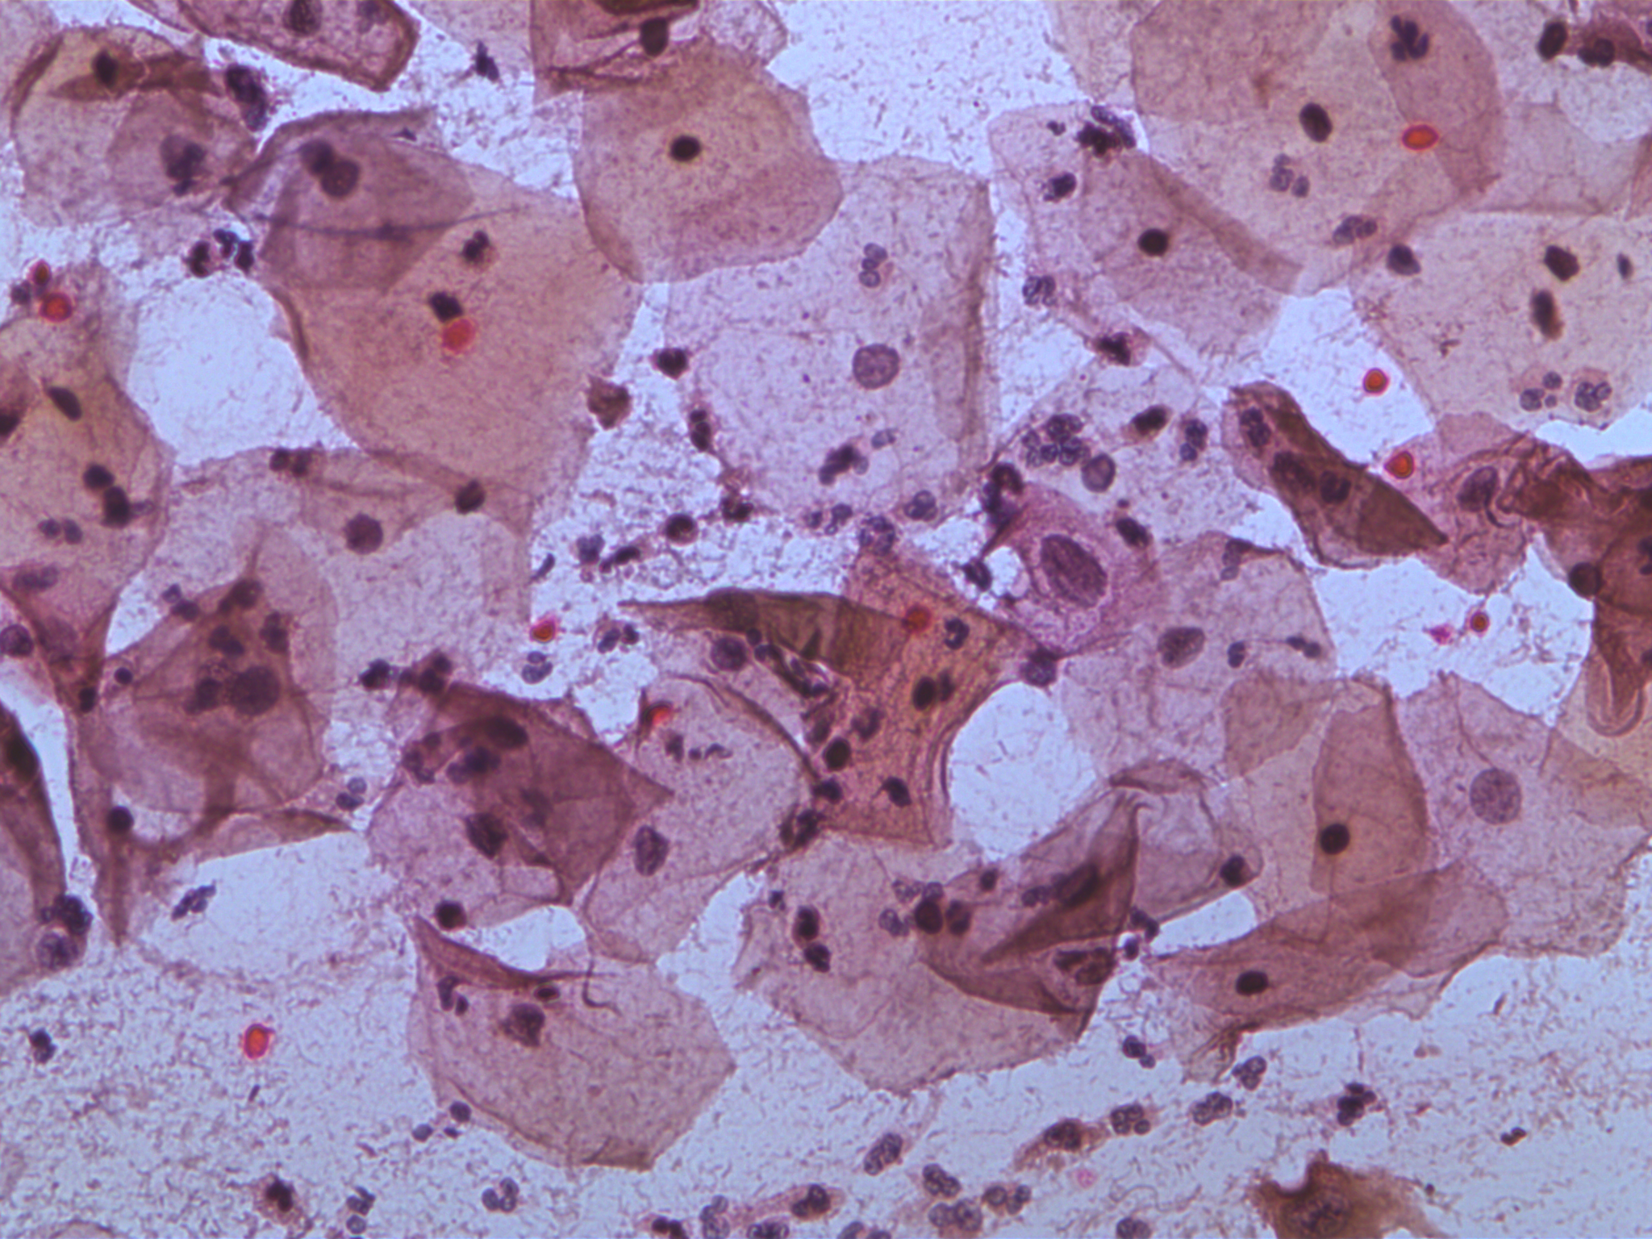
3. DATA PRE-PROCESSING
Raw SIPaKMeD slides require several transformation steps before they can be consumed by each model. This stage is implemented entirely in Notebook 1.
3.1 Annotation Parsing (.dat -> bounding boxes)
Each .dat file stores a variable-length list of (x, y) polygon vertex coordinates. We parse these files, compute the axis-aligned bounding rectangle of the polygon, and write the result as a YOLO-format label (.txt) file. The YOLO label format requires four normalised values: centre_x, centre_y, width, height — all relative to the image dimensions.
3.2 Train / Validation Split
We apply a stratified 80 / 20 split at the patient level (not the image level) to prevent data leakage. All images from a given patient slide appear in either the training set or the validation set, never both.
3.3 Mask Generation for U-Net
For U-Net training, ground-truth masks are created by flood-filling the cell polygon annotations:
- Pixels inside the cytoplasm polygon but outside the inner nucleus polygon -> class 1 (cytoplasm).
- Pixels inside the nucleus polygon -> class 2 (nucleus).
- All remaining pixels -> class 0 (background).
Masks are stored as single-channel PNG images with integer pixel values {0, 1, 2} and resized to 128 × 128 pixels.
3.4 Data Augmentation (EfficientNet)
To prevent over-fitting on the limited medical dataset, the EfficientNet training pipeline applies the following augmentations on every training epoch:
Augmentation | Parameters | Purpose
Random Horizontal Flip | p = 0.5 | Orientation invariance
Random Vertical Flip | p = 0.5 | Orientation invariance
Random Rotation | ±15° | Rotational invariance
Color Jitter | brightness=0.2, contrast=0.2, saturation=0.1 | Staining variation robustness
Normalisation | mean=[0.485,0.456,0.406], std=[0.229,0.224,0.225] | ImageNet pre-training alignment

4. DETAILED MODEL REVIEW
4.1 YOLOv8 – Real-Time Cell Detection
YOLOv8 (You Only Look Once, version 8) is the state-of-the-art real-time object detector developed by Ultralytics. We use the YOLOv8-nano variant (YOLOv8n) to balance speed with accuracy on the available hardware.
Why YOLO and not a sliding-window or classical approach?
- Classical Hough-circle transforms fail when cells are overlapping, out-of-focus, or irregularly shaped.
- A sliding-window CNN would require thousands of evaluations per slide (too slow for real-time use).
- YOLO processes the entire image in a single forward pass in under 50 ms on a GPU.
Training Configuration:
Parameter | Value
Base Model | YOLOv8n (pre-trained on COCO)
Fine-tuning Epochs | 100
Image Size | 640 × 640 px
Batch Size | 16
Optimiser | SGD (built into YOLO)
Output | runs/detect/sipakmed_yolo/weights/best.pt

After training, YOLO is applied to full-resolution slides during inference. Each bounding box prediction is cropped from the original image and passed to the downstream models. The system gracefully handles the case where no cells are detected by treating the entire image as a single cell.

Sample Image after cell detectons
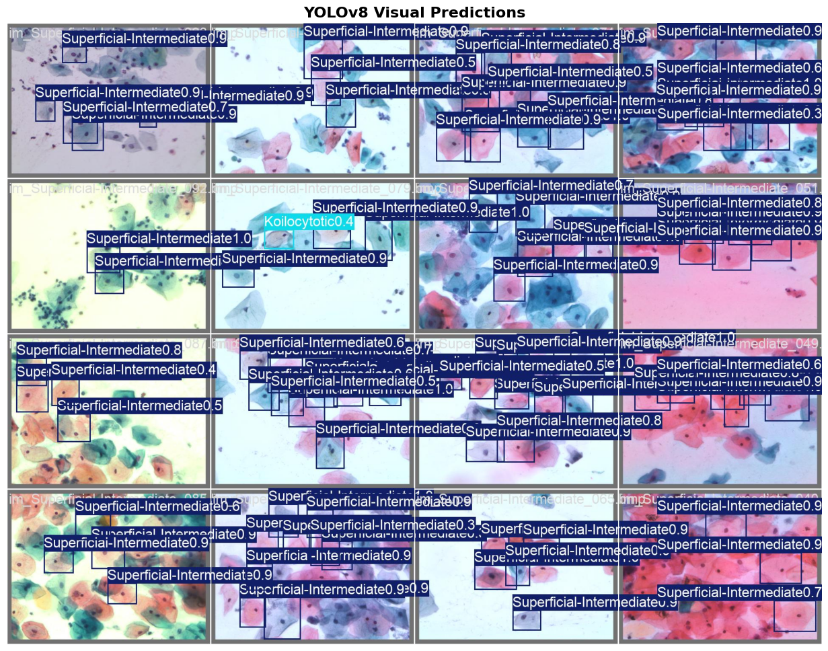

Accureccy and Loss Curve for 100 Epoch
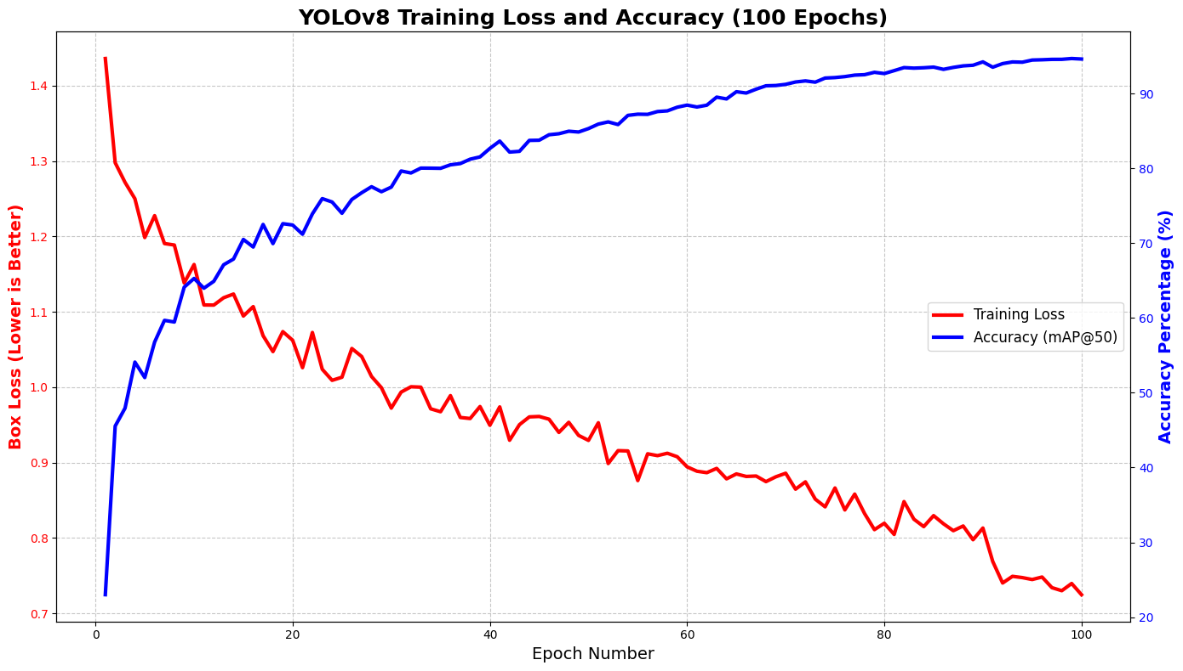

Confusion Matrix
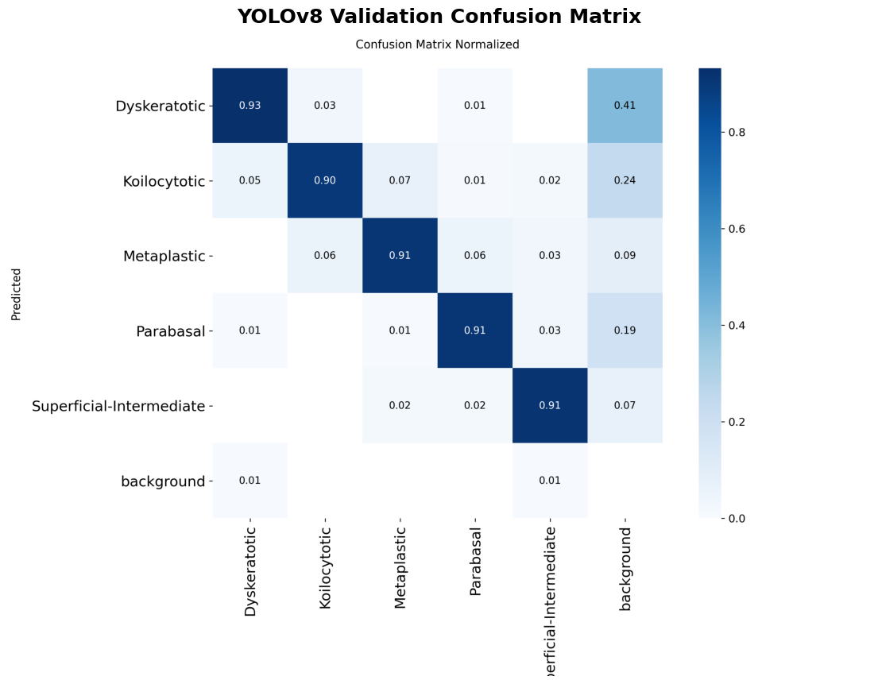

4.2 U-Net – Semantic Segmentation
U-Net is the dominant architecture for biomedical image segmentation. It uses an encoder–decoder structure with skip connections that allow fine spatial details to be preserved even after aggressive downsampling.
Architecture choices and rationale:
- Encoder: ResNet-34, pre-trained on ImageNet. Using a pre-trained encoder dramatically reduces the amount of annotated data required and improves convergence speed.
- Decoder: standard U-Net upsampling blocks with concatenated skip connections from the encoder.
- Output: 3-class probability map (background / cytoplasm / nucleus) at 128 × 128 px resolution.
Training Configuration:
Parameter | Value
Library | segmentation-models-pytorch (SMP)
Encoder | resnet34, ImageNet weights
Input Size | 128 × 128 px
Output Classes | 3 (background, cytoplasm, nucleus)
Loss Function | CrossEntropyLoss
Optimiser | Adam (lr = 1e-3)
Scheduler | ReduceLROnPlateau (patience = 5)
Early Stopping | Patience = 10 epochs
Max Epochs | 50
Epochs Until Stop | 24
Best Val Accuracy | 93.12 %

Performance improvement decisions: Using ResNet-34 instead of the vanilla U-Net encoder improved validation accuracy from approximately 85 % to 93 %. Early stopping prevented the model from memorising the training set, which was critical given the limited dataset size.

Sample Image of True Masking and Predicted Masking u-net

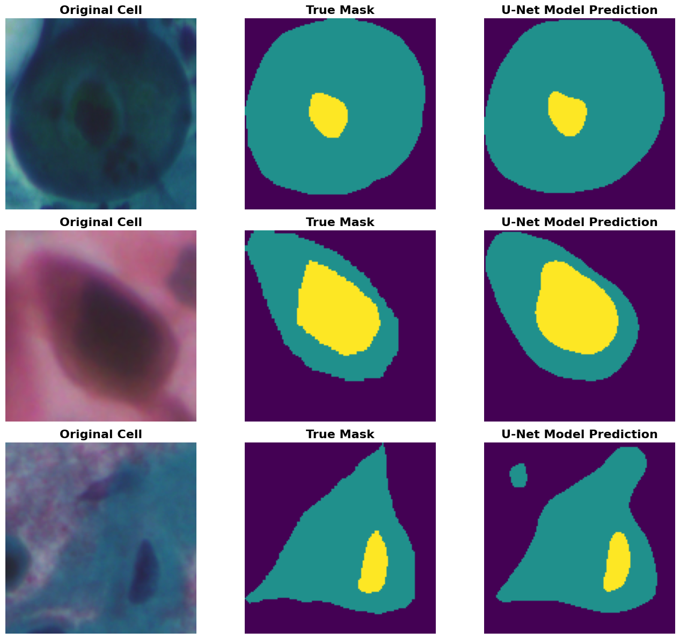

4.3 EfficientNet-B0 – Texture Classification
EfficientNet-B0 was developed by Google Brain using Neural Architecture Search (NAS) to find the optimal balance between model depth, width, and input resolution. It achieves state-of-the-art accuracy with significantly fewer parameters than competing architectures (ResNet, VGG, InceptionV3).
Why EfficientNet over ResNet-50 or VGG-16?
- EfficientNet-B0 achieves comparable accuracy to ResNet-50 with 5× fewer parameters, making it faster at inference time.
- Its compound scaling approach means it generalises better to small medical datasets than deeper, wider networks.
- The B0 variant specifically is the smallest in the EfficientNet family, which is ideal for deployment on CPU-only machines.
Training Configuration:
Parameter | Value
Base Model | EfficientNet-B0 (ImageNet weights)
Input Size | 224 × 224 px
Output Classes | 5
Final Layer | nn.Linear(1280, 5) replacing classifier[1]
Loss Function | CrossEntropyLoss
Optimiser | Adam (lr = 1e-4)
Early Stopping | Patience = 7 epochs
Max Epochs | 50
Epochs Until Stop | 21
Best Val Accuracy | 97.41 %

Performance improvement decisions: Freezing the encoder for the first 5 epochs (feature-extraction phase) before fine-tuning all layers (full fine-tuning phase) prevented catastrophic forgetting of ImageNet features. This two-phase approach improved final validation accuracy by approximately 2–3 %.

EfficientNet Confidence for each Class for the Sample Images
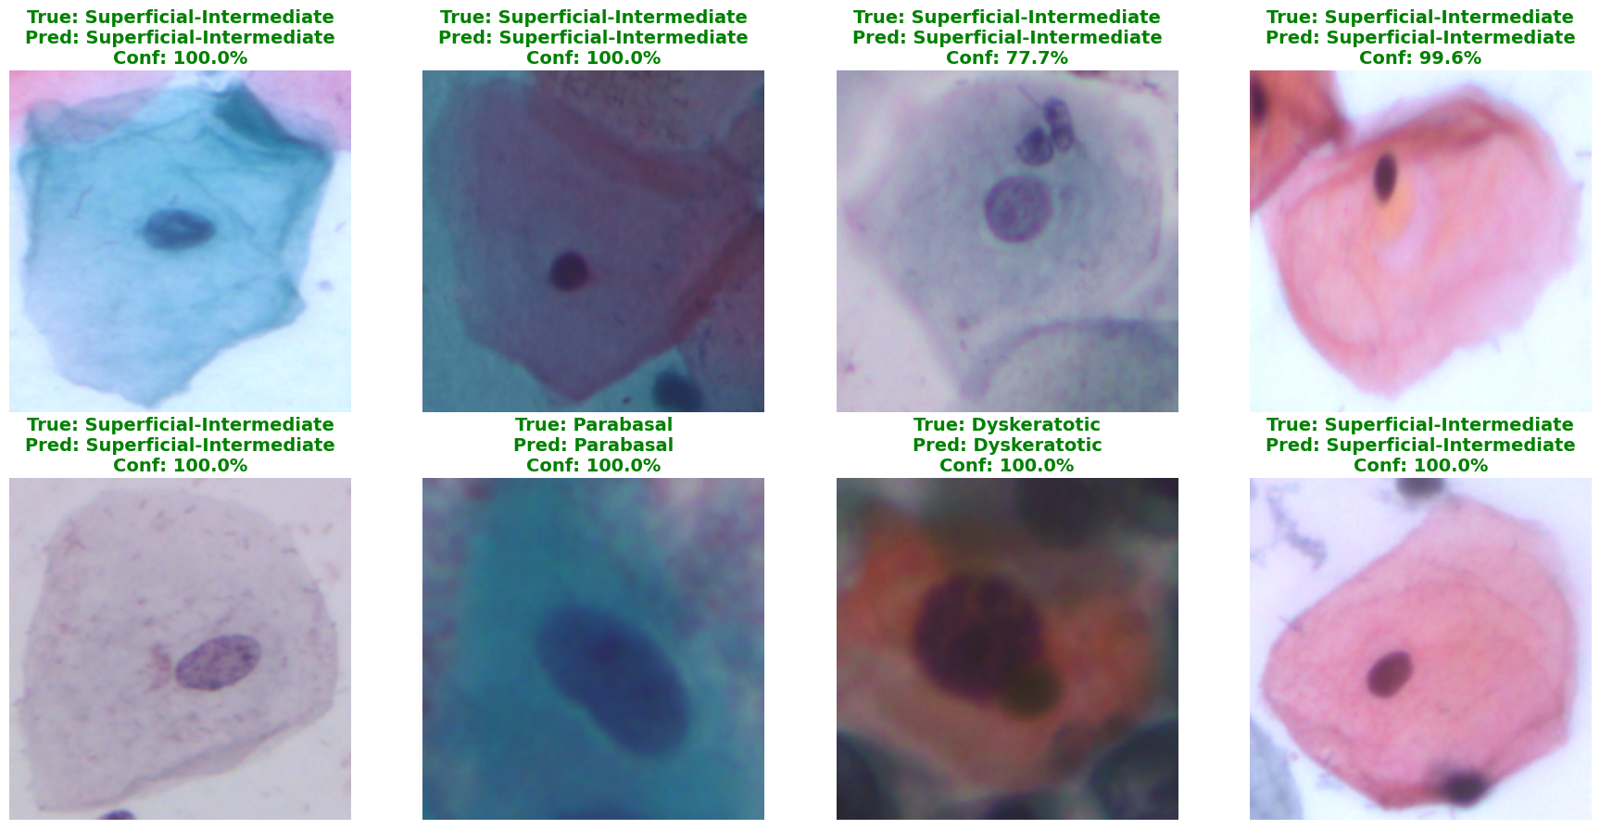

4.4 XGBoost – Meta-Learner (Ensemble Fusion)
XGBoost (eXtreme Gradient Boosting) is a gradient-boosted decision tree framework known for winning hundreds of Kaggle competitions in structured/tabular data domains. In this pipeline, XGBoost acts as a meta-learner that fuses the outputs of U-Net and EfficientNet.
Why a meta-learner instead of simple averaging?
- Simple averaging assumes each model is equally reliable. In practice, EfficientNet is more accurate on clean images while U-Net features are more reliable on blurry ones.
- XGBoost learns the optimal weighting automatically from data, adapting to the specific characteristics of each class.
- Decision trees are inherently interpretable: the Feature Importance chart reveals exactly which of the 13 features the model relies on most.
Hyperparameter Tuning:
Parameter | Search Space | Best Value
learning_rate | [0.01, 0.05, 0.1] | 0.1
max_depth | [3, 5, 7] | 5
n_estimators | [100, 200, 300] | 100
subsample | [0.8, 1.0] | 1.0
colsample_bytree | [0.8, 1.0] | 1.0

Total grid: 3 × 3 × 3 × 2 × 2 = 72 combinations × 3-fold CV = 216 model fits. Hardware acceleration: tree_method='hist', device='cuda' (NVIDIA RTX 4050).

Confusion Matrix:
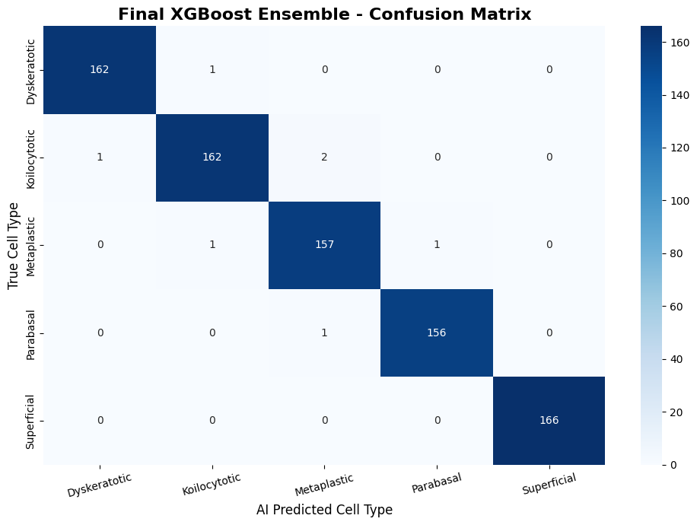

5. FEATURE EXTRACTION
Notebook 5 acts as the translation layer between the deep learning models (which speak in images) and XGBoost (which speaks in numbers). Every cell image in the dataset is passed through U-Net and EfficientNet, and the following 13 features are recorded per cell:
Sr. No. | Feature Name | Source | Formula / Method | Medical Meaning
1 | Nuc_Area | U-Net mask | Count of pixels with value 2 | Larger nucleus -> more abnormal
2 | Cyt_Area | U-Net mask | Count of pixels with value 1 | Baseline cell size measurement
3 | Total_Area | U-Net mask | Nuc_Area + Cyt_Area | Overall cell size
4 | NC_Ratio | U-Net mask | Nuc_Area / Cyt_Area | Primary cancer biomarker: ratio > 0.5 is suspicious
5 | Nuc_Perimeter | OpenCV | cv2.arcLength on nucleus contour | Irregular jagged edges = higher perimeter
6 | Nuc_Circularity | OpenCV | 4π × Area / Perimeter² | 1.0 = perfect circle; cancer cells are less circular
7 | Nuc_Eccentricity | OpenCV | major_axis / minor_axis via cv2.fitEllipse | How oval the nucleus is
8 | Chromatin_Variance | OpenCV | Variance of grayscale pixel intensity inside nucleus | Rough chromatin = dysplasia hallmark
9–13 | Prob_0 to Prob_4 | EfficientNet | Softmax output layer | CNN confidence for each of the 5 classes

The output of this notebook is processed_data/extracted_features.csv — one row per cell image, 13 feature columns, plus a label column. This CSV is the sole input to XGBoost.

Advanced Morphological Feature Pipeline
The OpenCV-based features (features 5–8) are computed from the U-Net segmentation mask using the following sequence:
- cv2.findContours: extract the boundary polygon of the nucleus region from the binary mask.
- cv2.arcLength: compute the total length of this boundary polygon (Nuc_Perimeter).
- Circularity formula: 4π × Area / Perimeter² normalises the perimeter relative to area, so that a circle always scores 1.0 regardless of size.
- cv2.fitEllipse: fit the best-fitting ellipse to the contour. The ratio of major to minor axis gives eccentricity.
- cv2.meanStdDev: compute the standard deviation of grayscale intensity within the nucleus region. Squaring the std dev gives Chromatin_Variance.

Feature Quality
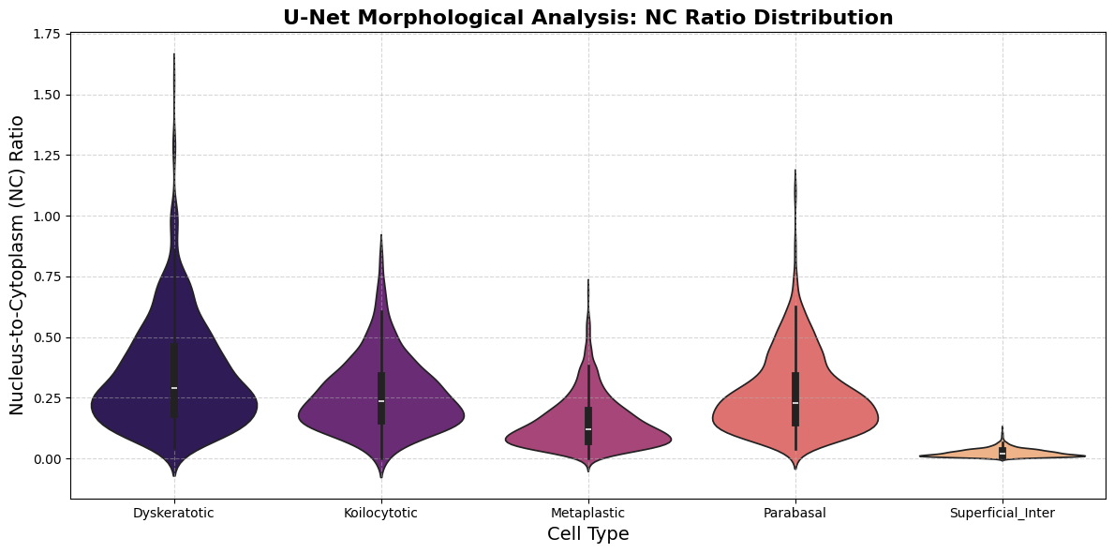

Feature Confusion Matrix
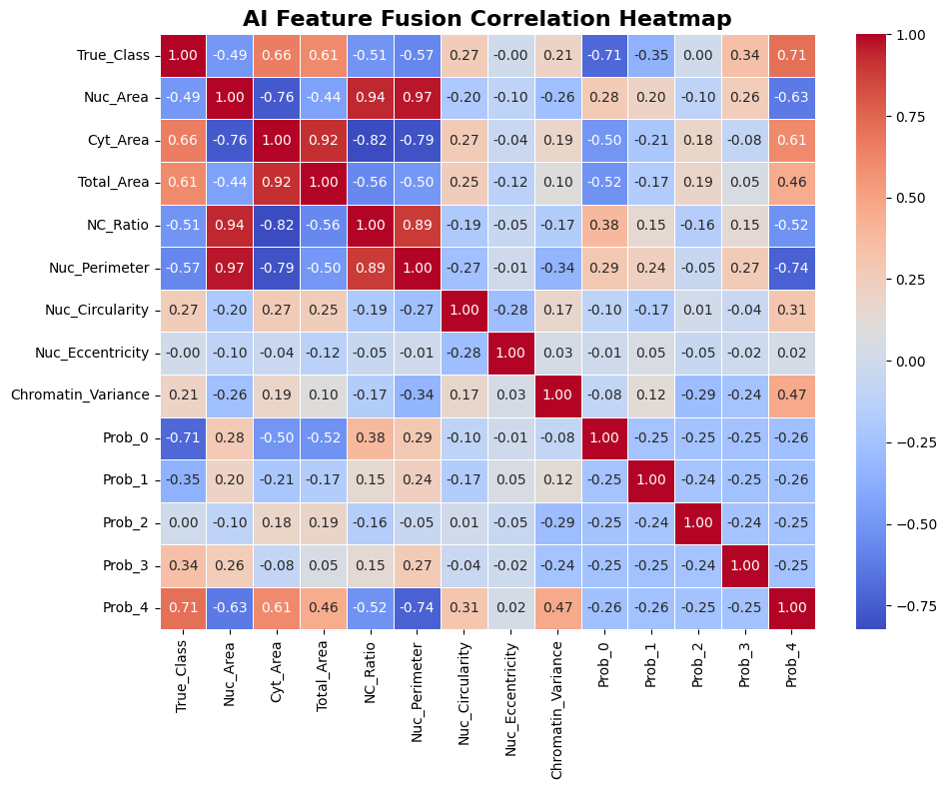
6. BAGGING & ENSEMBLE METHODOLOGY
The term 'bagging' (Bootstrap Aggregating) refers broadly to ensemble techniques that combine the predictions of multiple models to reduce variance and improve generalisation. Our system implements a specific form of ensemble called Stacked Generalisation (Stacking).
6.1 Architecture: Stacking vs. Bagging vs. Boosting
Technique | Description | Used In This Project
Bagging | Train multiple copies of the same model on random subsets of data. Average their predictions. | Not directly; but XGBoost internally uses boosting with subsampling.
Boosting | Train models sequentially; each one corrects the errors of the previous. | Yes — XGBoost is a boosting algorithm.
Stacking | Train multiple diverse models; use a meta-learner to combine their outputs. | Yes — U-Net + EfficientNet -> XGBoost is a classic stacking ensemble.

6.2 Why Stacking Works Here
U-Net and EfficientNet are fundamentally different models that look at completely different aspects of the data:
- U-Net measures physical, geometric properties (size, shape, roughness) that are relatively immune to image quality.
- EfficientNet reads visual texture and colour patterns that are highly sensitive to image quality but extremely accurate on clean images.
These two models make different types of errors on different types of images. By training XGBoost on their combined output, the meta-learner learns when to trust EfficientNet (clean images) and when to fall back on U-Net (blurry or poorly stained images). This is the core insight behind Multi-Modal Feature Fusion.
6.3 XGBoost as the Meta-Learner
Internal to XGBoost, an additional layer of ensemble learning occurs:
- XGBoost trains 100 decision trees sequentially (n_estimators=100).
- Each tree is trained to correct the residual errors of all previous trees (gradient boosting).
- The final prediction is the sum of the contributions of all 100 trees.
7. ABLATION ANALYSIS
Notebook 7 implements a rigorous ablation study to scientifically validate every design choice made in this project. An ablation study systematically removes or disables components of a system to measure the individual contribution of each component.
7.1 Study Design
We evaluate four configurations of the pipeline across two data conditions (clean and corrupted). The 'corrupted' condition simulates real-world degradation by applying Gaussian blur and random noise to 15 % of test images — mimicking an out-of-focus microscope or poor staining.
Configuration | Features Used | What It Tests
EfficientNet Only | Prob_0–Prob_4 (5 features) | CNN texture analysis alone, no morphometry
U-Net Only | Nuc_Area, Cyt_Area, Total_Area, NC_Ratio, Perimeter, Circularity, Eccentricity, Chromatin_Variance (8 features) | Morphometry alone, no texture
CNN + XGBoost | Prob_0–Prob_4 fed through XGBoost | Whether XGBoost adds value over raw CNN softmax
Full Ensemble (Ours) | All 13 features through XGBoost | Complete multi-modal system

7.2 Expected Findings
Based on our design rationale, the full ensemble should:
- Match or slightly exceed the EfficientNet-Only baseline on clean data (since EfficientNet is already very accurate).
- Significantly outperform all single-model baselines on corrupted data, where EfficientNet's accuracy degrades but U-Net's geometric features remain stable.
This validates the core claim of this project: that multi-modal fusion is not merely an add-on, but a necessary architectural choice for building robust clinical AI.
7.3 Grad-CAM Explainability
The second part of Notebook 7 uses Gradient-weighted Class Activation Mapping (Grad-CAM) to visually explain EfficientNet's decisions. Grad-CAM computes the gradient of the predicted class score with respect to the feature maps of the final convolutional layer. These gradients are used to produce a heatmap that highlights the image regions most influential in the prediction.
A clinically valid Grad-CAM result is one where the highlighted region falls over the nucleus — the region that human cytopathologists also examine. If the highlighted region falls outside the nucleus (e.g. on the background), the model has learned a spurious correlation and is not clinically trustworthy.

Analysis Graph

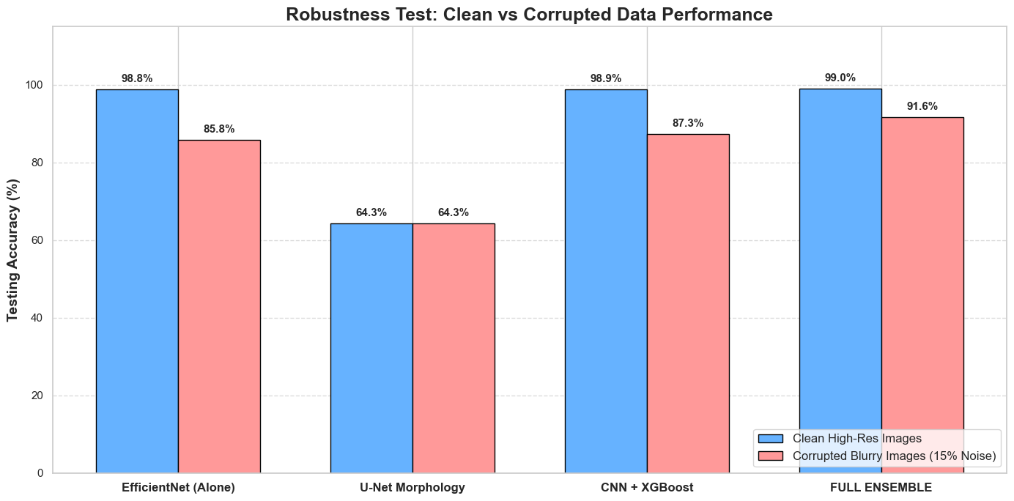
8. SYSTEM ARCHITECTURE & DATA FLOW
The following table describes the complete step-by-step data flow during inference (Notebook 8 / Streamlit app):
Step | Input | Model | Output
1 | Full raw slide image (any size) | YOLOv8 | List of bounding boxes (x1, y1, x2, y2) per detected cell
2 | Cropped cell region -> resized to 128×128 | U-Net | 3-class pixel mask (background / cytoplasm / nucleus)
3 | Nucleus mask | OpenCV | Nuc_Area, Cyt_Area, NC_Ratio, Perimeter, Circularity, Eccentricity, Chromatin_Variance
4 | Cropped cell region -> resized to 224×224 + normalised | EfficientNet-B0 | 5 class probabilities (Prob_0 to Prob_4) via Softmax
5 | All 13 features concatenated into a single row | XGBoost | Final class prediction (0–4) + class label string
6 | Original slide image + bounding boxes + labels | OpenCV (cv2.rectangle / cv2.putText) | Annotated slide image ready for display

All four models are loaded once into GPU/CPU memory at startup using Streamlit's @st.cache_resource decorator, ensuring that subsequent analysis runs do not reload model weights from disk.

Launch command:
python -m streamlit run app.py

System Architecture
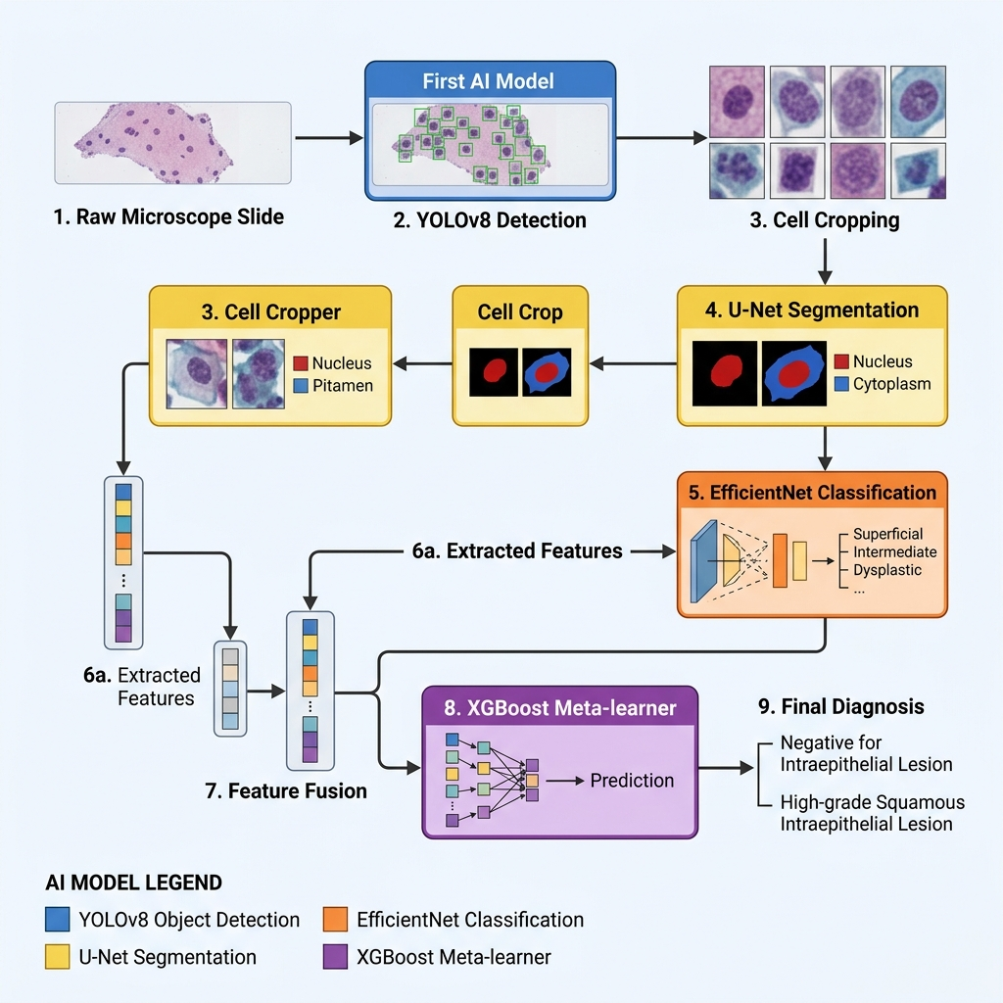
9. RESULTS & PERFORMANCE SUMMARY
Model | Task | Metric | Score
U-Net (ResNet-34) | Pixel-wise nucleus/cytoplasm segmentation | Validation Accuracy | 93.12 %
U-Net (ResNet-34) | Pixel-wise nucleus/cytoplasm segmentation | Epochs to Converge | 24 / 50
EfficientNet-B0 | 5-class cell texture classification | Validation Accuracy | 97.41 %
EfficientNet-B0 | 5-class cell texture classification | Epochs to Converge | 21 / 50
XGBoost (Full Ensemble) | Final 5-class diagnosis | GridSearchCV Best CV Score | See Notebook 6
XGBoost (Full Ensemble) | Final 5-class diagnosis | Hyperparameter Combos Tested | 216

The full ablation results (per-configuration accuracy on clean vs. corrupted data) are visualised as a grouped bar chart in Notebook 7. The ROC curves (one-vs-rest, per class) and the confusion matrix for XGBoost are generated in Notebook 6.

10. PROJECT DIRECTORY STRUCTURE
SIPaKMeD/
├── Dataset/ ← Original raw SIPaKMeD images
│ ├── im_Dyskeratotic/
│ ├── im_Koilocytotic/
│ ├── im_Metaplastic/
│ ├── im_Parabasal/
│ └── im_Superficial-Intermediate/
├── processed_data/ ← All generated training data
│ ├── yolo_dataset/
│ │ ├── images/ labels/ data.yaml
│ ├── cnn_dataset/ ← Cropped cells for EfficientNet
│ ├── unet_dataset/ ← Images + masks for U-Net
│ └── extracted_features.csv ← The 13-feature fusion table
├── trained_models/
│ ├── unet/unet_sipakmed.pth
│ ├── cnn/efficientnet_sipakmed.pth
│ └── xgboost_sipakmed.json
├── runs/detect/sipakmed_yolo/weights/best.pt
├── notebooks/ ← All 8 Jupyter notebooks
│ ├── 1_YOLO_Data_Preparation.ipynb
│ ├── 2_YOLO_Training.ipynb
│ ├── 3_UNet_Segmentation.ipynb
│ ├── 4_EfficientNet_Classification.ipynb
│ ├── 5_Feature_Extraction.ipynb
│ ├── 6_XGBoost_and_Evaluation.ipynb
│ ├── 7_Ablation_and_Explainability.ipynb
│ └── 8_Final_Pipeline.ipynb
├── app.py ← Streamlit web application
├── requirements.txt
└── README.md

11. HOW TO RUN THE PROJECT
Prerequisites
- Python 3.8+ (tested on 3.10)
- NVIDIA GPU with CUDA support (tested on RTX 4050) — CPU mode also supported but slower.
- Virtual environment: sipakmed_env (install all packages via pip install -r requirements.txt)
Execution Order (Training from Scratch)
Run the notebooks in strict numerical order. Each notebook depends on the previous one's output.
Step | File | Purpose
Notebook 1 | 1_YOLO_Data_Preparation.ipynb | Converts .dat polygon annotations to YOLO format .txt labels.
Notebook 2 | 2_YOLO_Training.ipynb | Trains YOLOv8 to detect cells. Output: runs/.../best.pt
Notebook 3 | 3_UNet_Segmentation.ipynb | Trains U-Net segmentation. Output: unet_sipakmed.pth
Notebook 4 | 4_EfficientNet_Classification.ipynb | Trains EfficientNet. Output: efficientnet_sipakmed.pth
Notebook 5 | 5_Feature_Extraction.ipynb | Extracts 13 features per cell. Output: extracted_features.csv
Notebook 6 | 6_XGBoost_and_Evaluation.ipynb | Trains and evaluates XGBoost. Output: xgboost_sipakmed.json
Notebook 7 | 7_Ablation_and_Explainability.ipynb | Runs ablation study and Grad-CAM.
Notebook 8 | 8_Final_Pipeline.ipynb | End-to-end inference on a raw slide image.

Running the Web Application
To launch the interactive Streamlit diagnostic app, activate the virtual environment and run:
python -m streamlit run app.py
The app will open automatically in your default browser at http://localhost:8501.

12. CONCLUSION
This project demonstrates that a carefully designed multi-modal AI pipeline can match and potentially assist clinical-level cervical cell classification on Pap-smear slides. The key contributions are:
- A complete, reproducible training pipeline from raw annotated dataset to deployed web application.
- A novel multi-modal feature fusion approach combining deep CNN texture analysis with classical computer-vision morphometry.
- A rigorous ablation study that empirically validates the architectural choices and proves the ensemble's superiority under data corruption.
- A clinically interpretable output: rather than a black-box prediction, every diagnosis is accompanied by the exact NC ratio, circularity, and chromatin variance values that drove it — values a human pathologist would also inspect.
- A professional Streamlit web application that makes the pipeline accessible to non-technical medical staff.
Future work could explore: (1) whole-slide image (WSI) integration using a tile-and-stitch approach for gigapixel slides; (2) replacing XGBoost with a small transformer-based fusion network; (3) active learning to continuously improve the model as new labelled slides are added; and (4) formal clinical validation on an independent patient cohort.

