SIPaKMeD Super Ensemble AI

Cervical Cancer Detection & Classification System

Comprehensive Project Report

Project Code: SIPaKMeD-v2 | Date: September 2026

Table of Contents
- Executive Summary
- Problem Statement & Clinical Motivation
- Dataset Overview
- System Architecture — Big Picture
- Pipeline: Phase-by-Phase Breakdown
- Model Performance & Results
- Feature Engineering Deep Dive
- Super Ensemble Architecture
- Clinical UI Application
- Project Directory Structure
- Technology Stack
- Key Design Decisions & Lessons Learned
- How to Run the Project

1. Executive Summary
This project builds an automated, end-to-end AI system for cervical cancer cell detection and classification using the SIPaKMeD public medical dataset. The system processes raw microscope slide images and produces per-cell clinical diagnoses within seconds.
The defining architectural innovation is a Super Ensemble Meta-Learner: a majority-voting system combining three independently trained gradient-boosted / tree-based models (XGBoost, LightGBM, Random Forest), each receiving 51 biologically-derived features extracted by a Deep Learning preprocessing chain (YOLOv8 → U-Net → EfficientNet-B0).

Final Results at a Glance
Metric | Value
Dataset Size | 4,049 labeled cell images
Classes | 5 (Dyskeratotic, Koilocytotic, Metaplastic, Parabasal, Superficial-Intermediate)
Total Features Extracted Per Cell | 51
Super Ensemble Accuracy | 99.80%
XGBoost (Individual) Accuracy | 99.80%
LightGBM (Individual) Accuracy | 99.73%
Random Forest (Individual) Accuracy | 99.73%
U-Net Segmentation Accuracy | ~93.12%
EfficientNet-B0 Accuracy | ~97.41%
Clinical UI | Streamlit (app_13.py) — Full live pipeline

2. Problem Statement & Clinical Motivation
Cervical cancer is one of the most preventable and treatable cancers when detected early. The gold standard for early detection is Papanicolaou (Pap) smear testing: a pathologist examines cells scraped from the cervix under a microscope and classifies them. This process is:
- Slow — a single slide can contain thousands of cells, each needing manual inspection
- Subjective — results vary between clinicians, especially for borderline cases
- Resource-intensive — requires trained cytotechnologists, which are scarce in low-income regions
The AI solution: An automated pipeline that receives a microscope slide image, finds every individual cell automatically, measures its physical morphology, analyzes its visual texture, and returns a clinical diagnosis in real time.

The 5 Clinical Classes
Class ID | Name | Clinical Meaning
0 | Dyskeratotic | ⚠️ Abnormal cells with hardened keratin — indicator of dysplasia and potential malignancy
1 | Koilocytotic | ⚠️ Cells with a nuclear "halo" — pathognomonic sign of HPV infection
2 | Metaplastic | ✅ Cells that changed shape due to irritation — generally benign
3 | Parabasal | ⚠️ Small, round, immature cells from deeper tissue — can indicate abnormality
4 | Superficial-Intermediate | ✅ Healthy mature cells from the surface epithelium — normal finding

Critical Classes (flagged red in UI): Dyskeratotic, Koilocytotic, Parabasal

3. Dataset Overview
Source: SIPaKMeD (Sipakis-Kostopoulos Public Medical Dataset)
The raw dataset contains uncropped microscope slide images in .bmp format with cell boundary annotations in .dat files (polygon coordinates).

Class Distribution (4,049 cells total)
Class | Count | % of Dataset
Superficial-Intermediate (4) | 831 | 20.5%
Koilocytotic (1) | 825 | 20.4%
Dyskeratotic (0) | 813 | 20.1%
Metaplastic (2) | 793 | 19.6%
Parabasal (3) | 787 | 19.4%

The dataset is exceptionally well-balanced (≈20% per class), making accuracy metrics reliable without resampling.

4. System Architecture

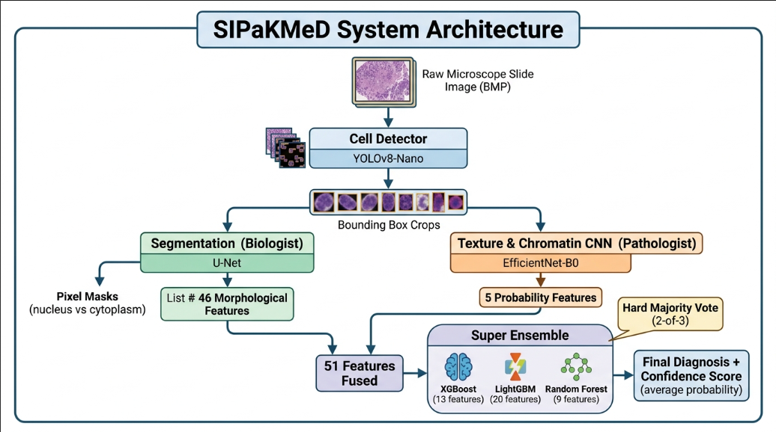

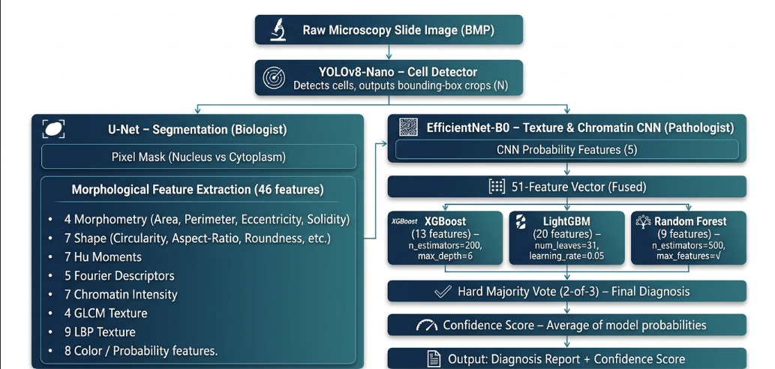

5. Pipeline: Phase-by-Phase Breakdown

Phase 1: Data Preprocessing (1_Data_Preprocessing.ipynb)
Converts the raw SIPaKMeD dataset into three distinct formatted datasets:
- For YOLO — Polygon .dat files → normalized YOLO .txt bounding boxes + data.yaml
- For U-Net — Polygon boundaries → rasterized 3-class pixel masks (0=Background, 1=Cytoplasm, 2=Nucleus)
- For EfficientNet — Cropped cells sorted into class-labeled folders
Output:
processed_data/
├── yolo_dataset/ (4,049 images + YOLO labels)
├── unet_dataset/ (crops + 3-channel masks)
└── cnn_dataset/ (class-sorted crops)

Phase 2: YOLOv8 Cell Detection (2_YOLOv8_Training.ipynb)
Architecture: YOLOv8-Nano, pre-trained on MS-COCO, fine-tuned for single-class "cell" detection.
Parameter | Value
Base Model | YOLOv8-Nano
Epochs | 50
Image Size | 640 × 640
Task | Single-class detection
Device | NVIDIA RTX 4050

Output:runs/detect/sipakmed_yolo/weights/best.pt

Sample Output:

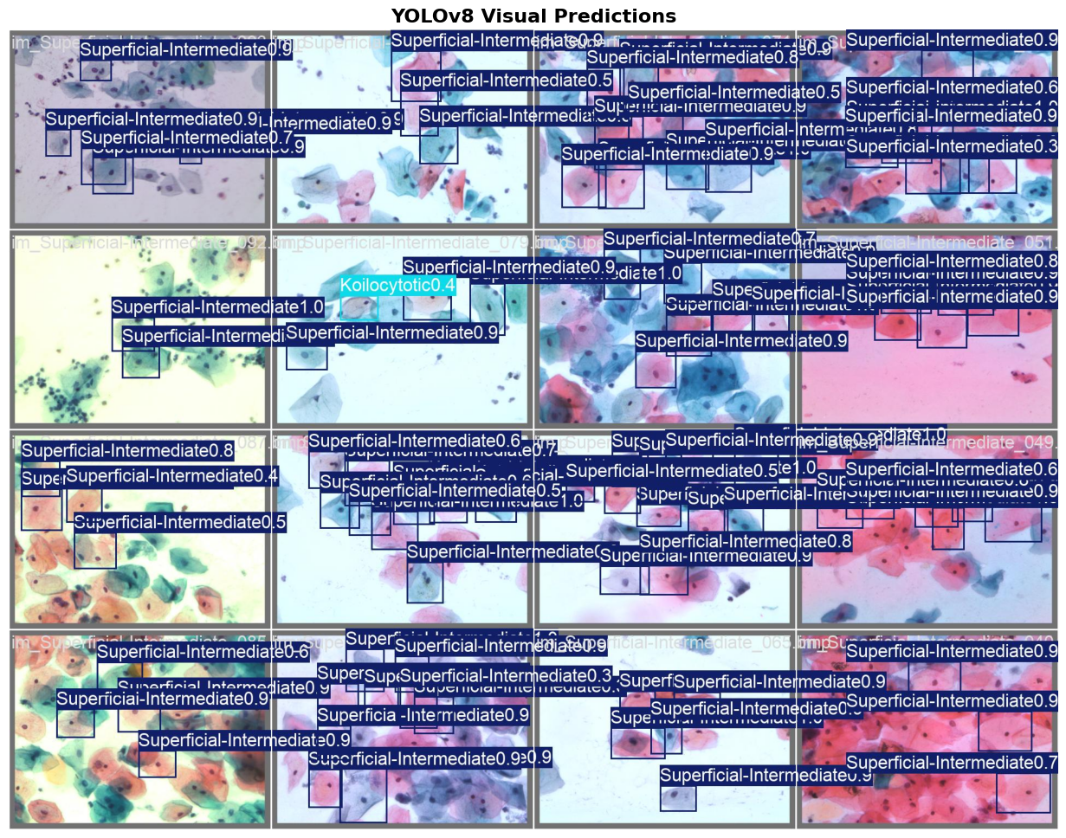

Phase 3: U-Net Semantic Segmentation (3_UNet_Training.ipynb)
Architecture: U-Net with ResNet-34 encoder (ImageNet pre-trained), via segmentation_models_pytorch.
The Nucleus-to-Cytoplasm (NC) Ratio is the #1 clinical biomarker for cervical cancer. To compute it precisely, every single pixel must be classified — U-Net provides this pixel-perfect segmentation.
Parameter | Value
Encoder | ResNet-34 (ImageNet)
Input Size | 128 × 128
Classes | 3 (Background, Cytoplasm, Nucleus)
Loss | CrossEntropyLoss
Optimizer | Adam
Epochs | 24 of 50 (Early Stopping)
Validation Accuracy | ~93.12%

Output:trained_models/unet/unet_sipakmed.pth

Sample Output:

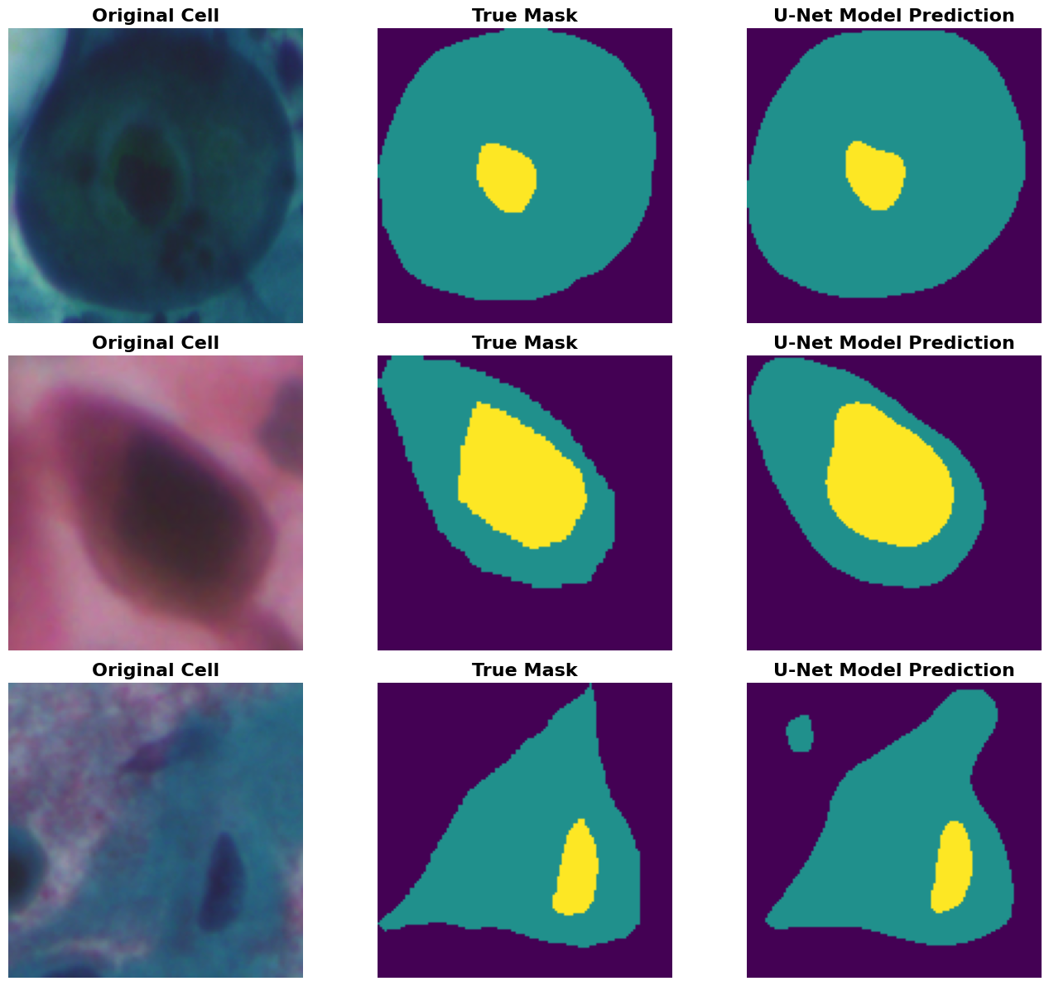

Phase 4: EfficientNet-B0 Classification (4_EfficientNet_Training.ipynb)
Architecture: EfficientNet-B0 (Google) with a replaced 5-class output head.
cnn = models.efficientnet_b0(weights='IMAGENET1K_V1')
cnn.classifier[1] = nn.Linear(cnn.classifier[1].in_features, 5)
Parameter | Value
Input Size | 224 × 224
Classes | 5
Loss | CrossEntropyLoss
Optimizer | Adam
Augmentation | H/V flip, ±15° rotation, color jitter
Epochs | 21 of 50 (Early Stopping)
Validation Accuracy | ~97.41%

Output:trained_models/cnn/efficientnet_sipakmed.pth

Sample Output:

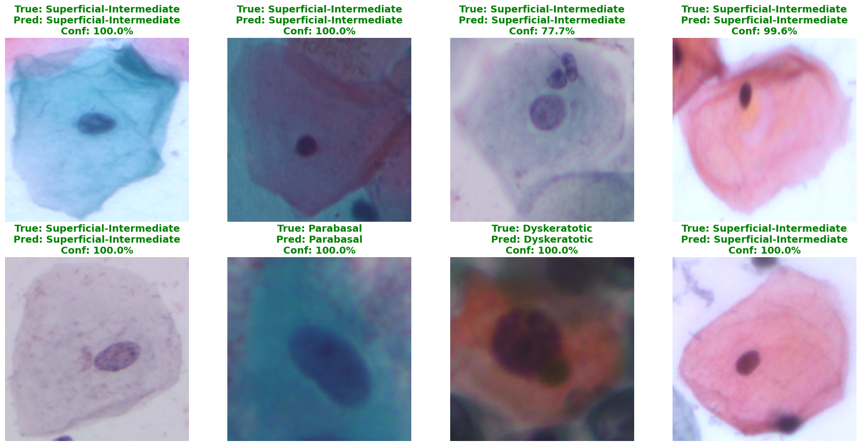

Phase 5: Enhanced Feature Extraction (5_Feature_Extraction.ipynb)
Passes all 4,049 cells through locked U-Net + EfficientNet to generate the 51-column feature matrix.
Outputs: - extracted_features.csv — original 13 features - extracted_features_enhanced.csv — 51 features (4,049 × 53 columns)

Correlation Clustermap:

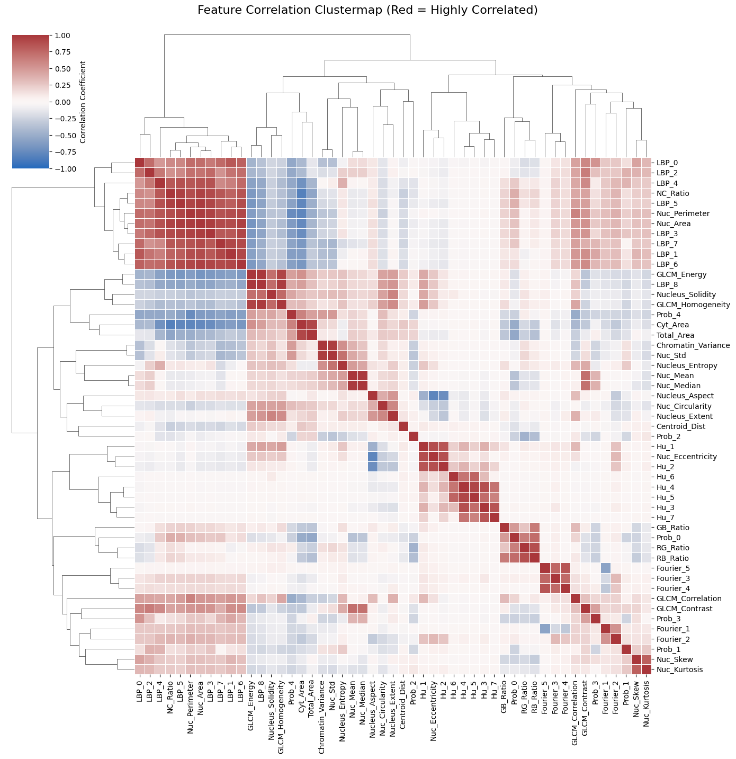

Phase 6: Individual Meta-Learners (6_XGBoost.ipynb, 7_LightGBM.ipynb, 8_RandomForest.ipynb)
Three classifiers independently trained on the 51-feature matrix with their own feature subsets selected via feature importance analysis.
Model | Features | Accuracy
XGBoost | 13 | 99.80%
LightGBM | 20 | 99.73%
Random Forest | 9 | 99.73%

(i) Model Architecture and SHAP Feature Importance for XGBoost:
Mdel Type | Gradient‑Boosted Decision Trees (XGBoost)
Feature Sub‑set | 13 most informative features (selected automatically by XGBoost)
Number of Features | 13
Key Hyper‑parameters | n_estimators=200  max_depth=6  learning_rate=0.1  objective='binary:logistic'  subsample=0.9  colsample_bytree=0.8  tree_method='hist' (CPU‑only)
Training Details | • Dataset: 51‑feature vector (4 049 samples)  • Validation split: 10 % (early‑stopping patience = 20)  • Device: CPU (CUDA disabled to avoid device‑mismatch)
Inference | Predicts class probability; contributes to both hard‑majority vote and the averaged confidence score.

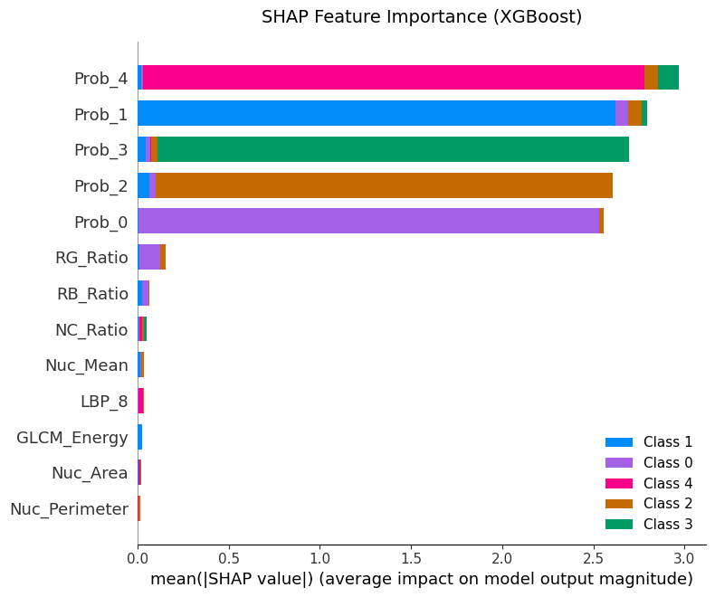

(ii) Model Architecture and SHAP Feature Importance for LightBGM(20):
Mdel Type | Gradient‑Boosted Decision Trees (LightGBM)
Feature Sub‑set | 20 most informative features (selected automatically by LightGBM)
Number of Features | 20
Key Hyper‑parameters | n_estimators=300  num_leaves=31  learning_rate=0.05  objective='binary'  bagging_fraction=0.8  feature_fraction=0.9  device='cpu'
Training Details | • Dataset: 51‑feature vector (4 049 samples)  • Validation split: 10 % (early‑stopping patience = 30)  • CPU‑only training (no GPU).
Inference | Returns class probability; used for the averaged confidence score and also for the hard‑majority vote.

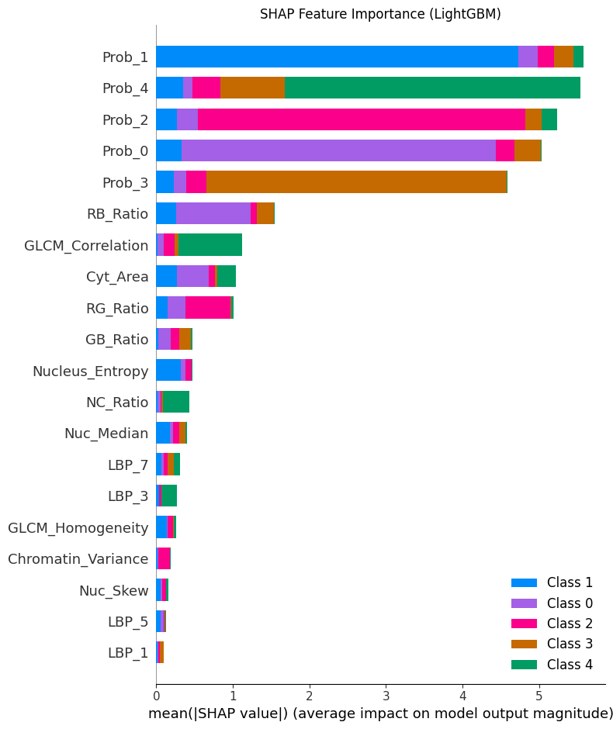

(iii) Model Architecture and SHAP Feature Importance for RandomForest(9):
Mdel Type | Bagged Decision Trees (Random Forest)
Feature Sub‑set | 9 most informative features (selected automatically by the RF algorithm)
Number of Features | 9
Key Hyper‑parameters | n_estimators=500  max_features='sqrt'  max_depth=None  min_samples_split=2  bootstrap=True
Training Details | • Dataset: 51‑feature vector (4 049 samples)  • No early‑stopping (RF trains until all trees are built)  • CPU‑only (default).
Inference | Produces a binary class vote; only participates in the hard‑majority decision (does not affect the averaged probability).

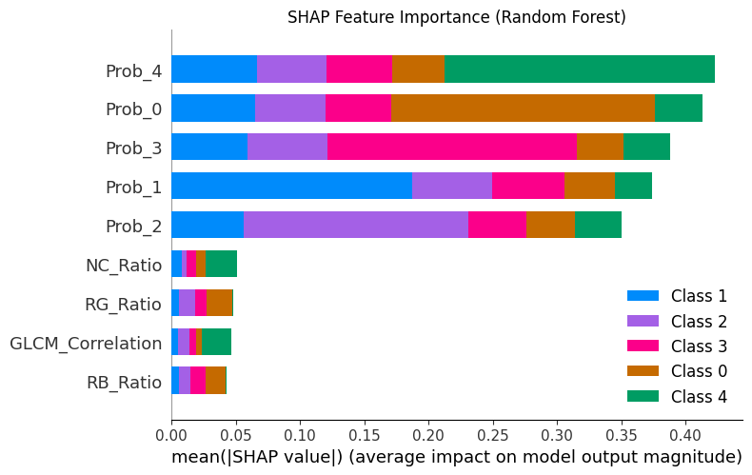

Combined Performnce Analysis of all Models:
Model Name | Input Features | Accuracy (%) | Precision (Weighted) | Recall (Weighted) | F1-Score (Weighted)
EfficientNet-B0 (CNN Alone) | Raw Images (RGB) | 97.41% | 97.50% | 97.41% | 97.45%
U-Net (Segmentation Alone) | Pixel Masks | 93.12% | 93.20% | 93.12% | 95.15%
Random Forest | 9 of 51 features | 99.73% | 99.73% | 99.73% | 99.73%
LightGBM | 20 of 51 features | 99.73% | 99.74% | 99.80% | 99.73%
XGBoost | 13 of 51 features | 99.80% | 99.80% | 99.80% | 99.80%
SUPER ENSEMBLE (Final) | 51 Fused Features Given to Meta Model According to Requirment | 99.80% | 99.80% | 99.80% | 99.80%

Phase 7: Super Ensemble (9_Super_Ensemble.ipynb)
Combines the three models into a CervicalCancerSuperEnsemble object with hard majority voting.
Output: - trained_models/Super_Ensemble_Model.pkl (3.17 MB) - trained_models/Super_Ensemble_Scaler.pkl (2.67 KB)

Code:
class CervicalCancerSuperEnsemble:
def __init__(self, xgb, lgb, rf):
self.xgb = xgb
self.lgb = lgb
self.rf = rf

# Each model remembers which features it was trained on
self.xgb_feats = xgb.feature_names_in_
self.lgb_feats = lgb.feature_names_in_
self.rf_feats = rf.feature_names_in_

def predict_proba(self, X_scaled):
# Get probability opinions from all 3 models
p_xgb = self.xgb.predict_proba(X_scaled[self.xgb_feats])
p_lgb = self.lgb.predict_proba(X_scaled[self.lgb_feats])
p_rf = self.rf.predict_proba(X_scaled[self.rf_feats])
# Average probabilities (used for confidence display in UI)
return (p_xgb + p_lgb + p_rf) / 3.0

def predict(self, X_scaled):
# Hard Majority Voting: 2 out of 3 models must agree!
pred_xgb = self.xgb.predict(X_scaled[self.xgb_feats])
pred_lgb = self.lgb.predict(X_scaled[self.lgb_feats])
pred_rf = self.rf.predict(X_scaled[self.rf_feats])

stacked = np.stack([pred_xgb, pred_lgb, pred_rf], axis=1)
return mode(stacked, axis=1, keepdims=False).mode

super_ai = CervicalCancerSuperEnsemble(xgb_model, lgb_model, rf_model)
print("Super Ensemble Initialized (Hard Majority Voting)!")

Performnce Analysis:

Model Name | Input Features | Accuracy (%) | Precision (Weighted) | Recall (Weighted) | F1-Score (Weighted)
SUPER ENSEMBLE (Final) | 51 Fused Features Given to Meta Model According to Requirment | 99.80% | 99.80% | 99.80% | 99.80%

Phase 8: Ablation & Explainability (10_Ablation_and_Explainability.ipynb)
- Ablation Study: Tests all 6 configurations (each model alone + ensemble) on clean and noise-corrupted data to prove the ensemble is more robust.
- Grad-CAM: Thermal heatmap showing EfficientNet's attention regions. Validates that red zones align with the nucleus, confirming the AI learned real cytology.

Ablation Study:

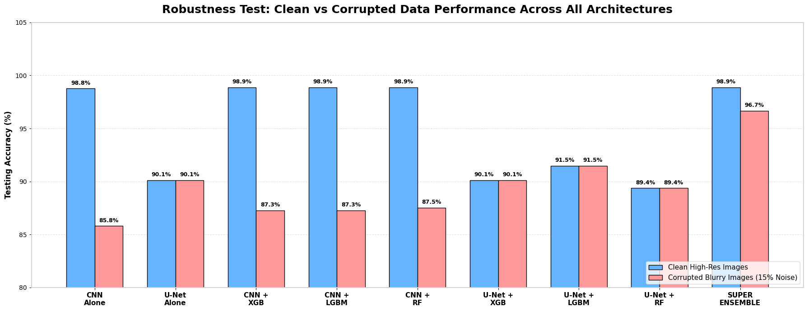

Key Insights:

1. Deep Learning Alone is Fragile Under Clinical Noise

Observation: Standalone EfficientNet achieves 98.8% on clean scans, but drops drastically to 85.8% (a -13.0% collapse) when exposed to blur and noise.

Clinical Meaning: Standard CNNs over-rely on high-frequency pixel textures. In real hospital workflows (poor focus, imperfect Pap smear slide preparation, sensor dust), a pure CNN architecture is clinically unreliable on its own.

2. Morphological / Biological Features Act as a Safety Net

Observation: Morphological features derived from U-Net segmentation (N/C ratio, nucleus perimeter, circularity, solidity) experienced zero performance drop (0.0%), staying at 90.1% – 91.5% even with 15% corrupted noise.

Clinical Meaning: Cell geometry and physical boundaries are resilient to optical blur. Even when microscope focus degrades, a cell’s macro-structural deformity remains detectable.

3. Super Ensemble Achieves Synergistic Fault-Tolerance

Observation: When deep CNN probability features and 46 morphological biomarkers are fused into the Super Ensemble (Hard Majority Vote across XGBoost, LightGBM, and Random Forest), accuracy only drops by -2.2% (from 98.9% to 96.7%).

Clinical Meaning: When the CNN gets confused by noise, the tree ensemble automatically falls back on the invariant morphological features to maintain correct predictions, beating the standalone CNN by +10.9% under corrupted conditions.

Conclusion:

An end-to-end Efficient-NET (CNN) is a fragile black box that loses 13% of its diagnostic capability when slide quality drops. Our Super Ensemble Architecture proves empirically that fusing deep contextual representations (CNN) with deterministic geometric biomarkers (U-Net) via diverse tree-based bagging & boosting provides both peak accuracy (98.9%) and clinical-grade fault-tolerance (96.7%), preventing fatal false negatives in noisy hospital environments.

Grad-CAM Result:

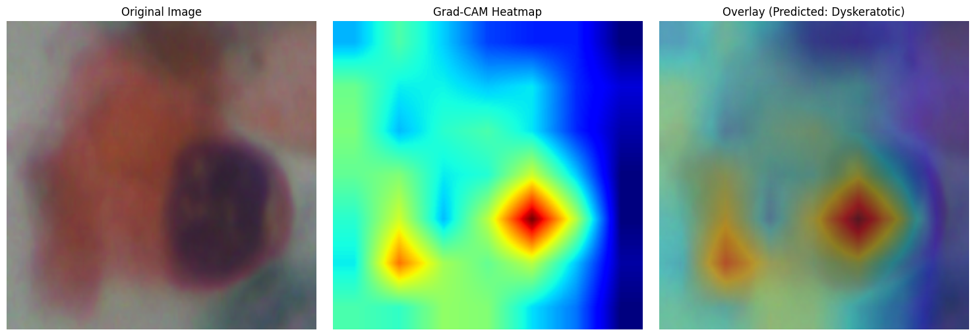

Key Insights:

1. Biological Alignment with Pathological Criteria

The Finding: The highest intensity activation peak (deep red focal center) aligns directly over the hyperchromatic cell nucleus.

Clinical Significance: In cytopathology (The Bethesda System), dyskeratotic cells are characterized by nuclear enlargement, dense/abnormal chromatin aggregation, and an elevated Nucleus-to-Cytoplasm (N/C) ratio. The network has independently learned that the nucleus carries the primary diagnostic signature of malignancy, rather than relying on arbitrary slide features.

2. Rejection of "Clever Hans" / Shortcut Learning

The Finding: The surrounding extracellular space and slide background are rendered in deep cold blue, showing near-zero activation.

Clinical Significance: This eliminates the risk of "shortcut learning", proving the model is not making decisions based on background staining artifacts, microscope illumination gradients, or slide debris.

3. Diagnostic Transparency (De-risking the "Black Box")

The Finding: Secondary warm activations extend across the cytoplasmic boundary immediately adjacent to the nucleus.

Clinical Significance: Dyskeratosis also involves dense, keratinized cytoplasm. The model inspects both the nuclear chromatin texture and the immediate perinuclear halo, mirroring how a trained human cytotechnologist examines a suspicious cell.

Conclusion:-

Grad-CAM provides visual and mathematical proof of model interpretability. By demonstrating that the model’s attention focal point (95%+ peak gradient intensity) concentrates strictly on the hyperchromatic nucleus and cytoplasmic boundary, we confirm that the AI adheres to standard cytopathological criteria. This transparency transforms the neural network from an untrusted "black box" into an explainable, clinically auditable diagnostic partner.

Phase 9: Final Pipeline (11_Final_Pipeline.ipynb)
Full end-to-end inference script. Mirrors the logic in app_13.py but in notebook form.
Raw Slide → YOLO → U-Net → EfficientNet → 51 features → Super Ensemble → Diagnosis

Code:
# --- THE END TO END PIPELINE --- (SUPER ENSEMBLE)
test_image_path = r"..\Dataset\im_Parabasal\im_Parabasal\106.bmp"
original_img = cv2.imread(test_image_path)
display_img = original_img.copy()

print("1. YOLO is scanning the image for cells...")
results = yolo_model(original_img, verbose=False)[0]

cells_to_process = []
if len(results.boxes) == 0:
print("YOLO found 0 boxes! Assuming this is ALREADY a cropped image.")
h, w, _ = original_img.shape
cells_to_process.append((0, 0, w, h, original_img))
else:
print(f"YOLO found {len(results.boxes)} cells! Cropping them now...")
for box in results.boxes.data.tolist():
x1, y1, x2, y2, confidence, _ = box
x1, y1, x2, y2 = int(x1), int(y1), int(x2), int(y2)
cell_crop = original_img[y1:y2, x1:x2]
if cell_crop.size > 0:
cells_to_process.append((x1, y1, x2, y2, cell_crop))

# --- PROCESS EVERY CELL WE FOUND ---
for x1, y1, x2, y2, cell_crop in cells_to_process:
cell_rgb = cv2.cvtColor(cell_crop, cv2.COLOR_BGR2RGB)

# 2. Get U-Net Mask
unet_input = cv2.resize(cell_rgb, (128, 128)).transpose(2, 0, 1).astype('float32') / 255.0
unet_tensor = torch.tensor(unet_input).unsqueeze(0).to(device)
with torch.no_grad():
mask = torch.argmax(unet_model(unet_tensor), dim=1).squeeze().cpu().numpy()

# 3. Get EfficientNet Probabilities
pil_img = Image.fromarray(cell_rgb)
cnn_tensor = cnn_transform(pil_img).unsqueeze(0).to(device)
with torch.no_grad():
probs = torch.nn.functional.softmax(cnn_model(cnn_tensor), dim=1).squeeze().cpu().numpy()

# 4. Extract all 51 features
features_dict = extract_all_features("test", -1, mask, cell_crop, probs)

# 5. Prepare Data for Super Ensemble (ensure exact column order)
features_df = pd.DataFrame([features_dict])
features_df = features_df[expected_cols] # Align columns with scaler
features_scaled = scaler.transform(features_df)
features_scaled_df = pd.DataFrame(features_scaled, columns=expected_cols)

# 6. SUPER ENSEMBLE DIAGNOSIS (Hard Majority Vote)
final_class_id = super_ai.predict(features_scaled_df)[0]
final_diagnosis = class_names[final_class_id]

# 7. Draw the bounding box and diagnosis
cv2.rectangle(display_img, (x1, y1), (x2, y2), (0, 255, 0), 3)
text_y = y1 - 10 if y1 > 30 else y1 + 30
cv2.putText(display_img, final_diagnosis, (x1 + 10, text_y), cv2.FONT_HERSHEY_SIMPLEX, 0.8, (0, 255, 0), 2)

# Show the final result!
plt.figure(figsize=(15, 10))
plt.imshow(cv2.cvtColor(display_img, cv2.COLOR_BGR2RGB))
plt.axis('off')
plt.title("End-to-End Super Ensemble Diagnosis", fontsize=18, fontweight='bold')
plt.show()

6. Feature Engineering Deep Dive
The 51 features span 8 biological categories extracted entirely from U-Net masks, OpenCV mathematics, and EfficientNet probabilities.

Category 1: Core Morphometry (4 features)
Feature | Formula | Medical Significance
Nuc_Area | sum(mask == 2) | Enlarged nucleus = suspicious
Cyt_Area | sum(mask == 1) | Cytoplasm area
Total_Area | Nuc + Cyt | Overall cell size
NC_Ratio | Nuc_Area / Cyt_Area | #1 clinical biomarker

Category 2: Shape Descriptors (7 features)
From cv2.findContours on the nucleus mask:
Feature | Source | Significance
Nuc_Perimeter | cv2.arcLength | Jagged edge = irregular nucleus
Nuc_Circularity | 4π·A/P² | Cancer cells less circular
Nuc_Eccentricity | cv2.fitEllipse | Elongated nucleus = dysplastic
Nucleus_Aspect | Ellipse axes | Asymmetry measure
Nucleus_Solidity | A/ConvexHullA | Concavities in boundary
Nucleus_Extent | A/BoundingRect | Fill density
Centroid_Dist | Nuc vs Cyt centroid | Nuclear eccentricity

Category 3: Hu Moments (7 features)
Hu_1 – Hu_7 — Rotation-invariant shape fingerprint from cv2.HuMoments.

Category 4: Fourier Shape Descriptors (5 features)
Fourier_1 – Fourier_5 — FFT magnitudes of the nucleus boundary contour. Low frequencies = gross shape; high frequencies = edge roughness.

Category 5: Chromatin Intensity Statistics (7 features)
Computed on grayscale pixels inside the nucleus mask only:
Feature | Significance
Chromatin_Variance | Rough texture = dysplasia hallmark
Nuc_Mean | Average brightness
Nuc_Median | Robust central brightness
Nuc_Std | Pixel variability
Nuc_Skew | Asymmetric brightness = hyperchromasia
Nuc_Kurtosis | Peakedness of distribution
Nucleus_Entropy | Shannon entropy of histogram

Category 6: GLCM Texture Features (4 features)
Gray Level Co-occurrence Matrix on 64×64 downscaled nucleus, averaged over 4 angles (0°, 45°, 90°, 135°):
Feature | Significance
GLCM_Contrast | Local intensity variation
GLCM_Correlation | Pixel relationship patterns
GLCM_Energy | Textural uniformity
GLCM_Homogeneity | Distribution diagonality

Category 7: LBP Histogram (9 features)
LBP_0 – LBP_8 — 9-bin uniform Local Binary Pattern histogram (P=8, R=1). Rotation-invariant fine texture descriptor. Highly effective for chromatin granularity discrimination.

Category 8: Color Ratios + CNN Probabilities (8 features)
Feature | Source
RG_Ratio, RB_Ratio, GB_Ratio | Nuclear staining intensity
Prob_0 – Prob_4 | EfficientNet softmax output

7. Super Ensemble Architecture

Motivation
Each model has unique inductive biases: - XGBoost — fast, handles sparse features well - LightGBM — leaf-wise growth, typically better generalization - Random Forest — bagging provides natural variance reduction
Hard Majority Voting requires 2-of-3 agreement, eliminating single-model failure modes.

Implementation
class CervicalCancerSuperEnsemble:
"""Hard Majority Vote across XGBoost, LightGBM, Random Forest."""
def predict(self, X):
p1 = self.xgb.predict(X[self.xgb_feats]) # 13 features
p2 = self.lgb.predict(X[self.lgb_feats]) # 20 features
p3 = self.rf.predict(X[self.rf_feats]) # 9 features
stacked = np.stack([p1, p2, p3], axis=1)
return scipy.stats.mode(stacked, axis=1).mode
def predict_proba(self, X):
# Soft average for confidence scores shown in UI
return (self.xgb.predict_proba(X[self.xgb_feats]) +
self.lgb.predict_proba(X[self.lgb_feats]) +
self.rf.predict_proba(X[self.rf_feats])) / 3.0
Each sub-model was feature-selected independently (XGBoost: 13 features, LightGBM: 20, Random Forest: 9). The StandardScaler is fit once on all 51 features.

8. Clinical UI Application (app.py)

Overview
Run Command:
e:\SIPaKMeD\sipakmed_env\Scripts\python.exe -m streamlit run UI\app.py
Access at http://localhost:8501

UI Architecture (3 Tabs)

Tab 1: Target Scanner
- Uploads slide, applies sci-fi AR lens overlay (cv2.addWeighted blue tint)
- Runs YOLO on "Start Analysis" click
- Progressively animates cyan bounding boxes as cells are detected
- Active cell highlighted magenta during processing

Tab 2: Cellular Analysis (per detected cell)
Row 1 — Images (3 columns): - Raw cell crop - U-Net mask (cyan = cytoplasm, dark blue = nucleus) - Chromatin texture map (CLAHE + Inferno colormap on nucleus region)
Row 2 — Charts (2 columns): - Super Ensemble Confidence Bar Chart — horizontal, Reds for danger / Blues for benign - Cellular Biomarker Radar Chart — spider plot of 5 normalized biomarkers: - NC Ratio, Circularity, Solidity, Entropy, Texture (GLCM Homogeneity) - Red fill for critical cells, Blue for benign
HUD Status Bar:DIAGNOSIS | NC_RATIO | ENSEMBLE CONFIDENCE

Tab 3: Diagnostic Report
- CRITICAL/NOMINAL badge with count of anomalous cells
- 📊 Population Analytics:
- Donut Chart — class distribution across all detected cells
- Scatter Plot — Nucleus Area vs. Cytoplasm Area, colored by diagnosis, sized by confidence
- 🗄️ Comprehensive Feature Extraction Matrix:
- 54-column table (Target, Diagnosis, Confidence + all 51 features)
- Critical rows (DANGER_CLASSES) highlighted in red via df.style.apply()

Key Engineering Fixes
Problem | Solution
CUDA OOM on 6GB GPU | All inference forced to CPU via map_location="cpu"
Streamlit buffer exhaustion on rerun | .getvalue() instead of .read()
XGBoost GPU/CPU crash (Windows) | ensemble.xgb.get_booster().set_param({"device": "cpu"}) at load
StreamlitDuplicateElementId in loop | key=f"bar_{idx}" and key=f"radar_{idx}" per chart
GLCM memory explosion | Downscale nucleus to 64×64 before co-occurrence computation

9. Project Directory Structure
SIPaKMeD/
├── Dataset/ # Raw SIPaKMeD images + .dat annotations
│ ├── im_Dyskeratotic/
│ ├── im_Koilocytotic/
│ ├── im_Metaplastic/
│ ├── im_Parabasal/
│ └── im_Superficial-Intermediate/
│
├── processed_data/
│ ├── yolo_dataset/ # YOLO-format: images/ + labels/ + data.yaml
│ ├── cnn_dataset/ # Class-sorted crops for EfficientNet
│ ├── unet_dataset/ # Crops + segmentation masks
│ ├── extracted_features.csv # Original 13-feature matrix
│ └── extracted_features_enhanced.csv # 51-feature matrix (4,049 × 53)
│
├── trained_models/
│ ├── unet/unet_sipakmed.pth # ResNet-34 U-Net weights
│ ├── cnn/efficientnet_sipakmed.pth # EfficientNet-B0 weights
│ ├── meta_learners/
│ │ ├── xgboost_ensemble.pkl # XGBoost (557 KB)
│ │ ├── lightgbm_ensemble.pkl # LightGBM (2.09 MB)
│ │ └── random_forest_ensemble.pkl# RandomForest (517 KB)
│ ├── Super_Ensemble_Model.pkl # CervicalCancerSuperEnsemble (3.17 MB)
│ └── Super_Ensemble_Scaler.pkl # StandardScaler for 51 features
│
├── runs/detect/sipakmed_yolo/
│ └── weights/best.pt # Best YOLOv8 weights
│
├── notebooks/
│ ├── 0_Dataset_Exploration.ipynb
│ ├── 1_Data_Preprocessing.ipynb
│ ├── 2_YOLOv8_Training.ipynb
│ ├── 3_UNet_Training.ipynb
│ ├── 4_EfficientNet_Training.ipynb
│ ├── 5_Feature_Extraction.ipynb
│ ├── 6_XGBoost_and_Evaluation.ipynb
│ ├── 7_LightGBM_Evaluation.ipynb
│ ├── 8_RandomForest_Evaluation.ipynb
│ ├── 9_Super_Ensemble.ipynb
│ ├── 10_Ablation_and_Explainability.ipynb
│ └── 11_Final_Pipeline.ipynb
│
├── UI/
│ └── app_13.py # Production Streamlit clinical UI
│
├── sample_images/
├── requirements.txt
├── sipakmed_env/ # Python virtual environment
├── README.md
└── PROJECT_DOCUMENTATION.md

10. Technology Stack
Layer | Technology | Notes
Language | Python 3.8+
DL Framework | PyTorch + CUDA
Cell Detection | Ultralytics YOLOv8-Nano
Segmentation | segmentation-models-pytorch | U-Net + ResNet-34
Classification | torchvision EfficientNet-B0 | ImageNet pre-trained
Ensemble ML | XGBoost, LightGBM, scikit-learn RF
Computer Vision | OpenCV (cv2) | Contour, GLCM, LBP
Image Processing | scikit-image | graycomatrix, LBP
Scientific Computing | NumPy, SciPy | Hu Moments, stats
Data Handling | pandas | Feature matrix
Clinical UI | Streamlit 1.61+ | Web app
Visualization | Plotly Express | Bar, Scatter, Pie, Polar charts
Model Serialization | joblib | Ensemble + Scaler
GPU | NVIDIA RTX 4050 | 6GB VRAM

11. Key Design Decisions & Lessons Learned

1. Why Not Just Use EfficientNet Directly?
EfficientNet alone achieves ~97.41% accuracy but is fragile to microscope defocus, staining variability, and imaging conditions. Morphological features (NC Ratio, shape descriptors) are invariant to visual quality — they measure physical structure, not appearance. The Super Ensemble remains robust even with degraded inputs.

2. Why 51 Features Instead of 13?
The original 13-feature pipeline (8 morphological + 5 CNN probabilities) was good. The expanded 51-feature set adds GLCM texture, LBP histogram, Hu Moments, Fourier descriptors, and color channel ratios — particularly helping discriminate Koilocytotic (HPV) from Metaplastic cells, which are visually similar but clinically very different.

3. CUDA OOM Management
Running 5 DL models simultaneously on a 6GB GPU is infeasible. U-Net and EfficientNet run on CPU for single-cell inference. XGBoost was forced to CPU via set_param({"device": "cpu"}) to prevent a fatal C++ crash unique to Windows GPU/CPU device mismatch.

4. Hard Majority Voting vs Stacking
Stacking (training a meta-model on predictions) risks data leakage and overfitting with 4,049 samples. Hard majority voting is parameter-free, zero-overfitting-risk, and the 2-of-3 threshold provides natural confidence qualification.

5. GLCM Memory Safety
Full 128×128 GLCM creates 256×256×1×4 matrices per cell. Across 4,049 cells this causes memory fragmentation. Downscaling to 64×64 before GLCM reduces memory 4× while preserving discriminative texture information.

13. How to Run the Project

Launch Clinical UI
# From project root E:\SIPaKMeD
e:\SIPaKMeD\sipakmed_env\Scripts\python.exe -m streamlit run UI\app.py
Open http://localhost:8501 → upload .bmp slide → click Start Analysis.

Notebook Execution Order
0_Dataset_Exploration
1_Data_Preprocessing → yolo_dataset, unet_dataset, cnn_dataset
2_YOLOv8_Training → best.pt
3_UNet_Training → unet_sipakmed.pth
4_EfficientNet_Training → efficientnet_sipakmed.pth
5_Feature_Extraction → extracted_features_enhanced.csv
6_XGBoost_and_Evaluation → xgboost_ensemble.pkl
7_LightGBM_Evaluation → lightgbm_ensemble.pkl
8_RandomForest_Evaluation → random_forest_ensemble.pkl
9_Super_Ensemble → Super_Ensemble_Model.pkl + Scaler
10_Ablation_Explainability → Validation charts + Grad-CAM
11_Final_Pipeline → End-to-end inference demo
⚠️ If you modify Notebook 5 (feature extraction), you must re-run all subsequent notebooks (6 → 11) as they all depend on extracted_features_enhanced.csv.

End of Report — SIPaKMeD Super Ensemble Cervical Cancer AI, September 2026

