- Install adobe reader
- Open the pdf related to medical info
- Look for Use a certificate
- Click on use a certificate -> digitally sign -> then it will ask to select square area on pdf itself, look for change in cursor -> select squared area on pdf ->
Then window for selecting crt file will appear ->
click on “Configure new Digitial ID” ->

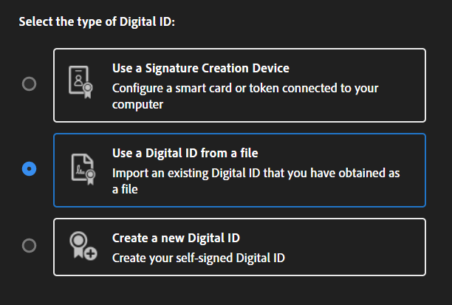
- Select following options and continue

- Browse and select file and enter same password used at time of creation –

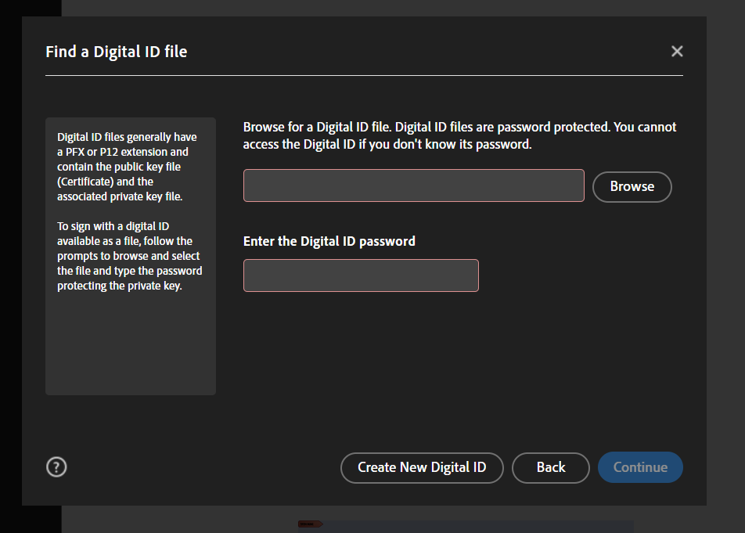
- Click continue until sign button appears and there also enter same password and sign in
- Now again reopen the pdf
- On top it should be like this
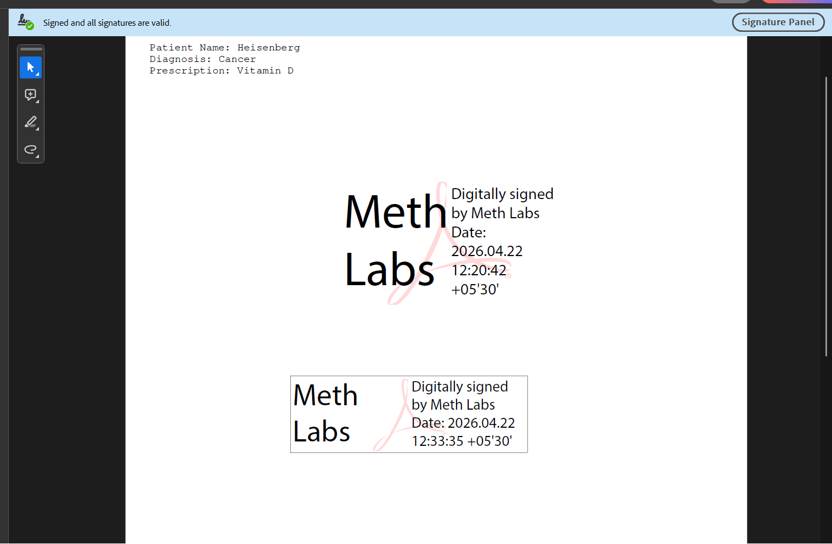

If not click on signature part on pdf –
And follow
If shows UNKNOWN → Fix it
- Click Show Signer’s Certificate
- Go to Trust tab
- Click Add to Trusted Certificates
- Tick all options
- OK
👉 Close and reopen PDF

