**Calculator – App – iOS**

**MAPD 714**

**Group 23**

**Assignment 1**

1. **Deep Harishkumar Mehta – 301212407**
2. **Khushboo Kodwani – 301273818**
3. **Parth Narharibhai Maru – 301209761**

**Github Repository Link:**

[**https://github.com/DeepMehta-2/Calcuator-App-iOS**](https://github.com/DeepMehta-2/Calcuator-App-iOS)

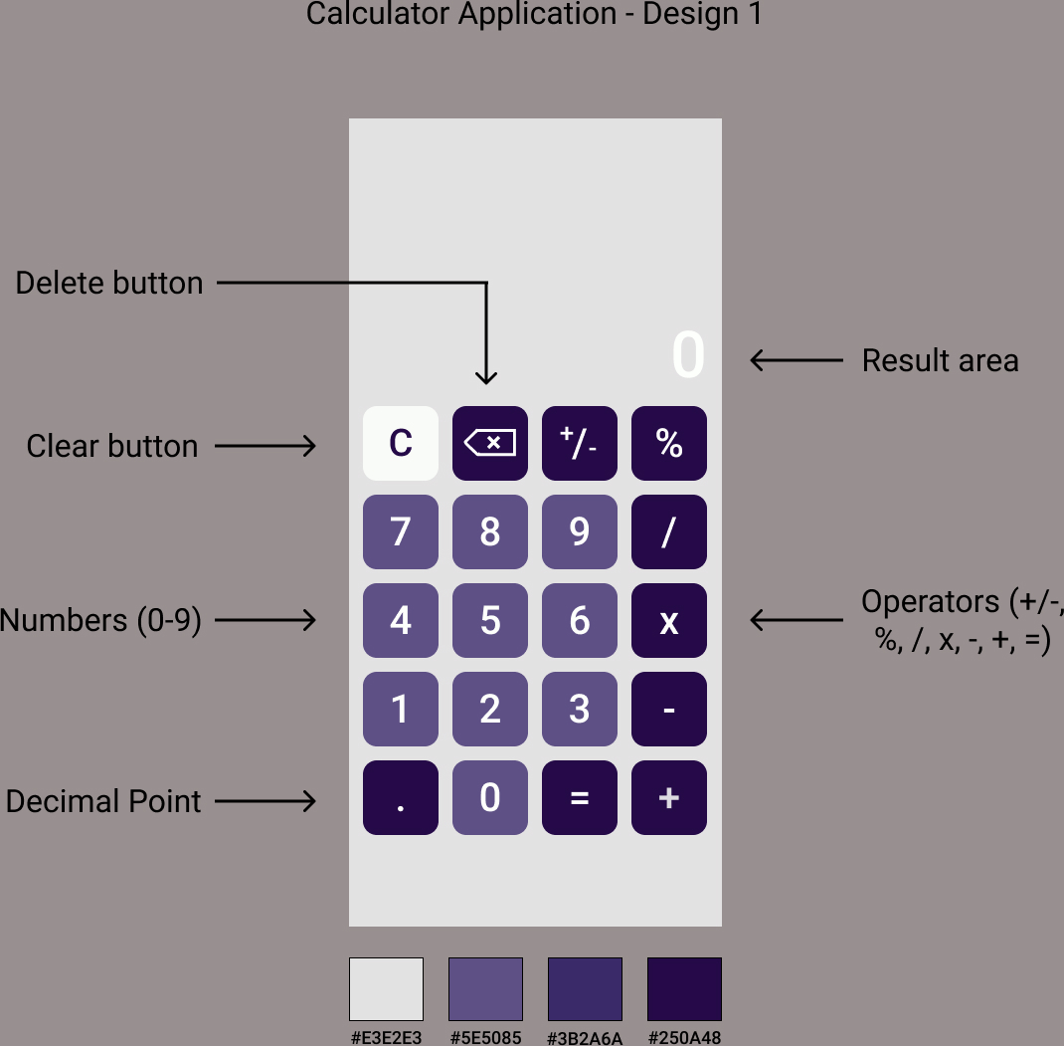

Design 1

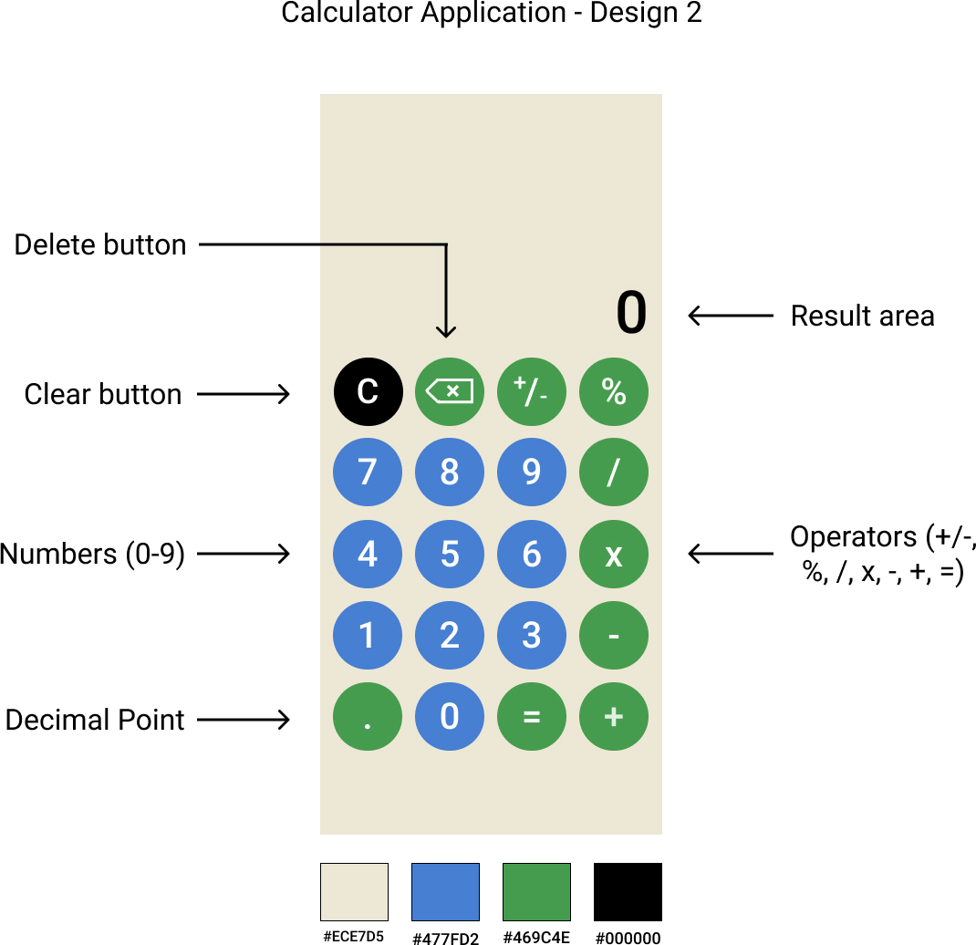

Design 2