
Container Orchestration & automation
Assignment-1

Submitted By: Parth Pachauri
Roll No: R2142220587
Batch: CCVT B7
SAP: 500107058

1. Introduction
The Bakery Management System is a web-based application designed to manage bakery orders, products, and their statuses. It consists of a React frontend for the user interface, a Flask backend for processing orders, and a PostgreSQL database for storing product and order data.
2. System Architecture Overview
The system follows a microservices architecture, comprising three major components:
- Frontend: A React-based user interface for interacting with the bakery.
- Backend: A Flask REST API that handles order creation, order status updates, and product management.
- Database: PostgreSQL stores product and order information.
The components communicate with each other using HTTP requests and responses. The frontend and backend run in Docker containers, allowing for efficient development, testing, and deployment.
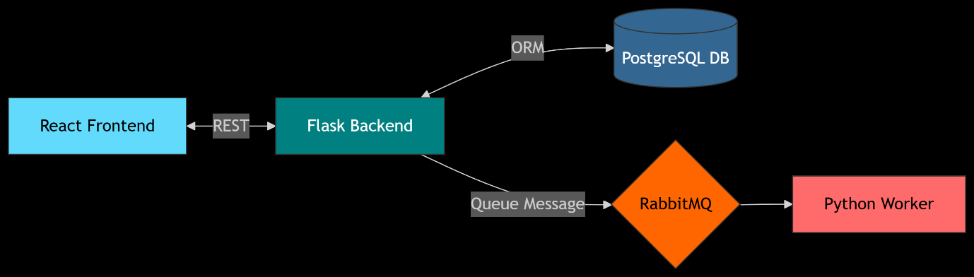
Technologies Used
- Frontend: React.js, React Router
- Backend: Flask
- Database: PostgreSQL
- Message Queue: RabbitMQ
- Containerization: Docker, Docker Compose
- API Testing: Postman or Insomnia (for manual testing)

Setup Instructions:-
Prerequisites
- Docker and Docker Compose installed on your machine.
Steps to Run the System
1. **Clone the repository**:
```bash
git clone https://github.com/your-username/bakery-management-system.git
cd bakery-management-system
```
2. **Build and start the containers**:
- Run the following command to build and start all services using Docker Compose:
```bash
docker-compose up --build
```
3. **Access the system**:
- **Frontend** will be available at `http://localhost:3000`
- **Admin Panel** will be accessible at `http://localhost:3000/admin`
- **Backend API** is accessible on port `5000`.
- **PostgreSQL Database** is accessible at `localhost:5433` with the credentials:
- `user: bakery_user`
- `password: bakery_pass`
- `database: bakery_db`
- **RabbitMQ** management interface is available at `http://localhost:15672` with the default username `guest` and password `guest`.
4. **Stop the system**:
- To stop all running containers, use the following command:
```bash
docker-compose down
```

API Documentation
Endpoints
1. GET /products
- **Description**: Fetch all available products.
- **Response**:
```json
[
{
"id": 1,
"name": "Croissant",
"price": 2.5
},
{
"id": 2,
"name": "Bagel",
"price": 1.8
}
]
```
2. POST /order
- **Description**: Place an order for a product.
- **Request Body**:
```json
{
"product_id": 1
}
```
- **Response**:
```json
{
"order_id": "abc123"
}
```
3. GET /order/{orderId}
- **Description**: Check the status of an order.
- **Response**:
```json
{
"status": "pending"
}
```
4. PUT /order/{orderId}
- **Description**: Update the status of an order (admin only).
- **Request Body**:
```json
{
"status": "completed"
}
```
- **Response**:
```json
{
"message": "Order status updated!"
}
```
5. POST /products
- **Description**: Add a new product (admin only).
- **Request Body**:
```json
{
"name": "Cupcake",
"price": 3.0
}
```
- **Response**:
```json
{
"message": "Product added!"
}
README.md:
# Bakery Management System
This is a Bakery Management System that allows customers to place orders and check the status of their orders. The system also provides an admin panel to manage the orders and update their statuses.
## System Architecture Overview
The system is built using the following technologies:
- **Frontend**: React.js
- **Backend**: Flask
- **Database**: PostgreSQL
- **Messaging**: RabbitMQ (for message queueing)
- **Containerization**: Docker
### Architecture Components
1. **Frontend**:
- The React-based frontend provides an interface where customers can view products, place orders, and check the status of their orders.
- The admin panel allows administrators to view and update the status of orders.
2. **Backend**:
- The Flask backend handles API requests from the frontend, processes the order information, and interacts with the database to store and retrieve order details.
- It communicates with RabbitMQ for any event-driven updates or processes that require message queuing.
3. **Database**:
- PostgreSQL is used for data storage, including products, orders, and their statuses.
- Docker volumes are used to persist the database data between container restarts.
4. **RabbitMQ**:
- RabbitMQ is used to handle communication for background tasks such as order status updates or other asynchronous tasks.
5. **Docker**:
- The system is containerized using Docker for easy deployment and scaling. Each component (frontend, backend, database, RabbitMQ) runs in its own container.
OUTPUT SCREENSHOTS:
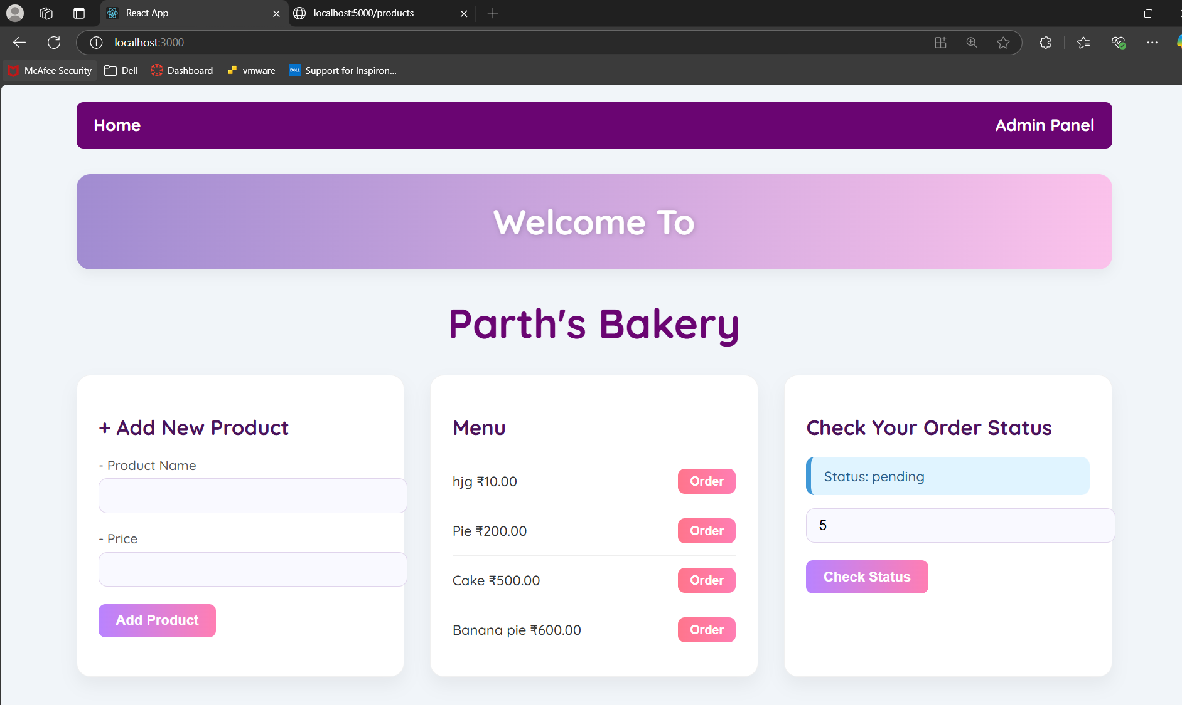
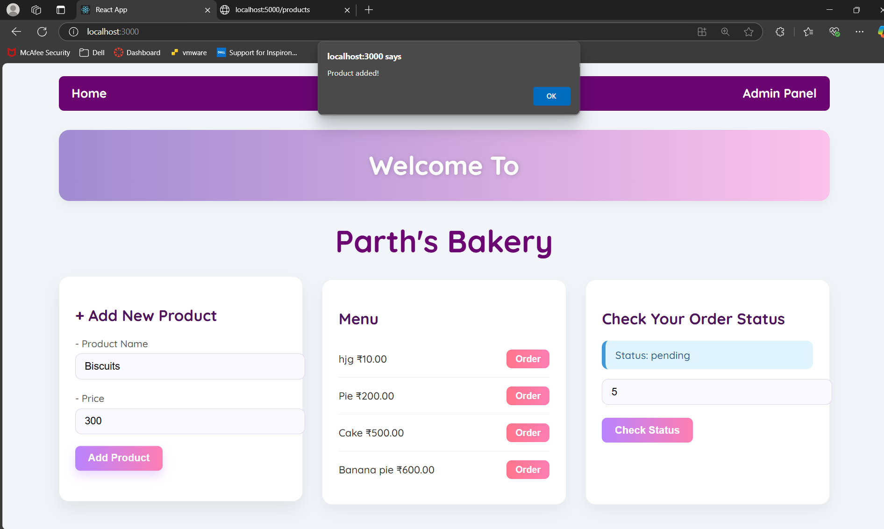
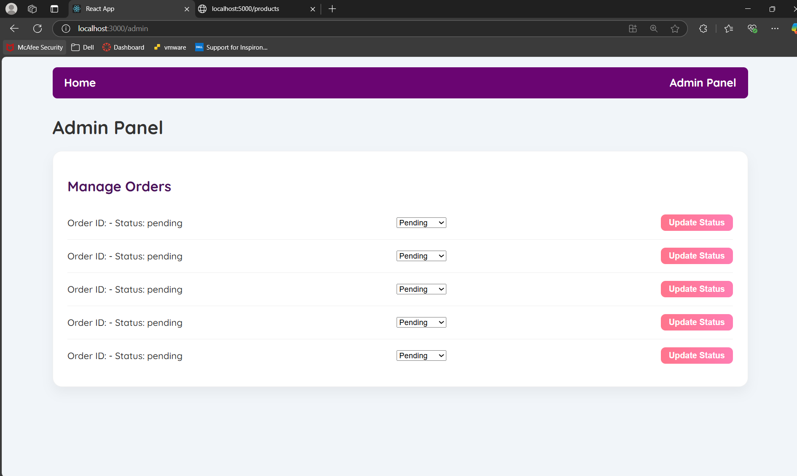

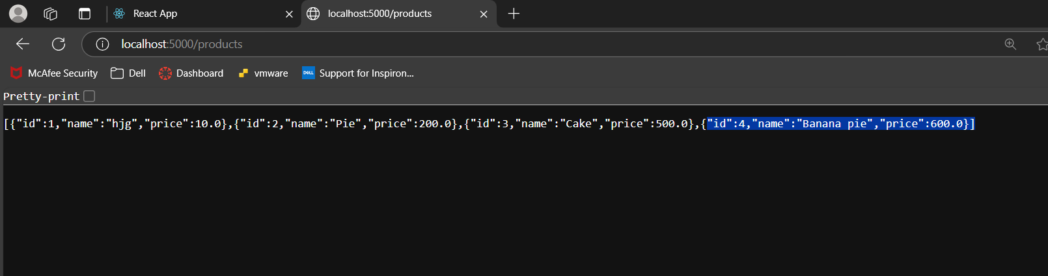
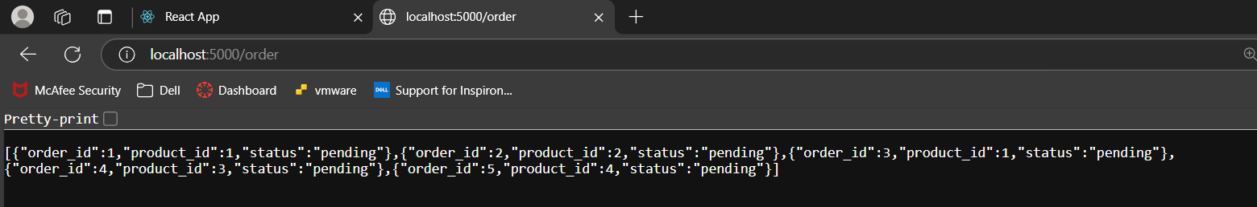
Video Link: https://drive.google.com/file/d/1sFns7OLsgRu0q698zOX4NbFRmqvhw9Uu/view?usp=sharing

