Email Spam Detection Using Multinomial Naive Bayes with Log Transform, Chi-Square Feature Selection and Threshold Tuning
Parth Sidhapura, Vansh Patel and Riya Lakhani

Abstract— Spam email wastes user time and is a common carrier of phishing and fraud. Naive Bayes is the classic spam filter because it is fast and interpretable, but its standard Multinomial form performs poorly on the skewed word-frequency features found in real email data. This paper improves Multinomial Naive Bayes (MNB) with three simple, low-cost steps: a log(1 + x) transform, chi-square feature selection, and a decision threshold tuned by cross-validation. Six hand-engineered features are also evaluated. Experiments use the UCI Spambase dataset (4,601 emails, 57 features); after removing 391 duplicates, the data is split 80:20 into 3,368 training and 842 test emails. The model is compared with Gaussian NB, Bernoulli NB, Logistic Regression, Decision Tree, K-Nearest Neighbors, Support Vector Machine and Random Forest using accuracy, precision, recall, F1-score, AUC-ROC, average precision and training time. Step by step, accuracy rises from 78.9% (plain MNB) to 88.5% (log transform), 90.3% (top-20 chi-square features) and 91.7% (threshold 0.6), and F1 rises from 0.721 to 0.898. The final model uses only 20 of the 57 features, halves the false positives of the log-only model (84 to 41), trains in about 3 ms, and outperforms Bernoulli NB, Decision Tree and KNN in both accuracy and F1. Random Forest remains the most accurate model (94.5%) but trains about 140 times slower. The results show that careful preprocessing lets a very light, explainable model approach the performance of much heavier classifiers.
Index Terms— spam detection, Naive Bayes, feature selection, chi-square, threshold tuning, text classification, machine learning.

I. Introduction

A. Background
Email remains one of the most widely used communication tools for students, companies and governments. A large share of email traffic is spam: advertisements, fake offers, chain letters and phishing messages that try to steal passwords or money [1]. Manually deleting spam wastes time, and a single phishing click can compromise an entire organization.
Early spam filters used hand-written rules, such as blocking messages containing certain words. Spammers quickly learned to bypass fixed rules, so filters moved to machine learning (ML), where a model learns the patterns of spam and legitimate mail (ham) automatically from labelled examples [2], [3]. Today almost every email provider relies on some form of ML-based filtering.

B. Literature Gap
Naive Bayes (NB) is the most widely taught spam filter, yet several gaps remain:
- Sensitivity to feature distribution. Multinomial NB assumes count-like features. The features of the Spambase dataset [4] are extremely skewed (average skewness 11.2), and plain MNB reaches only 78.9% accuracy.
- Unquestioned defaults. Most studies use all available features and the default 0.5 probability cut-off, without checking whether removing weak features or moving the cut-off helps.
- Cost of accurate models. SVM and Random Forest are more accurate but train 100 to 300 times slower than NB, and their decisions are harder to explain.
- Incomplete evaluation. Many reports give only accuracy, without recall, false positives, cross-validation or training time.

C. Proposed Solution
We keep Naive Bayes and correct its weak points with three inexpensive steps, each tuned using only the training data: (i) a log(1 + x) transform that compresses very large values so that no feature dominates; (ii) chi-square feature selection that keeps only the features most related to the label; and (iii) threshold tuning that moves the spam cut-off from 0.5 to the value with the best cross-validated F1-score. We also engineer six new features and test whether they help. The final model remains as fast and interpretable as standard Naive Bayes.

D. Contributions
- A complete, reproducible Python pipeline with 24 analysis plots, from data cleaning and exploratory analysis to final evaluation, on UCI Spambase.
- An improved Multinomial NB model that reaches 91.7% accuracy and 0.898 F1-score on a held-out test set of 842 emails, up from 78.9% and 0.721 for plain MNB.
- A step-by-step ablation that quantifies each improvement: +9.6 points from the log transform, +1.8 from feature selection and +1.4 from threshold tuning.
- A feature engineering study of six new features, showing that only a spam-word score helps, with an explanation of why.
- A fair comparison with seven other classifiers using test metrics, 5-fold cross-validation, precision-recall analysis and training time.

II. Related Work
Prior work on spam filtering falls into four groups: Naive Bayes filters, corrections to Naive Bayes, margin- and tree-based classifiers, and survey studies. Our work belongs to the first two groups.

A. Naive Bayes Spam Filters
Sahami et al. [5] were among the first to apply a Bayesian classifier to junk email and showed that it could learn spam patterns automatically. Androutsopoulos et al. [6] evaluated Naive Bayes anti-spam filtering in detail and showed that false positives are more costly than missed spam, and that the probability threshold controls this trade-off. McCallum and Nigam [7] compared the Bernoulli and Multinomial event models and found the multinomial model better when word frequencies are available. Metsis et al. [8] compared five NB variants for spam and found that the variant and the feature representation strongly change performance.

B. Correcting Naive Bayes and Selecting Features
Rennie et al. [9] showed that raw term frequencies follow a heavy-tailed distribution that the multinomial model fits poorly, and proposed simple corrections, including a log transform of term frequencies, that make NB competitive with SVM while remaining much faster. Yang and Pedersen [10] compared feature selection methods for text categorization and found that the chi-square statistic can remove a large share of terms with little or no loss in accuracy.

C. Margin-Based and Tree-Based Classifiers
Drucker et al. [11] applied Support Vector Machines to spam categorization and found them more accurate than several alternatives, at a higher training cost. Carreras and Màrquez [12] used boosted decision trees for anti-spam filtering. Random Forest [13], an ensemble of decision trees, is now a strong baseline on tabular data such as Spambase.

D. Surveys
Surveys by Blanzieri and Bryl [14], Guzella and Caminhas [2] and Dada et al. [3] compare NB, SVM, KNN, decision trees, neural networks and ensembles. They consistently describe NB as the fastest and simplest option, and ensembles or SVMs as more accurate but more expensive. Table I summarizes these families.
TABLE I
Comparison of Supervised Approaches to Spam Filtering
Approach | Strength | Weakness
Naive Bayes [5]–[8] | Very fast, interpretable | Independence assumption; sensitive to feature distribution
Logistic Regression | Fast, probabilistic | Needs scaling; linear boundary
SVM [11] | High accuracy | Slow training; hard to interpret
Decision / boosted trees [12] | Readable rules | Overfits if deep
Random Forest [13] | Highest accuracy on tabular data | Heavy; less interpretable

E. Position of This Work
Most comparisons on Spambase use Gaussian NB on raw features with all 57 features and a 0.5 cut-off, which makes Naive Bayes look weak. Few studies combine the log correction of [9], chi-square selection [10] and threshold tuning [6] in one controlled pipeline, measure the gain of each step, and report recall, false positives and training time together. This paper fills that gap.

III. Proposed Method

A. System Overview
The proposed system is an eight-stage pipeline (Fig. 1). The three highlighted stages are our improvements over standard Naive Bayes; every choice inside them is made on the training set only.
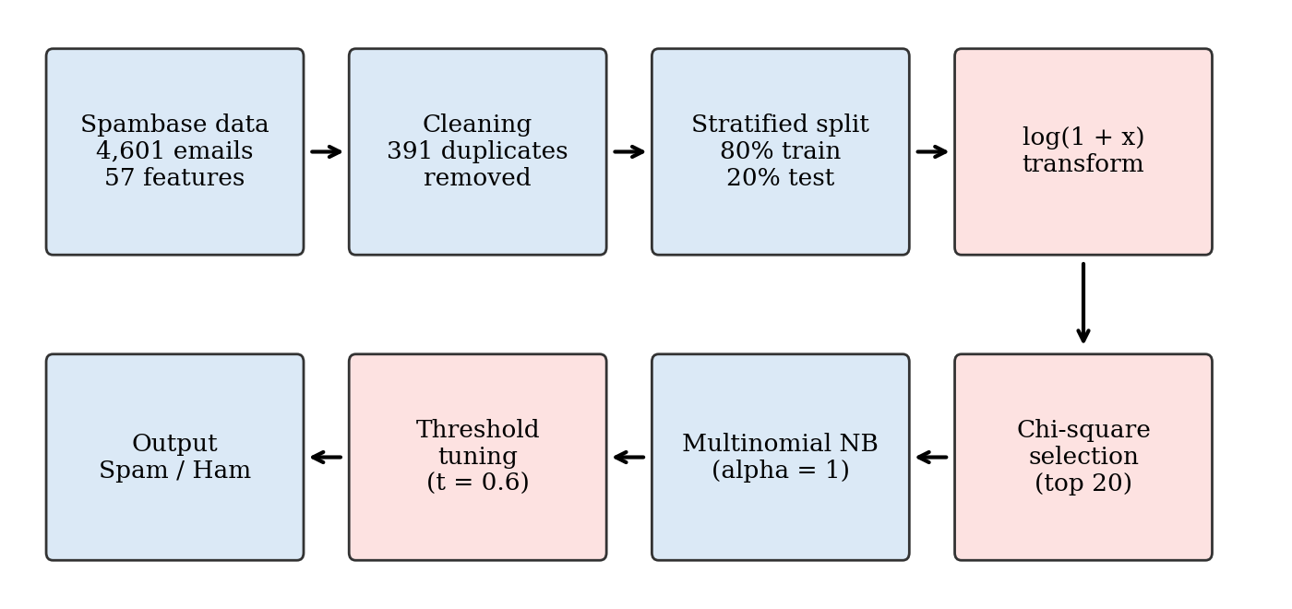
Fig. 1. Proposed spam detection pipeline. Red boxes are the improvement steps added to standard Multinomial Naive Bayes.

B. Mathematical Formulation
Problem: each email is a feature vector x = (x₁, …, x_{d}), and the goal is to predict its class y ∈ {0 = ham, 1 = spam}. By Bayes' theorem,
$P(c|x)=\frac{P(c) P(x|c)}{P(x)}$ (1)
Multinomial Naive Bayes: assuming features are independent given the class, the log-score of class c is
$score(c)=log P(c)+\sum_{i=1}^{d}{{x'}_{i} log θ_{ci}}$ (2)
where θ_{ci} is the probability of feature i in class c. With Laplace smoothing α, N_{ci} the sum of feature i over training emails of class c and N_{c} the sum of all features in class c,
$θ_{ci}=\frac{N_{ci}+α}{N_{c}+αd}$ (3)
Log transform: each raw value is replaced by
${x'}_{i}=log(1+x_{i})$ (4)
This keeps zero values at zero, preserves order and compresses large values; for example, the total capital-run length reaches 15,841 in the raw data but only about 9.7 after the transform.
Chi-square score: for feature i, O_{ci} is the observed sum of x'_{i} in class c and E_{ci} = P(c) × (total sum of x'_{i}) is the value expected if the feature were unrelated to the class:
${χ²}_{i}=\sum_{c∈\{0,1\}}{\frac{(O_{ci}−E_{ci})²}{E_{ci}}}$ (5)
The k features with the highest scores are kept.
Decision threshold: instead of the fixed value 0.5, an email is labelled spam when its spam probability reaches a threshold t:
$ŷ=1 if P(spam|x)≥t, otherwise ŷ=0$ (6)
t is searched from 0.30 to 0.95 in steps of 0.05 and set to the value with the highest F1-score in 5-fold cross-validation on the training set. Naive Bayes has no iterative optimizer or loss function; training is a single counting pass, which explains its speed.

C. Engineered Features
Six new features were created from the original columns using simple sums, counts and ratios (Table II).
TABLE II
Engineered Features
Feature | Definition
spam_score | Sum of 15 spam words (free, money, credit, 000, remove, $, !, your, business, …)
ham_score | Sum of 24 ham words (hp, hpl, george, 650, lab, meeting, edu, …)
total_word_freq | Sum of all 48 word features
total_char_freq | Sum of the 6 character features
nonzero_count | Number of the 54 word/character features above 0
capital_ratio | Longest capital run / average capital run

D. Algorithm
The complete training procedure is summarized below.
- Transform: X ← log(1 + X) for training and test emails.
- Compute the chi-square score of every feature on the training set.
- For k ∈ {5, 10, …, 57}, compute the 5-fold CV accuracy of MNB on the top-k features; set k* to the best k (k* = 20).
- Obtain 5-fold CV spam probabilities of MNB on the top-k* features.
- For t ∈ {0.30, 0.35, …, 0.95}, compute the CV F1-score; set t* to the best t (t* = 0.6).
- Train MNB (α = 1) on the top-k* features of the full training set.
- Label each test email spam if P(spam|x) ≥ t*, otherwise ham.

E. Implementation Details
All experiments were implemented in Python 3.12 with scikit-learn 1.8 [15], pandas 3.0, NumPy 2.4 and Matplotlib 3.10, in a Jupyter notebook, on a CPU-only machine without a GPU. Key settings are listed in Table III.
TABLE III
Implementation Settings
Item | Value
Final model | MultinomialNB(alpha = 1.0)
Features | Top 20 chi-square features of log(1 + x) data
Threshold | 0.6 (chosen by 5-fold CV F1)
Feature selection | SelectKBest(chi2); k from 5 to 57
Threshold search | cross_val_predict(cv = 5, predict_proba)
Split | 80:20, stratified, random_state = 42
Baseline scaling | StandardScaler (LR, KNN, SVM only)

IV. Experimental Setup

A. Dataset
We use the UCI Spambase dataset [4], collected at Hewlett-Packard Labs in 1999 and released under a CC BY 4.0 license. Each row is one email described by 48 word-frequency features (percentage of words matching a given word), 6 character-frequency features (; ( [ ! $ #), 3 capital-letter run-length features (average, longest and total), and a binary label (1 = spam).
Preprocessing: no missing values were found. We removed 391 duplicate rows so that the same email cannot appear in both training and test sets, avoiding data leakage. The remaining 4,210 emails were split with a stratified 80:20 split (Table IV). The log transform was applied for the NB models, and StandardScaler (fitted on training data only) for Logistic Regression, KNN and SVM. Feature selection and threshold tuning used the training set only; the test set was used once, for the final evaluation. Instead of a separate validation set, 5-fold cross-validation on the training set was used for all tuning.
TABLE IV
Data Splits
Set | Emails | Ham | Spam | Spam %
Original | 4,601 | 2,788 | 1,813 | 39.4
After de-duplication | 4,210 | 2,531 | 1,679 | 39.9
Training (80%) | 3,368 | 2,025 | 1,343 | 39.9
Test (20%) | 842 | 506 | 336 | 39.9

Exploratory analysis: the features most positively correlated with spam are your (0.38), 000 (0.33), remove (0.33) and $ (0.32); the most negatively correlated are hp (−0.26), hpl (−0.23) and george (−0.18), which come from the dataset creators' workplace (Fig. 2). The raw features are highly skewed (Fig. 3); the log transform reduces the average skewness of the 57 features from 11.2 to 5.2. The engineered features also separate the classes visibly (Fig. 4): spam has an average spam_score of 4.73 versus 0.90 for ham.
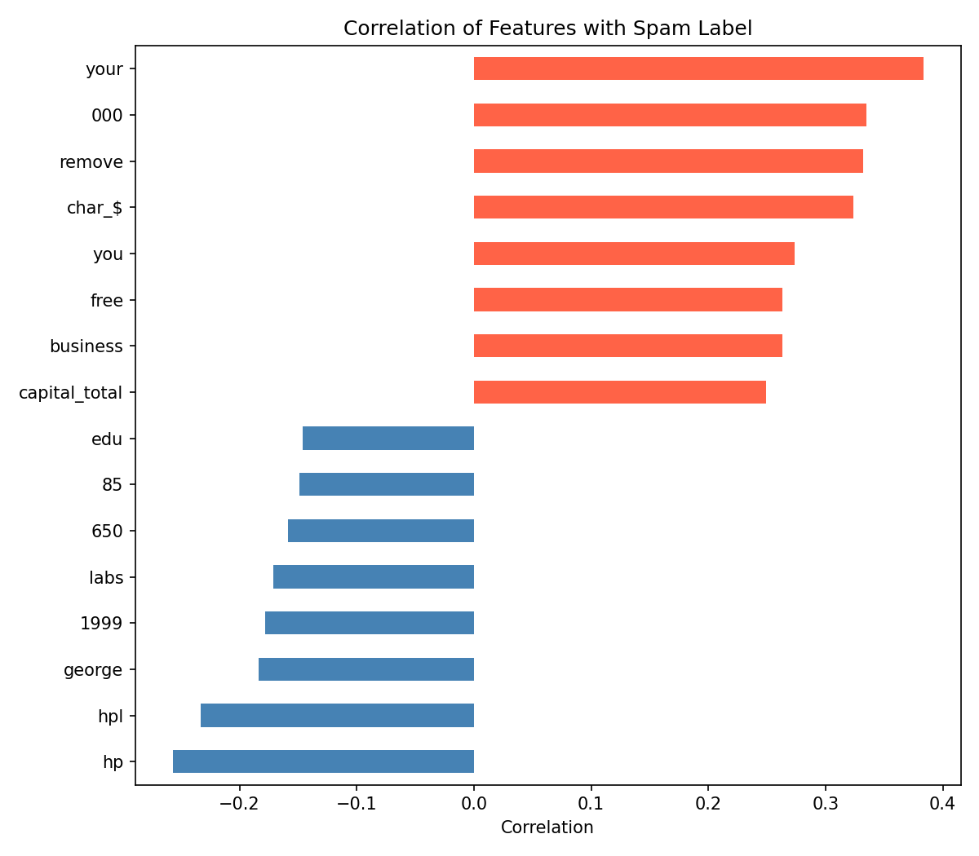
Fig. 2. The eight most negative (blue) and eight most positive (red) correlations between features and the spam label.
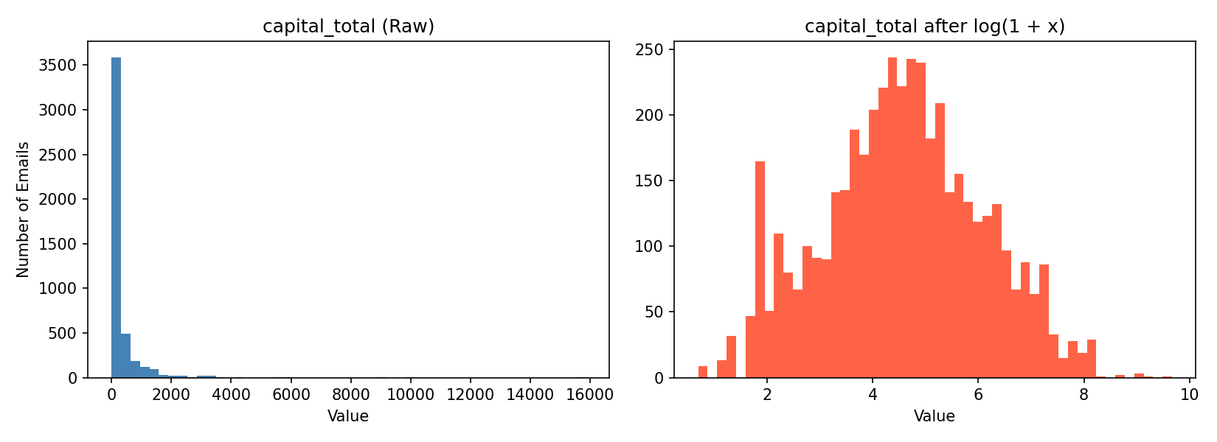
Fig. 3. Distribution of the total capital-run length before (left) and after (right) the log(1 + x) transform.
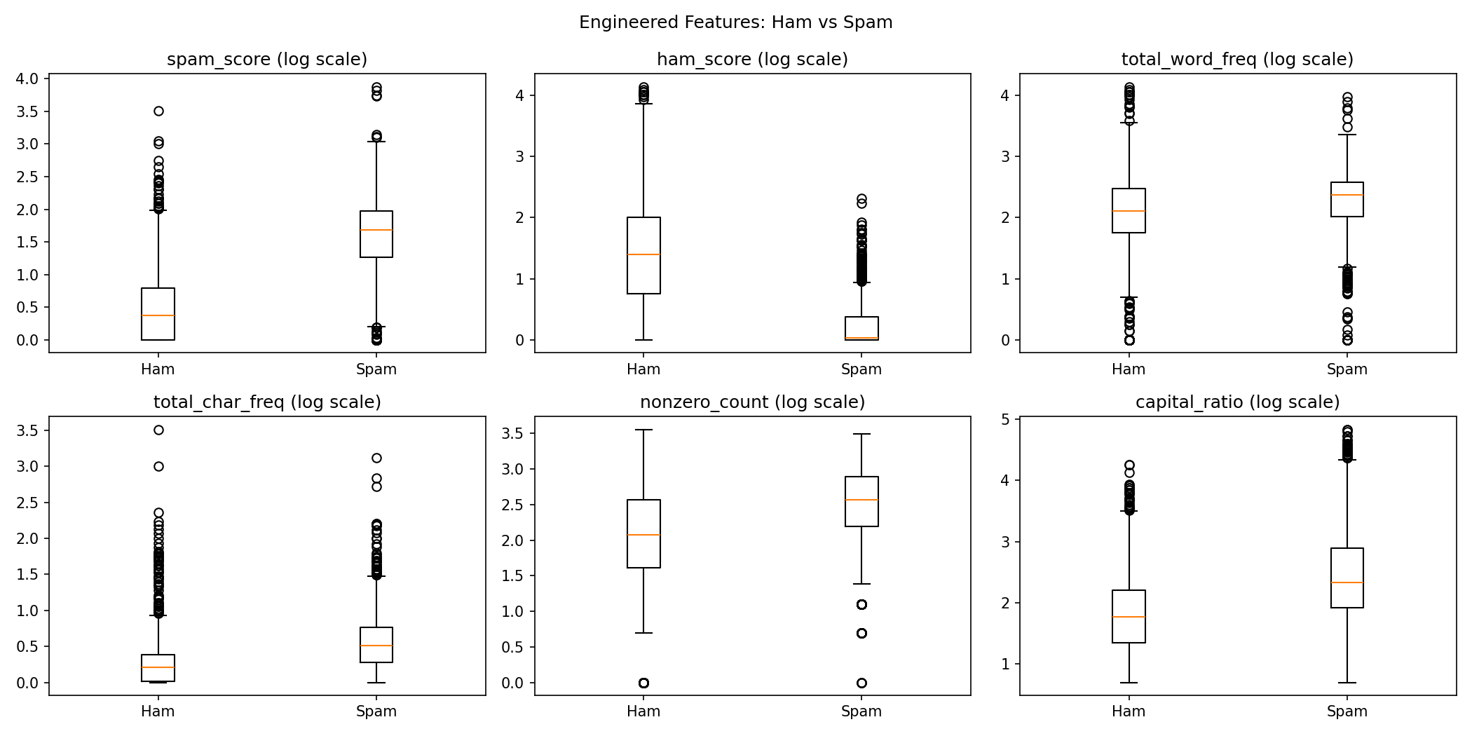
Fig. 4. Boxplots of the six engineered features for ham and spam emails (log scale).

B. Baseline Models
Seven baselines were trained on the same split with scikit-learn defaults unless stated: Gaussian NB and Bernoulli NB on raw features; Logistic Regression (max_iter = 1000), KNN (k = 5) and SVM (RBF kernel) on standardized features; Decision Tree (max depth 5) and Random Forest (100 trees) on raw features. MNB with the log transform alone (MNB + log) is also reported as an intermediate model.

C. Evaluation Metrics
Spam is the positive class. With TP, TN, FP and FN denoting true/false positives/negatives,
$Precision=\frac{TP}{TP+FP}, Recall=\frac{TP}{TP+FN}$ (7)
$F_{1}=\frac{2·Precision·Recall}{Precision+Recall}$ (8)
We also report accuracy, the area under the ROC curve (AUC-ROC), average precision (AP, the area under the precision-recall curve), training time in milliseconds, and 5-fold cross-validation accuracy on the training set.

V. Results

A. Quantitative Results
Table V compares all models on the 842 test emails. The final improved MNB reaches 91.7% accuracy and 0.898 F1-score, outperforming Bernoulli NB, Decision Tree and KNN in both metrics and coming within 1.6 points of SVM in accuracy. Random Forest obtains the best accuracy, precision, F1 and AUC, but trains about 140 times slower than the final model. MNB + log has the highest recall (96.1%) but low precision; the improvements trade a little recall for much higher precision.

TABLE V
Test-Set Performance and 5-Fold CV Accuracy of All Models (Best Values in Bold)
Model | Accuracy | Precision | Recall | F1-score | AUC-ROC | CV accuracy (± std) | Train time (ms)
Final improved MNB (ours) | 0.9169 | 0.8822 | 0.9137 | 0.8977 | 0.9704 | — | 3.4
MNB + log | 0.8848 | 0.7936 | 0.9613 | 0.8694 | 0.9757 | 0.8893 ± 0.0125 | 3.4
Gaussian NB | 0.8361 | 0.7240 | 0.9524 | 0.8226 | 0.9525 | 0.8263 ± 0.0102 | 5.2
Bernoulli NB | 0.8943 | 0.8777 | 0.8542 | 0.8658 | 0.9609 | 0.8866 ± 0.0062 | 5.7
Logistic Regression | 0.9347 | 0.9297 | 0.9048 | 0.9170 | 0.9768 | 0.9207 ± 0.0073 | 13.2
Decision Tree (depth 5) | 0.8990 | 0.9169 | 0.8214 | 0.8666 | 0.9141 | 0.9050 ± 0.0019 | 21.0
KNN (k = 5) | 0.9133 | 0.9148 | 0.8631 | 0.8882 | 0.9546 | 0.8949 ± 0.0061 | 1.7
SVM (RBF) | 0.9323 | 0.9319 | 0.8958 | 0.9135 | 0.9772 | 0.9252 ± 0.0090 | 1064.1
Random Forest (100 trees) | 0.9454 | 0.9367 | 0.9256 | 0.9311 | 0.9895 | 0.9454 ± 0.0015 | 462.5

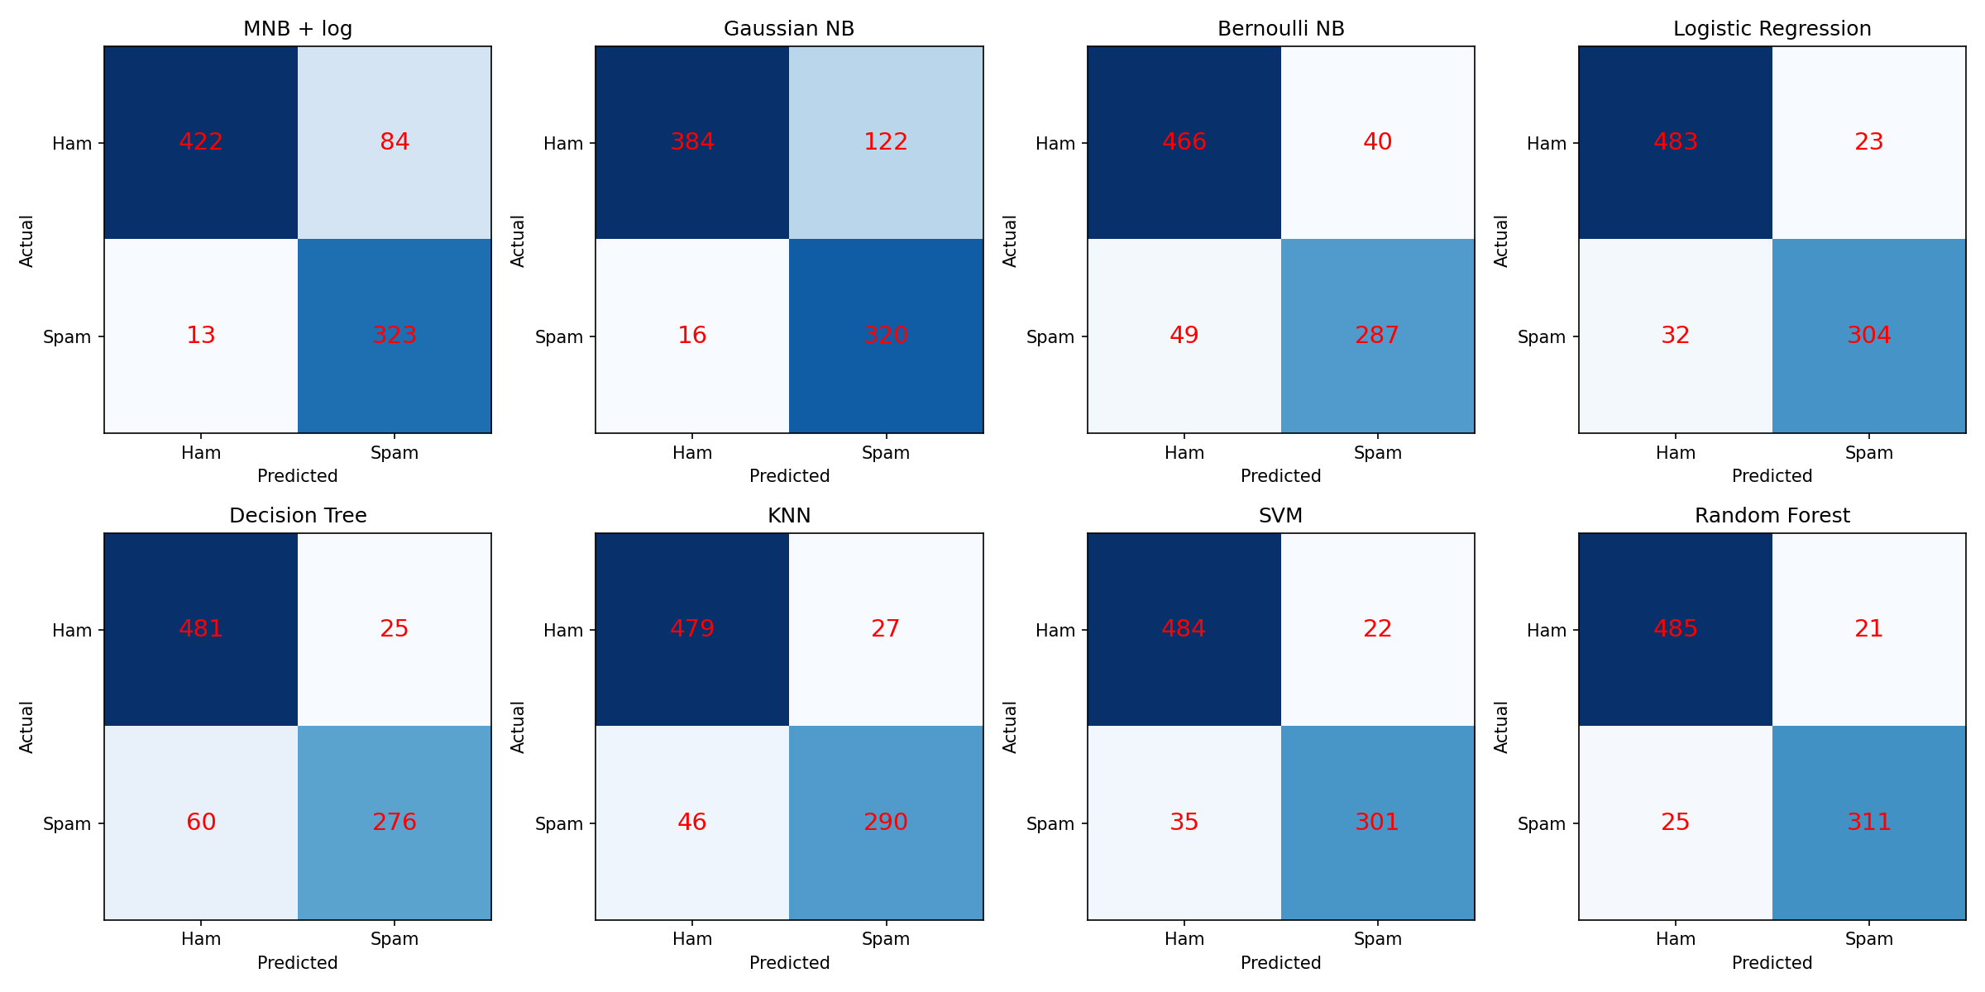
Fig. 5. Confusion matrices of the eight base models on the test set (rows: actual class; columns: predicted class).

Training times were measured on a CPU-only machine and vary slightly between runs; all other values are exactly reproducible with random_state = 42. Cross-validation accuracy ranks the models in the same order as the test set, and the low standard deviations (all ≤ 1.3%) indicate stable results. Fig. 6 summarizes accuracy and F1-score for all nine models.
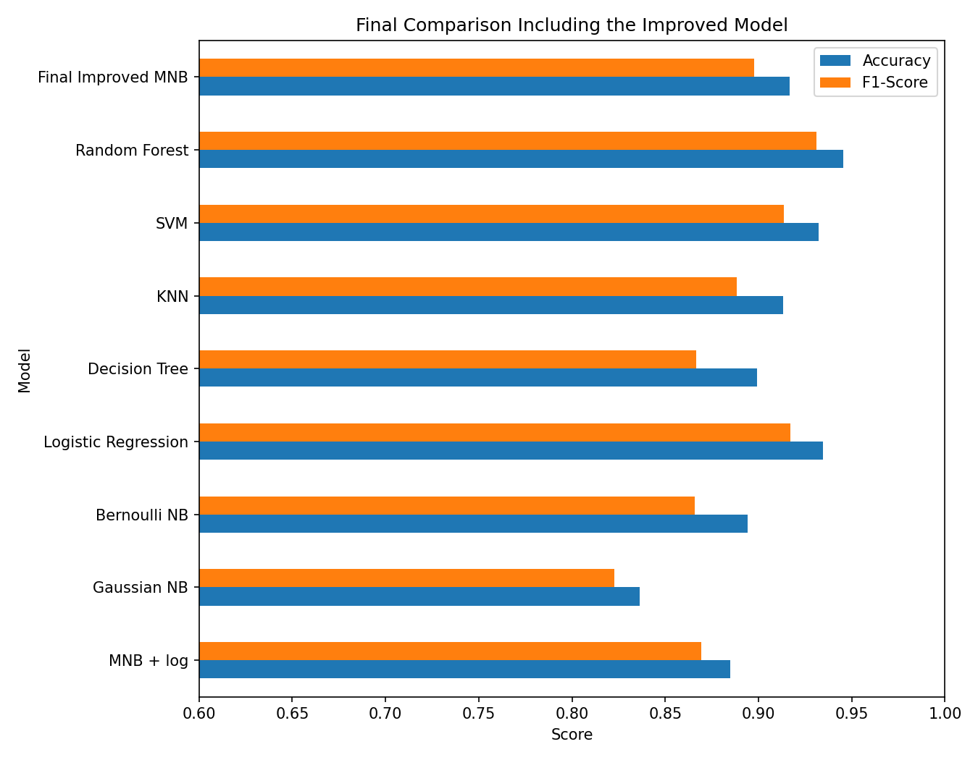
Fig. 6. Accuracy and F1-score of all nine models, including the final improved model.
ROC and precision-recall analysis: MNB + log has AUC 0.976, almost equal to Logistic Regression and SVM (0.977), and far above Gaussian NB (0.953) (Fig. 7). Its average precision is 0.967, higher than Logistic Regression (0.962) and SVM (0.960) and second only to Random Forest (0.984) (Fig. 8). MNB + log therefore ranks emails very well; its weakness at the default threshold lies in where the cut-off is placed, which motivates threshold tuning.
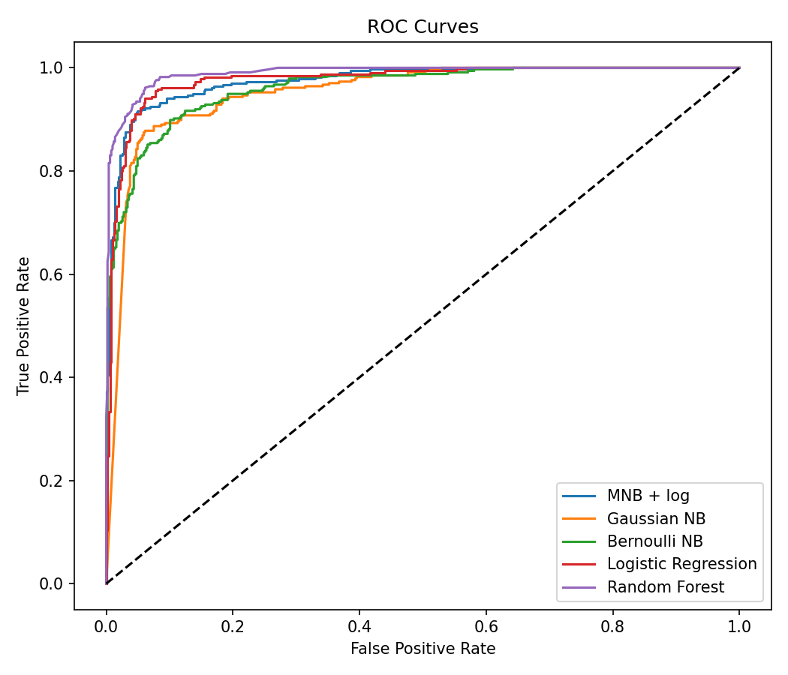
Fig. 7. ROC curves of five representative models.
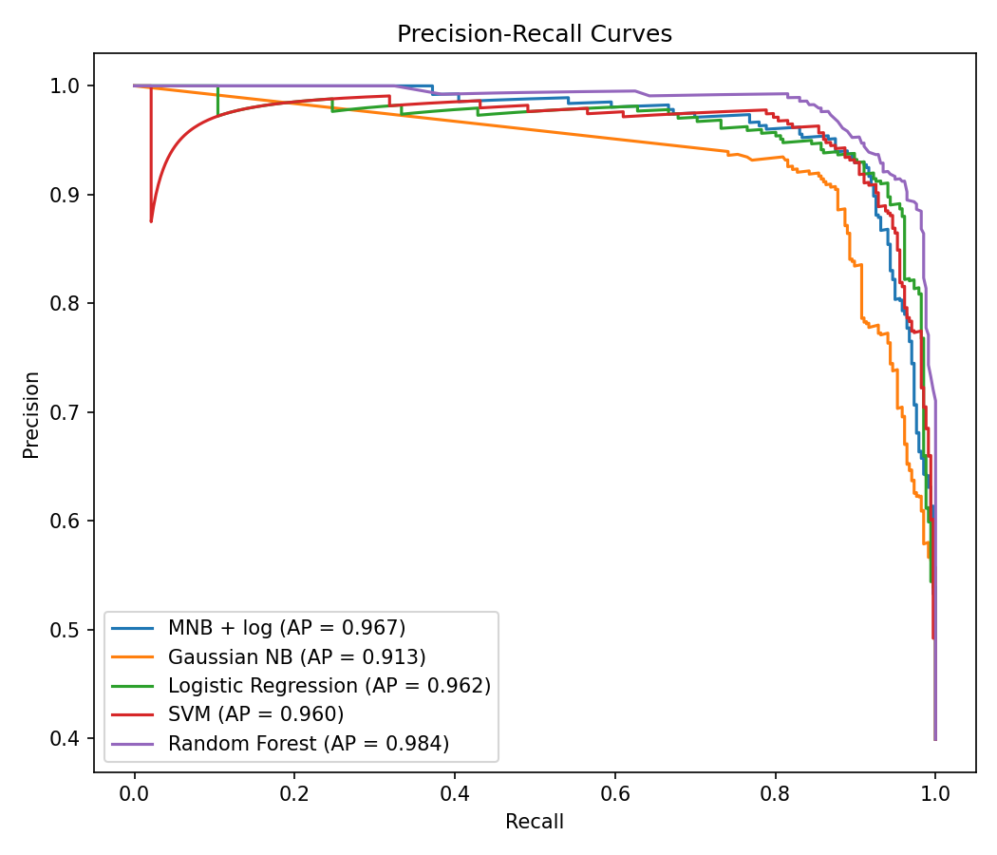
Fig. 8. Precision-recall curves and average precision (AP) of five representative models.

B. Qualitative Results
Fig. 5 shows the confusion matrices of the base models and Table VI lists their errors. Gaussian NB marks 122 legitimate emails as spam; MNB + log reduces this to 84 but still has the most false positives among the stronger models, whereas the tree and distance models make the opposite mistake (Decision Tree misses 60 spam emails). The final model reduces total errors from 97 to 70.
TABLE VI
Errors on the Test Set (506 Ham, 336 Spam)
Model | FP | FN | Total
MNB + log | 84 | 13 | 97
Final improved MNB | 41 | 29 | 70
Gaussian NB | 122 | 16 | 138
Bernoulli NB | 40 | 49 | 89
Logistic Regression | 23 | 32 | 55
Decision Tree | 25 | 60 | 85
KNN | 27 | 46 | 73
SVM | 22 | 35 | 57
Random Forest | 21 | 25 | 46

Most informative features: from the trained MNB + log model we computed log P(feature | spam) − log P(feature | ham) for each feature (Fig. 9). The strongest spam indicators are remove (+3.11), 000 (+2.91), credit (+2.49) and money (+2.29); the strongest ham indicators are george (−5.10), lab (−4.31), cs (−4.11) and hp (−3.72). Spam words relate to money, offers and mailing lists, while ham words come from the creators' workplace, names and phone codes. In sample predictions, emails containing "hp" receive P(spam) ≈ 0, whereas emails with "$", "!" and "money" receive P(spam) above 0.99.
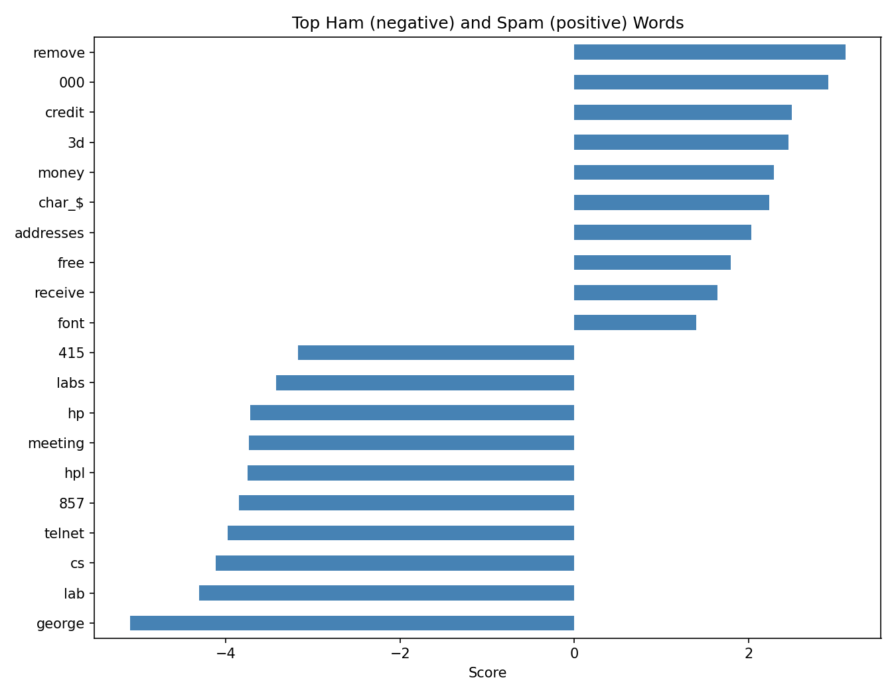
Fig. 9. Top ten ham indicators (negative score) and spam indicators (positive score) learned by MNB + log.

C. Step-by-Step Improvement
Each improvement step raises accuracy and F1-score (Table VII, Fig. 10). The log transform mainly fixes recall (68% to 96%); feature selection and threshold tuning then raise precision (79% to 88%). False positives fall from 84 to 41 (−51%) while missed spam rises only from 13 to 29 (Fig. 11).
TABLE VII
Effect of Each Improvement Step (Test Set)
Step | Acc. | Prec. | Rec. | F1
1. MNB, raw features | 0.7886 | 0.7616 | 0.6845 | 0.7210
2. + log(1 + x) | 0.8848 | 0.7936 | 0.9613 | 0.8694
3. + chi-square (top 20) | 0.9026 | 0.8256 | 0.9583 | 0.8871
4. + threshold 0.6 | 0.9169 | 0.8822 | 0.9137 | 0.8977

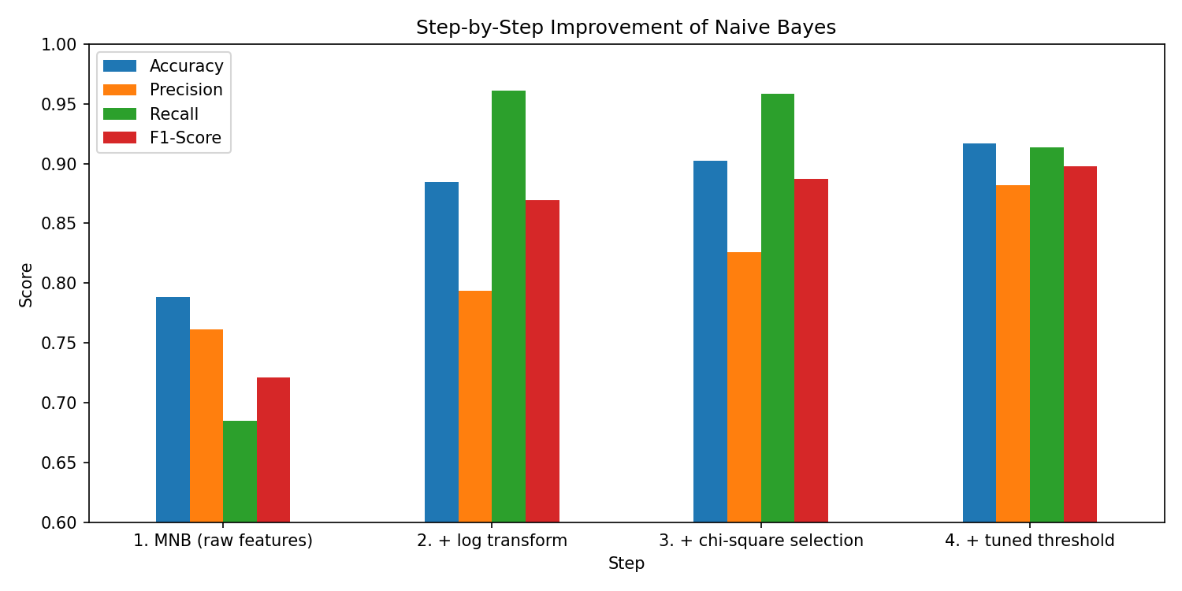
Fig. 10. Accuracy, precision, recall and F1-score after each improvement step.
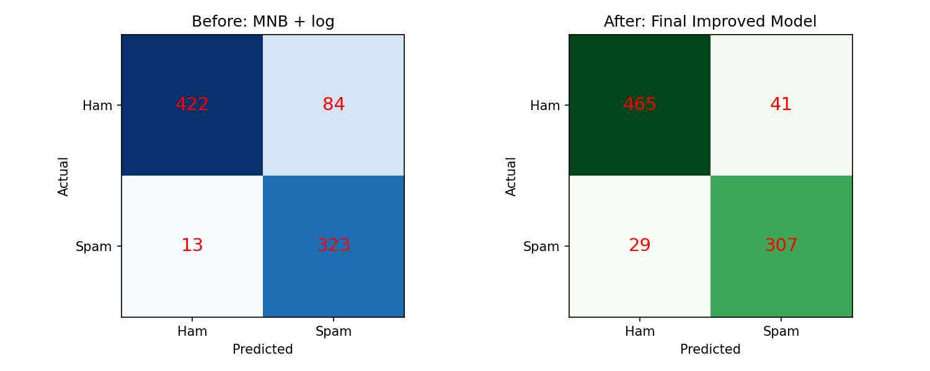
Fig. 11. Confusion matrices of MNB + log (left) and the final improved model (right).
Feature selection: the highest chi-square scores belong to hp (497), capital_longest (456), free (423), your (417), ! (345) and remove (336). Cross-validated accuracy rises quickly up to k = 20 and then declines slightly (Table VIII, Fig. 12), so the final model uses only 35% of the original features.
TABLE VIII
Number of Selected Features vs 5-Fold CV Accuracy
k | 5 | 10 | 15 | 20 | 25 | 30 | 40 | 57
CV acc. | 0.825 | 0.858 | 0.887 | 0.901 | 0.890 | 0.893 | 0.893 | 0.889

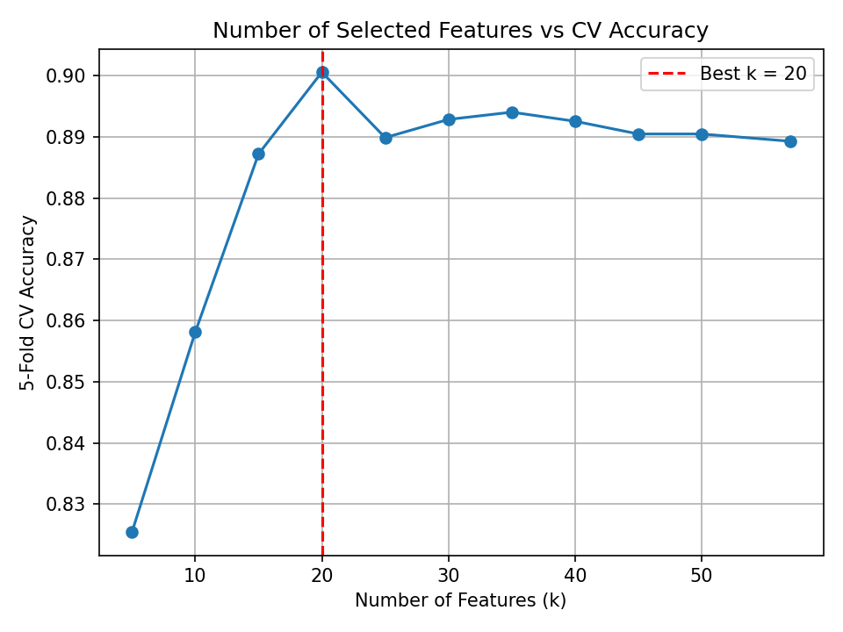
Fig. 12. 5-fold CV accuracy for different numbers of selected features; the best value is k = 20.
Threshold tuning: as the threshold increases, precision rises and recall falls (Fig. 13). Cross-validated F1 peaks at t = 0.6, where precision (0.890) and recall (0.898) are almost equal (Table IX).
TABLE IX
Threshold vs Cross-Validated Scores (Training Set)
Threshold | Precision | Recall | F1-score
0.40 | 0.764 | 0.950 | 0.847
0.50 (default) | 0.835 | 0.935 | 0.882
0.55 | 0.859 | 0.917 | 0.887
0.60 (chosen) | 0.890 | 0.898 | 0.894
0.65 | 0.907 | 0.879 | 0.893
0.70 | 0.925 | 0.852 | 0.887
0.80 | 0.941 | 0.777 | 0.852
0.90 | 0.967 | 0.637 | 0.768

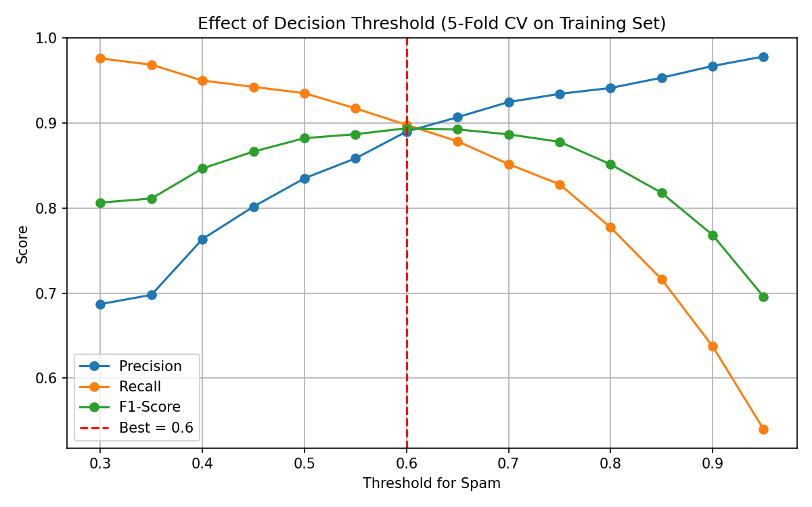
Fig. 13. Precision, recall and F1-score for thresholds from 0.30 to 0.95 (5-fold CV on the training set).

D. Feature Engineering Results
Only one of the six engineered features improved the model (Table X, Fig. 14). Adding spam_score raised CV accuracy from 0.889 to 0.893 and test accuracy from 0.885 to 0.898; adding ham_score, or all six features together, lowered accuracy. spam_score was not included in the final model because its gain was small and keeping only original features avoids a hand-made word list.
TABLE X
Effect of Engineered Features on MNB + log
Feature set | CV acc. | Test acc.
Original 57 features | 0.8893 | 0.8848
+ spam_score | 0.8934 | 0.8979
+ ham_score | 0.8723 | 0.8717
+ total_word_freq | 0.8907 | 0.8872
+ total_char_freq | 0.8901 | 0.8848
+ nonzero_count | 0.8896 | 0.8848
+ capital_ratio | 0.8890 | 0.8848
+ all 6 features | 0.8786 | 0.8812

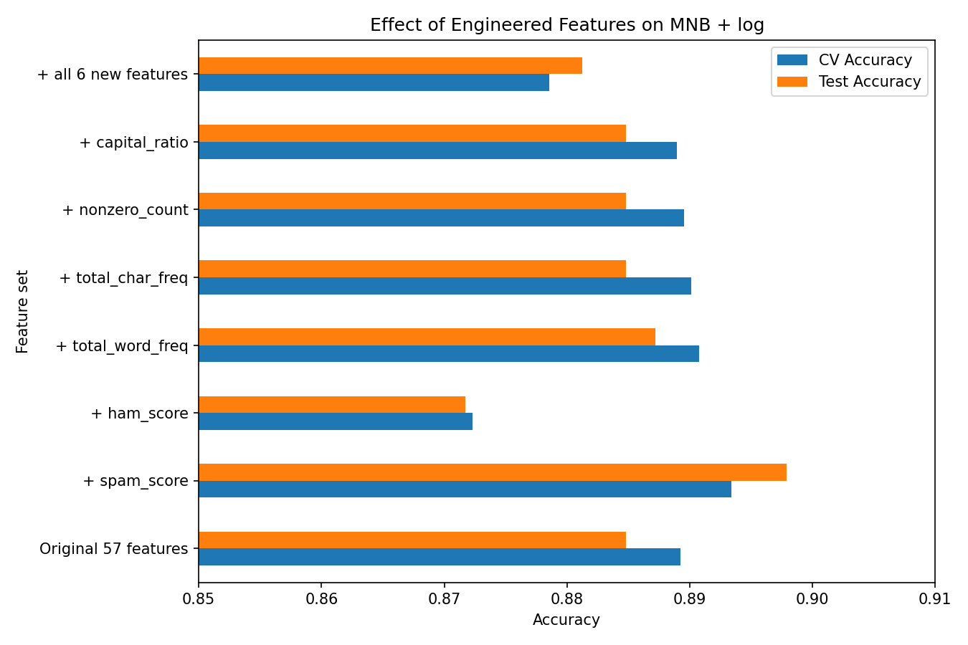
Fig. 14. CV and test accuracy of MNB + log when each engineered feature is added.

E. Ablation Study
Table XI removes or changes individual parts of MNB + log. The log transform is the single most important component (+9.6 accuracy points). With the same log features, Gaussian NB reaches only 84.2%, confirming that the multinomial model is the right NB variant. Word features carry most of the signal, while character or capital-letter features alone are weak. Smoothing barely matters: accuracy stays between 88.4% and 88.7% for α from 0.01 to 10 (Appendix). The learning curve (Fig. 15) shows that test accuracy is already 90.0% with only 336 training emails and 90.3% with all 3,368, and that training and test accuracy stay close, so the model does not overfit.
TABLE XI
Ablation of MNB + log (Test Set, Threshold 0.5)
Variant | Accuracy | F1-score
MNB without log transform | 0.7886 | 0.7210
MNB with log (57 features) | 0.8848 | 0.8694
Gaussian NB with log | 0.8420 | 0.8270
Only 48 word features | 0.8848 | 0.8677
Only 6 character features | 0.7435 | 0.5574
Only 3 capital features | 0.6033 | 0.0118
Without capital features (54) | 0.8848 | 0.8684

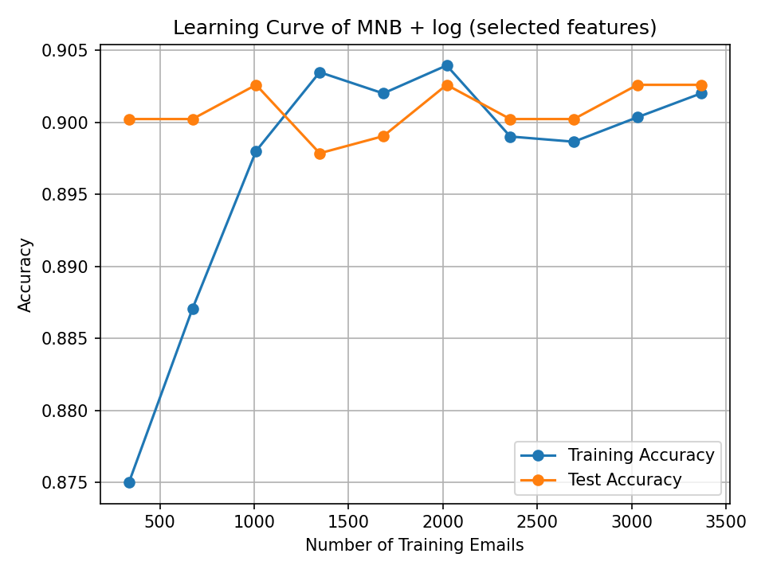
Fig. 15. Learning curve of MNB on the 20 selected log features (threshold 0.5).

VI. Discussion

A. Interpretation
Log transform. Multinomial NB sums x_{i} log θ_{ci} over all features. In the raw data, the capital-letter features reach hundreds or thousands while word frequencies are usually below 5, so they dominate the score and drown out the word evidence. After log(1 + x), all features lie on a similar scale and the discriminative words can influence the decision.
Feature selection. Naive Bayes counts every feature as independent evidence, including weak or noisy ones. Many of the 57 features (e.g., parts, table, 3d) are rare and nearly unrelated to the label; keeping only the 20 strongest removes this noise.
Threshold tuning. The ROC and precision-recall curves show that MNB + log already ranks emails well (AUC 0.976, AP 0.967). Because of the independence assumption, however, NB produces over-confident probabilities, and many ham emails receive P(spam) just above 0.5. Raising the cut-off to 0.6 moves these borderline emails back to ham and halves the false positives.
Engineered features. MNB already sums the evidence of every word, so a feature that is a sum of words largely repeats information the model has and counts it twice. spam_score helped slightly because it adds weight to a focused group of strong spam words; ham_score hurt because its words are already the strongest features, and double-counting them made the model over-confident toward ham.
Random Forest. Random Forest learns feature interactions and non-linear boundaries that NB cannot represent, which explains its higher accuracy at the cost of about 140 times longer training and less transparent decisions.

B. Comparison with Prior Work
The dataset documentation reports a typical misclassification error of about 7% [4]. Our Logistic Regression (93.5%), SVM (93.2%) and Random Forest (94.5%) agree with this figure, and the improved NB (91.7%) approaches it. The importance of the event model agrees with [7] and [8]. As in Rennie et al. [9], simple corrections bring NB close to SVM: MNB + log matches SVM in AUC (0.976 vs 0.977) and the final model is 1.5 points behind SVM in accuracy. Consistent with Yang and Pedersen [10], chi-square selection removed most features without loss; here, removing 65% of the features even improved accuracy. The precision-recall trade-off controlled by the threshold matches the observations of Androutsopoulos et al. [6].

C. Limitations
- The final model still flags 41 of 506 legitimate emails (8.1%) as spam, about twice as many as Random Forest.
- Threshold tuning trades recall for precision: missed spam rises from 13 to 29.
- Ham emails come from a single organization in 1999, so words such as "george", "hp" and "650" act as ham signals; the model would not transfer directly to a modern inbox.
- The 57 features are fixed, so new spam vocabulary cannot be learned, and the hand-made word lists for engineered features could bias that experiment.
- A spammer who avoids the listed words or inserts ham-like words can lower P(spam).
- With 842 test emails, differences below about one percentage point should not be over-interpreted.

D. Future Work
- Apply bag-of-words or TF-IDF features to raw text from a modern corpus such as Enron-Spam.
- Choose the threshold by minimizing a weighted cost (e.g., a false positive costing five times a missed spam) instead of maximizing F1.
- Evaluate Complement NB [9], which is designed for text classification.
- Build a two-stage filter that sends only uncertain emails (0.4 ≤ P(spam) ≤ 0.8) to Random Forest.
- Deploy the model in a lightweight web interface for interactive use.

VII. Conclusion
This paper presented an email spam detector for the UCI Spambase dataset based on Multinomial Naive Bayes, improved with three steps tuned on training data only: a log(1 + x) transform, chi-square selection of the top 20 features, and a decision threshold of 0.6. Together, these raised accuracy from 78.9% to 91.7% and F1-score from 0.721 to 0.898, and halved the false positives of the log-only model. The final model uses 20 of 57 features, trains in about 3 ms and outperforms Bernoulli NB, Decision Tree and KNN. Of six engineered features, only a spam-word score helped, and only slightly. Random Forest remains the most accurate model (94.5%); the improved NB is preferable when speed, simplicity and interpretability matter. The main takeaway is that understanding the data and tuning simple preprocessing steps can matter as much as choosing a more complex algorithm.

Appendix
Hyperparameter grid for α: test accuracy of MNB + log was 0.8872, 0.8860, 0.8848, 0.8848, 0.8848, 0.8836 and 0.8836 for α = 0.01, 0.1, 0.5, 1, 2, 5 and 10, respectively.
Code and data availability: the dataset is available from the UCI Machine Learning Repository (https://archive.ics.uci.edu/dataset/94/spambase). The complete source code (Jupyter notebook Email_Spam_Detection.ipynb), result tables and all 24 figures are provided with this submission.

Acknowledgment
The authors thank [faculty guide name], [Department], for guidance throughout this project.

References
[1] L. F. Cranor and B. A. LaMacchia, "Spam!," Commun. ACM, vol. 41, no. 8, pp. 74–83, 1998.
[2] T. S. Guzella and W. M. Caminhas, "A review of machine learning approaches to spam filtering," Expert Syst. Appl., vol. 36, no. 7, pp. 10206–10222, 2009.
[3] E. G. Dada, J. S. Bassi, H. Chiroma, S. M. Abdulhamid, A. O. Adetunmbi, and O. E. Ajibuwa, "Machine learning for email spam filtering: review, approaches and open research problems," Heliyon, vol. 5, no. 6, e01802, 2019.
[4] M. Hopkins, E. Reeber, G. Forman, and J. Suermondt, "Spambase," UCI Machine Learning Repository, 1999. [Online]. Available: https://doi.org/10.24432/C53G6X
[5] M. Sahami, S. Dumais, D. Heckerman, and E. Horvitz, "A Bayesian approach to filtering junk e-mail," in Proc. AAAI-98 Workshop on Learning for Text Categorization, Madison, WI, USA, 1998.
[6] I. Androutsopoulos, J. Koutsias, K. V. Chandrinos, G. Paliouras, and C. D. Spyropoulos, "An evaluation of naive Bayesian anti-spam filtering," in Proc. Workshop on Machine Learning in the New Information Age, 11th Eur. Conf. Machine Learning, Barcelona, Spain, 2000, pp. 9–17.
[7] A. McCallum and K. Nigam, "A comparison of event models for naive Bayes text classification," in Proc. AAAI-98 Workshop on Learning for Text Categorization, 1998, pp. 41–48.
[8] V. Metsis, I. Androutsopoulos, and G. Paliouras, "Spam filtering with naive Bayes – which naive Bayes?," in Proc. 3rd Conf. Email and Anti-Spam (CEAS), Mountain View, CA, USA, 2006.
[9] J. D. M. Rennie, L. Shih, J. Teevan, and D. R. Karger, "Tackling the poor assumptions of naive Bayes text classifiers," in Proc. 20th Int. Conf. Machine Learning (ICML), Washington, DC, USA, 2003, pp. 616–623.
[10] Y. Yang and J. O. Pedersen, "A comparative study on feature selection in text categorization," in Proc. 14th Int. Conf. Machine Learning (ICML), Nashville, TN, USA, 1997, pp. 412–420.
[11] H. Drucker, D. Wu, and V. N. Vapnik, "Support vector machines for spam categorization," IEEE Trans. Neural Netw., vol. 10, no. 5, pp. 1048–1054, 1999.
[12] X. Carreras and L. Màrquez, "Boosting trees for anti-spam email filtering," in Proc. Int. Conf. Recent Advances in Natural Language Processing (RANLP), Tzigov Chark, Bulgaria, 2001.
[13] L. Breiman, "Random forests," Mach. Learn., vol. 45, no. 1, pp. 5–32, 2001.
[14] E. Blanzieri and A. Bryl, "A survey of learning-based techniques of email spam filtering," Artif. Intell. Rev., vol. 29, no. 1, pp. 63–92, 2008.
[15] F. Pedregosa et al., "Scikit-learn: Machine learning in Python," J. Mach. Learn. Res., vol. 12, pp. 2825–2830, 2011.

P. Sidhapura, V. Patel and R. Lakhani are with the [Department of Computer Science and Engineering], [Institute Name], [City], India (e-mail: [parth@example.com]; [vansh@example.com]; [riya@example.com]).

