Developer Onboarding Handbook (Expanded Edition)

1. Introduction

2. System Requirements
Install the following:
- Java 17 (core runtime)
- Maven 3.8+ (build tool)
- Git (version control)
- IntelliJ IDEA (recommended IDE)

3. Architecture Overview
The architecture uses a clean layered pattern:
- Controller (HTTP entry point)
- Service (business logic)
- Repository (data persistence)
- DTOs (input/output mapping)
- Validation (@Valid + constraints)
- Contract definitions (Spring Cloud Contract)
- Error handling (GlobalExceptionHandler)
This separation ensures maintainability and testability.

4. Project Structure Deep Dive
src/main/java:
- controller: REST endpoints
- service: business rules, validations
- repository: JPA interfaces
- model: Entity classes for DB
- dto: Request objects with validation
- exception: Global exception mapping
src/test/java:
- unit tests: isolated service tests
- controller tests: MockMvc + validation
- integration tests: H2 full-stack tests
- contract tests: auto-generated SCC tests

5. Frameworks & Libraries
Spring Boot powers the application.
Key libraries:
- Spring Web: REST layer
- Spring Data JPA: Persistence
- Spring Validation: Input validation
- Spring Cloud Contract: API compatibility enforcement
- Mockito + JUnit: Testing stack
- H2 DB: Lightweight test DB

6. Dependency Breakdown
Dependencies include:
- spring-boot-starter-web → REST
- spring-boot-starter-data-jpa → DB access
- spring-boot-starter-validation → validation engine
- spring-boot-starter-test → all test utilities
- mockito-core → mocking framework
- h2 → test DB
- spring-cloud-starter-contract-verifier → contract tests
- jacoco-maven-plugin → coverage
- sonar-maven-plugin → static analysis

7. Running the Application
Launch using:
mvn spring-boot:run
OR run the DemoApplication class in your IDE.
Default port: 8080
Health check: http://localhost:8080/actuator/health

8. Environment Setup
Ensure JAVA_HOME is set.
Install SonarQube (optional):
docker run -d -p 9000:9000 sonarqube
Run analysis after full verify:
mvn clean verify sonar:sonar

9. DTO and Validation Overview
DTOs prevent exposing entity models.
Validation examples:
@NotBlank → ensures non-empty strings
@Email → ensures valid email structure
@Valid → enforces nested validations
Validation happens BEFORE service layer.

10. Controller Layer Deep Dive
Controller tasks:
- Receive requests
- Validate DTOs
- Map to service-layer objects
- Return proper response status
- Avoid business logic
Responses use ResponseEntity.
Errors resolved via GlobalExceptionHandler.

11. Service Layer Deep Dive
Service responsibilities:
- Validate business rules
- Prevent duplicates
- Ensure domain correctness
- Call repository layer
This is the core logic layer. All unit tests focus here.

12. Repository Layer Deep Dive
Uses JPARepository:
- findByEmail()
- save()
- findById()
Spring Data generates implementations automatically.
H2 database used during testing.

13. Exception Handling Strategy
GlobalExceptionHandler maps:
- IllegalArgumentException → 400 or 409
- Validation exceptions → 400
- Malformed JSON → 400
- Unsupported media → 415
This ensures consistent API behavior.

14. Testing Strategy
Testing layers:
- Unit tests → service logic
- Controller tests → HTTP/JSON
- Integration tests → end-to-end stack
- Contract tests → enforce API compatibility
- Negative tests → invalid inputs, malformed payloads

15. Unit Testing Deep Dive
Tools: Mockito + JUnit
Unit tests mock repositories.
Test scenarios:
- duplicate email
- null inputs
- blank fields
- unknown IDs
Goal: verify logic, not Spring behaviors.

16. Controller Testing Deep Dive
Tools: @WebMvcTest + MockMvc
Tests simulate HTTP traffic.
Checks:
- JSON bodies
- HTTP codes
- validation failures
- malformed payloads
Goal: Validate request/response mapping
No DB interaction; service mocked.

17. Integration Testing Deep Dive
Tools: @SpringBootTest + MockMvc + H2
Includes:
- real repository
- real DB writes
- real serialization
Goal: Validates system-wide consistency.

18. Contract Testing Deep Dive
Spring Cloud Contract uses Java DSL.
Build step generates verifier tests.
If API deviates → build fails.
Spring Cloud Contract enforces API correctness.

19. Negative Testing Strategy
Negative tests verify robustness:
- Missing fields → 400
- Malformed JSON → 400
- Invalid ID → 404
- Empty request body → 400

20. Code Quality & SonarQube
Sonar enforces:
- Coverage > 80%
- No critical vulnerabilities
- Low code smell density
- Stable maintainability
Uses JaCoCo report: target/site/jacoco/jacoco.xml

21. Test Coverage Report
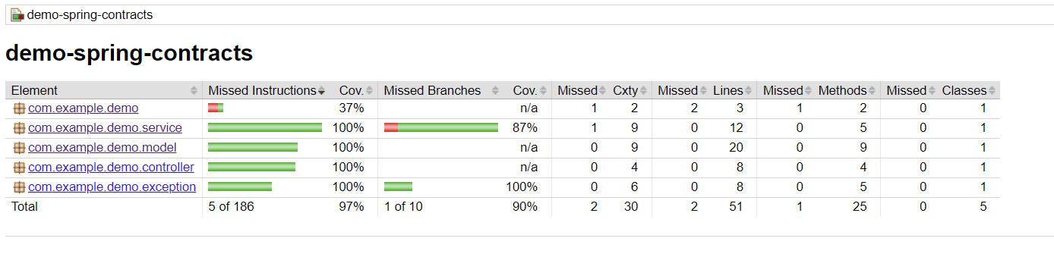

22. SonarQube Setup on Windows
Follow these exact steps to set up SonarQube locally for development and POCs.
1. Download SonarQube:
https://www.sonarsource.com/products/sonarqube/downloads/
Use Community Edition ZIP.
2. Extract SonarQube:
Extract to: C:\sonarqube
3. Start SonarQube:
Navigate to:
C:\sonarqube\bin\windows-x86-64
Run: StartSonar.bat
Keep the terminal open.
4. Access Dashboard:
Go to http://localhost:9000
Login: admin / admin (change password)
5. Generate Token:
User → My Account → Security → Create Project → Generate Token
6. Run Maven Scan:
mvn clean verify sonar:sonar
-Dsonar.host.url=http://localhost:9000
-Dsonar.login=<TOKEN>
7. Verify Results:
Check dashboard for:
- Coverage
- Bugs
- Code smells
- Quality Gate status

22. Reference Links
Spring Boot: https://spring.io/projects/spring-boot
Spring Contract: https://spring.io/projects/spring-cloud-contract
Mockito: https://site.mockito.org/
SonarQube: https://sonarqube.org
REST Standards: https://restfulapi.net
Spring Boot Reference: https://docs.spring.io/spring-boot/docs/current/reference/html/
Spring Validation: https://docs.spring.io/spring-framework/reference/core/validation/
Spring Testing Docs: https://docs.spring.io/springboot/docs/current/reference/htmlsingle/#features.testing
JUnit 5 User Guide: https://junit.org/junit5/docs/current/user-guide/
SonarQube Docs: https://docs.sonarsource.com/sonarqube/latest/

