POC: Spring Boot Actuator + SLF4J Logging + GitHub CI/CD Setup
This Proof of Concept (POC) provides a complete starter guide to make Spring Boot applications production-ready. It covers:
- Observability using Actuator
- Logging using SLF4J + Logback
- Automation using GitHub CI/CD
- Example dashboards and pipeline diagrams
- A reference section for deeper learning

1. Project Overview
Tech stack used:
- Java 17
- Spring Boot 3.x
- Maven
- GitHub Actions
- SLF4J + Logback
- Actuator
Outcome:
A fully instrumented, observable application with automated build + test pipelines.

2. Enabling Actuator Endpoints

Step 1 — Add Actuator dependency
<dependency>
<groupId>org.springframework.boot</groupId>
<artifactId>spring-boot-starter-actuator</artifactId>
</dependency>

Step 2 — Configure endpoints in application.yml
management:
endpoints:
web:
exposure:
include: "health,info,metrics,loggers,threaddump"
endpoint:
health:
show-details: always

Step 3 — Test endpoints
Run app:
mvn spring-boot:run
Check:
- /actuator/health
- /actuator/info
- /actuator/metrics

3. Monitoring Dashboard Example
Typical Grafana dashboard for Spring Boot metrics:
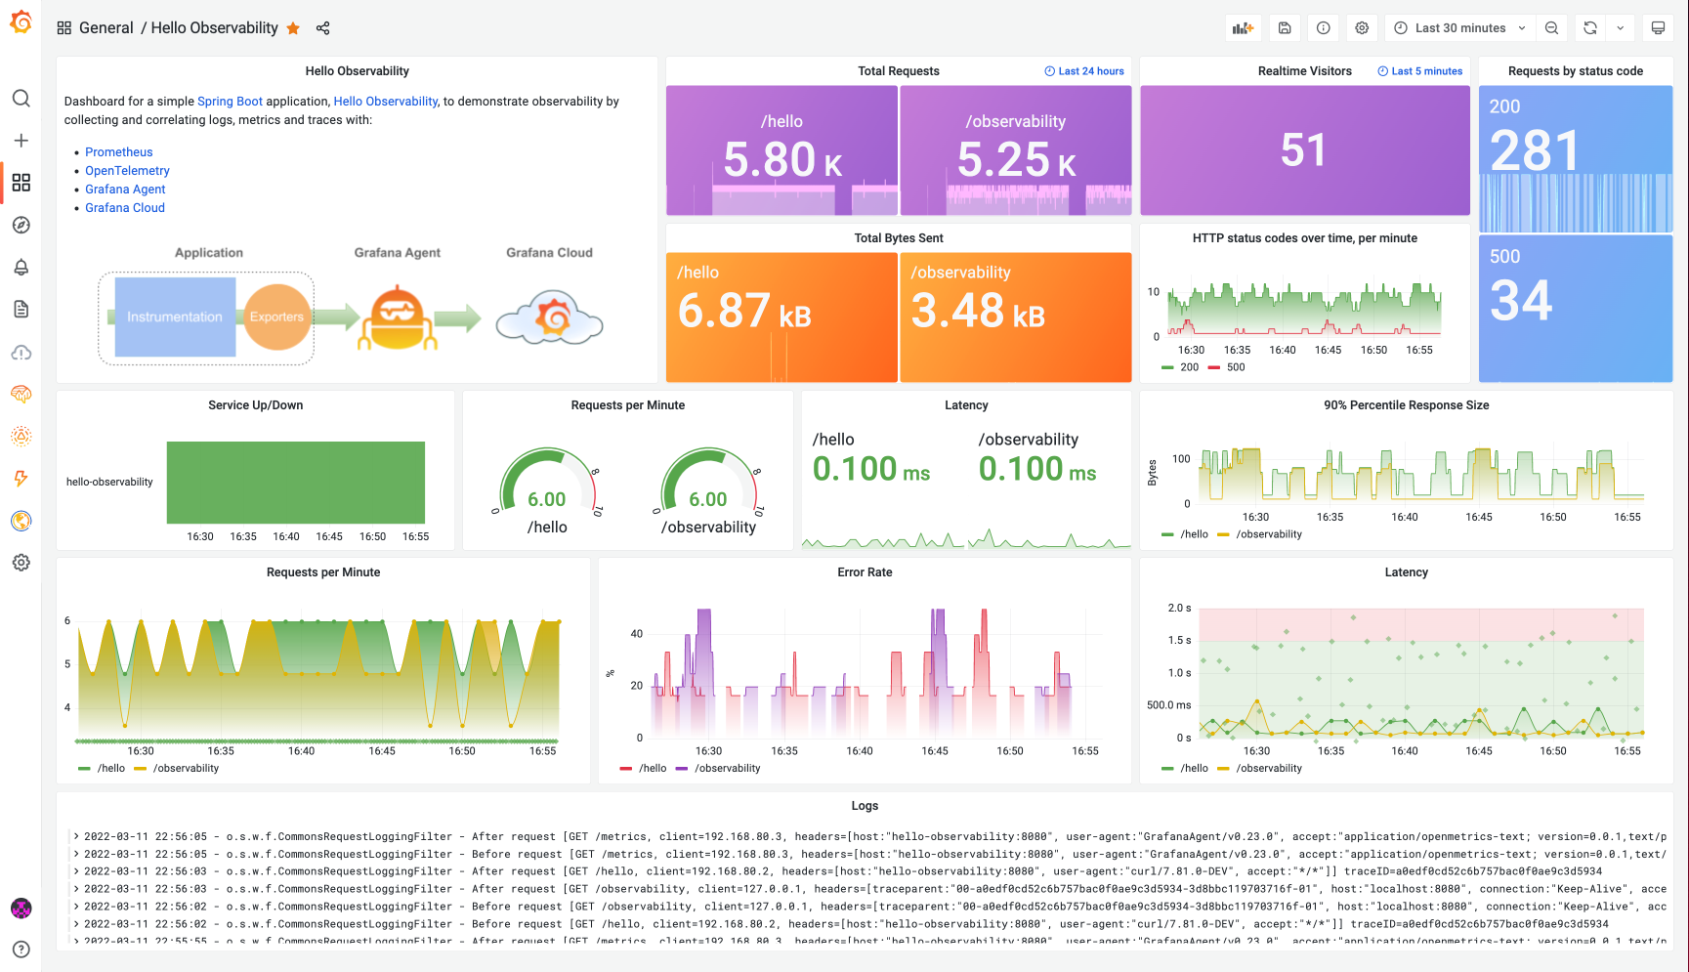
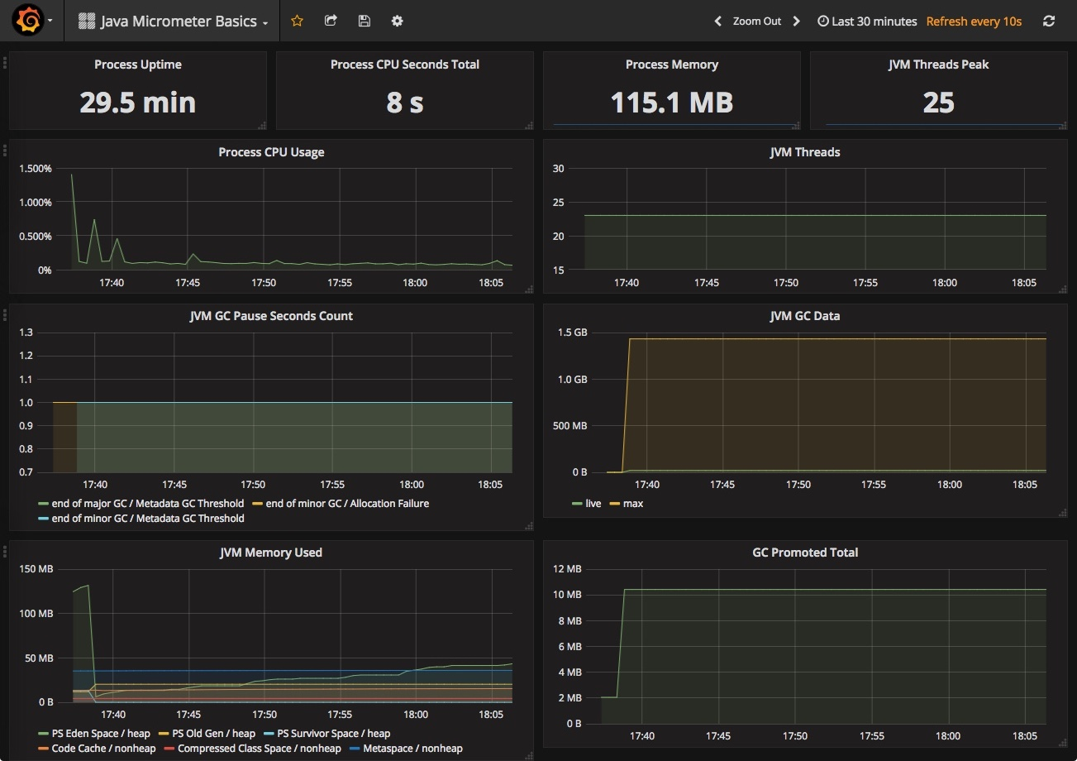
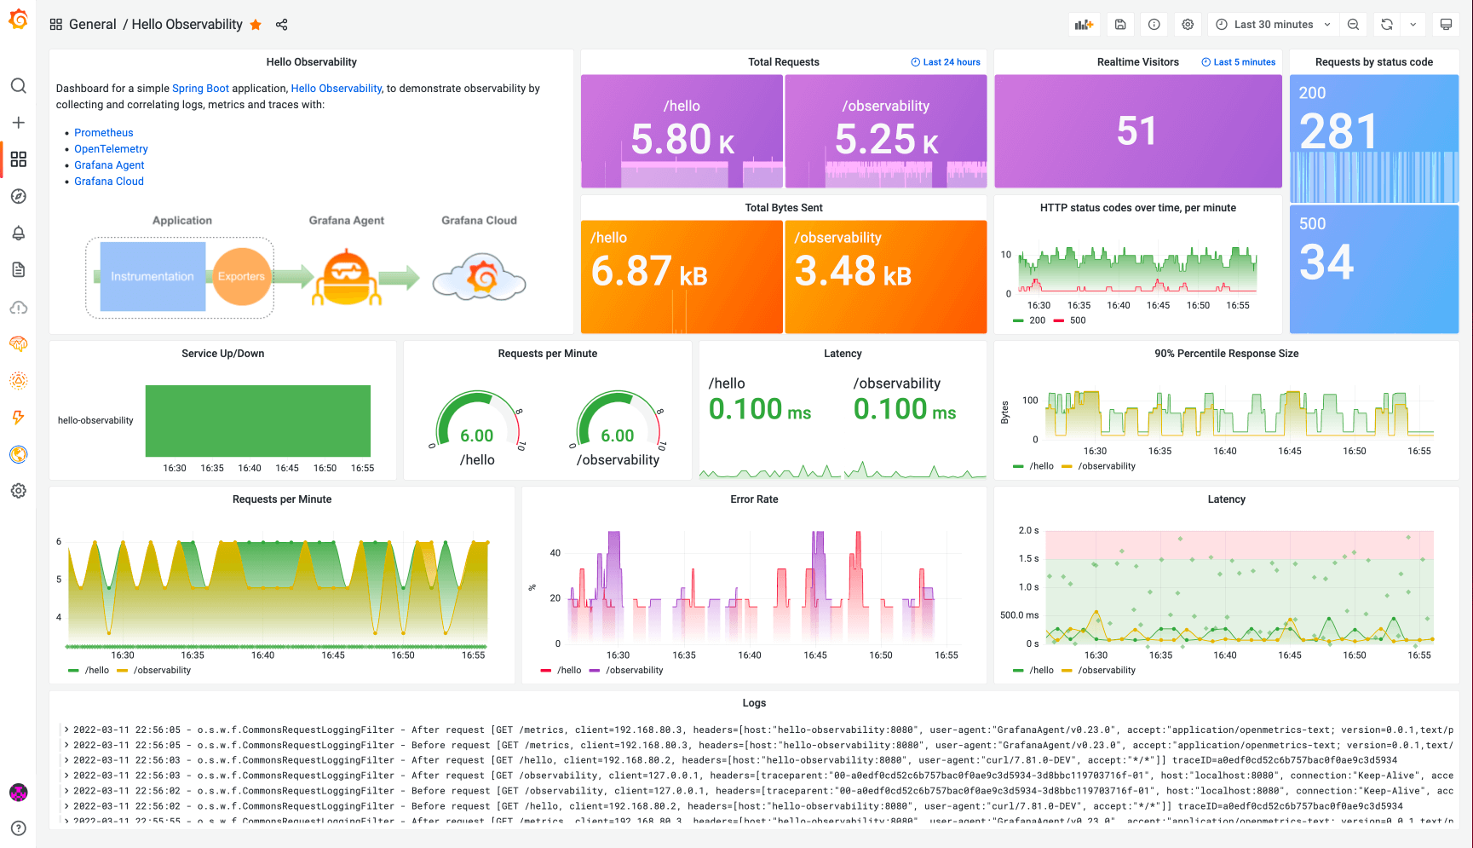
4
Dashboards show:
- JVM memory
- CPU load
- Thread pool metrics
- HTTP latency/performance
- Custom app metrics

4. Setting up SLF4J Logging
Spring Boot uses Logback by default, with SLF4J as the abstraction.

Step 1 — Add Lombok (optional but recommended)
<dependency>
<groupId>org.projectlombok</groupId>
<artifactId>lombok</artifactId>
<version>1.18.28</version>
<scope>provided</scope>
</dependency>

Step 2 — Add @Slf4j
@Slf4j
@Service
public class UserService {
public void execute() {
log.info("Service started");
log.debug("Debug details...");
}
}

Step 3 — Basic Logback configuration
src/main/resources/logback-spring.xml
<configuration>

<property name="LOG_PATH" value="logs"/>

<appender name="CONSOLE" class="ch.qos.logback.core.ConsoleAppender">
<encoder>
<pattern>%d{yyyy-MM-dd HH:mm:ss} %-5level %logger{36} - %msg%n</pattern>
</encoder>
</appender>

<appender name="FILE" class="ch.qos.logback.core.rolling.RollingFileAppender">
<file>${LOG_PATH}/application.log</file>
<rollingPolicy class="ch.qos.logback.core.rolling.TimeBasedRollingPolicy">
<fileNamePattern>${LOG_PATH}/application.%d{yyyy-MM-dd}.log.gz</fileNamePattern>
<maxHistory>7</maxHistory>
</rollingPolicy>
<encoder>
<pattern>%d{yyyy-MM-dd HH:mm:ss} %-5level %logger{36} - %msg%n</pattern>
</encoder>
</appender>

<logger name="com.example.prodapp" level="DEBUG"/>

<root level="INFO">
<appender-ref ref="CONSOLE"/>
<appender-ref ref="FILE"/>
</root>

</configuration>

5. GitHub CI/CD Pipeline Setup
File: .github/workflows/ci-cd.yml
name: CI-CD

on:
push:
branches: ["main"]
pull_request:
branches: ["main"]

jobs:
build-test:
runs-on: ubuntu-latest

steps:
- name: Checkout Repository
uses: actions/checkout@v4

- name: Setup Java 17
uses: actions/setup-java@v4
with:
distribution: 'temurin'
java-version: '17'
cache: 'maven'

- name: Run Tests
run: mvn -B test

- name: Build JAR
run: mvn -B clean package -DskipTests

- name: Upload Artifact
uses: actions/upload-artifact@v4
with:
name: springboot-app-jar
path: target/*.jar

6. CI/CD Pipeline Diagram
A simple GitHub actions pipeline flow:

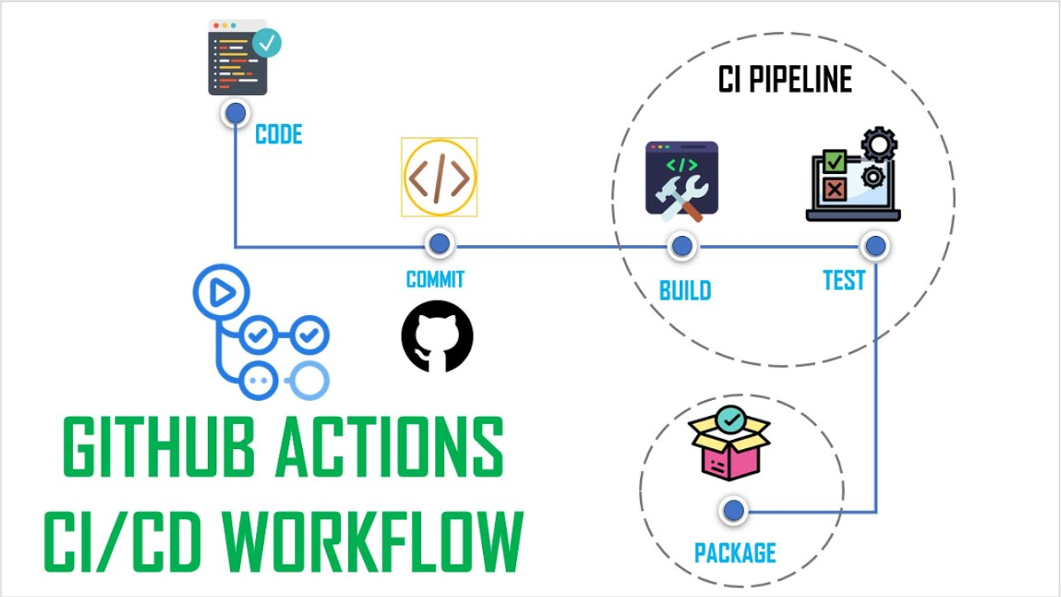
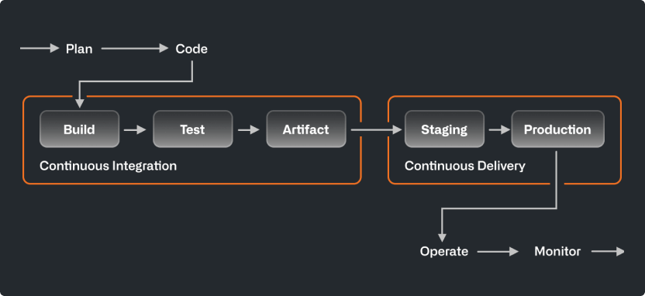
4
Flow:
- Developer pushes code
- GitHub Actions triggers
- Code is checked out
- Java is set up
- Tests run
- Application builds (JAR)
- Artifact uploaded
- Pipeline reports success/failure

7. Recommended Folder Structure
src/
main/
java/
com/example/prodapp/
controller/
service/
repository/
config/
resources/
application.yml
logback-spring.xml
test/
java/
com/example/prodapp/
.github/
workflows/
ci-cd.yml

8. What Junior Engineers Should Understand

✔ Actuator
- Health, metrics, environment visibility
- Used for Kubernetes readiness/live probes
- Used for monitoring (Grafana/Prometheus)

✔ Logging
- Always use @Slf4j, never System.out.println
- INFO for business events
- DEBUG for troubleshooting
- ERROR for failures
- Logback gives daily log rotation

✔ CI/CD
- Every commit runs tests
- Builds must be reproducible
- Pipelines enforce code quality
- Artifacts must be archived for deployment

9. References

Spring Boot
- https://docs.spring.io/spring-boot/docs/current/reference/html/
- https://docs.spring.io/spring-boot/docs/current/reference/htmlsingle/#actuator

SLF4J
- http://www.slf4j.org/manual.html

Logback
- https://logback.qos.ch/manual/

GitHub Actions
- https://docs.github.com/en/actions/learn-github-actions
- https://docs.github.com/en/actions/writing-workflows/workflow-syntax-for-github-actions

Monitoring
- https://grafana.com/docs/grafana/latest/
- https://prometheus.io/docs/introduction/overview/

