GrainPalette
A Deep Learning Odyssey In Rice Type Classification
Through Transfer Learning
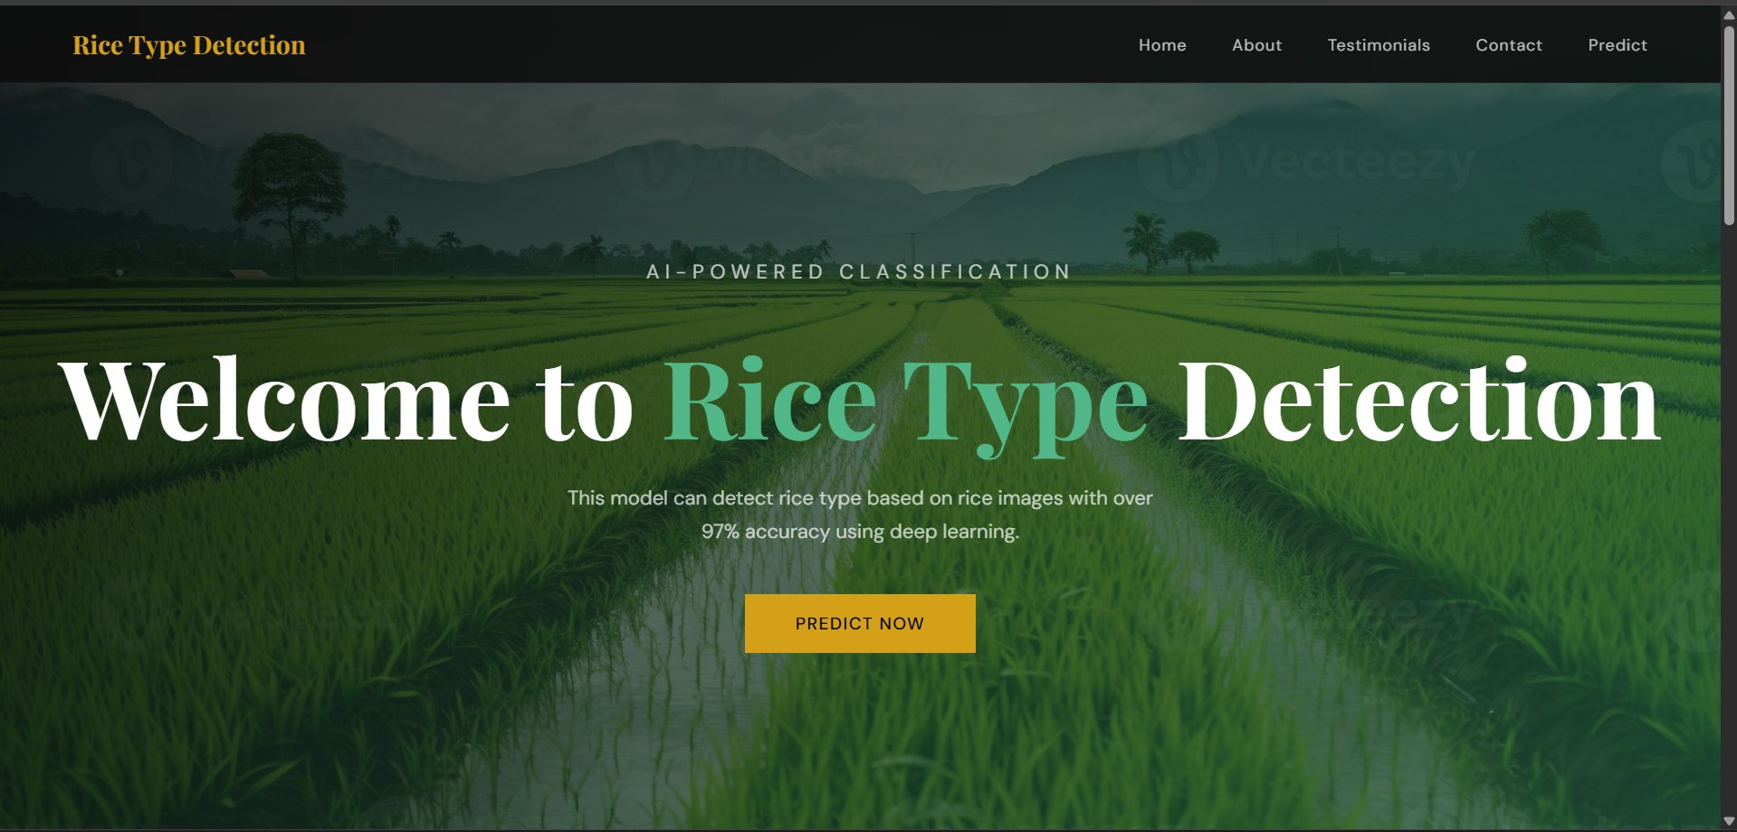
Figure 1: GrainPalette Web Application

Parth Shukla | March 2026

1. Introduction

Rice is one of the most important staple crops in the world, grown and consumed across Asia, Africa, and the Americas. With thousands of varieties available, identifying the correct rice type plays a critical role in agriculture, food quality control, and trade. Manual identification is time-consuming and requires expert knowledge — this is where AI steps in.

GrainPalette is a deep learning-based web application that can identify five different types of rice grains from an uploaded image. The system uses MobileNetV2, a pre-trained Convolutional Neural Network, and applies Transfer Learning to achieve over 97% accuracy. Users simply upload a rice grain image on the web interface and receive an instant prediction along with a confidence score.

This project demonstrates how modern deep learning techniques can be applied to solve practical agricultural problems, making advanced AI accessible to farmers, researchers, and home growers alike.

2. Project Objectives

- Build a deep learning model to classify 5 types of rice grains accurately
- Apply Transfer Learning using MobileNetV2 pretrained on ImageNet
- Preprocess and standardize rice grain images for model input
- Train the model and achieve high classification accuracy
- Deploy the trained model as a Flask web application
- Allow users to upload images and get real-time predictions with confidence scores

3. Use Case Scenarios

3.1 Farmers' Crop Planning
Farmers can use GrainPalette to plan their crop cultivation strategies before planting season. By uploading images of rice grains from their seed stock, they can identify the specific rice varieties they possess. This helps them make informed decisions about irrigation schedules, fertilization methods, and pest management strategies — all tailored to the specific requirements of each rice variety.

3.2 Research and Agricultural Extension Services
Agriculture scientists and extension workers can use this tool during field visits and research trials. Instead of sending samples to labs, they can simply capture an image and get a rapid classification. This speeds up data collection for variety testing, research studies, and extension programs — ultimately contributing to better agricultural productivity.

3.3 Home Gardening and Education
Home growers and gardening enthusiasts can use GrainPalette to learn about different rice varieties. By uploading images from seed packets or harvested crops, they can explore the diversity of rice types and understand their unique characteristics. This promotes agricultural biodiversity awareness and sustainable home gardening practices.

4. Project Flow

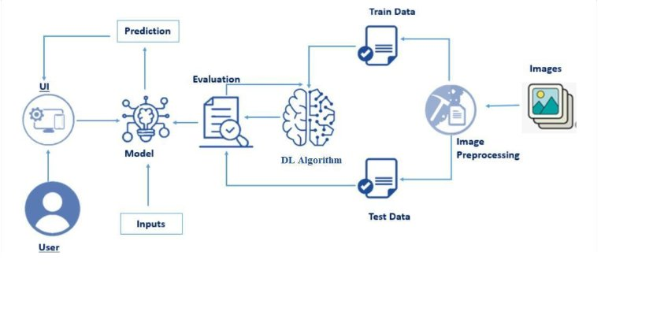
Figure 2: Project Flow Diagram

The project follows a standard end-to-end deep learning pipeline. Images are first collected from the Kaggle dataset, then preprocessed and split into training, validation, and test sets. The MobileNetV2 model is used as a frozen feature extractor, and a Dense output layer is trained on top. The trained model is saved and integrated into a Flask web application where users can interact with it through a browser.

5. Prerequisites & Technology Stack

5.1 Software & Tools
- VS Code — Code editor used for development
- Python 3.13 — Primary programming language
- Jupyter Notebook — For model training and experimentation
- Git & GitHub — Version control and project hosting

5.2 Python Packages
Package | Purpose
tensorflow / keras | Building and training the deep learning model
opencv-python (cv2) | Reading and resizing images
numpy | Numerical operations and array manipulation
scikit-learn | Train/test splitting and evaluation metrics
flask | Building the web application backend
matplotlib / plotly | Visualizing accuracy and loss graphs
kagglehub | Downloading the dataset from Kaggle

5.3 Prior Knowledge Required
- Convolutional Neural Networks (CNN) — Core architecture for image classification
- Transfer Learning — Using pretrained models as feature extractors
- Flask Framework — Python web framework for building the application
- MobileNetV2 — Lightweight CNN architecture pretrained on ImageNet

6. Project Structure

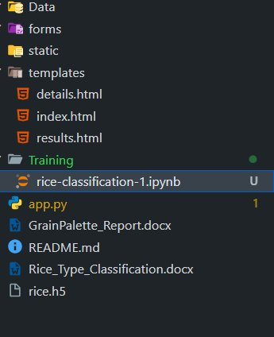
Figure 3: Project Folder Structure in VS Code

File / Folder | Description
Data/ | Contains rice image dataset organized by class
forms/ | HTML form files
static/style.css | External CSS stylesheet for the web app
static/uploads/ | Stores user-uploaded images for prediction
templates/index.html | Home page of the web application
templates/details.html | Image upload page
templates/results.html | Prediction results display page
Training/rice-classification-1.ipynb | Jupyter notebook with full training pipeline
app.py | Main Flask application with routes and prediction logic
rice.h5 | Saved trained Keras model file
GrainPalette_Report.docx | Project documentation report

7. Data Collection

The dataset used in this project is the Rice Image Dataset, publicly available on Kaggle. It was downloaded programmatically using the KaggleHub library, which directly downloads the dataset into the local cache. The dataset contains high-quality images of individual rice grains captured against a black background, making them ideal for classification.

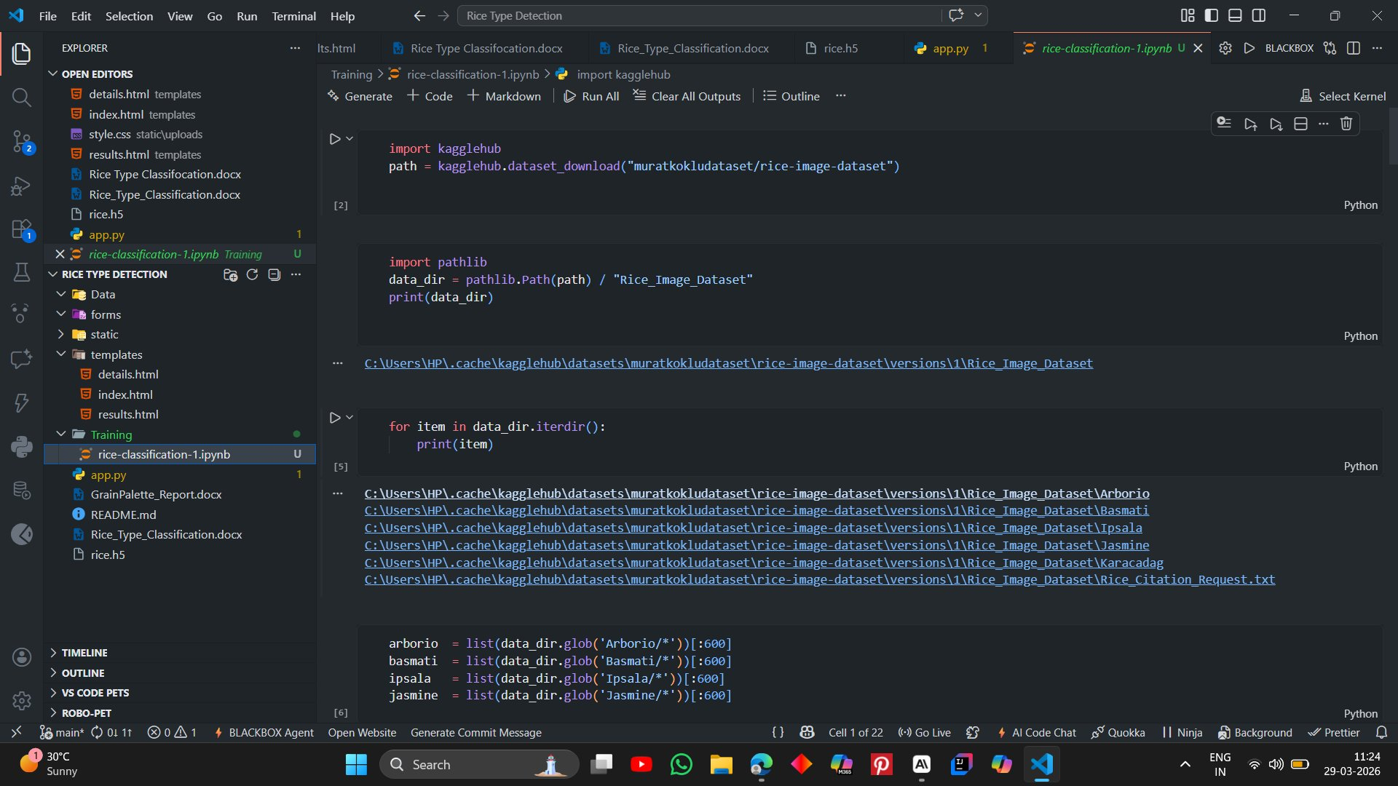
Figure 4: Dataset Download and Class Folders

Rice Type | Images | Label
Arborio | 600 | 0
Basmati | 600 | 1
Ipsala | 600 | 2
Jasmine | 600 | 3
Karacadag | 600 | 4

Total Images Used: 3,000 (600 per class)
Original Image Size: 250 x 250 pixels
Dataset Source: Kaggle — muratkokludataset/rice-image-dataset

8. Image Preprocessing & Visualization

Before feeding images into the model, several preprocessing steps were applied. Each image was read using OpenCV, resized to 224x224 pixels to match the MobileNetV2 input requirements, and normalized by dividing pixel values by 255 to bring them into the range [0, 1]. Labels were encoded as integers and the data was split into training, validation, and test sets.

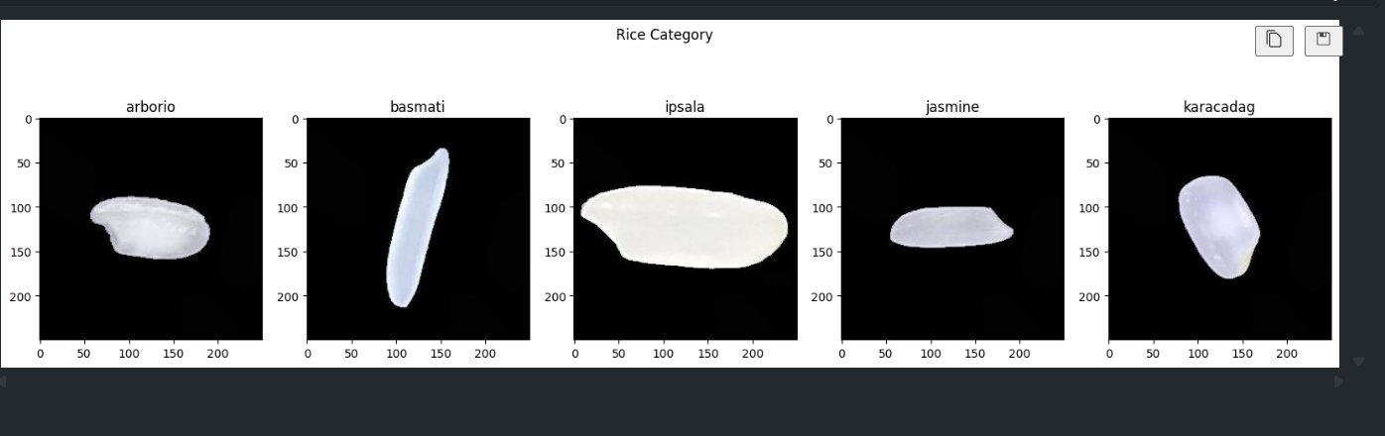
Figure 5: Sample Rice Grain Images from All 5 Classes

- Images read using cv2.imread()
- Resized to 224 x 224 pixels using cv2.resize()
- Normalized: pixel values divided by 255
- Data split: 75% Training, 12.5% Validation, 12.5% Testing

9. Model Building

The model uses MobileNetV2 as a pre-trained base. All convolutional layers were frozen (trainable=False) to preserve the ImageNet weights. A GlobalAveragePooling2D layer was added to flatten the feature maps, followed by a Dense output layer with 5 neurons and Softmax activation for multi-class classification.

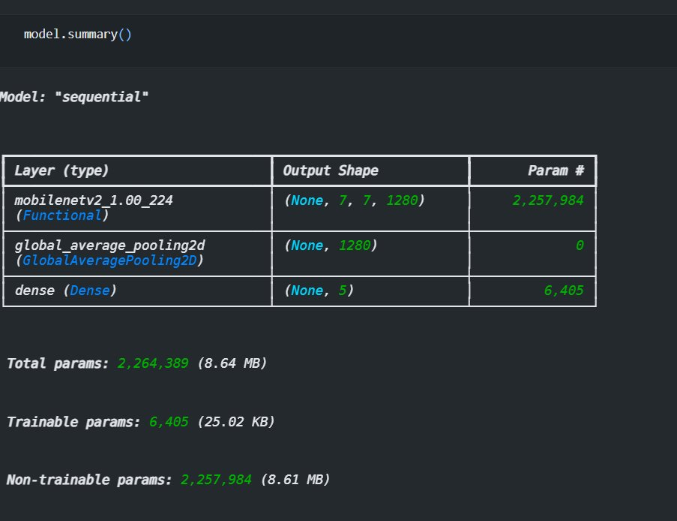
Figure 6: Model Architecture Summary

Layer | Output Shape | Parameters
MobileNetV2 (frozen) | (None, 7, 7, 1280) | 2,257,984
GlobalAveragePooling2D | (None, 1280) | 0
Dense + Softmax | (None, 5) | 6,405

Total Parameters: 2,264,389 (8.64 MB)
Trainable Parameters: 6,405 (25.02 KB)
Non-trainable Parameters: 2,257,984 (8.61 MB)

10. Model Training & Results

The model was compiled with the Adam optimizer and SparseCategoricalCrossentropy loss function. Training was carried out for 10 epochs with a batch size of 64. The model showed rapid improvement from the first epoch and maintained consistently high accuracy throughout training.

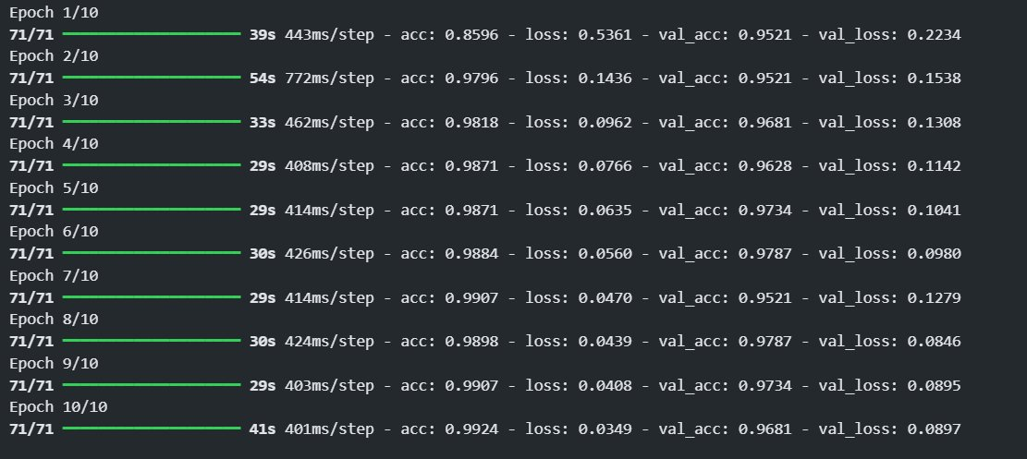
Figure 7: Training Output Across 10 Epochs

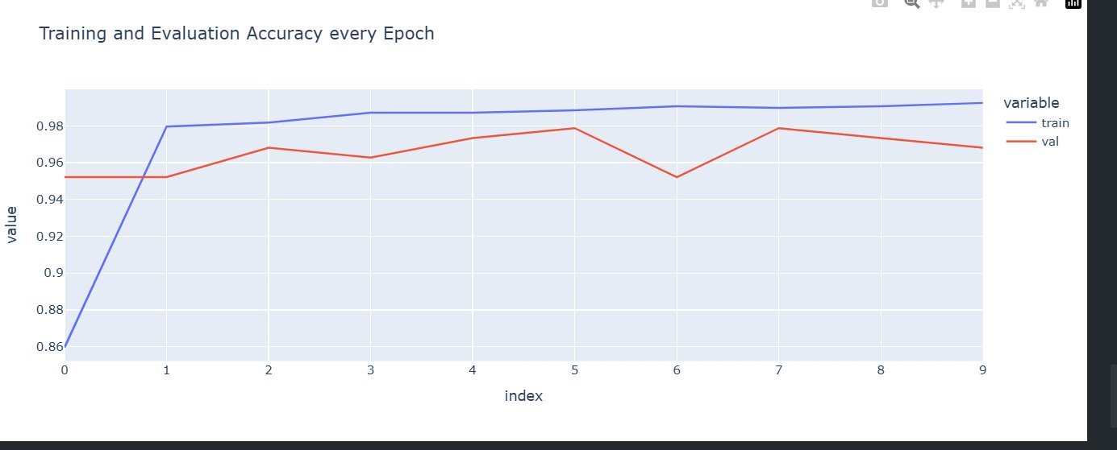
Figure 8: Training and Validation Accuracy per Epoch

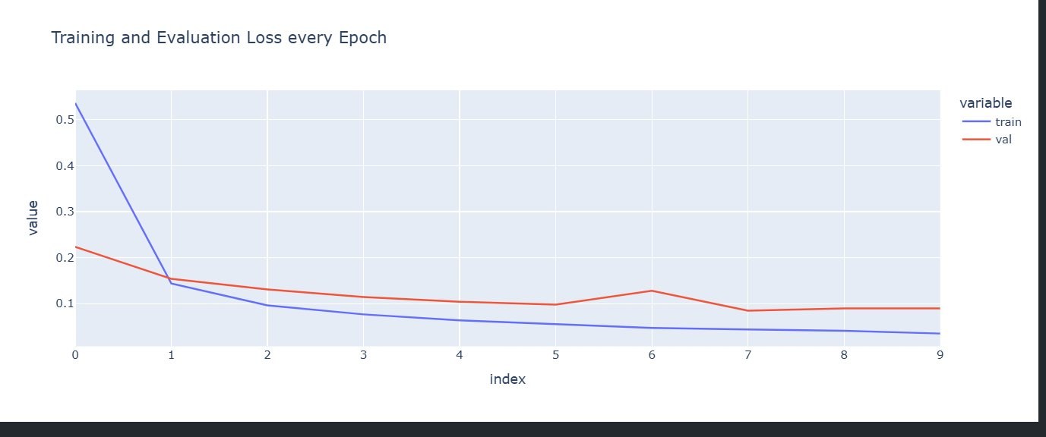
Figure 9: Training and Validation Loss per Epoch

Metric | Value
Training Accuracy (Final Epoch) | 99.24%
Validation Accuracy (Final Epoch) | 96.81%
Test Accuracy | 97.51%
Test Loss | 0.0943

Both graphs confirm the model learned effectively without overfitting. Training accuracy steadily increased while validation accuracy remained above 95% throughout. The loss curves show a sharp decrease in the early epochs and stabilization toward the end.

11. Saving the Model

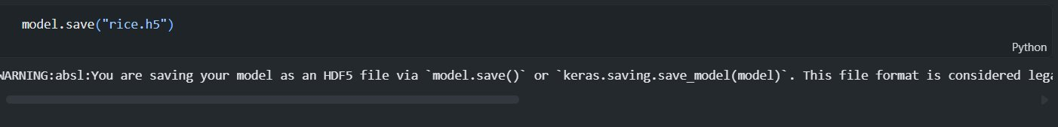
Figure 10: Model Saved as rice.h5

After training, the model was saved using model.save('rice.h5'). A warning about the legacy HDF5 format was shown — this does not affect model performance. The saved model file was then loaded in the Flask application for real-time predictions.

12. Application Building

The trained model was integrated into a Flask web application. The application has three HTML pages — a home page, an image upload page, and a results page. When a user uploads a rice grain image, the Flask backend preprocesses it, runs it through the model, and displays the predicted rice type along with a confidence score.


Figure 11: Home Page — Welcome to Rice Type Detection

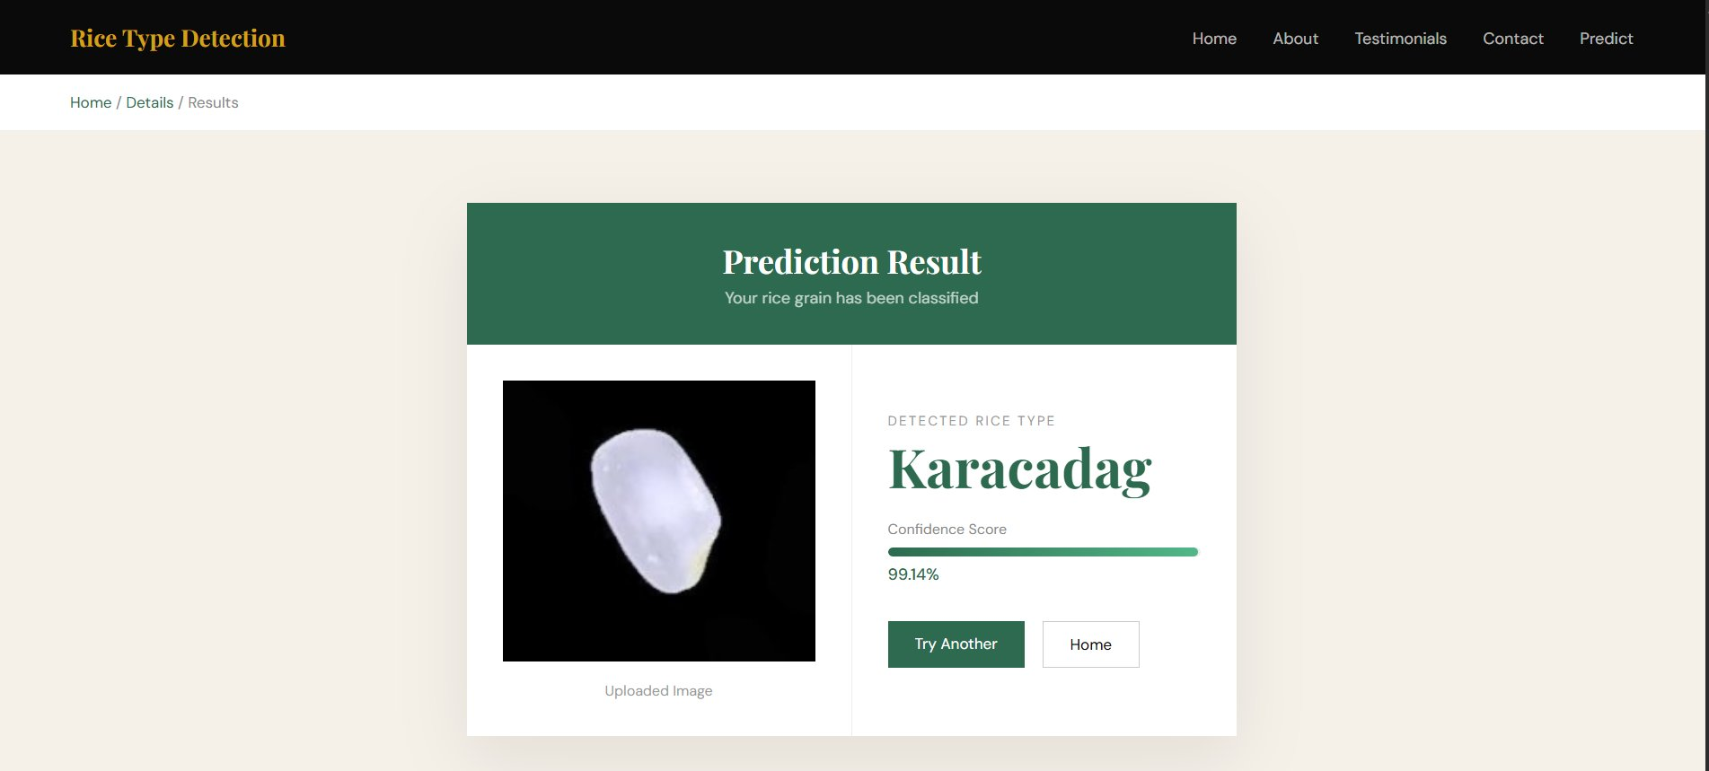
Figure 12: Results Page — Karacadag Detected with 99.14% Confidence

Page | File | Description
Home Page | index.html | Landing page with project info, about section, testimonials and contact
Details Page | details.html | Image upload interface where users submit their rice image
Results Page | results.html | Shows predicted rice type, confidence bar and rice description

13. What I Learned

- How to download and manage datasets programmatically using KaggleHub
- Image preprocessing techniques including resizing, normalization and train-test splitting
- How Transfer Learning works and why freezing pretrained layers is important
- Building a Sequential model in Keras with MobileNetV2 as a feature extractor
- Interpreting training accuracy and loss graphs to evaluate model performance
- Deploying a trained ML model as a web application using Flask
- How to structure a full-stack ML project with HTML, CSS and Python backend
- Version control using Git and hosting projects on GitHub

14. Conclusion

GrainPalette successfully demonstrates the power of Transfer Learning for image classification in the agriculture domain. By leveraging MobileNetV2 pretrained on ImageNet, the model achieved over 97% test accuracy on 5 rice varieties in just 10 training epochs — with minimal computational resources and training time.

The complete pipeline from dataset download to web deployment was built end-to-end, resulting in a practical and user-friendly tool. The application can be used by farmers, researchers, and home growers to identify rice types instantly from a grain image — making AI genuinely useful in real-world agricultural scenarios.

Future improvements could include expanding the number of rice varieties, improving performance on real-world camera images, and deploying the application to a cloud platform for wider accessibility.

15. References

- Koklu, M. (2021). Rice Image Dataset. Kaggle. https://www.kaggle.com/datasets/muratkokludataset/rice-image-dataset
- Sandler, M. et al. (2018). MobileNetV2: Inverted Residuals and Linear Bottlenecks. CVPR 2018.
- TensorFlow Documentation. https://www.tensorflow.org/api_docs
- Flask Documentation. https://flask.palletsprojects.com/
- Scikit-learn Documentation. https://scikit-learn.org/stable/

