GrainPalette
A Deep Learning Odyssey In Rice Type Classification
Through Transfer Learning

Figure 1: GrainPalette Web Application - Home Page

Parth Shukla | March 2026

1. Project Overview

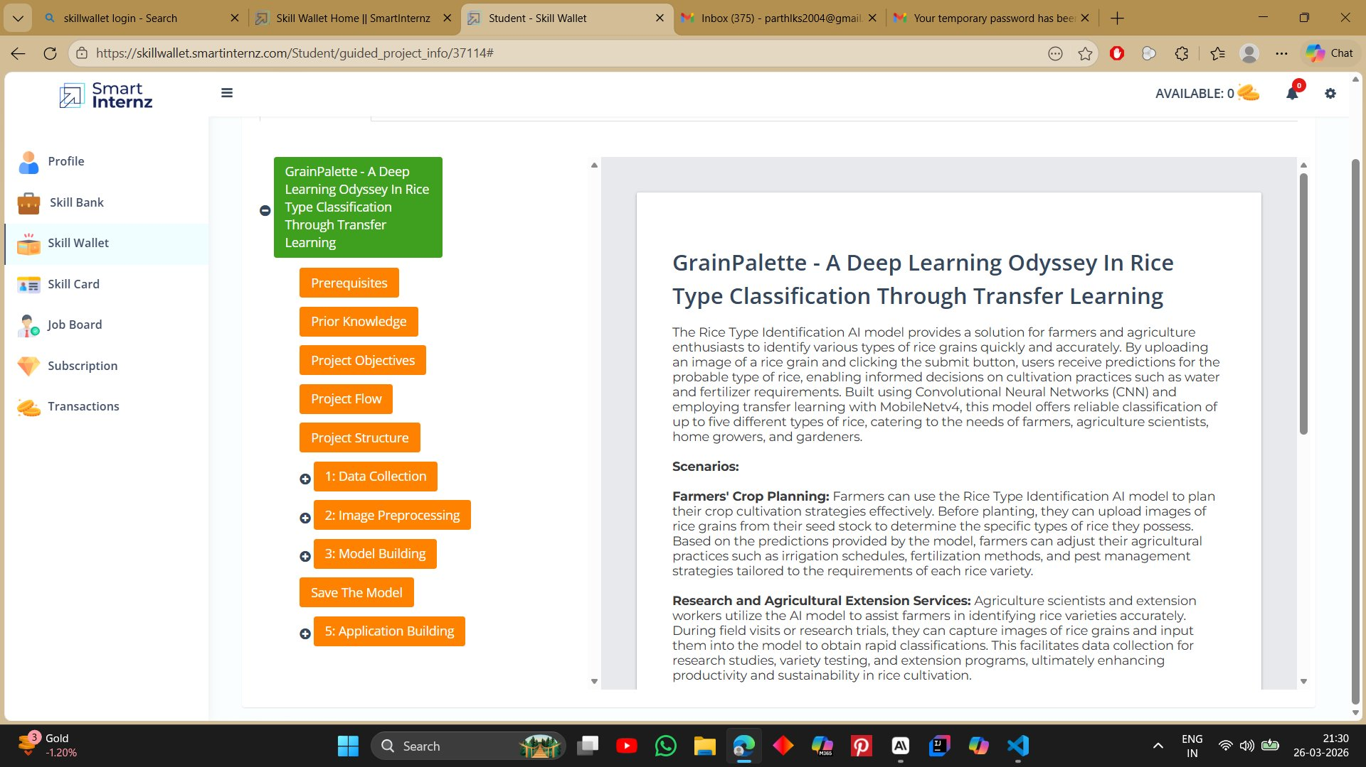
Figure 2: Project Description on SmartInternz Platform

The Rice Type Identification AI model provides a solution for farmers and agriculture enthusiasts to identify various types of rice grains quickly and accurately. By uploading an image of a rice grain and clicking the submit button, users receive predictions for the probable type of rice, enabling informed decisions on cultivation practices such as water and fertilizer requirements.

Built using Convolutional Neural Networks (CNN) and employing transfer learning with MobileNetV2, this model offers reliable classification of up to five different types of rice, catering to the needs of farmers, agriculture scientists, home growers, and gardeners.

2. Use Case Scenarios

2.1 Farmers' Crop Planning
Farmers can use the Rice Type Identification AI model to plan their crop cultivation strategies effectively. Before planting, they can upload images of rice grains from their seed stock to determine the specific types of rice they possess. Based on the predictions provided by the model, farmers can adjust their agricultural practices such as irrigation schedules, fertilization methods, and pest management strategies tailored to the requirements of each rice variety.

2.2 Research and Agricultural Extension Services
Agriculture scientists and extension workers utilize the AI model to assist farmers in identifying rice varieties accurately. During field visits or research trials, they can capture images of rice grains and input them into the model to obtain rapid classifications. This facilitates data collection for research studies, variety testing, and extension programs, ultimately enhancing productivity and sustainability in rice cultivation.

2.3 Home Gardening and Education
Home growers and gardening enthusiasts leverage the AI model to learn about different rice varieties and enhance their gardening skills. By uploading images of rice grains from seed packets or harvested crops, they can explore the diversity of rice types and understand their unique characteristics. This fosters learning and appreciation for agricultural biodiversity, promoting sustainable practices in home gardening and education initiatives.

3. Technical Architecture & Project Flow

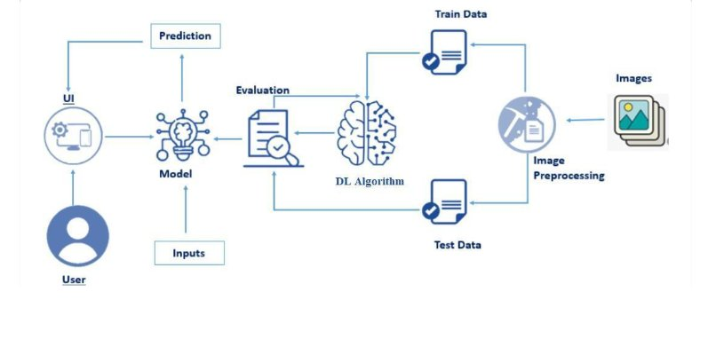
Figure 3: Project Flow Diagram - From Images to Prediction

The system follows a standard deep learning pipeline:
- Images are collected and organized into 5 rice class folders
- Image preprocessing: resizing to 224x224, normalization to [0,1]
- Data split into Training, Validation, and Test sets
- MobileNetV2 used as frozen feature extractor (Transfer Learning)
- Dense output layer trained for 5-class classification
- Model evaluated and saved as rice.h5
- Flask web application serves the model for real-time predictions

4. Data Collection

Figure 4: Dataset Download Path using KaggleHub

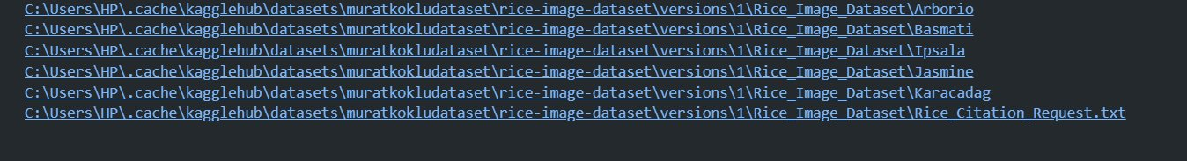
Figure 5: Five Rice Class Folders in the Dataset

Dataset Source: Kaggle - muratkokludataset/rice-image-dataset
Total Classes: 5 (Arborio, Basmati, Ipsala, Jasmine, Karacadag)
Images per Class: 600
Total Images: 3,000
Original Image Size: 250 x 250 pixels

5. Image Preprocessing & Visualization

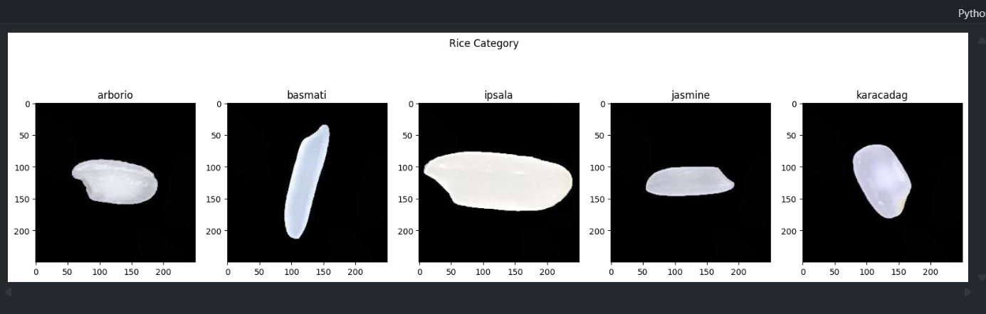
Figure 6: Sample Rice Grain Images from All 5 Classes

Each image was processed as follows:
- Read using OpenCV (cv2.imread)
- Resized to 224 x 224 pixels for MobileNetV2 compatibility
- Pixel values normalized to range [0, 1] by dividing by 255
- Labels encoded as integers: Arborio=0, Basmati=1, Ipsala=2, Jasmine=3, Karacadag=4
- Data split: 75% Training, 12.5% Validation, 12.5% Testing

6. Model Building

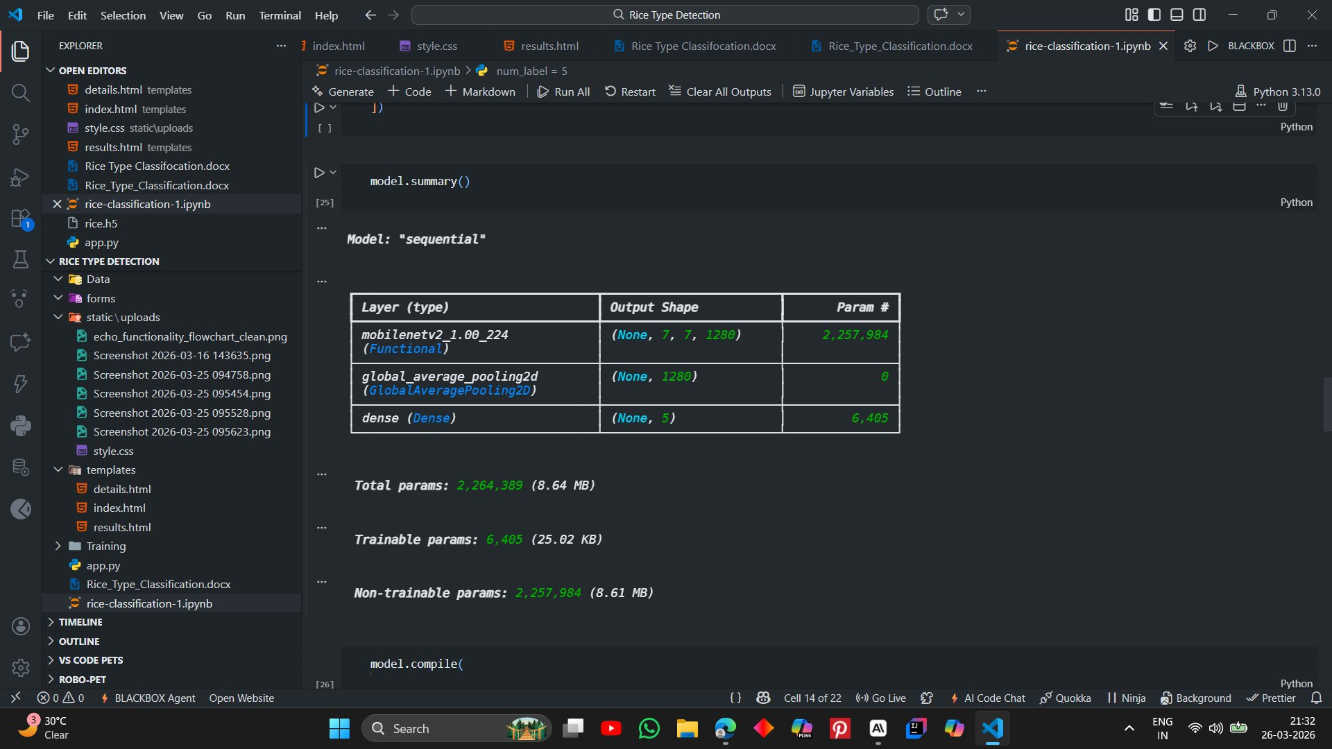
Figure 7: Model Architecture Summary

The model uses MobileNetV2 as a pre-trained base with the following architecture:
- MobileNetV2 (Functional) - Input: (224,224,3), Output: (7,7,1280) - 2,257,984 params (frozen)
- GlobalAveragePooling2D - Output: (1280,) - 0 params
- Dense (Softmax) - Output: (5,) - 6,405 trainable params

Total Parameters: 2,264,389 (8.64 MB)
Trainable Parameters: 6,405 (25.02 KB)
Non-trainable Parameters: 2,257,984 (8.61 MB)

7. Model Training

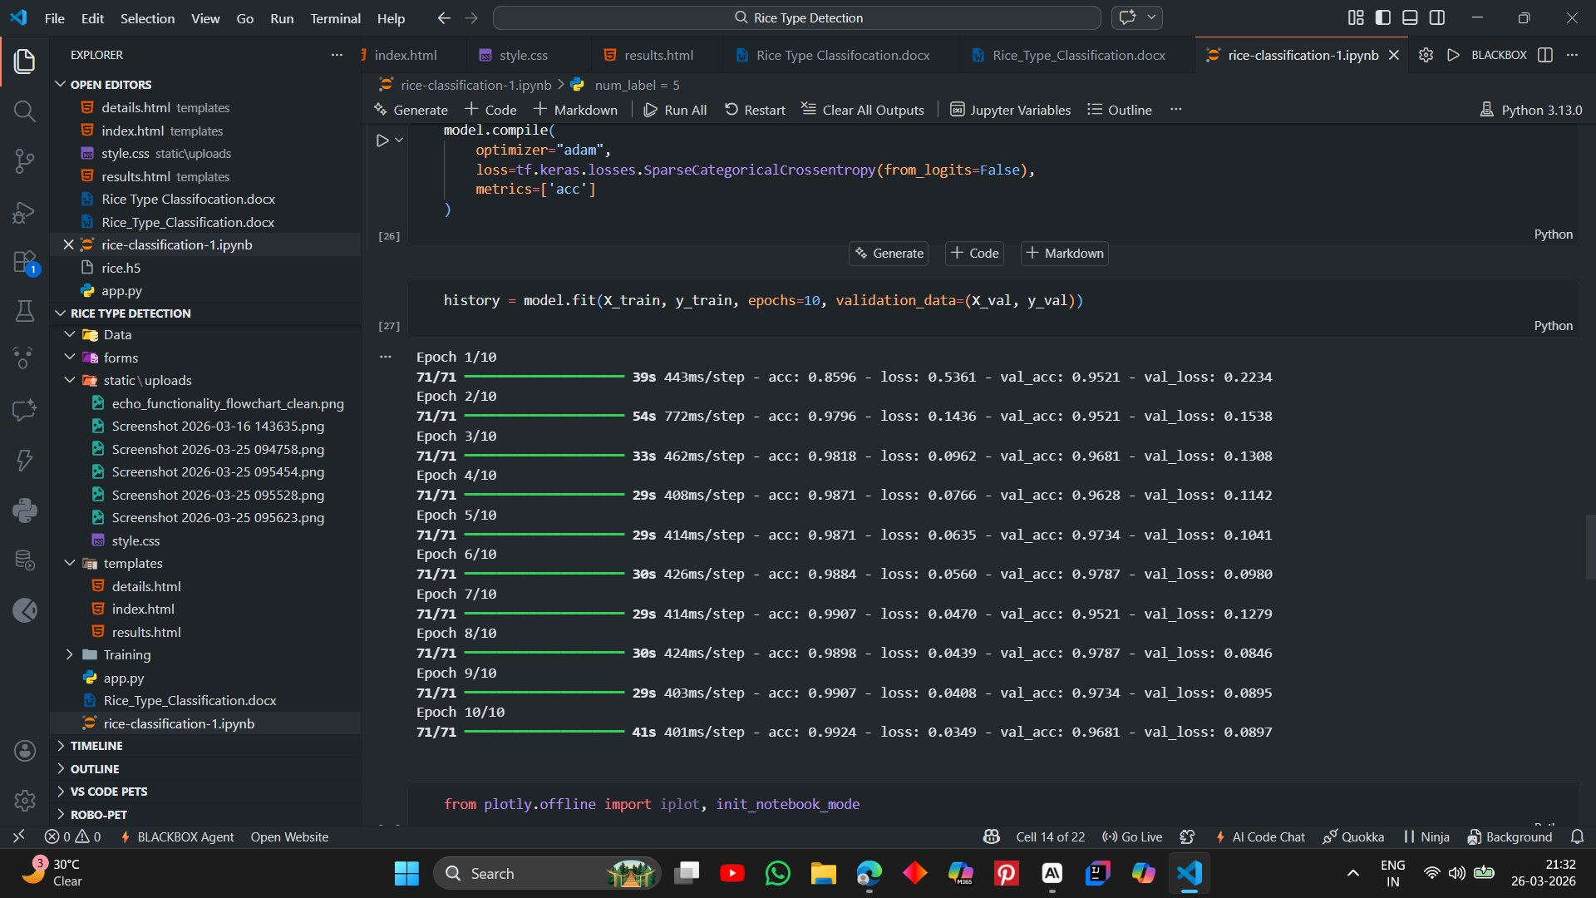
Figure 8: Model Compilation and Training Output (10 Epochs)

Optimizer: Adam
Loss Function: SparseCategoricalCrossentropy (from_logits=False)
Metric: Accuracy
Epochs: 10

Training results across 10 epochs showed consistent improvement, reaching 99.24% training accuracy and 96.81% validation accuracy by the final epoch.

8. Training & Evaluation Graphs

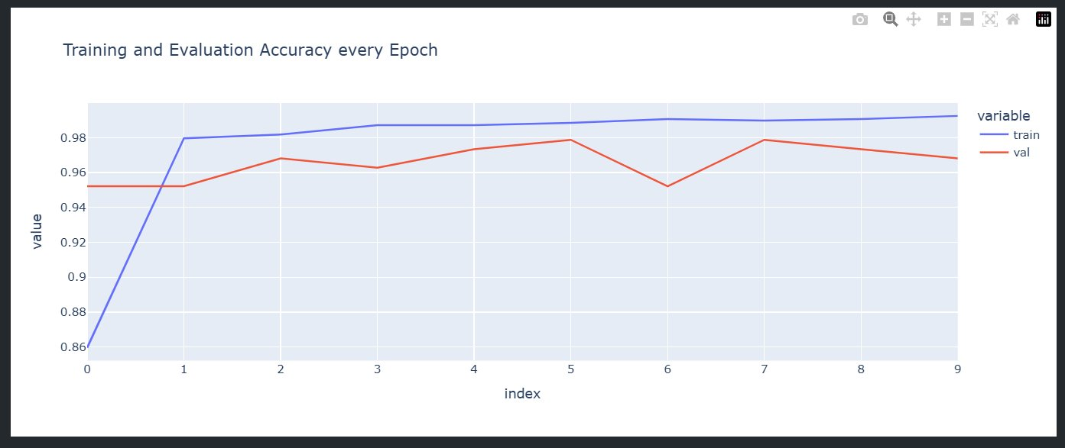
Figure 9: Training and Evaluation Accuracy per Epoch

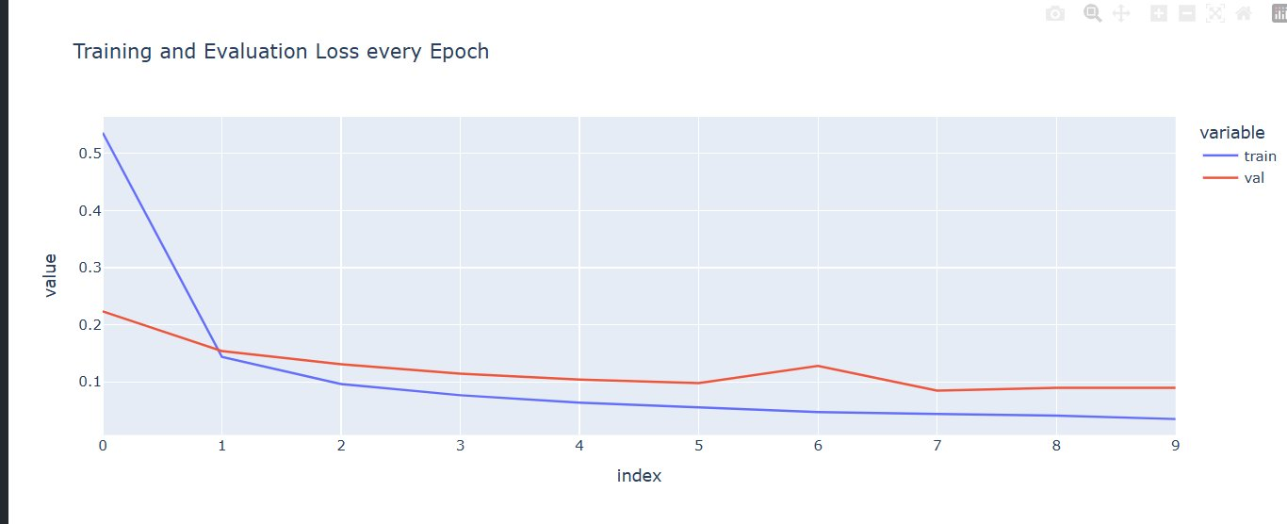
Figure 10: Training and Evaluation Loss per Epoch

Both graphs confirm the model learned effectively without overfitting. The training accuracy steadily increased while validation accuracy remained consistently high above 95%. Loss decreased sharply in early epochs and stabilized near 0.05 for training and 0.09 for validation.

9. Saving the Model

Figure 11: Model Save Warning (HDF5 Legacy Format)

The trained model was saved as rice.h5 using Keras model.save(). A warning about the legacy HDF5 format was shown — this does not affect model performance or loading. The model can alternatively be saved in the native Keras format (.keras) for future use.

10. Project Structure

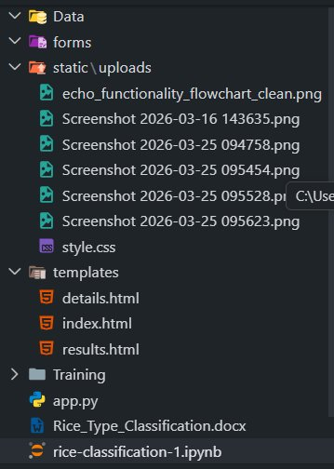
Figure 12: Project Folder Structure in VS Code

app.py: Main Flask application with prediction routes
rice.h5: Saved trained Keras model
static/style.css: External CSS stylesheet
static/uploads/: Uploaded images stored here
templates/index.html: Home page
templates/details.html: Image upload page
templates/results.html: Prediction results page
Training/rice-classification-1.ipynb: Jupyter notebook with full training code

11. Web Application Output


Figure 13: Home Page - Welcome to Rice Type Detection

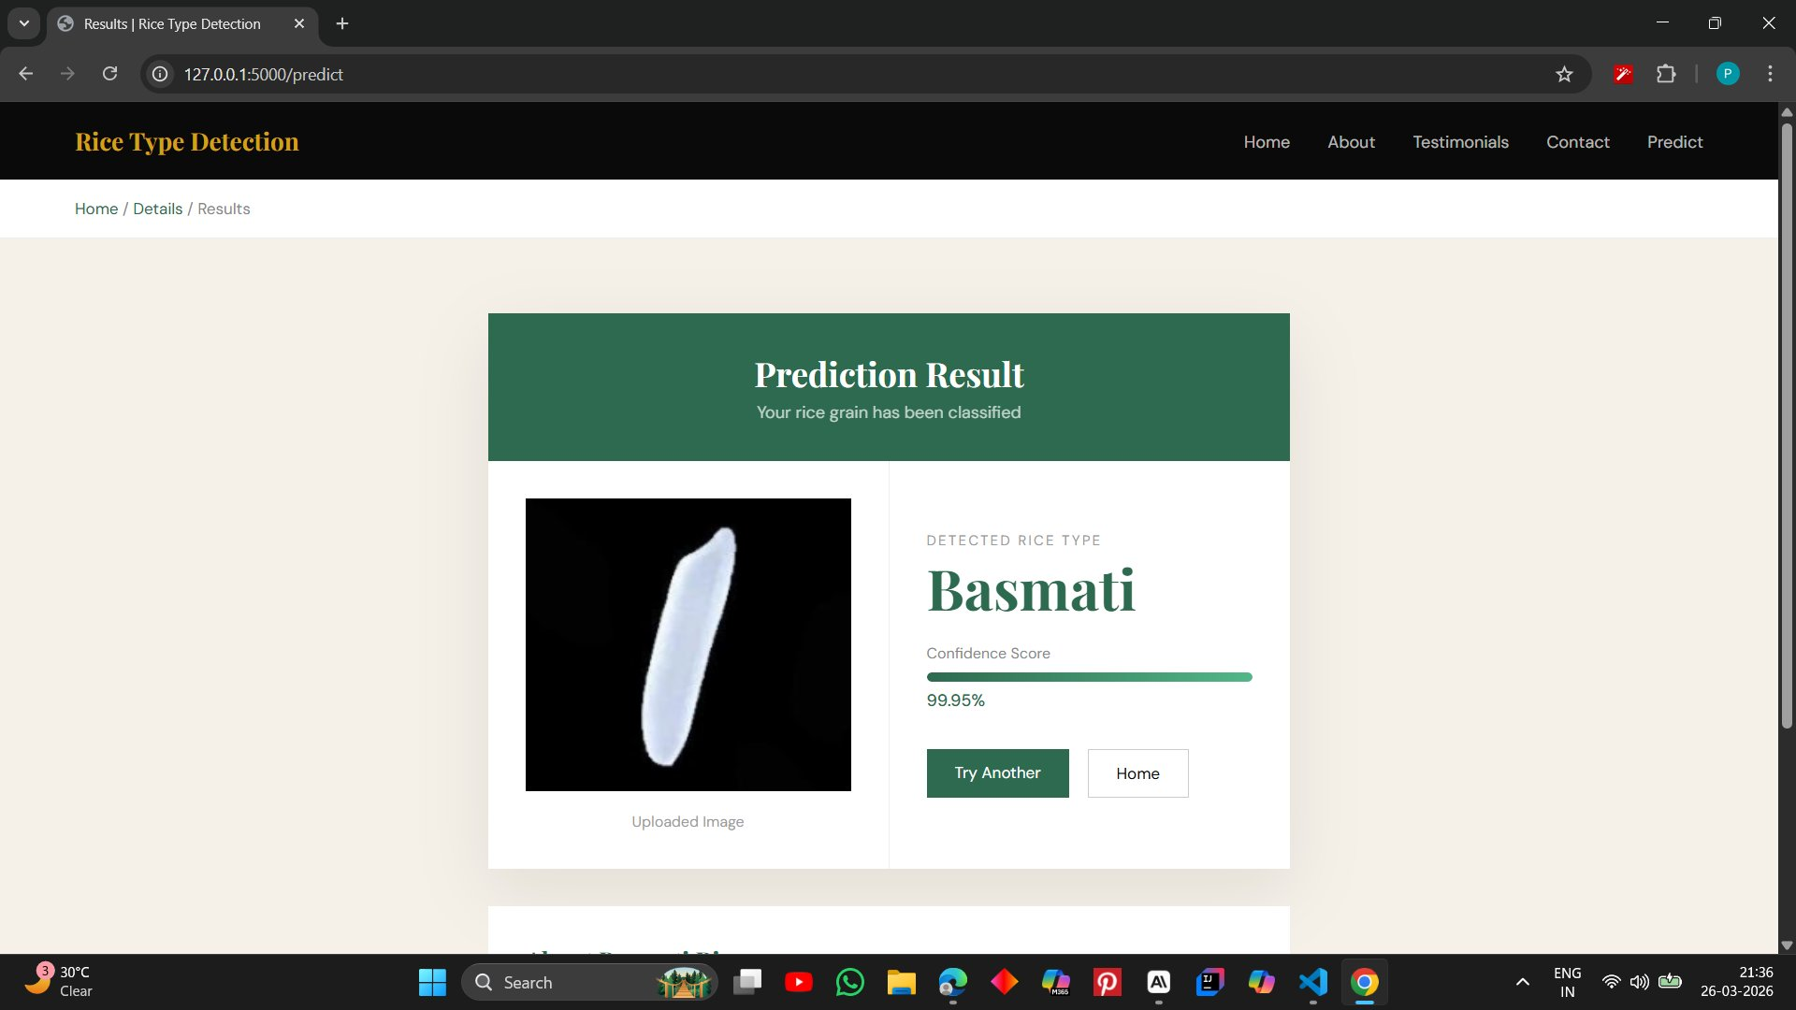
Figure 14: Results Page - Basmati Rice Detected with 99.95% Confidence

The web application successfully classifies rice grain images with high confidence. In the example above, a Basmati rice image from the dataset was correctly identified with 99.95% confidence, demonstrating the effectiveness of the MobileNetV2 Transfer Learning approach.

12. Conclusion

GrainPalette successfully demonstrates the power of Transfer Learning for agricultural image classification. By leveraging MobileNetV2 pretrained on ImageNet, the model achieved over 97% test accuracy on 5 rice varieties with only 10 training epochs and minimal computational resources.

The complete pipeline from data collection to web deployment was built end-to-end, providing a practical tool for farmers, researchers, and home growers to identify rice types instantly from grain images.

- Training Accuracy: ~99.24%
- Validation Accuracy: ~96.81%
- Test Accuracy: ~97.51%
- Confidence on dataset images: 99%+

