A Project Report On

Voice Notes Studio

Submitted in partial fulfillment of the requirement for the BCA Semester-4 Summer Internship Project-2 Subject

BACHELOR OF COMPUTER APPLICATIONS
(B.C.A.)

Academic Year 2026 - 27

Parth Nadiyapara - (92400527071)
Janvi Vaghela - (92400527105)
Niraj Vala - (92400527056)

Internal Guide
Prof. Jitesh Solanki

Rajkot-Morbi Road, At & PO : Gauridad, Rajkot 360 003. Gujarat. India.

CONTENTS

Chapters | Particulars | Page No.
1 | SYNOPSIS | 4
2 | PREAMBLE | 5
2.1 | General Introduction | 5
2.2 | Statement of Problem | 5
2.3 | Objective and Scope of the Study | 6
2.4 | Module Description with functionality | 6
3 | SYSTEM DESIGN AND DEVELOPMENT | 9
3.1 | Data Flow Diagram (DFD) | 9
3.2 | Table Structure | 11
3.3 | Menu Design | 13
3.4 | Screen Design (Screen shots with short description) | 14
4 | CONCLUSION | 15
5 | LEARNING DURING PROJECT WORK | 16
6 | BIBLIOGRAPHY | 17
6.1 | Online References | 17
6.2 | Offline References | 17

FIGURE INDEX

Sr. No. | Figure No. | Particulars | Page No.
1 | 1 | DFD Level 0 | 9
2 | 2 | DFD Level 1 | 10
3 | 3 | Menu Design | 13
4 | 4 | Main Dashboard Screen Design | 14

TABLE INDEX

Sr. No. | Table No. | Particulars | Page No.
1 | 1 | users | 11
2 | 2 | sessions | 12
3 | 3 | notes | 12

1. SYNOPSIS

This project focuses on designing and developing Voice Notes Studio, a web based system that allows users to create text notes by recording their voice.
The system captures audio through the browser microphone, sends it securely to the backend, converts the speech into text using a transcription service, and stores the final note in a MySQL database.
It provides Google OAuth based authentication, a clean dashboard for note management, search and sorting facilities, and an admin dashboard for viewing user and note statistics.
The main goal of the project is to make note creation faster, simpler, and more accessible for users who prefer speaking their thoughts instead of typing them manually.

2. PREAMBLE

2.1 General Introduction
Voice notes are useful for students, professionals, and general users because ideas can be captured quickly without typing. Modern browsers, cloud APIs, and database systems make it possible to convert spoken information into organized digital notes.
Voice Notes Studio is developed as a React and Express application. The frontend provides the user interface, while the backend handles authentication, file upload, transcription, note storage, and admin data.
The system uses MySQL for persistent storage and Google OAuth for secure login without storing user passwords.
2.2 Statement of Problem
Many users lose ideas because writing notes manually takes time, especially when they are busy or away from a keyboard. Traditional note systems mainly depend on typing and do not provide a simple voice-first workflow.
Another problem is secure note ownership. A notes system must ensure that every user can access only personal notes, while administrators can monitor basic user and note statistics.
This project solves these issues by providing a voice recording interface, automatic transcription, authenticated sessions, searchable note lists, and safe note update and delete operations.
2.3 Objective and Scope of the Study
The main objective of this project is to design and develop a web application that converts recorded speech into editable notes. It aims to provide simple note creation, secure login, note searching, note editing, note deletion, and basic admin reporting.
The scope of the study includes user authentication, audio recording, audio upload, transcription processing, note storage, note listing, note search, session management, and admin user listing. The system can be extended in future with folders, tags, reminders, export options, and multi-language transcription.
2.4 Module Description with functionality
User Authentication Module
This module allows users to sign in using Google OAuth. It creates or updates the user profile, generates a secure session token, validates the token for protected API requests, and supports logout.
Voice Recording Module
This module uses the browser microphone and MediaRecorder API to capture the user's voice. It starts and stops recording, prepares the audio file, and sends it to the backend for processing.
Transcription Module
This module accepts the uploaded audio file and sends it to the configured transcription provider. The returned text is cleaned and saved as a note with a generated or user supplied title.
Notes Management Module
This module stores notes in MySQL and allows users to view, search, sort, edit, and delete their own notes. It keeps note data linked with the logged-in user.
Admin Module
This module provides summary information such as total users and total notes. Admin users can also view user details with role and note count.
Database Management Module
This module creates and verifies the users, sessions, and notes tables. It stores user profiles, session tokens, note titles, note content, and timestamps.

3. SYSTEM DESIGN AND DEVELOPMENT

3.1 Data Flow Diagram (DFD)
The following DFDs show how users, authentication, transcription service, and database storage interact in Voice Notes Studio.
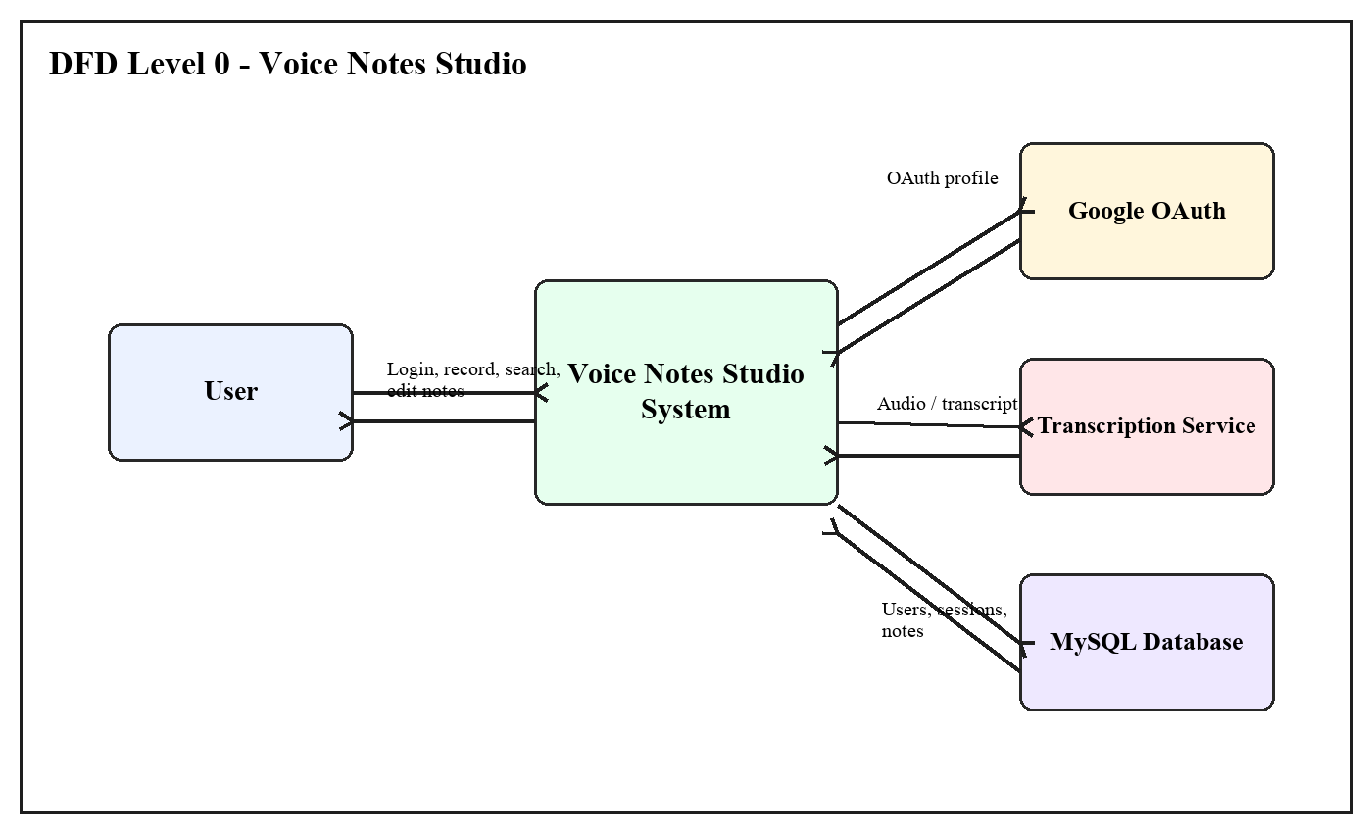
Figure 1: DFD Level 0
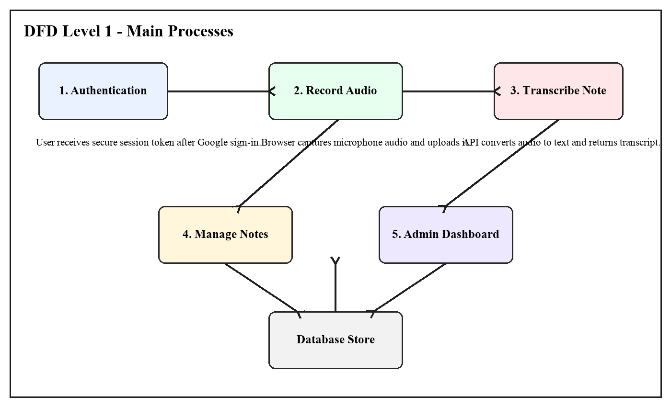
Figure 2: DFD Level 1

3.2 Table Structure
Table 1: users
Field Name | Data Type | Description
id | INT, Primary Key | Unique user id
name | VARCHAR(120) | User full name
email | VARCHAR(255), UNIQUE | User email address
password_hash | VARCHAR(255), NULL | Reserved password hash field
password_salt | VARCHAR(255), NULL | Reserved password salt field
oauth_provider | VARCHAR(40), NULL | OAuth provider name
oauth_subject | VARCHAR(255), NULL | Provider user id
avatar_url | VARCHAR(500), NULL | User profile picture
last_login_at | DATETIME, NULL | Last login date and time
role | ENUM('user','admin') | Access role
created_at | TIMESTAMP | Account creation time

Table 2: sessions
Field Name | Data Type | Description
id | INT, Primary Key | Unique session id
user_id | INT | Reference to users table
token_hash | CHAR(64), UNIQUE | Hashed session token
expires_at | DATETIME | Session expiry time
created_at | TIMESTAMP | Session creation time

Table 3: notes
Field Name | Data Type | Description
id | INT, Primary Key | Unique note id
user_id | INT, NULL | Owner user id
title | VARCHAR(255), NULL | Note title
content | TEXT | Transcribed or edited note text
created_at | TIMESTAMP | Note creation time

3.3 Menu Design
The menu design shows the main navigation and actions available in the Voice Notes Studio interface.
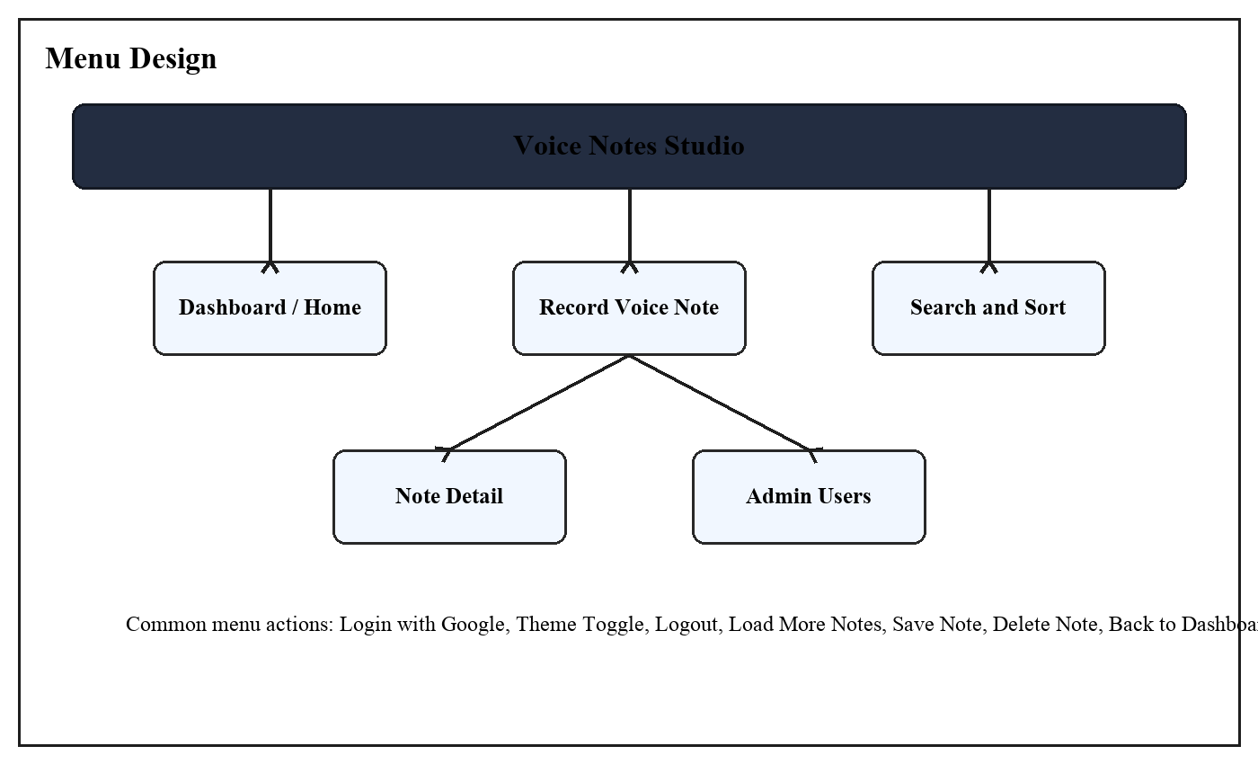
Figure 3: Menu Design

3.4 Screen Design (Screen shots with short description)
The main dashboard contains a header, recording panel, search box, sorting option, notes list, and note detail actions. Admin users can also open the user details page from the dashboard.
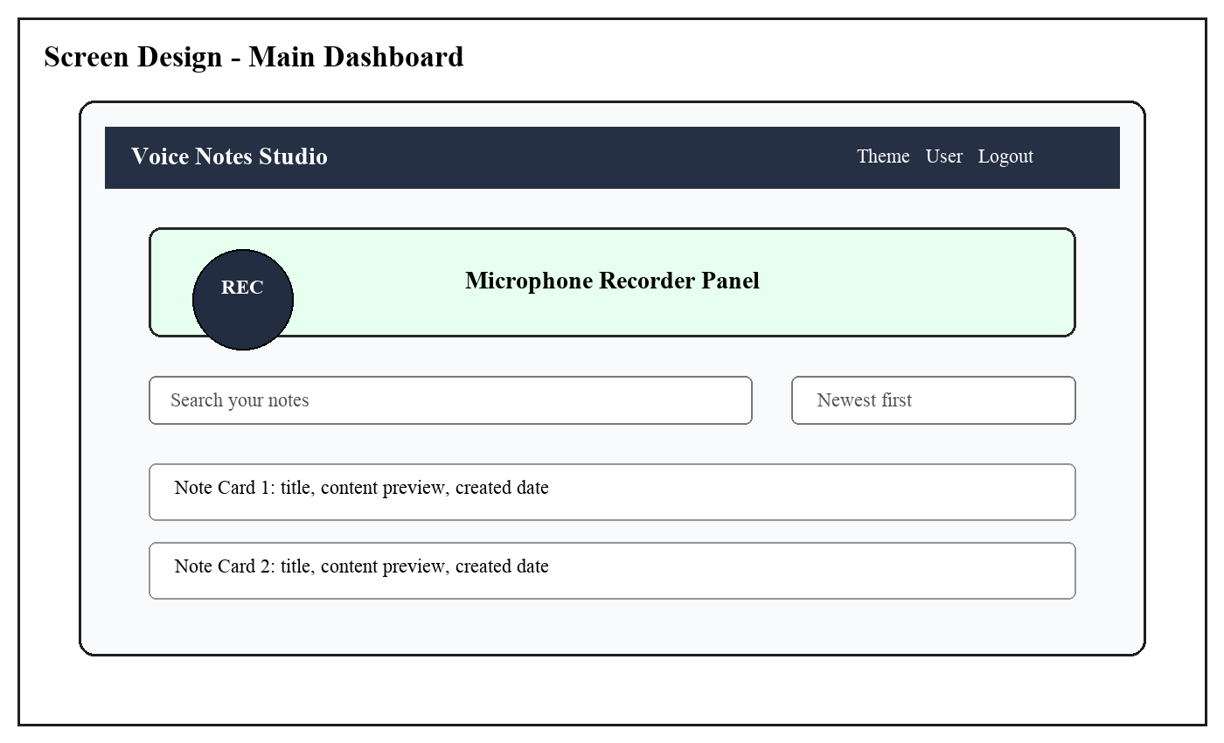
Figure 4: Main Dashboard Screen Design

4. CONCLUSION

Voice Notes Studio successfully provides a simple and useful platform for converting spoken ideas into organized text notes. It combines React, Express, MySQL, OAuth authentication, and transcription service integration into one working system.
The project reduces the effort required to create notes and gives users an efficient way to record, search, edit, and manage personal note content. The admin dashboard also helps in monitoring users and note counts.
In future, the system can be improved by adding tags, folders, note sharing, reminders, PDF export, and support for more languages.

5. LEARNING DURING PROJECT WORK

During this project work, we learned how to connect a frontend React application with a backend Express API. We also learned how to handle browser microphone recording, file upload, API based transcription, and MySQL database operations.
The project improved our understanding of OAuth authentication, session security, protected routes, role based admin access, and server side validation.
We also learned the importance of user friendly interface design, error handling, testing workflows, and maintaining clear project documentation.

6. BIBLIOGRAPHY

6.1 Online References
React Documentation - https://react.dev/
Express Documentation - https://expressjs.com/
MySQL Documentation - https://dev.mysql.com/doc/
Google OAuth Documentation - https://developers.google.com/identity/protocols/oauth2
MDN MediaRecorder API - https://developer.mozilla.org/en-US/docs/Web/API/MediaRecorder
6.2 Offline References
Class notes and practical guidance provided during BCA Semester-4.
Project source code and internal project discussion notes.

