A Project Report On
Voice Notes Studio
Submitted in partial fulfillment of the requirement for the BCA Semester-4 Summer Internship Project-2 Subject
BACHELOR OF COMPUTER APPLICATIONS
(B.C.A.)
Academic Year 2026 - 27
Parth Nadiyapara - (92400527071)
Janvi Vaghela - (92400527105)
Niraj Vala - (92400527056)
Internal Guide
Prof. Jitesh Solanki

Rajkot-Morbi Road, At & PO : Gauridad, Rajkot 360 003. Gujarat. India.

CONTENTS
Chapters | Particulars | Page No.
1 | SYNOPSIS | 4
2 | PREAMBLE | 5
2.1 | General Introduction | 5
2.2 | Statement of Problem | 5
2.3 | Objective and Scope of the Study | 6
2.4 | Module Description with functionality | 6
3 | SYSTEM DESIGN AND DEVELOPMENT | 8
3.1 | Data Flow Diagram (DFD) | 8
3.2 | Table Structure | 10
3.3 | Menu Design | 11
3.4 | Screen Design (Screen shots with short description) | 12
4 | CONCLUSION | 15
5 | LEARNING DURING PROJECT WORK | 16
6 | BIBLIOGRAPHY | 17
6.1 | Online References | 17
6.2 | Offline References | 17
FIGURE INDEX
Sr. No. | Figure No. | Particulars | Page No.
1 | 1 | DFD Level 0 | 8
2 | 2 | DFD Level 1 | 9
3 | 3 | Menu Design | 11
4 | 4 | Login/Register Page | 12
5 | 5 | User Dashboard | 13
6 | 6 | Admin Dashboard | 14
TABLE INDEX
Sr. No. | Table No. | Particulars | Page No.
1 | 1 | users | 10
2 | 2 | sessions | 10
3 | 3 | notes | 10

1. SYNOPSIS
Voice Notes Studio is a web based system developed to create, organize, and manage notes from recorded voice. The project helps users capture thoughts quickly by speaking instead of typing.
The system records audio from the browser, uploads it to the backend, converts the speech into text through a transcription service, and saves the final note in a MySQL database.
It also provides Google OAuth login, user wise note storage, searching, sorting, editing, deleting, and an admin dashboard for viewing total users and total notes.

2. PREAMBLE
2.1 General Introduction
Voice based note taking is useful when users need to save ideas quickly. Instead of typing long text manually, users can record a thought and allow the system to convert it into editable text.
Voice Notes Studio is developed using React for the frontend, Express for the backend, and MySQL for database storage. It uses Google OAuth for secure login and a transcription API for converting audio to text.
2.2 Statement of Problem
Traditional note taking systems mainly depend on typing. This is slow for users who want to save information while studying, working, or discussing ideas. Users may also face difficulty in organizing and searching recorded thoughts.
The project solves this problem by providing a voice first notes system with secure account access, automatic transcription, and simple note management.
2.3 Objective and Scope of the Study
The objective of this project is to design and develop a system that records user voice, converts it into text, and stores it as a personal note. The project also aims to provide secure login, note search, note edit, note delete, and admin monitoring features.
The scope includes authentication, recording, audio upload, transcription, note storage, searching, sorting, session handling, and admin user details. Future scope includes folders, tags, reminders, export to PDF, and multilingual transcription.
2.4 Module Description with functionality
Authentication Module
This module manages Google OAuth login, user profile creation, session token generation, session validation, and logout.
Recorder Module
This module records audio using the browser microphone and sends the audio file to the backend API.
Transcription Module
This module converts uploaded audio into text and creates a note title from the transcribed content.
Notes Management Module
This module allows users to view, search, sort, edit, and delete their own notes.
Admin Module
This module displays total users, total notes, and user details for admin users.

3. SYSTEM DESIGN AND DEVELOPMENT
3.1 Data Flow Diagram (DFD)
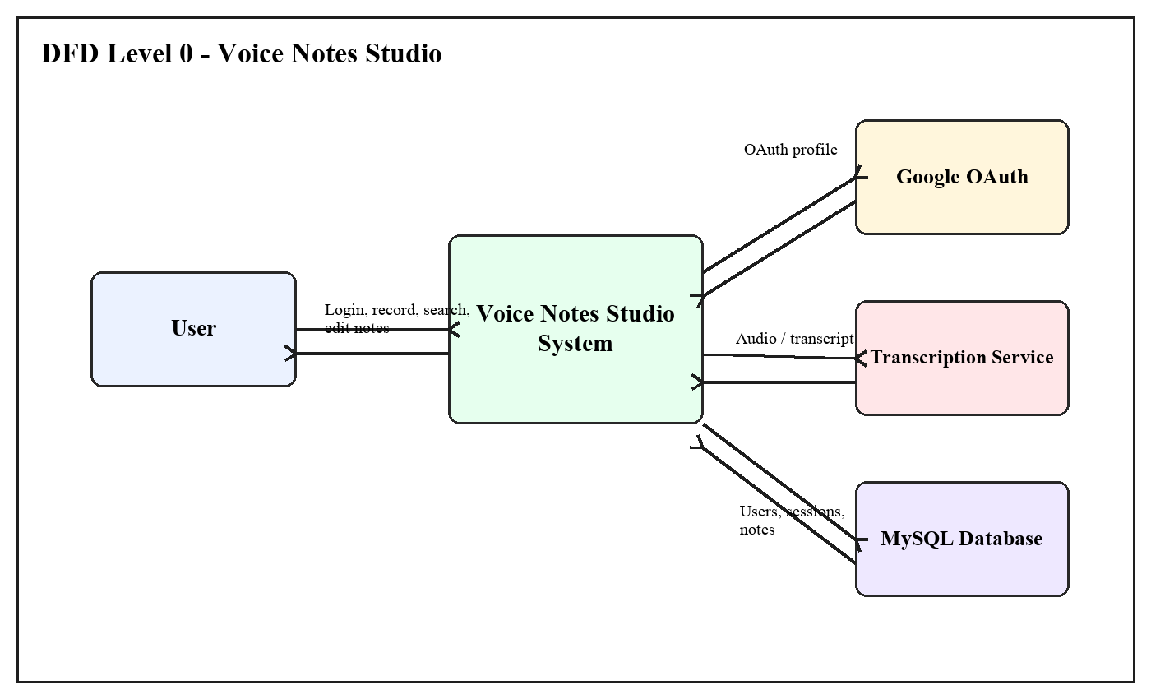
Figure 1: DFD Level 0
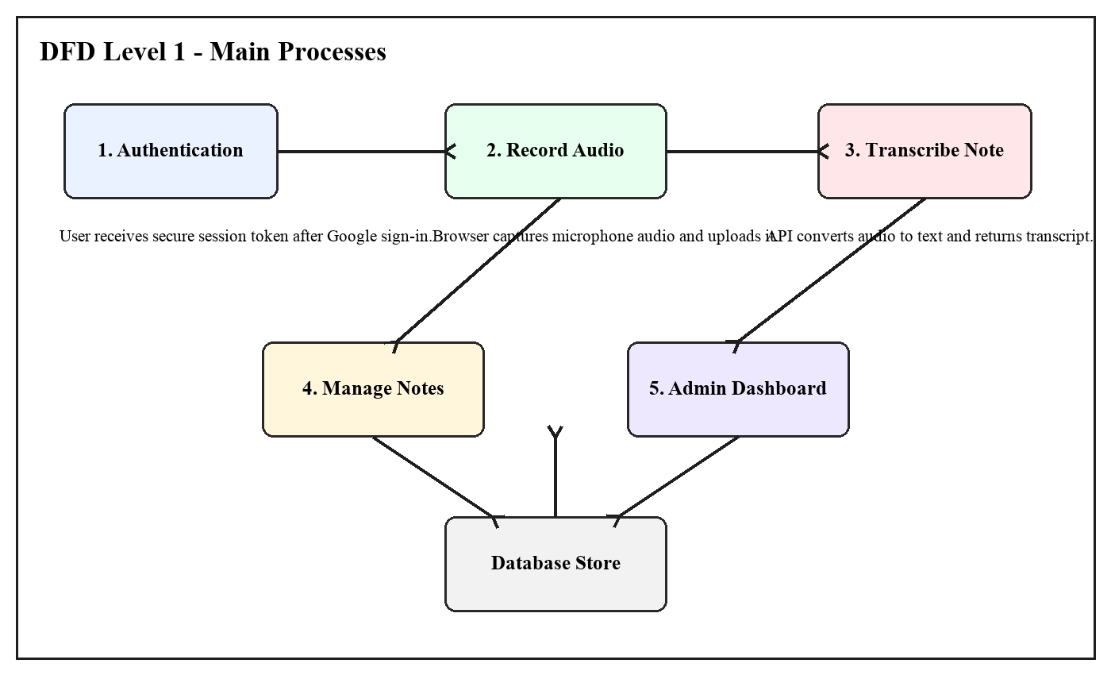
Figure 2: DFD Level 1
3.2 Table Structure
Table 1: users
Field | Type | Description
id | INT, Primary Key | Unique user id
name | VARCHAR(120) | User name
email | VARCHAR(255) | User email
oauth_provider | VARCHAR(40) | OAuth provider
oauth_subject | VARCHAR(255) | OAuth user id
avatar_url | VARCHAR(500) | Profile image
last_login_at | DATETIME | Last login
role | ENUM | User or admin
created_at | TIMESTAMP | Creation time
Table 2: sessions
Field | Type | Description
id | INT, Primary Key | Unique session id
user_id | INT | Linked user
token_hash | CHAR(64) | Secure token hash
expires_at | DATETIME | Expiry time
created_at | TIMESTAMP | Creation time
Table 3: notes
Field | Type | Description
id | INT, Primary Key | Unique note id
user_id | INT | Owner user
title | VARCHAR(255) | Note title
content | TEXT | Note content
created_at | TIMESTAMP | Creation time
3.3 Menu Design

Figure 3: Menu Design
3.4 Screen Design (Screen shots with short description)
Login/Register screen allows the user to continue with Google OAuth and start a secure session.
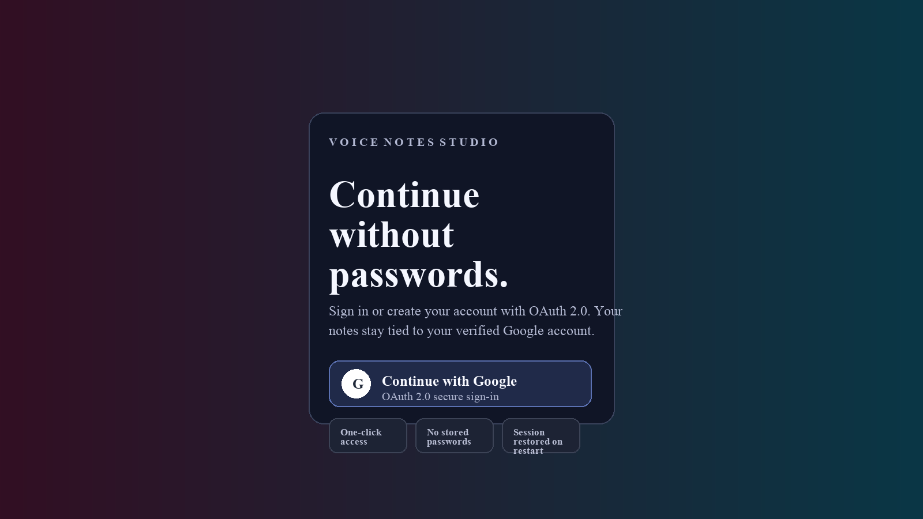
Figure 4: Login/Register Page
User dashboard shows the recorder, search box, sorting option, user menu, and note cards.
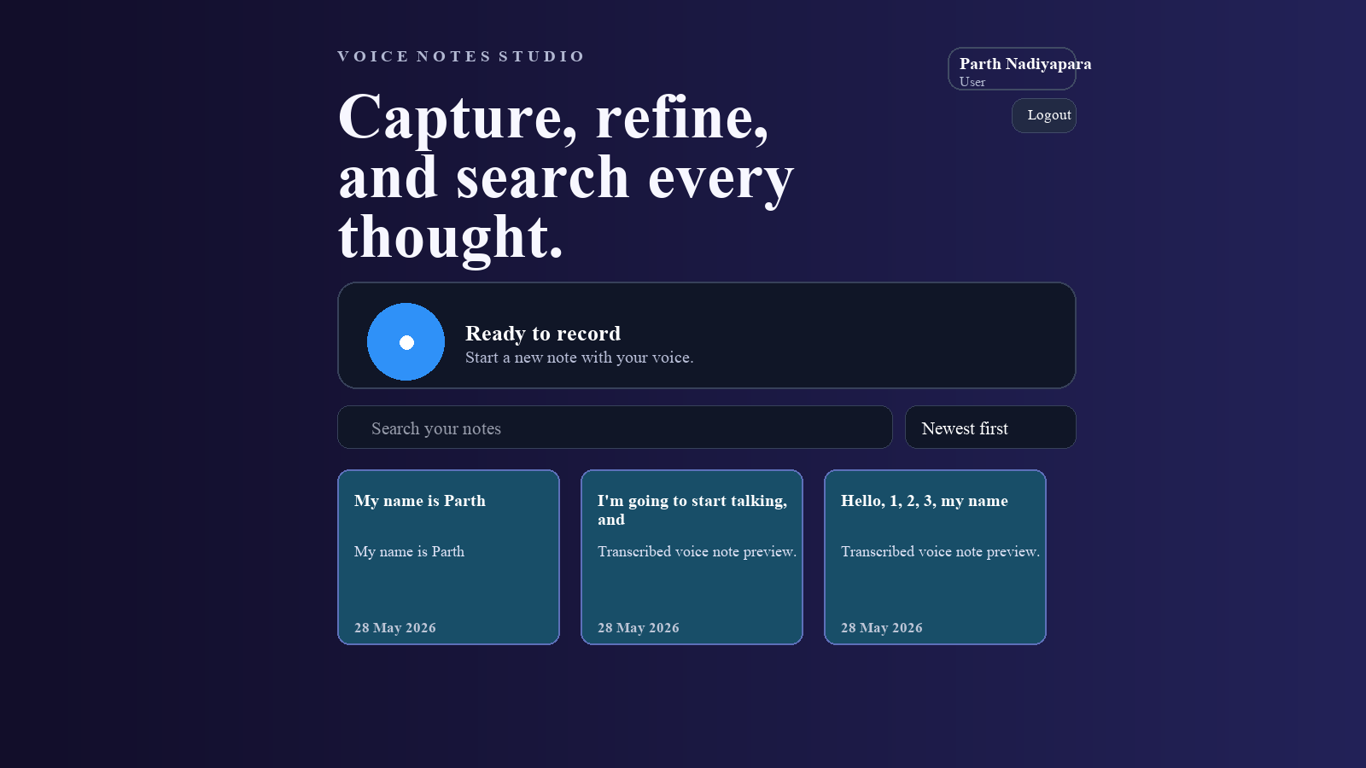
Figure 5: User Dashboard
Admin dashboard includes total user and note summary with access to user details.
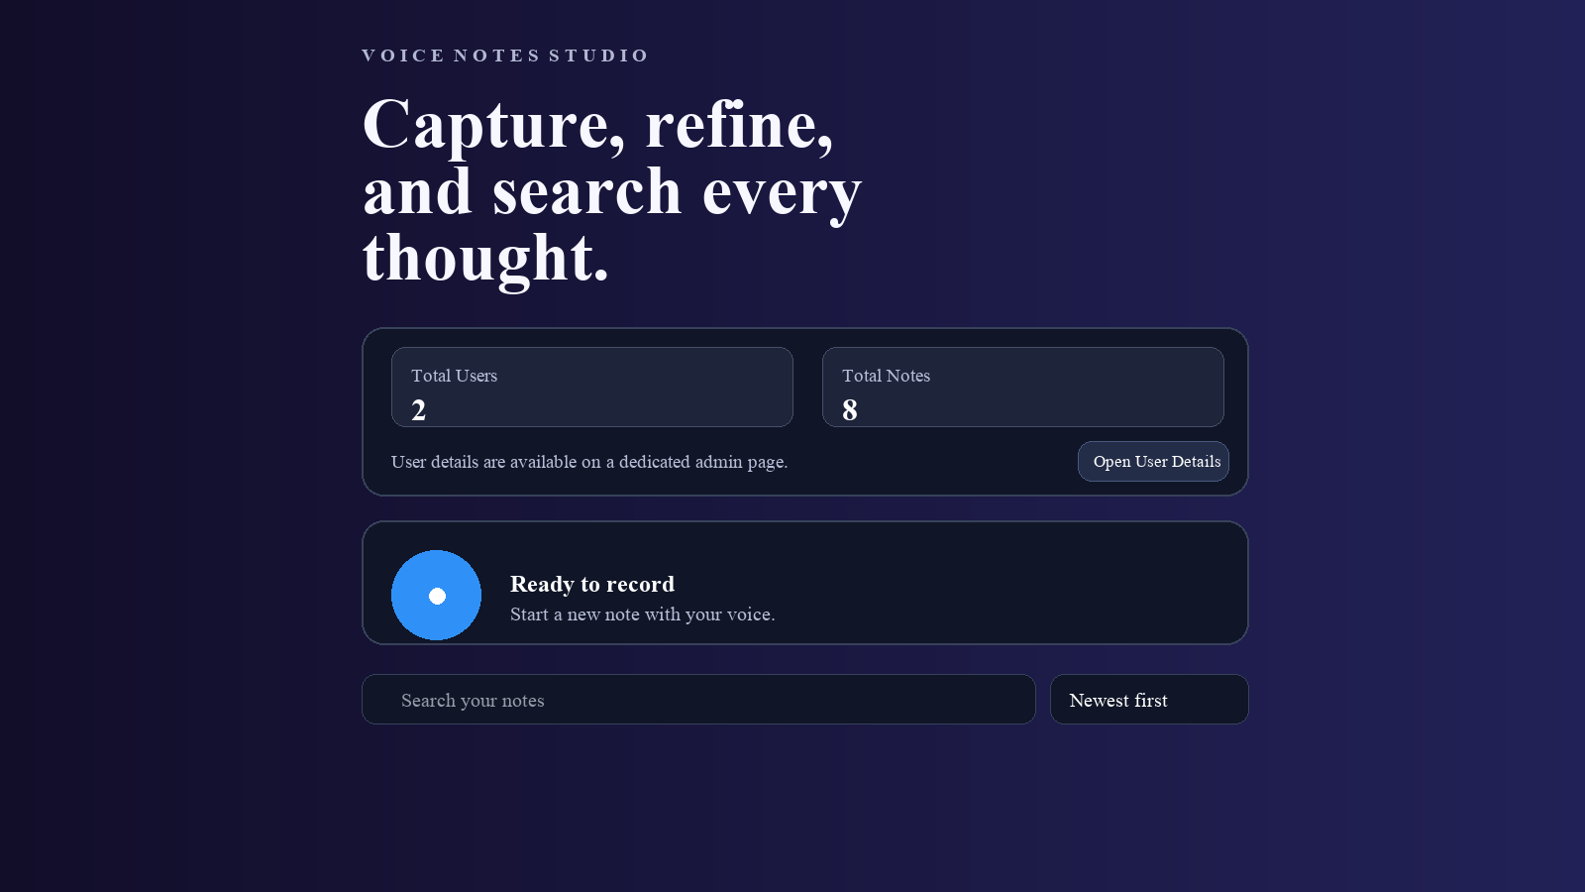
Figure 6: Admin Dashboard
4. CONCLUSION
Voice Notes Studio successfully provides a simple way to convert spoken thoughts into organized text notes. It combines secure login, audio recording, transcription, database storage, and note management in one system.
The project is useful for users who want faster note creation and easy searching of saved thoughts. It can be expanded in future with reminders, tags, sharing, export options, and more language support.
5. LEARNING DURING PROJECT WORK
During this project work, we learned how to connect a React frontend with an Express backend and MySQL database. We also learned how to handle microphone recording, audio upload, transcription, authentication, sessions, and role based admin access.
This project improved our practical knowledge of full stack development, API integration, database table design, debugging, and user interface planning.
6. BIBLIOGRAPHY
6.1 Online References
React Documentation - https://react.dev/
Express Documentation - https://expressjs.com/
MySQL Documentation - https://dev.mysql.com/doc/
Google OAuth Documentation - https://developers.google.com/identity/protocols/oauth2
MDN MediaRecorder API - https://developer.mozilla.org/en-US/docs/Web/API/MediaRecorder
6.2 Offline References
College notes
Faculty guidance
Project source code

