A Project Report On

Weather Data Analysis

Submitted in partial fulfillment of the requirement for the BCA Semester-4 Python Programming Subject Final Examination.
BACHELOR OF COMPUTER APPLICATIONS
(B.C.A.)

Academic Year 2025 – 26

Parth Nadiyapara - (92400527071)

Internal Guide
Prof. Jitesh Solanki



Rajkot-Morbi Road, At & PO : Gauridad, Rajkot 360 003. Gujarat. India.

CONTENTS

Chapters | Particulars | Page No.
1 | SYNOPSIS | 4
2 | PREAMBLE | 5
2.1 | General Introduction | 5
2.2 | Statement of Problem | 5
2.3 | Objective and Scope of the Study | 5
2.4 | Module Description with functionality | 6
3 | SYSTEM DESIGN AND DEVELOPMENT | 8
3.1 | Data Flow Diagram (DFD) | 8
3.2 | Table Structure | 10
3.3 | Menu Design | 11
3.4 | Screen Design (Screen shots with short description) | 12
4 | CONCLUSION | 13
5 | LEARNING DURING PROJECT WORK | 15
6 | BIBLIOGRAPHY | 16
6.1 | Online References | 16
6.2 | Offline References | 16

FIGURE INDEX

Sr. No. | Figure No. | Particulars | Page No.
1 | 1 | Menu Design Page | 11
2 | 2 | Home Page | 12
3 | 3 | History Page | 13

TABLE INDEX

Sr. No. | Table No. | Particulars | Page No.
1 | 1 | Favourite_Cities | 10
2 | 2 | Weather_History | 10

1. SYNOPSIS

This project focuses on analyzing weather data using Python and presenting the results through a modern graphical user interface built with CustomTkinter.

The system collects weather-related data such as temperature, humidity, wind speed, and atmospheric pressure from datasets or APIs.

It processes and visualizes this data to identify patterns, trends, and insights over time. The application provides users with an interactive interface where they can view summaries, graphs, and comparisons of weather conditions.

The goal of the project is to make weather data analysis simple, visually appealing, and accessible for users without requiring deep technical knowledge.

2. PREAMBLE

2.1 General Introduction

Weather data analysis plays an important role in understanding climate patterns and predicting environmental changes. With the advancement of technology, large amounts of weather data are generated daily, making it essential to analyze and interpret this information effectively.

This project utilizes Python, a powerful programming language, along with CustomTkinter to build a user-friendly application for analyzing weather data.

The system allows users to interact with data visually, making complex information easier to understand.

It combines data processing and graphical representation to enhance decision-making and awareness.

2.2 Statement of Problem

Many existing weather analysis tools are either too complex for beginners or lack an interactive and user-friendly interface. Users often face difficulties in understanding raw weather data due to the absence of proper visualization and simplified presentation.

Additionally, traditional systems may not provide real-time insights or easy navigation. This project addresses these issues by developing a simple, intuitive application using CustomTkinter that allows users to analyse weather data efficiently.

It aims to bridge the gap between complex data analysis and user accessibility.

2.3 Objective and Scope of the Study

The main objective of this project is to design and develop an application that can analyze and visualize weather data effectively using Python. It aims to provide clear insights into weather patterns through graphs and summaries. The scope of the study includes data collection, processing, and visualization within a desktop application environment.

The system can be extended in the future to include real-time data fetching, predictive analysis, and advanced graphical features. It is suitable for students, researchers, and general users who want to explore weather trends in a simple way.

Module Description with functionality

- User Interface Module (CustomTkinter GUI)

- This module is responsible for creating the graphical user interface of the application.
- It is developed using the CustomTkinter library.
- It allows users to:
  - Enter city names for weather search
  - View current weather details
  - Check 7-day forecast
  - Manage favorite cities
- It displays data in a visually attractive dashboard format with cards and panels.
- It also handles user interactions like button clicks, search actions, and navigation between sections.
- Implemented in: main_window.py

- Weather API Module

- This module is responsible for fetching real-time weather data from the external API.
- It connects to the OpenWeather API using HTTP requests.
- It provides:
  - Current weather data (temperature, humidity, wind, etc.)
  - Forecast data (5–7 days)
- It processes JSON responses and converts them into usable Python data structures.
- Ensures proper error handling if API fails or data is not found.
- Implemented in: weather_api.py

- Database Management Module

- This module handles all database operations using MySQL.
- It stores:
  - Weather search history
  - Favorite cities
- It provides functions to:
  - Insert weather data
  - Retrieve top searched cities
  - Add/remove favorite cities
- Ensures proper connection handling and error management.
- Helps in analyzing past weather searches.
- Implemented in: db_manager.py

- Favourites Management Module

- This module manages the list of favourite cities.
- It stores data locally in a JSON file for quick access.
- Functionalities include:
  - Add city to favourites
  - Remove city from favourites
  - Check if a city is already favourite
- It can also synchronize data with the database if available.
- Provides persistent storage even after application restart.
- Implemented in: favorites.py

- Data Visualization Module

- This module is responsible for displaying weather data in graphical form.
- It uses charts to show:
  - Temperature trends
  - Minimum and maximum temperature ranges
- Improves user understanding through visual representation.
- Uses matplotlib integrated with Tkinter.
- Implemented in: charts.py

- Configuration Module

- This module stores all important configuration settings of the application.
- It includes:
  - API keys
  - Database credentials
  - Application settings (window size, units, etc.)
- Centralizes configuration for easy modification and maintenance.
- Improves code reusability and security.
- Implemented in: config.p

3. SYSTEM DESIGN AND DEVELOPMENT

3.1 Data Flow Diagram (DFD)

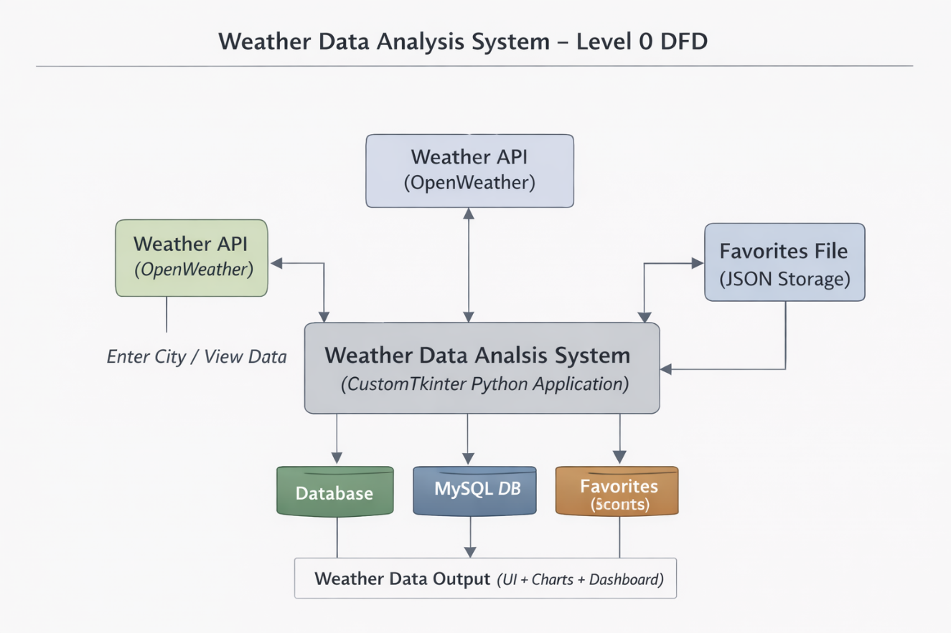
Fig : 1 DFD Diagram level 0

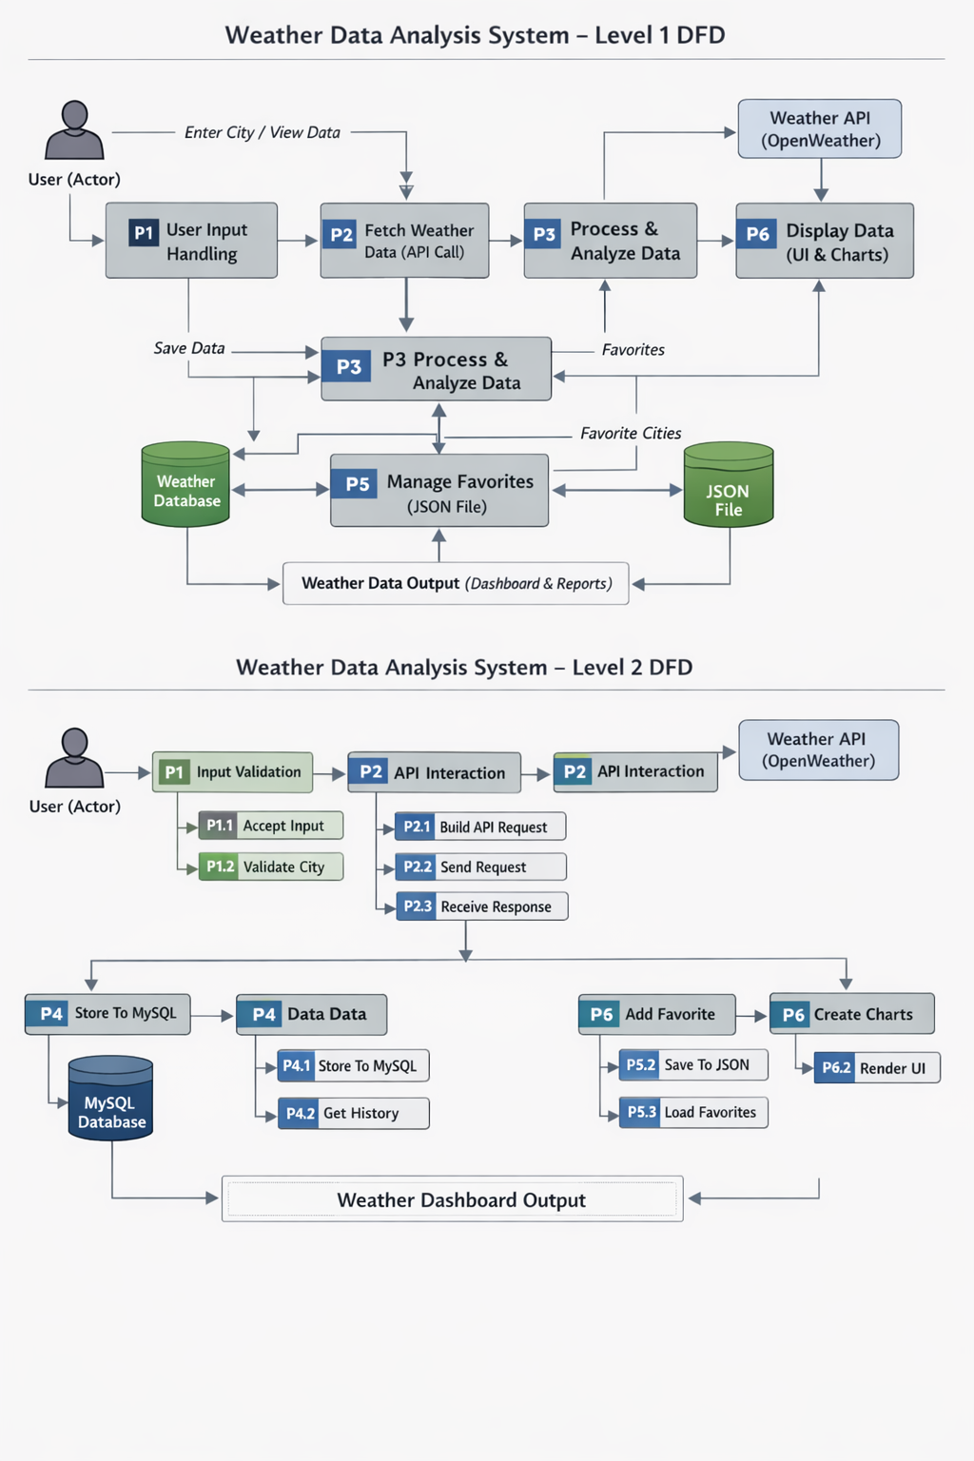
Fig : 2 DFD Diagram level 1


Fig : 3 DFD Diagram level 2

3.2 Table Structure

Favourite_Cities

Fields | Data-type | Description
Id | Int(11) | Unique ID of each city.
City | Varchar(100) | Name of the city.
Country | Varchar(100) | Country of the city.
Added_date | Datetime | Date when city was added.

Weather_history

Fields | Data-type | Description
Id | Int(11) | Unique ID of each record.
City | Varchar(100) | Name of the city.
Country | Varchar(10) | Country of the city.
Temperature | Float | Current temperature.
Feels_like | Float | Feels like temperature.
Humidity | Int(11) | Humidity level.
Pressure | Int(11) | Atmospheric pressure.
Wind_speed | Float | Wind speed.
Description | Varchar(200) | Weather condition.
Search_date | datetime | Date of weather search.

3.3 Menu Design

Fig 1 : Menu Design Page

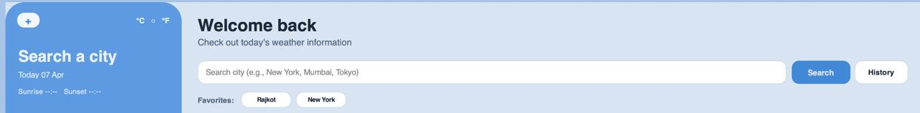
- It Allows users to search for any city and view its current weather details.

3.4 Screen Design

Fig 2 : Home Page

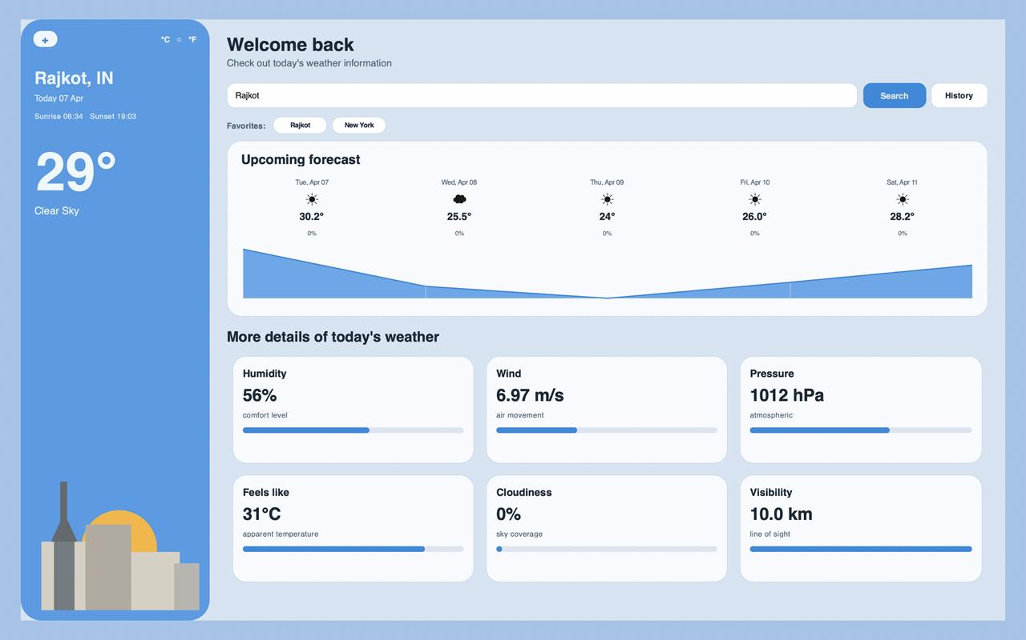

- It displays current weather, 5-day forecast, and detailed parameters like humidity, wind, pressure, and visibility.

Fig 3 : History Page

- It Shows the most searched cities along with their search frequency for user reference.

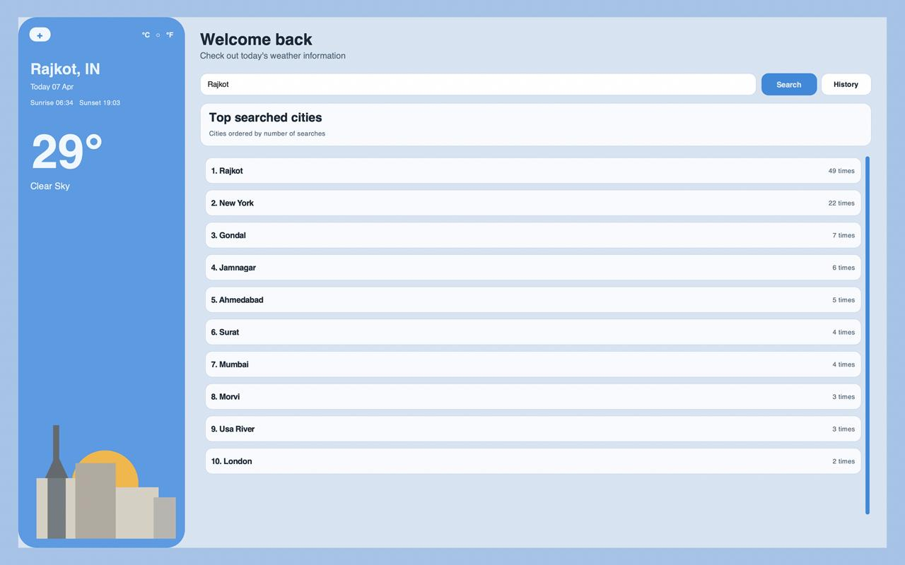

4. CONCLUSION

The Weather Data Analysis using CustomTkinter project successfully demonstrates how weather data can be collected, processed, and presented in an interactive and user-friendly manner using Python. The system integrates multiple components such as API communication, database management, and graphical visualization to provide accurate and meaningful weather insights.

The use of a modern GUI enhances the overall user experience, making it easy to understand complex weather information through charts and dashboards. This project not only meets its objective of simplifying weather data analysis but also provides a strong foundation for future enhancements such as real-time updates, predictive analysis, and mobile integration.

5. LEARNING DURING PROJECT WORK

During the development of this project, several important concepts and practical skills were gained. A deeper understanding of Python programming was developed, especially in handling APIs, managing data, and structuring a complete application. The use of CustomTkinter helped in learning how to design modern graphical user interfaces that are both functional and visually appealing.

Knowledge of database management using MySQL was improved by performing operations like storing and retrieving data. Additionally, working with data visualization libraries enhanced the ability to represent information clearly through charts.

This project also strengthened problem-solving skills, debugging techniques, and the ability to integrate multiple modules into a single working system, providing valuable real-world development experience

6. BIBLIOGRAPHY

6.1 Online References

Offical Python Documentation - https://docs.python.orga

CustomTkinter Documentation - https://github.com/TomSchimansky/CustomTkinter a

OpenWeather API Documentation - https://openweathermap.org/api a

W3Schools Python Tutorial - https://www.w3schools.com/python a

GeeksforGeeks - https://www.geeksforgeeks.orga

Offline References

- Python Programming Book
- College Notes
- Faculty Guidance

