Billing & Inventory Management System
Functional Requirements, High-Level Design and Database Schema
Business: Construction material retail — 1 shop, 2 godowns
Version: 2.2 — questionnaire answers; Vercel, Railway, Supabase; React + Tailwind UI, Go API
Date: 10 October 2026
Supersedes: Billing_Inventory_Requirements.docx v1.0
Companion file: schema.sql (Supabase-ready PostgreSQL, tested)

Contents

1. Introduction

1.1 Purpose and scope
This document turns the owner's questionnaire answers into functional requirements, and recommends a high-level design (HLD) and database schema for a web-based billing and inventory system used on desktop and phone. It replaces version 1.0, which was written on default assumptions.
In scope for version 1:
- Cash and Account bills (GST tax invoices) with labour and transport charges, discounts, editing and cancellation.
- GST e-invoicing (IRN and signed QR) for B2B invoices and credit notes, and e-way bill generation.
- Customer credit, part payments and ledger; dealer (supplier) purchases and payables.
- Inventory across one shop and two godowns: purchases into a chosen location, transfers, adjustments, returns.
- Category-specific item attributes and units defined while setting up each category.
- Shortage alerts to the Super Admin when a bill is blocked, plus reorder alerts.
- Dashboard, reports, Excel/PDF exports, Tally import (one-time) and Tally export (ongoing).
- Two roles (Super Admin, Admin); up to 10 user accounts, 3 using it at once.
Out of scope for version 1: card payments, thermal and A5 printing, Kannada invoices, batch and expiry tracking, online payment gateway, customer portal, more locations than shop + 2 godowns (the design allows adding them later).

1.2 What changed from version 1.0
Topic | Version 1.0 assumption | Version 2.0 (your answer)
Account bills | Like a quotation; no ledger; Super Admin only | Bills for payments received into the bank account; can be independent or copied from a Cash bill; post to the customer ledger immediately
GST | GST invoice, no e-invoicing | GST invoices and e-invoicing
Payment modes | Includes card | Cash, UPI, cheque, bank transfer; credit and part payments
Editing bills | Cancel only, no edit | Edit and cancel both allowed (with version history)
Extra charges | Transport, loading, discounts | Labour and transport charges
Units | Fixed list with conversions | Custom units, added while setting up a category
Selling price | One price per item | Price entered on every invoice (varies by customer and material)
Stock shortage | Block the bill | Block the bill and alert the Super Admin to reorder
Locations | Single location | One shop + two godowns; purchase entry names the godown
Item details | Brand + grade/size | Different attributes per category (brand, size, weight, shape)
Admin visibility | Cost, profit, Account bills hidden | Nothing hidden; Admins also enter purchases with rates
Users | 5 concurrent, 50 accounts | 3 concurrent, 10 accounts
Dead stock | Alert after 90 days | Not needed (no expiry)
Tally | One-time import only | Import from Tally and ongoing export to Tally
Hosting | Cloudflare Pages + Supabase Pro | Website on Vercel, backend on Railway, database on Supabase (Free in development, Pro in production); no self-managed database

1.3 Definitions
Term | Meaning
Cash bill | GST invoice that reduces stock at the chosen location when saved and posts to the customer ledger.
Account bill | GST invoice for sales paid into the shop's bank account. Never changes stock. Created independently or copied from a Cash bill. Has its own number series.
Account copy | An Account bill copied from a Cash bill. It is linked to the source and does not post to the ledger or sales again (see BR-04).
Location | Where stock is held: Shop, Godown 1, Godown 2.
Base unit | Unit in which an item's stock is stored; other units convert to it.
IRN / IRP | Invoice Reference Number issued by the GST Invoice Registration Portal for an e-invoice.
GSP / ASP | Licensed provider whose API the system calls to reach the IRP and e-way bill portal.
FY | Indian financial year, 1 April – 31 March.

2. Users and Roles
Admins run day-to-day billing, purchases and inventory and can see everything, including cost and profit. The Super Admin additionally controls actions that are irreversible or affect money already recorded.
Capability | Super Admin | Admin
Create Cash and Account bills; copy a Cash bill to an Account bill | Yes | Yes
Edit a saved bill | Yes | No — request edit (open item O-02)
Cancel a bill; cancel an e-invoice | Yes | No
Create sales returns | Yes | Yes (takes effect after approval)
Approve sales returns / credit notes | Yes | No
Record payments received and paid | Yes | Yes
Purchases with rates, transfers, stock adjustments | Yes | Yes
Create / edit categories, attributes, units, items, parties | Yes | Yes
Deactivate items, categories, parties | Yes | No
View cost, profit, stock value, all reports, exports | Yes | Yes
Receive shortage and reorder alerts | Yes | View only
Users, shop settings, e-invoice credentials, Tally import | Yes | No
Audit log | Yes | No

3. Functional Requirements
Priority: Must = needed at launch; Should = version 1, may follow shortly after launch; Could = later enhancement.

3.1 Login and users
ID | Requirement | Priority
FR-AU-01 | Login with email and password through Supabase Auth; "forgot password" by email. Public sign-up is disabled — only the Super Admin can invite users. | Must
FR-AU-02 | Super Admin creates users, assigns a role, resets passwords and deactivates users (history is kept). At least one active Super Admin must always exist. | Must
FR-AU-03 | Sessions refresh automatically while in use and end on logout; deactivating a user blocks their next API call immediately. | Must
FR-AU-04 | Every permission in Section 2 is enforced by the server, not only hidden in the screen. | Must

3.2 Billing — common to Cash and Account bills
ID | Requirement | Priority
FR-BL-01 | Bill header: type (Cash / Account), auto number, date, customer (search or quick-add), customer GSTIN, billing and site address, place of supply, vehicle number. | Must
FR-BL-02 | Line items: search item by name, category or attribute (brand, size, shape); choose unit from the item's units; enter quantity and rate. Rate is entered on every bill; the screen shows the last rate charged to this customer, the last purchase rate and the average cost as hints. | Must
FR-BL-03 | Each Cash bill line has a stock location (Shop by default; Godown 1 or 2 selectable). The screen shows available stock at every location for the item. | Must
FR-BL-04 | Charges: labour charge and transport charge (and named other charges), each with its own GST rate / SAC code. Line discount (% or amount) and bill discount. | Must
FR-BL-05 | Tax: CGST + SGST for intra-state supply, IGST for inter-state, decided by place of supply vs shop state. Prices entered GST-exclusive by default (setting allows inclusive). | Must
FR-BL-06 | Totals: taxable value, tax by rate, round-off, grand total, amount in words (Indian format). | Must
FR-BL-07 | Payment at billing: one or more of cash, UPI, cheque (number, bank, date) and bank transfer (UTR). Any unpaid balance is credit on the customer ledger. Walk-in customers (no ledger) must pay in full on Cash bills. | Must
FR-BL-08 | Credit limit check: warn when the customer's outstanding plus this bill exceeds the limit; Super Admin can override. | Should
FR-BL-09 | Drafts can be saved and resumed; a draft has no number and does not touch stock or ledger. | Must
FR-BL-10 | Numbering: separate gap-free series per FY for Cash bills, Account bills and credit notes, at most 16 characters (e.g. C/26-27/0001, A/26-27/0001). Numbers are never reused. | Must
FR-BL-11 | Bill list with filters: number, date, customer, type, status, payment status, e-invoice status, location. | Must
FR-BL-12 | Keyboard-first entry on desktop and a simplified phone layout. | Should

3.3 Cash bills
ID | Requirement | Priority
FR-CB-01 | On save, stock is reduced at each line's location by quantity × unit conversion. Bill, stock and ledger are saved in one database transaction. | Must
FR-CB-02 | If any line exceeds stock at its location, the bill is blocked; the screen lists the short lines with available quantity, and suggests a transfer if another location has stock. | Must
FR-CB-03 | Each blocked attempt raises a "reorder" alert to the Super Admin (in-app notification, plus WhatsApp or email if configured) naming item, location, required and available quantity and the user. | Must

3.4 Account bills
ID | Requirement | Priority
FR-AB-01 | An Account bill uses the same screen, layout and tax logic as a Cash bill, with its own number series and a distinct heading on the print. | Must
FR-AB-02 | An Account bill never changes stock. Stock at locations is shown for information only. | Must
FR-AB-03 | Create independently (named customer required) or with "Copy to Account bill" from an active Cash bill. A copy keeps a link to its source; a Cash bill can have at most one active Account copy. | Must
FR-AB-04 | An independent Account bill posts to the customer ledger immediately on save; any unpaid balance becomes outstanding. | Must
FR-AB-05 | An Account copy does not post to the ledger or count in sales a second time; the source Cash bill already did (see BR-04, open item O-01). | Must
FR-AB-06 | Payments recorded against Account bills are limited to bank modes: UPI, cheque and bank transfer (open item O-03). | Should

3.5 Editing and cancelling bills
ID | Requirement | Priority
FR-ED-01 | Super Admin can edit a saved bill (lines, rates, charges, customer, payments) with a mandatory reason. Before saving, the old version is stored in full in the bill's revision history. | Must
FR-ED-02 | An edit reverses the old stock and ledger effects and applies the new ones in one transaction. If the new version would make stock negative, the edit is blocked. | Must
FR-ED-03 | If an e-invoice (IRN) exists: within 24 hours of generation, the edit cancels the IRN and generates a new one; after 24 hours the bill cannot be edited and the system offers a credit note (or debit note) instead, as the IRN cannot be cancelled after 24 hours. | Must
FR-ED-04 | Edits are not allowed for bills in a period already exported to Tally or marked as GST-filed, unless the Super Admin unlocks the period (logged). | Should
FR-ED-05 | Cancel (Super Admin, with reason): reverses stock and ledger, cancels IRN / e-way bill if still allowed, keeps the number, and prints "CANCELLED" on reprints. | Must
FR-ED-06 | Bill screen shows version number and a "History" tab comparing versions. | Should

3.6 E-invoicing and e-way bills
ID | Requirement | Priority
FR-EI-01 | For B2B bills (customer GSTIN present) and their credit notes, generate an e-invoice through a GSP/ASP API after save, and store IRN, acknowledgement number/date and signed QR. B2C bills do not need an IRN. | Must
FR-EI-02 | E-invoice generation runs as a background job with automatic retry; failures appear on the dashboard and notify the Super Admin. A bill can be printed with the QR only after the IRN is received. | Must
FR-EI-03 | Cancel an IRN within the IRP's 24-hour window from the bill screen. | Must
FR-EI-04 | Generate e-way bill (Part A from bill data, Part B with vehicle number) when the consignment value requires it; store the EWB number and validity and print it on the invoice. | Should
FR-EI-05 | Every request and response to the GSP is logged for troubleshooting. | Must

3.7 Returns and credit notes
ID | Requirement | Priority
FR-RT-01 | Create a return against a Cash or Account bill, choosing items and quantity up to the quantity sold less earlier returns, and the location where goods go back. | Must
FR-RT-02 | Returns created by an Admin stay "Pending" until the Super Admin approves; on approval the credit note is numbered, stock is restored (Cash bills only, unless marked damaged) and the ledger is credited or a refund recorded. | Must
FR-RT-03 | Credit notes are GST-compliant and e-invoiced when the original was. | Must

3.8 Customers, ledger and payments
ID | Requirement | Priority
FR-CU-01 | Party master for customers and dealers: name, mobile, GSTIN (format-validated), state, address, sites, credit limit, opening balance. | Must
FR-CU-02 | Customer ledger with every bill, payment, credit note and opening balance, running balance, and PDF statement. | Must
FR-CU-03 | Record payments received (cash, UPI, cheque, bank transfer) on account or against specific bills; print a receipt. Cheques track status: pending, cleared, bounced (bounce re-opens the amount). | Must
FR-CU-04 | Outstanding report with ageing (0–30, 31–60, 61–90, 90+ days); share statement or reminder on WhatsApp. | Must

3.9 Categories, attributes, units and items
ID | Requirement | Priority
FR-IN-01 | Category setup wizard: name, default HSN and GST rate, the units allowed in this category (choose existing or add new units on the spot), and the attributes items in this category have. | Must
FR-IN-02 | Attributes per category: label, type (text, number, pick-list), unit (mm, kg/m, L), required or optional. Examples: Cement – brand; Steel – brand, size; Nails – size; Waterproofing – brand, pack size; Steel pipes – size, weight, shape. | Must
FR-IN-03 | Item: category, attributes, name (auto-built from attributes, editable), HSN, GST rate, base unit and alternate units with conversion factor, reorder level, optional SKU/barcode and image. No fixed selling price. | Must
FR-IN-04 | Duplicate check on category + attribute values. | Must
FR-IN-05 | Deactivate rather than delete; inactive items are hidden from billing but stay in history. | Must
FR-IN-06 | Bulk item import/export via Excel template per category (columns follow that category's attributes). | Should
FR-IN-07 | Unit conversion factors cannot change once an item has transactions; add a new unit instead. | Must

3.10 Purchases, dealers, transfers and adjustments
ID | Requirement | Priority
FR-PU-01 | Purchase entry (Admin or Super Admin): dealer, dealer invoice number and date, receiving location (Godown 1, Godown 2 or Shop; can differ per line), items, quantity, unit, rate, GST, freight. Duplicate dealer invoice numbers are rejected. | Must
FR-PU-02 | Saving adds stock at the location and updates the item's weighted average cost (freight apportioned). | Must
FR-PU-03 | Dealer ledger with payments made (all modes) and outstanding payable; purchase returns reduce stock. | Must
FR-PU-04 | Stock transfer between Shop and godowns with transfer note; stock moves in one transaction. | Must
FR-PU-05 | Stock adjustment with mandatory reason (damage, breakage, wastage, count correction, sample, other). | Must
FR-PU-06 | Physical stock count per location with variance report and one-click adjustment. | Should
FR-PU-07 | Item stock ledger: every movement with date, document, location, in, out, running balance, user. | Must

3.11 Dashboard
ID | Requirement | Priority
FR-DB-01 | Stock overview: total items, stock quantity and value overall, by category and by location (Shop, Godown 1, Godown 2). | Must
FR-DB-02 | Low-stock and out-of-stock list (reorder level vs total stock) with "Create purchase" and "Transfer" actions; blocked-bill alerts list. | Must
FR-DB-03 | Sales today / month / FY, Cash vs Account split, trend chart. | Must
FR-DB-04 | Gross profit for the period (sales value less average cost of goods sold). | Must
FR-DB-05 | Outstanding receivables and payables, top customers by outstanding, cheques pending. | Must
FR-DB-06 | Fast-moving and slow-moving items for the period (top / bottom 10 by quantity sold). | Must
FR-DB-07 | Pending work: e-invoice failures, returns awaiting approval, unsynced Tally exports. | Must
FR-DB-08 | Inventory grid: searchable, filterable by category, attribute and location, with stock per location, status badge and drill-down to stock ledger. | Must

3.12 Reports and exports
All reports filter by date range, location and category where relevant, and export to Excel and PDF.
Report | Contents
Sales register | Cash and Account bills (Account copies excluded) with tax and payment status
Bill-type register | Cash bills, Account bills, and link between copies and sources
Item / category-wise sales | Quantity, value, cost and profit
GST reports | B2B by GSTIN, B2C, HSN summary, credit notes, e-invoice status — to support GSTR-1 and GSTR-3B
Purchase register and input GST | By dealer, item and period
Stock summary / movement | Per location: opening, in, out, closing, value
Transfers and adjustments | With reasons and users
Outstanding and ageing | Receivables and payables
Collections and payments | By mode and date; cheque status
Edits and cancellations | All bill revisions and cancellations with reasons

3.13 Tally import and export
ID | Requirement | Priority
FR-TI-01 | One-time import from Tally (XML or Excel export): stock groups → categories, stock items, units, customer and dealer ledgers, opening stock per godown and opening balances at a cut-over date. Preview, fix and confirm before anything is written (scope: open item O-05). | Must
FR-TI-02 | Ongoing export to Tally as XML importable into Tally: sales vouchers (Cash and Account bills), credit notes, receipts, purchases, payments, and new ledgers / items. Ledger names are mapped once in settings. | Must
FR-TI-03 | Export is incremental: each document version is exported once; edited or cancelled bills are re-exported as alterations / cancellations. | Must
FR-TI-04 | Export history with period, counts and file download. | Must

3.14 Notifications, settings and audit
ID | Requirement | Priority
FR-NT-01 | In-app notification centre (bell icon) for shortage, reorder, return approval, e-invoice failure and backup failure. | Must
FR-NT-02 | Daily reorder digest to the Super Admin listing items at or below reorder level, by email or WhatsApp. | Should
FR-ST-01 | Settings: shop profile, GSTIN, bank / UPI details, invoice terms, number prefixes, GST options, GSP credentials, Tally ledger mapping, notification channels. | Must
FR-AL-01 | Append-only audit log of logins, creates, edits (before/after), cancellations, approvals, exports and settings changes. | Must

4. Business Rules
# | Rule
BR-01 | Only Cash bills, purchases, returns (restockable), transfers and adjustments change stock. Account bills never do.
BR-02 | Stock at any location can never go below zero. Enforced in the database.
BR-03 | Both Cash and Account bills are GST tax invoices and are included in GST reports.
BR-04 | A sale is counted once: an Account copy linked to a Cash bill does not post to the ledger, sales or profit again. Independent Account bills do.
BR-05 | Rate is entered on every line; there is no master selling price.
BR-06 | Profit uses weighted average cost at the moment of sale.
BR-07 | Every edit stores the previous version; numbers are never reused.
BR-08 | An e-invoiced bill can be edited or cancelled only within 24 hours of IRN generation; after that, corrections are by credit/debit note.
BR-09 | Credit sales require a named customer.

5. Non-Functional Requirements
ID | Requirement | Priority
NFR-01 | Performance: item search < 300 ms over 5,000 items; bill save < 2 s; dashboard < 3 s with 3 years of data; for 3 concurrent users. | Must
NFR-02 | Integrity: stock, bill and ledger written in one transaction; concurrent bills cannot oversell; money stored as fixed-point decimals. | Must
NFR-03 | Security: HTTPS only; logins through Supabase Auth; the browser never reads business tables directly — all data goes through the Railway API, which verifies the Supabase token and the user's role; business tables in a private schema not exposed by Supabase's Data API; secrets only in Railway / Vercel environment variables. | Must
NFR-04 | Backups (production): Supabase Pro daily backups (kept 7 days). In addition, a nightly encrypted pg_dump from the worker to separate storage, kept 30 days + 12 monthly. Restore tested before go-live and quarterly. Point-in-time recovery is an optional paid add-on if less than 24 hours of data loss is required. | Must
NFR-05 | Availability: 99.5% during shop hours on the production plans; external uptime monitor on the API health endpoint alerts the owner. | Must
NFR-06 | Usability: responsive from 360 px phone width; installable as a PWA; Indian formats (₹ 1,00,000.00, DD-MM-YYYY, IST). | Must
NFR-07 | Compliance: GST invoice fields per CGST Rules; records retained at least 72 months from the due date of the annual return; e-invoice integration through a licensed GSP/ASP. | Must
NFR-08 | Maintainability: Git repository; database changes only through versioned migrations (Supabase CLI) applied the same way to development and production; automated Go tests against a real PostgreSQL for tax, unit conversion, stock, numbering, edit/cancel and permissions. | Must
NFR-09 | Cost: development on free plans; production on Supabase Pro plus the lowest paid tiers of Railway and of the website host that permit business use (Section 6.5). No per-user licence fees. GSP charges are separate. | Must

6. High-Level Design (Recommended)

6.1 Architecture overview
The website is a React app hosted on Vercel. All business logic runs in a Go API and job worker on Railway. Supabase provides the PostgreSQL database, user logins and file storage, and is fully managed, so nobody at the shop has to run or patch a database server. Development uses the free plans; production moves the database to Supabase Pro.
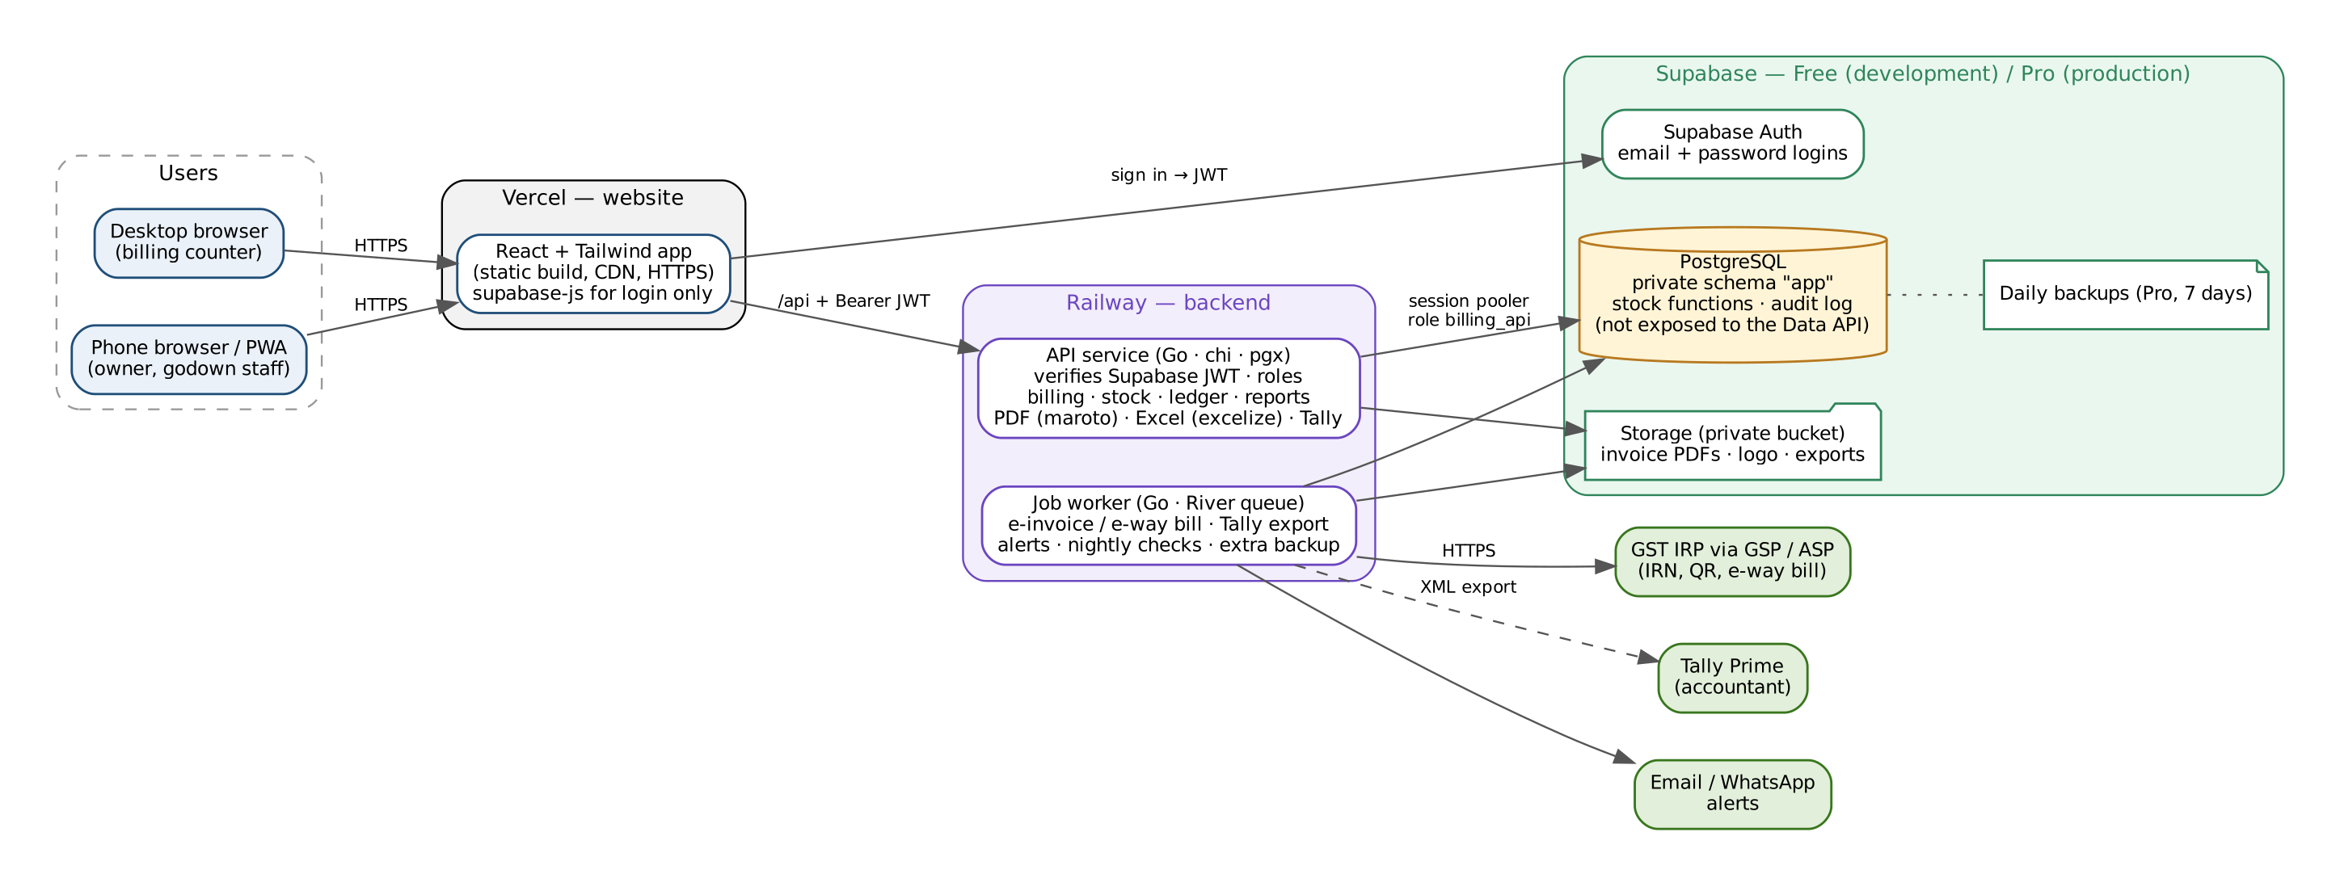
Figure 1 — Deployment and component view
The browser uses Supabase only to sign in. It never queries business tables directly: every read and write goes through the Railway API, which checks the user's role and runs stock and billing changes in one database transaction. This keeps the rules (stock blocking, numbering, edits, e-invoice) in one place.

6.2 Components
Component | Responsibility | Technology / host
Web app | Billing, inventory, dashboard and reports screens; responsive; installable PWA; sign-in through Supabase Auth | React 18 + TypeScript, Vite, Tailwind CSS, shadcn/ui components, TanStack Query and Table, React Hook Form + Zod, Recharts, supabase-js — Vercel
API service | Verifies the Supabase access token, loads the user's role, enforces permissions, business rules and transactions; PDF invoices; Excel exports; Tally import | Go 1.23+, chi router, pgx + sqlc (type-safe SQL), shopspring/decimal, go-playground/validator, maroto (PDF), excelize (Excel), JWKS token check — Railway
Job worker | E-invoice / e-way bill calls with retry, Tally XML export, shortage and reorder alerts, nightly stock check, extra nightly backup | Same Go codebase and binary; River job queue stored in PostgreSQL (no Redis) — Railway (runs inside the API process in development)
Database | All business data in private schema "app"; stock and numbering functions; constraints; audit log | Supabase PostgreSQL — Free (dev), Pro (prod)
Authentication | Email + password logins, password reset, sessions; role kept in app.app_user | Supabase Auth
File storage | Invoice PDFs, logo, export files in a private bucket; downloads through short-lived signed links from the API | Supabase Storage
External | IRP via GSP/ASP; email (SMTP); WhatsApp messages; uptime monitor | Chosen provider APIs

6.3 Technology choices
Area | Choice | Reason
UI | React 18 + TypeScript + Vite; Tailwind CSS; shadcn/ui (Tailwind-based, copy-in components) | Your choice of React + Tailwind; shadcn/ui gives ready forms, dialogs, tables and command search without a heavy UI library
UI data | TanStack Query (server state), TanStack Table (inventory grid, registers), React Hook Form + Zod (bill entry) | Fast keyboard-driven forms and large sortable tables
Charts | Recharts | Dashboard trends and category breakdowns
PWA | vite-plugin-pwa | Install on phones; caches the app shell (billing still needs internet)
API | Go, chi router, net/http | Small, fast, low memory on Railway (keeps usage cost down); single static binary
Database access | pgx driver + sqlc (SQL compiled to type-safe Go) | SQL stays explicit for stock functions and transactions; no ORM surprises
Money and quantity | shopspring/decimal in Go; numeric in PostgreSQL; strings in JSON | Never float64 for rupees or quantities
Background jobs | River (Postgres-backed queue for Go) | Retries and scheduled jobs (e-invoice, Tally export, alerts, backup) without Redis
Auth | Supabase Auth on the website; API verifies the access token against Supabase's JWKS (signing keys) | No password handling in our code
Documents | maroto (PDF invoices), excelize (Excel exports), encoding/xml (Tally XML) | Pure Go; no headless browser needed
Migrations | Supabase CLI migrations (schema.sql as the first one); River's own tables via its migrator | Same schema in development and production
Testing | Go tests with testcontainers-go (real PostgreSQL); Vitest + Playwright for the UI | Stock, tax and numbering rules tested against a real database
Logging / errors | Go slog (JSON logs to Railway); Sentry free tier optional | Trace failed bills and e-invoice calls

Suggested Go project layout: cmd/api (HTTP server + River worker), internal/billing, internal/inventory, internal/purchase, internal/ledger, internal/einvoice, internal/tally, internal/report, internal/auth, db/queries (sqlc .sql files), db/migrations.
River creates its own job tables. Install them in the app schema (or a separate "river" schema) and grant them to billing_api; they are not part of schema.sql.

6.4 Environments
 | Development (now) | Production (go-live)
Website | Vercel Hobby (free) | Vercel Pro, or Cloudflare Pages free tier (see 6.5)
Backend | Railway free plan; API and worker in one service | Railway Hobby (minimum monthly fee that includes some usage); API and worker as one or two services
Database | Supabase Free project — test data only | Separate Supabase Pro project — real data
Backups | None needed (test data) | Supabase daily backups (7 days) + worker's nightly dump to separate storage
E-invoice | GSP sandbox credentials | GSP production credentials
Data | Sample data and a test import from Tally | Final Tally import at the cut-over date

Keep development and production as two separate Supabase projects. The same migration files (Supabase CLI) create both, so the schema is always identical.

6.5 Plan limits to plan for
Service | Limit on the free plan | Impact and action
Supabase Free | Project pauses after 7 days without activity; no automatic backups; 500 MB database | Fine for development. Reactivate from the dashboard if it pauses. Move to Pro before entering real data.
Supabase Pro | About US$25/month; daily backups kept 7 days; no pausing; 8 GB database included | Production database. Enough for many years of this shop's data.
Railway free | After the trial, a very small monthly usage credit | An always-on API and worker will likely use it up; budget for the Hobby plan (about US$5/month minimum, including US$5 usage) once testing is regular.
Vercel Hobby | Personal, non-commercial use only | Fine while building. Before staff use it for real billing, move to Vercel Pro (about US$20 per member/month) or host the same static build on Cloudflare Pages' free tier, which allows business use.

Indicative production cost: about US$30/month (Supabase Pro + Railway Hobby + Cloudflare Pages), or about US$50/month with Vercel Pro, plus the GSP subscription. Prices should be rechecked before go-live.

6.6 Key flows
Sign in and call the API
- User signs in on the web app with Supabase Auth and receives an access token (JWT).
- Each API call sends the token; the Go API verifies it against Supabase's JWKS signing keys (cached), loads app.app_user for the role and active flag, and rejects deactivated users.
Save Cash bill
- API validates rates, units, tax and permissions.
- In one transaction: allocate the number (row-locked series), insert bill, lines and charges, call fn_post_bill which deducts stock per location (fails if short) and posts ledger and payments.
- If stock is short, the transaction rolls back, the API returns the short lines, and a separate transaction writes the Super Admin shortage alert; the worker also sends it by WhatsApp/email.
- After commit, an e-invoice job is queued for B2B bills; the worker stores the IRN and QR, then generates the PDF into Storage.
Copy Cash bill to Account bill
- Pre-fill a new Account bill from the Cash bill; save with source_bill_id, affects_stock = false, posts_to_ledger = false.
Edit bill
- Check edit rules (role, 24-hour IRN window, locked periods); snapshot the current version into bill_revision.
- In one transaction: fn_unpost_bill (reverse stock and ledger), replace lines, fn_post_bill (re-apply). If the bill had an IRN, queue cancel + regenerate.
Purchase into godown / Tally export
- Purchase: fn_stock_in adds stock at the chosen location, recalculates weighted average cost, credits the dealer ledger.
- Tally export: worker collects documents not yet exported (or edited since), builds Tally XML, records them in tally_export_item and saves the file to Storage.

6.7 Security design
- Business tables live in schema "app", which is not added to Supabase's exposed API schemas; the anon and authenticated roles have no rights on it, and RLS is enabled with access only for the API role.
- The API connects as a dedicated database role (billing_api) through Supabase's session pooler connection string, not as the postgres superuser. That role cannot delete stock history or change the audit log.
- The Supabase service-role key and database password exist only in Railway environment variables; the Vercel app holds only the public anon key used for sign-in.
- CORS on the API allows only the production website domain; rate limiting on login-related endpoints.
- Role checks on every endpoint; edit, cancel and approve re-verified server-side and written to the audit log.
- Supabase Auth settings: public sign-ups disabled (Super Admin invites users), strong password policy, email confirmation on.

6.8 Deployment and operations
- Code in GitHub (one repository with /web and /api folders). Vercel builds the React app and Railway builds the Go API from a small Dockerfile, both automatically on each push to the main branch; pull requests get preview deployments for testing.
- Database migrations live in the repository (Supabase CLI) and are applied to development first, then to production as a deliberate release step.
- Monitoring: uptime check on the API /health endpoint; the worker emails the Super Admin on failed e-invoices, failed backups and nightly stock mismatches. Railway and Supabase dashboards show logs and usage.
- Restore drill before go-live: restore a Supabase backup and the nightly dump into a fresh project and verify stock and ledger totals.

7. Database Schema (Recommended)

7.1 Design principles
- Supabase PostgreSQL. All tables, types and functions are in private schema "app"; pg_trgm is installed in the "extensions" schema as Supabase recommends. Money numeric(14,2), quantity numeric(14,3), cost numeric(14,4); no floating point.
- Users sign in through Supabase Auth; app.app_user holds the name and role and its id is the auth.users id (foreign key).
- Stock held per item per location in stock_balance with CHECK (qty >= 0), so negative stock is impossible even if application code has a bug.
- Every stock change is also written to stock_movement (immutable), which gives the item stock ledger and allows nightly reconciliation.
- Category-specific attributes are defined in category_attribute and stored on the item as JSONB, indexed for search.
- Customers and dealers share one party table and one party_ledger (debit / credit postings), so balances and statements use the same logic.
- Bills keep a snapshot of customer details as printed; edits store full prior versions in bill_revision.
- Document numbers come from doc_series with a row lock: gap-free, per document type, per financial year.
- Critical operations are database functions called inside the API's transaction: fn_next_doc_no, fn_stock_in, fn_stock_out, fn_post_bill, fn_unpost_bill, fn_alert_shortage.

7.2 Entity-relationship diagrams
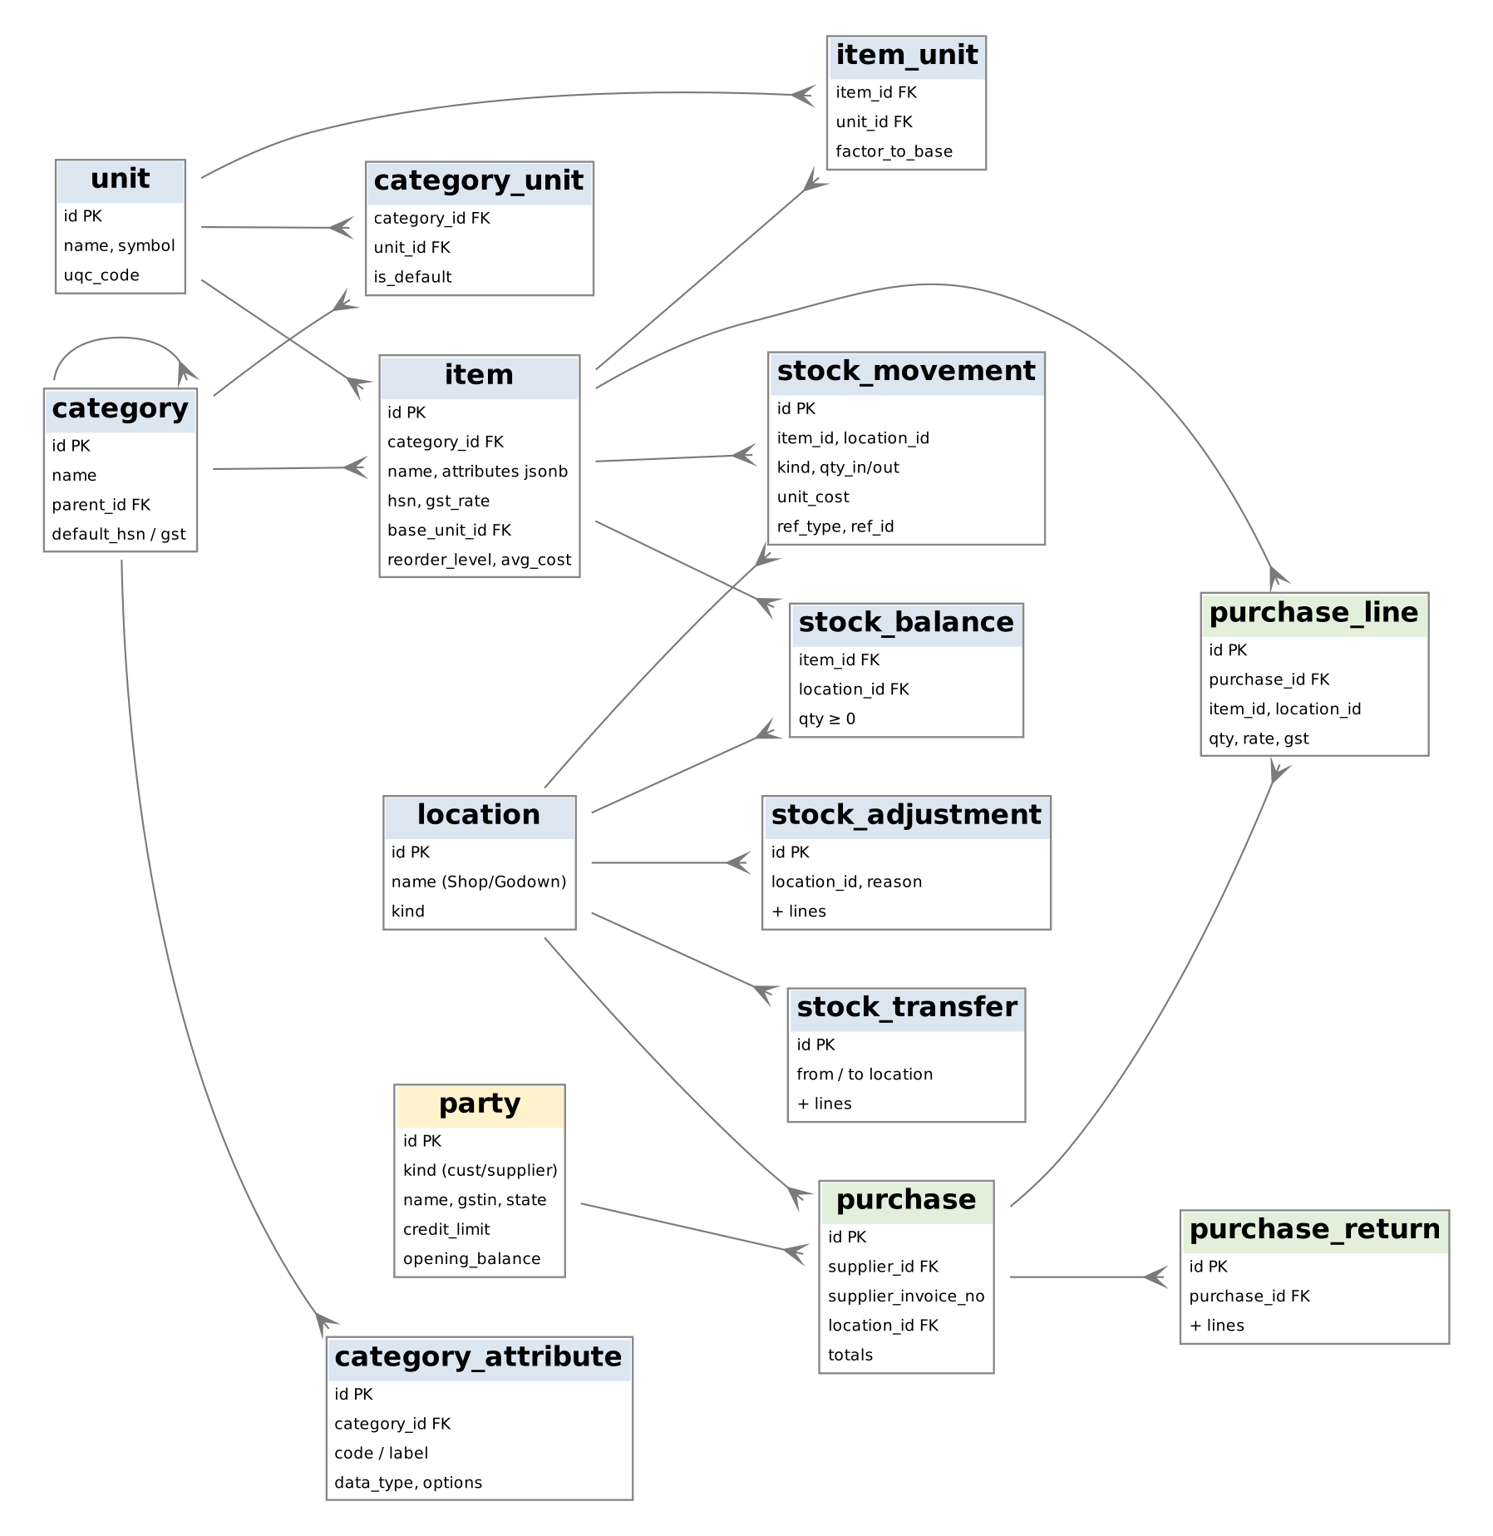
Figure 2 — Catalogue, stock and purchases (crow's foot = "many")
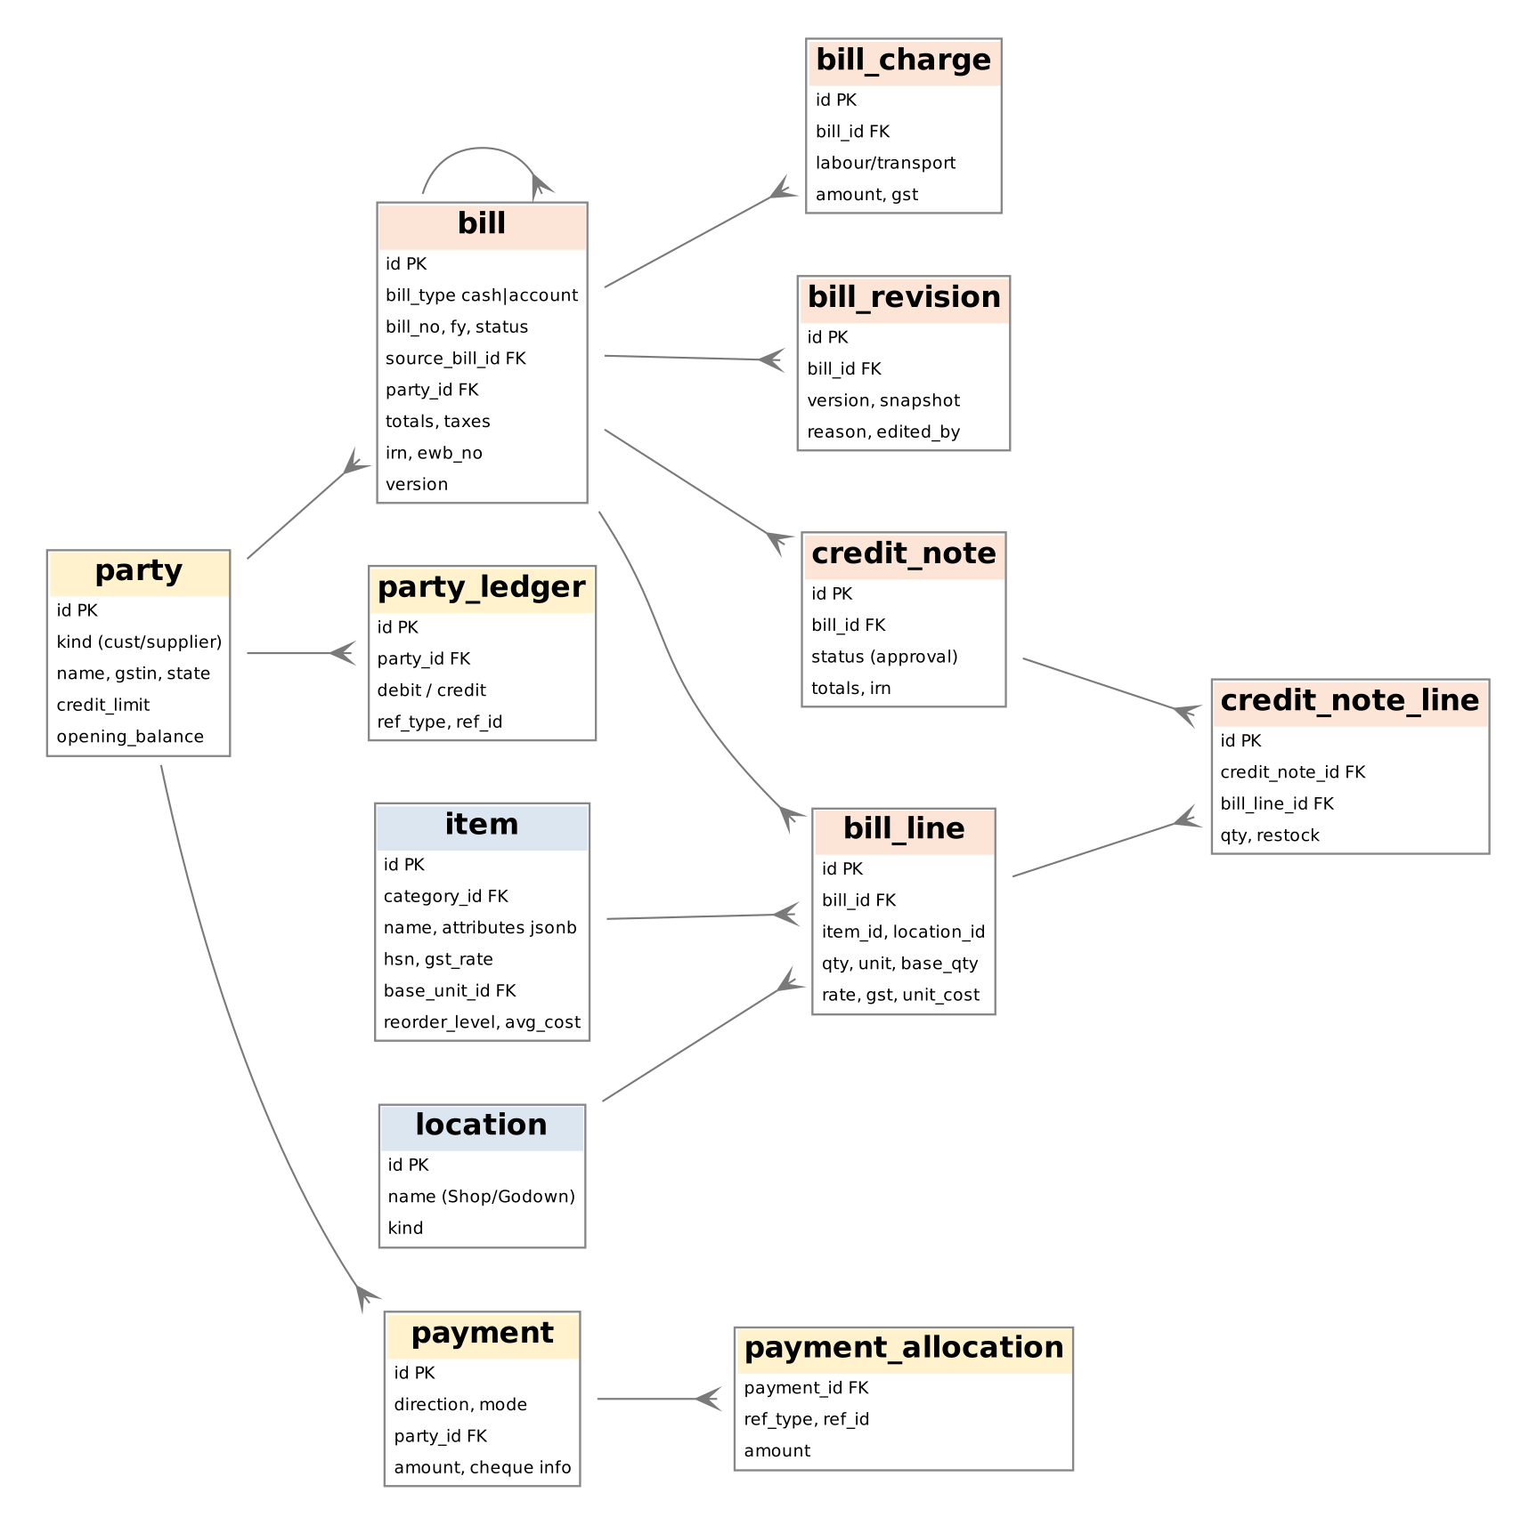
Figure 3 — Sales, returns, parties and payments

7.3 Table catalogue
Table | Purpose | Key columns / constraints
app_user | Profile and role of each Supabase Auth user | id = auth.users.id, email, role (super_admin/admin), is_active
shop_settings | Single-row shop profile and options | gstin, state_code, bank, terms, e-invoice flag
location | Shop, Godown 1, Godown 2 | kind, one default billing location
unit | Custom units | name, symbol, GST UQC code, decimals
category | Product categories (9 today) | default HSN / GST, optional parent, Tally group
category_unit | Units allowed per category | PK (category, unit)
category_attribute | Attribute definitions per category | code, label, type, options, unit, required
item | ~5,000 products | attributes jsonb, HSN, gst_rate, base unit, reorder level, avg_cost; unique (category, name)
item_unit | Alternate units | factor_to_base > 0
stock_balance | Current stock per location | PK (item, location), qty ≥ 0
stock_movement | Immutable stock ledger | kind, qty_in / qty_out, unit_cost, document reference
party, party_site | Customers and dealers; delivery sites | GSTIN format check, credit limit, opening balance
party_ledger | Receivable / payable postings | debit, credit, document reference, reversal flag
doc_series | Numbering | PK (doc_type, fy), prefix, next_no
bill | Cash and Account bills | bill_type, number unique per type+FY, source_bill_id, affects_stock, posts_to_ledger, totals, IRN / EWB fields, version
bill_line | Bill items | location, qty, unit, base_qty (generated), rate, taxes, unit_cost
bill_charge | Labour, transport, other charges | kind, SAC, amount, GST
bill_revision | Version history for edits | snapshot jsonb, reason, edited_by
payment, payment_allocation | Receipts and dealer payments; link to bills/purchases | mode, cheque details and status, allocations
credit_note, credit_note_line | Sales returns | approval status, restock flag, IRN
purchase, purchase_line | Dealer purchases into a location | unique (supplier, supplier invoice no), landed cost
purchase_return (+ lines) | Returns to dealers | reference to purchase lines
stock_transfer (+ lines) | Shop ⇄ godown moves | from ≠ to location
stock_adjustment (+ lines) | Damage, count corrections | reason enum
einvoice_log | GSP request / response log | action, success, error code
tally_sync, tally_export_item | Import / export runs; which document versions were exported | PK (ref_type, ref_id, version)
notification | Alerts to Super Admin / users | kind, item, read flag
audit_log | Append-only audit trail | update/delete blocked by rules

7.4 Views and functions
Object | Use
v_item_stock | Dashboard inventory grid: stock by location, value, status (ok / low / out)
v_party_balance | Customer and dealer outstanding balances
v_sales | Sales, tax and gross profit — active bills that post to the ledger (no double counting)
fn_fy, fn_next_doc_no | Financial year label and gap-free numbering
fn_stock_in / fn_stock_out | Atomic stock changes with movement record and weighted average cost; stock_out raises INSUFFICIENT_STOCK
fn_post_bill / fn_unpost_bill | Apply or reverse a bill's stock and ledger effects (used for save, edit, cancel)
fn_alert_shortage | Writes the Super Admin reorder notification for a blocked bill

The full DDL is in schema.sql; run it in the Supabase SQL editor or as the first Supabase CLI migration. It was tested on PostgreSQL 16 with a simulated Supabase setup (auth schema, anon and authenticated roles), running as the billing_api role, for: weighted average cost, per-godown deduction, blocking on shortage with alert, Account copy not changing stock or ledger, cancellation reversal, FY numbering, append-only audit log and stock history, and no table access for the browser roles.

8. Points to Review Before Build
These follow from the answers and affect stock accuracy or GST compliance. They should be confirmed with the shop's accountant.
# | Point | Design response
R-1 | An independent Account bill does not reduce stock. If goods are actually delivered against it, stock will show more than is physically present. | Dashboard shows "Account bills not linked to a Cash bill" for review; open item O-04.
R-2 | Under GST, a tax invoice is required for every taxable sale regardless of whether payment is in cash or to the bank. | Both bill types are GST invoices and both appear in GST reports (BR-03).
R-3 | E-invoicing applies when aggregate turnover has exceeded ₹5 crore in any year since 2017-18, and only to B2B invoices and credit/debit notes. | IRN generated only for bills with a customer GSTIN (FR-EI-01).
R-4 | An IRN can be cancelled only within 24 hours; after that a credit note is required. Taxpayers with turnover of ₹10 crore or more must report invoices to the IRP within 30 days. | Edit/cancel rules in FR-ED-03 and BR-08; e-invoice runs right after save.
R-5 | E-invoicing needs a GSP/ASP subscription and API credentials from the GST portal. | Provider to be selected (O-07); integration isolated in the worker.

9. Open Items
ID | Question | Assumption used in this document
O-01 | When an Account bill is copied from a Cash bill, should the copy post to the ledger as well? | No — the sale is counted once, on the Cash bill
O-02 | Who may edit saved bills: Super Admin only, or Admins too (e.g. same day)? | Super Admin only
O-03 | Are Account bills always paid by bank modes (UPI / cheque / transfer) or credit? | Yes
O-04 | When an independent Account bill is made, are goods delivered from stock? If yes, should stock reduce? | No stock change, as per original requirement
O-05 | Tally import scope and version (questionnaire E3, E5). | Masters + opening balances; Tally Prime
O-06 | Is the e-way bill needed (deliveries above the threshold)? | Yes, as "Should"
O-07 | Which GSP/ASP provider and WhatsApp channel? | To be selected
O-08 | Production website host: Vercel Pro or Cloudflare Pages? Is up to 24 hours of data loss acceptable, or add point-in-time recovery? | Decide before go-live; 24 hours with daily backups
O-10 | Who owns the Vercel, Railway, Supabase and GSP accounts and pays the bills? (Recommended: the shop owner, with the developer invited as a member.) | Shop owner
O-09 | Shop details for invoices (F1–F6): name, GSTIN, bank/UPI, prefixes, terms, sample bill. | Needed before go-live

